Chapter 9: What's Your Score?

The Assessment Chapter

The Assessment That Almost Didn't Exist

Friday, 4:15 PM — Echo Health Systems, Innovation Lab — Week 14 "We got lucky," Sarah Cedao said.

Marcus Williams looked up from his laptop. The operations dashboard showed green across all
metrics. Fifty thousand queries processed. 1.6-second average response. Zero compliance incidents.
"Lucky? We planned this for ninety days."
"We planned the build. But we stumbled into the starting point." Sarah pulled up the Week 0 gap analysis. "Remember? Five days arguing about where to begin. Then Swapna ran that informal assessment and everything clicked. One number told us more than six consultants."
"The twenty-eight."
"Other organizations will face the same chaos. Board mandates, budget pressure, no idea where to start." Sarah walked to the whiteboard. "What if we gave them what we didn't have? Thirty-six questions. Six dimensions. Thirty minutes. Their score tells them exactly what we wished we'd known on day one."

"And Echo's journey becomes the benchmark."
"Twenty-eight to eighty-nine. Every data point and every week documented." Sarah stepped back. "They don't have to guess what's possible."
This chapter is what they wrote down.

Diagram 1: Assessment Value, From Confusion to Clarity

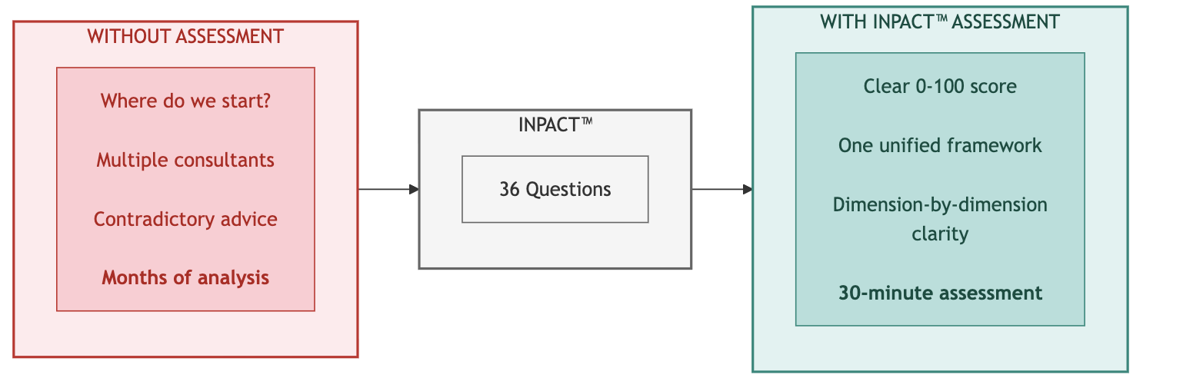
Key Takeaway: One assessment. Six dimensions. Complete clarity on where to invest.

Part 1: One Assessment Is All It Takes

Why One Assessment Works
Every enterprise attempting AI agent deployment faces the same question: Where do we start? The choices seem overwhelming: infrastructure gaps, governance requirements, operational concerns, technology choices. Many organizations commission multiple assessments, hire different consultants for each layer, and end up with contradictory recommendations that consume months before any real work begins.
There's a simpler path. A single assessment can measure everything that matters.
The Architecture of Trust integrates three frameworks into one coherent system. Understanding this integration reveals why one assessment delivers comprehensive insight:

INPACT™ defines what agents need. The six dimensions (Instant, Natural, Permitted, Adaptive, Contextual, and Transparent) capture the fundamental requirements any AI agent must have to operate reliably in an enterprise environment. For complete framework details, see Chapters 2 and 3.
The 7-Layer Architecture delivers those needs. Each layer addresses specific INPACT™ dimensions. For complete 7-Layer details, see Chapters 4, 5, and 6.
GOALS™ ensures sustainable operation. Five operational targets (Governance, Observability, Availability, Lexicon, and Solid) translate infrastructure capability into organizational outcomes. For complete GOALS™ framework detail, see Chapter 7.

These three frameworks form a chain of dependency. INPACT™ requirements drive architecture decisions. Architecture capabilities enable operational excellence. Operational excellence delivers the trust that makes agent adoption successful.
Diagram 2: Architecture of Trust Assessment Flow

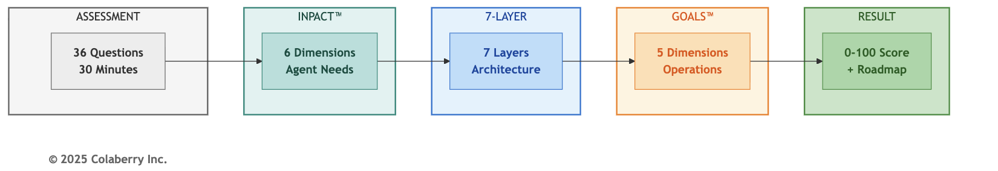

The integration principle is simple: if you assess INPACT™ comprehensively, you've assessed everything.
When you measure whether your infrastructure delivers Instant responses, you're simultaneously assessing Layer 1 (storage performance), Layer 2 (data freshness), and Layer 4 (caching efficiency). When you evaluate Permitted access control, you're measuring Layer 5 (governance) and Layer 6 (audit trails). Every INPACT™ dimension maps to specific layers and indicates GOALS™ readiness.
This is why 36 questions can measure your entire agent readiness posture. Not because the assessment is shallow, but because the questions target root causes that ripple through the entire system.
What This Chapter Gives You:
By the end of this chapter, you will have:
- Your INPACT™ score (0-100): A single number capturing your current agent readiness
- Dimension-by-dimension breakdown: Which of the six needs your infrastructure fulfills and which remain gaps
- Layer priorities: Which of the seven architecture layers need the most investment
- Timeline guidance: How long your transformation will take based on your starting point
- Benchmark comparison: How your journey compares to Echo Health Systems' 28→89 progression
The assessment takes approximately 30 minutes. The clarity it provides saves months of misdirected effort.
With the assessment's structure established, you need to understand what the numbers mean.

36 Questions, One Answer
The INPACT™ scoring system provides a standardized, repeatable method for measuring agent readiness. Every organization, regardless of industry, size, or current technology stack, can apply the same scale and achieve comparable results.
Scoring Scale (1-6 per dimension)
Each INPACT™ dimension is scored on a six-point scale:

Score | Label | Description | Infrastructure State
6 | Excellent | Best-in-class, competitive advantage | Production-grade, exceeds requirements
5 | Strong | Production-ready, meets all requirements | Full deployment appropriate
4 | Functional | Adequate for limited production | Deploy with monitoring
3 | Moderate | Basic capability, improvement needed | Pilot-only acceptable
2 | Significant Gap | Poor capability, major gaps | Not deployment-ready
1 | Critical Gap | Inadequate, blocks production | Immediate remediation required
This scale captures meaningful distinctions. The difference between a 3 and a 4 isn't arbitrary. It represents the threshold between pilot-only capability and production deployment. The difference between a 5 and a 6 distinguishes meeting requirements from achieving competitive advantage.
Calculation Method
The INPACT™ score calculation is simple:
- Score each dimension: Rate your infrastructure 1-6 on each of the six dimensions (I, N, P, A, C, T)
- Sum the raw scores: Total = I + N + P + A + C + T (range: 6-36)
- Calculate percentage: INPACT™ Score = (Total ÷ 36) × 100

For example, Echo Health Systems' Week 0 assessment:
  - I (Instant): 1
  - N (Natural): 2
  - P (Permitted): 1
  - A (Adaptive): 2
  - C (Contextual): 3
  - T (Transparent): 1
  - Total: 10 ÷ 36 = 28/100

Trust Bands
Raw scores translate into five trust bands that indicate agent readiness: Diagram 3: The Five Trust Bands
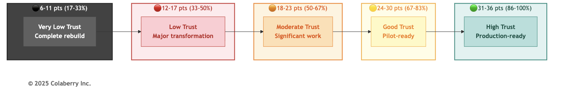
Raw Score | Percentage | Trust Band | Agent Readiness
31-36 | 86-100% | 🟢 High Trust | Production-ready for enterprise agents
24-30 | 67-85% | 🟡 Good Trust | Pilot-ready, minor gaps remain
18-23 | 50-67% | 🟠 Moderate Trust | Significant work needed before agents
12-17 | 33-50% | 🔴 Low Trust | Major transformation required
6-11 | 17-33% | - Very Low Trust | Complete rebuild required

These thresholds aren't arbitrary. They emerge from Colaberry's pattern recognition across enterprise implementations. Organizations scoring below 80/100 consistently experience agent failures in production. Those scoring 86+ achieve successful deployment with minimal post-launch issues.
See Part 4 for detailed guidance on what your trust band means for timeline, budget, and chapter navigation.

Six Dimensions & Seven Layers
INPACT™ covers the full architecture. Each dimension doesn't exist in isolation. It requires specific infrastructure layers to be fulfilled. When you score an INPACT™ dimension, you're simultaneously assessing the health of those underlying layers.
Diagram 4: INPACT™ Dimension to Layer Mapping
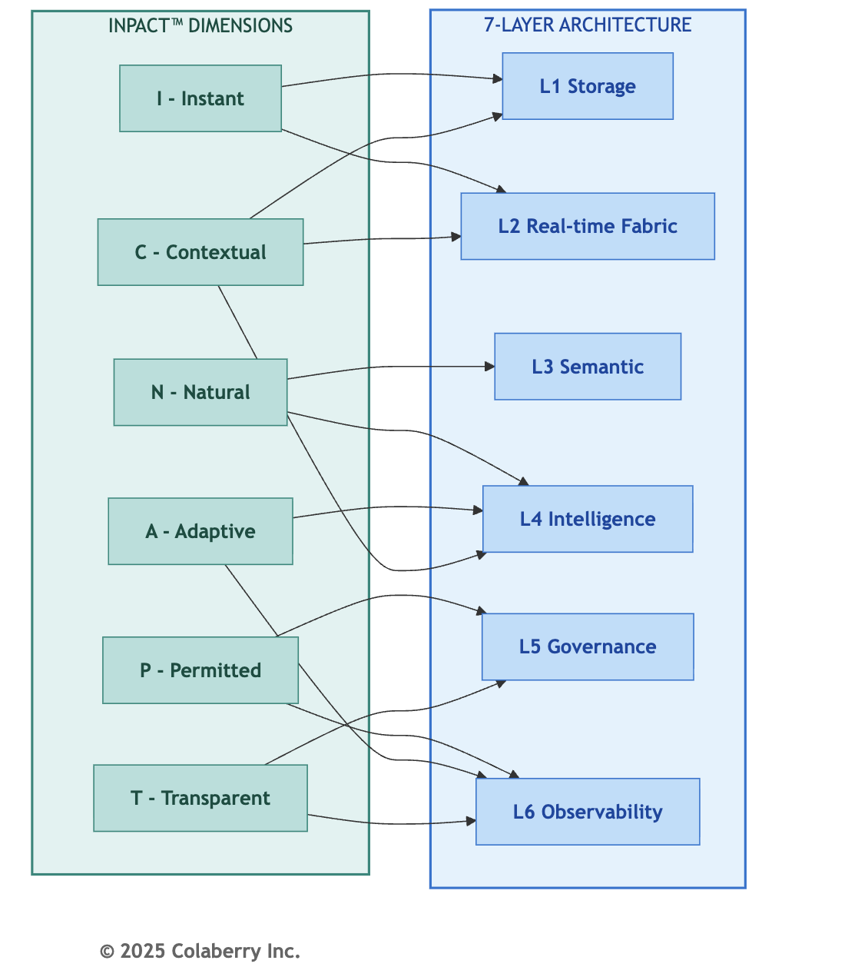

Coverage Verification: This mapping touches all seven layers. L7 (Orchestration) emerges when multiple dimensions reach production thresholds simultaneously. When you discover a low score in a particular dimension, you immediately know which layers require investment.

INPACT™ & GOALS™: The Connection

The INPACT™ assessment measures infrastructure readiness: can you build agents? The GOALS™ framework measures operational readiness: can you run agents? These are different questions, but they're connected.
INPACT™ → GOALS™ Indicators

INPACT™  Dimension | GOALS™  Indicator | The Connection
P - Permitted | G - Governance | ABAC policies, HITL workflows, and compliance controls constitute your governance capability
T - Transparent | O -  Observability | Audit trails, trace infrastructure, and monitoring dashboards enable organizational visibility
I - Instant | A - Availability | Response time and uptime directly determine whether users can access agent capabilities
N - Natural | L - Language | Semantic accuracy and NLU quality define whether users and agents speak the same language
A + C + T | S - Solid | Learning, context, and transparency combine to ensure reliable, trustworthy output
This mapping is indicative, not deterministic. A high INPACT™ score means your infrastructure foundation is strong, but operational excellence requires policies, procedures, training, and accountability structures that go beyond infrastructure. Chapter 8 detailed Echo's GOALS™ journey; Chapter 12 provides the operational playbook.
With the methodology clear, it's time to take the assessment.

Part 2: Your Turn: 36 Questions

Paper or Digital
You have two paths to complete your INPACT™ assessment, both yielding identical insights. Option 1: Online Assessment (Coming Q1 2026)
Colaberry is developing an automated assessment platform at https://trustbeforeintelligence.ai/assessment or colaberry.ai/assessment. The online tool will provide:
- Automated scoring engine with instant results
- Real-time gap analysis with visualizations
- Custom roadmap generation based on your specific scores
- Benchmark comparison against industry peers
- Free access for book readers
The online assessment uses the same 36 questions presented in this chapter. Early access registration is available now.
Option 2: Manual Assessment (Available Now)
Complete the assessment using this chapter's 36 questions:
- Read each question carefully
- Score your current infrastructure honestly (1-6)
- Record scores for all 36 questions
- Calculate your dimension totals (6 questions × 6 dimensions)
- Compute your INPACT™ score: (Total ÷ 36) × 100
- Interpret results using Part 4

Recommended Approach
Complete the manual assessment now. Thirty minutes of honest evaluation delivers immediate clarity on your agent readiness posture. If you use the online tool, you can validate your self-assessment and track progress over time.
Both approaches use identical questions and scoring methodology. Your scores will be directly comparable.

Honesty Is the Best Policy
The assessment's value depends entirely on honest answers. Inflated scores produce incorrect priorities and wasted investment. Accurate scores, even painful ones, lead to effective roadmaps.
Common Scoring Traps
- Aspirational scoring: "We're planning to implement real-time CDC next quarter." Score your current state, not your roadmap. If CDC isn't operational today, it doesn't count.
- Best-case scoring: "On a good day, we hit sub-2-second response times." Score your typical performance, not peak performance. If most queries take 5+ seconds, score accordingly.
- Departmental scoring: "Our data science team has a great semantic layer." Score your organization-wide capability. If the semantic layer serves one team but not the agents, it doesn't fulfill the need.
- Technology-possession scoring: "We own Databricks." Owning technology isn't the same as operational capability. Score based on what's working, not what's licensed.
Honest Assessment Tips
- Score what EXISTS today, not what's planned, budgeted, or promised
- Get multiple perspectives. Data engineers, operations staff, and business users often see different realities
- Use evidence: If you claim a score of 5, can you prove it with metrics?
- When uncertain, score lower. Conservative scores lead to appropriate investment, not over-engineering
- Revisit quarterly. Your score should improve as infrastructure matures

The Value of Honesty
Echo Health Systems scored 28/100 on their initial assessment. That number was painful to accept. Their CTO, Sarah Cedao, later reflected: "Twenty-eight felt like failure. But it was the most valuable number we'd ever seen. It told us exactly where to invest. Every dollar we spent addressed a real gap, not a perceived one."
An inflated score of 50/100 would have led Echo to skip foundational work. They would have attempted intelligence layers on unstable foundations. The agents would have failed, and the failure would have been blamed on AI, not infrastructure.
Accurate scores lead to accurate roadmaps. Accurate roadmaps lead to successful agents.

Ready? Let's Go
The assessment comprises six questions per dimension, covering the complete spectrum of agent infrastructure needs. Answer based on your current state, not planned improvements, not best-case scenarios, not what one team has achieved. Score your organization-wide reality.

Dimension 1: I (Instant) - Speed Builds Confidence
Agents operating at conversational speed require infrastructure that responds in milliseconds, not minutes. Users abandon slow agents. Trust erodes with every delay.
I.1: Response Time Capability

How quickly can your data infrastructure return query results for typical agent workloads?

Score | Criteria
6 | Sub-1-second P99 latency for complex queries
5 | Sub-2-second P95 latency, sub-5-second P99
4 | 2-5 second typical response, occasional delays
3 | 5-10 second responses common
2 | 10-30 second responses typical
1 | Over 30 seconds, frequent timeouts

I.2: Data Freshness

How current is the data available to your agents?

Score | Criteria
6 | Sub-5-second freshness (streaming)
5 | Sub-30-second freshness (real-time CDC)
4 | 1-8 hour freshness (frequent batch)
3 | 8-24 hour freshness (overnight batch)
2 | 24-72 hour freshness (daily batch)
1 | Over 72 hours (weekly or ad-hoc)

I.3: Caching Infrastructure

Do you have semantic caching that serves repeated or similar queries without full recomputation?

Score | Criteria
6 | ML-powered predictive caching, 80%+ hit rate
5 | Semantic caching operational, 60%+ hit rate
4 | Basic caching, 40-60% hit rate
3 | Simple key-value caching, under 40% hit rate
2 | Minimal caching, under 20% hit rate
1 | No caching infrastructure

I.4: Query Optimization

Is your storage layer optimized for agent query patterns (not just analyst workloads)?

Score | Criteria
6 | Agent-specific optimization with continuous tuning
5 | Optimized for agent patterns, regularly reviewed
4 | Some optimization for common queries
3 | Generic optimization, analyst-focused
2 | Minimal optimization
1 | No query optimization

I.5: Real-Time Data Pipelines

Do you have streaming or CDC pipelines that keep agent-accessible data current?

Score | Criteria
6 | Enterprise-wide streaming with sub-second latency
5 | CDC operational across primary systems
4 | CDC for some systems, others batch
3 | Limited streaming, mostly batch
2 | Batch-only with some micro-batch
1 | Overnight batch ETL only

I.6: Performance Monitoring

Can you detect and respond to performance degradation in real-time?

Score | Criteria
6 | Predictive alerting, auto-remediation
5 | Real-time monitoring with immediate alerts
4 | Near-real-time monitoring, manual response
3 | Periodic monitoring, delayed alerts
2 | Basic monitoring, reactive only
1 | No performance monitoring

I Dimension Total: ___ / 36 → I Score: ___ / 6 (divide by 6)

Dimension 2: N (Natural) - Understanding Builds Connection
Agents must understand business language without requiring users to learn SQL, know table names, or translate concepts. The semantic layer bridges human intent and data reality.
N.1: Semantic Layer Existence

Do you have a semantic layer that translates business terms to data structures?

Score | Criteria
6 | Universal semantic layer covering all domains
5 | Comprehensive coverage (80%+ of business concepts)
4 | Functional coverage (core concepts mapped)
3 | Partial coverage (limited domains)
2 | Minimal semantic layer (basic glossary only)
1 | No semantic layer

N.2: Natural Language Understanding Accuracy

What percentage of business questions does your system interpret correctly?

Score | Criteria
6 | Over 90% accuracy with ambiguity handling
5 | 75-90% accuracy on complex queries
4 | 60-75% accuracy, single-table queries strong
3 | 45-60% accuracy, simple queries only
2 | 30-45% accuracy, frequent misinterpretation
1 | Under 30% accuracy

N.3: Business Glossary Coverage

How completely are business terms defined and mapped to data?

Score | Criteria
6 | Complete glossary with automated maintenance
5 | Comprehensive glossary (500+ terms), regularly updated
4 | Functional glossary (200-500 terms)
3 | Basic glossary (50-200 terms)
2 | Minimal glossary (under 50 terms)
1 | No business glossary

N.4: Entity Resolution
Can your system resolve entities (customers, products, employees, accounts) across different naming conventions?

Score | Criteria
6 | ML-powered entity resolution with confidence scores
5 | Robust entity resolution across all systems
4 | Entity resolution for primary entities
3 | Basic entity resolution, manual rules
2 | Limited entity resolution, frequent errors
1 | No entity resolution

N.5: Query Understanding
Can agents handle multi-table joins, temporal logic, and complex business rules?

Score | Criteria
6 | Handles complex queries with business rule inference
5 | Multi-table joins, temporal logic, aggregations
4 | Multi-table queries, simple temporal logic
3 | Single-table queries, basic filters
2 | Simple lookups only
1 | Cannot interpret natural language queries
N.6: User Comprehension Feedback

Do you systematically capture and learn from cases where users were misunderstood?

Score | Criteria
6 | Automated learning from misunderstanding patterns
5 | Systematic feedback collection, regular model updates
4 | Feedback captured, periodic review
3 | Ad-hoc feedback collection
2 | Feedback captured but not analyzed
1 | No feedback mechanism

N Dimension Total: ___ / 36 → N Score: ___ / 6 (divide by 6)

Dimension 3: P (Permitted) - Security Builds Safety
Agents accessing sensitive data require dynamic authorization that respects who is asking, what they're asking for, when, where, and why. Static permissions fail in agent contexts.
P.1: Authorization Model

What authorization approach governs agent data access?

Score | Criteria
6 | Zero-trust ABAC with ML anomaly detection
5 | Comprehensive ABAC (40+ policies), sub-10ms evaluation
4 | ABAC operational with core attributes
3 | RBAC with some attribute-based rules
2 | Static RBAC only, shared service accounts
1 | No authorization or open access

P.2: Human-in-the-Loop (HITL)

Do you have workflows for human review of high-risk agent decisions?

Score | Criteria
6 | ML-powered risk scoring, adaptive escalation
5 | HITL workflows operational, under 15% escalation rate
4 | HITL defined for critical decisions
3 | Manual escalation process exists
2 | Ad-hoc escalation, no formal process
1 | No HITL capability

P.3: Audit Logging
How completely do you capture who accessed what, when, and why?

Score | Criteria
6 | Complete audit with ML-powered analysis
5 | 100% coverage, 7+ year retention, trace IDs
4 | Comprehensive logging, partial trace correlation
3 | User identity captured, limited context
2 | Basic database logs only
1 | No audit logging

P.4: Compliance Coverage
How well does your authorization system address regulatory requirements (e.g., GDPR, SOC 2, HIPAA, PCI-DSS, SOX)?

Score | Criteria
6 | Automated compliance reporting, continuous validation
5 | Full compliance coverage, audit-ready
4 | Major regulations addressed
3 | Partial compliance, gaps documented
2 | Compliance gaps, remediation needed
1 | Non-compliant, deployment blocked

P.5: Context-Aware Permissions
Do permissions adapt based on context (time, location, purpose, customer relationship)?

Score | Criteria
6 | Full context awareness with predictive access
5 | Rich context attributes (10+) in policy evaluation
4 | Core context attributes (role, time, location)
3 | Limited context (role + department)
2 | Role-only, no context adaptation
1 | Static permissions, no context

P.6: Escalation Protocols

Are escalation paths clearly defined for permission denials and edge cases?

Score | Criteria
6 | Automated escalation with SLA tracking
5 | Defined protocols, measured response times
4 | Escalation paths documented
3 | Informal escalation process
2 | Ad-hoc escalation
1 | No escalation process

P Dimension Total: ___ / 36 → P Score: ___ / 6 (divide by 6)

Dimension 4: A (Adaptive) - Improvement Builds Reliability
Agents must learn from their mistakes. Feedback loops, drift detection, and continuous improvement separate reliable agents from fragile prototypes.
A.1: Feedback Loop Existence

Do you have infrastructure to capture user feedback on agent responses?

Score | Criteria
6 | Multi-channel feedback with sentiment analysis
5 | Systematic feedback capture, integrated with training
4 | Feedback collection operational
3 | Basic feedback mechanism
2 | Feedback captured but not connected
1 | No feedback infrastructure

A.2: Model Retraining Cadence

How frequently can you update models based on new data and feedback?

Score | Criteria
6 | Continuous deployment with A/B testing
5 | Weekly retraining with validation
4 | Monthly retraining cycle
3 | Quarterly updates
2 | Annual or ad-hoc updates
1 | No retraining capability

A.3: Drift Detection

Can you detect when model performance degrades due to data or concept drift?

Score | Criteria
6 | Real-time drift detection with auto-remediation
5 | Automated drift alerts, defined response
4 | Regular drift monitoring
3 | Periodic manual drift checks
2 | Ad-hoc drift assessment
1 | No drift detection

A.4: Continuous Improvement Process

Do you have a defined process for turning feedback into improvements?

Score | Criteria
6 | Automated improvement pipeline
5 | Weekly improvement cycle with measured outcomes
4 | Regular improvement reviews
3 | Ad-hoc improvement process
2 | Improvements when critical issues arise
1 | No improvement process

A.5: Learning Automation

How automated is your feedback-to-improvement pipeline?

Score | Criteria
6 | Fully automated with human oversight
5 | Largely automated, manual approval gates
4 | Semi-automated, significant manual work
3 | Mostly manual with some automation
2 | Manual process
1 | No automation

A.6: Performance Trend Tracking

Do you track agent performance metrics over time to identify degradation?

Score | Criteria
6 | Predictive trend analysis with alerting
5 | Comprehensive trend dashboards, anomaly detection
4 | Key metrics tracked over time
3 | Basic trend tracking
2 | Point-in-time metrics only
1 | No performance tracking

A Dimension Total: ___ / 36 → A Score: ___ / 6 (divide by 6)

Dimension 5: C (Contextual) - Completeness Builds Accuracy
Agents answering real business questions need context that spans enterprise systems. Fragmented data produces fragmented answers.

C.1: System Integration Count

How many source systems feed your agent-accessible data layer?

Score | Criteria
6 | 10+ systems with automated discovery
5 | 7-10 systems integrated
4 | 4-6 systems integrated
3 | 2-3 systems integrated
2 | Single system only
1 | No integration

C.2: Cross-System Data Freshness

How current is data from your integrated systems?

Score | Criteria
6 | Sub-15-second freshness across all systems
5 | Sub-30-second freshness for primary systems
4 | Hourly freshness across systems
3 | Daily freshness
2 | Multi-day lag for some systems
1 | Weekly or longer lag

C.3: Entity Resolution Cross-Domain
Can you resolve the same entity (customer, employee, account) across different systems?

Score | Criteria
6 | Universal entity resolution with confidence scoring
5 | Robust cross-system entity resolution
4 | Entity resolution for primary entities
3 | Basic cross-system matching
2 | Limited cross-system resolution
1 | No cross-system entity resolution

C.4: Context Synthesis Capability

Can agents combine information from multiple systems to answer questions?

Score | Criteria
6 | Intelligent context assembly with relevance ranking
5 | Multi-system queries with unified response
4 | Cross-system queries with some limitations
3 | Basic cross-system queries
2 | Single-system queries only
1 | Cannot synthesize context

C.5: Cross-System Querying

Can a single agent query span multiple source systems transparently?

Score | Criteria
6 | Transparent multi-system queries with optimization
5 | Multi-system queries with sub-3-second response
4 | Multi-system queries, some performance impact
3 | Limited cross-system capability
2 | Manual system selection required
1 | Single-system queries only

C.6: Universal Context Availability

What percentage of business questions can be answered with available integrated data?

Score | Criteria
6 | Over 95% question coverage
5 | 80-95% question coverage
4 | 60-80% question coverage
3 | 40-60% question coverage
2 | 20-40% question coverage
1 | Under 20% question coverage

C Dimension Total: ___ / 36 → C Score: ___ / 6 (divide by 6)

Dimension 6: T (Transparent) - Transparency Builds Confidence
Users and regulators must understand how agents reach conclusions. Black-box decisions erode trust and invite compliance failures.
T.1: Audit Trail Completeness

How completely do you capture the reasoning chain from question to answer?

Score | Criteria
6 | Complete trails with ML-powered analysis
5 | 100% coverage, end-to-end trace IDs, 7+ year retention
4 | Comprehensive trails, partial correlation
3 | Basic audit trails, user identity captured
2 | Database query logs only
1 | No audit trails

T.2: Explainability Capability

Can agents explain their reasoning in terms users understand?

Score | Criteria
6 | Natural language explanations with confidence levels
5 | Structured explanations with reasoning steps
4 | Basic explainability, data sources shown
3 | Limited explainability
2 | Technical explanations only
1 | No explainability

T.3: Citation Provision

Do agent responses include citations to source data?

Score | Criteria
6 | Inline citations with confidence and freshness
5 | Citations for all claims with source links
4 | Citations for key claims
3 | Occasional citations
2 | Source system mentioned, no specifics
1 | No citations

T.4: Decision Traceability

Can you trace any agent decision back to the data and logic that produced it?

Score | Criteria
6 | Full traceability with replay capability
5 | Complete traceability, query replay
4 | Traceability for most decisions
3 | Limited traceability
2 | Partial traceability
1 | No traceability

T.5: Compliance Reporting

Can you generate compliance reports showing appropriate data access?

Score | Criteria
6 | Automated compliance reporting with alerts
5 | On-demand compliance reports, audit-ready
4 | Compliance reports with manual effort
3 | Basic compliance data available
2 | Limited compliance visibility
1 | No compliance reporting

T.6: User Trust in Transparency

Do users report understanding and trusting agent explanations?

Score | Criteria
6 | Over 90% user trust in explanations
5 | 75-90% user trust
4 | 60-75% user trust
3 | 40-60% user trust
2 | Under 40% user trust
1 | No user trust measurement

T Dimension Total: ___ / 36 → T Score: ___ / 6 (divide by 6)

INPACT™ SCORE CALCULATION WORKSHEET

Dimension | Your Score (1-6)
I - Instant | ___
N - Natural | ___
P - Permitted | ___
A - Adaptive | ___
C - Contextual | ___
T - Transparent | ___
Raw Total | ___ / 36
INPACT™ Score | (___ ÷ 36) × 100 = ___%
Your Trust Band: _______________

Part 3: 28 to 89: Echo's Path

Your INPACT™ score gains meaning through comparison. Echo Health Systems' transformation from 28/100 to 89/100 provides the definitive benchmark: a real progression through real infrastructure challenges with real investment decisions.
This section establishes Echo's journey as your reference point. Whether you're starting higher or lower, Echo's experience illuminates what each score means in practice.

Starting at 28
Echo Health Systems approached their initial assessment with confidence. Four hospitals, 23 clinics, 847 physicians, 340,000 annual patient encounters. They had data. They had technology. They had a board mandate to deploy AI agents.
They scored 28 out of 100.
Sarah Cedao, Echo's CTO, remembers the moment: "Twenty-eight out of a hundred. We're not ready for AI agents. We're barely ready for the questions."
The score exposed painful truth: five dimensions at critical gaps (1-2), only C (Contextual) showing any strength at 3/6, and all seven layers needing investment. At 28/100, the full 90-day transformation with no shortcuts wasn't optional. For Echo's complete dimension breakdown at Week 0, see Chapter 8.

The 90-Day Climb
Echo's progression from 28/100 to 89/100 followed a deliberate sequence. Each phase addressed specific dimensions, building capability that enabled subsequent phases.
Diagram 5: Echo's 90-Day INPACT™ Transformation

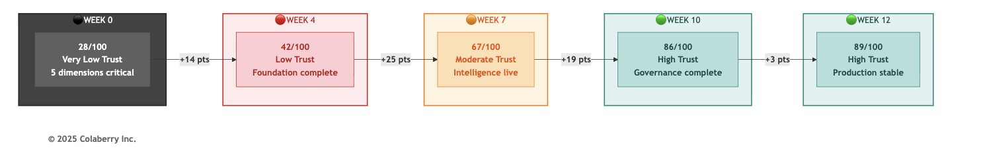

Echo's INPACT™ Progression: Milestone View

Milestone | Week | Score | Key Achievement | Trust Band
Baseline | 0 | 28/100 | Assessment complete, gaps identified | - Very Low Trust
Foundation | 4 | 42/100 | L1-L2 operational, real-time data flowing | 🔴 Low Trust
Intelligence | 7 | 67/100 | L3-L4 operational, semantic layer live | 🟠 Moderate Trust
Trust | 10 | 86/100 | L5-L7 operational, governance complete | 🟢 High Trust
Operations | 12 | 89/100 | GOALS™ validated, production stable | 🟢 High Trust

For complete dimension-by-dimension progression and what drove each jump, see Chapter 8.

What's Your Starting Point?
Echo's journey provides calibration for your own assessment.
If Your Score Matches Echo's Week 0 (25-35)
You face a complete transformation. You need:
- Full 90-day roadmap (Chapter 10)
- All four phases: Foundation → Intelligence → Trust → Operations
- Timeline: 10-12 weeks minimum to production readiness

If Your Score Exceeds Echo's Week 4 (40-65)
You have foundations in place. Your transformation compresses:
- Skip or abbreviate Phase 1 (Foundation)
- Focus on your weakest dimensions
- Timeline: 6-10 weeks to production readiness

If Your Score Exceeds Echo's Week 7 (65-80)
You're close to production readiness:
- Focus on dimensions scoring 3-4
- Governance and transparency often remain as final gaps
- Timeline: 4-6 weeks to production readiness

If Your Score Falls Below Echo's Week 0 (<25)
Consider extended timeline (16+ weeks), AIXcelerator acceleration, or phased approach to achieve pilot readiness first.
For complete budget guidance by score range, see Chapter 10 and Chapter 11.
Finding Your Starting Point
Your Lowest Dimensions | Echo Phase Match | Chapter 10 Entry Point
I and C below 3 | Echo Week 0-4 | Phase 1: Foundation
N below 3 | Echo Week 4-7 | Phase 2: Intelligence
P and T below 3 | Echo Week 7-10 | Phase 3: Trust
A below 3 | Echo Week 10-12 | Phase 4: Operations

Part 4: Breaking Down Your Score

You have your INPACT™ score. You've seen how Echo progressed from 28 to 89. Now translate your specific results into action.

Your Trust Band
Your trust band estimates your transformation timeline and investment level. Your lowest dimensions (next section) determine where to focus.
🟢 HIGH TRUST (86-100%)
Timeline: 2-4 weeks | Budget: $20K-$150K | Guide: Chapter 12
You're ready. Your infrastructure fulfills agent needs across all six dimensions. Deploy with confidence. Organizations in this band often arrived through prior modernization efforts: cloud migrations, data platform investments, or governance initiatives that weren't labeled "AI readiness" but delivered exactly that.
🟡 GOOD TRUST (67-85%)
Timeline: 4-8 weeks | Budget: $60K-$500K | Guide: Chapters 10-11
Solid foundations with gaps in specific dimensions. Production deployment is achievable with targeted investment. But don't underestimate P (Permitted) and T (Transparent). Organizations assume governance and transparency can be "added at the end." They're wrong. These dimensions become deployment blockers.
🟠 MODERATE TRUST (50-67%)
Timeline: 8-12 weeks | Budget: $120K-$900K | Guide: Chapters 10-11
You can see your data. You can run queries quickly. But your agents don't understand user questions, and you can't enforce who sees what. This is the dangerous zone. Don't deploy now and "add governance later." Organizations who tried crashed - agents returning confidential data to unauthorized users, misunderstanding questions so badly that users stopped trusting them entirely.
🔴 LOW TRUST (33-50%)
Timeline: 12-16 weeks | Budget: $190K-$1.2M | Guide: Chapters 10-11
Your infrastructure was built for a different era - BI reports, analyst queries, batch processing. Agents need something fundamentally different. Attempting to deploy agents on this foundation produces failures that get blamed on AI rather than infrastructure. Echo started at 28/100 in this band. Their 90-day transformation proves it's achievable, but it requires systematic investment.

- VERY LOW TRUST (<33%)
Timeline: 16+ weeks | Budget: $190K-$1.5M+ | Guide: Chapters 10-12
Your current infrastructure cannot support agent workloads. This isn't a gap to close - it's a foundation to build. Organizations who attempt deployment anyway experience predictable failures: agents that take minutes to respond, answers that contradict each other, security violations that trigger compliance investigations. The damage poisons future AI initiatives. "We tried AI and it didn't work" becomes organizational mythology.

*Budget ranges reflect the spectrum from pure open-source (low end) to commercial platforms (high end). See Chapter 10, Part 3 for detailed track options.*

Closing Your Gaps
Your trust band tells you how long and how much. Your lowest dimensions tell you where to focus. Regardless of your overall score, your lowest-scoring dimensions reveal which layers need the most attention. A score of 70 with weak Instant (I) still requires Phase 1 foundation work. Not all gaps are equal.
Diagram 6: Gap-to-Phase Prioritization Flow
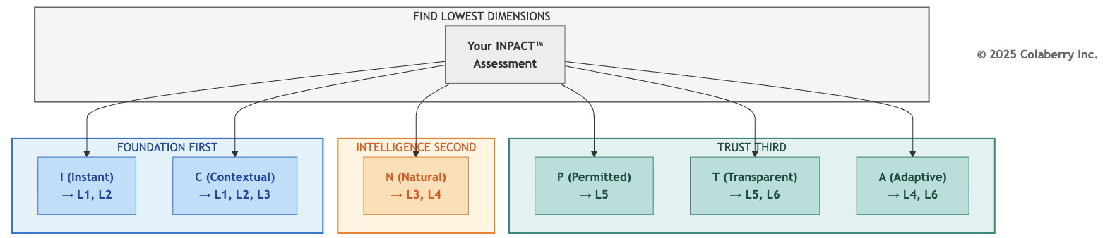

Gap Prioritization Matrix

If Your Lowest Dimension Is... | Priority Layers | Chapter 10 Phase
I (Instant) | L1, L2 | Phase 1: Foundation
N (Natural) | L3, L4 | Phase 2: Intelligence
P (Permitted) | L5 | Phase 3: Trust
A (Adaptive) | L4, L6 | Phase 3-4
C (Contextual) | L1, L2, L3 | Phase 1-2
T (Transparent) | L5, L6 | Phase 3
For detailed INPACT™-to-Layer mapping with technology recommendations, see Chapter 11, Section 1.1.

Interpreting Multiple Low Dimensions
If several dimensions score 1-2, prioritize based on dependencies: I and C first (foundational), N second (builds on data), P and T third (enable deployment), A fourth (can mature during production).
Your Action Plan
- Record your six dimension scores
- Identify your two lowest dimensions
- Map those dimensions to priority layers (table above)
- Proceed to Chapter 10 with clear focus

Bridge to Chapter 10

You now have:
- Your INPACT™ score (overall readiness)
- Your trust band (timeline and budget estimate)
- Your priority dimensions (where to focus)
- Your priority layers (from the Gap Prioritization Matrix)

Chapter 10 provides the week-by-week playbook. The four-phase sequence (Foundation → Intelligence → Trust → Operations) is fixed. What varies is where you invest the most time based on your priority layers.
Your assessment revealed the gaps. The playbook shows how to close them.

Turn the page to build your plan.

Chapter 9 Summary

Section | Key Takeaway
Part 1: Methodology | One INPACT™ assessment measures all three pillars: needs, architecture, and operations
Part 2: The 36 Questions | Complete self-assessment tool covering six dimensions with 1-6 scoring
Part 3: Echo's Benchmark | 28→89 progression provides calibration for your own journey
Part 4: Interpretation | Trust bands estimate timeline and budget; lowest dimensions determine focus

Your INPACT™ Score: ___/100
Your Trust Band: _______________
Your Priority Dimensions: _______________, _______________ Your Chapter 10 Entry Point: Phase ___
Acronyms
ABAC: Attribute-Based Access Control
CDC: Change Data Capture HITL: Human-in-the-Loop
NLU: Natural Language Understanding RAG: Retrieval-Augmented Generation
RBAC: Role-Based Access Control
© 2025 Colaberry Inc. All Rights Reserved.
INPACT™ and GOALS™ are trademarks of Colaberry Inc.

