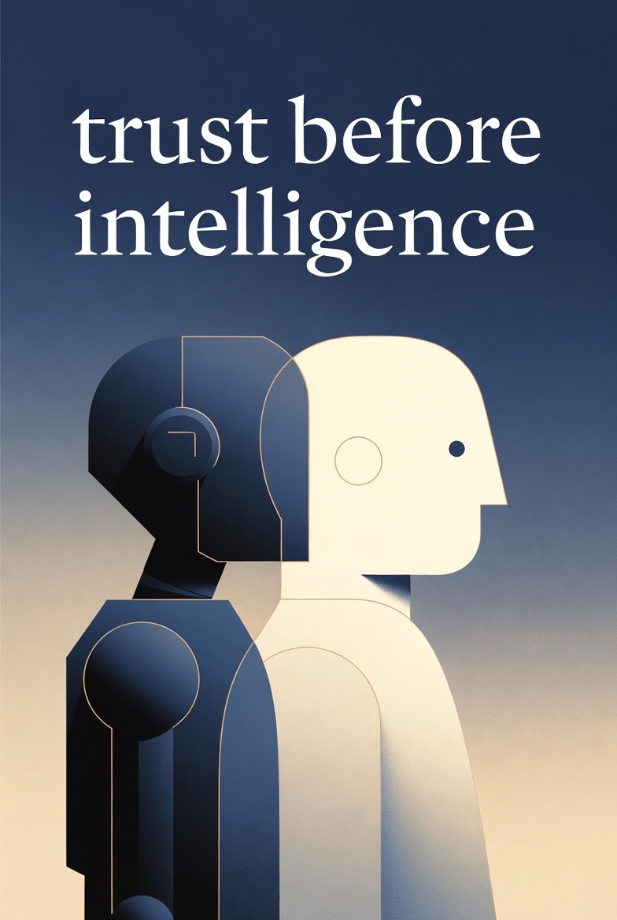

Trust Before Intelligence
Enterprise AI doesn’t need more Intelligence. It needs Trust!
By Ram Dhan Yadav Katamaraja | CEO, Colaberry Inc. | Harvard Business School OPM 60
THE PROBLEM
Enterprises are rushing to deploy AI agents with the goal of deploying autonomous systems that can schedule appointments, authorize payments, and make clinical decisions. But MIT research reveals 95% of these projects fail. Not because the AI isn't smart enough, but because the data infrastructure wasn't built for agents. The enterprises that win the agent era won't be those with the smartest AI. They'll be those who built the infrastructure that makes their AI trustworthy. This book solves that problem and shows you how in 90 days.
THE SOLUTION: THREE PROPRIETARY FRAMEWORKS
INPACT™ Framework | Agents aren't humans, they need to earn humans trust to collaborate with them. For humans to trust them they need to provide sub-second responses (Instant), have semantic understanding (Natural), follow dynamic permissions (Permitted), learn from feedback (Adaptive), work with full operational context (Contextual), and fully explain decisions (Transparent).
7-Layer Architecture | A complete technical blueprint of 7 layers spanning Data storage, Real-time processing, Semantic understanding, Intelligence, Governance, Observability, and Orchestration. All these layers together fulfills the INPACT™ needs showing exactly what to build and why.
GOALS™ Framework | Infrastructure built isn't infrastructure maintained. GOALS™ provides five operational excellence targets - Governance, Observability, Availability, Lexicon and Solid, that ensure trustworthy agent systems stay trustworthy through continuous monitoring and improvement.
WHY THIS BOOK, WHY NOW
The agent economy is exploding. Gartner predicts 85% of enterprises will deploy AI agents by 2027, yet infrastructure remains the #1 barrier. McKinsey finds agent-ready enterprises achieve 40% faster deployment with 60% less failure risk. Deloitte's 2025 research shows workers with high trust in AI are 5.4x more likely to engage with agent solutions. This book fills the critical gap between AI ambition and infrastructure reality, a gap that no other book addresses. Leaders are flying blind, repeating the same infrastructure mistakes. Trust Before Intelligence is the first comprehensive playbook for the Enterprise Agentic AI era.
CASE STUDY: ECHO HEALTH SYSTEMS
The book follows a regional healthcare system's transformation through a composite teaching case: transitioning from 28% to 89% INPACT score and a production deployment in 12 weeks. Readers see exactly how the three frameworks apply: $1.23M investment yielding $3.8M first-year, 209% ROI. Every metric, decision, and lesson is documented.
ABOUT THE AUTHOR
Ram Dhan Yadav Katamaraja founded Colaberry in 2012, now an Inc. 5000 company serving Fortune 2000 clients. He received the MIT's Most Promising Work of the Future Solution and McGovern Foundation's "AI for the Betterment of Humanity" awards. He's spoken at the United Nations, World Bank, Harvard Business School, MIT to name a few. Ram Dhan is an alumnus of Harvard University, is a Harvard Business School OPM 60 fellow and an alumnus of Jawaharlal Nehru Technological University. His frameworks emerged from three decades of Enterprise architecture work in education, healthcare, energy, agriculture, utilities, banking, finance, supply chain, telecom industries.
BOOK DETAILS
Target Audience: | CDOs, CTOs, VPs of Data & Analytics, Board Members
Length: | ~165,000 words | 13 chapters + appendices | 8-12 hour read
Comparable Titles: | Crossing the Chasm (Moore), The Phoenix Project (Kim), Designing Data-Intensive Applications (Kleppmann)
Target Publication: | Q1 2026
Materials Available: | Proposal, sample chapters, detailed outline, companion tools
"Infrastructure you can't trust creates intelligence you can't use."
Contact: Ram Dhan Yadav Katamaraja | ram@colaberry.com | colaberry.com

