Chapter 10: The AI Agent Readiness Playbook

From Assessment to Production in 90 Days

The Clock Starts Now

Tuesday, 2:15 PM Enterprise AI Summit, Main Stage Six Months After Production Launch
Sarah Cedao stepped to the podium. The room held four hundred IT leaders, all facing the same question her team had faced a year ago: how do you actually get from assessment to production?
"We scored twenty-eight out of a hundred," she began. "Ninety days later, we were at eighty-nine - three agents in production, fifty thousand daily interactions, zero compliance incidents." She clicked to her first slide. "Everyone asks for our secret. There isn't one. Just a playbook we followed week by week."
A hand went up. "You're healthcare. How do we know it works for manufacturing? Or finance?"
"The layers are the same," Sarah replied. "Foundation, intelligence, trust, operations. The sequence doesn't change. Your technologies might. Your timeline might. But the playbook? That's universal."
She clicked to the four-phase roadmap. "Let me show you exactly what we did." This chapter is that presentation.

Diagram 1: Roadmap Value: From Ad-Hoc to Structured

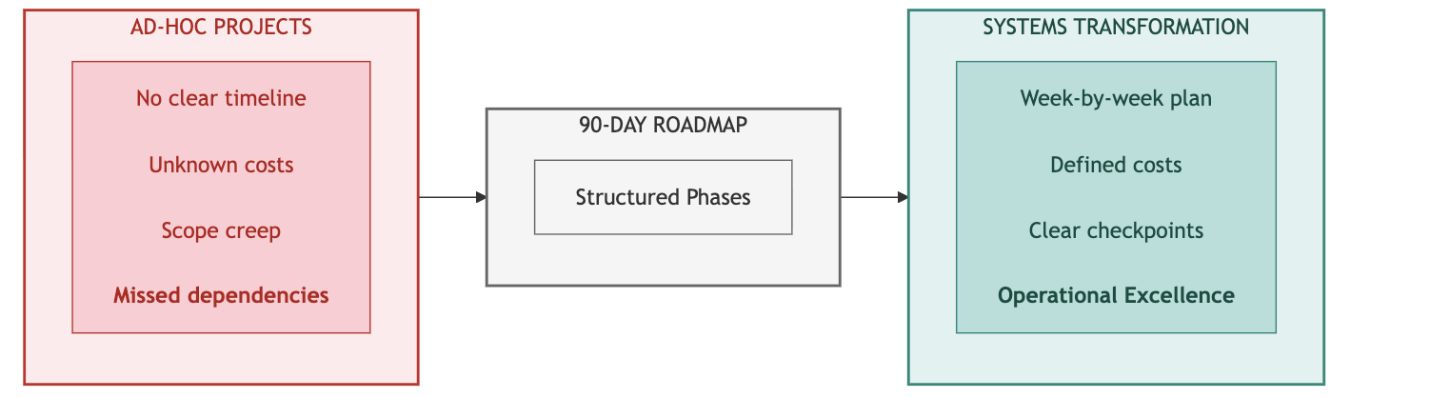
Key Takeaway: Ninety days from assessment to production. Week-by-week structure eliminates guesswork.

Part 1: The Roadmap

Your 90-Day Journey
Chapter 9 gave you the diagnosis: your INPACT™ score, trust band, and priority layers. This chapter gives you the treatment plan - a week-by-week playbook for transforming your infrastructure from assessment to production-ready. The playbook is universal.
Why 90 Days?
The 90-day timeline isn't arbitrary. It's the result of balancing three constraints:
- Business urgency: Executives lose patience with multi-year transformation programs. 90 days delivers measurable results before budget reviews and leadership changes.
- Technical dependency chains: The seven layers have dependencies. Layer 4 (Intelligence) requires Layer 1 (Storage) and Layer 3 (Semantic). Rushing creates gaps; extending creates complexity. 90 days provides enough time for sequential layer building with validation.
- Team sustainability: Transformation projects demand intense focus. Beyond 90 days, teams burn out, priorities shift, and momentum dissipates. The four-phase structure creates natural milestones that maintain energy.
The 90-day timeline typically breaks into 10 weeks of building plus 2 weeks of validation. Your timeline may vary based on starting point (Part 4), but the phase sequence remains constant.

What You'll Get from This Chapter
By the end of this chapter, you will have:
- Four phase structures with clear boundaries, budgets, and go/no-go checkpoints
- Implementation architecture diagrams showing technology stack options for each phase
- Risk management patterns that keep transformations on track when challenges emerge
- The 90-Day Tracker system - seven interconnected tracking sheets to manage your own transformation

How to Use This Roadmap
Chapter 9 gave you four things:
- Your INPACT™ score (overall readiness)
- Your trust band (timeline and budget estimate)
- Your priority dimensions (your two lowest-scoring dimensions)
- Your priority layers (from the Gap Prioritization Matrix)
Your trust band (from Chapter 9) tells you how long and how much. Your priority layers tell you where to focus in this playbook:

If Your Priority Layers Are... | Your Focus in This Playbook
L1, L2 (Foundation gaps) | Full attention to Phase 1; continue sequentially
L3, L4 (Intelligence gaps) | Validate Phase 1 (1-2 weeks); invest deeply in Phase 2
L5, L6, L7 (Trust gaps) | Validate Phases 1-2 (1-2 weeks each); invest deeply in Phase 3
Multiple layers across phases | Execute all phases fully as documented
The phase sequence never changes: Foundation → Intelligence → Trust → Operations. What varies is where you compress (validate only) and where you expand (full investment).

Important Cross-References
This chapter focuses on when to build. Other chapters provide complementary guidance:
- For how to assess your current state → Chapter 9 (INPACT™ methodology)
- For what technologies to select → Chapter 11 (vendor evaluation)
- For how to operate at scale → Chapter 12 (production operations)
- For week-by-week layer detail → Chapters 4-6
Change Management Approach
Technical transformation fails without organizational alignment. Invest deliberately in stakeholder communication and user adoption.

Communication Rhythm

Cadence | Audience | Content
Daily | Implementation team | Standup, blockers, coordination
Weekly | Extended team + sponsors | Progress, risks, decisions needed
Bi-weekly | Executive steering | Strategic decisions, budget status
Monthly | Board (prepared) | Transformation progress, ROI trajectory

Stakeholder Engagement
Identify four stakeholder groups with different concerns:
- End users: Will this make my job easier or harder? (Focus: workflow integration, training)
- IT/Operations: Can we support this? (Focus: infrastructure, monitoring, on-call burden)
- Compliance/Legal: Is this safe and auditable? (Focus: audit trails, liability, regulatory requirements)
- Finance: What's the ROI? (Focus: costs, benefits, payback period)
Schedule dedicated sessions with each group at phase boundaries, not just project kickoff. Early engagement prevents late-stage resistance.

Four Phases Overview
The transformation follows four distinct phases, each building on the previous. The sequence matters - attempting Phase 3 governance work before Phase 1 foundations produces the failures behind AI agents' 95% failure rate.[1]
Diagram 2: The 90-Day Four-Phase Roadmap
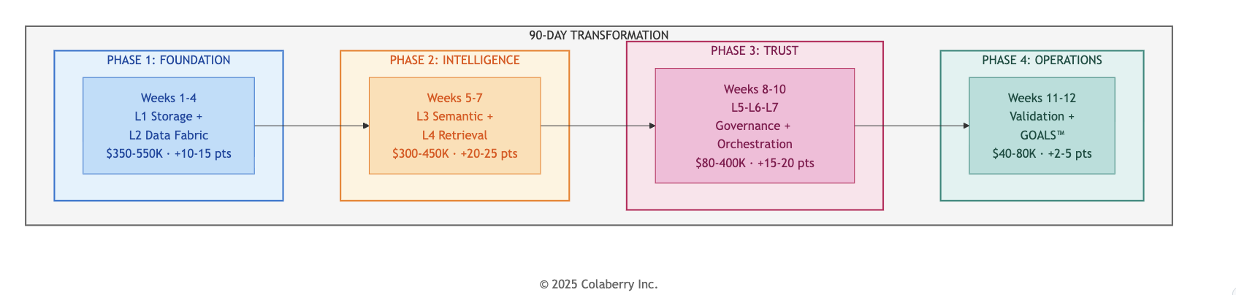

Part 2: The Four Phases

Phase 1: Foundation (Weeks 1-4)
Diagram 3: Foundation Layer Stack
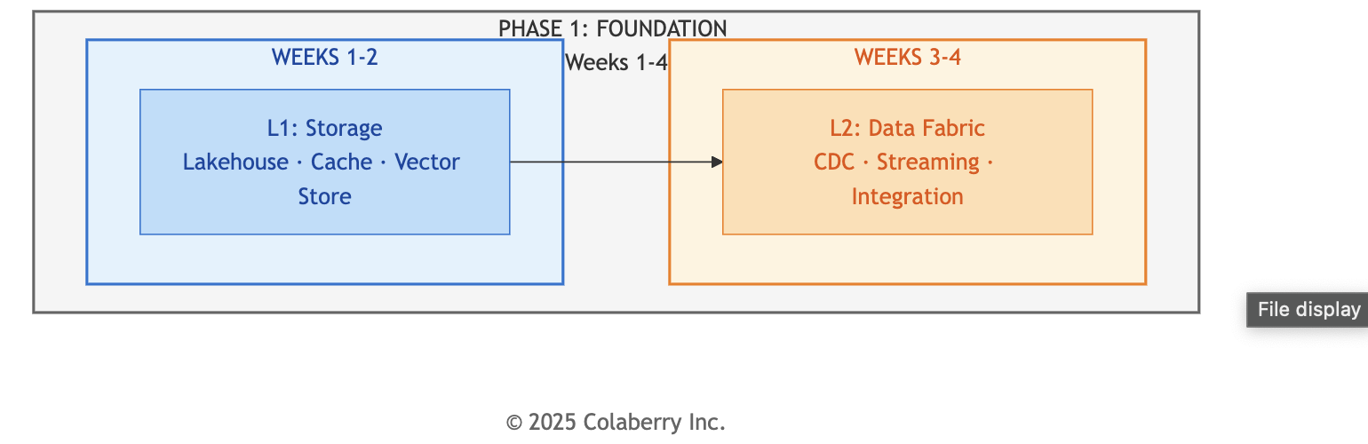

Attribute | Detail
Weeks | 1-4
Layers | L1 (Multi-Modal Storage) → L2 (Real-Time Data Fabric)
INPACT™ Target | +10-15 points
Budget Range | $80K-$550K (See Part 3: The Investment Approach)
Team | 2 senior data engineers, 1 cloud architect, 1 DBA, 2 CDC specialists (consulting)
Primary Focus | Data freshness (<30 seconds), query performance

What Gets Built
Phase 1 establishes the foundation everything else depends on. Build layer-by-layer to maintain momentum and clear dependencies:
Weeks 1-2: Layer 1 (Multi-Modal Storage)
- Unified lakehouse for analytics (Databricks, Snowflake, or equivalent)
- In-memory cache for sub-millisecond access (Redis, Memcached)
- Vector store preparation for Phase 2 semantic search

Weeks 3-4: Layer 2 (Real-Time Data Fabric)
- CDC captures changes from source systems (Debezium, Fivetran, or native connectors)
- Event streaming for real-time data flow (Kafka, Pulsar, or cloud-native)
- Target: <30-second data freshness (down from batch cycles)
Common Risk: CDC integration delays are typical - legacy system complexity often adds 1-3 days. Have parallel workstreams ready to maintain momentum.

Technology Options
For Layer 1 and Layer 2 technology details, see Chapter 4. For vendor selection guidance, see Chapter 11.

Phase Gate Checkpoint
- INPACT™ score ≥40 (±5% tolerance)
- CDC operational for critical tables (e.g., customers, transactions, core entities)
- Storage infrastructure provisioned and tested
- If behind: Add 1-2 weeks to Phase 1; never skip ahead to Phase 2
→ For complete week-by-week detail: Chapter 4 (Foundation Layers)

Phase 2: Intelligence (Weeks 5-7)

Diagram 4: Intelligence Layer Stack
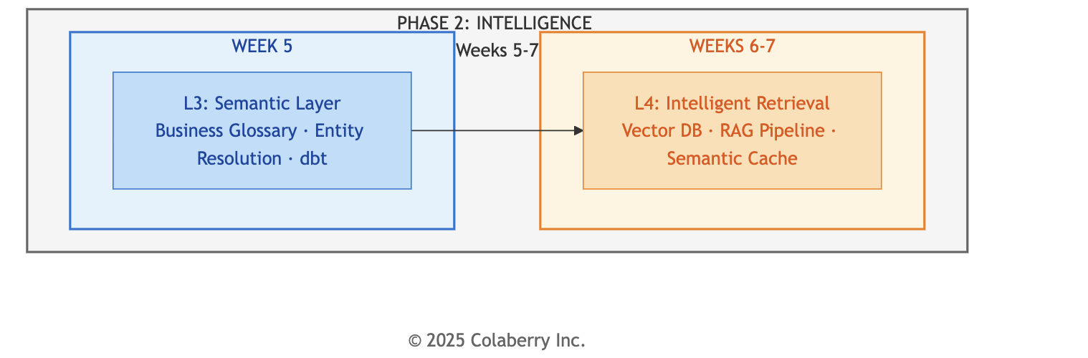
For RAG pipeline architecture details, see Chapter 5, Diagram 7: Layer 4 - Complete Intelligence Pipeline.

Attribute | Detail
Weeks | 5-7
Layers | L3 (Semantic Layer) → L4 (Intelligent Retrieval)
INPACT™ Target | +20-25 points
Budget Range | $60K-$450K (See Part 3: The Investment Approach)
Team | 2 ML engineers, 1 domain SME, semantic layer specialists
Primary Focus | NLU accuracy (target: 85%), semantic layer coverage, RAG pipeline

What Gets Built
Phase 2 gives agents the ability to understand and reason. Build layer-by-layer: Week 5: Layer 3 (Semantic Layer)
- Business glossary mapping domain terms to data structures (target: 1,000+ terms)
- Entity resolution achieving 95%+ accuracy across source systems
- Semantic models translating business concepts to technical queries (dbt, Cube, or equivalent)

Weeks 6-7: Layer 4 (Intelligent Retrieval)
- Vector database for semantic search (Pinecone, Weaviate, Chroma, or equivalent)
- Seven-stage intelligence pipeline (see Chapter 5, Diagram 7): Query → Embed → Retrieve → Rerank → Context → LLM → Cache
- Semantic caching to reduce LLM costs (target: 70%+ hit rate)

Common Risk: Accuracy often plateaus at 80-82% before hitting the 85% target. Solutions include adding reranking, hybrid search (combining vector and keyword retrieval), or expanding the semantic layer. Don't proceed with gaps - they compound in Phase 3.

Technology Options
For Layer 3 and Layer 4 technology details, see Chapter 5. For vendor selection guidance, see Chapter 11.

Phase Gate Checkpoint
- INPACT™ score ≥65 (±5% tolerance)
- Query accuracy ≥85% on test set (500 queries across all domains)
- Semantic layer operational with entity resolution
- If behind: Tune RAG pipeline; add reranking; extend Phase 2 by 1 week
→ For complete week-by-week detail: Chapter 5 (Intelligence Layers)

Phase 3: Trust & Orchestration (Weeks 8-10)
Diagram 6: Trust Layer Stack
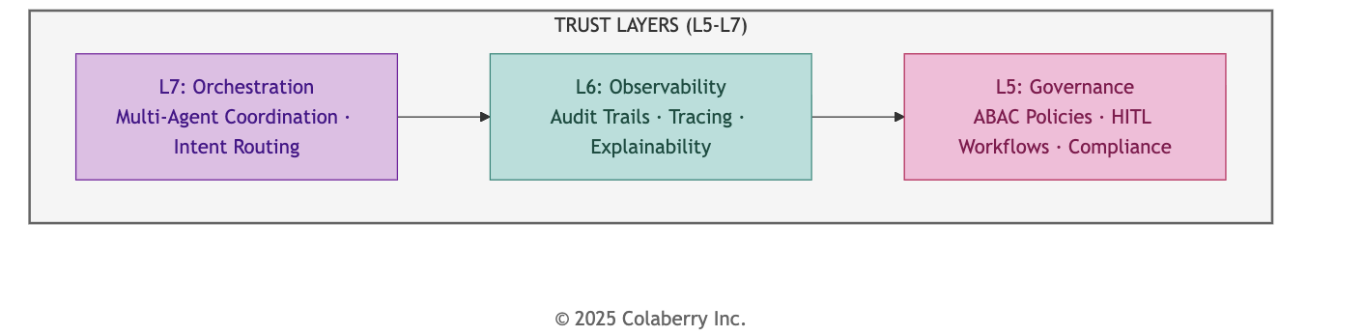

Attribute | Detail
Weeks | 8-10
Layers | L5 (Agent-Aware Governance) + L6 (Observability complete) + L7 (Orchestration)
INPACT™ Target | +15-20 points
Budget Range | $30K-$400K (See Part 3: The Investment Approach)
Team | 2 security engineers, 2 DevOps engineers, 1 compliance officer, 1 ML engineer
Primary Focus | ABAC policies, HITL workflows, audit trails, multi-agent coordination

What Gets Built
Phase 3 makes agents trustworthy:
- ABAC governance: Policy engine (OPA, Styra, or equivalent) evaluates access policies in <10ms - who is asking, what they're accessing, when, and from where
- HITL workflows: Confidence-based escalation routes high-risk decisions to human reviewers; target escalation rate <15%
- Observability complete: Distributed tracing (OpenTelemetry), APM (Datadog, New Relic, or equivalent), complete audit trails for compliance requirements
- Multi-agent orchestration: Coordination framework (LangGraph, AutoGen, or custom) manages specialized agents with shared state

Common Risk: Policy complexity often exceeds initial estimates - enterprises typically have 3-5× more access control edge cases than documented. Start with high-impact policies (PHI access, financial transactions) and expand iteratively.

Cost Optimization Opportunity
Phase 3 offers the largest budget variance potential. Open-source choices (OPA vs. commercial Styra, leveraging existing monitoring licenses, retrofitting pilot agents vs. rebuilding) can reduce costs by 50-80%. Evaluate build-vs-buy carefully - see Chapter 11, Section 3.

Technology Options
For Layer 5, 6, and 7 technology details, see Chapter 6. For vendor selection guidance, see Chapter 11.

Phase Gate Checkpoint
- INPACT™ score ≥80 (±5% tolerance)
- All 7 layers operational
- HITL escalation rate <15%
- Audit trail 100% complete
- If behind: Focus on governance policies; extend Phase 3 by 1 week
→ For complete week-by-week detail: Chapter 6 (Transparency + Orchestration Layers)

Phase 4: Operations (Weeks 11-12)

Attribute | Detail
Weeks | 11-12
Focus | Validation, UAT, Production Readiness
INPACT™ Target | +2-5 points (refinement)
Budget Range | $20K-$80K (See Part 3: The Investment Approach)
Team | UAT facilitators, compliance sign-off, training staff
Primary Focus | User Acceptance Testing, production cutover

What Gets Validated
Phase 4 validates everything works together:
- UAT with real users: Representative user group tests real scenarios over 2 weeks
- Edge case resolution: Identify and resolve edge cases before production (expect 30-60)
- Production readiness: 15-criteria checklist verified (see Chapter 12)
- GOALS™ operational targets: All five metrics at target levels

Success Criteria
Metric | Target
UAT success rate | ≥90%
Task completion | ≥90% of workflows completed successfully
User satisfaction | ≥4.0/5.0
NLU accuracy (production) | ≥85%
HITL override rate | <15%

Common Risk: UAT reveals unexpected workflow gaps - expect 30-60 edge cases requiring resolution. Build buffer time for iteration; rushing to production with unresolved issues creates post-launch incidents.

Phase Gate Checkpoint
- UAT success rate ≥90%
- All 15 production readiness criteria met
- Stakeholder sign-off obtained
- Go-live decision made

→ For complete operations guide: Chapter 12 (Production Operations)

Part 3: The Investment Approach

Budget Framework
Your investment depends on your technology strategy. Three tracks reflect different build-vs-buy decisions: Commercial Track (Speed priority, smaller technical teams)
Phase | Weeks | Budget Range | INPACT™ Gain
Foundation | 1-4 | $350K-$550K | +10-15 points
Intelligence | 5-7 | $300K-$450K | +20-25 points
Trust | 8-10 | $200K-$400K | +15-20 points
Operations | 11-12 | $40K-$80K | +2-5 points
Total | 12 weeks | $890K-$1.5M | +50-65 points

Hybrid Track (Balanced approach, selective open-source)

Phase | Weeks | Budget Range | INPACT™ Gain
Foundation | 1-4 | $200K-$350K | +10-15 points
Intelligence | 5-8 | $150K-$300K | +20-25 points
Trust | 9-11 | $80K-$200K | +15-20 points
Operations | 12-14 | $30K-$60K | +2-5 points
Total | 14 weeks | $460K-$910K | +50-65 points

Pure Open-Source Track (Budget priority, strong engineering team)

Phase | Weeks | Budget Range | INPACT™ Gain
Foundation | 1-5 | $80K-$150K | +10-15 points
Intelligence | 6-10 | $60K-$120K | +20-25 points
Trust | 11-14 | $30K-$80K | +15-20 points
Operations | 15-16 | $20K-$50K | +2-5 points
Total | 16 weeks | $190K-$400K | +50-65 points

Choosing Your Track

Factor | Commercial | Hybrid | Pure Open-Source
Timeline | 12 weeks | 14 weeks | 16 weeks
Internal engineering strength | Low-Medium | Medium | High
Ongoing operational burden | Low | Medium | High
Vendor support/SLAs | Yes | Partial | No
Best for | Speed to production | Balanced cost/speed | Maximum savings

Your Chapter 9 trust band provides timeline and total budget guidance. Use this framework to select the track that fits your organization's capabilities and constraints.
Cost Categories
Investment typically breaks down across three categories:

Category | Commercial | Hybrid | Open-Source
Technology (platforms, licenses) | 45-55% | 25-35% | 10-20%
Cloud Infrastructure | 10-15% | 20-30% | 25-35%
Services (consulting, training) | 20-30% | 20-25% | 15-20%
Staff (internal team time) | 15-20% | 25-30% | 35-45%
Open-source shifts cost from software licenses to staff time and cloud infrastructure.
Key Investment Insights

Track Selection Drives Total Cost
The same transformation can cost $190K or $1.5M depending on your technology choices. The INPACT™ outcome is the same - what differs is timeline, operational burden, and where the money goes.
Phase 3 Has Highest Variance Within Each Track Trust & Orchestration costs vary most based on:
- Policy engine: OPA (free) vs. Styra ($100K+)
- Monitoring: Grafana/Prometheus (free) vs. Datadog ($50K+)
- Orchestration: LangChain (free) vs. commercial platforms ($50K+)

Evaluate build-vs-buy carefully - see Chapter 11, Section 3.

Ongoing Operations
Monthly recurring costs after go-live vary by track:

Cost Component | Commercial | Hybrid | Open-Source
Cloud infrastructure | $25K-$40K | $15K-$25K | $25K-$45K
LLM API/inference | $10K-$20K | $5K-$12K | $2K-$8K
Platform licenses | $8K-$15K | $3K-$8K | $0-$2K
Support/maintenance | $5K-$10K | $5K-$10K | $8K-$15K
Total monthly | $48K-$85K | $28K-$55K | $35K-$70K
Open-source reduces platform license costs but increases cloud infrastructure (self-managed systems require more compute) and support/maintenance (internal staff time). The total cost of ownership converges across tracks - the difference is where the money goes, not how much.

ROI Expectations

Metric | Typical Range
Year 1 ROI | 150-250%
3-Year ROI | 400-600%
Payback Period | 8-14 weeks from production
ROI sources vary by industry but typically include: operational efficiency gains, reduced manual workload, improved accuracy, faster response times, and avoided compliance incidents.
Note: Budget and timeline figures in this chapter reflect typical ranges for mid-size enterprise implementations based on the 7-Layer Architecture methodology.

Part 4: Your Path

Receiving Your Chapter 9 Results
You arrived with:
- Trust band → Your timeline and budget envelope (from Chapter 9)
- Priority layers → Where to focus (from Chapter 9's Gap Prioritization Matrix)
This section shows how to adapt each phase based on your priority layers.
Phase Compression vs. Full Investment

Your Priority Layers | Phase 1 | Phase 2 | Phase 3 | Phase 4
L1, L2 | FULL (4 weeks) | Standard (3 weeks) | Standard (3 weeks) | Standard (2 weeks)
L3, L4 | Validate (1-2 weeks) | FULL (3 weeks) | Standard (3 weeks) | Standard (2 weeks)
L5, L6, L7 | Validate (1-2 weeks) | Validate (1-2 weeks) | FULL (3 weeks) | Standard (2 weeks)
All layers need work | FULL (4 weeks) | FULL (3 weeks) | FULL (3 weeks) | FULL (2 weeks)
FULL = Maximum investment - this is where your gaps live
Standard = Execute as documented in Part 2
Validate = Audit existing infrastructure, confirm phase gate criteria, fill gaps only (1-2 weeks)
Handling Multiple Priority Layers
If Chapter 9 identified priority layers spanning multiple phases (e.g., C dimension maps to L1, L2, L3):
- Start with foundational layers first - L1/L2 before L3/L4 before L5/L6/L7
- Don't skip phases - even if L3 is your priority, validate L1/L2 first
- Budget accordingly - your Chapter 9 trust band accounts for this complexity

Common Adaptation Patterns

Starting Condition | Adaptation | Rationale
Strong data warehouse, weak real-time | Compress L1, expand L2 | Your storage works; CDC is the gap
Good CDC infrastructure, no vector storage | Skip L2, expand L1 | Real-time exists; semantic search is missing
Semantic layer exists (dbt, Cube) | Validate L3, focus on L4 | Business terms defined; RAG pipeline needed
RBAC only, no attribute-based access | Expand Phase 3 by 1-2 weeks | Governance requires more policy work
Single agent working in pilot | Focus L7 orchestration | Agent logic proven; coordination missing
Regulated industry (healthcare, finance, government) | Add 1 week to Phase 3 | Additional compliance validation needed
Multi-cloud environment | Add 1 week to Phase 1 | Cross-cloud data fabric complexity

Scaling Considerations
The baseline roadmap scales for a mid-size organization (1,000-15,000 employees). Adjust timelines for your scale:

Organization Size | Timeline Adjustment | Budget Adjustment
Small (<1,000 employees) | -2 weeks | 0.6×
Mid-size (1,000-15,000 employees) | Baseline | 1.0×
Large (15,000-50,000 employees) | +2 weeks | 1.5×
Enterprise (50,000+ employees) | +4 weeks | 2.0-3.0×
Larger organizations require more stakeholder alignment, broader testing, and phased rollout across business units.

Part 5: Managing Risk

Risk Escalation Framework

Diagram 7: Risk Escalation Framework
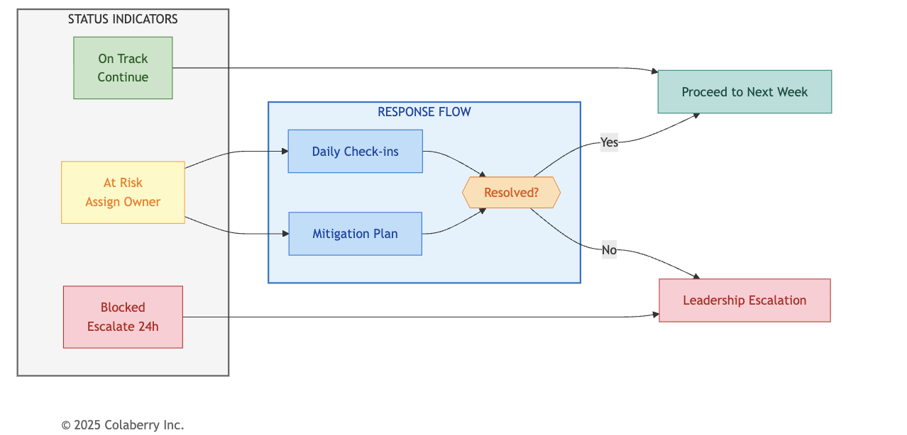
Phase Gate Checkpoints
Every phase ends with a formal go/no-go decision. These gates prevent the most common failure mode: proceeding with gaps that compound into production failures. Phase gate criteria are documented in each phase section (Part 2). The critical discipline: never skip a gate, never proceed with gaps.

Gate Decision Authority
CTO/CDO makes the final call with steering committee input. Never delegate gate decisions to the implementation team - they have incentive to proceed even with gaps.
Weekly Health Checks
Within each phase, Friday health checks catch issues early:
- 🟢 On Track: Continue as planned. No action required.
- 🟡 At Risk: Assign owner, define mitigation plan, begin daily check-ins. Target resolution within 5 business days.
- 🔴 Blocked: Escalate to leadership within 24 hours. Block cannot be resolved at team level.

Never let blockers persist across weekends without escalation.

Common Risk Patterns
Most transformations encounter 1-3 yellow weeks. Common patterns and mitigations:
Phase 1 Risk: CDC Complexity
- Issue: Legacy system CDC integration takes longer than planned
- Mitigation: Parallelize other workstreams while resolving; have batch fallback ready
- Prevention: Budget 1-2 extra days for CDC; engage source system experts early

Phase 2 Risk: Accuracy Plateau
- Issue: RAG accuracy stalls at 80-82%, below 85% gate requirement
- Mitigation: Add reranking layer; implement hybrid search; expand semantic layer
- Prevention: Build accuracy testing into daily workflow; don't wait for phase gate

Phase 3 Risk: Policy Complexity
- Issue: ABAC policy definition takes longer as edge cases emerge
- Mitigation: Start with core policies; add edge cases iteratively post-launch
- Prevention: Involve compliance early; document policy requirements in Phase 1

The weekly health check discipline catches issues before they become blockers.

Part 6: The AI Agent Readiness Tracker

Seven-Tab Overview
Diagram 8: Seven-Tab Tracker System
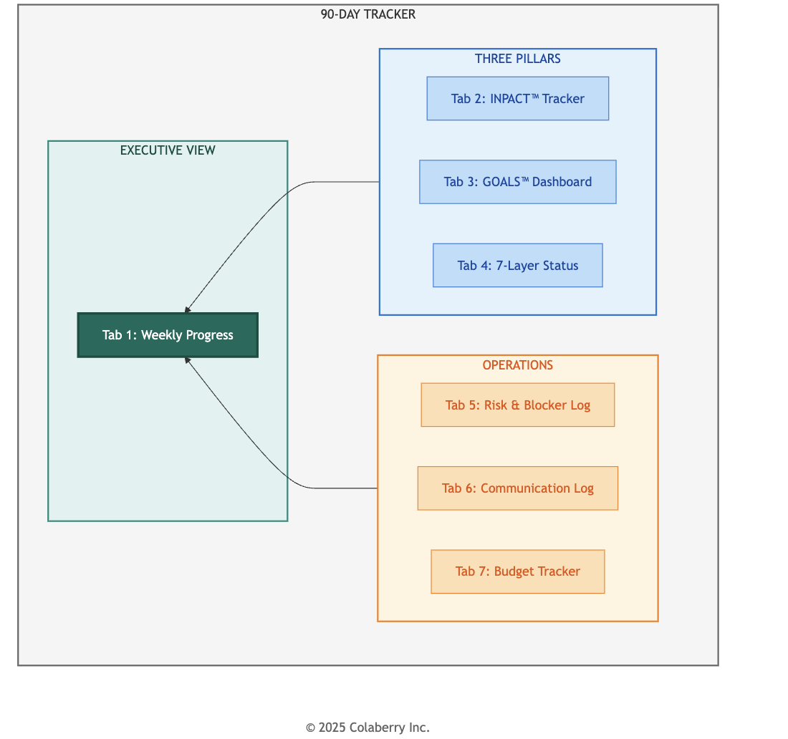

How the Tabs Work Together

Tab | Purpose | Primary User | Update Frequency
Tab 1: Weekly Progress | Executive dashboard - overall status | Project Manager | Weekly (Friday)
Tab 2: INPACT™ Tracker | Six dimensions, week-by-week scores | Data Architect | Weekly
Tab 3: GOALS™  Dashboard | Five operational metrics | Operations Lead | Weekly (Phase 3+)
Tab 4: 7-Layer Status | Layer-by-layer build progress | Technical Lead | Weekly
Tab 5: Risk & Blocker Log | Issue tracking and mitigation | Project Manager | As needed
Tab 6: Communication Log | Meetings, decisions, action items | Project Manager | Per meeting
Tab 7: Budget Tracker | Spend vs. plan by category | Finance | Weekly

Inside the Seven Tabs
Tab 1: Weekly Progress Dashboard

The executive view showing overall status at a glance. Columns include Week, Phase, Primary Layer Focus, INPACT™ Status, GOALS™ Progress (Phase 3+), Top Risk, Status (🟢 /🟡 /🔴 ), Key Deliverable, and Notes. Update every Friday; review in Monday leadership standup.
Tab 2: INPACT™ Progress Tracker
Tracks the six INPACT™ dimensions (I, N, P, A, C, T) week by week on a 1-6 scale. Your two lowest dimensions from Chapter 9 identify your priority layers. Use this tab to track whether those dimensions are improving as you execute the corresponding phases.
Tab 3: GOALS™ Health Dashboard
Monitors the five GOALS™ operational metrics: Governance, Observability, Availability, Lexicon, and Soundness. Activates in Phase 3 when operational concerns become primary. Target: all five metrics at ≥80% by Week 12.
Tab 4: 7-Layer Build Status
Technical tracking of layer-by-layer progress. Each layer shows weekly status (🔴 Not Started / 🟡 In Progress / 🟢 Operational / ✅ Production). Includes Key Components and Evidence columns to document what's deployed and how it's validated.

Tab 5: Risk & Blocker Log
Issue tracking with probability, impact, severity, owner, mitigation plan, and resolution status. Expect 10-15 risks over 12 weeks; most resolve within the week, 1-2 may require phase adjustments.

Tab 6: Stakeholder Communication Log
Documents every meeting, decision, and action item. Critical for maintaining alignment and providing audit trail. Expect 40-50 logged communications across 12 weeks including daily standups, weekly reviews, and bi-weekly executive steering.
Tab 7: Budget Tracker

Monitors spend by category (Technology, Services, Staff) against plan. Weekly actuals with variance tracking and
percentage spent. Threshold alerts: Green (within ±5%), Yellow (±5-10%), Red (>±10%).
Getting Started with the Tracker
Before Week 1:
- Download the template at trustbeforeintelligence.ai/90-day-tracker or colaberry.ai/90-day-tracker
- Complete your INPACT™ assessment (Chapter 9) to establish baseline scores
- Customize phase focus based on your priority layers (Part 4)
- Assign tab owners and establish update cadence

Week 1 Onward:
  - Friday: Update all tabs with current week's progress
  - Monday: Review Tab 1 in leadership standup, address any 🟡 /🔴 status
  - Ongoing: Log risks immediately in Tab 5; don't wait for Friday
  - Per meeting: Update Tab 6 with decisions and action items

Integration with Other Chapters
  - Chapter 11 provides technology selection guidance for each layer tracked in Tab 4
  - Chapter 12 provides operations detail for GOALS™ metrics in Tab 3
  - The tracker connects planning (Chapter 10) to execution (Chapters 11-12)

Part 7: Bridge to Chapters 11-12

You now have the complete implementation roadmap:
  - Part 1: Four phases with the rationale behind the 90-day timeline
  - Part 2: Phase-by-phase detail with technology stacks and phase gates
  - Parts 3-4: Investment summary and adaptation guidance for your context
  - Part 5: Risk management framework and phase gate checkpoints
  - Part 6: The 90-Day Tracker system with seven interconnected tabs

What's Next
Two questions remain: What technologies should you select? and How do you operate at scale? Chapter 11: Technology Selection Guide
How do you choose between Databricks and Snowflake? Pinecone and Weaviate? Build or buy? Chapter 11 provides:
  - Vendor evaluation methodology for each of the seven layers
  - Technology stack options with selection rationale
  - Build vs. buy analysis framework
  - Alternative options for different contexts and budgets

Chapter 12: Production Operations

Deployment is not the finish line. Chapter 12 covers everything after go-live:

  - 15-criteria production readiness checklist
  - MLOps practices for agent systems (model monitoring, drift detection, retraining)
  - Incident response and escalation procedures
  - Continuous improvement from feedback loops
  - Ongoing operations cost management

Your Monday Morning
Week 1 starts with Layer 1 storage provisioning. By Friday, you should have:
  - Current-state documentation complete (all seven layers assessed)
  - Stakeholder alignment confirmed (steering committee formed)
  - Storage infrastructure provisioning underway
  - Budget approved and resources allocated
  - Week 2 plan finalized with assigned owners The frameworks are proven. The tracker is ready.

The 90-day clock starts now.

Chapter Summary

Part | Content | Key Takeaway
Part 1 | Roadmap overview | Four phases with clear boundaries and checkpoints
Part 2 | Phase summaries | Foundation → Intelligence → Trust → Operations
Part 3 | Investment summary | $770K-$1.5M range, 400-600% 3-year ROI potential
Part 4 | Adaptation guidance | Customize based on your priority layers from Chapter 9
Part 5 | Risk management | Phase gates, escalation framework
Part 6 | 90-Day Tracker | Seven tabs for implementation tracking
Evidence Note: Budget and timeline figures in this chapter are informed by Echo Health Systems' implementation ($992K actual, 12 weeks, 28→89 INPACT™). For Echo's complete journey, see Chapter 8.

References

[1] Challapally, A., et al. (2025). "The GenAI Divide: Why 95% of Enterprise GenAI Projects Fail and How to Be in the 5%." MIT Sloan School of Management, New Architectures for Next-Generation Data Analytics (NANDA) Lab. Analysis of 300+ enterprise GenAI initiatives. https://mitsloan.mit.edu/ideas-made-to-matter/why-95-enterprise-genai-projects-fail
For technology selection references and vendor documentation, see Chapter 11.

Acronym Reference
© 2025 Colaberry Inc. All Rights Reserved.
INPACT™ and GOALS™ are trademarks of Colaberry Inc.

Acronym | Definition
ABAC | Attribute-Based Access Control
CDC | Change Data Capture
HITL | Human-in-the-Loop
LLM | Large Language Model
NLU | Natural Language Understanding
OPA | Open Policy Agent
RAG | Retrieval-Augmented Generation
UAT | User Acceptance Testing

