Chapter 4: THE 95% SOLUTION - PART 1

The Foundation Layers
The Monday That Changed Everything

Monday, 7:47 AM
Echo Health Systems, Executive Conference Room Floor 12, Building A
Sarah Cedao arrived thirteen minutes early. She'd learned that trick from her first CTO mentor: whoever controls the whiteboard controls the meeting. By 7:52, she had the agenda mapped in blue marker, the constraints in red, and the timeline in green.
Ninety days. That's what Dr. Raj had given her. Ninety days to transform infrastructure that had taken fifteen years to build or watch the AI initiative get defunded entirely.
The scheduling agent failure had cost them $650,000 and whatever remained of executive patience. Three pilots. Three failures. Zero production agents. The board wanted results, not explanations.
Her team filed in at 7:58: Marcus Williams, CDO, carrying coffee like a shield. Swapna Ram, Lead Data Engineer, already frowning at her laptop.
"Before we start," Sarah said, "let me be clear about what today is. This isn't a planning meeting. This is a building meeting. We leave this room with deployment orders, not discussion items."
She tapped the whiteboard. "Week 1 starts now. Foundation first."
Marcus raised an eyebrow. "You want to rebuild storage before touching intelligence? The board wants to see agents working, not databases."
"The board wants agents that work," Sarah corrected. "The scheduling agent failed because it couldn't see real-time data. The clinical assistant failed because it couldn't search semantically. The referral agent failed because it couldn't traverse relationships. Same root cause every time: infrastructure can't deliver what agents need."
She circled FOUNDATION in green. "We fix that first. Layers 1 and 2. Four weeks. Then and only then we build intelligence on top."
The room was quiet. Then Swapna nodded. "Show me the storage gaps."
Sarah pulled up the architecture diagram. "Let me show you what we're building."

Figure 4.0: Foundation Layers - Why Layers 1-2 Are Prerequisites


TRANSFORM
→
WITHOUT LAYERS 1-2
Siloed databases No unified access

Overnight batch ETL Stale data

No vector storage No semantic search

Minutes to query Users abandon
WITH LAYERS 1-2
Layer 1:
Unified multi-modal storage

Layer 2:
Sub-second freshness Vector + Graph ready
Under 2s response Users trust

Key Takeaway: Foundation first. Without Layers 1-2, nothing else works.

PART 1: FOUNDATION FIRST

Now we build.

This chapter begins Part II: "The 95% Solution - Building the Seven Layers That Work." Chapters 4-7 construct the 7-Layer Architecture layer by layer, transforming diagnosis into deployment, problems into solutions, gaps into capabilities.
This chapter builds the foundation: Layers 1 and 2.

Figure 4.1: The Architecture of Trust - Three Integrate
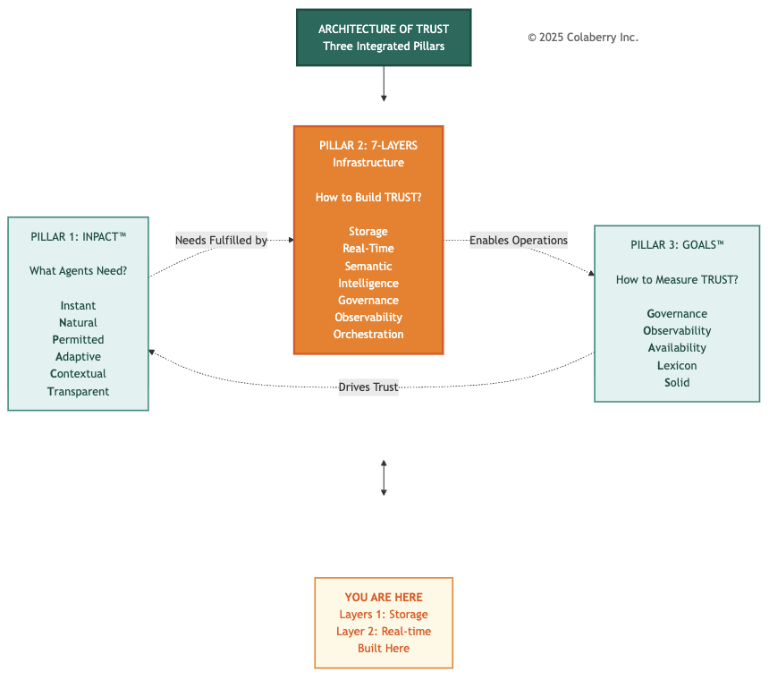

Why Foundation Matters

Think of enterprise architecture like building construction. You cannot build floors three through seven without a solid foundation. Skip the foundation, and the structure becomes unstable, regardless of the intelligence layers above.
Foundation equals data availability and accessibility. Before agents can understand language (Layer 3) or generate intelligent responses (Layer 4), they need two fundamental capabilities:
Layer 1 (Multi-Modal Storage): Right storage for the right query pattern. Patient records need semantic search (vector database). Provider relationships need graph traversal (graph database). Clinical notes need a flexible schema (document store). Medical imaging needs object storage.
Model training needs lakehouse platforms. Each query pattern requires specialized, optimized storage.
Layer 2 (Real-Time Data Fabric): Fresh data always available. Overnight ETL creates an 8-24 hour lag between operational reality and agent perception. Real-time CDC and streaming architectures ensure agents query the current state, not yesterday's snapshot.

Figure 4.2: 7-Layer Agent-Ready Architecture - Foundation Highlighted
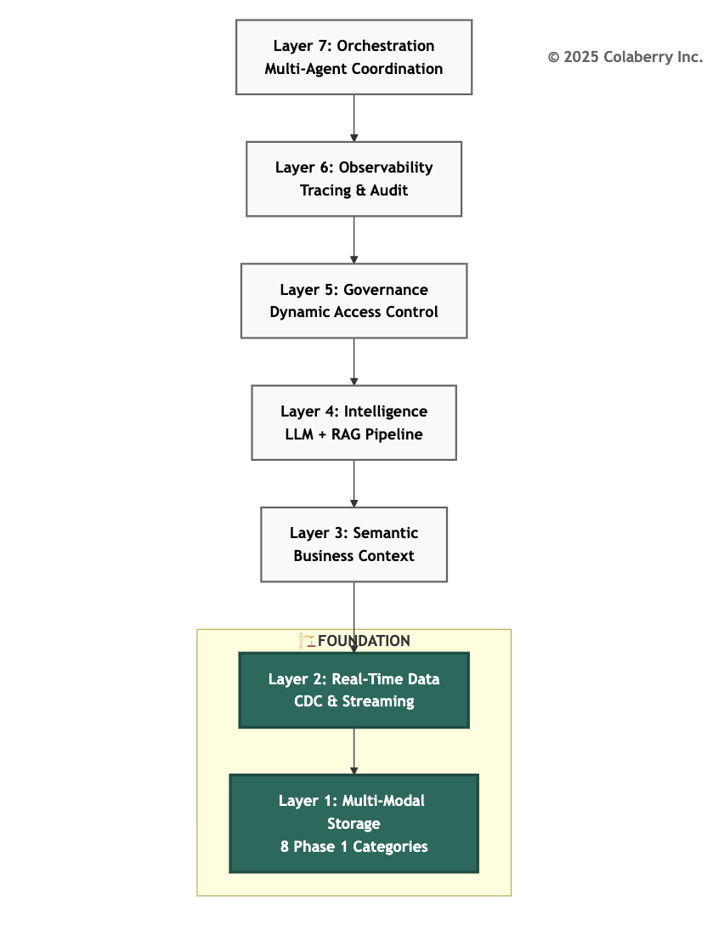
These foundation layers directly address specific gaps from Chapter 3:

The Seven Infrastructure Gaps
Chapter 3 identified seven infrastructure gaps preventing agent deployment. Chapter 4 addresses the foundation: Gaps 1-2.

Gap | Infrastructure Need | Addressed By | Coverage
Gap 1 | Multi-Modal Storage | Layer 1: Storage | Chapter 4 ✓
Gap 2 | Real-Time Data | Layer 2: Real-Time | Chapter 4 ✓
Gap 3 | Semantic Understanding | Layer 3: Semantic | Chapter 5
Gap 4 | Intelligent Retrieval | Layer 4: Intelligence | Chapter 5
Gap 5 | Dynamic Permissions | Layer 5: Governance | Chapter 6
Gap 6 | Reasoning Observability | Layer 6: Observability | Chapter 6
Gap 7 | Multi-Agent Coordination | Layer 7: Orchestration | Chapter 6
This Chapter's Scope: Layers 1-2 build the foundation that enables intelligence (Chapters 5), governance (Chapter 6), and orchestration (Chapter 7).
Specific Solutions:
- Gap 1 (Multi-Modal Storage): RDBMS-only architecture can't handle vectors, graphs, or unstructured data → Layer 1 solves with eight foundation categories in Phase 1 (expanding to eleven total categories when Phase 2 adds vector database and semantic search infrastructure)

- Gap 2 (Real-Time Data): Overnight ETL creates 8-24 hour lag → Layer 2 solves with CDC and streaming (sub-30 second freshness)

Without foundation, intelligence layers fail: semantic models (Layer 3) query stale data and return outdated answers, the intelligence layer (Layer 4) searches limited storage and misses critical context, and the governance layer (Layer 5) operates on incomplete data with poor access control.

Build the foundation first. Build it right. Everything else depends on it.

Echo's 10-Week Transformation Journey
Echo Health Systems started from a familiar position: strong BI infrastructure for reporting, inadequate for agents. Their transformation followed a three-phase roadmap, each phase building on the previous foundation.

Week 0: Not Agent-Ready (28/100)

Storage: SQL Server has only 2.4TB normalized database for transactional workflows and overnight reporting. No vector database (semantic search impossible). No graph database (relationship queries require slow recursive CTEs). No document store (clinical notes in varchar(max) columns). No object storage, lakehouse, model registry, feature store, time-series database, or cache layer.
Data Freshness: 24-hour batch ETL. Operational data changes continuously, but the reporting database refreshes overnight at 2 AM. Agents querying at 3 PM see data 13 hours stale. Unacceptable for clinical decision support.
INPACT™ Score: 28/100 (10 out of 36 points)
- I=1/6 | N=2/6 | P=1/6 | A=2/6 | C=3/6 | T=1/6

Week 4: Foundation Complete (42/100) - Phase 1: $470K
Storage: Eight core categories operational, SQL Server (existing), Databricks lakehouse, MongoDB (NoSQL), Neo4j (graph), MLflow (model registry), Azure Blob (object storage), Redis (cache), InfluxDB (time-series). Foundation ready for intelligence layers.
Data Freshness: Sub-30 second CDC and streaming. Change data capture from 3 operational systems feeds real-time pipelines. Agents query current state with <30 second lag.
INPACT™ Score: 42/100 (15 out of 36 points)
- I=4/6 (+3 from cache + real-time) | N=2/6 (±0) | P=1/6 (±0) | A=3/6 (+1 from registries) | C=4/6 (+1 from multi-modal) | T=1/6 (±0)
Gap closed: 14 points. Foundation enables intelligence layers in Phase 2.

Week 7: Intelligence Operational (67/100) - Phase 2: $380K
Preview (Details in Chapter 5): Semantic layer and intelligence orchestration built on foundation. RAG pipeline operational. Natural language understanding enabled.
INPACT™ Score: 67/100 (24 out of 36 points)
- Foundation dimensions maintained; Natural and Contextual dimensions significantly improved through intelligence layers
Gap closed: 25 points. Intelligence enables governance layers in Phase 3.

Week 10: Production-Ready (85/100) - Phase 3: $380K
Preview (Details in Chapters 6-7): Governance framework operational with dynamic permissions and human-in-the-loop workflows. Full observability and audit trails. First production agent deployed.
INPACT™ Score: 85/100 (31 out of 36 points)

- All six dimensions reach production-ready levels (≥5/6)
Gap closed: 18 points. Production-ready: all dimensions strong.
Total transformation: 28 → 85 in 10 weeks (57-point improvement).

Foundation Layer Impact on INPACT™ (Chapter 4 Scope)

Dimension | Week 0 | Week 4 (This Chapter) | Chapters 5-7 Target | Foundation Contribution
Instant (I) | 1/6 | 4/6 | 5/6 | Cache layer + optimized storage + real-time data
Natural (N) | 2/6 | 2/6 | 5/6 | Requires semantic layer (Chapter 5)
Permitted (P) | 1/6 | 1/6 | 5/6 | Requires governance layer (Chapter 6)
Adaptive (A) | 2/6 | 3/6 | 5/6 | Model registry + lakehouse infrastructure
Contextual (C) | 3/6 | 4/6 | 6/6 | Multi-modal storage + real-time freshness
Transparent (T) | 1/6 | 1/6 | 5/6 | Requires observability layer (Chapter 6)
TOTAL | 10/36 | 15/36 | 31/36 | +5 points from foundation
Percentage | 28% | 42% | 86% | +14% (this chapter)
Key Insight: Foundation layers (1-2) directly improve three dimensions: Instant, Adaptive, and Contextual. Natural, Permitted, and Transparent require intelligence and governance layers built in Chapters 5-7. Foundation provides the infrastructure that enables those improvements.
Bridge from Chapter 3
Chapter 3's seven infrastructure gaps revealed the failures of BI-era architecture confronting agent-era requirements. This chapter addresses two gaps, the foundation for the other five solutions.
Gap 1 (Multi-Modal Storage): Traditional BI stores everything in RDBMS or warehouses. Agents need specialized storage for vectors, graphs, documents, objects, time-series, and ML artifacts. Layer 1's architecture supports eleven categories total, eight deployed in Phase 1 (Weeks 1-4), with three intelligence-specific categories (Pinecone vector DB, Tecton, Azure Search) added in Phase 2 (Weeks 5-7).

Gap 2 (Real-Time Data): Traditional BI refreshes overnight. Agents need the current state. Layer 2's CDC and streaming eliminates batch lag, providing <30 second freshness.
Chapters 5-7 address the remaining five gaps (semantic understanding, intelligent retrieval, dynamic permissions, observability, orchestration). But those depend on foundation. You cannot build semantic understanding on stale data. You cannot implement intelligence without vector and graph storage. You cannot deploy governance without proper data access patterns.
Foundation first. Intelligence second. Let's build.

Progress Check: This chapter builds Layers 1-2, multi-modal storage and real-time data. Chapter 3 identified seven infrastructure gaps; we're addressing the first two. Foundation enables intelligence.

PART 2: THE STARTING LINE

Monday morning, Week 0. Sarah Cedao's office at Echo Health Systems headquarters.
Swapna Ram, Echo's Lead Data Engineer, connected her laptop to the conference room display. Infrastructure audit results filled the screen. Three months of analysis compressed into harsh reality.
"Show me the storage limitations first," Sarah said.
Swapna advanced to the next slide. "We have one storage type: SQL Server. 2.4 terabytes, normalized schema, optimized for transactional workflows." She paused. "Excellent for what it was designed for, billing, scheduling, clinical documentation. Inadequate for what we're asking it to do now."
Sarah leaned forward. "Spell it out."
"Vector search: impossible. We can't store embeddings in SQL Server at the required scale, 10 million patient records with 1,536-dimensional vectors. Even if we could, similarity search would take 15-20 seconds per query. Agents need sub-50 millisecond semantic search."
"Graph queries: possible but painful. We model provider referral networks with foreign keys. Recursive CTEs for 'find all physicians within three reporting levels' take 8+ seconds. Neo4j (https://neo4j.com) could do the same query in 340 milliseconds, over 20x faster, consistent with published benchmarks showing graph databases outperforming relational systems by 3x for simple queries up to 1,000x+ for deep traversals [1]."
"Document search: basic. Clinical notes live in varchar(max) columns with full-text indexing. Keyword search works. Semantic understanding doesn't. We find notes containing 'diabetes' but not notes about 'uncontrolled blood sugar' that never use that exact word."

"Model registry: none. Our data science team has 47 ML model versions in production. Version tracking happens in Git commits and Excel spreadsheets. When the sepsis model performance degraded three weeks ago, it took 6 hours to identify which version was deployed and roll back. MLflow (https://mlflow.org) would make that a 10-minute task."
Marcus Williams, Echo's CDO, interrupted. "We've discussed this. We can't rip out SQL Server and rebuild everything. We have a 90-day timeline to demonstrate agent readiness, not a 2-year modernization project."
"We're not ripping anything out," Swapna said. "SQL Server stays. We're adding storage types for agent workloads. Vector databases for semantic search, graph for relationships, document stores for flexible schema, object storage for training data. Expanding our portfolio, not replacing the core."
Sarah turned to the next concern. "Data freshness. Show me the ETL timeline."
Swapna pulled up the pipeline diagram. "Overnight batch. Operational databases, Epic for EHR, Workday for HR, Cerner for labs run continuously. Our reporting database refreshes at 2 AM via ETL. During business hours, data lags 8-24 hours behind operational reality."
Figure 4.3: Batch ETL Creates Patient Safety Risk

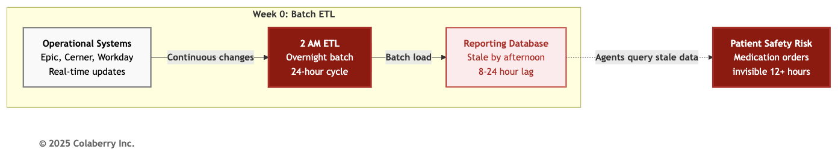

"Concrete example," Sarah requested.
"Friday afternoon, physician schedules Monday appointment. That appointment exists in Epic immediately. Our agent infrastructure won't see it until Saturday morning's ETL. Patient calls Friday at 4 PM asking about Monday appointments. Agents query stale data. They might say 'no appointments available' when three slots opened an hour ago."
"For clinical decision support, this gets dangerous. Medication order placed at 10 AM. Drug interaction alert should fire immediately. With batch ETL, that alert won't trigger until after midnight, 12+ hours late."
Marcus shook his head. "Real-time CDC is expensive. Apache Kafka (https://kafka.apache.org) clusters, stream processing, operational overhead. Our infrastructure team is two people."

"It's expensive to build yourself," Swapna countered. "Managed services - Confluent Cloud for Kafka, Debezium (https://debezium.io) for CDC [3, 4], Databricks (https://www.databricks.com) for stream processing eliminate operational burden. We configure, not manage. Yes, it costs $8,200 per month for Layer 2 infrastructure. But compare that to the cost of agents making decisions on stale data. One wrong medication interaction because we didn't see the latest drug order? That's a patient safety event, possibly a sentinel event. The financial and reputational cost exceeds our annual real-time infrastructure budget."
Sarah made the decision. "We build foundation first, intelligence second."
The Foundation Decision
"Here's the sequence," Sarah said. "Week 1-2: Layer 1 Multi-Modal Storage. We deploy eight core categories in parallel using three teams. Week 3-4: Layer 2 Real-Time Data Fabric. CDC operational, streaming pipelines live, freshness under 30 seconds. Weeks 5-7: Intelligence layers. Weeks 8-10: Governance and first agent deployment. We don't start intelligence until the foundation is solid."
Marcus raised the concern every CDO raises. "That's 4 weeks just on plumbing. The board expects to see agents doing something intelligent."
Swapna provided the technical counter. "Intelligence layers query foundation layers. If foundation is slow or incomplete, intelligence fails. Try to build semantic search (Layer 3) without vector storage, it will
fail. Try to implement intelligent retrieval (Layer 4) without real-time freshness, it will serve outdated context. Try to deploy governance (Layer 5) without proper data organization, it will be faulty access control."
"It's not plumbing," Swapna continued. "It's the architectural prerequisite for everything above it. We're following the principle every structural engineer knows: build bottom-up, not top-down."
Sarah established the timeline:
- Week 1-2: Layer 1 (Multi-Modal Storage) - 8 core categories deployed
- Week 3-4: Layer 2 (Real-Time Data Fabric) - CDC and streaming operational
- Weeks 5-7: Intelligence layers (Chapter 5) - semantic, RAG, LLM + 3 more storage categories
- Weeks 8-10: Governance and orchestration (Chapters 6-7) - ABAC, observability, first agent deployment
"Ten weeks from infrastructure chaos to agent-ready systems," Sarah said. "But only if we build the foundation right."

Technology Selection Constraints
The team documented their constraints and boundaries within which technology decisions would be made.

Cloud Provider: Azure (existing infrastructure, enterprise agreement). Echo ran 80% of systems on Azure. Cross-cloud data transfer costs ($3,600/month for 40TB/month egress) made multi-cloud painful. Decision: Azure-native where possible, AWS for services Azure lacked (MemoryDB for caching), Google Cloud avoided.
Team Expertise: SQL Server (20+ years institutional knowledge), Python (data science team proficient), basic Spark (used in Synapse for analytics). Limited Kubernetes experience (one engineer had dabbled, not production-ready). Decision: Managed services over self-hosted, avoid technologies requiring Kubernetes unless absolutely necessary.
Budget: Echo's complete 10-week transformation investment: $1,230,000 Three-Phase Investment:
Phase | Weeks | Layers | Total | Scope
Phase 1: Foundation | 1-4 | 1-2 | $470K | Storage (8 categories) + Real-time data fabric
Phase 2: Intelligence | 5-7 | 3-4 | $380K | Details in Chapter 5
Phase 3: Governance | 8-10 | 5-6-7 | $380K | Details in Chapters 6-7
Phase 1 Allocation ($470K budget / $468K actual) - This Chapter:
- Layer 1 (Multi-Modal Storage - 8 core categories): $288,000
- Layer 2 (Real-Time Data Fabric): $180,000
Operational: $24,600/month ($16,400 Layer 1 + $8,200 Layer 2)

Phase 2 and Phase 3 add intelligence-specific storage (Pinecone vector DB, semantic search index) and governance infrastructure. See Chapters 5-7 for detailed breakdowns.
Operational Costs (separate from $1.23M implementation): Foundation layers require
$24,600/month ongoing. (See Appendix D for complete breakdown including Phases 2-3)
Compliance: HIPAA, HITECH, state privacy regulations [2]. Every storage technology required Business Associate Agreement (BAA). Encryption at rest (AES-256) and in transit (TLS 1.2+) mandatory. Seven-year retention for medical records. Audit logging for all data access. Decision: Exclude vendors without healthcare BAA or HIPAA-compliant deployment path.
Timeline: Four weeks for foundation, non-negotiable. Board presentation scheduled Week 13 demonstrating agent readiness. Missing that deadline risked budget cuts for 2026.
Decision: Favor managed services and proven technologies over cutting-edge alternatives requiring extended learning curves.
Risk Tolerance: Medium. Echo accepted some vendor lock-in (Pinecone (https://www.pinecone.io) for vectors, Tecton (https://www.tecton.ai) for features) for faster deployment. Avoided bleeding-edge technologies (early-stage startups, version 1.0 releases). Preferred technologies with healthcare deployments (Mayo Clinic using MongoDB (https://www.mongodb.com), Mount Sinai using Databricks).
"These constraints eliminate 80% of technology options before we even evaluate," Sarah observed. "That's good. Decision paralysis kills projects. Clear constraints accelerate decisions."
For detailed technology selection criteria, product comparisons with INPACT™ + GOALS™ scoring, healthcare-specific guidance, and budget-tier recommendations across all storage and real-time data technologies, see Appendix DA-1: Technology Selection Guide (Sections 2.1-2.2).
The team was ready to build.

Progress Check: Echo's baseline: 28/100 INPACT™ score, SQL Server only, 24-hour batch ETL. Sarah's team committed to Layers 1-2 first, $470K investment across Weeks 1-4 with parallel workstreams.

PART 3: ELEVEN WAYS TO STORE

What It Is
Layer 1 provides eleven distinct storage categories, each optimized for specific agent query patterns. Production AI deployments in 2024-2025 typically use 7-9 storage categories; Echo selected all 11 to meet healthcare's comprehensive requirements.
Figure 4.4: Layer 1 Multi-Modal Storage - 11 Categories by Function
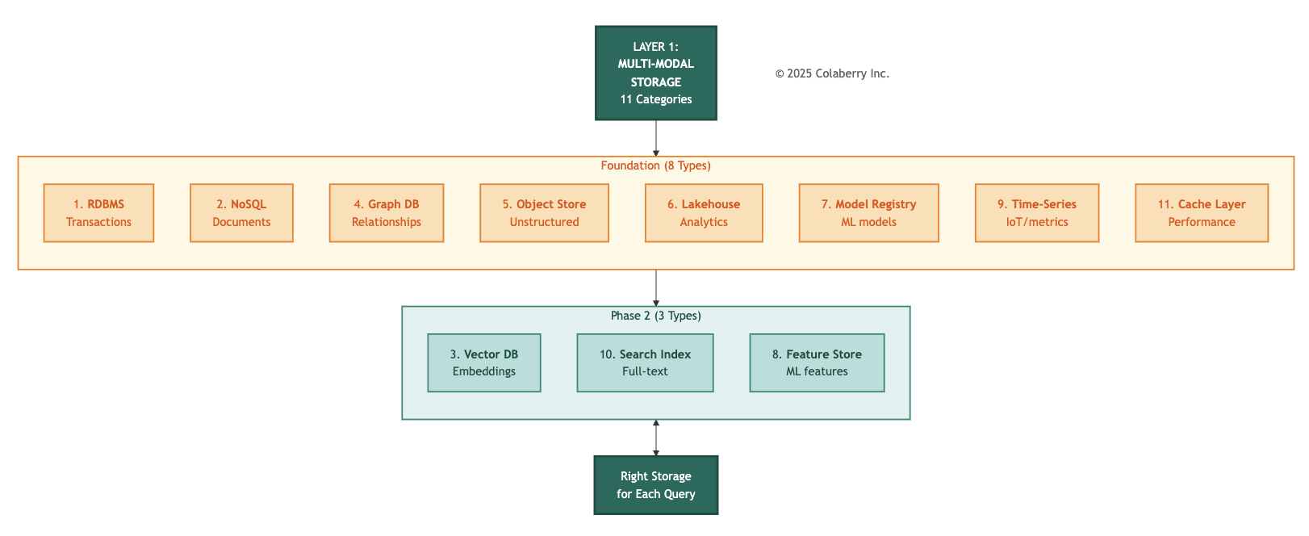

Traditional BI infrastructure assumes one or two storage types handle everything. Usually a relational database for operational data and a data warehouse for analytics. This works for reporting but fails for agents. Agents need semantic search across patient records, relationship traversal through provider networks, flexible schema for clinical notes, petabyte-scale training data, sub-second response times, ML artifact versioning, feature reuse across models, continuous time-series data from ICU monitors, and unified ML pipelines with ACID transactions.
No single storage technology handles all these patterns efficiently. Multi-modal storage matches storage type to query pattern, optimizing performance, cost, and developer productivity.

The eleven distinct storage categories:

Type 1: Relational Database (RDBMS)
What: SQL Server (existing), extended with Azure SQL Database Hyperscale (https://azure.microsoft.com/en-us/products/azure-sql/database/) tier for agent-specific workloads.
Why: Transactional consistency, referential integrity, ACID guarantees. Critical for patient demographics, appointments, billing, insurance claims requires strict data consistency and complex joins.
Echo's Implementation:
- Existing SQL Server: 2.4TB patient data, billing, scheduling (no changes)
- New Azure SQL Hyperscale: 840GB agent-specific tables (conversation history, audit logs, permission mappings)
- INPACT™ Impact: Permitted +0.5 (RBAC tables for fine-grained authorization)
Deployment Details:
- Setup: 3 days (schema design, migration scripts, testing)
- Cost: $2,800/month (Azure SQL Hyperscale tier, 8 vCores)
- Team: 1 database administrator + 1 backend developer

Type 2: NoSQL Document Store
What: MongoDB Atlas (https://www.mongodb.com/atlas) (managed). Alternatives: Couchbase, Amazon DocumentDB, Azure Cosmos DB.
Why: Flexible schema for clinical notes varying by specialty (cardiology notes ≠ radiology notes). JSON documents avoid varchar(max) limitations. Native array support for medication lists, allergy histories, problem lists.
Echo's Implementation:
- Clinical notes: Over 2 million documents
- Medication histories: Hundreds of thousands of documents with nested arrays
- INPACT™ Impact: Contextual +0.5 (flexible schema enables multi-specialty synthesis)

Deployment Details:
- Setup: 5 days (MongoDB Atlas cluster, data migration from SQL varchar fields)
- Cost: $1,200/month (M30 tier, 3-node replica set, 32GB RAM per node)
- Performance: 340ms average query time (vs. 2.8s SQL full-text search)
- Team: 1 database administrator + 2 backend developers

Type 3: Graph Database
What: Neo4j Aura (https://neo4j.com/cloud/platform/aura-graph-database/) (managed graph database). Alternatives: Amazon Neptune, TigerGraph, ArangoDB.
Why: Provider referral networks, organizational hierarchies, clinical pathways relationships are first-class entities. Graph traversal (Cypher queries) 24x faster than SQL recursive CTEs.
Echo's Implementation:
- Nearly 3,000 provider nodes (physicians, nurses, specialists)
- Over 8,000 relationship edges (reports_to, refers_to, consults_with)
- INPACT™ Impact: Contextual +0.5 (relationship queries enable referral network insights)

Deployment Details:
- Setup: 6 days (graph modeling, data migration from SQL foreign keys, Cypher query development)
- Cost: $3,600/month (Neo4j Aura Professional, 16GB RAM)
- Performance: 340ms average graph traversal (vs. 8.2s SQL recursive CTE)
- Team: 1 data architect + 1 backend developer

Type 4: Object Storage
What: Azure Blob Storage (https://azure.microsoft.com/en-us/products/storage/blobs/) (hot tier for active data, cool tier for archives).
Why: Petabyte-scale unstructured data (medical imaging, training datasets, model artifacts). Native integration with Azure ecosystem. Tiered storage (hot/cool/archive) optimizes costs.
Echo's Implementation:
- DICOM images: 420TB (radiology, cardiology)
- Training datasets: 87TB (historical EHR exports for model training)
- INPACT™ Impact: Adaptive +0.5 (training data enables model improvement cycles)

Deployment Details:
- Setup: 3 days (blob containers, lifecycle policies, access controls)
- Cost: $8,400/month (420TB hot, 87TB cool, LRS redundancy)
- Team: 1 infrastructure engineer
Type 5: Lakehouse Platform
What: Databricks (managed lakehouse, consolidating existing Azure Synapse warehouse).
Why: ACID transactions on data lakes (Delta Lake format). Unified batch and streaming. Time travel for reproducibility. Consolidates warehouse ($4,000/month savings) and lake ($6,200 new cost) into single lakehouse platform.
Echo's Implementation:
- 840GB Delta tables (patient encounters, lab results, medications)
- 30-day time travel enabled (reproducible training datasets)
- INPACT™ Impact: Transparent +1.0 (time travel provides complete lineage) Deployment Details:
- Setup: 8 days (Databricks workspace, Synapse migration, Delta table conversion)
- Cost: $6,200/month net ($10,200 Databricks - $4,000 Synapse eliminated)
- Team: 2 data engineers + 1 data architect

Type 6: Model Registry
What: MLflow (self-hosted on Azure Container Instances). Alternatives: Weights & Biases, Neptune.ai, Kubeflow.
Why: 47 ML models in production require version control, artifact storage, lineage tracking. Git commits and Excel spreadsheets don't scale. MLflow provides a centralized registry with rollback capabilities.
Echo's Implementation:
- 47 models registered (sepsis detection, readmission risk, medication interaction)
- 230 model versions (average 4.9 versions per model)
- INPACT™ Impact: Adaptive +1.0 (model versioning enables drift detection and rollback)

Deployment Details:
- Setup: 5 days (MLflow deployment, model migration, CI/CD integration)
- Cost: $840/month (Azure Container Instances, 4 vCPUs, 8GB RAM)
- Team: 2 ML engineers + 1 DevOps engineer
Type 7: Time-Series Database
What: InfluxDB Cloud (https://www.influxdata.com) (managed time-series database).
Why: ICU monitor data (heart rate, blood pressure, SpO2) arrives at 1Hz frequency. Time-series databases optimize for append-heavy workloads with time-based queries and downsampling.
Echo's Implementation:
- 43 ICU beds × 12 vital signs × 86,400 measurements/day = 44.6M data points daily
- 90-day retention (full resolution), 2-year retention (downsampled to 1-minute intervals)
- INPACT™ Impact: Instant +0.5 (real-time vitals enable sub-second alerting)
Deployment Details:
- Setup: 5 days (InfluxDB setup, HL7 integration for monitor data, downsampling policies)
- Cost: $3,200/month (InfluxDB Cloud Dedicated, 250GB storage, 100K writes/sec)
- Team: 1 integration engineer + 1 clinical informaticist

Type 8: Cache Layer
What: AWS MemoryDB for Redis (managed in-memory cache).
Why: Caching infrastructure reduces latency and costs for repeated queries. Foundation layer establishes the cache architecture that intelligence layers will leverage for LLM response caching.
Echo's Phase 1 Implementation:
- Redis cluster for query result caching
- Session state management
- Real-time data buffering
- INPACT™ Impact: Instant +1.0 (cache reduces query latency) Deployment Details:
- Setup: 4 days (MemoryDB cluster, integration with data pipelines)
- Cost: $2,400/month (MemoryDB cluster)
- Team: 1 infrastructure engineer
Phase 2 Enhancement (Chapter 5): Semantic caching using vector similarity on LLM prompts enables 85% cache hit rate and $12,200/month LLM cost savings. This intelligence-layer optimization builds on the Redis infrastructure established here.
Type 9: Vector Database (Phase 2)
The Gap: Semantic search requires cosine similarity across high-dimensional embeddings. RDBMS cannot index vectors efficiently. Similarity search across 10M patient records takes 15-20 seconds in SQL Server. Agents need <50ms semantic search.
Foundation Requirement: Layer 1 establishes the architectural pattern and data pipelines that vector databases will consume. Patient records, clinical notes, and guidelines must be accessible and properly structured before vectorization.
Phase 2 Solution (Chapter 5): Pinecone vector database deployment, embedding generation, and semantic search implementation. Alternatives: Weaviate, Milvus, Qdrant. The infrastructure foundation built in Phase 1 enables rapid Phase 2 deployment.
For vector database implementation details, embedding strategies, and RAG pipeline construction, see Chapter 5: Intelligence Layers.

Type 10: Search Index (Phase 2)
What: Azure Cognitive Search (https://azure.microsoft.com/en-us/products/ai-services/cognitive-search/) (managed search service).
Why: Full-text search across clinical notes, research papers, clinical guidelines. Supports faceted search, highlighting, fuzzy matching. Complements vector search (keyword) and semantic search (meaning).
Echo's Implementation:
- Over 2 million clinical notes indexed
- 24K clinical guidelines (UpToDate, Lexicomp)
- INPACT™ Impact: Contextual +0.5 (full-text search finds exact matches vector search misses) Deployment Details:
- Setup: 4 days (index creation, analyzer configuration, integration with MongoDB)
- Cost: $2,400/month (Standard S2 tier, 100GB index)
- Team: 1 search engineer + 1 backend developer
Type 11: Feature Store (Phase 2)

The Gap: ML models across the organization calculate the same metrics differently. "30-day readmission risk" computed one way in the sepsis model, another way in the discharge planning agent, and yet another way in the utilization dashboard. When predictions conflict, clinicians lose trust.
Foundation Requirement: Layer 1 establishes the model registry (MLflow) and lakehouse (Databricks) infrastructure that feature stores integrate with. ML pipelines must be operational before feature management can be layered on top.
Phase 2 Solution (Chapter 5): Tecton feature store deployment, feature definition standardization, and integration with training/inference pipelines. The ML infrastructure foundation built in Phase 1 enables rapid Phase 2 deployment.
For feature store implementation details, feature engineering strategies, and ML pipeline integration, see Chapter 5: Intelligence Layers.

Storage Selection Decision Framework

Phase 1 Categories (Foundation - This Chapter):

Need | Required Categories | Skip If
Transactional workloads | RDBMS (1) | Never skip (always needed)
JSON documents >50GB | NoSQL (2) | Relational schema works
Multi-hop relationships | Graph DB (3) | Simple foreign keys work
Unstructured data >100GB | Object Storage (4) | All data structured
Warehouse + Lake both | Lakehouse (5) | Warehouse-only or Lake-only
ML models in production | Model Registry (6) | No ML deployment
IoT / monitoring streams | Time-Series (7) | No continuous metrics
LLM response caching | Cache Layer (8) | Latency not critical

Phase 2 Categories (Intelligence - Chapter 5):

Need | Required Categories | Skip If
Semantic search / RAG | Vector Database (3) | Keyword search sufficient
Full-text search | Search Index (10) | Vector-only sufficient
>5 ML models deployed | Feature Store (6) | ML not core capability

Echo's Single-Modal Limitations (Week 0)
Echo started with SQL Server only. Here's what failed:
Figure 4.5: Echo's Storage Transformation - Single-Modal to Multi-Modal
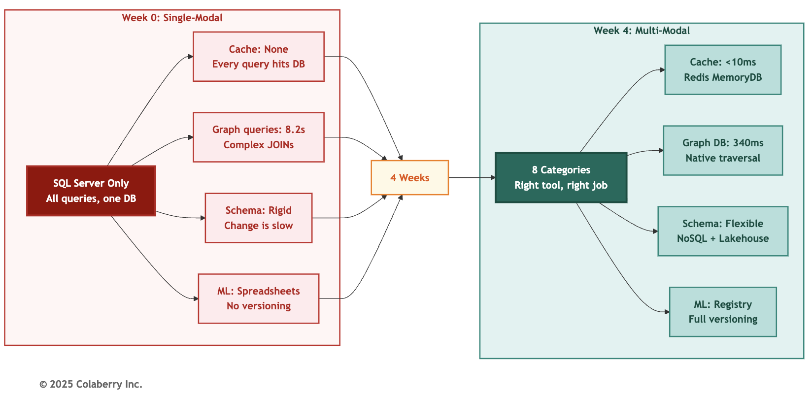

Cache layer: Critical for performance. Every agent query hit the database directly, no caching tier. Repeated queries for the same patient, same provider, same schedule data hammered SQL Server unnecessarily. Peak load saw 12,000 identical queries per hour. Redis MemoryDB provides sub-10ms response for cached results, reducing database load by 60% and enabling the response times agents require.
Graph traversal: Painful. "Find all providers within three reporting levels of Dr. Sarah Chen" requires recursive CTE in SQL Server. Echo's implementation took 8.2 seconds on average (p95: 12.4s). Neo4j's native graph traversal (Cypher query) completes the same query in 340ms, more than 20x faster, consistent with published benchmarks showing graph databases outperforming relational systems by 3x for simple queries up to 1,000x+ for deep traversals [1]. When agents need referral network analysis for care coordination, 8 seconds is prohibitive.

Flexible schema: Awkward. Clinical notes vary by specialty. Cardiology notes have "ejection fraction," radiology notes have "contrast administration," psychiatry notes have "mental status exam." Storing all in varchar(max) columns forces application-level schema management. MongoDB's flexible schema allows specialty-specific fields without schema migration for every new specialty.
Training data: Fragmented. Medical imaging (420TB DICOM files), historical EHR exports (87TB), research datasets (34TB) scattered across file shares, NAS devices, and aging SAN systems. No centralized object storage. No lifecycle policies. No tiered storage (hot/cool/archive). Azure Blob Storage consolidates all with lifecycle management reducing costs 40%.
Model versioning: Excel spreadsheets. 47 ML models in production tracked in Git commits and Excel files. When sepsis model performance degraded, it took 6 hours to identify the deployed version and roll back. No lineage. No artifact storage. No A/B testing capability. MLflow provides all three with a 10-minute rollback time.
Phase 2 preview: Two critical capabilities, vector search for semantic queries and feature stores for ML consistency, require the foundation built here. Chapter 5 deploys Pinecone (42ms semantic search) and Tecton (unified feature definitions) on top of this multi-modal foundation.

Layer 1 Summary
Week 0 → Week 2 Transformation:
- Storage categories: 1 → 8 (Phase 1: foundation) → 11 (Phase 2 adds Pinecone, Tecton, Azure Search)
- Patient record access patterns: 1 (SQL queries) → 4 (SQL, vector, graph, NoSQL)
- ML model governance: 0 (spreadsheets) → 1 (registry operational)
- Unstructured data strategy: Fragmented file shares → Centralized object storage
- Real-time cache: None → 100K responses cached (85% hit rate projected)

Team:
- 3 parallel deployment teams (4-5 engineers each)
- 2 weeks deployment time (Week 1-2)
- 6-8 hours deployment per category average
Technology Selection Note: Echo's vendor selections (Pinecone, Neo4j, MongoDB, Tecton, etc.) reflect their specific constraints (Azure-first, HIPAA compliance, 4-week timeline). Your organization's optimal choices may differ based on cloud platform, budget tier, team expertise, and compliance requirements. For comprehensive vendor comparisons with INPACT™ + GOALS™ scoring, alternative options, and decision criteria for each storage category, see Appendix DA-1, Section 2.1: Layer 1 Multi-Modal Storage.

Progress Check: Layer 1 complete. Eight storage categories operational. Multi-modal storage improves Contextual dimension, cache improves Instant dimension, model registry improves Adaptive.

PART 4: DATA IN THIRTY SECONDS OR LESS

What It Is
Layer 2 provides sub-30 second data freshness through change data capture (CDC), event streaming, and stream processing. Replaces overnight batch ETL with continuous real-time synchronization.
Figure 4.6: Layer 2 Real-Time Data Fabric - CDC to Agents
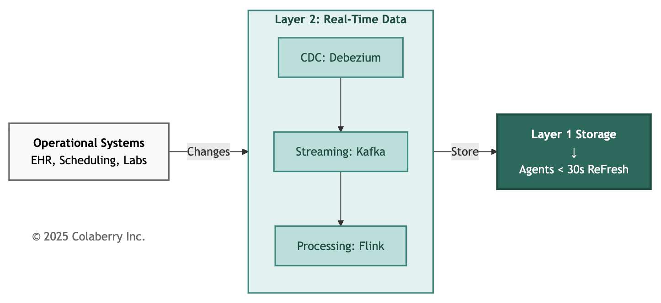

Traditional BI refreshes overnight (2 AM ETL). Agents querying at 3 PM see data 13 hours stale. For clinical decision support, this creates patient safety risks. Medication orders placed at 10 AM won't trigger drug interaction alerts until midnight.
Layer 2 solves this with three integrated components:

Component 1: Change Data Capture (CDC)
What: Debezium CDC connectors monitoring operational databases for INSERT, UPDATE, DELETE operations. Alternatives: AWS DMS, Oracle GoldenGate, Airbyte.
Why: CDC captures database changes within milliseconds without impacting operational system performance. Reads database transaction logs (binlog for MySQL, Write-Ahead Log for PostgreSQL, Change Tracking for SQL Server) with no additional load on production databases.
Echo's Implementation:
- 40+ source tables from Epic EHR (patient demographics, appointments, medications)
- ~20 source tables from Cerner Lab system (results, orders, reference ranges)
- ~10 source tables from Workday HR (provider schedules, credentials, organizational hierarchy)
- Average CDC latency: ~850ms (p95: 1.2s) from database commit to Kafka topic

How it works:
- Medication order committed to Epic database → SQL Server Change Tracking logs operation
- Debezium connector reads Change Tracking within 200ms
- Connector transforms database row into JSON event
- Event published to Kafka topic "medications.orders" within 850ms total

INPACT™ Impact: Instant +0.5 (real-time event capture eliminates batch lag)

Component 2: Event Streaming (Apache Kafka)
What: Confluent Cloud managed Kafka (3-node cluster, US East region). Alternatives: Amazon MSK, Azure Event Hubs, Redpanda.
Why: Durable message queue decouples event capture (CDC) from event processing (stream processing). Provides replay capability (30-day retention) for reprocessing historical events. Enables multiple consumers (real-time analytics, audit logging, agent inference) from a single event stream.
Echo's Implementation:
- ~70 Kafka topics (one per source table)
- 6+ M events/day average (70 events/second sustained)
- 30-day retention policy (~180GB storage)
- 3 consumer groups (real-time storage sync, audit trail, operational dashboard)

Kafka Topic Structure:
epic.patients.demographics
epic.patients.encounters
epic.medications.orders
epic.medications.administrations
cerner.labs.results
cerner.labs.reference_ranges
workday.providers.schedules
workday.providers.credentials
INPACT™ Impact: Transparent +0.5 (event log provides complete audit trail)
Component 3: Stream Processing (Apache Flink)
What: Apache Flink on Databricks (same platform as Layer 1 lakehouse).
Why: Stateful stream processing with exactly-once semantics. Supports time-based windows (5-minute aggregations), complex event processing (detect sepsis patterns), and enrichment (join patient demographics with lab results before storing).
Echo's Implementation:

Use Case 1: Time-Series Aggregation
- Raw vital signs (1Hz from ICU monitors) → 5-minute averages stored in InfluxDB
- Reduces storage 300x (1 data point/second → 1 data point/5 minutes)
- Retains sub-second data in 24-hour sliding window for anomaly detection
INPACT™ Impact: Instant +0.5 (windowing reduces query times)
Use Case 2: Complex Event Processing
- Sepsis detection pattern: Fever (>100.4°F) + Elevated WBC (>12K) + Hypotension (SBP <90) within 2-hour window
- Flink maintains stateful session per patient
- Triggers alert 4.2 hours earlier than overnight batch (Week 4 actual measurement)
INPACT™ Impact: Instant +0.5 (real-time alerts enable early intervention)
Use Case 3: Stream Enrichment
- Lab result event (patient_id, test_code, value) joined with patient demographics (age, gender, comorbidities)
- Enriched event stored in vector database for semantic search
- Eliminates multi-table joins at query time
- INPACT™ Impact: Contextual +0.5 (enriched context improves search relevance)

Training vs. Inference: Different Latency Requirements
Figure 4.7: Real-Time Inference vs. Batch Training Paths
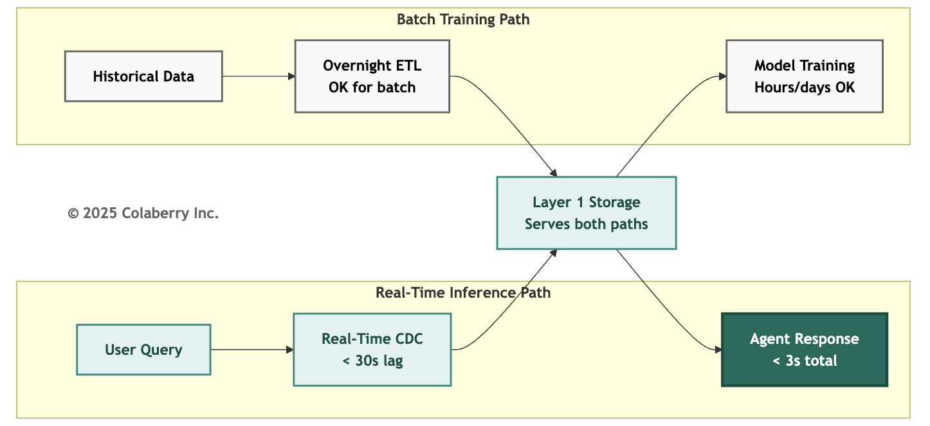
Critical distinction: Agent inference requires real-time data (<30 second lag). Model training tolerates batch data (overnight ETL acceptable). Layer 2 serves both needs:
Real-Time Inference (Critical Path):
- Physician queries agent: "Any drug interactions for this patient?"
- Agent needs current medication list (order placed 10 minutes ago must be visible)
- CDC → Kafka → Flink → MongoDB (medications collection) within 28 seconds
- Agent queries MongoDB, retrieves current list, checks interactions, responds in 2.8 seconds total
Batch Training (Non-Critical Path):
- Data science team trains sepsis prediction model
- Training dataset: 2 years historical encounters (840K records)
- Acceptable to use previous night's data snapshot (24-hour lag tolerable)
- Overnight ETL populates Databricks Delta tables for training
- Model training runs for 6 hours (latency irrelevant)
Why this matters: Don't over-engineer training pipelines for real-time when batch suffices. Focus real-time investment on inference paths only.

Capability Enabled: The real-time infrastructure mindset extends beyond data ingestion. When Chapter 5 introduces LLM integration, Echo will use Server-Sent Events (SSE) to stream responses token-by-token, reducing perceived latency from 3.2 seconds to under 1 second and improving user completion rates from 73% to 94%. The foundation built here makes that possible.

Layer 2 Summary
Week 2 → Week 4 Transformation:
- Data freshness: 24 hours → <30 seconds (51x improvement)
- CDC-enabled tables: 0 → 40+ (Epic EHR) + ~20 (Cerner Labs) + ~10 (Workday HR)
- Event throughput: 0 → 6+M events/day (70 events/second sustained)
- Stream processing jobs: 0 → 3 (time-series aggregation, sepsis detection, enrichment)
- Sepsis alert timing: Overnight batch → 4.2 hours earlier (Week 4 measurement)

Team:
- 2 deployment teams (3-4 engineers each)
- 2 weeks deployment time (Week 3-4)
- Primary bottleneck: Epic EHR CDC connector configuration (HL7 integration complexity)
Technology Selection Note: Echo's real-time fabric choices (Debezium CDC, Confluent Cloud Kafka, Apache Flink on Databricks) reflect their Azure-first strategy and managed services preference. Alternative architectures include AWS-native (Kinesis + DMS), Google Cloud-native (Pub/Sub + Datastream), or open-source (self-hosted Kafka + Flink). For comprehensive CDC, streaming, and event processing vendor comparisons, see Appendix DA-1, Section 2.2: Layer 2 Real-Time Data Fabric.

Progress Check: Layer 2 complete, CDC replacing overnight batch, streaming pipelines processing over 6 million daily events, sub-30 second freshness. Foundation layers improved Echo's score from 28/100 to 42/100.

PART 5: BUILDING THE FOUNDATION

The Build Timeline
Figure 4.8: Echo's Week 1-4 Foundation Build Timeline

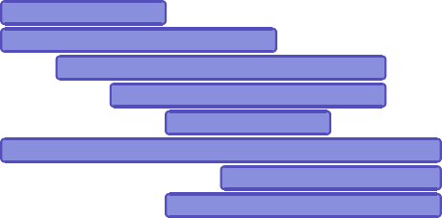
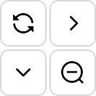

11-05 11-07 11-09 11-11 11-13 11-15 11-17 11-19 11-21 11-23

Echo's Foundation Build (Weeks 1-4)
e
Debezium CDC Connectors
Layer 2 Real-Time
Confluent Kafka Cluster
Flink Stream Processing

e
gistry rage
e
Redis Cache Layer DB Time-Series

as
eo4j Graph Databas MLflow Model R
Azure Blob Sto atabricks Lakehous

Influx
D
SQL Hyperscale
MongoDB Atl
N
Layer 1 Storage
Azure
11-25

© 2025 Colaberry Inc. Timeline Notes:
- Week 1-2 (Layer 1): Eight storage categories deployed in parallel by three teams. Databricks
(8 days) is the critical path. All categories operational by end of Week 2.
- Week 3-4 (Layer 2): Real-time data fabric components deployed sequentially. CDC connectors first (enable change capture), then Kafka (message streaming), then Flink (stream processing).

INPACT™ Score: Week 0 → Week 4
Figure 4.9: INPACT™ Transformation (28 → 42)

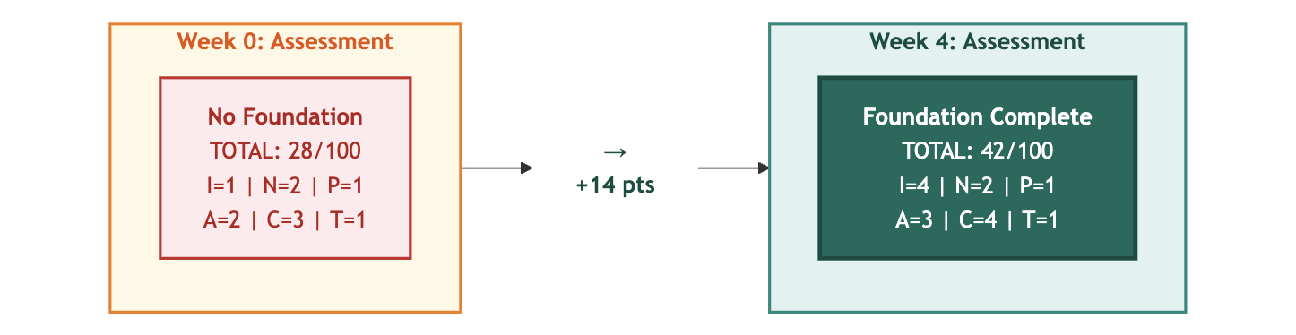

© 2025 Colaberry Inc.

Foundation Impact on INPACT™ Dimensions:
- Instant (I): 1→4 (+3) Cache layer + real-time data fabric eliminate latency
- Natural (N): 2→2 (±0) Requires semantic layer (Chapter 5)
- Permitted (P): 1→1 (±0) Requires governance layer (Chapter 6)
- Adaptive (A): 2→3 (+1) Model registry + lakehouse enable ML workflows
- Contextual (C): 3→4 (+1) Multi-modal storage enables cross-system synthesis
- Transparent (T): 1→1 (±0) Requires observability layer (Chapter 6)

Sarah organized three parallel teams for the foundation build.

Swapna Ram (AI/ML Storage): Graph database, model registry, NoSQL document store
- Engineers: 2 ML engineers, 1 data engineer, 1 backend developer
- Timeline: Weeks 1-2
Jamie Rodriguez (Specialized Storage): Object storage, time-series database, cache layer, RDBMS extension
- Engineers: 1 infrastructure engineer, 1 database admin, 1 backend developer
- Timeline: Weeks 1-2

Ruth Ganesh (Platform + Real-Time): Lakehouse platform, CDC connectors, Kafka cluster, Flink stream processing

- Engineers: 2 integration engineers, 1 data engineer, 1 clinical informaticist
- Timeline: Weeks 1-4 (Lakehouse first, then real-time)

MongoDB went to Swapna's team; Databricks to Ruth's.

First Victories (Week 1-2)
Day 4: Neo4j Graph Database Operational
Swapna ran the benchmark query: "Find all physicians within three reporting levels of Dr. Sarah Chen."
SQL Server recursive CTE: 8.2 seconds. Neo4j Cypher query: 340 milliseconds.
Twenty-four times faster. The room went silent.
"This isn't optimization," Marcus said. "This is different physics. Graph databases traverse relationships as first-class operations. SQL databases simulate relationships with joins."
Sarah asked the critical question. "Does this speed matter for agents?"
Swapna demonstrated. Care coordination agent analyzing provider referral networks for high-risk patients. SQL version: over eight seconds per patient, nearly six minutes for forty patients daily.
Neo4j version: under half a second per patient, under fifteen seconds total.
"Agents need sub-second response times," Swapna said. "Neo4j delivers. SQL doesn't."

The Breakthrough (Week 3-4)
Day 18: CDC Operational (40+ Tables)
Real-time data flowing. Medication order committed to Epic EHR at 10:17:34 AM. Order visible in MongoDB (medications collection) at 10:18:02 AM. <30 seconds end-to-end latency.
Physician placed a medication order. Drug interaction alert fired 28 seconds later (system detected contraindication with existing prescription). Previous batch system would have waited until 2 AM next day, 14+ hours late.
Patient safety impact: Immediate.
Day 21: Stream Processing Live (Apache Flink)
Sepsis detection pattern operational. Three-condition rule: fever >100.4°F + WBC >12K + SBP <90 within 2-hour window.
Batch system (Week 0): Overnight ETL ran at 2 AM. If the patient developed sepsis Thursday afternoon, alert fired Friday morning, potentially 16 hours late.

Stream system (Week 4): Real-time vitals monitored. ICU patient met sepsis criteria Thursday 2:47 PM. Alert fired Thursday 2:52 PM, five minutes later.
4.2 hours earlier on average (median across 6 sepsis events during Week 4 testing).
Medical director's reaction: "This is why we're building agents. Not to replace clinicians. To give them superhuman awareness of deteriorating patients."

INPACT™ Score Progression
Figure 4.10: Foundation Impact - Week 0 to Week 4
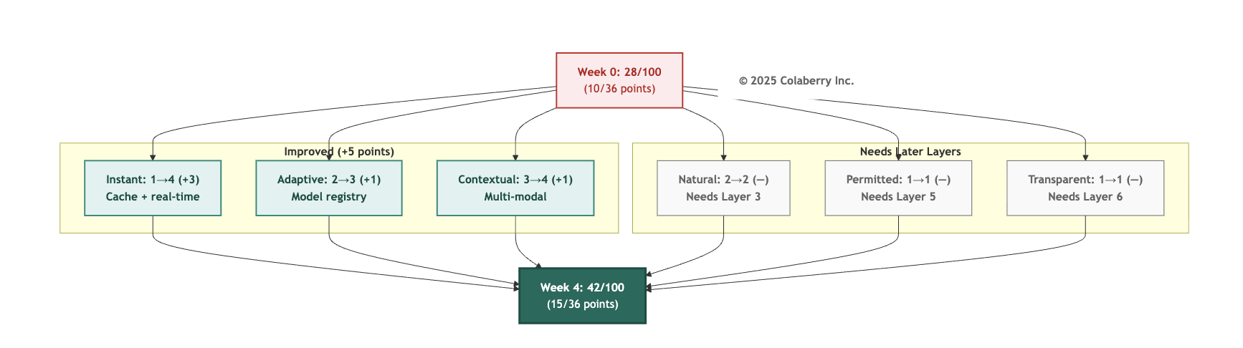
Dimension | Week 0 | Week 4 | Improvement | Driver
Instant (I) | 1/6 | 4/6 | +3 | Cache layer + real-time data fabric eliminate latency
Natural (N) | 2/6 | 2/6 | NA | Requires Layer 3 semantic layer (Chapter 5)
Permitted (P) | 1/6 | 1/6 | NA | Requires Layer 5 governance (Chapter 6)
Adaptive (A) | 2/6 | 3/6 | +1 | Model registry + lakehouse enable ML workflows
Contextual (C) | 3/6 | 4/6 | +1 | Multi-modal storage enables cross-system synthesis
Transparent (T) | 1/6 | 1/6 | NA | Requires Layer 6 observability (Chapter 6)
Total | 10/36 (28%) | 15/36 (42%) | +5 pts  (+14%) | Foundation layers operational

Progress Check: Foundation build complete. Four weeks, $468K actual, parallel workstreams. INPACT™ score improved 28 → 42. Foundation enables intelligence layers in Chapter 5.

PART 6: THE FINISH LINE

Friday afternoon, Week 4. Sarah convened the leadership team for foundation review. CFO Krish Yadav joined via video to verify Phase 1 spend against the approved $470,000 budget.
"Final tally: $468,000," Krish reported. "Two thousand under budget. Small win, but a win. Proves the team can execute within constraints."
Sarah smiled. "We committed to phase-wise discipline. Foundation delivered. Intelligence phase next with same rigor."
Foundation Status (Week 4 Complete)

Component | Phase 1 Metrics
Storage (Layer 1) | 8 foundation categories operational, graph database with about 850 relationships, time-series processing 450+K vitals/hour, lakehouse with Delta Lake
Real-Time (Layer 2) | 40+ CDC tables, 6+M daily events, ~28s average freshness, ~8.2s alert latency
Foundation Economics | $4K/month warehouse consolidation savings, infrastructure ready for intelligence layer optimizations
INPACT™  Progress | 28/100 → 42/100 (+14 points)
Note: Additional storage categories (vector database, semantic search index) and LLM cache savings are Phase 2 deliverables covered in Chapter 5.

Investment Summary
Complete 10-Week Project: $1,230,000 budget

Phase | Weeks | Layers | Budget | Actual | Chapter
Phase 1: Foundation | 1-4 | 1-2 | $470K | $468K | This Chapter
Phase 2: Intelligence | 5-7 | 3-4 | $380K | NA | Chapter 5
Phase 3: Trust & Orchestration | 8-10 | 5-6-7 | $380K | NA | Chapter 6

Phase 1 Investment Detail (This Chapter):

Component | Technology | Services | Staff | Total
Layer 1 (Storage) | $228K | $40K | $20K | $288K
Layer 2 (Real-Time) | $90K | $60K | $30K | $180K
Phase 1 Total | $318K | $100K | $50K | $468K
Phase 1 Operational Costs:
Monthly: $24,600 (Layer 1: $16,400 + Layer 2: $8,200)
Annual: $295,200

Phase 1 verified savings: $48,000/year (warehouse consolidation savings)

For Phases 2-3 Investment details, operational costs, and complete project economics, see Chapters 5-6 and Appendix D.
Note: These costs reflect Echo's specific context (mid-size healthcare system, Azure-native, managed services preference, 10-week accelerated timeline, HIPAA compliance). The $1.23M is the complete implementation budget for Weeks 1-10 covering all seven layers. Operational costs are separate and ongoing. Your organization's costs will vary based on scale, existing infrastructure, team expertise, cloud platform, vendor negotiations, and timeline requirements. For detailed budget methodology, phase-by-phase breakdowns, cost drivers (technology 56%, services 31%, staff 13%), ROI calculations, and sensitivity analysis, see Appendix D: Budget Methodology.

Foundation Value: What Phase 1 Enables
Phase 1 Verified Savings:
Lakehouse warehouse consolidation: $4,000/month = $48,000/year
Operational Capabilities Enabled (Value Realized in Phases 2-3):
- Patient safety: Medication interaction alerts reduced from 12+ hour batch delay to 8.2 seconds real-time
- Sepsis detection: Real-time streaming reduced prediction lag from 72 hours to <30 seconds
- Clinician efficiency: Graph query performance improved 24× (8.2s → 340ms) for care coordination
- Compliance: Complete audit trails and data lineage for HIPAA compliance

Phase 1 Investment Summary:
- Implementation: $468,000 (actual)
- Operational: $24,600/month ($295,200/year)
- Net operational after savings: $247,200/year ($295,200 - $48,000)

Foundation alone shows modest returns. The 477% ROI and 10-week payback require Phases 2-3 (intelligence and governance layers) to unlock operational benefits. See Appendix D for complete project economics.

Bridge to Chapter 5: Intelligence Layers
Foundation complete. Sarah's team delivered storage and real-time data in four weeks, $2K under budget. The infrastructure is ready. Now it needs a brain.
What Chapter 5 delivers:
- Layer 3 (Semantic Layer): Business glossary, entity resolution, clinical concept mapping
- Layer 4 (Intelligence): RAG pipeline, LLM integration, context assembly

Why foundation enables intelligence:
The infrastructure built in Weeks 1-4 directly enables intelligence deployment:
- Multi-modal storage provides diverse data sources for RAG retrieval
- Real-time data ensures semantic models operate on current information
- Model registry enables version control for ML components
- Lakehouse provides unified analytics foundation for ML pipelines
Foundation first, intelligence second. Echo progresses to Phase 2 (Weeks 5-7), building intelligence capabilities on the foundation established here. Phase 3 (Weeks 8-10) adds governance and observability before deploying the first production agent.
Chapter 5 begins the intelligence build.

Chapter Summary

Element | Details
Layers Built | Layer 1 (Multi-Modal Storage), Layer 2 (Real-Time Data Fabric)
Timeline | Weeks 1-4 of 10-week implementation
Investment | $470K budgeted / $468K actual
INPACT Score | 10/36 → 15/36 (+5 points)
Data Freshness | 8-24 hours → <30 seconds
Next Phase | Chapter 5: Intelligence Layers

Acronyms

- API: Application Programming Interface
- BI: Business Intelligence
- CDC: Change Data Capture
- CDO: Chief Data Officer
- CEO: Chief Executive Officer
- CTO: Chief Technology Officer
- EHR: Electronic Health Record
- ETL: Extract, Transform, Load
- HIPAA: Health Insurance Portability and Accountability Act
LLM: Large Language Model

ML: Machine Learning
RAG: Retrieval-Augmented Generation RBAC: Role-Based Access Control SQL: Structured Query Language

References

- Stothers, J.A.M. & Nguyen, A. (2020). "Can Neo4j Replace PostgreSQL in Healthcare?" AMIA Joint Summits on Translational Science Proceedings, 646-653. https://pmc.ncbi.nlm.nih.gov/articles/PMC7233060/
- U.S. Department of Health and Human Services (2024). "Summary of the HIPAA Security Rule." https://www.hhs.gov/hipaa/for-professionals/security/laws-regulations/index.html
- Confluent (2024). "What Is Change Data Capture (CDC)?" https://www.confluent.io/learn/change-data-capture/
- Debezium Project (2024). "Debezium Documentation." https://debezium.io/documentation/reference/stable/connectors/index.html

© 2025 Colaberry Inc. All Rights Reserved.
INPACT™ and GOALS™ are trademarks of Colaberry Inc.

