**CONSOLE OUTPUT:**

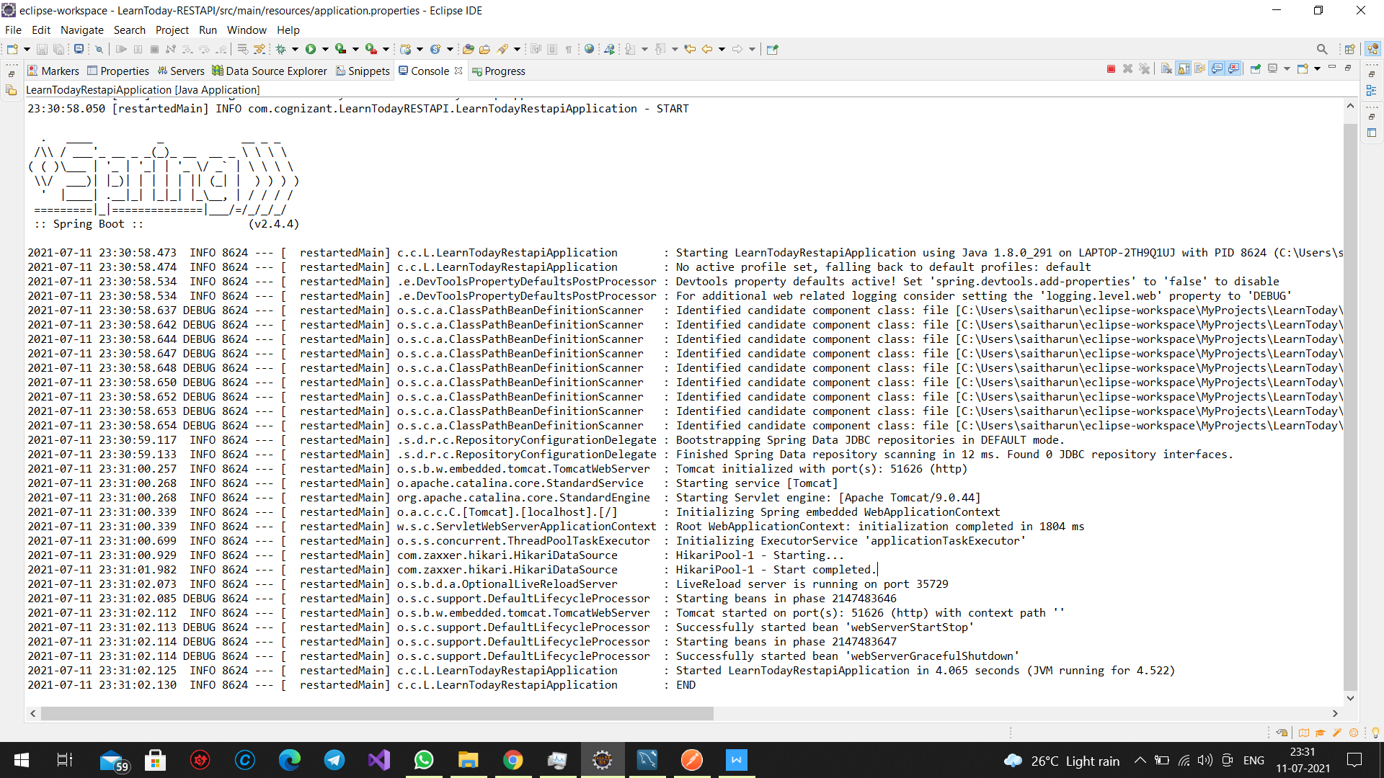

**ADMIN CONTROLLER:(GET MAPPING):GET ALL COURSES**

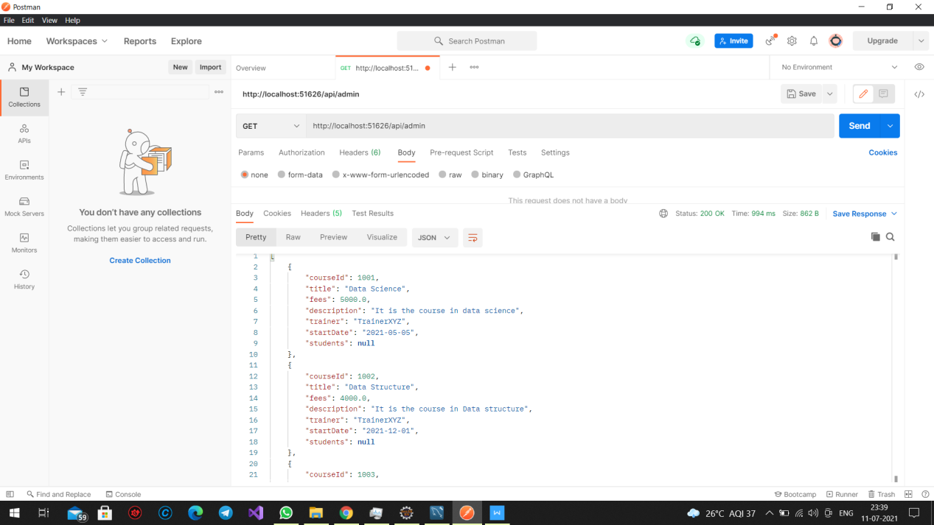

**ADMIN CONTROLLER (GET MAPPING):GET COURSE BY ID**

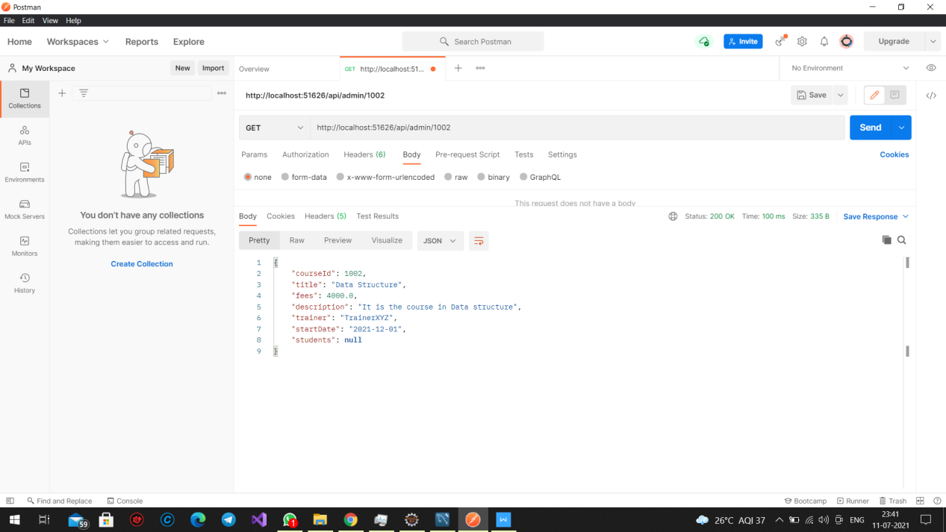

**STUDENT CONTROLLER(GET COURSES):**

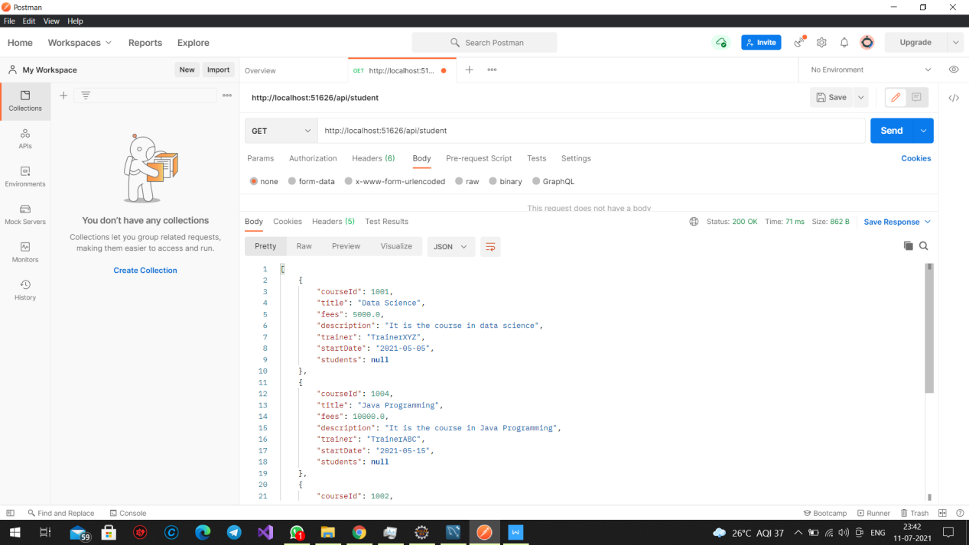

**STUDENT CONTROLLER:DELETING STUDENT RECORD BY ID:**

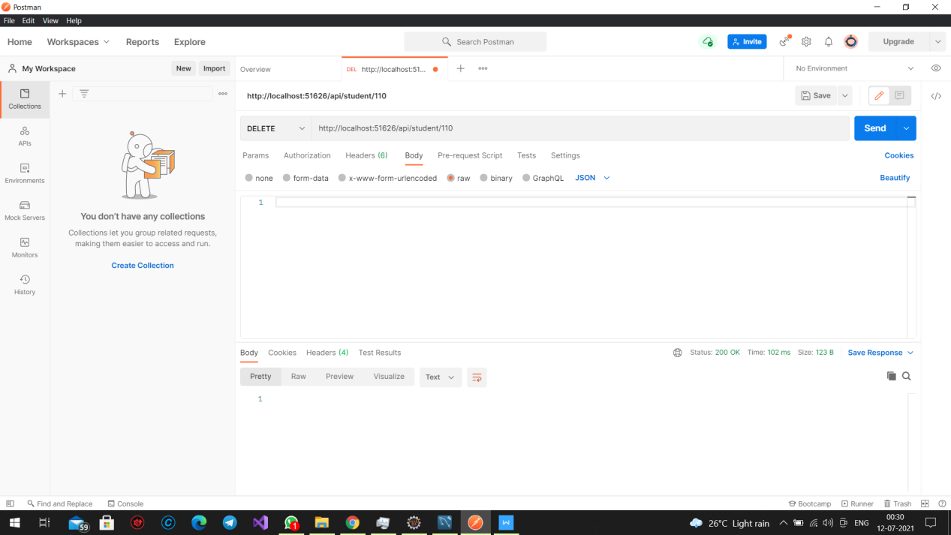

**SQL AFTER EXECUTING ABOVE STEP:**

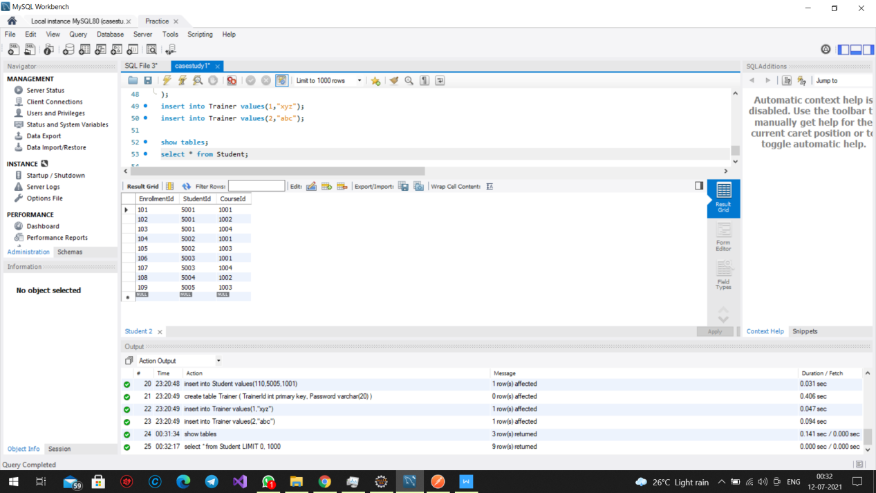

**TRAINER CONTROLLER :POSTING TRAINER ID:**

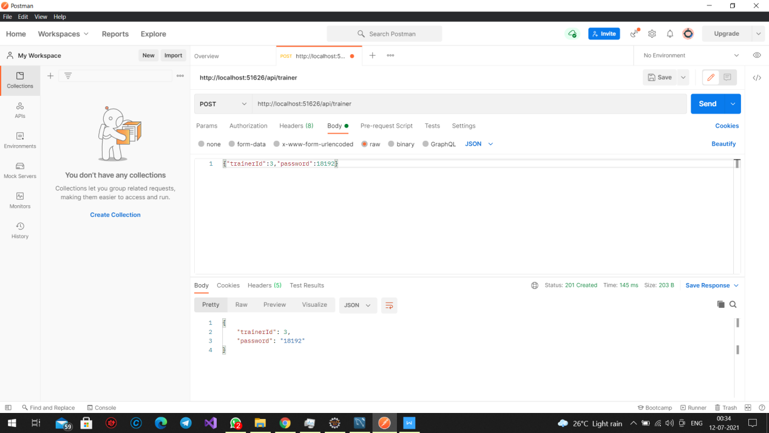

**SQL AFTER POSTING TRAINER DETAILS:**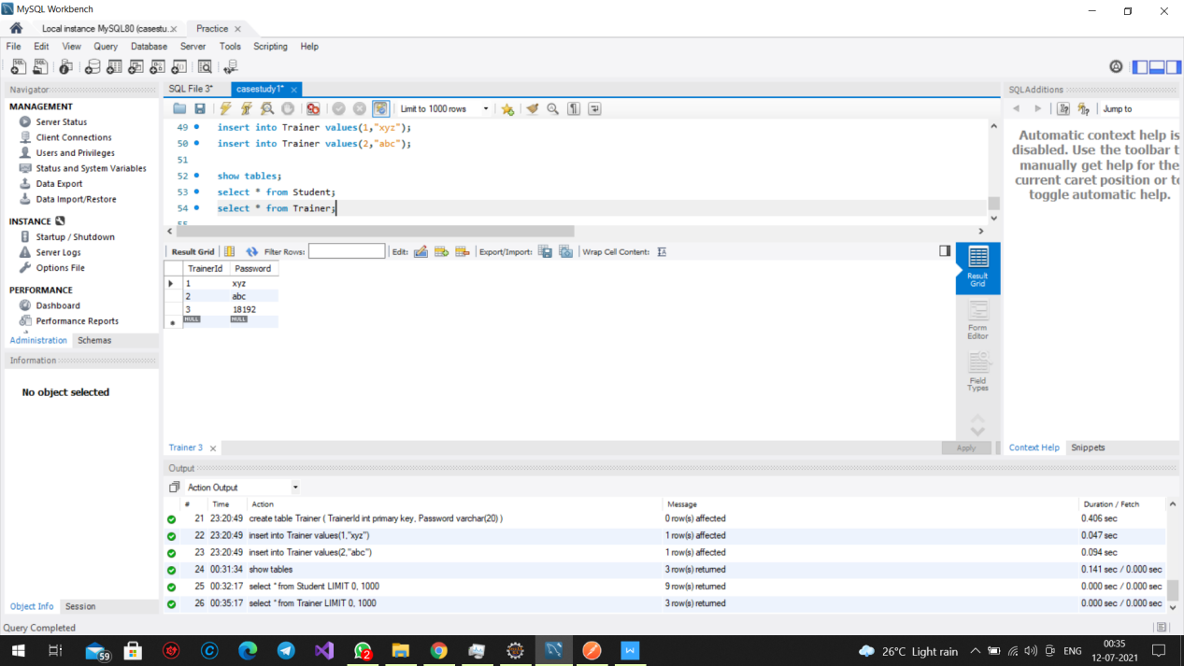

**SQL AFTER POSTING TRAINER DETAILS:**

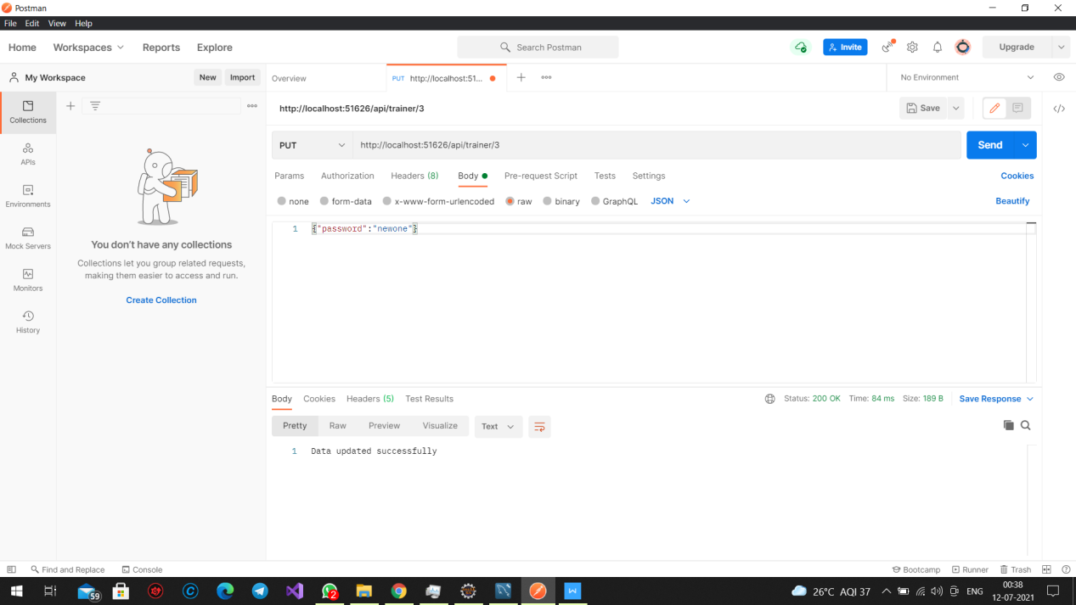**SQL AFTER CHANGING THE PASSWORD FOR TRAINER ID 3:**

