AWS Account creation
Search on google aws. Management console like snip
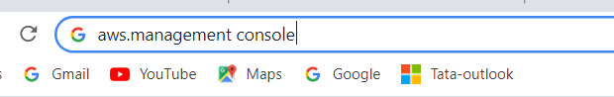

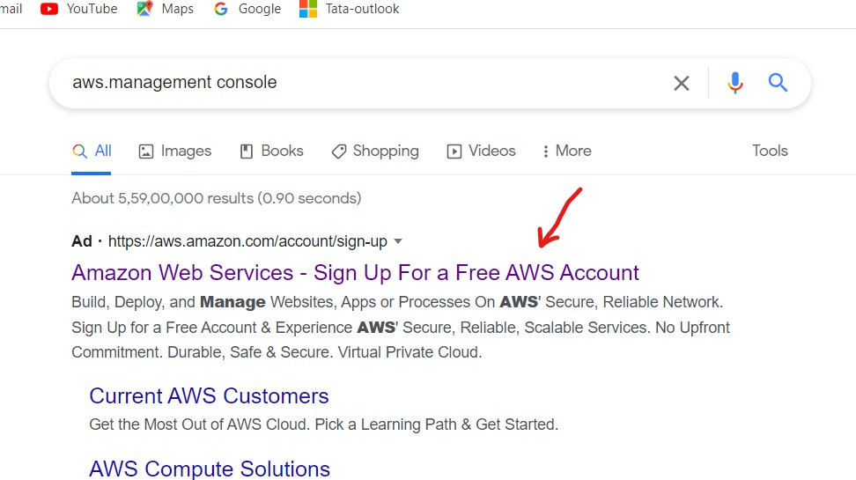
Click the first link
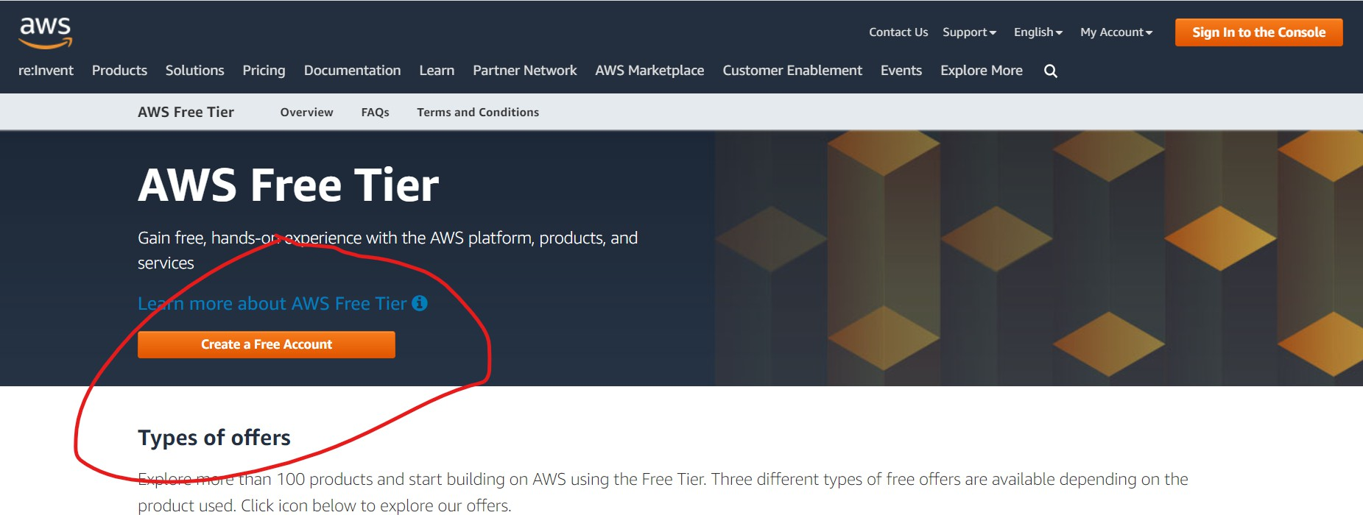

Fill your details and click continue
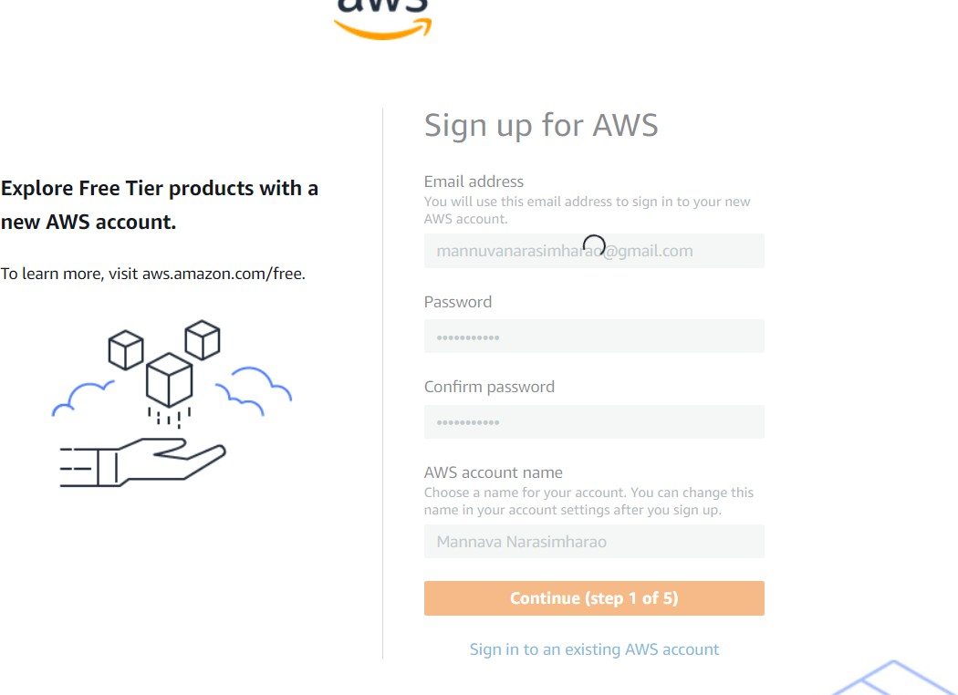
And select your personal for your own projects, enter your name, phone number, country name,address,city name, state name, postal code and click the check box and continue.

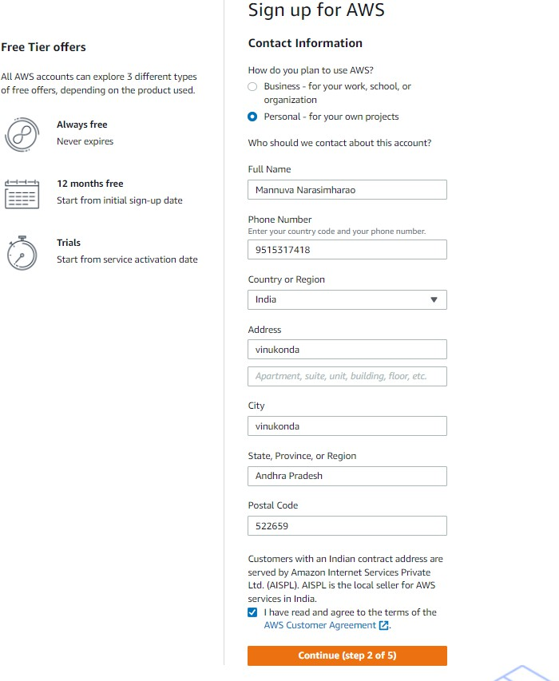
Next enter your card details. And click continue. I’m using visa card.

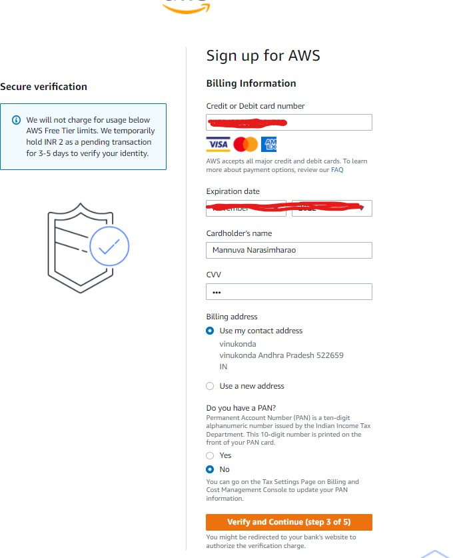

Enter your OTP and click submit.

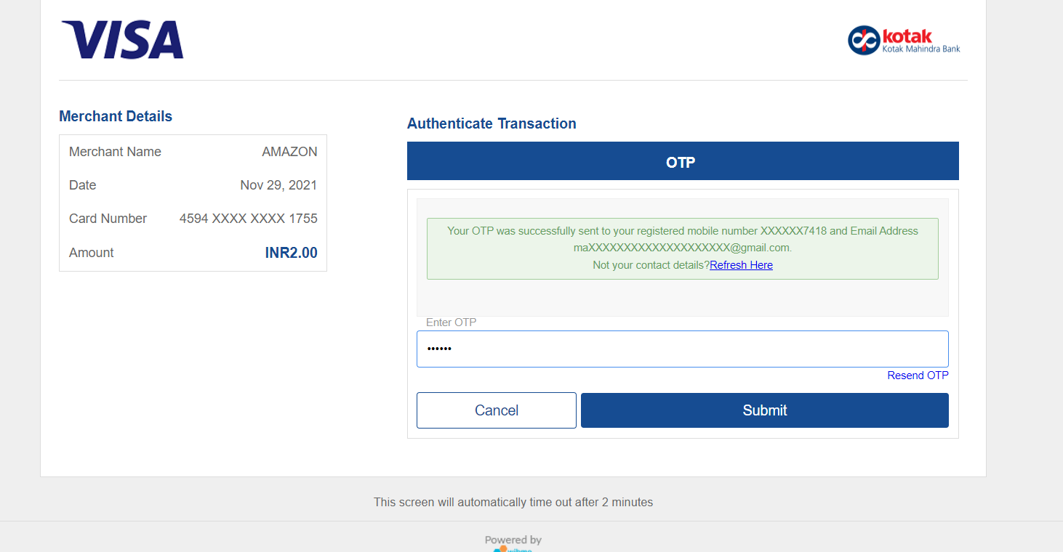
Step 4

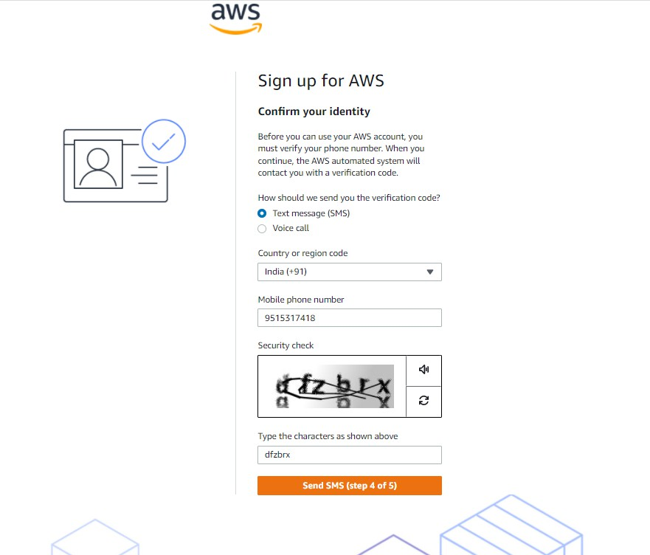

Select basic support

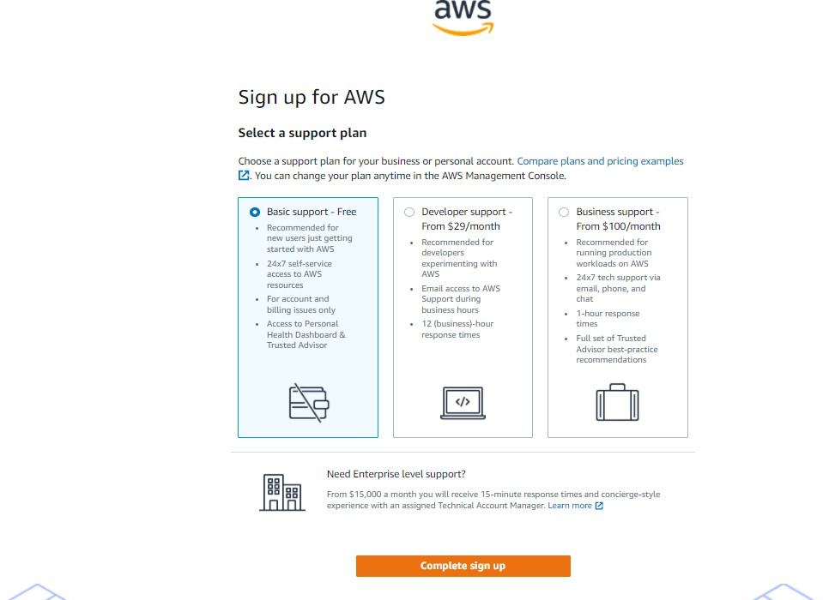
Click complete sign up And goto

AWS account creation completed.sign in your aws account.

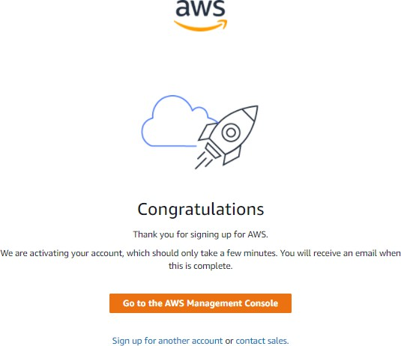

Click her to sign in your account
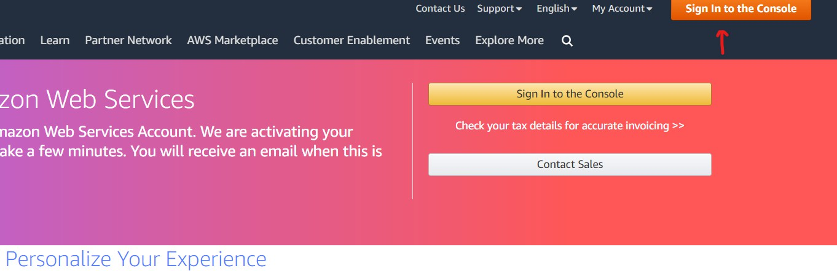
Select root user and enter your mail id and click next.

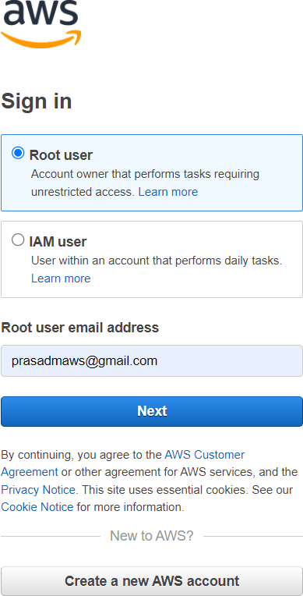

Enter chapta

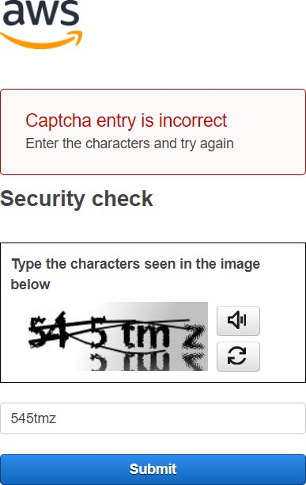

Enter your password and sign in your account.

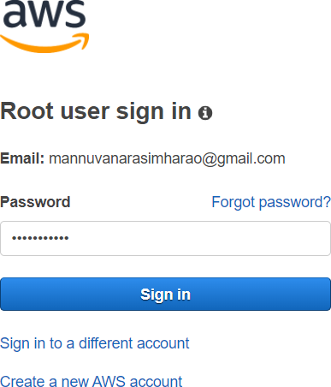

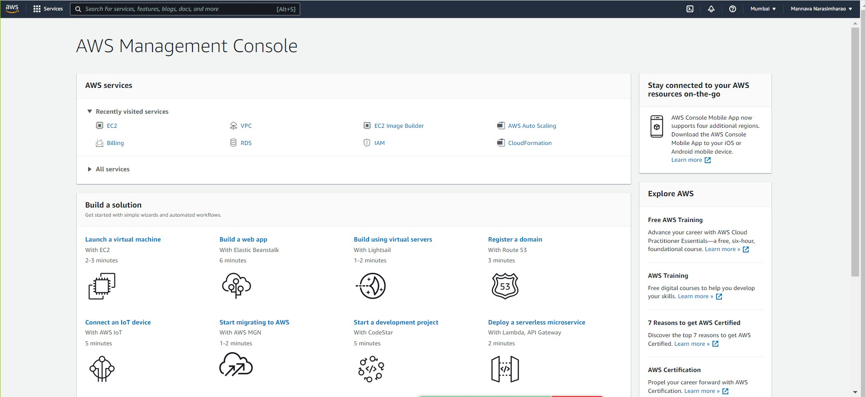
The End

