EmployeeManagment

**Application**:-

The primary role of this application is to manage employee who will be associated with a department and department will be associated with multiple languages.

**Technology & Tools**:-

1) Java (works on JDK1.8 and above)

2) Spring Framework (Spring Boot (2.3 version), Spring MVC,Spring Security, Spring Data JPA)

3) H2 (In Memory Database)

4) Maven (Build Dependency Tool)

4) Junit (5.0 version) for unit testing

5) Postman (to test RESTful web services)

6) Eclipse IDE

* To start the application navigate to root of the project where (pom.xml or target folder exists) and use below commands

**mvn spring-boot:run**

OR

**java -jar target/employeemangement-0.0.1-SNAPSHOT.jar**

* Currently web services can be accessed with specific users who has specific roles
* Generally there are two roles(USER,ADMIN) for this application and ADMIN role can access all the resources (employee ,department ,languages) on other hand USER role can access only (employee resource with fetching all employees and fetch employee based on their employee Id)
* Below are credentials for user who is associated with USER role and ADMIN role

Username: user (for ADMIN role replace username as admin)

Password: password (same for both USER and ADMIN role)

* In memory database can be accessed on URL <http://localhost:8106/api/h2-console>

**Below are sample request and response for accessing web services**

* **Save Language**:- This method create particular language in database

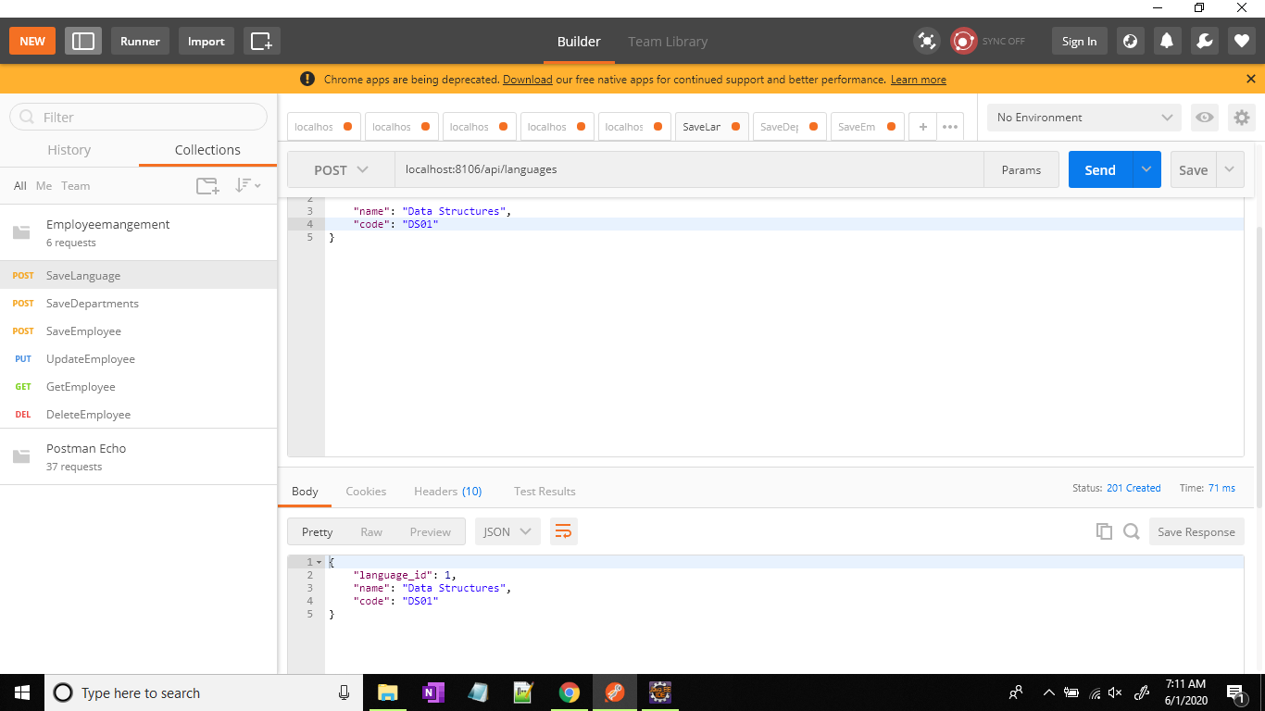

* **Save Department**-:This method creates a particular department which can be associate with one or more languages

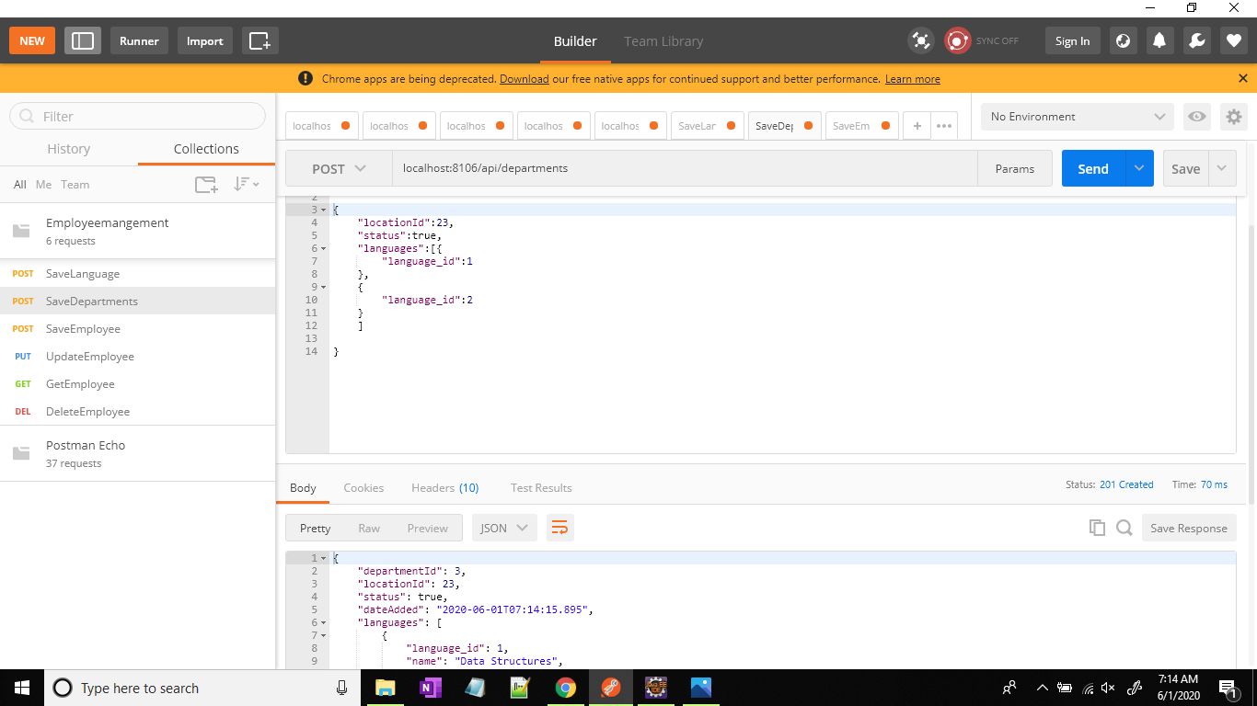

* **Save Employee**-:Who will be associated with department and language respectively

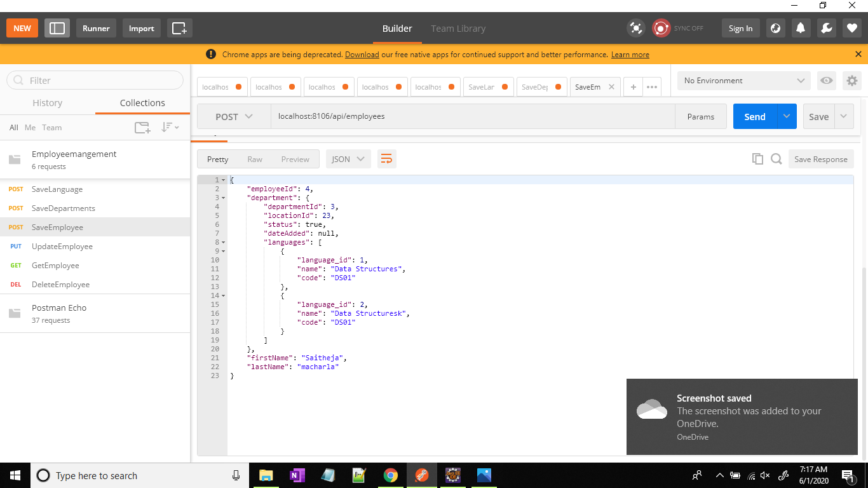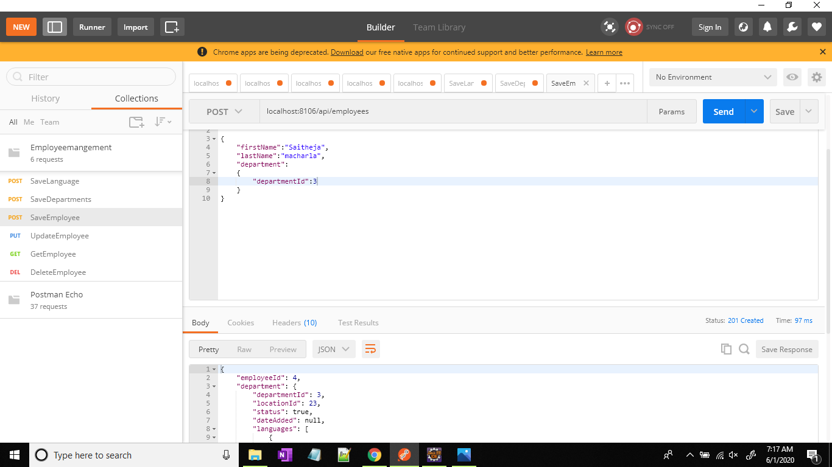

* Sample request and responses are attached to postman.json file which will be share along with project.