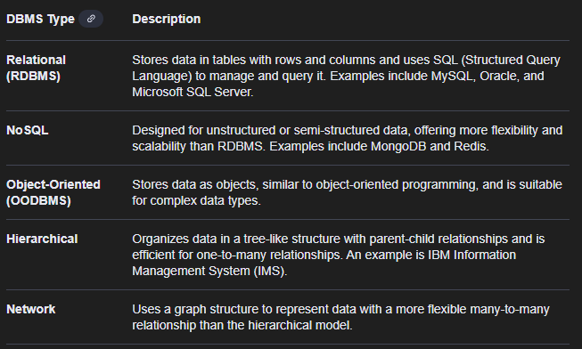
DBMS - Database Management System

- It help’s to process the data
- Data are stored in Json format
- Most of the time we used mysql

To Display the data of customers
SELECT * FROM Customers;
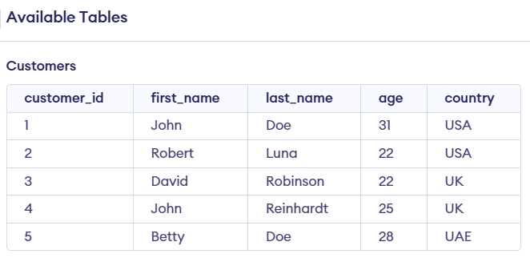

To Display the data of customers of age greater than 22
SELECT * FROM Customers where age > 21; aa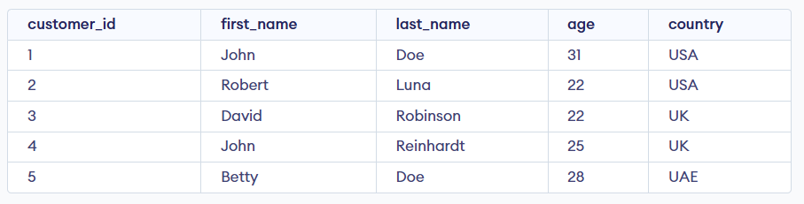
To Create a new Table for students
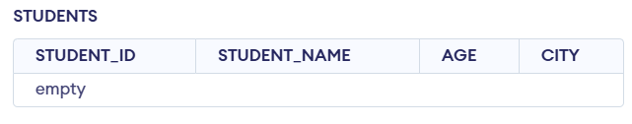
CREATE TABLE STUDENTS(STUDENT_ID VARCHAR(100),STUDENT_NAME VARHCHAR(37),AGE INT,CITY VARCHAR(100));

To Insert data in created table
Lets take an example
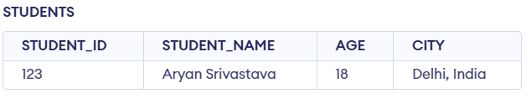
INSERT INTO STUDENTS VALUES(123,"Aryan Srivastava",18,"Delhi, India");

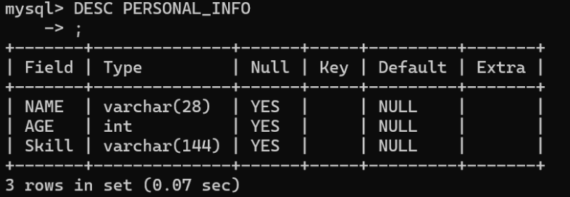
To check the Structure of DB .

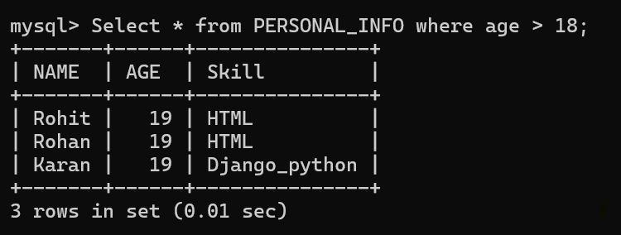
To use where clause for conditions

To delete data in table we use this query
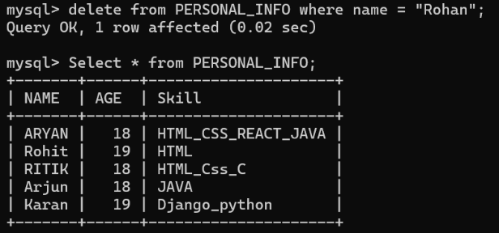
delete from PERSONAL_INFO where name = "Rohan";

The Rohan data has been deleted from the table Personal_Info
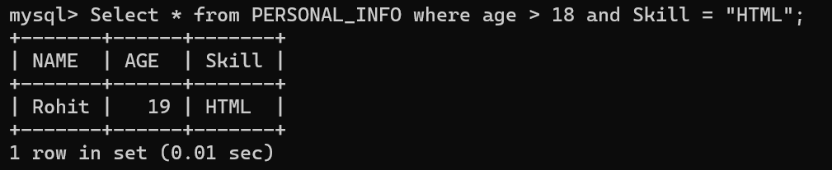
We can also use logical operator like AND, OR, NOT

OR operator – Which mean any one condition should be True or can be both.
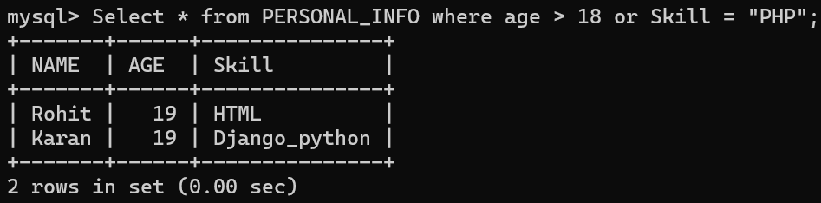

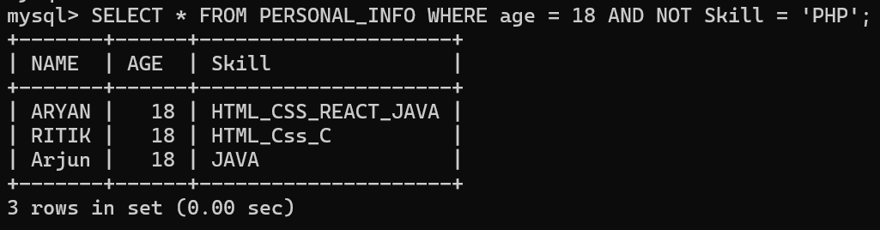
NOT operator – Which mean it check the condition of false

DDL – (DATA DEFINITION LANGUAGE)
It is related to the structure of Database or table
- Create – to create a table into the database
- Alter – to changes in existing table
- Drop – Remove the DB
- Truncate – Remove the Table
DML – (DATA MANIPULATION LANGUAGE)
It is related to data manipulation
- Select – to output a data
- Update – to Update the data in a table
- Insert - to insert data in a table
- Delete – to remove the data from table

