**1.WHY REACT JS OR WHAT IS REACT JS OR REACT ADVANTAGES?**

* **REACT IS JAVASCRIPT LIBRARY FOR BUILDING USER INTERFACES**
* **RE-USABLE COMPONENTS**
* **UNI-DIRECTIONAL DATA FLOW**
* **REACT USES THE JSX.JSX ALLOWS HTML AND JAVASCRIPT TOGETHER.**
* **REACT USES VIRTUAL DOM SO PERFORMANC WISE GOOD**
* **IT SUPPORTS SERVER-SIDE RENDERING**

**2.LIMITATIONS OF REACT JS OR REACT DISADVANTAGES.**

* **REACT JS ONLY FOCUSES ON THE VIEW SECTION OF APPLICATION. IF YOU ARE DEVELOPING LARGE APPLICATION YOU HAVE TO INCLUDE SOME OTHER LIBRARIES.**
* **THE FILE SIZE OF REACT JS IS LARGE.**
* **QUITE CONFUSING JSX. HTML AND JAVASCRIPT TOGETHER MOST OF THE FRAMEWORKS KEEPING HTML SEPARATE FROM JAVASCRIPT CODE.**
* **LACK OF SEO.**

**3.LIBRARY VS FRAMEWORK?**

|  |  |
| --- | --- |
| **LIBRARY** | **FRAMEWORK** |
| **LIBRARY IS SET OF CODE PREVIOUSLY WRITTEN.THAT CAN BE CALLED WHILE DEVELOPING CODE.** | **FRAMEWORK IS A SUPPORTING STRUCTURE.HERE WE WILL DEFINE OUR OWN CODE.** |
| **LIBRARIES ARE LIGHT WEIGHT, THERE IS A FREEDOM TO CHOOSE DIFFERENT TOOLS.** | **FRAMEWORK DON’T** |
| **JQUERY, REACT JS** | **ANGULAR, VUE JS, DJANGO** |

**4.STATEFUL COMPONENTS VS STATELESS COMPONENTS?**

|  |  |
| --- | --- |
| **STATEFUL COMPONENTS** | **STATELESS COMPONENTS** |
| **STATEFUL COMPONENT HOLDS SOME STATE** | **STATELESS COMPONENTS NO STATE.** |
| **STATEFUL COMPONENTS ARE USED WHEN YOU WANT TO ADD A FUNCTIONALITY.** | **STATELESS COMPONENTS ARE USED JUST SHOW SOMETHING ON THE SCREEN VIA PROPS.** |
| **STATEFUL COMPONENTS ALSO KNOWN AS CONTAINER AND SMART COMPONENTS** | **STATELESS COMPONENTS ALSO KNOWN AS PRESENTAIONAL AND DUMP COMPONENTS** |

**5.REACT JS IS IT POSSIBLE WITHOUT NODE JS,NPM,CREATE-REACT-APP ?**

**YES POSSIBLE. WE CAN USE CDN(CONTENT DELIVERY NETWORK). REACT AND REACT DOM ARE AVAILBLE OVER CDN.**

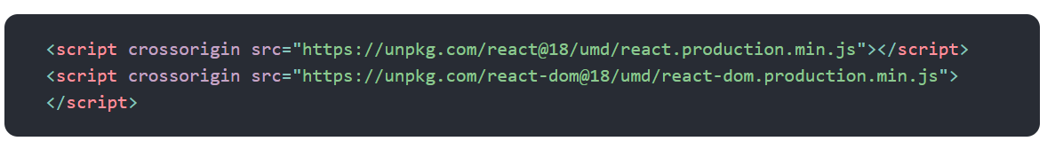

**6.WHAT IS VIRTUAL DOM?**

* **REACT STORES A COPY OF BROWSER DOM WHICH IS CALLED VIRTUAL DOM.**
* **WHEN WE MADE CHANGES. REACT CREATES NEW VIRTUAL DOM AND COMPARES WITH PREVIOUS ONE.**
* **COMPARISON IS DONE BY DIFFING ALOGRITHAM.AFTER COMPARING NEW VIRTUAL DOM HAVING CHANGES.**
* **THEN UPDATES THE BROWSER DOM WITH PARTICULAR CHANGES,WITHOUT RE-RENDERING DOM AGAIN.**
* **THIS PROCESS KNOWN AS RECONCILATION.**

**7.WHAT IS DIFFING ALGORITHAM?**

**DIFFING ALGORITHM OF REACT COMPARES TWO TREES AND RETURNS WHICH NEED TO BE CHANGE.**

**8.WHAT IS RECONCILATION?**

* **WHEN WE MADE CHANGES. REACT CREATES NEW VIRTUAL DOM AND COMPARES WITH PREVIOUS ONE.**
* **COMPARISON IS DONE BY DIFFING ALOGRITHAM.AFTER COMPARING NEW VIRTUAL DOM HAVING CHANGES.**
* **THEN UPDATES THE BROWSER DOM WITH PARTICULAR CHANGES, WITHOUT RE-RENDERING DOM AGAIN. THIS PROCESS KNOWN AS RECONCILATION.**

**9.WHICH VERSION REACT YOU ARE USING**

**17.1**

**10.CURRENTLY WHICH VERSION IS THERE IN REACT**

**18.2**

**11.REACT 18 FEATURES**

**AUTMATIC BATCHING**

**TRANSITIONS**

**CREATEROOT**

**HYDERATEROOT**

**SOME NEW HOOKS LIKE,useId,useTransition,useDeferredValue,useSyncExternalStore**

**useInsertionEffect**

**12.WHAT IS JSX?**

* **JSX STANDS FOR JAVASCRIPT XML**
* **JSX MAKES EASIER TO WRITE HTML AND JAVASCRIPT TOGETHER IN REACT AND PLACE THE THEM IN THE DOM WITHOUT ANY ‘CREATE ELEMENT’ AND ‘APPEND CHILD’ METHOD**
* **USING JSX WE CAN WRITE EXPRESSIONS INSIDE CURLY BRACES**
* **JSX ELEMENTS MUST BE CLOSED**
* **JSX MUST HAVE PARENT ELEMENT.**
* **USE ATTRIBUTE ‘className’ INSTEAD OF ‘CLASS’.**
* **ATTRIBUTE MUST BE ‘camelLCase’**

**13.WHY YOU ARE USING ‘className’ IN JSX INSTEAD OF “class”?**

**“CLASS” KEYWORD IS A RESERVERD KEYWORD IN JAVASCRIPT. IT IS NOT ALLOWED TO WRITE IN JSX.**

**14.HOW MANY ELEMENTS JSX RETURN?**

**ONE**

**15.WHY CAN’T BROWSER READ JSX?**

**BROWSER CANNOT READ JSX DIRECTLY BECAUSE THEY CAN ONLY UNDERSTAND JAVASCRIPT OBJECTS.**

**JSX IS NOT REGULAR JAVASCRIPT OBJECT. WE NEED TO TRANSFORM JSX FILE INTO JAVASCRIPT OBJECT.**

**USING BABEL TRANSPILER WE CAN ACHEIEVE THAT.**

**16.WHAT IS FRAGMENT?**

**FRAGMENT ALLOWS US TO ADD MORE THAN ONE ELEMENT WITHOUT EXTRA NODES. THE SHORTER SYNATAX FOR FRAGMENT WE CAN USE EMPTY TAGS.EMPTY TAGS WON’T ALLOW KEY ATTRIBUTE.**

**17. CAN I USE REACT WITHOUT JSX.**

**YES.JSX IS NOT MANDATORY.WITHOUT JSX WE CAN USE “REACT.CREATEELEMENT” METHOD.**

**18.WHAT IS BABEL**

**BABEL IS A JAVASCRIPT TRANSPILER WHICH TRANSFILES NEW FEATURES INTO OLD STANDARD.WE HAVE ES6,ES7,ES8 FEATURES BREAK IN SOME OLD BROWSERS. IN THIS CASE BABLE CONVERT NEW FEAUTURES INTO**

**17.FUNCTIONAL COMPONENT VS CLASS COMPONENTS?**

|  |  |
| --- | --- |
| **FUNCTIONAL COMPONENT** | **CLASS COMPONENT** |
| **FUNCTIONAL COMPONENTS ARE JAVASCRIPT FUNCTIONS** | **CLASS COMPONENTS ARE REQUIRES EXTEND “FROM REACT.COMPONENT”** |
| **THERE IS NO RENDER METHOD USED IN FUNCTIONAL COMPONENTS** | **MUST HAVE RENDER METHOD TO RETURN JSX** |
| **CONSTRUCTORS ARE NOT USED IN FUNCTIONAL COMPONENTS** | **CONSTRUCTORS ARE USED IN CLASS COMPONENTS TO STORE STATE.** |
| **IT HAS LESS CODE MORE READABLE** | **IT HAS MORE CODE LESS READABLE** |
| **FUNCTIONAL COMPONENTS EASY TO TEST AND DEBUG** | |

**18.CLASS OR FUNCTIONAL COMPONENT WHICH IS BETTER?**

**FUNCTIONAL COMPONENT IS BETTER THAN CLASS COMPONENT.**

* **“THIS” KEYWORD IS NOT REQUIRED IN FUNCTIONAL COMPONENTS**
* **FEWER LINES OF CODE SO BETTER PERFORMANCE**
* **EASIER TO UNDERSTAND, EASIER TO TEST AND EASIER TO DEBUG**

**19.WHAT IS COMPONENT?**

* **UI BROKEN DOWN INTO MULTIPLE INDIVIDUAL PIECES OF CODE THAT IS CALLED COMPONENTS AND MERGE THEM IN PARENT COMPONENT.THAT IS FINAL UI.**
* **THERE ARE TWO TYPES OF COMPONENTS**

**1.FUNCTIONAL COMPONENTS**

**2.CLASS COMPONENTS**

**20. WHICH VERSION RELEASED HOOKS?**

**16.8**

**21.WHAT IS HOOK?**

**USING HOOKS WE CAN USE STATES AND LIFECYCLE METHODS IN FUNCTIONAL COMPONENT.**

* **HOOKS CAN ONLY CALLED IN FUNCTIONAL COMPONENTS**
* **HOOKS CAN ONLY CALLED AT THE TOP LEVEL OF COMPONENT**
* **HOOKS WE CANNOT USE INSIDE LOOPS, CONDITIONS, OR NESTED FUNCTIONS.**

**22.HOOKS RULES**

* **HOOKS CAN ONLY CALLED IN FUNCTIONAL COMPONENTS**
* **HOOKS CAN ONLY CALLED AT THE TOP LEVEL OF COMPONENT**
* **HOOKS WE CANNOT USE INSIDE LOOPS, CONDITIONS, OR NESTED FUNCTIONS.**

**23.LIST OUT HOOKS?**

**useState**

**useEffect**

**useReducer**

**useCallback**

**useMemo**

**useRef**

**useContext**

**24.HOOKS OF REACT ROUTER**

**useHistory**

**useParams**

**useLocation**

**useRoutermatch**

**25.USESTATE**

**“USESTATE” HOOK ALLOWS US TO TRACK STATE IN FUNCTIONAL COMPONENTS.**

**“USESTATE” ACCEPTS TWO VALUES.**

**1.INITIAL STATE**

**2.FUNCTION THAT UPDATES INITIAL STATE**

**“USESTATE” CAN USED FOR STRINGS,NUMBERS,BOOLEANS,ARRAYS,OBJECTS**

**26.** **USEEFFECT**

* **USEEFFECT ALLOWS US TO PERFORM SIDE EFFECTS, LIKE FETCHING DATA, DIRECTLY UPDATING THE DOM AND TIMERS.**
* **IT WILL ACCEPT TWO ARGUMENTS. FIRST ONE IS CALLBACK AND SECOND ONE IS DEPENDENCY.**
* **USEEFFECT WILL IMPLEMENT THREE LIFECYCLE METHODS**

**1.COMPONENTDIDMOUNT**

**2.COMPONENTDIDUPDATE**

**3.COMPONENTWILLUNMOUNT**

**27.IF DEPENDECY NOT PASSED WHAT WILL HAPPEN IN USEEFFECT**

**“USEEFFECT” RUNS ON EVERY RENDER.**

**28.IF DEPENDENCY([]) PASSED WHAT WILL HAPPEN IN USEEFFECT**

**“USEEFFECT” RUNS ON ONLY FIRST RENDER**

**28.CAN WE USE MORE THAN ONE USEEFFECT IN SINGLE COMPONENT?**

**YES WE CAN USE MULTIPLE USEEFFECTS**

**30.USEEFFECT SECOND PARAMETER IS MANDATORY?**

**NOT MANDATORY. IF WE PASSED EMPTY ARRAY AS SECOND PARAMETER USEEFFCT WILL RUN FIRST RENDER ONLY. IF WE ARE NOT PASSED DEPENDECY USEEFFECT WILL RUN EVERY RENDER.**

**31.HOW MANY LIFECYCLE METHODS WE CAN IMPLEMENT FUNCTIONAL COMPONENTS.**

**3**

**COMPONNENTDIDMOUNT**

**COMPONENTDIDUPDATE**

**COMPONENTWILLUNMOUNT**

**32.HOW TO IMPLEMENT LIFECYCLE METHODS IN FUNCTIONAL COMPONENTS.**

**USING “USE EFFECT” WE CAN IMPLEMENT LIFECYCLE METHODS.**

**COMPONNENTDIDMOUNT**

**COMPONENTDIDUPDATE**

**COMPONENTWILLUNMOUNT**

**COMPONENT DIDMOUNT**

**USEEFFECT WILL ACCEPT TWO ARGUMENTS. FIRST ONE IS CALLBACK AND SECOND ONE IS DEPENDENCY.**

**IF YOU PASS EMPTY ARRAY DEPENDENCY.IT IS SIMILAR COMPONENTDIDMOUNT**

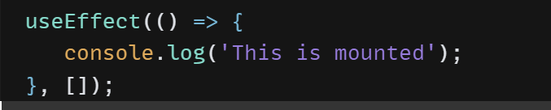

**COMPONENTDIDUPDATE**

**WHEN EVER DEPENDENCY UPDATED, IT IS SIMILAR TO “COMPONENTDIDUPATE”**

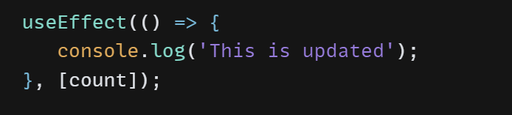

**COMPONENTWILLUNMOUNT**

**IF YOU RETUN CLEANUP FUNCTION IN USEEFFECT CALLBACK FUNCTION, IT IS SIMILAR TO COMPONENTWILLUNMOUNT.**

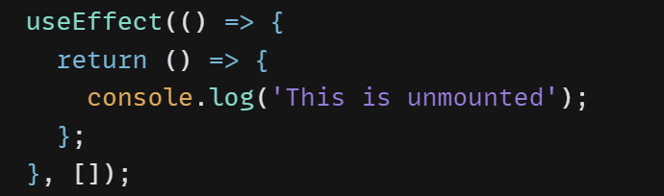

**33.USECONTEXT**

**CONTEXT PROVIDES A WAY PASS DATA THROUGH COMPONENT TREE WITHOUT PASS PROPS DOWN MANUALLY AT EVERY LEVEL.**

**34.HOW TO AVOID INFINTE LOOP.**

**WE CAN USE “USEREF”**

**35.USEREF**

**USE REF HOOK ALLOWS US DIRECTLY CREATE REFERNCE TO THE DOM ELEMENT IN FUNCTIONAL COMPONENTS.**

**USEREF RETURN RETURNS OBJECT. THE OBJECT HAS A PROPERTY CALLED CURRENT.**

**IT DOES NOT RE-RENDER WHEN STATE IS UPDATED.**

**36.USESTATE VS USEREF**

* **USESTATE CAUSES RE-RENDER,USE REF DOES NOT RE-RENDER**
* **THE REFERENCE UPDATE IS SYNCHRONOUS. THE UPDATED REFERENCE IMMEDIATELY AVAILABLE.BUT THE STATE UPDATE IS ASYNCHRONOUS,VALUE UPDATED AFTER RE-RENDERING**

**37.REACT JS DEFAULT PROPS**

**DEFAULT PROPS IS REACT COMPONENT PROPERTY THAT ALLOWS YOU TO SET DEFAULT VALUES FOR THE PROPS ARGUMENT.**

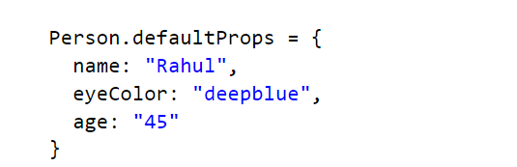

**38.SINGLE PAGE APPLICATION VS MULTI PAGE APPLICATION.**

|  |  |
| --- | --- |
| **SINGLE PAGE APPLICATION** | **MULTI PAGE APPLICATION** |
| **SPA HAS ONLY ONE HTML PAGE,CONTENT IS RENDERED ON CLIENT.** | **MPA HAS MULTIPLE HTML PAGES,CONTENT IS RENDERED ON SERVER.** |
| **SINGLE PAGE APP DATA RELOADS THE DATA NECESSARY FOR THE USER** | **MULTIPAGE APP,ENTIRE WEB PAGE CONTENT IS REFRESHED.** |

**39.LIFECYCLE METHODS IN REACT?**

**WE HAVE 3 PHASES**

**1.MOUNTING**

**2.UPDATING**

**3.UNMOUNTING**

**IN MOUNTING PHASE**

**CONSTRUCTOR()**

**GET DERIVEDSTATE FROM PROPS()**

**RENDER ()**

**COMPONENTDIDMOUNT**

**IN UPDATING PHASE**

**GET DERIVED STATE FROM PROPS ()**

**SHOULD COMPONENT DID UPDATE ()**

**RENDER ()**

**GETSNAPSHOT BEFORE UPDATE**

**COMPONENT DID UPDATE**

**IN MOUNTING PHASE**

**COMPONENT WILL UNMOUNT**

**40.WHICH COMPONENT YOU ARE USING**

**BOTH I USED NOW I AM USING FUNCTIONAL COMPONENTS**

12.NAMED EXPORT VS DEFAULT EXPORT?

NAMED COMPONENT

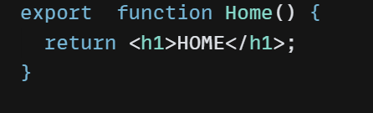

* WHEN YOU ARE IMPORTING NAMED COMPONENT YOU USE THE SAME NAME EXPORTED WITH.
* 
* NAMES MUST BE IMPORTED INSIDE CURLY BRACKETS 
* Named exports allow multiple exports in a single file

DEFAULT EXPORT EXAMPLE

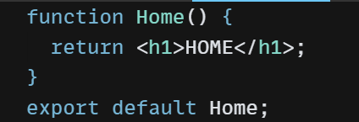

* When importing a default export, you don’t use curly brackets.



* When you import a default export, you can give it whatever name you want.



* modules can only have one default export.

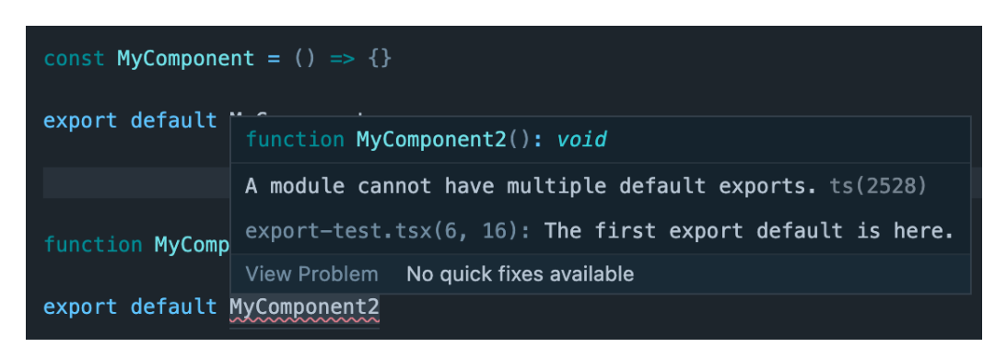

13.HOW TO PASS AND ACCESS PROPS IN FUNCTIONAL COMPONENT IN REACT

App.js

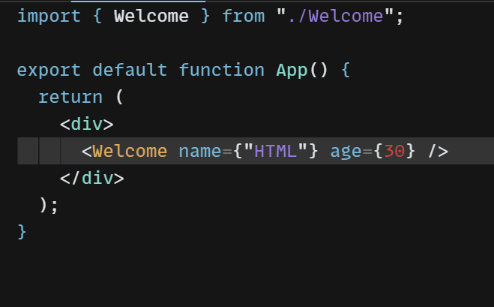

Welcome.js

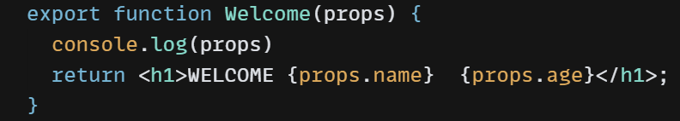

24.IF YOU NOT MENTIONED KEY ATTRIBUTE WHAT WARNING WILL COME?

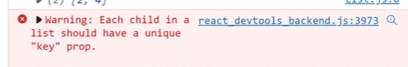

25.WHICH LIBRARY YOU ARE USING FOR API CALLS OR HOW YOU ARE CALLING API

AXIOS

**27.PROPS VS STATE**

|  |  |
| --- | --- |
| **PROPS** | **STATE** |
| **PROPS ARE IMUTABLE** | **STATE IS MUTABLE** |
| **PROPS ARE USED TO PASS DATA FROM ONE COMPONENT TO ANOTHER COMPONENT** | **STATE HOLDS THE DATA WITH IN COMPONENT ONLY** |
| **PROPS CAN BE ACCESSED BY CHILD COMPONENTS** | **STATE CANNOT BE ACCESSED BY CHILD COMPONENTS** |

**28.”USEMEMO”**

USEMEMO RETURN MEMONIZED VALUE

TO FIX THE PERFORMANCE ISSUE WE CAN USE “USE MEMO” HOOK.

TO MEMONIZE THE EXPENSIVE CALUCULATION FUNCTION.

EXPENSIVE FUNCTION WILL RUN WHEN DEPENDENCY HAVE CHANGED.

**29.WITHOUT REDUX HOW TO HANDLE STATE MANAGEMENT IN REACT**

**WE CAN USE “USE CONTEXT” HOOK**

**30.HOW TO IMPROVE PERFOMANCE IN REACT JS OR OPTIMIZATION**

**TO IMPROVE PERFORMANCE, WE CAN USE PURE COMPONENTS, REACT.MEMO,LAZY LOADING, AVOID INDEX AS KEY,USE FRAGMENTS WITHOUT ADDING EXTRA NODES,USE MEMO,USE CALLBACK.**

**31.HOW TO AVOID PROPDRILLING?**

**TO AVOID PROPDRILLING WE CAN USE**

**CONTEXT API**

**REDUX**

**HIGH ORDER COMPONENT**

**RENDERPROPS**

**COMPOSITION**

**32.WHAT IS PROPDRILLING?**

**PROP DRILLING IS THE PROCESS PASS DATA MORE THAN ONE LEVEL EVEN THEY DON’T NEED UNTIL REACHES THE ONE THAT YOU USE PROPS.**

**33.WHAT ARE THE WAYS TO STYLING REACT COMPONENT.**

**INLINE STYLING**

**USING JAVASCRIPT OBJECT**

**CSS STYLESHEET**

**CSS MODULES**

**SASS**

**USING BOOTSTRAP**

**34.WHAT IS HIGH ORDER COMPONENT**

**IF YOU WANT TO REUSE THE LOGIC WITHOUT DUPLICATING THE CODE WE WILL USE HIGHORDER COMPONENT.**

**35.DIFFRENCE BETWEEN USEMEMO VS USECALLBACK**

**BOTH ARE SIMILAR. THE MAIN DIFFERENCE IS USEMEMO RETURNS MEMONIZED VALUE AND USECALLBACK RETURNS MEMONIZED CALLBACK FUNCTION.**

**36.HOW TO PASS DATA PARENT TO CHILD**

**WE CAN USE PROPS**

**37.HOW TO HANDLE EXCEPTIONS WHILE CONSUMING API IN REACT JS?**

**WE CAN USE THEN AND CATCH METHOD. IF API IS RESOLVED THEN BLOCK WILL EXECUTE. IF API IS REJECTED CATCH BLOCK WILL EXECUTE.**

**38.HOW TO HANDLE BROWSER COMPATABILTY ISSUES?**

**WE CAN USE POLLYFILLS AND TRANSPILERS.**

**39.HOW TO IMPLEMENT MULTIPAGE APLLICTAION**

**USING ROUTER**

**40.WINDOWS COMMANDS**

|  |  |
| --- | --- |
| **WINDOWS COMMAND** | **USECASE** |
| **CODE .** | **IF YOU USE CODE . COMMAND IN COMMAND LINE INTERFACE IT WILL OPEN VISUAL STUDIO CODE** |

**41.VISUAL STUDIO TIPS**

|  |  |
| --- | --- |
| **FORMAT DOCUMENT** | **IT FORMATS THE ENTIRE FILE** |

**42.DO YOU HAVE EXPERIENCE MAPS AND CHARTS?**

* **YES, I HAVE EXPERIENCE D3 CHARTS, BAR CHARTS, BUBBLE CHARTS.**
* **MAPS I DON’T HAVE EXPERIENCE.**

**43.WHAT IS MEMONIZATION?**

**MEMONIZATION IS OPTIMIZATION TECHNIQUE THAT ALLOWS THE INCREASE PERFORMANCE OF APPLICATION.**

**44.WHAT IS PURE COMPONENT?**

**PURECOMPONENT IT WILL UPDATE SHOULD COMPONENT METHOD FOR US. IT WIL STOP UNNECESSARY RE-RENDERING.**

**45.WHICH COMMAND YOU WILL USE INSTALL REACT-APP?**

**NPX CREATE-REACT-APP PROJECTNAME**

**46.FOLDER STRUCTURE IN REACT**

**NODEMODULES**

**PUBLIC**

**GITIGNORE**

**PACKAGE.LOCK. JSON**

**PACKAGE.JSON**

**README**

**47.WHAT IS NPM**

**NPM IS SOFTWARE PACKAGE MANAGER.**

**NPM INSTALLED WITH NODE JS.**

**IT IS INSTALLED ALL THE DEPENDENCES OF THE PROJECT.**

**48.HOW MANY YEARS OF EXPERIENCE IN REACT JS**

**2 YEARS**

**49.HOW MUCH YOU WILL GIVE RATING OUT OF 5 IN REACT**

**3**

**50.HOW TO CREATE RE-USABLE FORM IN REACT OR HOW TO DEVELOP FORM ELEMENTS RE-USABLE IN REACT**

**WE CAN USE CUSTOM FORM COMPONENT**

**51.HOW TO HANDLE TYPES IN APPLICATION**

* **IN REACT WE CAN USE ‘PROP-TYPES’**
* **IN JAVASCRIPT WE CAN USE ‘TYPEOF’ OPERATOR**

**52.APART OF REACT ANY OTHER FRAMEWORK YOU ARE USING.**

**NO**

**53.IF YOU WANT TO ACCESS ANY COMPONENT WHICH HOOK USED**

**WE CAN USE “USEREF” HOOK**

**54.WHICH FILE TYPE ARE USING REACT**

**JSX**

**55.IS IT JSX BROWSER COMPATABILE**

**NO. BABEL TRANSPILER CONVERT TO NEWFEATURES TO ES5.**

**56.HOW TO CHANGE STATE IN REACT?**

**IN CLASS COMPONENTS WE WILL USE “SETSTATE”. FUNCTIONAL COMPONENTS WE WILL USE “USE STATE”**

**57.WHICH HOOK YOU WILL USE FOR API CALL OR FETCHING DATA**

**AXIOS**

**58. WHAT IS THE EQUIVALENT OF DOCUMENT GETELEMENTBYID() IN REACT?**

**WE CAN USE “REF”**

**59.STATE LIFTING REACT**

**PASSING STATE CHILD COMPONENT TO CLOSEST PARENT COMPONENT CALLED STATE LIFTING.**

**60. ”LAZY LOADING” IN REACT?**

**LAZYLOADING TECHNIQUE USED LOADING COMPONENTS WHEN THEY ARE ACTUALLY NEEDED.IT WILL HELP IMPROVE THE PERFORMANCE OF REACT APPLICATION.**

**WE HAVE SEVERAL WAYS TO IMPLEMENT LAZY LOADING**

**1.REACT.LAZY()**

**2.DYNAMICIMPORTS**

**3.THIRD-PARTY LIBARIES ALSO WE CAN USE**

**61.WHAT IS UNI DIRECTIONAL**

**“UNI DIRECTIONAL” IS DEFAULT PATTERN IN REACT.DATA IS PASSED PARENT COMPONENT TO CHILD COMPONENT THROUGH PROPS.IT DOESN’T MEAN THE DATA CAN’T FLOW BACK TO THE PARENT COMPONENT.IT MEANS FLOW IS CONTROLLED.IF YOU WANT TO PASSS DATA CHILD COMPONENT TO PARENT COMPONENT WE CAN USE CALLBACKS.**

**62.WHAT IS AXIOS**

**AXIOS IS USED TO MAKE HTTP REQUESTS.IT WILL SUPPORT GET,POST,PUT,DELETE.**

**COUPLE OF BENFITS USING AXIOS**

**REQUEST AND RESPONSE INTERCEPTORS**

**AUTOMATIC JSON DATA TRANSFORMATION**

**SUPORT FOR UPLOADING FILES**

**SUPPORT FOR CANCELING REQUESTS**

**63.RENDERING VS MOUNTING REACT JS**

**RENDERING**

**RENDERING IS THE PROCESS TAKING COMPONENT GETS CALLED WHICH RETURNS SET OF INSTRUCTIONS FOR CREATING DOM.**

**MOUNTING**

**MOUNTING IS WHEN REACT RENDERS THE COMPONENT FOR THE FIRST TIME AND BUILDS THE INITIAL DOM.**

**34.USE MEMO VS REACT.MEMO**

**USEMEMO USED TO CREATE MEMONIZED VALUE.IT TAKES TWO ARGUMENTS.FUNCTION THAT RETURNS THE VALUE TO BE MEMONIZED AND ARRAY OF DEPENDENCIES.THE VALUE IS ONLY RECALUCULATED IF ONE OF THE DEPENDENCIES CHANGED.**

**REACT.MEMO IS HIGHER ORDER COMPONENT THAT CAN BE USED TO WRAP FUNCTIONAL COMPONENTS AND MAKE IT ONLY RE-RENDER WHEN PROPS HAVE CHANGED.**

**USEMEMO ALLOWS MEMONIZE THE VALUE AND REACT.MEMO IS HIGHER-ORDER COMPONENT ALLOWS MEMONIZE COMPONENT.**

**35.WHY WE CANNOT UPDATE STATE DIRECTLY.**

**STATE UPDATE ALWAYS DONE BY USING setState() OR BY USING useState hook.UPDATING STATE DIRECTLY CAUSE ISSUES WITH LIFE CYCLE METHODS AND COMPONENTS PROPS.**

**36.CSS MODULES IN REACT**

**CSS MODULES ALLOWS TO WRITE CSS CODE IN SEPARATE FILE AND THEN IMPORT INTO REACT COMPONENTS.IT CAN BE SCOPED SPECIFIC COMPONENT.IT PREVENT NAMING CONFLLICTS AND CSS RE UCSABLE.**

**37.HOW TO HANDLE INVALID URL IN REACT**

**YOU CAN HANDLE INVALID URL BY RENDERING “404 NOT FOUND” OR RE-DIRECTING THE USER DIFFERENT PAGE.**

**38.KEY IN REACT**

**“KEY” ATTRIBUTE WHICH ITEMS HAVE CHANGED,ADDED,OR REMOVED IN LIST.KEYS SHOULD BE UNIQUE AND STABLE.WHICH MEANS THEY SHOULD NOT CHANGE WHEN COMPONENT RE-RENDERS.**

**39.HOW TO HANDLE SECURITY IN REACT APPLICATION.**

**WE CAN USE**

**AUTHENTICATION AND AUTHORIZATION**

**INPUT VALIDATION**

**CROSS SITE SCRIPTING**

**40.DEPENDENCIES VS DEV DEPENDENCIES**

**DEPENDENCIES**

**DEPENDENCIES ARE PACKAGES REQUIRED FOR APPLICATION TO RUN.**

**DEVDEPENDENCIES**

**DEV DEPENDENCIES ARE ONLY NEEDED DURING DEVELOPMENT PROCESS.DEV DEPENDENCIES ARE WEBPACK,BABEL,ESLINT ETC.**

**41.HOW TO PASS DATA CHILD COMPONENT TO PARENT COMPONENT.**

**PASS DATA FROM CHILD COMPONENT TO PARENT COMPONENT USING CALLBACK FUNCTION.THE CALLBACK FUNCTION IS PASSED AS PROP TO THE CHILD COMPONENT.**

**42.BATCHING**

**BATCHING IS THE PROCESS OF COLLECTING MULTIPLE UPDATES TO THE COMPONENT STATE AND APPLYING THEM ALL AT ONCE.IT WILL IMPROVE PERFORMANCE OF APPLICATION REDUCING THE NUMBER OF TIMES COMPONENT NEEDS TO RE-RENDER. TO IMPLEMENT BATCHING WE WILL USE FIBER.**

**43.CONTROLLED VS UNCONTROLLED COMPONENT REACT**

* **CONTROLLED COMPONENT THAT IS CONTROLLED BY REACT STATE.**
* **UNCONTROLLED COMPONENT MANAGES OWN STATE.**
* **CONTROLLED COMPONENT RECIEVES VALUE FROM PARENT COMPONENT THROUGH PROPS.**
* **UNCONTROLLED COMPONENT USES REF DIRECTLY ACCESS THE DOM ELEMENT.**

**44.SYNTHETIC EVENTS IN REACT**

**SYNTHETIC EVENTS ARE WAY TO HANDLE EVENTS ACROSS DIFFERENT BROWSERS.**

**SYNTHETIC EVENT SYSTEM MAPS BROWSER EVENTS TO CONSISTENT API.**

**IT ALLOWS DEVELOPERS WRITE CODE SAME WAY ACROSS DIFFERENT BROWSERS.**

**45.CLIENT SIDE RENDERING VS SERVER SIDE RENDERING**

**IN CLIENT SIDE RENDERING,JAVASCRIPT CODE FOR THE REACT APPLICATION IS SENT TO THE BROWSER.**

**INITIAL RENDER OF THE APPLICATION HAPPENS IN THE BROWSER.AFTER JAVASCRIPT HAS BEEN LOADED AND EXECUTED.**

**IN SERVER SIDE RENDERING,THE INITIAL RENDER OF THE APPLICATION IS DONE ON THE SERVER.**

**SERVER SIDE RENDERING IMPROVE INITIAL LOAD TIME OF APPLICATION.**