Rajamani

Karthikeyan

1001267157

# Programming Assignment 4

PHP Scripting with Relational Database

Contents

Programming Assignment 4 1

1 Login.php 2

2. Logged in 2

2. Invalid login message 3

3. Register for New user 3

4. New user Registered 4

5. New user saved in db_cheapbooks database 4

6. search book by author after logged in 5

7. Search by Title 5

8. Add items to cart 6

9. Shopping cart 6

10, After buy books is clicked. 7

11. After logout 7

## 1 Login.php

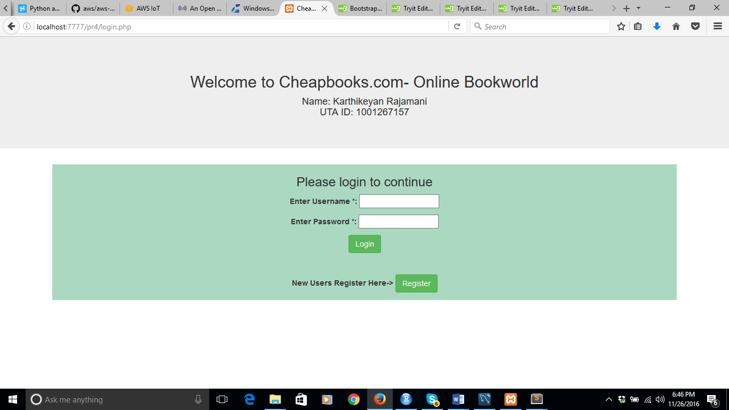

## 2. Logged in

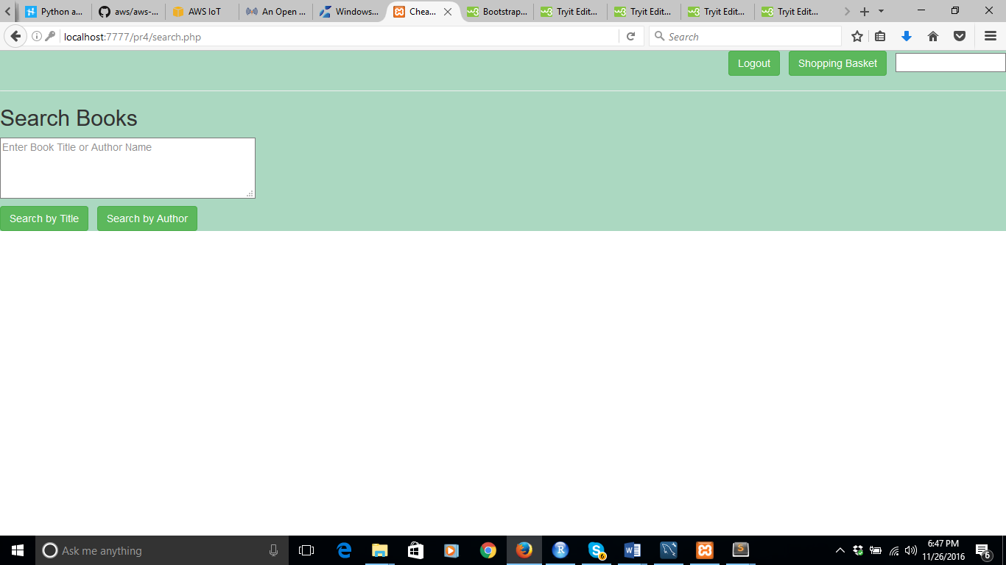

## 2. Invalid login message

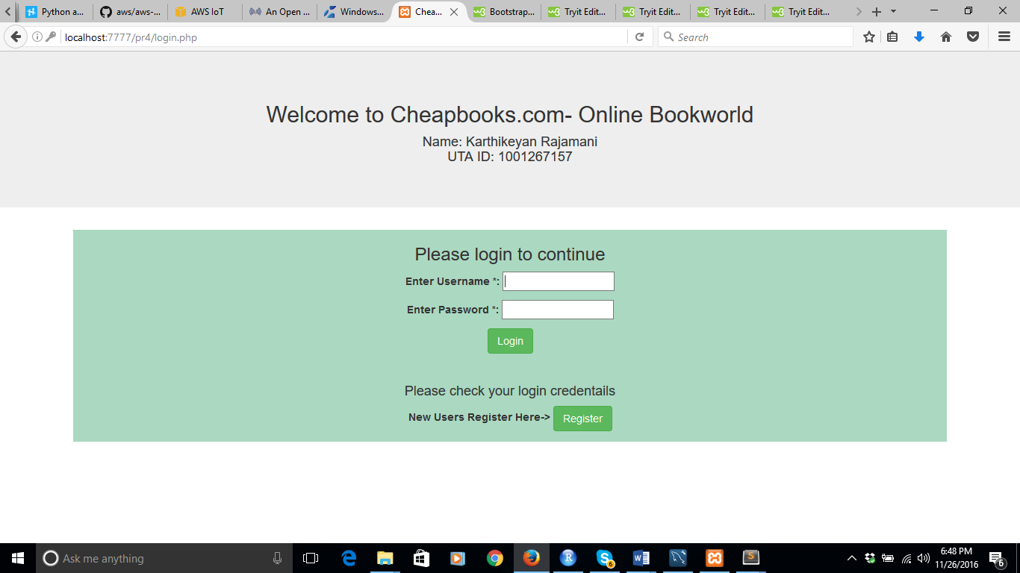

## 3. Register for New user

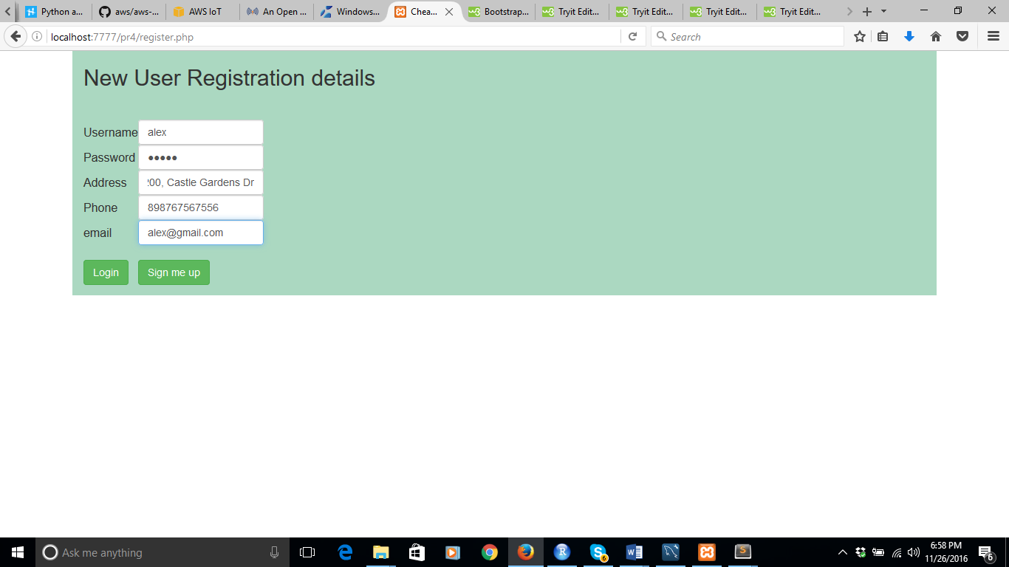

## 4. New user Registered



## 5. New user saved in db_cheapbooks database

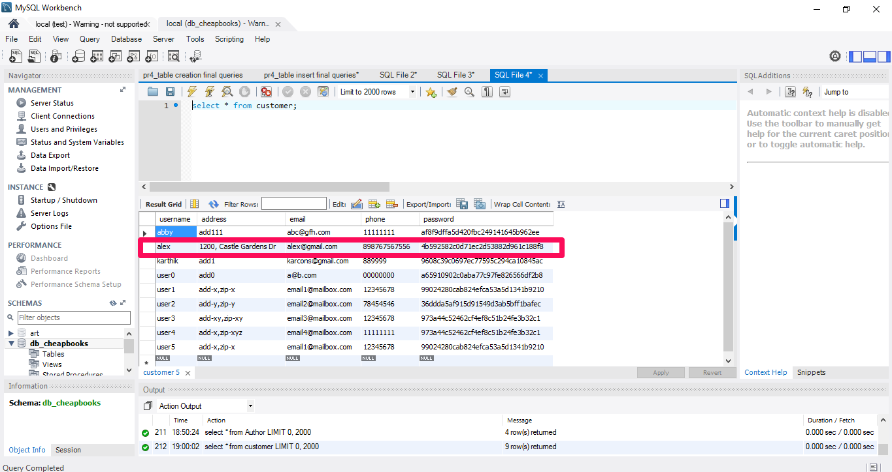

## 6. search book by author after logged in

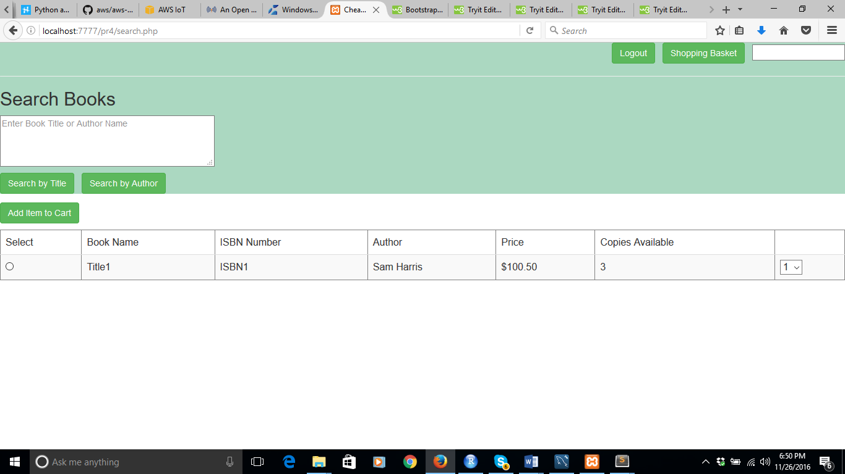

## 7. Search by Title

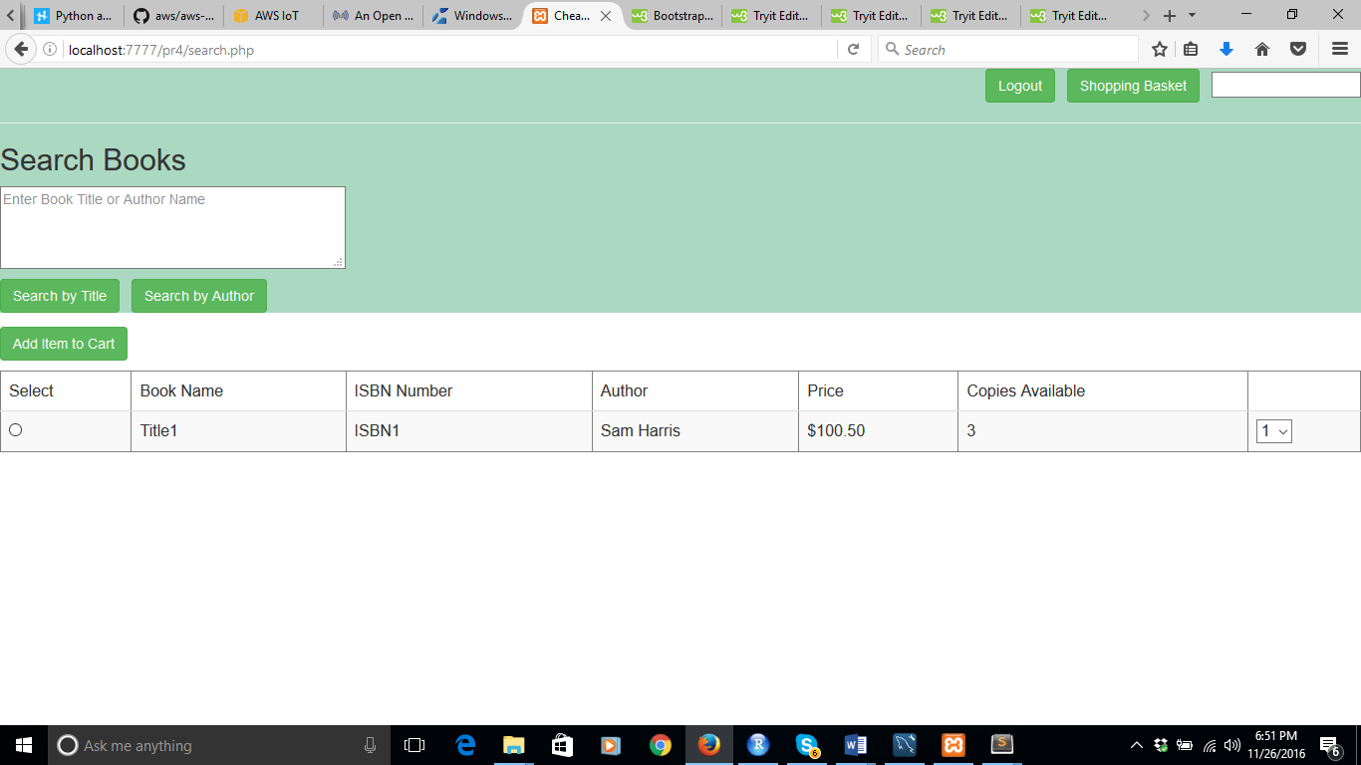

## 8. Add items to cart

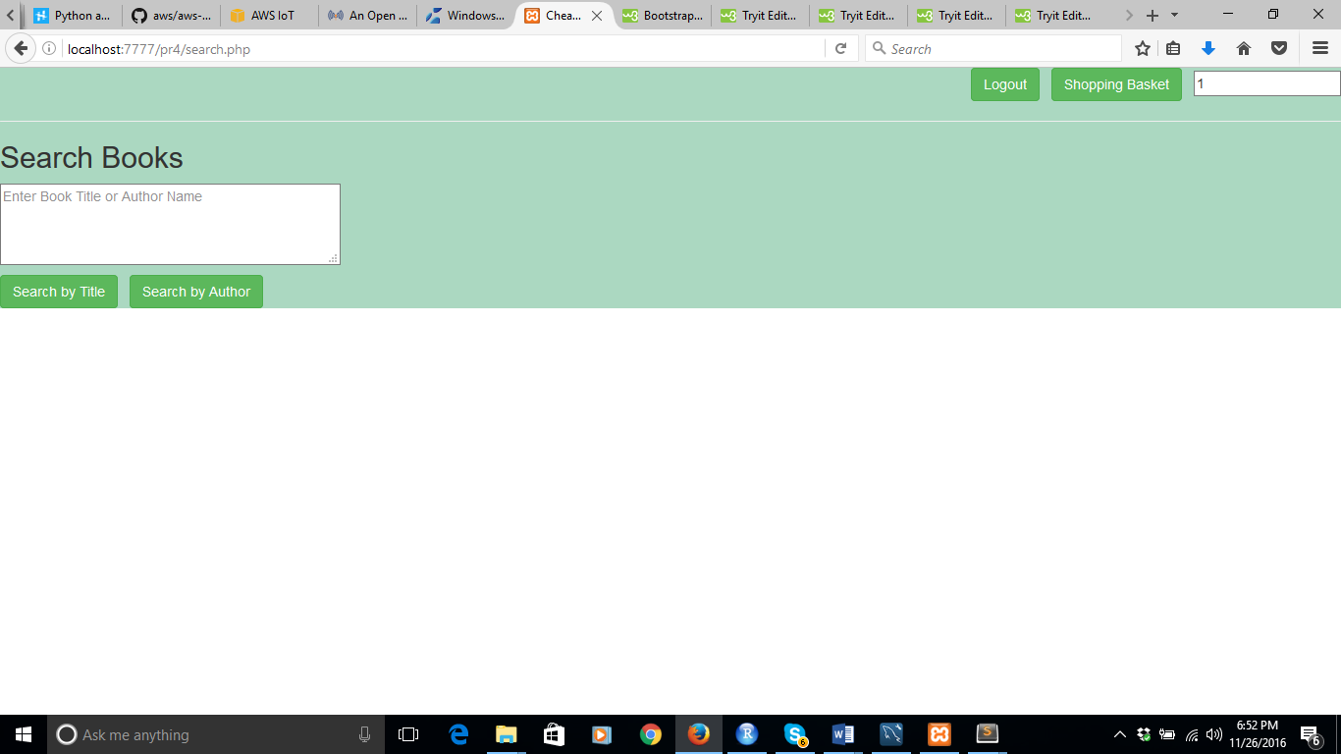

## 9. Shopping cart

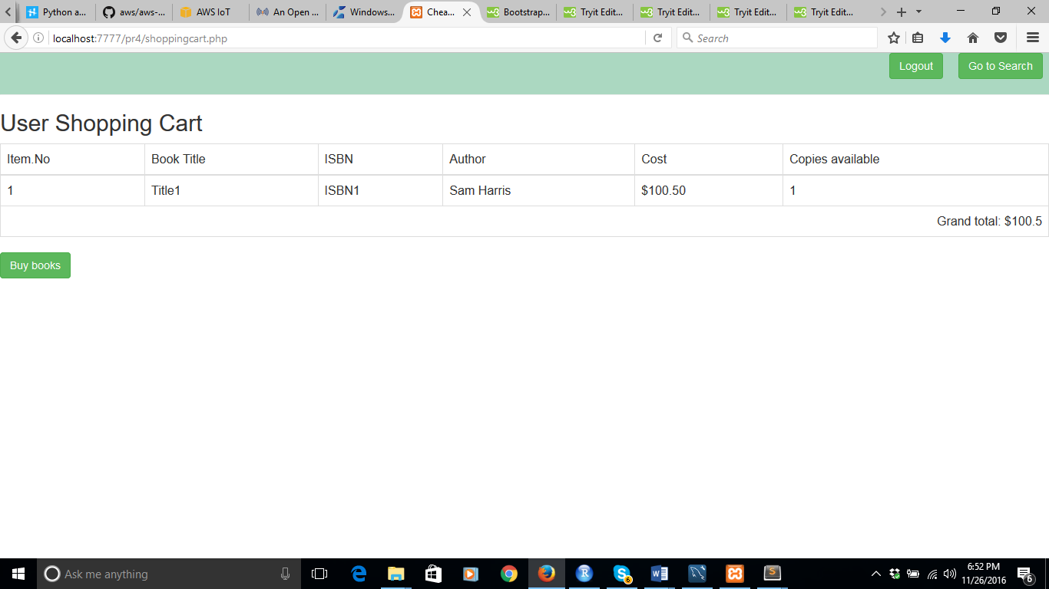

## 10, After buy books is clicked.

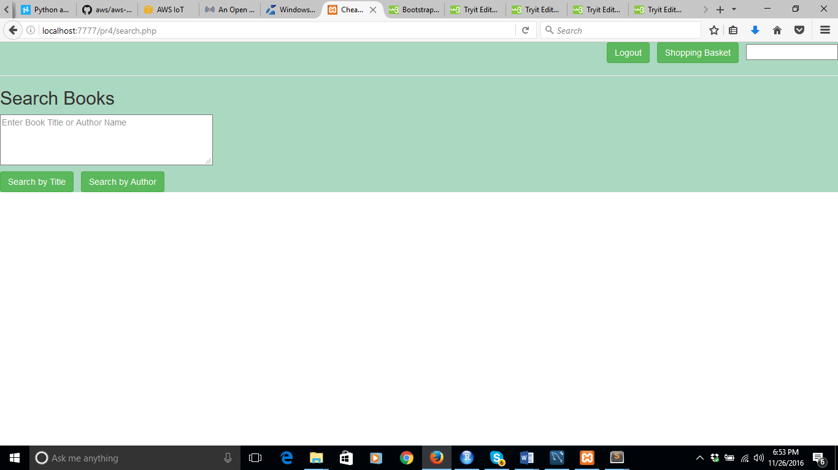

## 11. After logout

