Last Name: Rajamani

First Name: Karthikeyan

UTA Id: 1001267157

Name of the Assignment: Homework Assignment7- Build 3 classifier Models

1. Choose a unique Dataset
2. Choose 3 classifiers from Bayesian, KNN, Neural Network, SVM, Naive Bayes, Ensemble
3. Build 3 classifiers from the chosen list.
4. Plot results.
5. Analyze results

Contents

Dataset: 1

KNN Classifier: 1

KNN Plot 2

KNN Accuracy 2

Neural Network classifier: 2

Neural Network Plot: 3

Accuracy of Neural Network Classifier: 3

SVM Classifier: 3

SVM Accuracy: 3

SVM classifier plot: 4

Accuracy of SVM Classifier: 4

Analyze results: 4

## Dataset:

<http://archive.ics.uci.edu/ml/datasets/Heart+Disease>

## KNN Classifier:

for(i in 1:n){

test<-ldply(folds[i])

train<-ldply(folds[-i])

#KNN Model

KNN_Train_Model=knn(train=train[,2:14],test=test[,2:14],cl=train$heartdisease,k=3)

KNN_confusion.matrix <- table(KNN_Train_Model,test$heartdisease)

KNNacc[i] <- sum(diag(KNN_confusion.matrix))/sum(KNN_confusion.matrix)

## KNN Plot

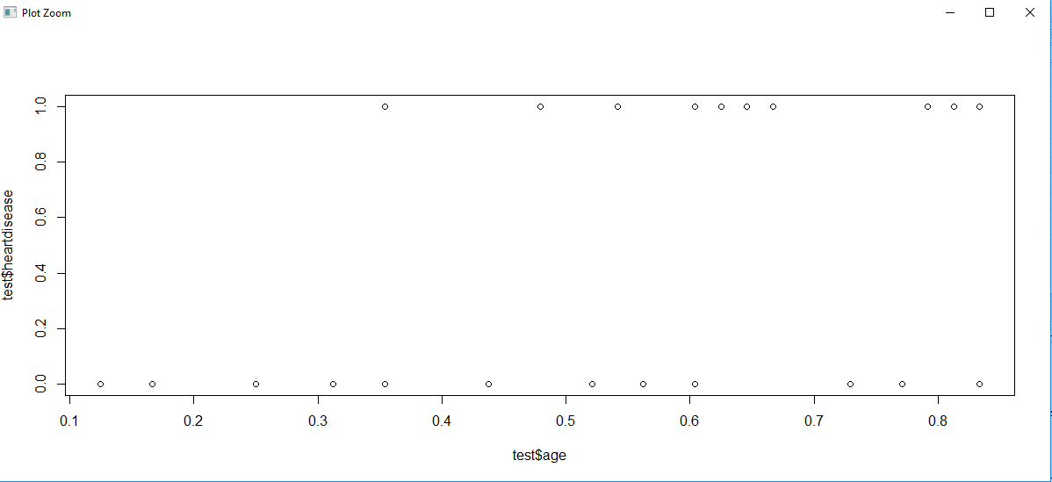

## KNN Accuracy

> cat ("The Accuracy of KNN Model is", mean(KNNacc))

The Accuracy of KNN Model is **0.807816092**

## Neural Network classifier:

#Neural Network Model

trainingdata <- cbind(train$age+train$sex+train$cp+train$trestbps+train$chol,train[15])

colnames(trainingdata) <- c("Input","Output")

NNET_Train_Model= neuralnet(Output~Input,trainingdata, hidden=10, threshold=0.01)

NNET_Predict<-compute(NNET_Train_Model,test$age+test$chol+test$chol+test$trestbps)

NNET_Predict.round <- round(as.numeric(NNET_Predict$net.result))

NNET_confusion.matrix <- table(test$heartdisease, NNET_Predict.round)

NNETacc[i]<-sum(diag(NNET_confusion.matrix))/sum(NNET_confusion.matrix)

## Neural Network Plot:

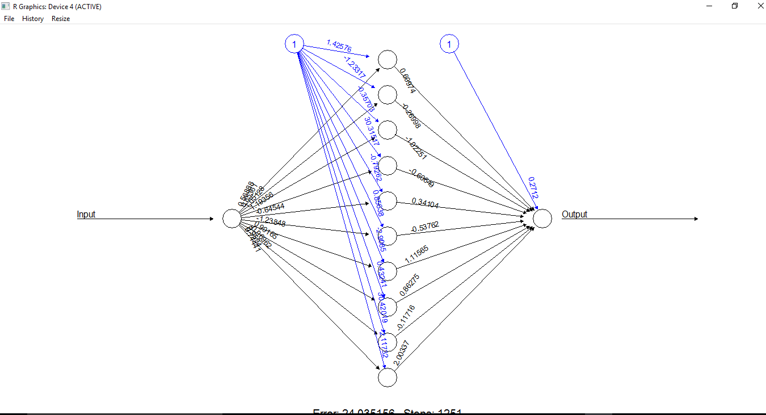

## Accuracy of Neural Network Classifier:

> cat ( "The Accuracy of Neural Network",mean(NNETacc))

The Accuracy of Neural Network 0.5349425287

## SVM Classifier:

#SVM Model

SVM_Train_Model<-svm(heartdisease~age+sex+cp+trestbps+chol,data=train,type="C-classification")

RSVM_Predict<-predict(SVM_Train_Model,test[2:10])

SVM_Predict<-predict(SVM_Train_Model,test[,2:15])

SVM_confusion_matrix<-table(test$heartdisease,SVM_Predict)

SVMacc[i]<-sum(diag(SVM_confusion_matrix))/sum(SVM_confusion_matrix)

## SVM Accuracy:

> cat("The accuracy of SVM Model is",mean(SVMacc))

The accuracy of SVM Model is 0.7647126437

## SVM classifier plot:

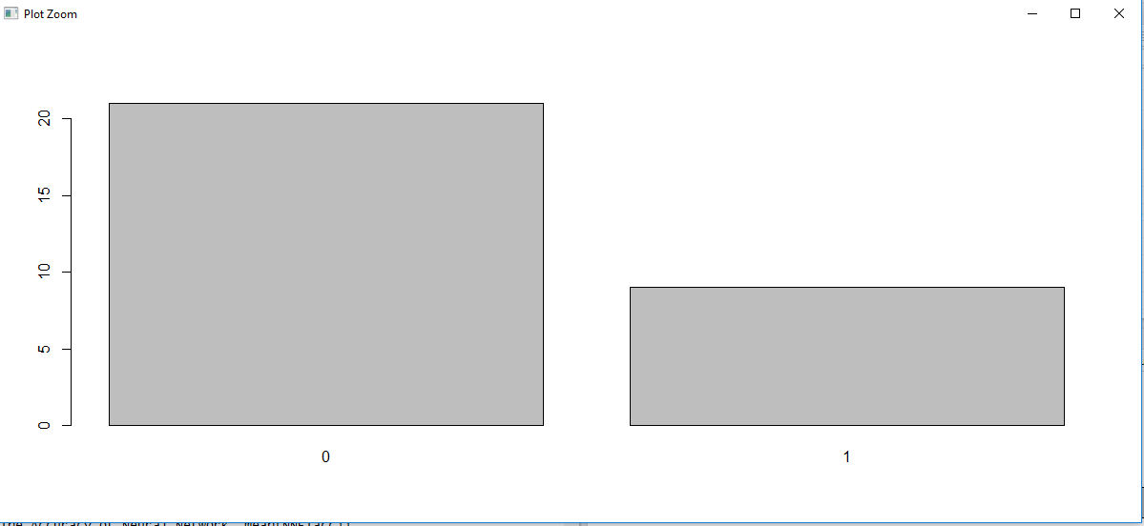

## Accuracy of SVM Classifier:

> cat("The accuracy of SVM Model is",mean(SVMacc))

The accuracy of SVM Model is **0.7685057471**

## Analyze results:

> cat ("The Accuracy of KNN Model is", mean(KNNacc))

The Accuracy of KNN Model is 0.8051724138

> cat ( "The Accuracy of Neural Network",mean(NNETacc))

The Accuracy of Neural Network 0.5320689655

> cat("The accuracy of SVM Model is",mean(SVMacc))

The accuracy of SVM Model is 0.7685057471

KNN is more accuate in predicting with 80% , followed by SVM with 77%, Neural network has relatively less accuracy for the given dataset & parameters with 53%.