Karthikeyan Rajamani 1001267157

Vineel Krishna Vellanki 1001228753

Database Systems CSE 5330 –summer 2016

Project 1

Contents

1. Software environment & tools 1

2. Creation of Table for SOCCER database 1

2.1 Schema diagram 2

2.2 Load the records from files to tables in SOCCER DB 2

2.3 Loaded data screenshot 3

3. SQL Queries 3

4. Integrity constraints violation-Insert 4

5. Referential Integrity constraint violation-Delete 5

6. Integrity constraints –Inserts not violating 5

# 1. Software environment & tools

* MySQl 5.7.13
* MySQL Workbench

# 2. Creation of Table for SOCCER database

* The SOCCER database was created & DDL queries to create tables COUNTRY, PLAYER, MATCH_RESULTS, PLAYER_ASSISTS_GOALS, PLAYER_CARDS with the constraints were written in TableCreation_1.txt file, the output is spooled in spool_TableCreation_1.out
* Text file with queries TableCreation_1.txt is attached.
* spool_TableCreation_1.out spool file is attached.

## 2.1 Schema diagram

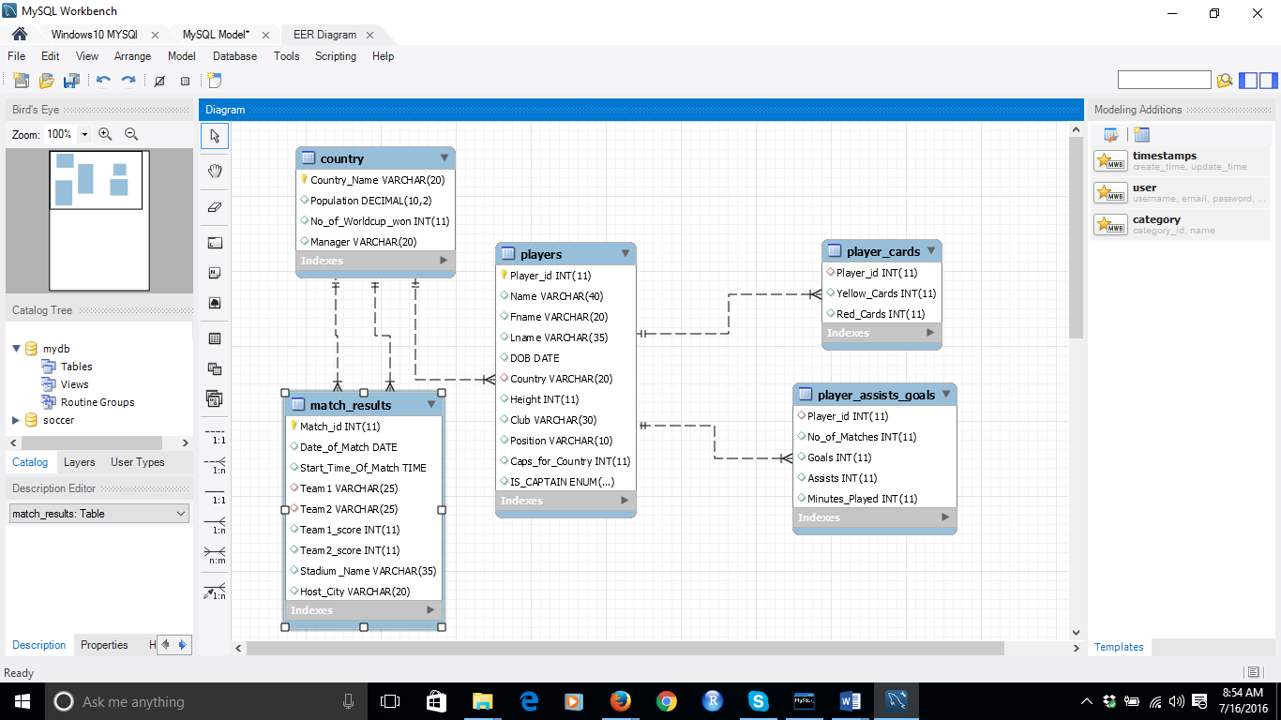

## 2.2 Load the records from files to tables in SOCCER DB

* Load Infile command was executed from MySQL from Loaddata_2.txt file which contains the scripts below for loading the data from the CSV files in to the respective tables.
* Loaddata_2.txt script file is attached.
* Spool file spool_Loaddata_2.out is attached.

LOAD DATA LOCAL INFILE 'D:/DB1/Files/Country.csv' INTO TABLE SOCCER.COUNTRY FIELDS TERMINATED BY ',' ENCLOSED BY '"' LINES TERMINATED BY '\n';

LOAD DATA LOCAL INFILE 'D:/DB1/Files/Players.csv' INTO TABLE SOCCER.PLAYERS FIELDS TERMINATED BY ',' ENCLOSED BY '"' LINES TERMINATED BY '\n';

LOAD DATA LOCAL INFILE 'D:/DB1/Files/Match_results.csv' INTO TABLE SOCCER.MATCH_RESULTS FIELDS TERMINATED BY ',' ENCLOSED BY '"' LINES TERMINATED BY '\n';

LOAD DATA LOCAL INFILE 'D:/DB1/Files/Player_cards.csv' INTO TABLE SOCCER.PLAYER_CARDS FIELDS TERMINATED BY ',' ENCLOSED BY '"' LINES TERMINATED BY '\n';

LOAD DATA LOCAL INFILE 'D:/DB1/Files/Player_assists_goals.csv' INTO TABLE SOCCER.PLAYER_ASSISTS_GOALS FIELDS TERMINATED BY ',' ENCLOSED BY '"' LINES TERMINATED BY '\n';

## 2.3 Loaded data screenshot

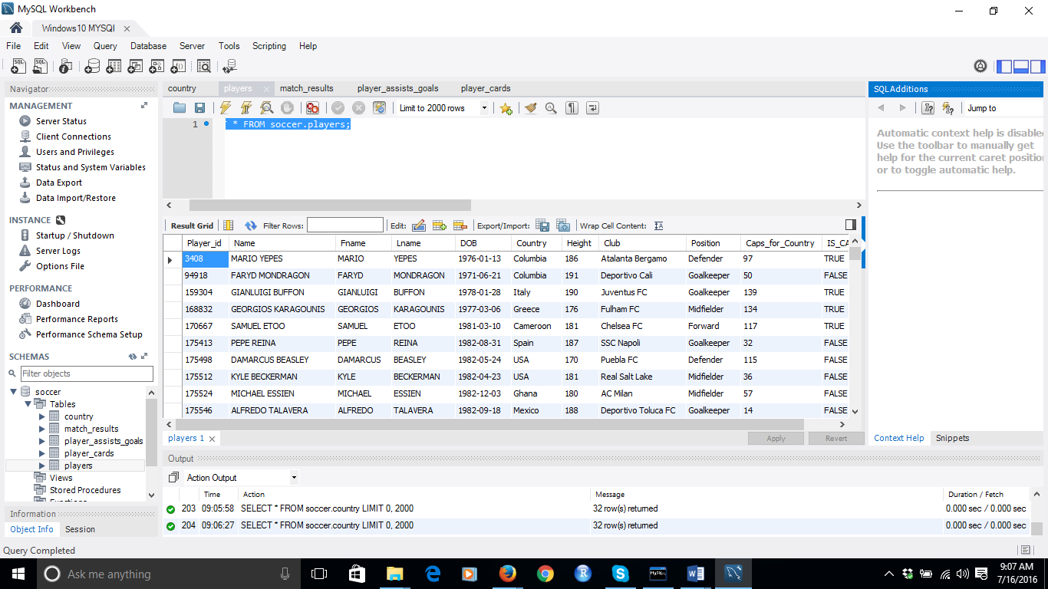

# 3. SQL Queries

* Text file with queries Queries_3.txt is attached.
* spool_Queries_3.out spool file is attached.

1. Retrieve the name, position, club, and Caps_for_Country for the players whose country is ‘Germany’

**select Name,Position,Club,** **Caps_for_Country from SOCCER.players where Country='Germany';**

1. Retrieve the names of countries participating in the 2014 world cup (this database) that have won the world cup at least once.

**select Country_Name from soccer.country where No_of_Worldcup_won>0;**

1. Retrieve the names of countries participating in the 2014 world cup (this database) that have never won the world cup.

**select Country_Name from soccer.country where No_of_Worldcup_won=0;**

1. Retrieve the name and country of the player with the most yellow cards in the 2014 world cup.

**select Name,Country from PLAYERS where PLAYERS.Player_Id in (select Player_Id from PLAYER_CARDS where Yellow_Cards=(select max(Yellow_Cards) from PLAYER_CARDS));**

1. For each Host city, retrieve the HostCity and the total number of games played in that city.

**select Host_City,count(Host_City) as 'Total games' from MATCH_RESULTS group by Host_city;**

1. For each country, retrieve the country name and the number of games they played as Team1 in the MATCH_RESULTS table, and the total goals scored (SUM of Team1_score) and the goals against (SUM of Team2_score).

**select Team1 'Country Name', count(Team1) as 'No Games Played' ,sum(Team1_score) as 'Total Goals Scored', sum(Team2_score) as 'Goals Against' FROM soccer.match_results group by Team1;**

1. For each country, retrieve the country name and the number of games they played as Team2 in the MATCH_RESULTS table, and the total goals scored (SUM of Team12_score) and the goals against (SUM of Team1_score)

**select Team2 'Country Name', count(Team2) as 'No Games Played' ,sum(Team2_score) as 'Total Goals Scored', sum(Team1_score) as 'Goals Against' FROM soccer.match_results group by Team2;**

1. Write a query that combines the results of the queries in 5. and 6. to get the total number of games each country has played (either as Team1 or as Team2), their total goals scored and their total goals against. Create a view TEAM_SUMMARY that has the following data attributes to hold the result of the combined query: CountryName, NoOfGames, TotalGoalsFor, TotalGoalsAgainst. Order in descending order of number of games played.

**create view TEAM_SUMMARY as**

**select a.Team1 as 'Country Name',sum(a.aa+b.bb) as NoofGames, sum(a.gf+b.gf) as 'Total Goals For',sum(a.ga+b.ga) as 'Total Goals Against' from**

**(select count(Team1) as aa, Team1,sum(Team1_score) as gf,sum(Team2_score) as ga FROM soccer.match_results group by Team1) a,**

**(select count(Team2) as bb,Team2,sum(Team2_score) as gf,sum(Team1_score) as ga FROM soccer.match_results group by Team2) b**

**where a.Team1=b.Team2 group by Team1 order by NoofGames desc;**

1. Find all the matches played with country ‘USA’ as Team1 or Team2.

**select * from MATCH_RESULTS where Team1='USA' or Team2='USA';**

1. Retrieve the names of the players who have scored at least one goal, the player’s country, and the number of goals each player scored. Order the result by number of goals scored in descending order.

**select b.Name,b.Country as 'Players Country', a.Goals as 'No of Goals' from**

**PLAYER_ASSISTS_GOALS a,PLAYERS b where a.Player_id=b.Player_id and a.Goals>0 order by a.Goals desc;**

1. Repeat 11. but only for the players who have more than 2 goals.

**select b.Name,b.Country as 'Players Country', a.Goals as 'No of Goals' from**

**PLAYER_ASSISTS_GOALS a,PLAYERS b where a.Player_id=b.Player_id and a.Goals>2 order by a.Goals desc;**

1. Make a list of participating countries and their population, ordered in descending order of population.

**select Country_Name as 'Participating Countries',Population from country order by Population desc;**

# 4. Integrity constraints violation-Insert

* Text file with queries Insert_Delete_Violation__Valid Insert_4_5_6.txt is attached.
* spool_ Insert_Delete_Violation__Valid Insert_4_5_6.out spool file is attached.

Australia already exists in the COUNTRY Table causing a ‘PRIMARY’ key or key violation.

**insert into COUNTRY(Country_Name,Population,No_of_Worldcup_won,Manager) Values**

**('Australia',25,0,'Perth');**

Referential Integrity or Foreign key constraint fails because ‘Antartica’ does not exist in CONTRY tables Country_Name

**Insert into PLAYERS(Player_id,Name,Fname,Lname,DOB,Country,Height,Club,Position,Caps_for_Country,IS_CAPTAIN)**

**values (12345,'ABDELMOUMENE DJABOU','ABDELMOUMENE','DJABOU','1987-01-31','Antartica',168,'Club Africain','Forward',7,'FALSE');**

Entity Integrity constraint fails as Country_Name which is the primary key cannot be null.

**insert into COUNTRY(Country_Name,Population,No_of_Worldcup_won,Manager) Values**

**(null,25,0,'Perth');**

# 5. Referential Integrity constraint violation-Delete

Referential Integrity or Foreign key constraint fails on delete as ‘Australia’ is referenced by PLAYERS & MATCH_RESULTS table.

**delete from country where Country_Name='Australia';**

# 6. Integrity constraints –Inserts not violating

Three records are inserted as they do not violate any constraints

**insert into**

**COUNTRY(Country_Name,Population,No_of_Worldcup_won,Manager) Values**

**('Newcountry1',10,0,'newcity1');**

**Insert into PLAYERS(Player_id,Name,Fname,Lname,DOB,Country,Height,Club,Position,Caps_for_Country,IS_CAPTAIN)**

**values (12345,'ABDELMOUMENE DJABOU','ABDELMOUMENE','DJABOU','1987-01-31','Newcountry1',168,'Club Africain','Forward',7,'FALSE');**

**Insert into MATCH_RESULTS(Match_id,Date_of_Match,Start_Time_Of_Match,Team1,Team2,Team1_score,Team2_score,Stadium_Name,Host_city) values**

**(100,'2016-07-17','17:00:00','Newcountry1','Croatia',3,1,'Arena de Sao Paulo','Sao Paulo');**