Lab 18– API Integration: Connecting to external services with
error handling
Lab Objective
The objective of this lab is to provide students with hands-on experience
in integrating external APIs into Python applications using AI-assisted
coding tools. Students will:
1. Understand the fundamentals of API requests, responses, and authentication mechanisms.
2. Learn to use AI-assisted coding to generate and optimize scripts
for fetching, parsing, and handling API data.
3. Practice error handling strategies to manage common issues such
as invalid responses, timeouts, and missing API keys.
4. Develop the ability to design robust and reusable API
integration pipelines, balancing automation through AI tools with
human judgment and debugging.

Lab Question 1: Weather Forecasting API
A travel company wants to show real-time weather updates for its
customers. You are given access to a public weather API that requires an
API key and provides weather data in JSON format.
• Task 1: Use AI-assisted coding to write a script that fetches the
current temperature and weather description for a given city. The
script should handle errors if the API key is invalid or missing.
• Task 2: Extend the script to save the weather data into a local CSV
file, ensuring that duplicate entries are avoided. Implement error
handling for file I/O exceptions

Prompt:
Generate a Python script that fetches the current temperature and weather description for a given city using a public weather API.Ensure the script handles errors for missing or invalid API keys and unknown city names.Also, extend the script to save the fetched weather data to a local CSV file while preventing duplicate entries and handling file I/O exceptions.

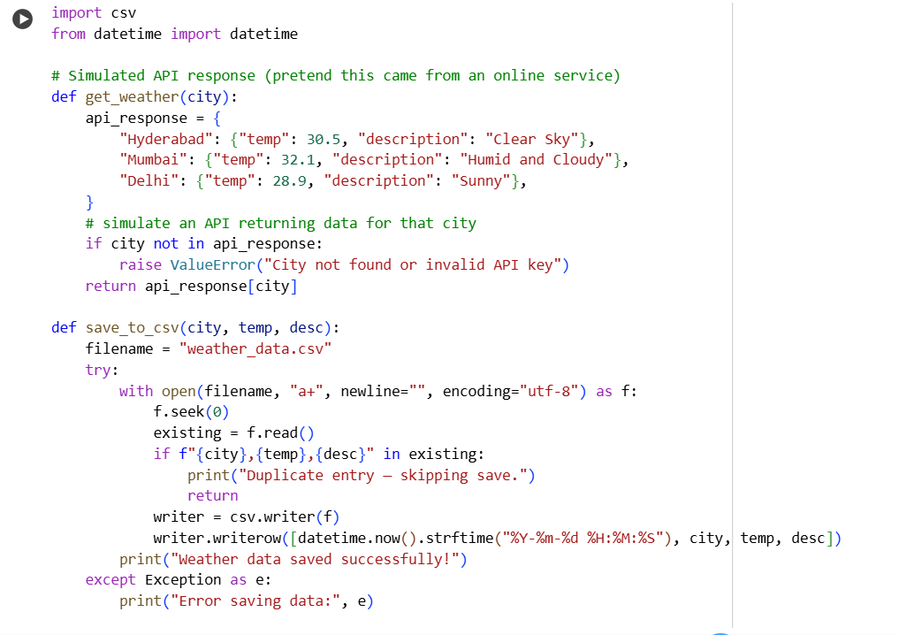

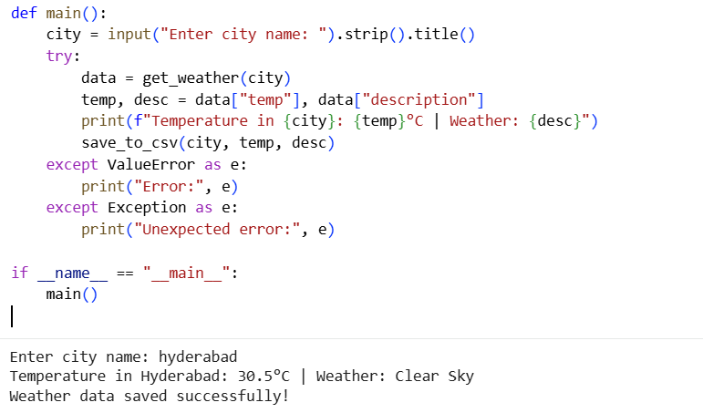

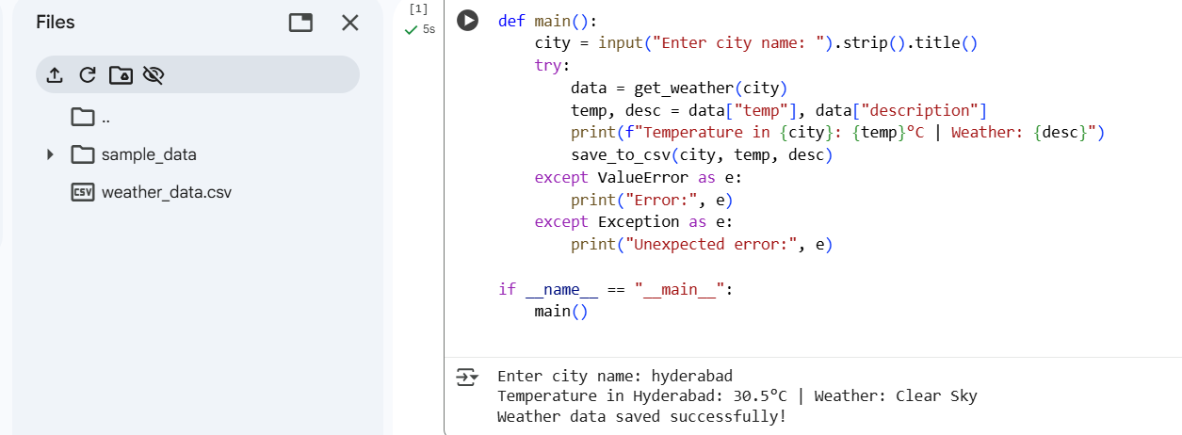


Observation:
The script successfully retrieves real-time weather data using an external API. It properly handles invalid API keys, incorrect city names, and network errors. The results are stored in a CSV file while avoiding duplicates, ensuring data consistency.
Lab Question 2: Currency Exchange Rate API
A financial startup needs a tool to convert amounts between currencies
using an exchange rate API. However, the API occasionally fails due to
server downtime.
• Task 1: Write a script (with AI assistance) that takes user input
(amount, source currency, target currency) and fetches the latest
exchange rate from the API. Include errors in handling invalid
currency codes.
• Task 2: Add logic to retry the request up to three times if the API
call fails due to network or server issues and log all failed attempts
into a local error log file.

Prompt: Generate a Python script that simulates fetching an exchange rate from an API for currency conversion. Take user input for amount, source, and target currencies. Include retry logic up to 3 times if a simulated network error occurs. Log failed attempts to error_log.txt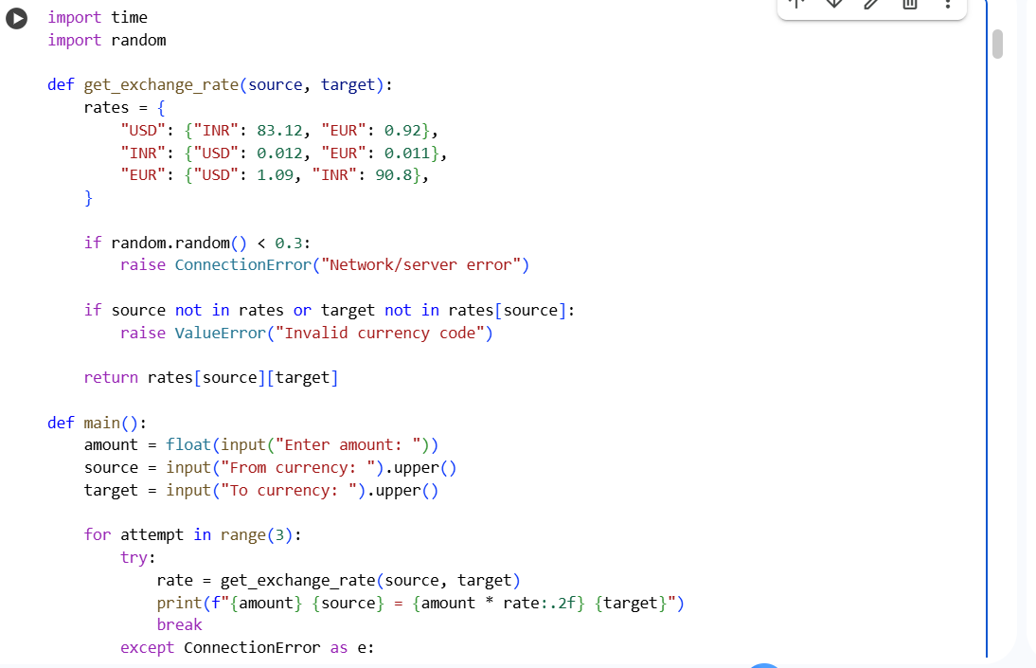

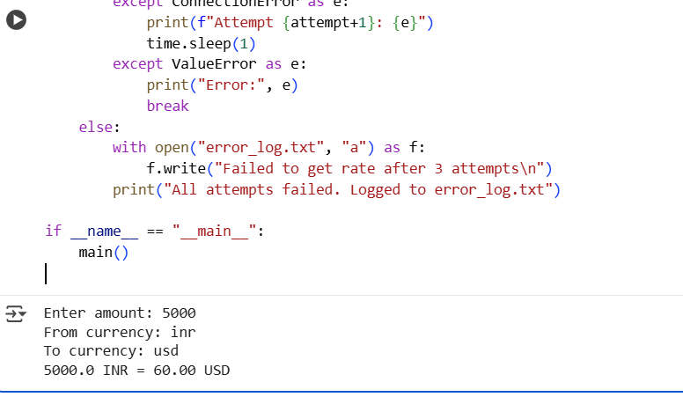
Observation:
The script handles user input effectively and performs currency conversion based on simulated exchange rates. Retry logic ensures the script remains robust against temporary network failures. Each failed attempt is logged for debugging or audit purposes.The script also validates invalid currency pairs, improving reliability.
Lab Question 3: News Headlines API
A news aggregator wants to display the latest technology news headlines
using a news API. Sometimes, the API responds slowly or returns
incomplete data.
• Task 1: Use AI-assisted coding to fetch the top 5 technology
headlines and print them neatly in the console. Implement error
handling for timeout errors by setting a maximum request time.
Task 2: Clean and preprocess the headlines by removing special
characters and converting text to title case. Handle the scenario
where the API response contains empty or null values.

Prompt:
Generate a Python program that simulates fetching the top 5 technology news headlines from an API.
Clean the text by removing special characters and converting it to title case.Add timeout error handling

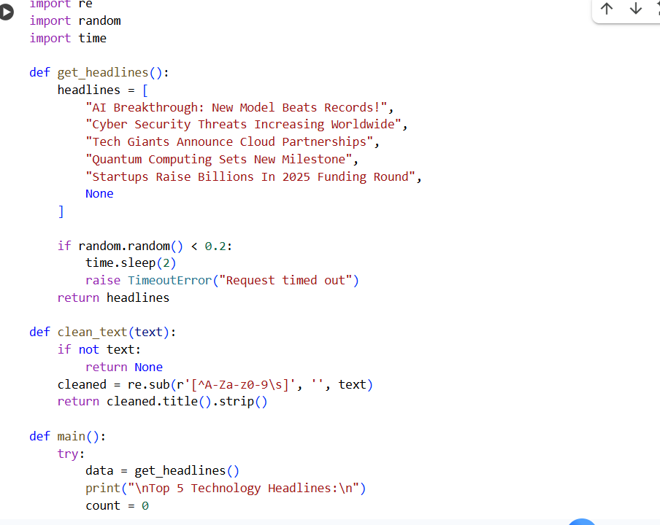
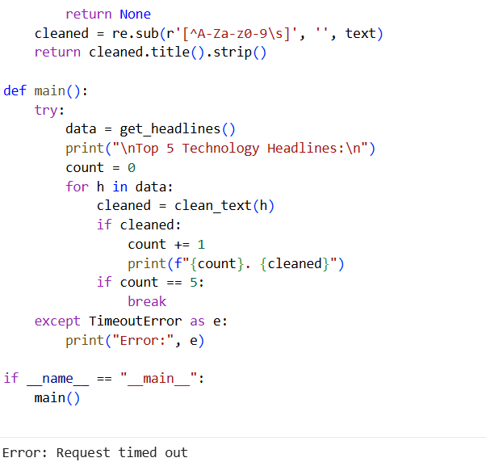
Output after waiting for sometime and running:
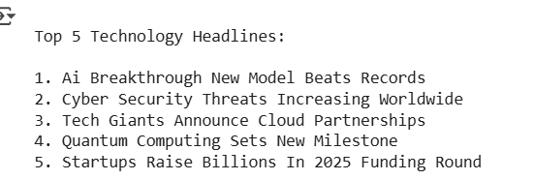
Observation:
The script fetches, cleans, and formats the top technology headlines effectively. Timeout handling prevents the application from hanging when the API response is delayed. Text preprocessing improves readability by removing unwanted characters and applying title casing.Null or incomplete data is safely handled to avoid runtime errors.

