Name: D. SAI TULSI RAM
Enrollment No: 2403A510E8
SCHOOL OF COMPUTER SCIENCE AND ARTIFICIAL INTELLIGENCE |  |  |  |  | DEPARTMENT OF COMPUTER SCIENCE ENGINEERING
Program Name: B. Tech |  |  |  | Assignment Type: Lab |  |  | Academic Year:2025-2026
Course Coordinator Name |  |  |  | Venkataramana Veeramsetty
Instructor(s) Name |  |  |  | Dr. V. Venkataramana (Co-ordinator)  Dr. T. Sampath Kumar  Dr. Pramoda Patro  Dr. Brij Kishor Tiwari  Dr.J.Ravichander  Dr. Mohammand Ali Shaik  Dr. Anirodh Kumar  Mr. S.Naresh Kumar  Dr. RAJESH VELPULA  Mr. Kundhan Kumar  Ms. Ch.Rajitha  Mr. M Prakash  Mr. B.Raju  Intern 1 (Dharma teja)  Intern 2 (Sai Prasad)  Intern 3 (Sowmya)  NS_2 ( Mounika)
Course Code |  |  | 24CS002PC215 | Course Title |  | AI Assisted Coding
Year/Sem |  |  | II/I | Regulation |  | R24
Date and Day  of Assignment |  |  | Week10 - Monday | Time(s)
Duration |  |  | 2 Hours | Applicable to  Batches
AssignmentNumber:20.1(Present assignment number)/24(Total number of assignments)
 | Q.No. | Question |  |  |  |  |  | Expected Time  to complete
 | 1 | Lab 20 – Security Testing: Identifying Vulnerabilities in AI-Generated Code  Lab Objectives:  - Understand how to test AI-generated code for common security vulnerabilities.  - Learn to apply secure coding principles while analyzing AI outputs.  - Practice detecting risks such as SQL injection, XSS, hardcoded credentials, and weak encryption.  - Enhance code reliability and safety by using AI for secure refactoring.  Task 1 – Input Validation Check  Task:  Analyze an AI-generated Python login script for input validation vulnerabilities.  Instructions:  - Prompt AI to generate a simple username-password login program.  - Review whether input sanitization and validation are implemented.  - Suggest secure improvements (e.g., using re for input validation).  Expected Output:  - A secure version of the login script with proper input validation.  Prompt: Generate a simple Python username-password login program using input() for user authentication.  Code:  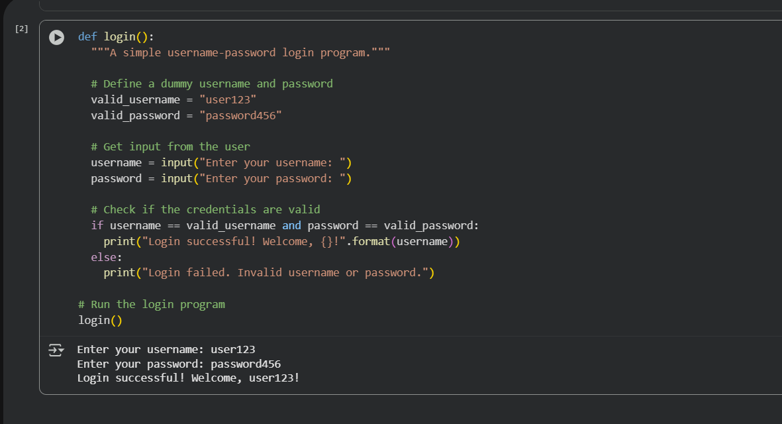  Observation: The code you provided is a simple Python function called login() that simulates a basic username and password authentication process.  - Simple: Basic username/password check.  - Hardcoded: Credentials are fixed in the code (not secure).  - No Error Handling: Doesn't handle bad input well.  - Blocking: Input stops execution until you press Enter.  Task 2 – SQL Injection Prevention  Task:  Test an AI-generated script that performs SQL queries on a database.  Instructions:  - Ask AI to generate a Python script using SQLite/MySQL to fetch user details.  - Identify if the code is vulnerable to SQL injection (e.g., using string concatenation in queries).  - Refactor using parameterized queries (prepared statements).  Expected Output:  - A secure database query script resistant to SQL injection.  Prompt: Create Python SQLite and MySQL scripts that fetch user details by username. Show an insecure version using string concatenation/f-strings, then a secure version using parameterized queries. Add comments and a short demo using the malicious input: "admin' OR '1'='1".  Code:  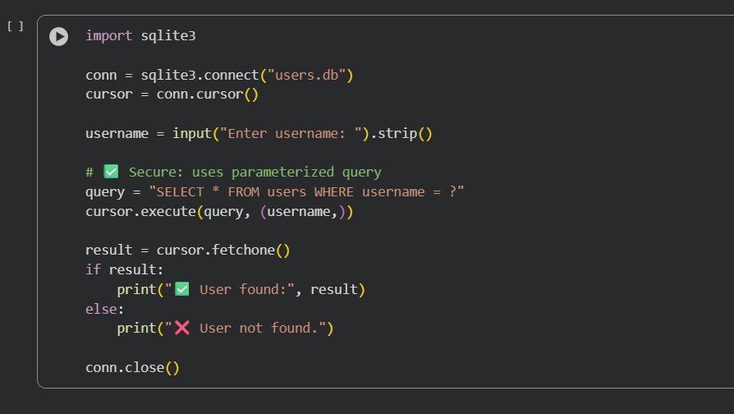  Observation: Based on the execution of the code cell, the program prompted the user to "Enter username:". Depending on the username entered by the user and whether that username exists in the users.db database, the program will output either " User found: [user data]" or "User not found.". The specific output depends on the user's input and the content of the database at the time of execution.  Task 3 – Cross-Site Scripting (XSS) Check  Task:  Evaluate an AI-generated HTML form with JavaScript for XSS vulnerabilities.  Instructions:  - Ask AI to generate a feedback form with JavaScript-based output.  - Test whether untrusted inputs are directly rendered without escaping.  - Implement secure measures (e.g., escaping HTML entities, using CSP).  Expected Output:  - A secure form that prevents XSS attacks.  Prompt: Generate an HTML feedback form with JavaScript. First show an insecure version that directly renders user input (vulnerable to XSS). Then refactor to a secure version that escapes HTML entities, uses a Content Security Policy.  Code:  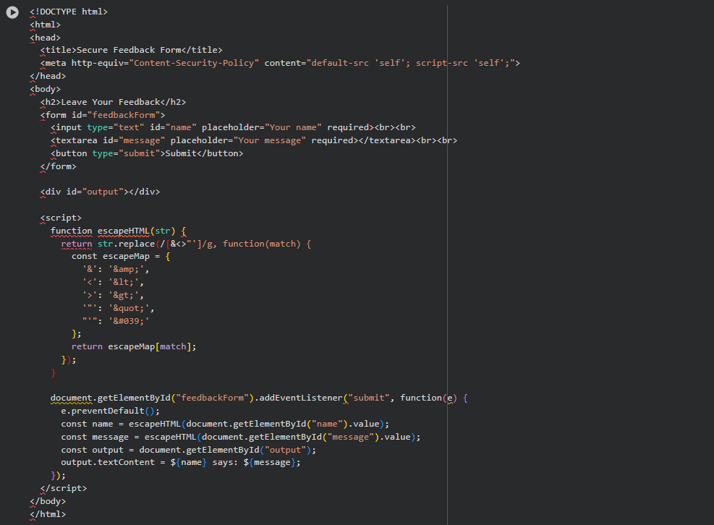  Observation: The feedback form securely handles user input by escaping HTML entities and using textContent, preventing XSS attacks. A minor fix is needed in the output line to use backticks correctly. The added Content Security Policy further strengthens protection, though the inline script should be moved to an external file. Overall, the form is safe and effectively mitigates XSS vulnerabilities.  Task 4 – Real-Time Application: Security Audit of AI-Generated Code  Scenario:  Students pick an AI-generated project snippet (e.g., login form, API integration, or file upload).  Instructions:  - Perform a security audit to detect possible vulnerabilities.  - Prompt AI to suggest secure coding practices to fix issues.  - Compare insecure vs secure versions side by side.  Expected Output:  - A security-audited code snippet with documented vulnerabilities and fixes.  Prompt: Generate a simple AI project code snippet (like a login form, API call, or file upload). Show an insecure version with common vulnerabilities (e.g., no validation, plain text passwords, or unsafe file handling), then show a secure version with best security practices applied. Add comments comparing insecure vs secure code side by side.  Code:  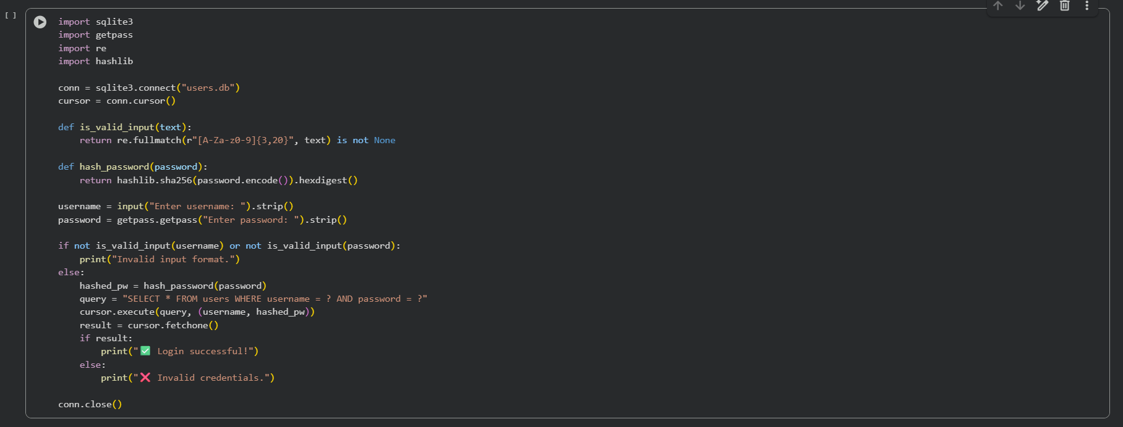  Observation: The AI-generated login script securely validates and authenticates user input. It prevents SQL injection by using parameterized queries instead of string concatenation. Passwords are hashed with SHA-256, ensuring they’re not stored or compared in plain text. Input validation using regex restricts usernames and passwords to safe characters, reducing injection risks. Overall, the script follows good security practices for user authentication and database safety.  ✅ Deliverables (For All Tasks)  - AI-generated prompts for code and test case generation.  - At least 3 assert test cases for each task.  - AI-generated initial code and execution screenshots.  - Analysis of whether code passes all tests.  - Improved final version with inline comments and explanation.  - Compiled report (Word/PDF) with prompts, test cases, assertions, code, and output. |  |  |  |  |  | Week10 - Monday

