Name: D.SAI TULSI RAM
Enrollment No: 2403A510E8
SCHOOL OF COMPUTER SCIENCE AND ARTIFICIAL INTELLIGENCE |  |  |  |  | DEPARTMENT OF COMPUTER SCIENCE ENGINEERING
Program Name: B. Tech |  |  |  | Assignment Type: Lab |  |  | Academic Year:2025-2026
Course Coordinator Name |  |  |  | Venkataramana Veeramsetty
Instructor(s) Name |  |  |  | Dr. V. Venkataramana (Co-ordinator)  Dr. T. Sampath Kumar  Dr. Pramoda Patro  Dr. Brij Kishor Tiwari  Dr.J.Ravichander  Dr. Mohammand Ali Shaik  Dr. Anirodh Kumar  Mr. S.Naresh Kumar  Dr. RAJESH VELPULA  Mr. Kundhan Kumar  Ms. Ch.Rajitha  Mr. M Prakash  Mr. B.Raju  Intern 1 (Dharma teja)  Intern 2 (Sai Prasad)  Intern 3 (Sowmya)  NS_2 ( Mounika)
Course Code |  |  | 24CS002PC215 | Course Title |  | AI Assisted Coding
Year/Sem |  |  | II/I | Regulation |  | R24
Date and Day  of Assignment |  |  | Week6 - Monday | Time(s)
Duration |  |  | 2 Hours | Applicable to  Batches
AssignmentNumber:12.1(Present assignment number)/24(Total number of assignments)
 | Q.No. | Question |  |  |  |  |  | Expected Time  to complete
 | 1 | Lab 12: Algorithms with AI Assistance – Sorting, Searching, and Optimizing Algorithms  Lab Objectives:  - Apply AI-assisted programming to implement and optimize sorting and searching algorithms.  - Compare different algorithms in terms of efficiency and use cases.  - Understand how AI tools can suggest optimized code and complexity improvements.  Task Description #1 (Sorting – Merge Sort Implementation)  - Task: Use AI to generate a Python program that implements the Merge Sort algorithm.  - Instructions:  - Prompt AI to create a function merge_sort(arr) that sorts a list in ascending order.  - Ask AI to include time complexity and space complexity in the function docstring.  - Verify the generated code with test cases.  - Expected Output:  - A functional Python script implementing Merge Sort with proper documentation.  Prompt:  Write a Python program to implement Merge Sort with a merge_sort function and a helper merge function (user based input). Add docstrings and show an example with a sample list  Code:  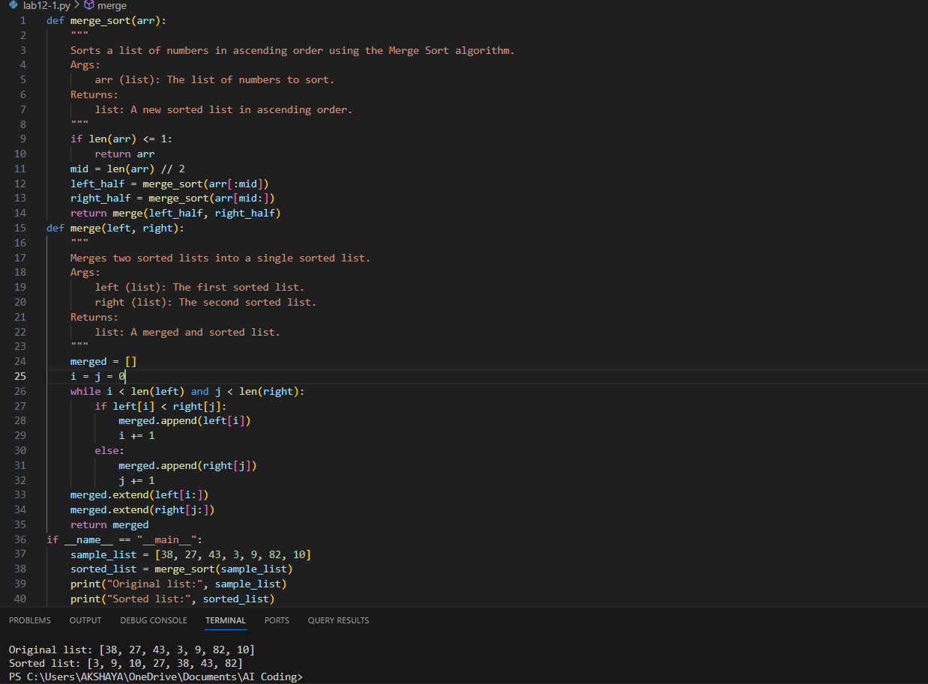  Observation: Merge Sort works by breaking a list into smaller parts, sorting them, and merging back. Example: [38, 27, 43, 3, 9, 82, 10] → [3, 9, 10, 27, 38, 43, 82]. It runs in O(n log n) time and O(n) space  Task Description #2 (Searching – Binary Search with AI Optimization)  - Task: Use AI to create a binary search function that finds a target element in a sorted list.  - Instructions:  - Prompt AI to create a function binary_search(arr, target) returning the index of the target or -1 if not found.  - Include docstrings explaining best, average, and worst-case complexities.  - Test with various inputs.  - Expected Output:  - Python code implementing binary search with AI-generated comments and docstrings.  Prompt: Create a Python program that performs Binary Search on a sorted list. Write a function binary_search(arr, target) that returns the index of the target element or -1 if it’s not present. Add a docstring describing the algorithm and its time complexities (best, average, worst). Use AI-generated comments for clarity, and demonstrate the function with multiple test cases  Code:  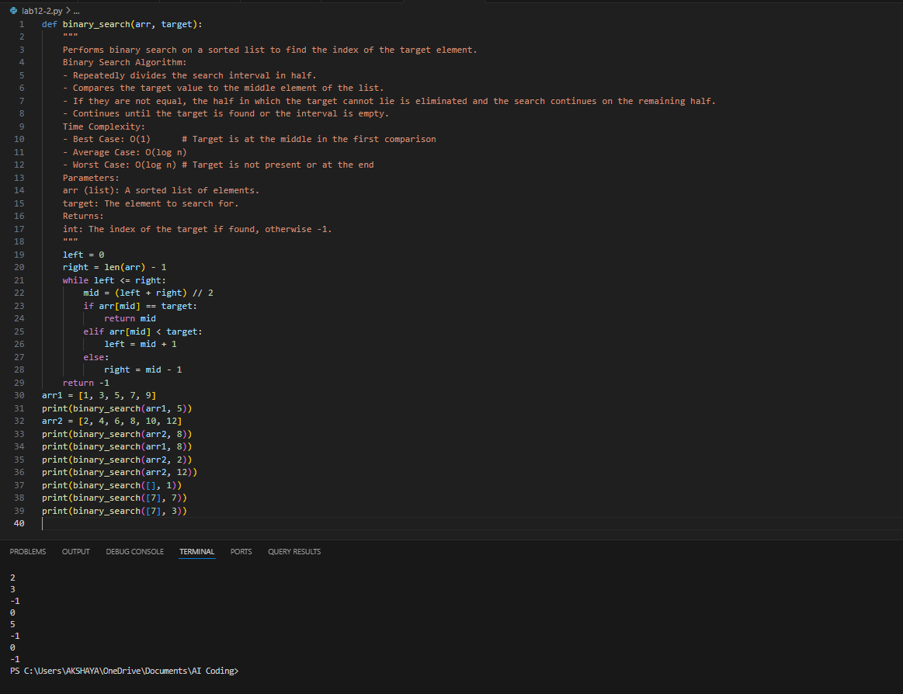  Observation:This Binary Search implementation works as expected, dividing the list to quickly find targets. It correctly identifies elements (e.g., index 2 for 5 in [1, 3, 5, 7, 9]) and returns -1 for absent values. It also manages edge cases properly, with O(log n) efficiency in general.  Task Description #3 (Real-Time Application – Inventory Management System)  - Scenario: A retail store’s inventory system contains thousands of products, each with attributes like product ID, name, price, and stock quantity. Store staff need to:  - Quickly search for a product by ID or name.  - Sort products by price or quantity for stock analysis.  - Task:  - Use AI to suggest the most efficient search and sort algorithms for this use case.  - Implement the recommended algorithms in Python.  - Justify the choice based on dataset size, update frequency, and performance requirements.  - Expected Output:  - A table mapping operation → recommended algorithm → justification.  - Working Python functions for searching and sorting the inventory.  Prompt: Design a Python program for managing a retail inventory containing thousands of products (with fields like ID, name, price, and quantity). Implement efficient search and sorting algorithms suitable for this dataset, considering factors such as data size, update frequency, and performance. Include functions that accept dynamic user input for adding and retrieving product details. Justify why the chosen algorithms are appropriate for this scenario, and demonstrate the program with sample inputs  Code:  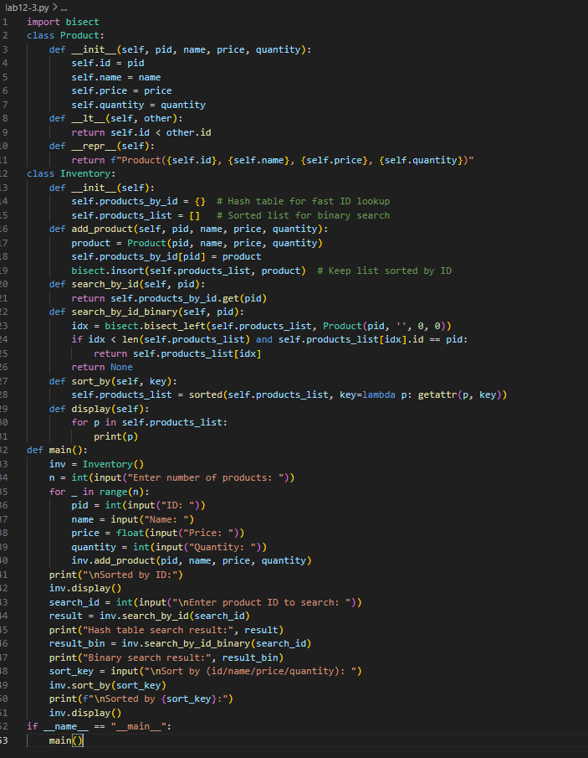  Observation: The inventory system combines a hash table and a sorted list to balance speed and flexibility. Hashing enables instant ID lookups, while binary search and sorting functions allow efficient queries by attributes like name, price, or quantity. The design ensures accurate results with strong performance.  ✅ Deliverables (For All Tasks)  - AI-generated prompts for code and test case generation.  - At least 3 assert test cases for each task.  - AI-generated initial code and execution screenshots.  - Analysis of whether code passes all tests.  - Improved final version with inline comments and explanation.  - Compiled report (Word/PDF) with prompts, test cases, assertions, code, and output. |  |  |  |  |  | Week6 - Monday

