SCHOOL OF COMPUTER SCIENCE AND ARTIFICIAL INTELLIGENCE |  |  |  |  | DEPARTMENT OF COMPUTER SCIENCE ENGINEERING
ProgramName:B. Tech |  |  |  | Assignment Type: Lab |  |  | AcademicYear:2025-2026
CourseCoordinatorName |  |  |  | Venkataramana Veeramsetty
Instructor(s)Name |  |  |  | Dr. V. Venkataramana (Co-ordinator)  Dr. T. Sampath Kumar  Dr. Pramoda Patro  Dr. Brij Kishor Tiwari  Dr.J.Ravichander  Dr. Mohammand Ali Shaik  Dr. Anirodh Kumar  Mr. S.Naresh Kumar  Dr. RAJESH VELPULA  Mr. Kundhan Kumar  Ms. Ch.Rajitha  Mr. M Prakash  Mr. B.Raju  Intern 1 (Dharma teja)  Intern 2 (Sai Prasad)  Intern 3 (Sowmya)  NS_2 ( Mounika)
CourseCode |  |  | 24CS002PC215 | CourseTitle |  | AI Assisted Coding
Year/Sem |  |  | II/I | Regulation |  | R24
Date and Day  of Assignment |  |  | Week4 - Wednesday | Time(s)
Duration |  |  | 2 Hours | Applicableto  Batches
AssignmentNumber:9.3(Present assignment number)/24(Total number of assignments)
 | Q.No. | Question |  |  |  |  |  | ExpectedTime  to complete
 | 1 | Lab 8: Documentation Generation: Automatic documentation and code comments  Lab Objectives:  - To understand the importance of documentation and code comments in software development.  - To explore how AI-assisted coding tools can generate meaningful documentation and inline comments.  - To practice generating function-level and module-level docstrings automatically.  - To evaluate the quality, accuracy, and limitations of AI-generated documentation.  - To develop a small automated tool for documentation generation in Python..  Lab Outcomes (LOs):  After completing this lab, students will be able to:  - Apply AI-assisted coding tools to generate docstrings and inline comments for Python code.  - Critically analyze AI-generated documentation for correctness, completeness, and readability.  - Create structured documentation (function-level, module-level) following standard formats.  - Design and implement a mini documentation generator tool to automate code commenting and docstring creation.  Task Description#1 Basic Docstring Generation  - Write python function to return sum of even and odd numbers in the given list.  - Incorporate manual docstring in code with Google Style  - Use an AI-assisted tool (e.g., Copilot, Cursor AI) to generate a docstring describing the function.  - Compare the AI-generated docstring with your manually written one.  Expected Outcome#1: Students understand how AI can produce function-level documentation  PROMPT: Code a python program to calculate the sum of even and odd in the given list(dynamic) user input ,using python function.(manual documentation)  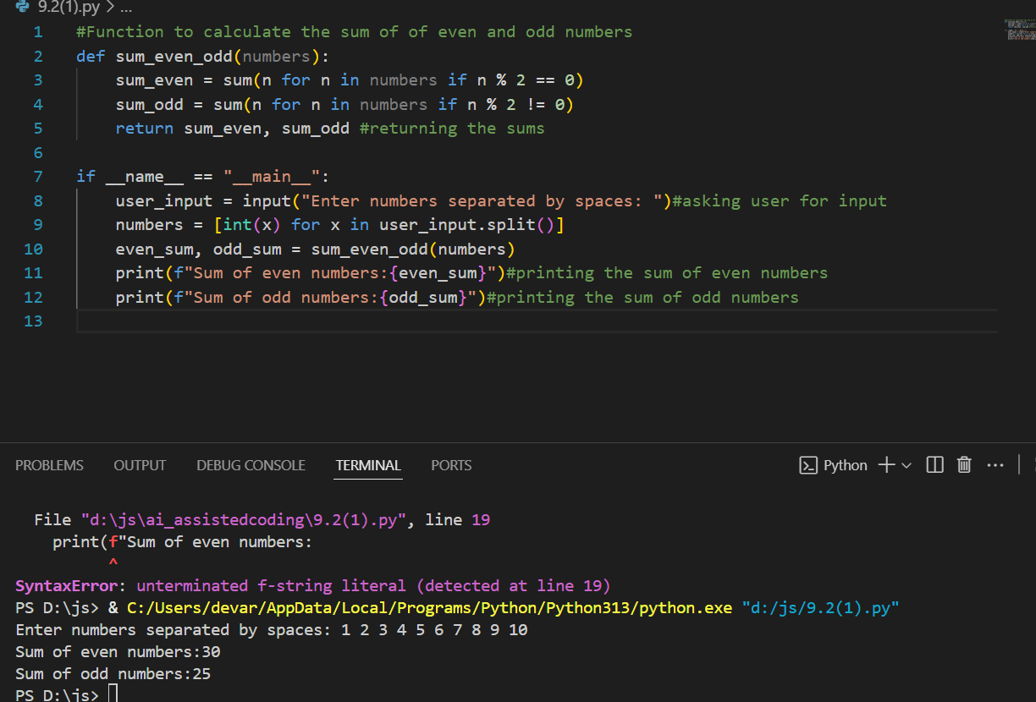  AI GENERATED DOCUMENTATION:  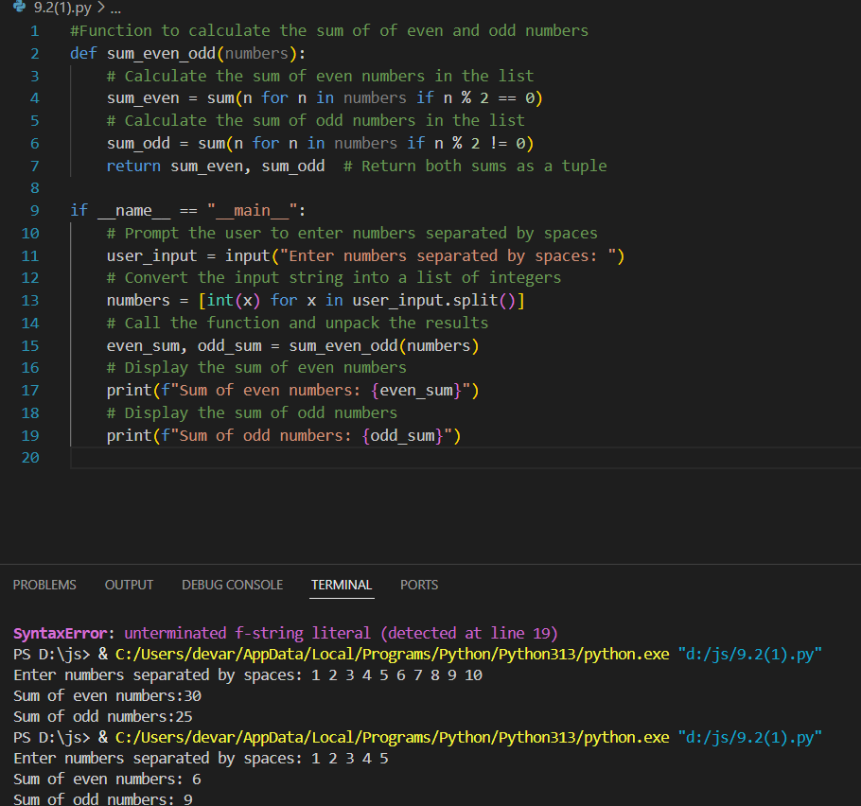  OBSERVATION:  The manually written Google-style docstring is more structured, and more instructive than the AI-generated one. It clearly states the function’s purpose, explains the logic in plain language, and in a shorter way. This makes it easily understandable, especially for the one’s who don’t know how to code. The AI-generated docstring, while concise, increases error handling, and detailed context, making it less useful for onboarding or debugging. The manual version also adheres strictly to Google Style formatting, ensuring consistency and readability. Overall manual docstring is the better one as compared to the ai docstring because of the shorter and understandable commenting.But the AI documentation is in more precised way .  Task Description#2 Automatic Inline Comments  - Write python program for sru_student class with attributes like name, roll no., hostel_status and fee_update method and display_details method.  - Write comments manually for each line/code block  - Ask an AI tool to add inline comments explaining each line/step.  - Compare the AI-generated comments with your manually written one.  Expected Output#2: Students critically analyze AI-generated code comments.  PROMPT:Write program for sru_student class with attributes like name, roll no., hostel_status and fee_update method and display_details method(user input).  MANUAL DOCUMENTATION:  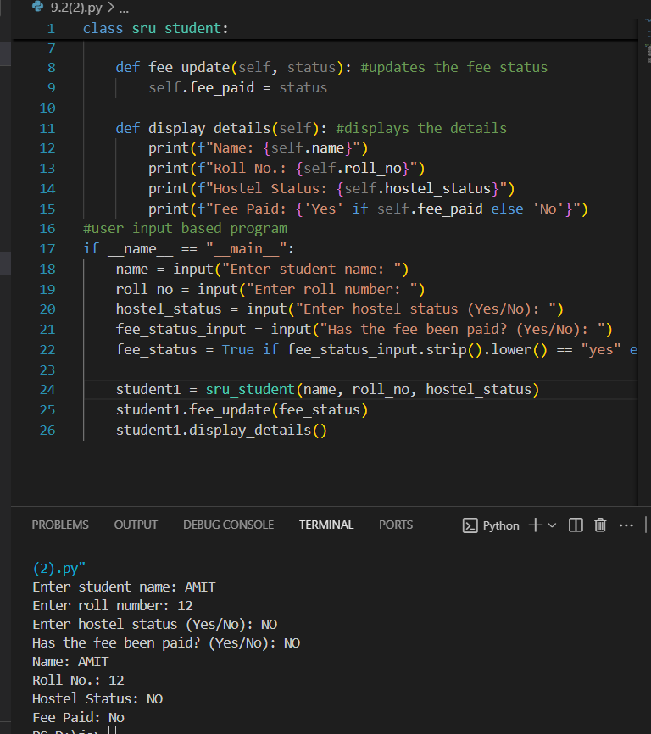  AI GENERATED DOCUMENTATION:  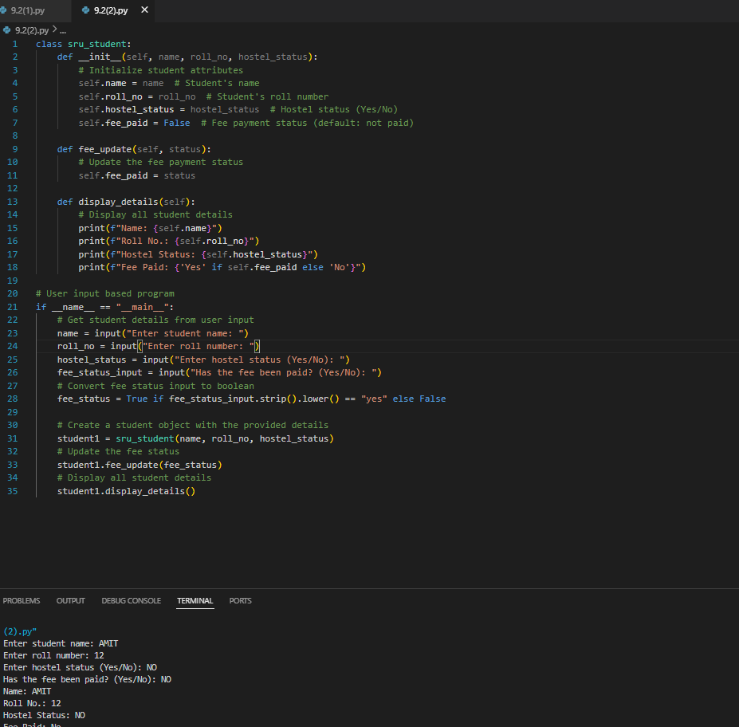  OBSERVATION:  As the AI generated documentation is more detailed manner, it adds documentation for every line of the code and it is in more professional way whereas the manually documented one is in shorter way and it comments only the important lines of the code it is not in professional way but it is easily understandable as compared to AI one.  Task Description#3  - Write a Python script with 3–4 functions (e.g., calculator: add, subtract, multiply, divide).  - Incorporate manual docstring in code with NumPy Style  - Use AI assistance to generate a module-level docstring + individual function docstrings.  - Compare the AI-generated docstring with your manually written one.  Expected Output#3: Students learn structured documentation for multi-function scripts  PROMPT:Write a Python script that defines a simple calculator with 4 functions: add, subtract, multiply, and divide. (user based input) no documentation  MANUALLY DOCUMENTED:  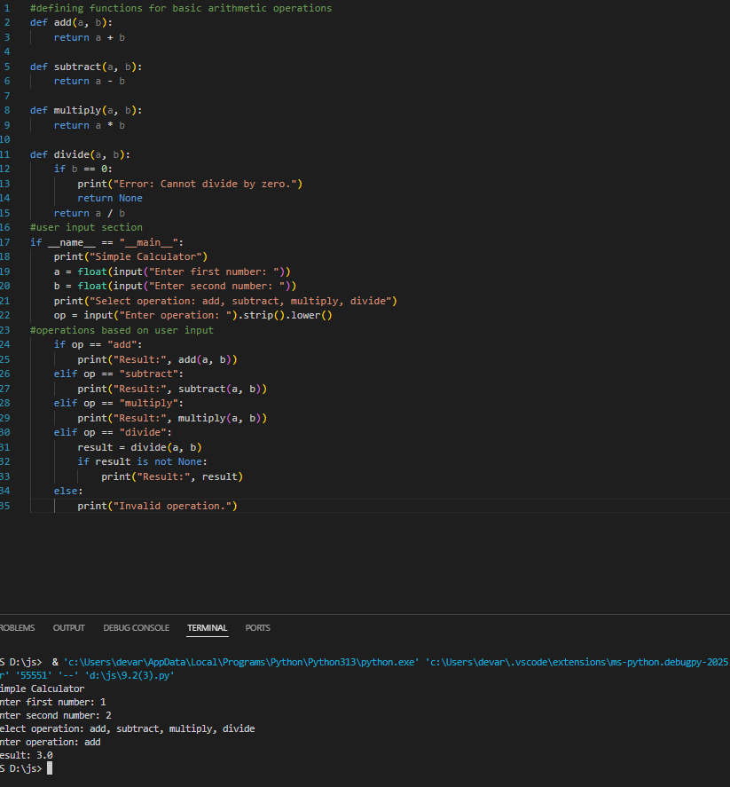  AI GENERATED DOCUMENTATION(NUMPY STYLE):  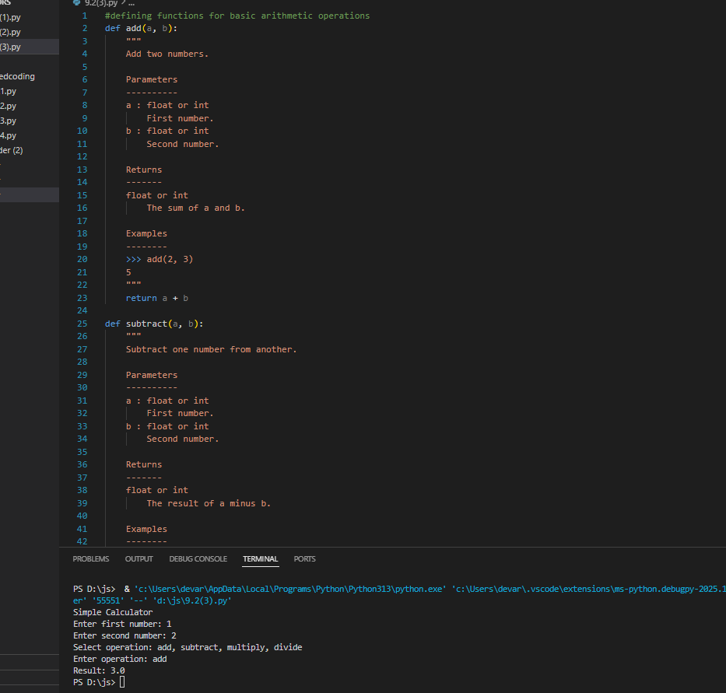  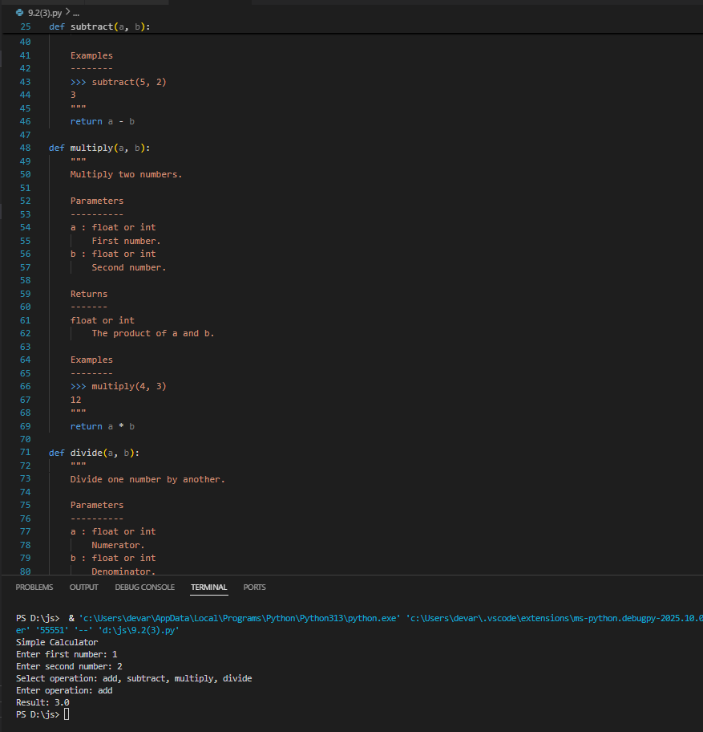  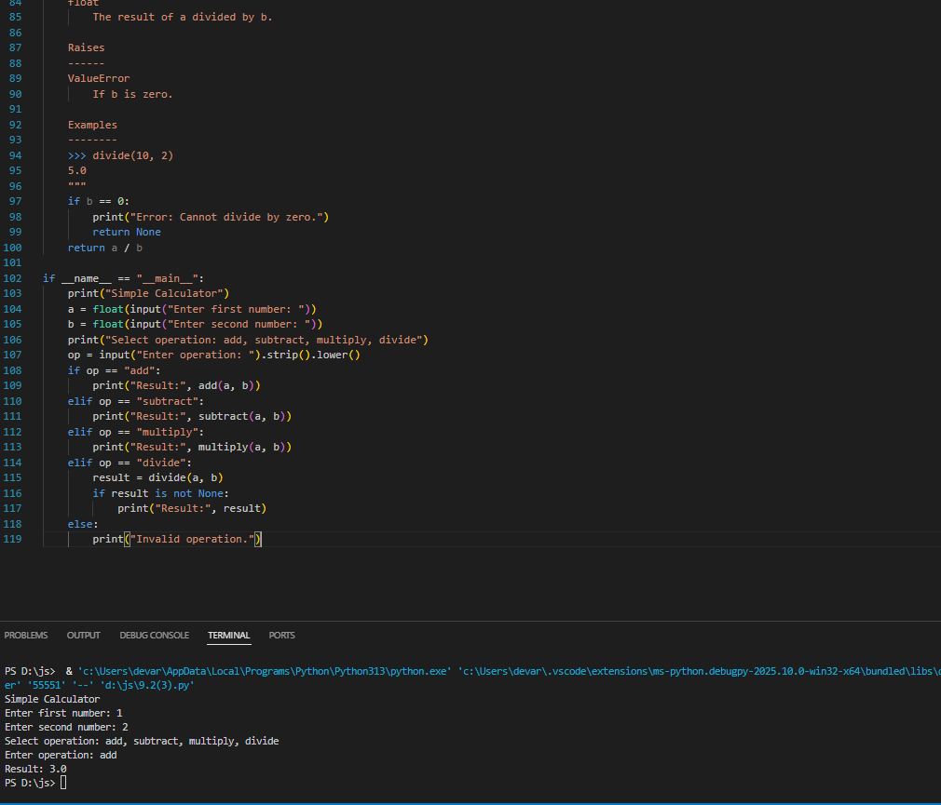  OBSERVATION:  In this task we have done two documentations: 1. Numpy style documentation which is more precised way line by line documented one.  Whereas the other one is manually documented one it highlights only the important lines of the code.  Push documentation whole workspace as .md file in GitHub Repository  Note: Report should be submitted a word document for all tasks in a single document with prompts, comments & code explanation, and output and if required, screenshots. |  |  |  |  |  | Week4 - Wednesday

