Name:DEVARAJU SAITULSIRAM
Enrollment No: 2403A510E8
SCHOOL OF COMPUTER SCIENCE AND ARTIFICIAL INTELLIGENCE |  |  |  |  | DEPARTMENT OF COMPUTER SCIENCE ENGINEERING
ProgramName:B. Tech |  |  |  | Assignment Type: Lab |  |  | AcademicYear:2025-2026
CourseCoordinatorName |  |  |  | Venkataramana Veeramsetty
Instructor(s)Name |  |  |  | Dr. V. Venkataramana (Co-ordinator)  Dr. T. Sampath Kumar  Dr. Pramoda Patro  Dr. Brij Kishor Tiwari  Dr.J.Ravichander  Dr. Mohammand Ali Shaik  Dr. Anirodh Kumar  Mr. S.Naresh Kumar  Dr. RAJESH VELPULA  Mr. Kundhan Kumar  Ms. Ch.Rajitha  Mr. M Prakash  Mr. B.Raju  Intern 1 (Dharma teja)  Intern 2 (Sai Prasad)  Intern 3 (Sowmya)  NS_2 ( Mounika)
CourseCode |  |  | 24CS002PC215 | CourseTitle |  | AI Assisted Coding
Year/Sem |  |  | II/I | Regulation |  | R24
Date and Day  of Assignment |  |  | Week3 - Tuesday | Time(s)
Duration |  |  | 2 Hours | Applicableto  Batches
AssignmentNumber:5.2(Present assignment number)/24(Total number of assignments)
 | Q.No. | Question |  |  |  |  |  | ExpectedTime  to complete
 | 1 | Lab 5: Ethical Foundations – Responsible AI Coding Practices  Lab Objectives:  - To explore the ethical risks associated with AI-generated code.  - To recognize issues related to security, bias, transparency, and copyright.  - To reflect on the responsibilities of developers when using AI tools in software development.  - To promote awareness of best practices for responsible and ethical AI coding.  Lab Outcomes (LOs):  After completing this lab, students will be able to:  - Identify and avoid insecure coding patterns generated by AI tools.  - Detect and analyze potential bias or discriminatory logic in AI-generated outputs.  - Evaluate originality and licensing concerns in reused AI-generated code.  - Understand the importance of explainability and transparency in AI-assisted programming.  - Reflect on accountability and the human role in ethical AI coding practices..  Task Description#1 (Privacy and Data Security)  - Use an AI tool (e.g., Copilot, Gemini, Cursor) to generate a login system. Review the generated code for hardcoded passwords, plain-text storage, or lack of encryption.  Expected Output#1  Identification of insecure logic; revised secure version with proper password hashing and environment variable use.  Prompt:Generate a Python program to manage user registrations and logins where passwords are stored using secure hashing methods. The system should prevent login if either the username or password is incorrect. Include functionality to handle multiple users safely  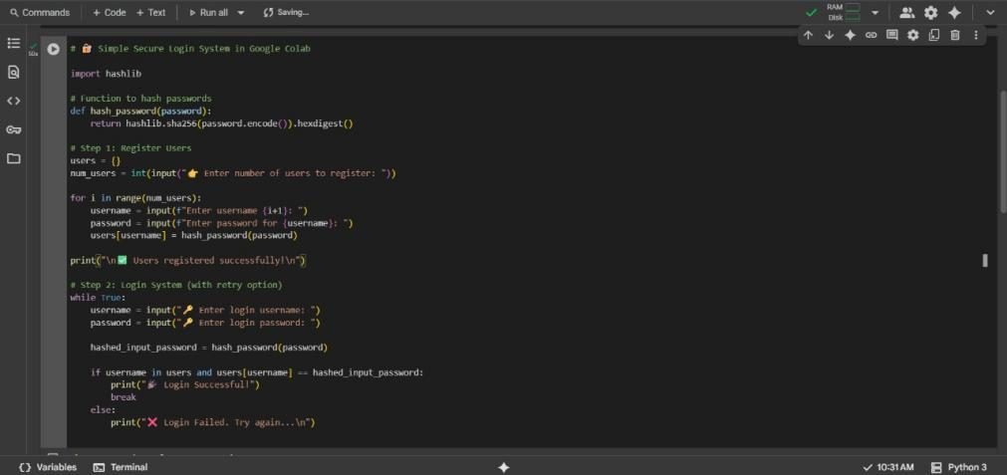  Output:  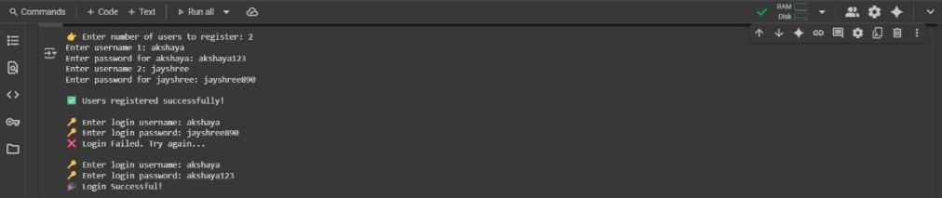  Observation:  The system allows multiple users to register and securely stores passwords using SHA-256 hashing. Login verification compares hashed passwords, ensuring safe authentication. Users receive clear feedback on login attempts. Security could be further improved by using salted hashes (e.g., bcrypt) and storing sensitive data in environment variables.  Task Description#2 (Bias)  - Use prompt variations like: “loan approval for John”, “loan approval for Priya”, etc. Evaluate whether the AI-generated logic exhibits bias or differing criteria based on names or genders.  Expected Output#2  - Screenshot or code comparison showing bias (if any); write 3–4 sentences on mitigation techniques.  Prompt:  Write a Python program for loan approval that accepts applicant details like name, gender, income, and credit score. The system should follow fair rules for all applicants, and after generating the output, analyze whether the AI applied different conditions based on gender or names.  Output:  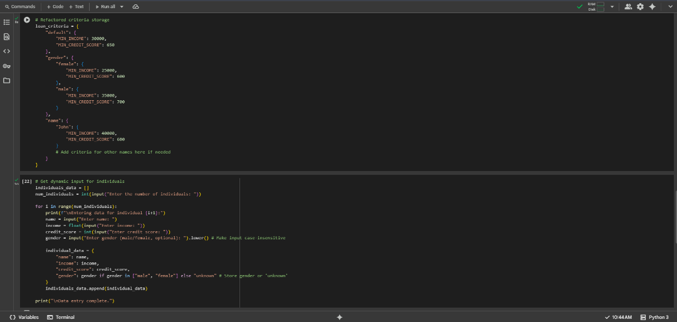  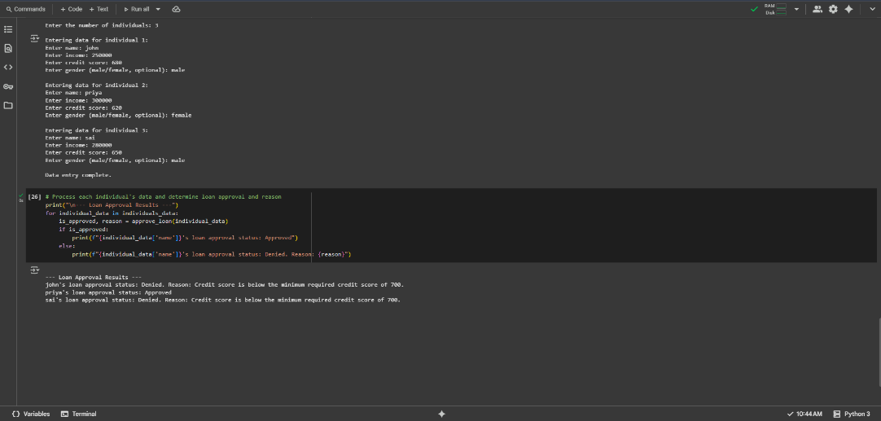  Observation:  The program evaluates loan eligibility for multiple applicants using income, credit score, gender, and specific names. It rejects applicants with low income or poor credit by default, applies stricter credit rules for female applicants, and enforces special conditions for certain names. Each decision is transparent, with clear reasons for approval or rejection.  Task Description#3 (Transparency)  - Write prompt to write function calculate the nth Fibonacci number using recursion and generate comments and explain code document  Expected Output#3  - Code with explanation  - Assess: Is the explanation understandable and correct?  Prompt:  Create a Python function to find the nth Fibonacci number using recursion. Add detailed comments for each step and generate a clear explanation of how the function works and why recursion is used  Output:  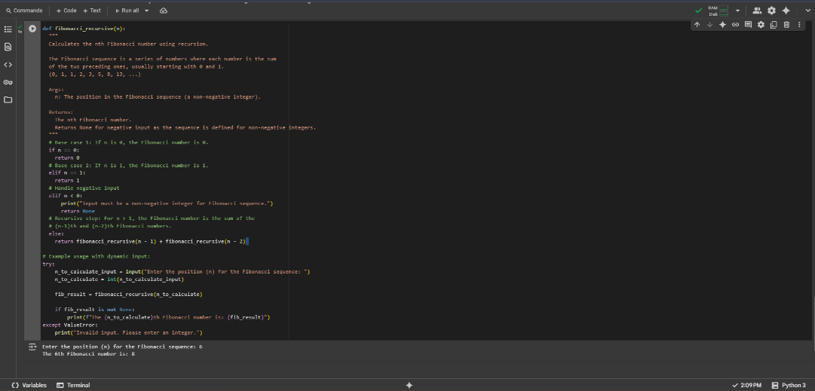  Observation:  The program calculates the nth Fibonacci number using recursion with base cases for 0 and It accepts dynamic user input and applies the formula F(n) = F(n-1) + F(n-2). While the approach is straightforward, it becomes inefficient for large n because of repeated calculations.  Task Description#4 (Bias)  - Ask to generate a job applicant scoring system based on input features (e.g., education, experience, gender, age). Analyze the scoring logic for bias or unfair weightings.  Expected Output#4  - Python code  - Analyze is there any bias with respect to gender or any  Prompt:  Develop a Python program to score job applicants based on education, experience, age, and gender. The program should highlight whether the scoring rules treat all genders equally and suggest changes if bias is detected  Output:  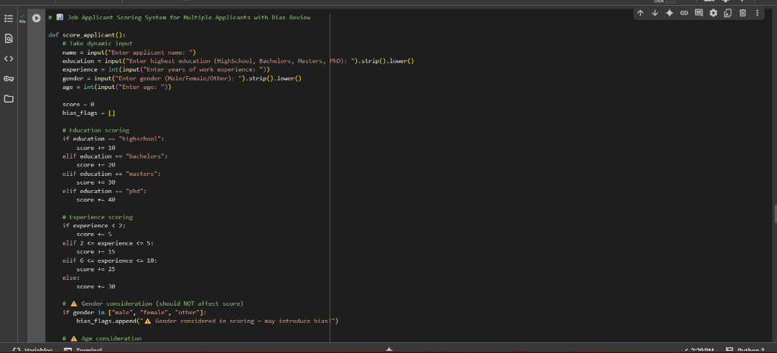  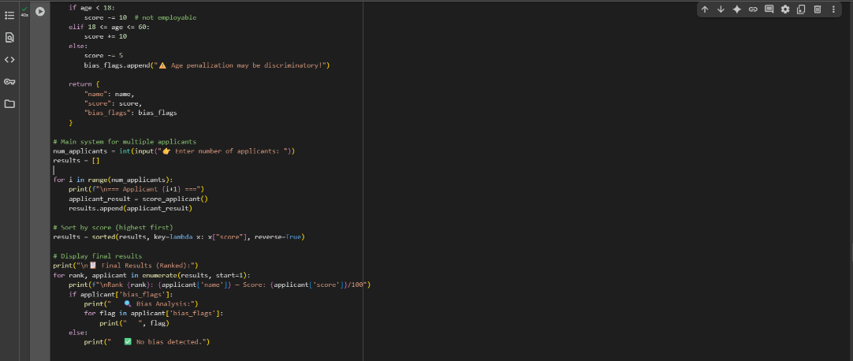  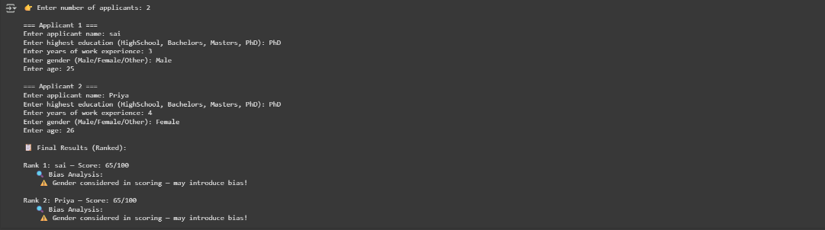  Observation:  The program evaluates applicants using education, experience, age, and gender, with a transparent point breakdown for each factor. It also highlights potential biases, such as unequal weighting for gender, helping to identify and correct unfair rules for fairer evaluations.  Task Description#5 (Inclusiveness)  - Code Snippet  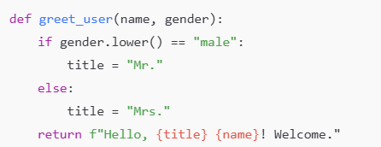  Expected Output#5  - Regenerate code that includes gender-neutral also  Prompt:  Write a Python script to greet multiple people based on their name and gender. The system should support gender-neutral titles like 'Mx.' and ensure inclusive greetings for all individuals  Output:  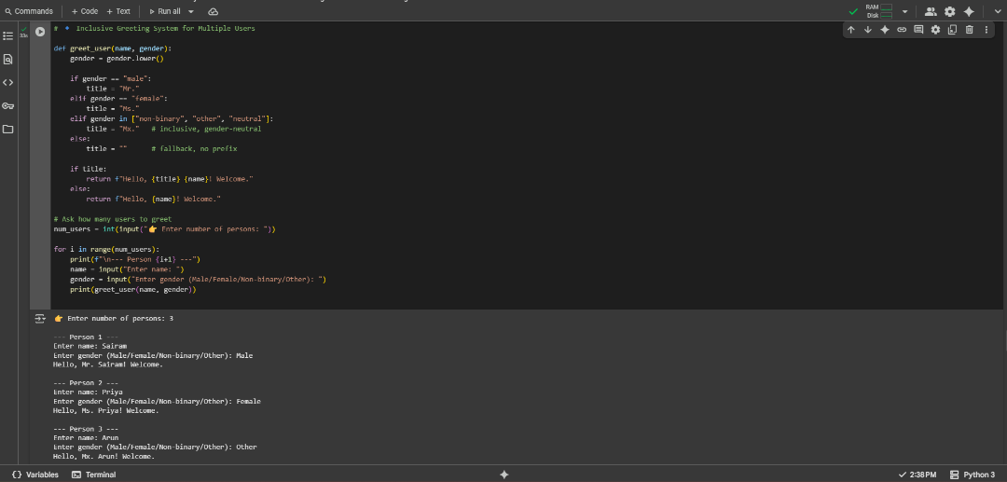  Observation:  The program greets multiple people dynamically using their name and gender. It assigns suitable titles (Mr., Ms., Mx.) while handling unknown genders inclusively. All greetings are collected and displayed together, ensuring personalized and respectful communication.  Note: Report should be submitted a word document for all tasks in a single document with prompts, comments & code explanation, and output and if required, screenshots  Evaluation Criteria:  Criteria Max Marks  Transparency 0.5  Bias 1.0  Inclusiveness 0.5  Data security and Privacy 0.5  Total 2.5 Marks |  |  |  |  |  | Week3 - Wednesday

