Auto-Lab-3.R

saiup

2022-10-07

library(ggplot2)  
library(tidyverse)

## ── Attaching packages ─────────────────────────────────────── tidyverse 1.3.2 ──  
## ✔ tibble 3.1.8 ✔ dplyr 1.0.10  
## ✔ tidyr 1.2.1 ✔ stringr 1.4.1   
## ✔ readr 2.1.2 ✔ forcats 0.5.2   
## ✔ purrr 0.3.4   
## ── Conflicts ────────────────────────────────────────── tidyverse_conflicts() ──  
## ✖ dplyr::filter() masks stats::filter()  
## ✖ dplyr::lag() masks stats::lag()

library(ISLR2)  
library(lmtest)

## Loading required package: zoo  
##   
## Attaching package: 'zoo'  
##   
## The following objects are masked from 'package:base':  
##   
## as.Date, as.Date.numeric

mpg_regression <- lm(mpg ~ horsepower, data = Auto)  
mg_regressionResids <- mpg_regression$residuals  
mpg_regressionFitted <- mpg_regression$fitted.values  
plot(mpg_regressionFitted, mg_regressionResids)

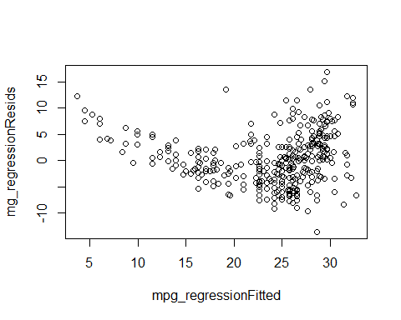

qqnorm(mg_regressionResids)

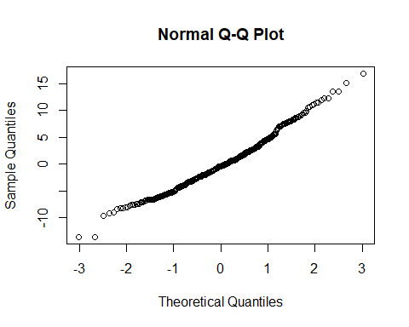

horsepower <- lm(horsepower~weight, data = Auto)  
horsepoweResids <- horsepower$residuals  
horsepowerFitted <- horsepower$fitted.values  
plot(horsepowerFitted, horsepoweResids)

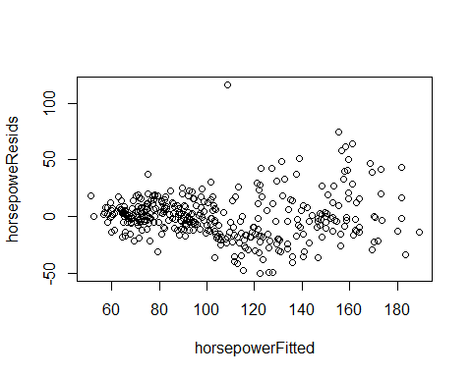

qqnorm(horsepoweResids)

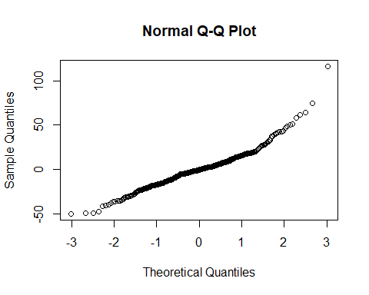

horsepower <- lm(horsepower~origin, data = Auto)  
horsepoweResids <- horsepower$residuals  
horsepowerFitted <- horsepower$fitted.values  
plot(horsepowerFitted, horsepoweResids)

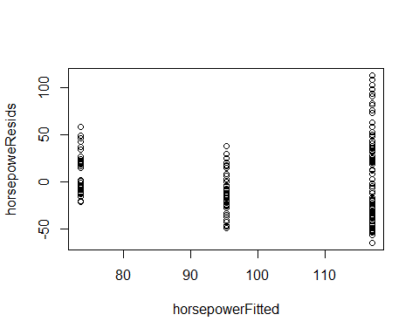

qqnorm(horsepoweResids)

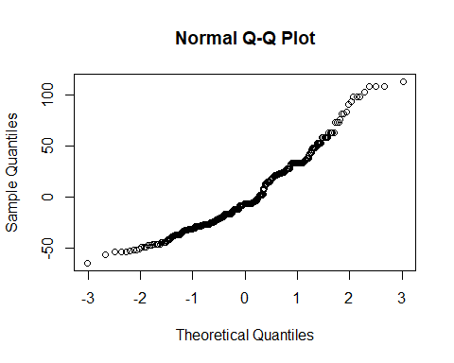

horsepower <- lm(horsepower~cylinders, data = Auto)  
horsepoweResids <- horsepower$residuals  
horsepowerFitted <- horsepower$fitted.values  
plot(horsepowerFitted, horsepoweResids)

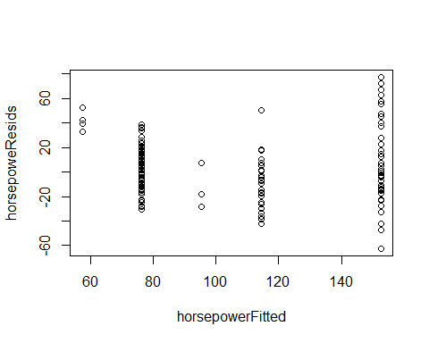

qqnorm(horsepoweResids)

