**ITIL foundation:** Information Technology Infrastructure Library

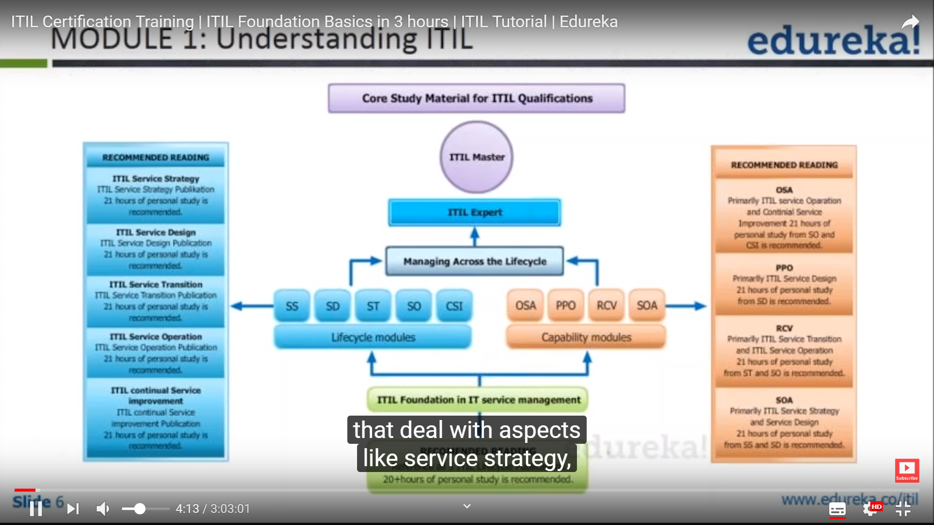

**Understanding ITIL- understand customer,ensure tailor your services to customer with optimal cost and minimal risk.**

Service improvement,

Delivers value to customer

Business strategy and customer needs**, services it sells, business strategy and customer** needs, 3 spokes integrated.

Measures monitor and optimises IT services

Manages IT investment and budget Risk, knowledge and capabilities

Standard approach across the enterprise

Improves interaction and relationship with customer

Optimizes and reduces cost

**Structure**

**Strategy**

**Design**

**Transition**

**Operations**

**Continual service improvement**

**Service management:** set of organisational capabilities for providing value to customers in the form of services.

Functions are series of processes/ activity or combination

**Service**

**Process**

**Function**

**Need :**

User expectations evolves

Business and technology changes

Competition forces org to push service barriers.

If service is goal, what you do to achieve it is the process

Touch points in SMLC

Customer

User

Service provider

Supplier

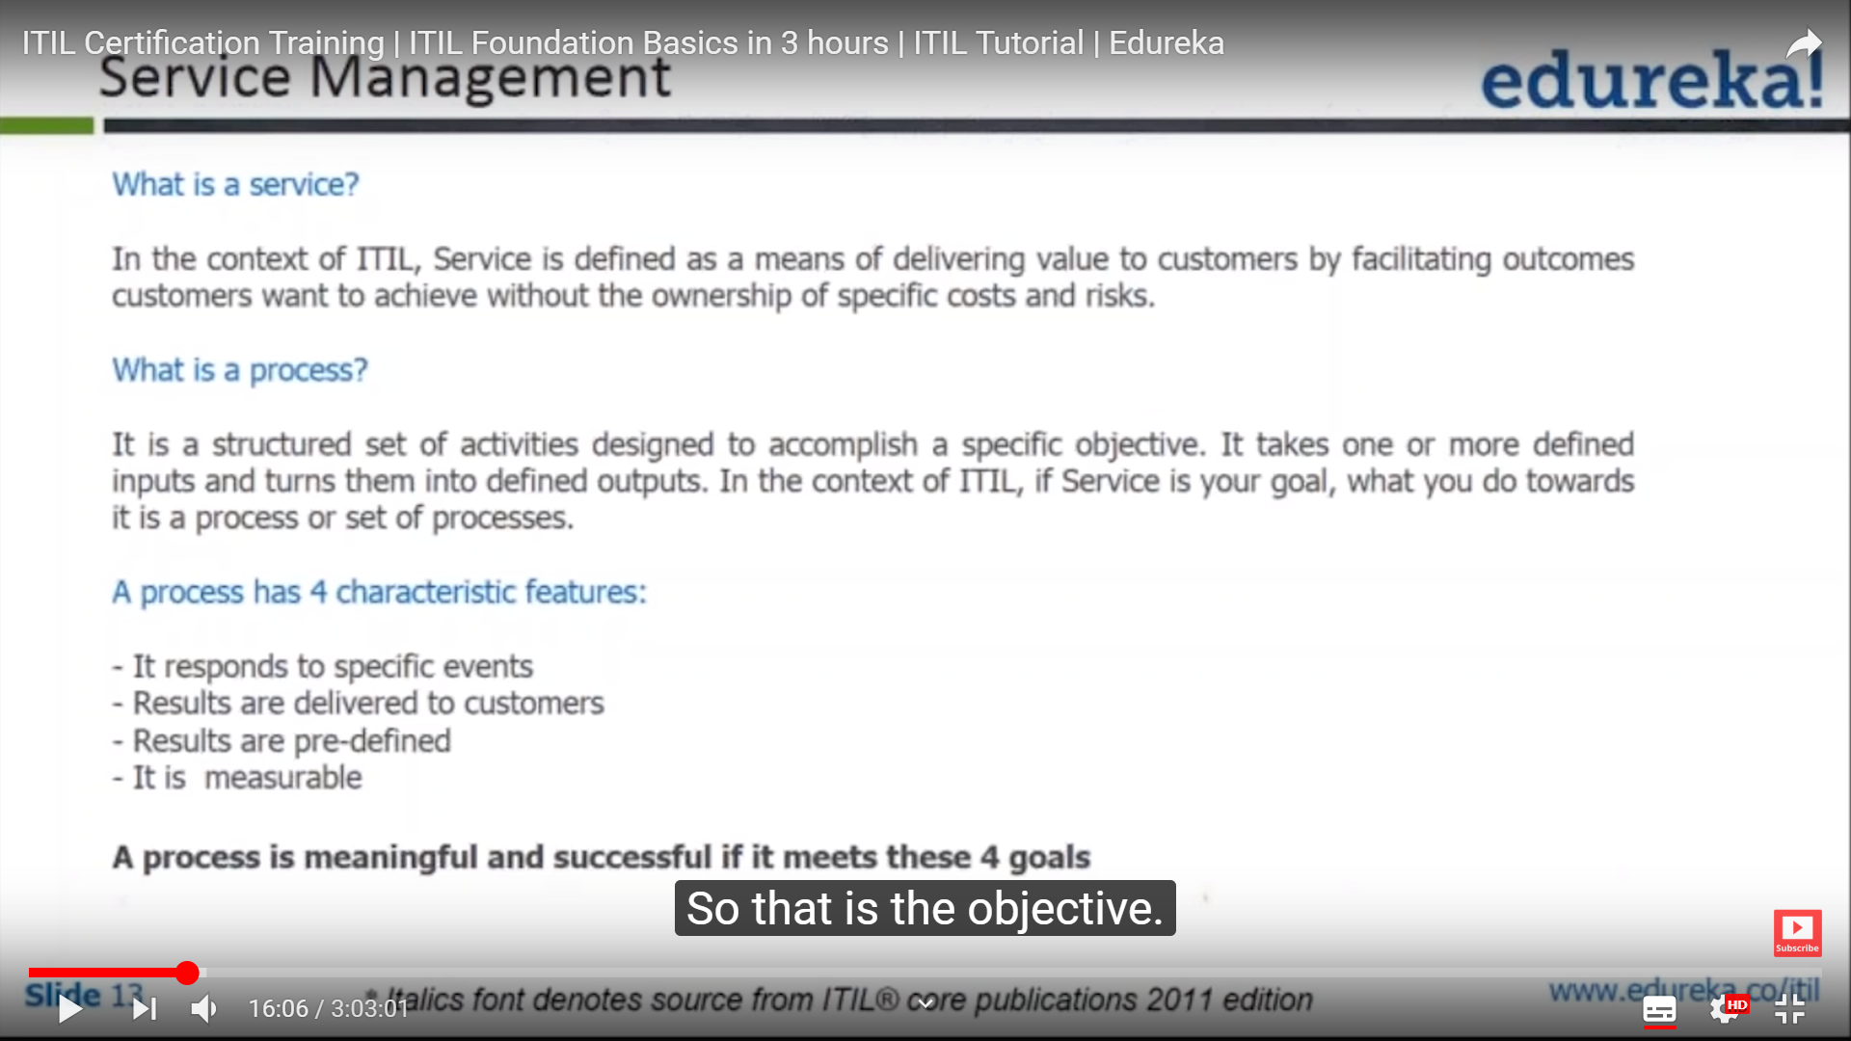

**RACI architecture – Responsible Accountable Consulted Informed**

Role is an authority given to a person or group to execute and activity.

Stakeholder are divided into process owner, practitioner and manager

**Process owner** – role is to design, develop and document processes that are aimed at new business objective.

Owns a delivery process, sponsor, design change management taking care of issues during execution phase, teams are put in and providing resources, measuring thru metrics

**Process practitioner - mu**ltiple processes within one particular activity.  
practical knowledge of process designed and operation

Thorough understanding of the process end to end

**Process manager –** operations of process in areas of planning and coordination.

Carry, monitor and report on the performance of process

Many process managers in and org

**Service owner -** after implementation is done initiation and ongoing support to customer ,accountable for specific delivery of a service either to service manager /director .

Handover from Business relationship manager to ensure service delivered meet the customer requirement.

Represents CAB

SLA,OLA negotiation.

Recommends process improvement

