A Project Report on

DISSECTING THE DIGITAL LANDSCAPE:

A comprehensive Analysis of social media.

**by**

**TEAM LEADER : GANTHI SAI VAMSI (20AT1A05C9)**

**STUDENT 1 : YEDDULA SIVA KUMAR(20AT1A05E6)**

**STUDENT 2 : L UDAY KIRAN (20AT1A05H7)**

**STUDENT 3 : L SUJITH(20AT1A05G2)**

**STUDENT 5 : PUTTA SUBBA REDDY (20AT1A05G0)**

**Under the Guidance of**

**MRS.M. JAYA SUNITHA, MTech**

**Associate Professor**



**DEPARTMENT OF COMPUTER SCIENCE ENGINEERING**

**G. PULLAIAH COLLEGE OF ENGINEERING AND TECHNOLOGY**

**(Autonomous)**

(Approved by AICTE | NAAC Accreditation with ‘A’ Grade | Accredited by NBA (ECE, CSE, EEE, CE) |

Permanently Affiliated to JNTUA)

ABSTRACT

Social media platform provides a wealth of information about customer behavior, preferences, and interests. Without social media analysis, businesses may miss out an opportunity to better understand their target audience and make data driven decisions. Social media data provides valuable insights for better understanding of Customers, Improved Marketing Effectiveness, Competitive Analysis. Product and Services Devolopment.This project provides a detailed and in depth analysis of various social media platforms, including Facebook, Instagram, google,twitter,youtube and LinkedIn. The

Analysis covers a wide range of analysis about topics related to social media. Such as the history and evolution of social media, the demographics of social media on communication and society and the challenges and opportunities of social media for businesses and organizations.

This paper presents a literature review of empirical research related to the use and effects of social media in higher education settings. The adoption of social media has been steadily increasing. However, a majority of the research reported focuses on students’ perception on the effects of social media in learning. The research on the effects of social media on student learning and faculty perspectives are still limited. This literature review focused on the empirical studies that involved the use of social media in higher education in the computing field. Recommendations for future research directions were presented as the result of this literature review.

**Contents**

**Abstract** 2

**Contents** 3

**List of Figures and Tables** 4

**CHAPTER 1 INTRODUCTION 4**

**CHAPTER 2 LITERATURE REVIEW 5**

**CHAPTER 3 PROPOSED METHOD 6**

**CHAPTER 4 EXPERIMENTAL RESULTS 7-9**

**CHAPTER 5 APPLICATIONS/ADVANTAGES 10-11**

**CHAPTER 6 CONCLUSIONS & FUTURE SCOPE 12**

**LIST OF FIGURES AND** **TABLES**

Database collected from IBM cogon’s about the DISSECTING THE DIGITAL LANDSCAPE: A comprehensive Analysis of social media.

**CHAPTER 1**

**INTRODUCTION**

Social media platform provides a wealth of information about customer behavior, preferences, and interests. Without social media analysis, businesses may miss out an opportunities to better understand their target audience and make data driven decisions. Social media data provides valuable insights for better understanding of Customers, Improved Marketing Effectiveness, Competitive Analysis. Product and Services Devolopment.This project provides a detailed and in depth analysis of various social media platforms, including facebook,Instagram,google,twitter,youtube and LinkedIn. The

Analysis covers a wide range of analysis about topics related to social media. Such as the history and evolution of social media, the demographics of social media on communication and society and the challenges and opportunities of social media for businesses and organizations

**What is social media?**

Social media is an internet-based form of communication. Social media platforms allow users to have conversations, share information and create web content. There are many forms of social media, including blogs, micro-blogs, wikis, social networking sites, photo-sharing sites, instant messaging, video-sharing sites, podcasts, widgets, virtual worlds, and more.

**What are the benefits of using social media?**

Billions of people around the world use social media to share information and make connections. On a personal level, social media allows you to communicate with friends and family, learn new things, develop your interests, and be entertained. On a professional level, you can use social media to broaden your knowledge in a particular field and build your professional network by connecting with other professionals in your industry. At the company level, social media allows you to have a conversation with your audience, gain customer feedback, and elevate your brand.

**CHAPTER 2**

**LITERATURE REVIEW**

* In today’s digital environment businesses face the challenge of effectively utilizing social media platforms for marketing purposes. To overcome this challenge, a comprehensive analysis of digital landscape is needed to maximize social media marketing strategies.
* Various Business Problems are.
* Insufficient measurement and analytics.
* Inefficient Resource allocation
* Poor Audience Targeting
* Platform Selection
* Unclear Objectives
* Limited Awareness
* The popularity of social media sites has been steadily increasing over the last few years, and over 70 % of online adults are now using a social networking site of some kind. Many users of social networking sites have more than one account, and check these accounts several times daily [[6](https://link.springer.com/chapter/10.1007/978-3-319-20367-6_11#ref-CR6)]. But even as social media has been widely adopted by many users, its use for higher education has also been questioned by educators. Although faculty in higher education often utilizes social networking sites in a professional context, many are reluctant to use social networking sites for teaching and learning. Moreover, even though computing faculty members may have more experience with the technology, their adoption of social media for teaching purpose has been at a lower rate comparing to faculty in other fields such as Humanities and Arts, Professions and Applied Sciences, and Social Sciences [[6](https://link.springer.com/chapter/10.1007/978-3-319-20367-6_11#ref-CR6), [20](https://link.springer.com/chapter/10.1007/978-3-319-20367-6_11#ref-CR20)].
* Web 2.0 (often referred to as the “social web”), with its many benefits such as social networking and user-generated content, has drawn much attention for teaching and learning [[2](https://link.springer.com/chapter/10.1007/978-3-319-20367-6_11#ref-CR2)]. Learning paradigms have shifted over the last decades from a traditional classroom setting to include online learning, e-learning, collaborative learning, and many hybrid forms. This shift indicates a move from instructor-led and instructor-cantered learning environments to learner-cantered environments, which focus on knowledge creation and building rather than knowledge transmission [[3](https://link.springer.com/chapter/10.1007/978-3-319-20367-6_11#ref-CR3), [5](https://link.springer.com/chapter/10.1007/978-3-319-20367-6_11#ref-CR5)]. At first glance, Web 2.0 applications such as social networks, wikis, blogging, and micro blogging seem to be well suited for learner-cantered environments, but a closer look reveals that the adoption of Web 2.0 technologies and applications in higher education learning is lagging behind the adoption of Web 2.0 technologies overall. Although roughly 90 % of young adults (18-29 years old) use some social network site, many faculty members also see limitations and potential problems with the use of online and interactive technologies.

**CHAPTER 3**

**PROPOSED METHOD**

* How do businesses leverage social media for marketing and customer engagement?
* What are the advertising models and monetization strategies employed by social media platforms?
* How can businesses effectively reach and engage with their target audience through social media?
* Sentiment analysis: displays the sentiment of social media data, showing proportion of positive, negative and neutral sentiment in conversation.
* Heart Maps: displays geographic distribution of social media data, showing where Conversation and engagement are happening in real time. This can help to identify regional trends.

Customer Satisfaction:

* By analyzing the behavior of the user on the platform, business organizations target their customer based on their interests.

Business Model:

* By analyzing social media engagement and user behavior, business can optimize their advertising campaigns to reach their target audience more effectively.

Scalability of the Solution:

* Audience size and engagement metrics.
* Customer feedback.
* Competitor analysis.
* Market trends.
* Expanding production.
* Increasing marketing efforts.

**CHAPTER 4**

**EXPERIMENTAL RESULTS**

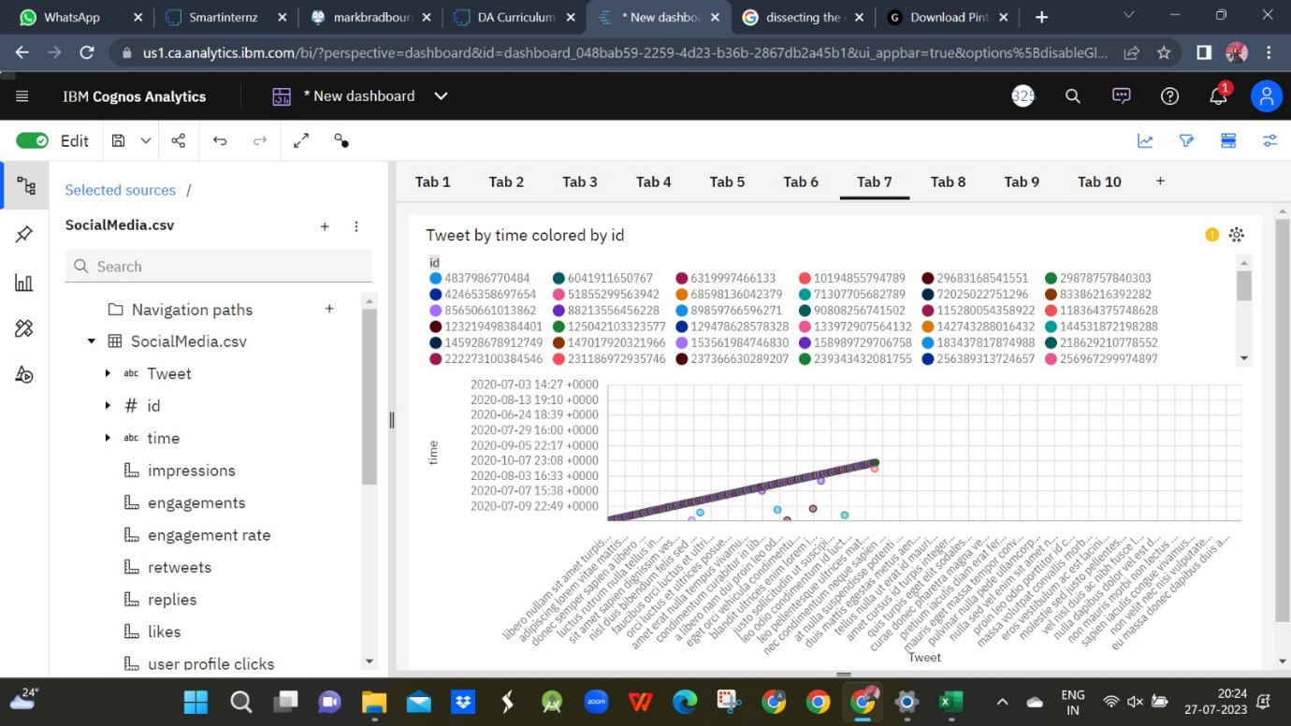

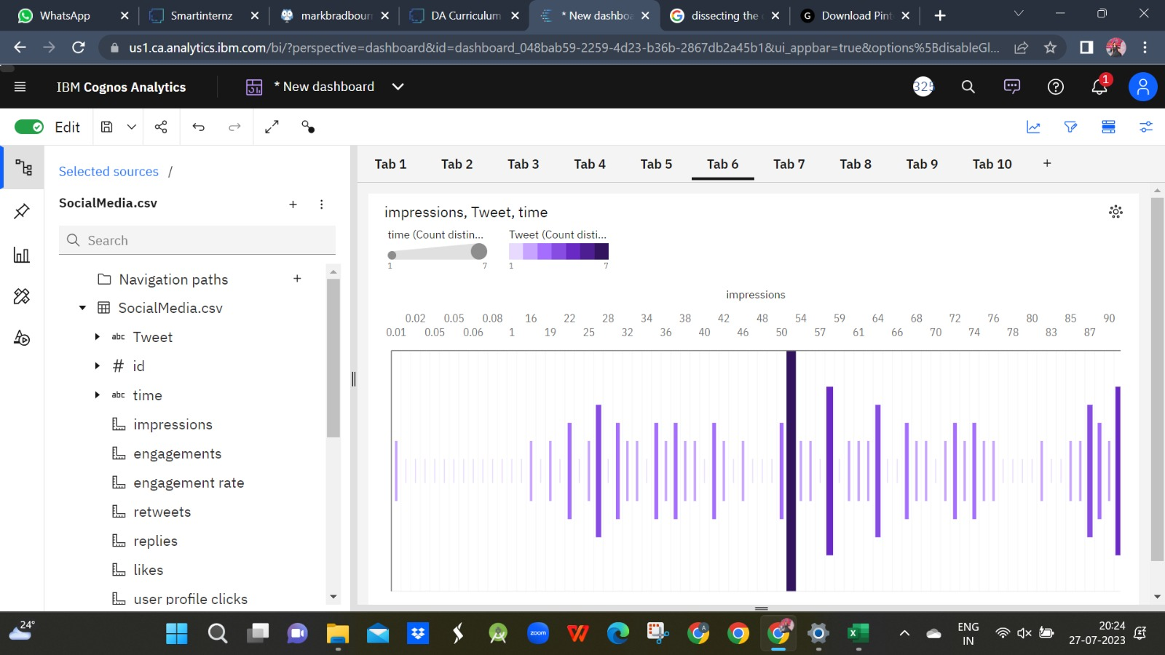

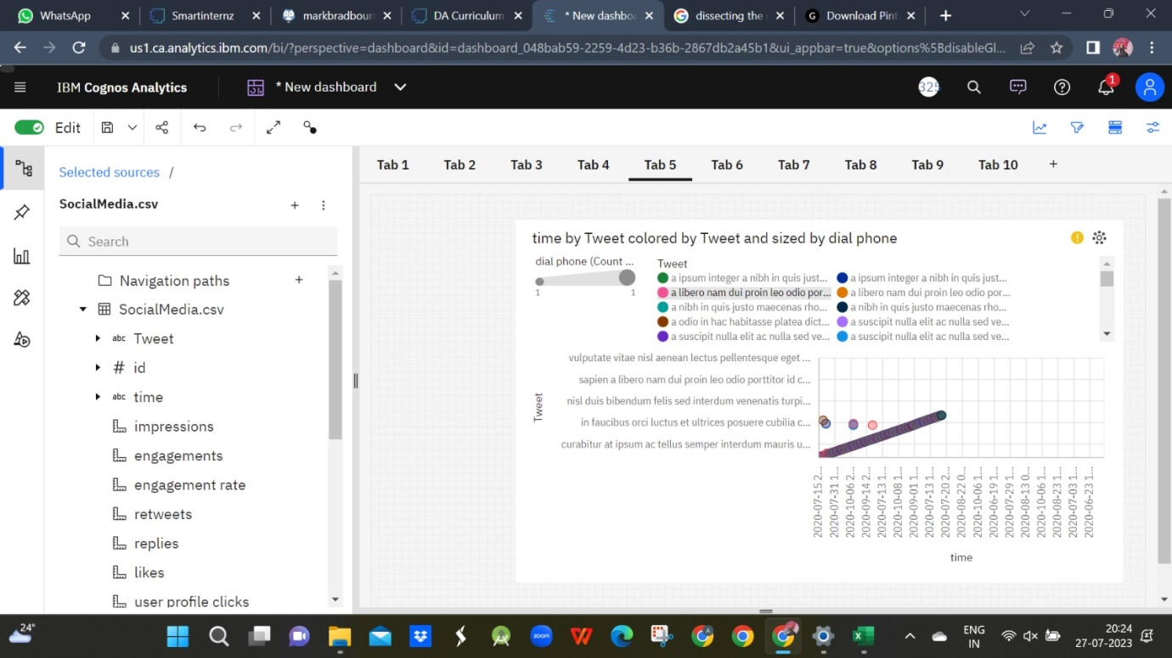

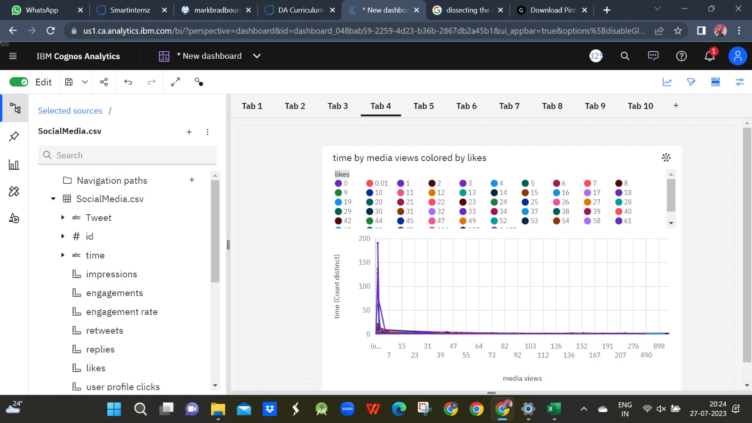

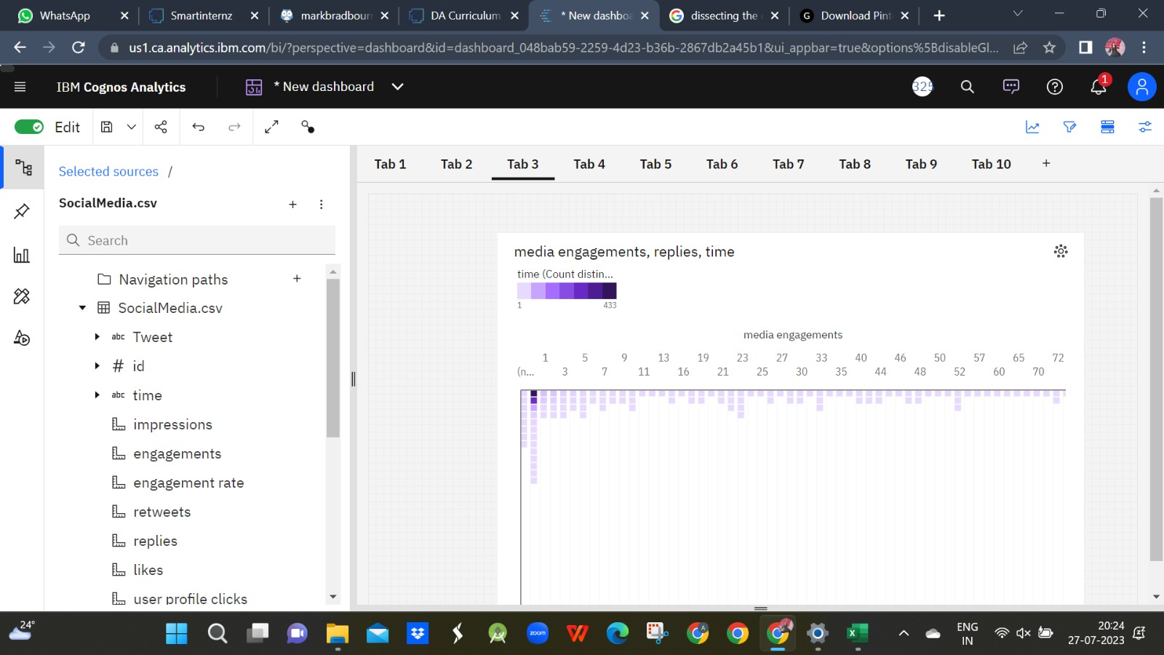

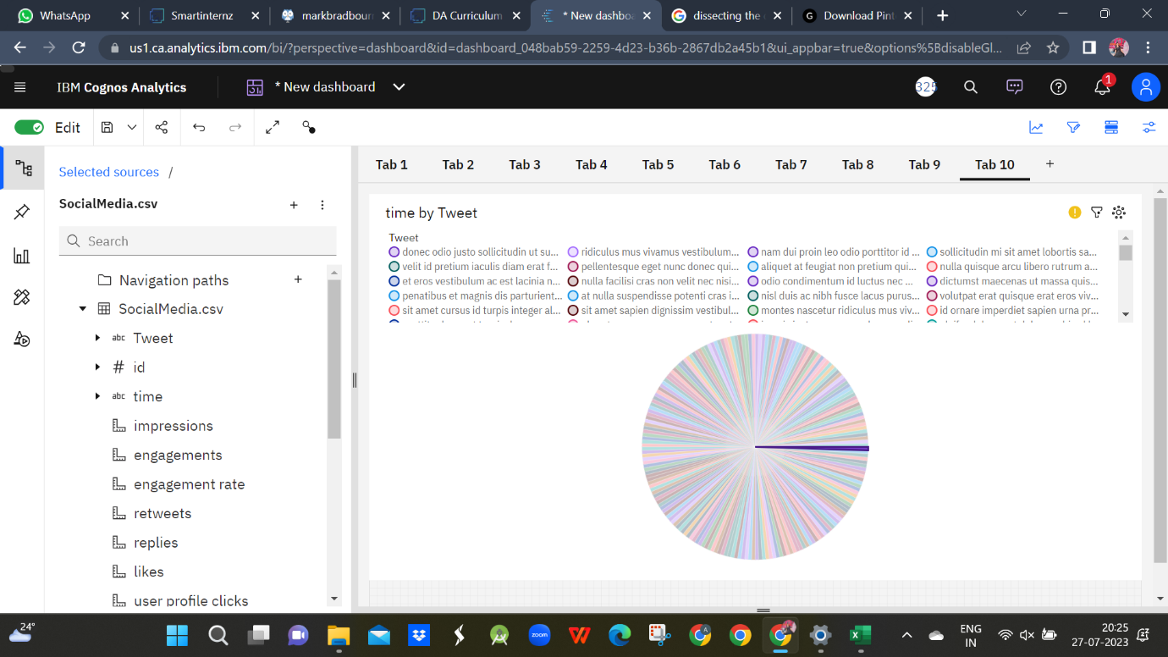

**CHAPTER 5**

**APPLICATIONS/ADVANTAGES**

**ADVANTAGES**

1. Understanding user behavior
2. Audience segmentation
3. Identifying trends
4. Competitive analysis
5. Brand reputation management
6. Influencer identification
7. Measuring campaign effectiveness

**DIS ADVANTAGES**

1. Information Overloaded
2. Privacy Concerns
3. Bias and misinterpretation
4. Rapidly evolving landscape
5. Incomplete data picture
6. Resources intensive & Ethical consideration

**APPLICATIONS**

Every web-based-application that supports information publishing and sharing (text, video, audio, photo), the building of personal profiles, connecting to a community and searching within the community is considered as a social media application.

Applications / social media

From sources across the web



LinkedIn

Snapchat



Instagram



TikTok



Twitter



Facebook



Reddit

Hootsuite



Clubhouse

1. 1. Facebook. Let's start with the obvious choices. ...
2. Instagram. If you enjoy exploring captivating images and short, snappy video clips, then Instagram is undoubtedly the ideal social network for you. ...
3. Twitter. ...
4. LinkedIn. ...
5. Snapchat. ...
6. Tumblr. ...
7. Pinterest. ...
8. Sina Weibo.

**CHAPTER 6**

**CONCLUSIONS & FUTURE SCOPE**

**CONCLUSION**

The analysis of social media within the context of digital marketing strategies reveals its significant impact and potential for businesses.

Businesses should also be mindful of the ethical implications and challenges that comes with social media marketing.

Business Organization must stay updated on emerging trends, algorithm changes and user behavior to adapt their strategies effectively.

**FUTURE SCOPE**

The scope of social media in India is immense and increasing rapidly. It is the 10th biggest economy and also has the 2nd largest population in the world.  A survey in 2019, which includes the top businesses admitted that 15-20% of their marketing budget is allocated for social media advertising. From that, it is understood the importance of social media in brand advertising.

There will not be any person who doesn’t know what social media is. Isn’t it? But many individuals may not know how it is important in digital marketing and how[social media marketing](https://avivdigital.in/social-media-marketing-strategy/) can enhance career growth.  Based on the Statista analysis it is been found that the number of users of the social network in India will be 258.27 million. It is a drastic rise from approximately 168 million users in 2016.

India is encountering development in the number of mobile users; regardless it contains just 16 percent of the nation’s aggregate populace with access to the web. In addition, it is assessed that India’s web clients will end up noticeably the world’s biggest web base, after China and the US.

Inference

IBM Database extracted from smart internz.

Google.