- Use case
Train & Test Data Sets

View Trained and Tested Accuracy in Bar Chart

View Trained and Tested Accuracy Results

REGISTER AND LOGIN

PREDICT BUG REPORT TYPE
Service Provider
Remote User
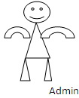
View Bug Report Type
VIEW YOUR PROFILE

View Bug Report Type_Ratio

Download Predicted Data Sets

View Bug Report Type Ratio Results,View All Remote Users

