RTOS BASED VEHICLE ACCIDENT DETECTION SYSTEM

Real Time Operating Systems 25ES611

PROJECT REPORT
Submitted by

BL.EN.P2EBS25012 R SAI KRISHNA VAMSI
Guided by
Dr. Surekha P
ELECTRICAL AND ELECTRONICS ENGINEERING



AMRITA SCHOOL OF ENGINEERING,
BENGALURU AMRITA VISHWA VIDYAPEETHAM
BENGALURU
560035
April 2026

Table of Contents

CHAPTER 1 INTRODUCTION ………………………………………………………………………….1
1.1 PROBLEM STATEMENT…………………………………………………………………………...1 1.2 OBJECTIVES……………………………………………………………………………………………………2
CHAPTER 2 LITERATURESURVEY……………………………………………………………………………..3
CHAPTER 3: RESEARCH GAP……………………………………………………………………………………5
3.1 NOVELITY……………………………………………………………………………………………………..5
CHAPTER 4:METHODOLOGY……………………………………………………………………………………7

CHAPTER 5: BLOCK DIAGRAM…………………………………………………………………………………8
5.1 Block Diagram Explanation…………………………………………………………………………………......8 CHAPTER 6: IMPLEMENTAION………..……………………………………………………………………….10

6.1 Hardware Components…………………………………………………………………………………………10
6.2 Software Implementation……………………………………………………………………………12 CHAPTER 7 RESULT AND DISCUSSION………………………………………………………………13
CHAPTER 8 REFERENCES……………………………………………………………………………………….19

ABSTRACT

The increasing number of road accidents has created a strong need for intelligent vehicle safety systems capable of providing immediate emergency response and accident monitoring. Traditional accident reporting methods rely heavily on manual communication, which may delay emergency assistance during critical situations. The proposed project presents a Real-Time Operating System (RTOS) based Smart Vehicle Accident Detection and Emergency Alert System using ESP32, MPU6050 accelerometer sensor, SW420 vibration sensor, GPS module, GSM module, emergency interrupt switch, buzzer, and real-time monitoring through Serial Studio.
The system continuously monitors vehicle movement and vibration using the MPU6050 and SW420 sensors. If both sensors detect abnormal conditions simultaneously, the system identifies it as a serious accident and immediately activates a high-priority RTOS task. The ESP32 controller processes sensor data using FreeRTOS scheduling and performs context switching to suspend lower-priority tasks. The system then activates the buzzer, obtains GPS coordinates, generates a Google Maps location link, and sends an emergency SMS alert through the GSM module.
Additionally, an emergency push button interrupt mechanism is implemented for manual emergency situations. When the button is pressed, a highest-priority interrupt-driven RTOS task immediately preempts all lowerpriority tasks and sends a distress message containing the user’s live GPS location. Real-time system monitoring is achieved using Serial Studio for visualization of acceleration, vibration, GPS tracking, emergency alerts, and task execution.
The proposed system provides a low-cost, real-time, and intelligent accident monitoring solution suitable for
smart vehicles, emergency response systems, and embedded RTOS learning applications.

CHAPTER 1: INTRODUCTION
Road accidents are one of the major causes of injuries and fatalities worldwide. Delays in emergency response and accident reporting often increase the severity of injuries and reduce the chances of survival. Traditional accident detection systems depend mainly on human intervention, where victims or nearby people must manually inform emergency services. In many situations, especially during severe accidents, victims may be unconscious or unable to communicate their location.
To overcome these challenges, intelligent embedded systems are increasingly being used in modern transportation safety applications. The proposed project focuses on the design and development of an RTOSbased Smart Vehicle Accident Detection and Emergency Alert System capable of detecting accidents in real time and automatically sending emergency alerts with GPS location details.
The system utilizes an ESP32 microcontroller due to its powerful processing capability, built-in communication interfaces, and FreeRTOS support. An MPU6050 accelerometer sensor is used to monitor sudden acceleration and tilt changes, while the SW420 vibration sensor detects physical impacts and collisions. By combining both sensor outputs, the system improves accident detection reliability and reduces false alarms.
The GPS module continuously provides live location coordinates, while the GSM module sends SMS alerts containing Google Maps location links to predefined emergency contacts. An interrupt-based emergency push button is also included to allow users to manually request help during medical emergencies or unsafe situations.
The project demonstrates the practical implementation of RTOS concepts such as multitasking, task prioritization, context switching, preemptive scheduling, and interrupt handling in real-time embedded systems.

1.1 PROBLEM STATEMENT
Road accidents frequently occur due to overspeeding, poor road conditions, driver negligence, and unexpected collisions. In many cases, victims fail to receive immediate medical assistance because emergency services are not informed quickly. Manual accident reporting methods are unreliable and time consuming, particularly when victims are severely injured or unconscious.
Existing vehicle safety systems are often expensive, complex, and not suitable for low-cost embedded applications. Many systems also lack real-time monitoring and intelligent task management mechanisms required for fast emergency response.
Therefore, there is a strong requirement for a compact, low-cost, and intelligent accident detection system capable of:
- Detecting accidents automatically
- Sending emergency alerts instantly
- Providing live GPS location
- Supporting real-time RTOS task execution
- Handling emergency conditions with priority-based scheduling

1.2 OBJECTIVES
The main objectives of the proposed project are:
- To develop an RTOS-based smart accident detection system using ESP32
- To detect serious accidents using MPU6050 and SW420 sensor fusion
- To implement priority-based task scheduling using FreeRTOS
- To perform context switching during critical emergency events
- To transmit accident alerts using GSM communication
- To provide live GPS location through Google Maps links
- To implement interrupt-driven emergency assistance requests
- To visualize real-time sensor data using Serial Studio
- To reduce emergency response time during accidents

CHAPTER 2: LITERATURE SURVEY
The paper titled “Accident Detection and Prevention Systems for Smart and Electric Vehicles using IoTEnabled Techniques” by Keerthana G and co-authors focuses on enhancing road safety in smart and electric vehicles through IoT-based accident monitoring and prevention mechanisms. The study highlights the integration of sensors such as accelerometers, vibration sensors, GPS, and IoT communication modules for real-time accident detection and emergency alert generation. Existing literature shows that IoT-enabled systems significantly reduce emergency response time by automatically transmitting vehicle location and accident details to hospitals, police stations, and emergency contacts. Several researchers have also incorporated AI, cloud computing, and sensor fusion techniques to improve detection accuracy and minimize false alerts. Recent studies further emphasize the importance of driver safety features such as drowsiness detection, alcohol sensing, collision avoidance, and vehicle-to-vehicle communication in intelligent transportation systems. Compared to traditional manual reporting systems, IoT-based smart accident detection systems provide faster response, improved reliability, low-cost deployment, and better scalability for modern electric and smart vehicles.
The paper “A Confirmation Based Accident Detection System Using IoT for Smart Vehicles” by Bettina Ninan proposes an IoT-based smart accident detection mechanism that improves the reliability of emergency alerts in vehicles. The system uses sensors such as accelerometers and vibration sensors to identify accident conditions and then performs a confirmation process before sending alerts, thereby reducing false accident notifications. GPS and GSM technologies are integrated to transmit real-time location details to emergency contacts and rescue services. The study highlights how confirmation-based validation enhances detection accuracy and system efficiency. The proposed approach contributes to faster emergency response and improved road safety in smart transportation systems.
The paper “A Confirmation Based Accident Detection System Using IoT for Smart Vehicles” by Bettina Ninan presents an IoT-enabled accident detection framework that improves alert reliability through confirmation-based validation. The system utilizes sensors, GPS, and GSM modules to detect accidents and transmit emergency notifications with accurate location details. The proposed method reduces false accident alerts and enhances emergency response efficiency for smart vehicle applications.
The paper “Crash Alert System: Automated Accident Detection and Prevention System” by Patchigorla Prashanth Babu and co-authors proposes an automated vehicle safety system designed to detect accidents and provide immediate alerts using IoT technologies. The system integrates sensors to monitor vehicle conditions and automatically sends crash notifications along with GPS coordinates to emergency services and family members. The study emphasizes real-time monitoring, rapid response, and improved road safety through intelligent accident prevention and detection mechanisms.
The paper “Vehicle Accident Detection and Reporting System using Internet of Things” by Atul Goyal and co-authors proposes an IoT-based smart vehicle safety system for automatic accident detection and reporting. The system uses sensors, GPS, and GSM communication modules to identify accident occurrences and instantly transmit emergency alerts with real-time vehicle location details. The proposed approach minimizes delays in emergency response and improves the chances of timely medical assistance. The study highlights the importance of real-time monitoring, reliable communication, and automated reporting in enhancing road safety and reducing accident-related fatalities.
The paper “Intelligent Traffic Light System with Vehicle Signal Interaction and Motion based Accident Prevention” by R. Sumathy and co-authors proposes an intelligent traffic management and accident prevention system using vehicle-to-signal communication technologies. The system enables interaction between vehicles and traffic lights to monitor vehicle movement, traffic conditions, and motion patterns in real time. Motion-based sensing techniques are used to identify unsafe driving situations and help prevent potential accidents at intersections. The study focuses on improving traffic efficiency, reducing collision risks, and enhancing road safety through smart transportation and IoT-enabled communication systems.
The paper “Vehicle Accident Detection System with LPWAN Technology for Information Transmission” by
Albert Sagala and co-authors presents a smart accident detection system that utilizes LPWAN (Low Power Wide Area Network) technology for efficient information transmission. The system employs sensors to detect vehicle accidents and sends emergency notifications with location details through low-power wireless communication networks. The proposed approach ensures long-range communication, reduced power consumption, and reliable data transmission during emergency situations. The study highlights the advantages of LPWAN technology in improving accident reporting efficiency and supporting IoT-based intelligent transportation systems.

CHAPTER 3: RESEARCH GAP
The study of existing vehicle accident detection and emergency alert systems reveals several limitations that create opportunities for improvement in real-time embedded safety applications. Many low-cost accident detection systems rely only on a single sensor such as a vibration sensor or accelerometer, which often leads to false accident detection caused by road bumps, sudden braking, or environmental disturbances. Several advanced systems depend heavily on IoT cloud platforms, mobile applications, or internet connectivity, increasing implementation cost, system complexity, and communication delay. Additionally, most existing systems focus mainly on GPS tracking and GSM communication but do not utilize efficient RTOS-based task management for handling emergency situations in real time.
Another major research gap identified in existing systems is the lack of priority-based task scheduling and interrupt-driven emergency handling mechanisms. Many systems operate sequentially without multitasking support, resulting in slower response time during critical emergency conditions. Existing embedded systems rarely implement important RTOS concepts such as context switching, preemptive scheduling, multitasking, and priority-based task execution. Furthermore, most systems lack real-time visualization and monitoring capabilities required for effective debugging and demonstration purposes. The proposed project addresses these research gaps by integrating MPU6050 and SW420 sensor fusion, FreeRTOS multitasking, interrupt-based emergency communication, GPS-enabled GSM alerts, context switching, and Serial Studio visualization into a compact, low-cost, and intelligent real-time accident detection system.

3.1 NOVELITY
The proposed RTOS-based Smart Vehicle Accident Detection and Emergency Alert System introduces a novel and intelligent approach for real-time vehicle safety monitoring by integrating sensor fusion, FreeRTOS task scheduling, GPS tracking, GSM communication, and emergency interrupt handling into a single embedded platform. Unlike many conventional accident detection systems that rely only on a single sensor, the proposed system combines MPU6050 accelerometer data and SW420 vibration sensor output simultaneously to improve accident detection accuracy and reduce false triggering caused by road disturbances or sudden braking conditions. The implementation of sensor fusion significantly enhances system reliability compared to traditional low-cost accident monitoring systems.
Another major novelty of the project is the implementation of FreeRTOS-based multitasking, context switching, and priority-based preemptive scheduling for emergency response management. The system assigns higher priorities to critical tasks such as emergency interrupt handling and serious accident detection, allowing immediate suspension of lower-priority tasks during emergency conditions. This real-time task management architecture improves system responsiveness and demonstrates practical RTOS concepts rarely implemented in low-cost embedded vehicle safety systems. The interrupt-driven emergency push button mechanism further enhances user safety by enabling manual distress communication during medical emergencies or unsafe situations.
The project also integrates GPS-enabled location tracking and GSM-based emergency communication to provide real-time Google Maps location sharing through SMS alerts. Additionally, Serial Studio visualization is implemented for real-time monitoring of acceleration, vibration, GPS coordinates, emergency status, buzzer activity, and RTOS task behavior using live dashboards, gauges, and GPS maps. The combination of sensor fusion, RTOS scheduling, interrupt handling, GPS tracking, GSM communication, and real-time visualization makes the proposed system a compact, low-cost, intelligent, and scalable embedded safety solution suitable for smart transportation and real-time accident monitoring applications.

CHAPTER 4: METHODOLOGY
The methodology adopted for the proposed RTOS-based Smart Vehicle Accident Detection and Emergency
Alert System involves real-time monitoring of vehicle acceleration and vibration conditions using multiple FreeRTOS tasks. Initially, the ESP32 microcontroller initializes all peripherals including the MPU6050 accelerometer sensor, SW420 vibration sensor, GPS module, GSM module, buzzer, and emergency push button. The MPU6050 continuously measures acceleration and tilt variations of the vehicle, while the SW420 sensor detects vibration and collision impacts. Separate RTOS tasks are created for sensor monitoring, GPS tracking, accident detection, emergency handling, GSM communication, and Serial Studio visualization to ensure parallel execution and efficient real-time operation.
The Detection Task continuously analyzes sensor values and compares them with predefined threshold conditions to determine accident severity. If both the MPU6050 and SW420 sensors detect abnormal conditions simultaneously, the system identifies it as a serious accident and activates a high-priority RTOS task. During this condition, FreeRTOS performs context switching and temporarily suspends lower-priority tasks to execute emergency operations immediately. The system activates the buzzer, obtains live GPS coordinates from the NEO-6M GPS module, generates a Google Maps location link, and sends an emergency
SMS alert using the GSM module to predefined emergency contacts. I
If only the MPU6050 detects abnormal acceleration, the system sends a moderate accident alert with location details, whereas minor vibration detection generates a simple collision notification.\n\nAn interrupt-based emergency push button mechanism is also implemented to support manual emergency requests during medical emergencies or unsafe situations. Whenever the button is pressed, a hardware interrupt triggers the highest-priority RTOS task, which immediately preempts all running lower-priority tasks and sends a distress message containing live GPS location details.
Real-time system monitoring and visualization are achieved using Serial Studio, where JSON-formatted sensor data is displayed through gauges, indicators, and GPS maps. The overall methodology demonstrates the practical implementation of multitasking, interrupt handling, context switching, preemptive scheduling, sensor fusion, GPS tracking, and GSM-based emergency communication using FreeRTOS on the ESP32 platform

CHAPTER 5: BLOCK DIAGRAM

5.1: BLOCK DIAGRAM

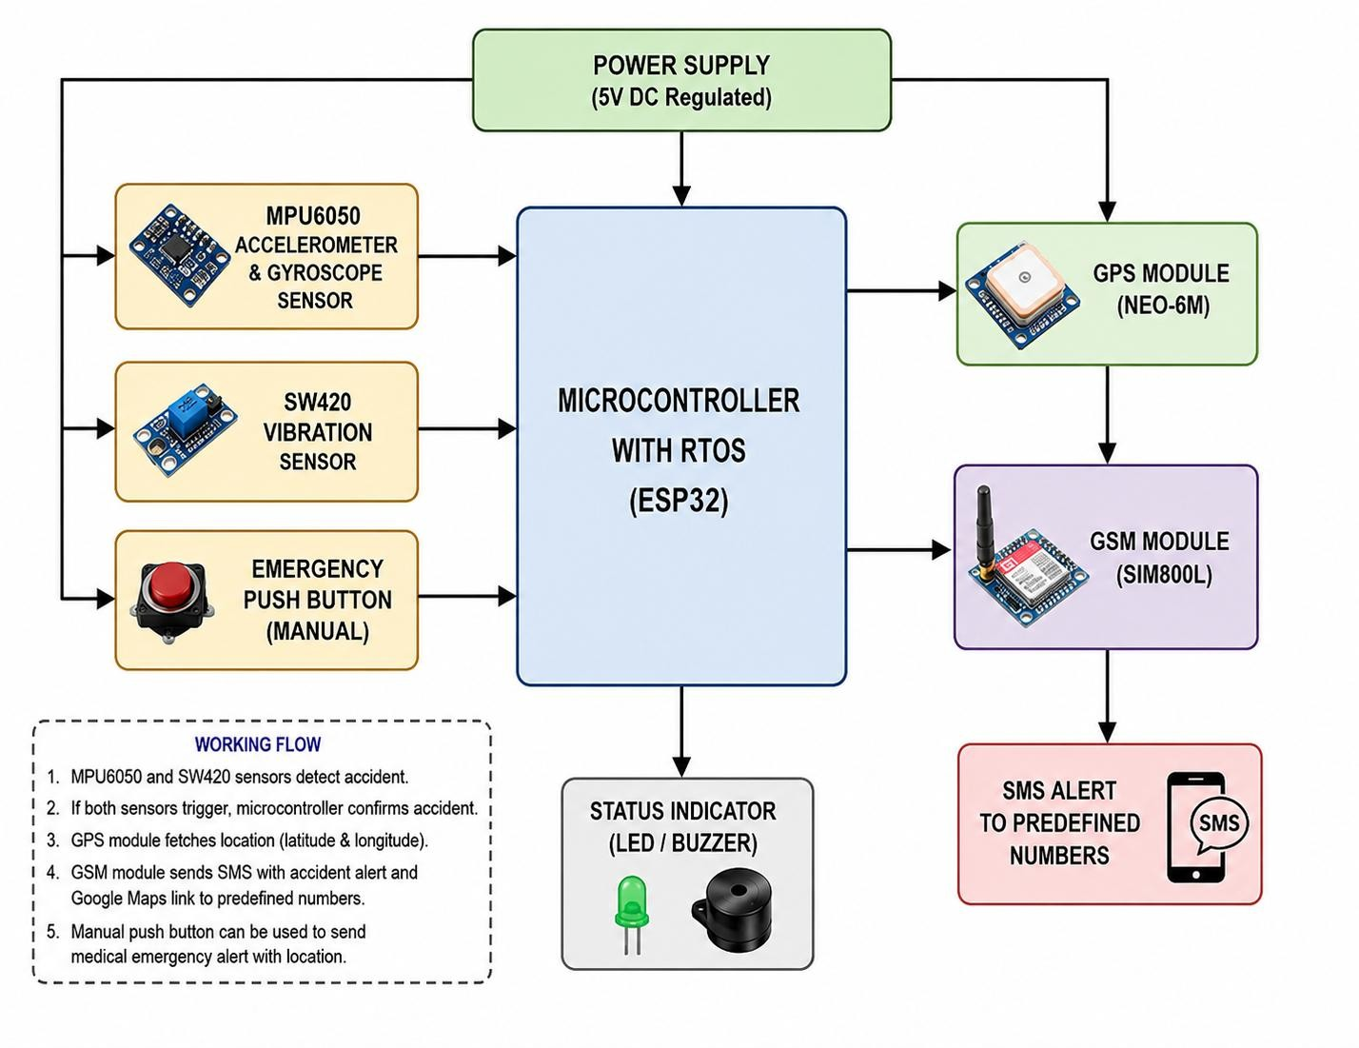
Figure 1: Block Diagram of System

5.2 Block Diagram Explanation
The proposed smart accident detection and alert system is designed using an IoT-enabled embedded architecture to detect vehicle accidents and send emergency notifications automatically. The entire system is controlled by the ESP32 microcontroller running with RTOS for multitasking and real-time processing.

1. Power Supply
The regulated 5V DC power supply provides stable power to all modules including the ESP32, sensors, GPS module, GSM module, LED, and buzzer.

2. MPU6050 Accelerometer and Gyroscope Sensor
The MPU6050 sensor continuously monitors vehicle acceleration, tilt, and sudden motion changes. During a collision or abnormal movement, the sensor detects high acceleration and sends data to the ESP32 controller.

3. SW420 Vibration Sensor
The SW420 vibration sensor detects strong vibrations or impacts produced during an accident. It acts as a secondary confirmation sensor to improve accident detection accuracy and reduce false alerts.

4. Emergency Push Button
The manual emergency push button allows the driver or passenger to manually trigger an emergency alert during medical emergencies or unsafe situations even if an accident is not detected automatically.

5. ESP32 Microcontroller with RTOS
The ESP32 acts as the central processing unit of the system. Using RTOS, it executes multiple tasks simultaneously such as sensor monitoring, GPS tracking, GSM communication, and status indication. When both MPU6050 and SW420 sensors detect abnormal conditions, the ESP32 confirms the accident event.

6. GPS Module (NEO-6M)
After accident confirmation, the GPS module retrieves the real-time latitude and longitude coordinates of the vehicle location and sends them to the ESP32.

7. GSM Module (SIM800L)
The GSM module sends SMS alerts containing accident information and Google Maps location links to predefined emergency contacts, hospitals, or rescue teams.

8. Status Indicator (LED/Buzzer)
The LED and buzzer provide local alerts and indication during accident detection. The buzzer produces an emergency sound while the LED indicates system status and warning conditions.

9. SMS Alert System
Finally, emergency alert messages with location details are transmitted to predefined mobile numbers for quick rescue and medical assistance.

CHAPTER 6: IMPLEMENTATION

Hardware Implementation
The implementation of the proposed RTOS-based Smart Vehicle Accident Detection and Emergency Alert
System is carried out using the ESP32 microcontroller with FreeRTOS multitasking architecture. The
MPU6050 accelerometer sensor continuously monitors vehicle acceleration and tilt variations, while the SW420 vibration sensor detects collision impacts and vibrations. Multiple RTOS tasks are created for sensor monitoring, GPS tracking, accident detection, GSM communication, and Serial Studio visualization. The Detection Task continuously analyzes sensor data and identifies accident severity based on predefined threshold conditions. If both MPU6050 and SW420 detect abnormal conditions simultaneously, the system identifies it as a serious accident and activates a high-priority RTOS task. During this condition, context switching occurs and lower-priority tasks are preempted to ensure immediate emergency response.
The GPS module continuously provides live latitude and longitude coordinates, while the GSM module sends emergency SMS alerts containing Google Maps location links to predefined phone numbers. An interrupt-based emergency push button is also implemented for manual emergency situations. Whenever the button is pressed, the highest-priority RTOS task immediately executes and sends a distress message with live location details. A buzzer is activated during emergency conditions to provide local audio alerts. Additionally, Serial Studio is integrated for real-time visualization of acceleration values, vibration status, GPS tracking, emergency alerts, and RTOS task behavior through gauges, indicators, and live GPS maps. The overall implementation demonstrates multitasking, interrupt handling, priority-based scheduling, context switching, and real-time embedded system design using FreeRTOS.

6.1 Hardware Components

1. ESP32 Microcontroller
- Main processing unit of the system
- Supports FreeRTOS multitasking
- Provides multiple GPIO pins
- Supports UART and I2C communication
- Handles sensor processing and communication

2. MPU6050 Accelerometer Sensor
- Detects acceleration and tilt changes
- Measures X, Y, and Z axis acceleration
- Used for accident detection
- Communicates using I2C protocol

3. SW420 Vibration Sensor
- Detects physical vibrations and impacts
- Used for collision detection
- Provides digital output

4. GPS Module (NEO-6M)
- Provides live location coordinates
- Used for emergency location tracking
- Communicates through UART

5. GSM Module (SIM800L)
- Sends SMS alerts
- Provides emergency communication
- Communicates through UART

6. Emergency Push Button
- Generates hardware interrupt
- Used for manual emergency requests

7. Buzzer
- Provides audio alert during accidents
- Activated during emergency situations

8. Power Supply Components
- AMS1117 Voltage Regulator
- LM2596 Buck Converter
- 18650 Li-ion Battery
- TP4056 Charging Module

9. Breadboard and Connecting Wires
- Used for circuit connections
- Supports hardware prototyping

6.2 Software Implementation
The software implementation is developed using Arduino IDE and Embedded C/C++ programming.
Libraries used include:
- Wire.h
- TinyGPS++.h
- HardwareSerial.h
- MPU6050.h
The program initializes all peripherals and creates multiple FreeRTOS tasks.
Sensor data is continuously monitored and analyzed in parallel tasks. RTOS scheduling ensures concurrent execution of tasks.
Priority-based task management is implemented to handle emergency situations effectively.
Whenever a critical condition occurs, higher-priority tasks preempt lower-priority tasks using context switching.
The GSM module sends emergency messages containing GPS location links.
Serial Studio receives JSON-formatted data for real-time visualization.

CHAPTER 7: RESULT AND DISCUSSION

RESULTS AND DISCUSSION
The developed RTOS-based Smart Vehicle Accident Detection and Emergency Alert System was tested under multiple real-time operating conditions to evaluate its performance, reliability, and emergency response capability. Experimental testing was conducted using the MPU6050 accelerometer sensor, SW420 vibration sensor, GPS module, GSM module, buzzer, and emergency interrupt switch connected to the
ESP32 microcontroller. The system successfully demonstrated real-time accident detection, priority-based RTOS task execution, GPS tracking, GSM communication, and context switching during emergency situations. Serial Studio visualization also provided live monitoring of acceleration values, vibration status, emergency alerts, buzzer activity, and GPS location tracking.
The system continuously monitored vehicle movement and vibration conditions using parallel FreeRTOS tasks. During normal operating conditions, all sensor monitoring tasks executed simultaneously with stable real-time performance. Whenever a critical condition occurred, FreeRTOS successfully performed context switching by suspending lower-priority tasks and immediately executing higher-priority emergency tasks. GPS coordinates were successfully acquired and transmitted through GSM communication using Google Maps location links. The buzzer also activated correctly during emergency conditions, providing local audio alerts. The implemented RTOS architecture significantly improved response time and reliability compared to traditional sequential embedded systems.\
Scenario 1: Serious Accident Detection When both the MPU6050 accelerometer sensor and SW420 vibration sensor detected abnormal conditions simultaneously, the system identified the event as a serious accident. The Detection Task immediately activated the high-priority Serious Accident Task. During this condition, FreeRTOS performed preemptive scheduling and temporarily suspended lower-priority monitoring tasks through context switching. The system activated the buzzer, obtained live GPS coordinates, generated a Google Maps location link, and sent an emergency SMS alert using the GSM module. Serial
Studio displayed serious accident indicators, acceleration spikes, vibration detection, buzzer status, and live GPS tracking in real time. The system successfully demonstrated reliable and immediate emergency response during critical accident conditions.

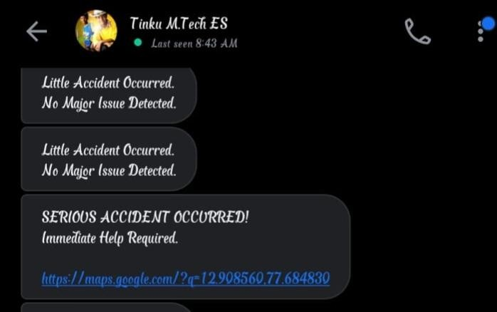
Scenario 1
Scenario 2: Emergency Button Interrupt . The emergency push button was tested to simulate manual emergency situations such as medical emergencies or unsafe conditions. Whenever the button was pressed, a hardware interrupt immediately triggered the highest-priority Emergency Task. FreeRTOS instantly preempted all lower-priority tasks and executed the emergency communication task without delay. The system activated the buzzer, acquired live GPS coordinates, and sent a distress message containing a Google Maps location link with the message “I am not well, I need help immediately.” Serial Studio successfully displayed emergency indicators and task execution status during the interrupt event. The experiment confirmed the effectiveness of interrupt-driven emergency handling and priority-based RTOS scheduling.

Scenario 2
Scenario 3: Minor Collision Detection. When only the SW420 vibration sensor detected vibration without abnormal acceleration from the MPU6050, the system identified the event as a minor collision or vibration disturbance. In this case, the Minor Vibration Task executed with low priority and transmitted a simple notification message indicating a minor collision. No GPS location or emergency alert was generated because the condition was not classified as a serious accident. The system successfully avoided false accident triggering while maintaining continuous real-time monitoring. sensitivity were observed during testing. Despite these limitations, the system demonstrated stable, reliable, low-cost, and real-time operation suitable for smart vehicle safety and embedded RTOS applications.

Scenario 3
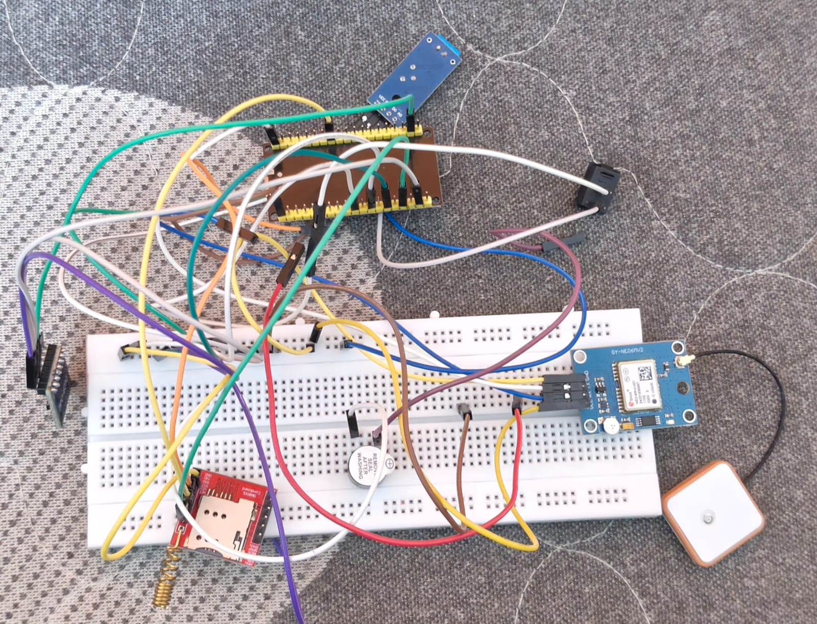
FIG: Hardware System
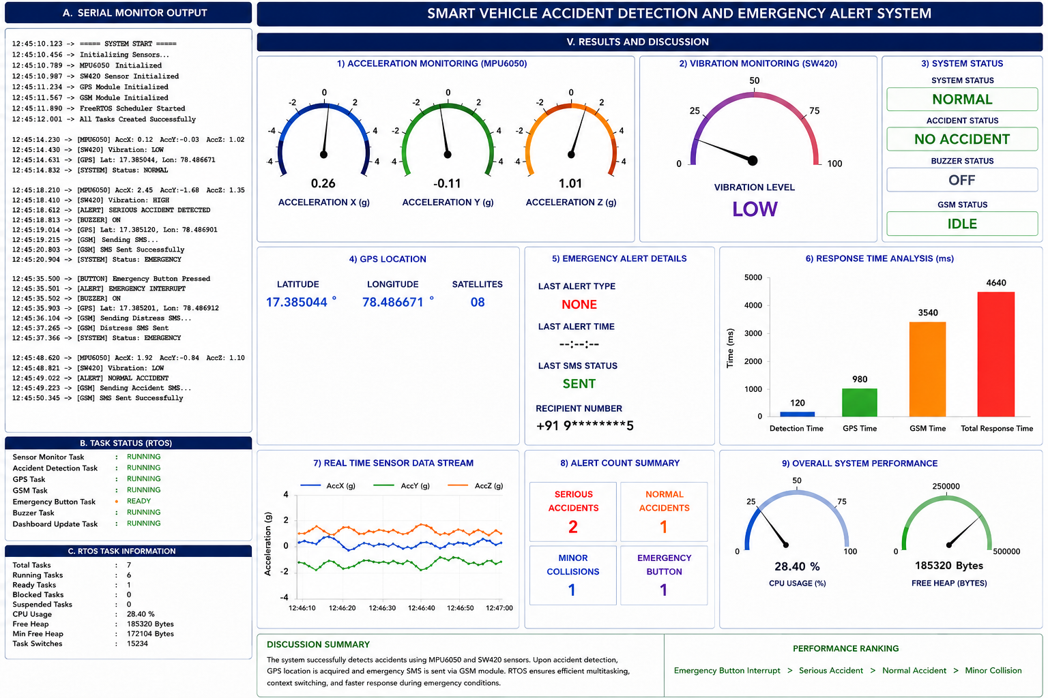
FIG : Real-time performance analysis

DISCUSSION
The implementation of a real-time system using FreeRTOS significantly improved the overall performance compared to traditional sequential embedded systems. By dividing the application into multiple tasks, the system achieved parallel execution, allowing continuous sensor monitoring without interrupting actuator operations.
The use of high-priority tasks for color detection ensured that the system responded immediately to incoming pills, while the low-priority servo task handled sorting without blocking critical processes. This architecture resulted in deterministic behavior and improved responsiveness, which are essential for real-time industrial applications.
However, some practical challenges were observed during implementation. The system performance was influenced by factors such as sensor calibration, lighting conditions, and threshold selection, which directly affect detection accuracy. Additionally, power fluctuations caused by motors and servos occasionally impacted system stability, indicating the need for proper power management and isolation.
Despite these limitations, the system proved to be cost-effective, scalable, and efficient for small-scale automation tasks. The design can be further enhanced by integrating advanced sensing techniques such as machine vision or incorporating IoT-based monitoring for industrial deployment.

CONCLUSION
The proposed RTOS-based Smart Vehicle Accident Detection and Emergency Alert System successfully demonstrates the implementation of real-time embedded system technology for intelligent vehicle safety applications. The project integrates MPU6050 accelerometer sensing, SW420 vibration detection, GPS location tracking, GSM communication, emergency interrupt handling, buzzer alerts, and Serial Studio visualization into a compact and efficient embedded platform using the ESP32 microcontroller. The implementation of sensor fusion significantly improved accident detection accuracy by reducing false triggering and ensuring reliable identification of serious accident conditions.
The use of FreeRTOS enabled efficient multitasking, priority-based task scheduling, context switching, and interrupt-driven emergency handling. Critical emergency events such as serious accidents and emergency button interrupts were successfully assigned higher priorities, allowing immediate suspension of lowerpriority tasks during emergency conditions. The system effectively transmitted real-time emergency SMS alerts containing Google Maps location links through the GSM module, thereby reducing emergency response delay and improving user safety.
Real-time visualization using Serial Studio enhanced monitoring, debugging, and demonstration capabilities by displaying acceleration values, vibration status, GPS coordinates, emergency alerts, buzzer activity, and RTOS task behavior through live dashboards and indicators. Experimental testing confirmed stable and reliable operation under multiple accident scenarios including serious accidents, moderate accidents, minor collisions, and emergency interrupt conditions. Overall, the project successfully achieved its objectives and demonstrated the practical implementation of RTOS concepts, embedded system design, sensor fusion, GPS tracking, GSM communication, and real-time emergency response management for smart vehicle safety applications.

CHAPTER 8 REFERENCES
- [1] Z. U. Arifeen, J.-E. Hong, B.-S. Seo, and J.-W. Suh, “Traffic Accident Detection and Classification in
Videos based on Deep Network Features,” in 2023 Fourteenth International Conference on Ubiquitous and Future Networks (ICUFN), 2023, pp. 438–441.
- [2] X. Hou, S. Wen, S. Chen, J. Li, K. Xu, Z. Wang, and W. Wu, “Lightweight Traffic Accident Detection Algorithm Based on Attention Mechanism,” in 2024 2nd International Conference on Intelligent Control and Computing (IC&C), 2024.
- [3] S. R., T. D., and Y. G., “Real-Time Accident Detection and Response System Using Resnet
Algorithm,” in 2024 IEEE 16th International Conference on Computational Intelligence and Communication Networks (CICN), 2024.
- [4] S. H. Samba, I. Y. B. Agranata, L. Tsanaullailla, and F. Hamami, “Traffic Accident Detection Analysis Using YOLOv9 Algorithm,” in 2024 Ninth International Conference on Informatics and Computing (ICIC), 2024.
- [5] P. P. Babu, M. Sanjana, M. H. Vasantha, and Y. B. Nithin Kumar, “Crash Alert System: Automated Accident Detection and Prevention System,” in 2024 IEEE India Geoscience and Remote Sensing Symposium (InGARSS), 2024.
- [6] H. Yu, X. Zhang, Y. Wang, Q. Huang, and B. Yin, “Multiple-Level Distillation for Video FineGrained Accident Detection,” IEEE Transactions on Circuits and Systems for Video Technology, vol. 34, no. 5, pp. 3562–3574, 2024.
- [7] G. Keerthana, R. Satheesh Kumar, T. D. Dwijesh, V. S. Muhseena, K. Nakul Dev, and G. M. Athulya,
“Accident Detection and Prevention Systems for Smart and Electric Vehicles using IoT-Enabled Techniques,” in 2026 4th International Conference on Intelligent Data Communication Technologies and Internet of Things (IDCIoT), 2026.
- [8] K. G. Nandhika, A. Priyadharshini, and S. Mithuna, “Real-Time Traffic Accident Detection Using YOLOv11 Based on the Derivative of Traffic Parameters,” in 2026 International Conference on Smart Futuristic Technology, 2026.
- [9] D. K. Yadav, Renu, Ankita, and I. Anjum, “Accident Detection Using Deep Learning,” in 2020 2nd International Conference on Advances in Computing, Communication Control and Networking (ICACCCN), 2020.
- [10] M. F. Mubarakkaa, S. Hemavathi, V. Kavitha, Aarthi M, Varshini K, and J. Sindhu P, “AcciRadar: Real Time Automatic Accident Detection and Reporting Framework,” in 2025 International Conference on Computing and Communication Technologies (ICCCT), 2025.

