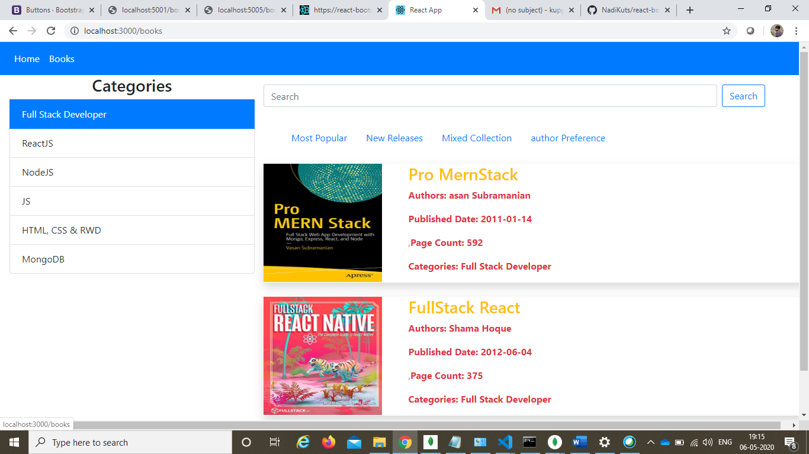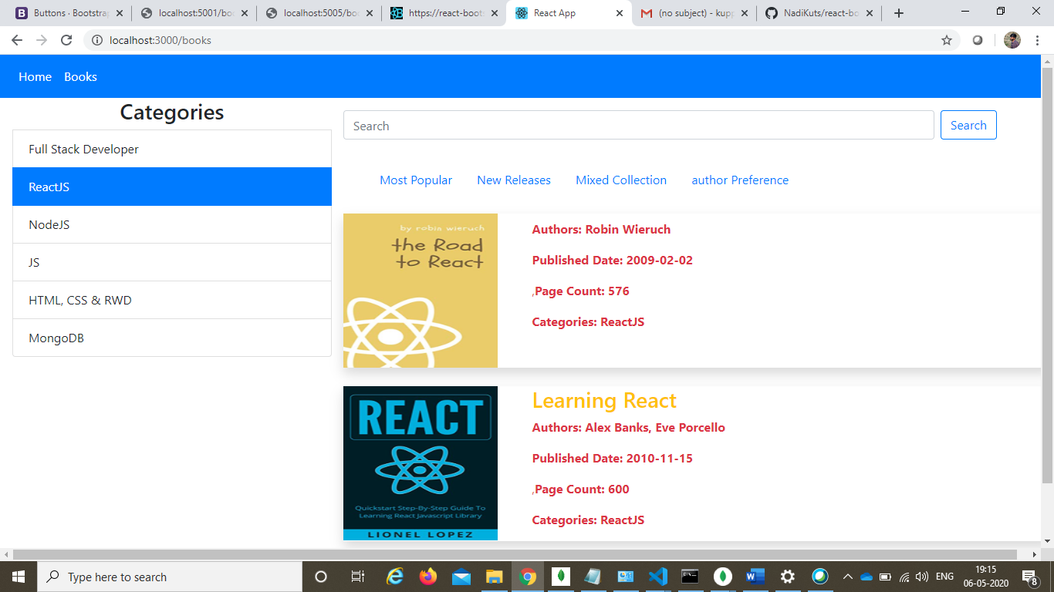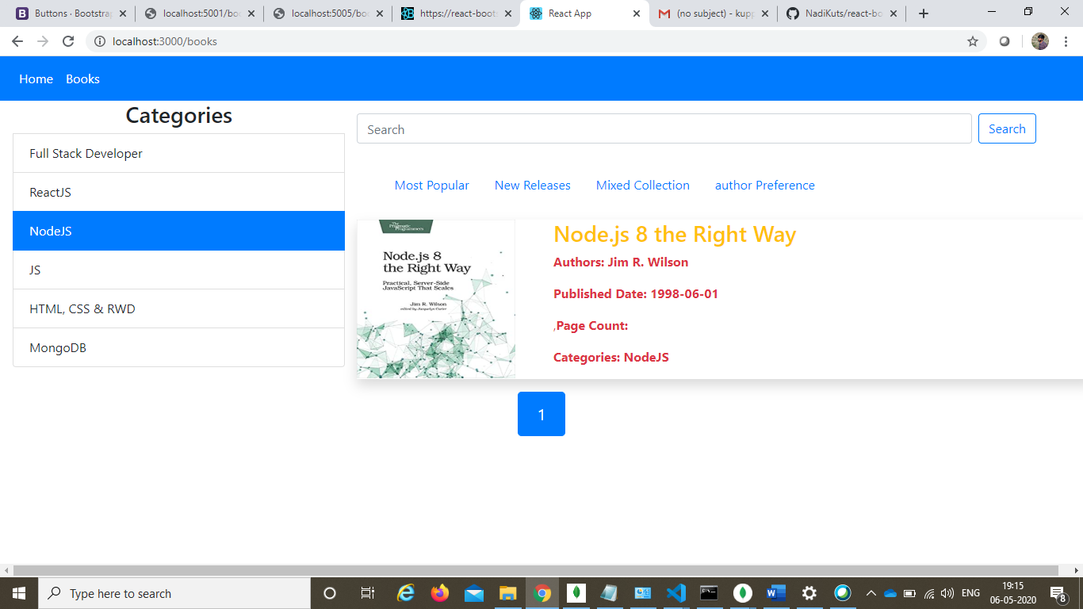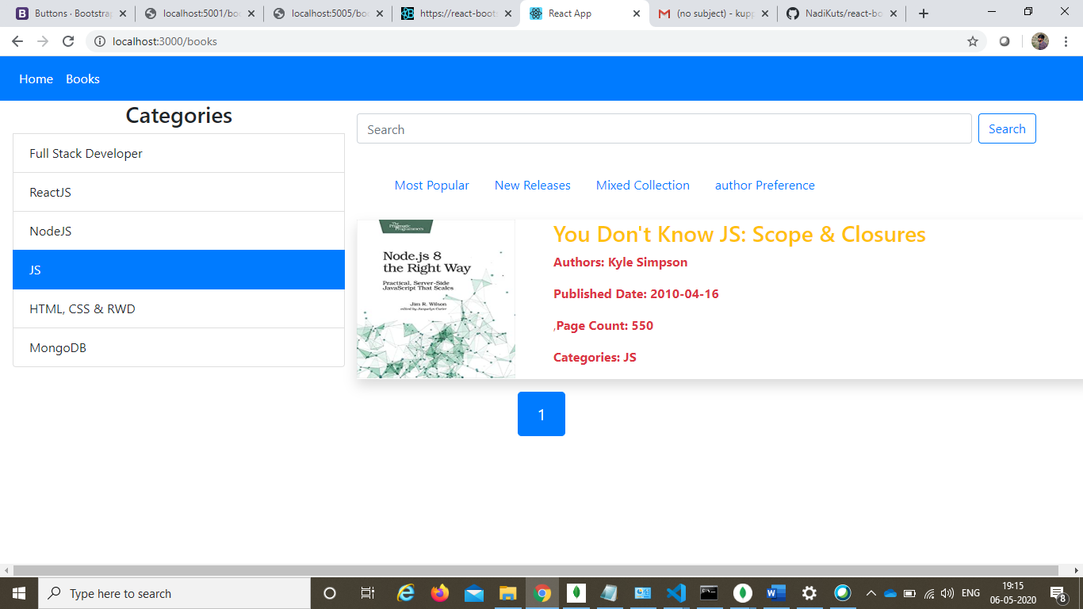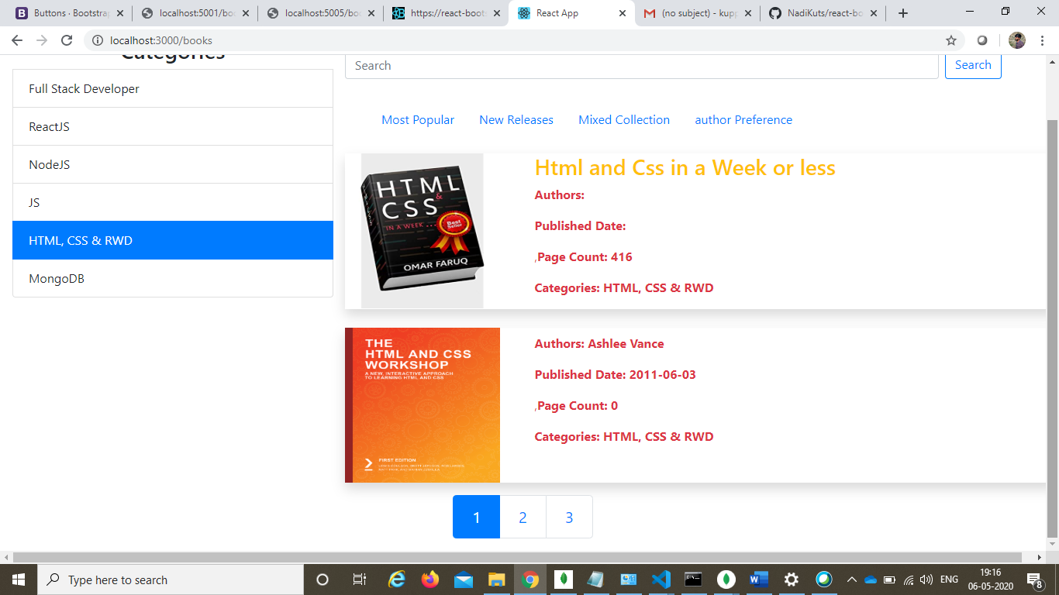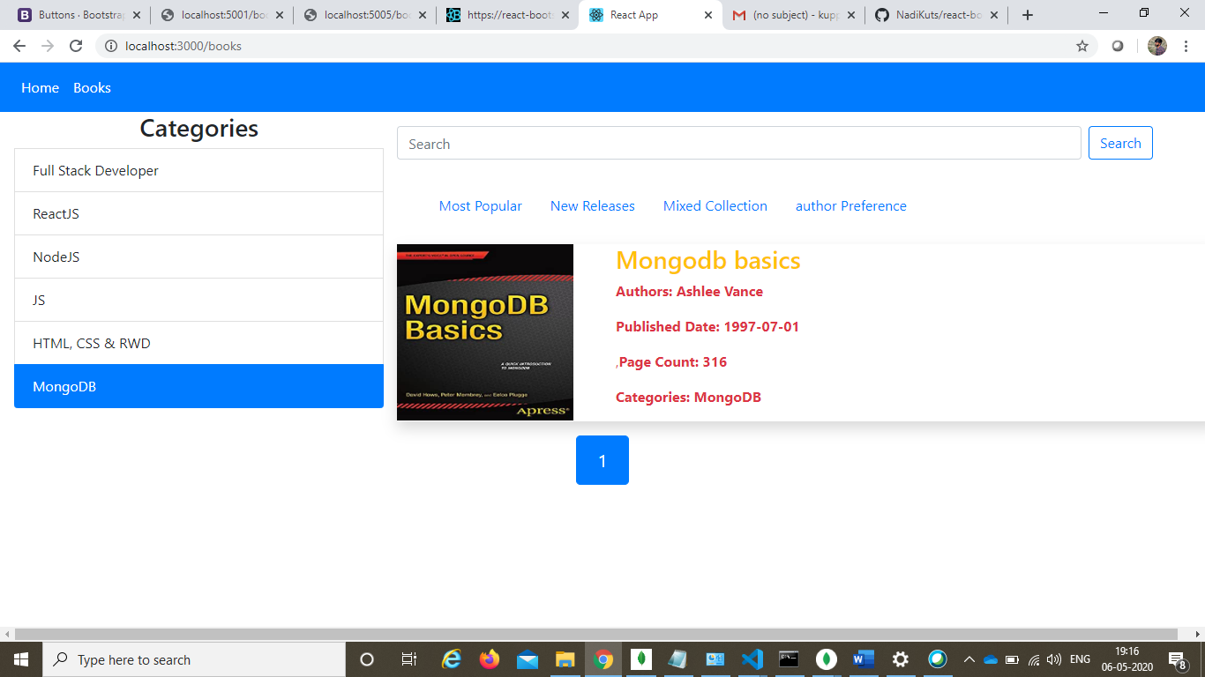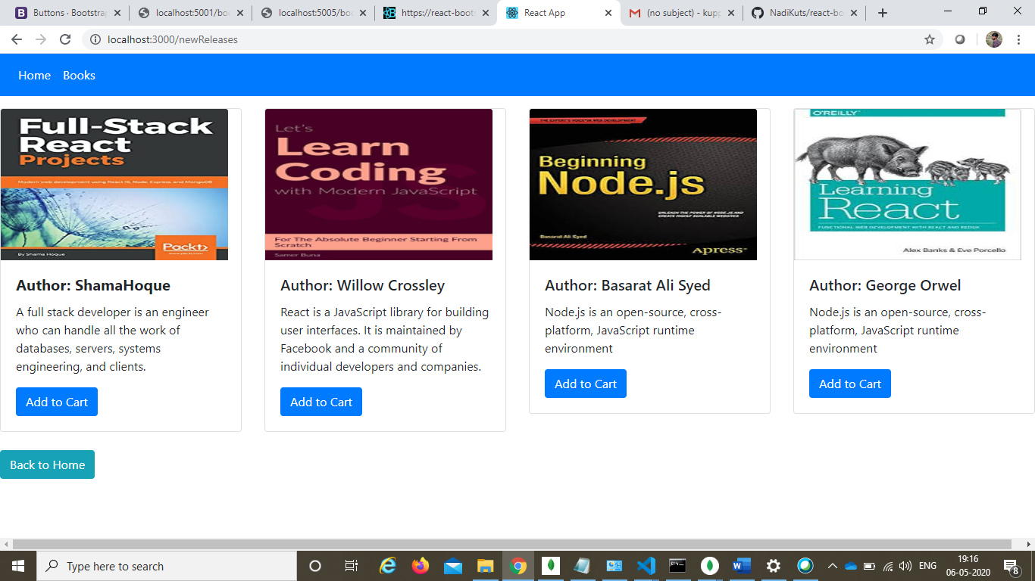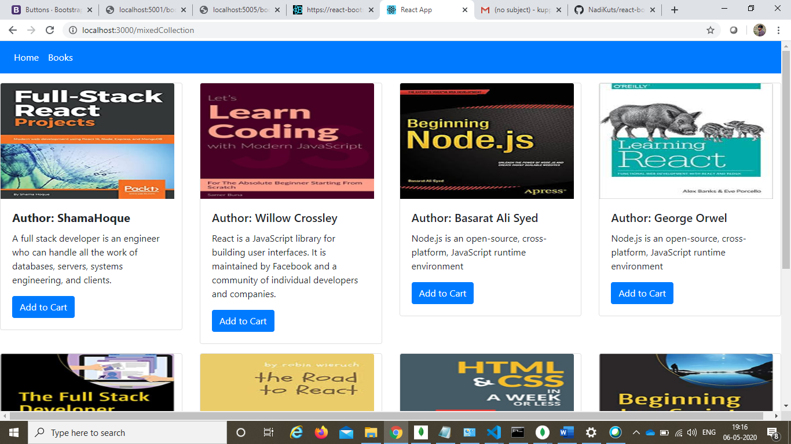

Mongodatabse:

[

{

"_id" : 1,

"title": "Html and Css in a Week or less",

"pageCount": 416,

"rating": 4,

" publishedDate": "2009-04-01",

" authors": "Mr David Cannadine",

"genre": "HTML, CSS & RWD",

"price": 100,

"url": "https://images-eu.ssl-images-amazon.com/images/I/813RgKL-bZL._AC._SR360,460.jpg"

},

{

"_id": 2,

"title": "Pro MernStack",

"pageCount": 592,

"rating": 5,

"publishedDate": "2011-01-14",

"authors": "asan Subramanian",

"genre": "Full Stack Developer",

"price": 150,

"url": "https://m.media-amazon.com/images/I/51vrozt03WL.jpg"

},

{

" _id": 3,

" title": "The Html and CSS workshop",

"pageCount": 0,

"rating": 6,

"publishedDate": "2011-06-03",

"authors": "Ashlee Vance",

"genre": "HTML, CSS & RWD",

"price": 200,

"url": "https://www.packtpub.com/media/catalog/product/cache/e4d64343b1bc593f1c5348fe05efa4a6/9/7/9781838824532-original.png"

},

{

"_id": 4,

" title": "The Road to Learn React",

"pageCount": 576,

"rating": 9,

"publishedDate": "2009-02-02",

"authors": "Robin Wieruch",

"genre": "ReactJS",

"price": 250,

"url": "https://m.media-amazon.com/images/I/31apmbgpwkL.jpg"

},

{

"_id": 5,

"title": "Learning React",

"pageCount": 600,

"rating": 2,

"publishedDate": "2010-11-15",

"authors": "Alex Banks, Eve Porcello",

"genre": "ReactJS",

"price": 300,

"url": "https://m.media-amazon.com/images/I/41IiBTZOGCL.jpg"

},

{

"_id": 6,

"title": "FullStack React",

"pageCount": 425,

"rating": 6,

"publishedDate": "2008-10-01",

"authors": ["Anthony Accomazzo, Nate Murray, Ari Lerner"],

"genre": "ReactJS",

"price": 350,

"url": "https://i.gr-assets.com/images/S/compressed.photo.goodreads.com/books/1495796544i/32705383._UY2000_SS2000_.jpg"

},

{

"_id": 7,

"title":"The Html and CSS basics",

"pageCount": 432,

"rating": 5,

"publishedDate": "2008-12-01",

"authors": "Ashlee Vance",

"genre": "HTML, CSS & RWD",

"price": 400,

"url": "https://images-na.ssl-images-amazon.com/images/I/81tupHf5z5L.jpg"

},

{

"_id": 8,

"title": "React: Up & Running",

"pageCount": 265,

"rating": 1,

"publishedDate": "2010-10-15",

"authors": ["Stoyan Stefanov"],

"genre": "ReactJS",

"price": 450,

"url": "https://images-na.ssl-images-amazon.com/images/I/81PYNxYc4BL.jpg"

},

{

"_id": 9,

"title": "FullStack React",

"pageCount": 375,

"rating": 3,

"publishedDate": "2012-06-04",

"authors": "Shama Hoque",

"genre": "Full Stack Developer",

"price": 500,

"url": "https://images-na.ssl-images-amazon.com/images/I/51HDRK4FC4L.jpg"

},

{

"_id": 10,

" title": "FullStack Developer",

"pageCount": 325,

"rating": 10,

"publishedDate": "2011-12-12",

"authors": ["Chris Northwood"],

"genre": "Full Stack Developer",

"price": 550,

"url": "https://images-na.ssl-images-amazon.com/images/I/41sgpXr+sTL._SX348_BO1,204,203,200_.jpg"

},

{

" _id": 11,

"title": "Head First HTML with CSS & XHTML",

"pageCount": 592,

"rating": 8,

"publishedDate": "2008-01-01",

"authors": ["Eric Freeman, Elisabeth Freeman"],

"genre": "HTML, CSS & RWD",

"price": 600,

"url": "https://images-na.ssl-images-amazon.com/images/I/51Fnp0p8cvL._SX430_BO1,204,203,200_.jpg"

},

{

"_id": 12,

"title": "React in Action",

"pageCount": 258,

"rating": 10,

"publishedDate": "2009-11-01",

"authors": ["Mark Tielens Thomas"],

"genre": "ReactJS",

"price": 650,

"url": "https://images-na.ssl-images-amazon.com/images/I/71W632wBuWL.jpg"

},

{

"_id": 13,

"title": "Mongodb basics",

"pageCount": 316,

"rating": 7,

"publishedDate": "1997-07-01",

"authors": ["Ashlee Vance"],

"genre": "MongoDB",

"price": 700,

"url": "https://images-eu.ssl-images-amazon.com/images/I/51XparJ4P%2BL._SX342_QL70_ML2_.jpg"

},

{

"_id": 14,

"title": "A Smarter Way to Learn HTML & CSS",

"pageCount": 344,

"rating": 3,

"publishedDate": "2008-12-01",

"authors": ["Mark Myers"],

"genre": "HTML, CSS & RWD",

"price": 750,

"url": "https://images-na.ssl-images-amazon.com/images/I/51RgT-XfErL._SX348_BO1,204,203,200_.jpg"

},

{

"_id": 15,

"title": "You Don't Know JS: Scope & Closures",

"pageCount": 550,

"rating": 9,

"publishedDate": "2010-04-16",

"authors": ["Kyle Simpson"],

"genre": "JS",

"price": 800,

"url" : "https://images-eu.ssl-images-amazon.com/images/I/51f-ZfMU3nL._SX342_QL70_ML2_.jpg "

},

{

"_id": 16,

"title": "The Complete Reference HTML and CSS",

"pageCount": 0,

"rating": 9,

"publishedDate": "2011-12-12",

"authors": ["Rob Larsen"],

"genre": "HTML, CSS & RWD",

"price": 850,

"url": "https://www.freepdf-books.com/doc-images/8275.png"

},

{

"_id": 17,

"title": "Node.js 8 the Right Way",

" pageCount": 504,

"rating": 10,

"publishedDate": "1998-06-01",

"authors": ["Jim R. Wilson"],

"genre": "NodeJS",

"price": 900,

"url": "https://images-eu.ssl-images-amazon.com/images/I/51f-ZfMU3nL._SX342_QL70_ML2_.jpg"

},

{

" _id": 18,

"title": "Beginning Node.js",

"pageCount": 550,

"rating": 4,

"publishedDate":"1999-08-01",

"authors": ["Basarat Ali Syed"],

" genre": "NodeJS",

"price": 950,

"url": "https://images-na.ssl-images-amazon.com/images/I/61alsGT8dpL.jpg"

}

]