Applying Machine Learning Algorithms for the Classification of Sleep Disorders
Sleep disorder classification is crucial in improving human quality of life. Sleep disorders and apnoea can have a significant influence on human health. Sleep-stage classification by experts in the field is an arduous task and is prone to human error. The development of accurate machine learning algorithms (MLAs) for sleep disorder classification requires analyzing, monitoring and diagnosing sleep disorders. This paper compares deep learning algorithms and conventional MLAs to classify sleep disorders.
This study proposes an optimized method for the Classification of Sleep Disorders and uses the Sleep Health and Lifestyle Dataset publicly available online to evaluate the proposed model.
Dataset Link:-
https://www.kaggle.com/datasets/uom190346a/sleep-health-and-lifestyle-dataset
The dataset includes approximately 400 rows and 13 columns with various features representing sleep and daily activities. The k-nearest neighbors, support vector machine, decision tree, random forest and artificial neural network (ANN) deep learning algorithms were assessed. The experimental results reveal significant performance differences between the evaluated algorithms.

Screenshots:
To execute this project double click on ‘run.bat’ files. It will give below screen
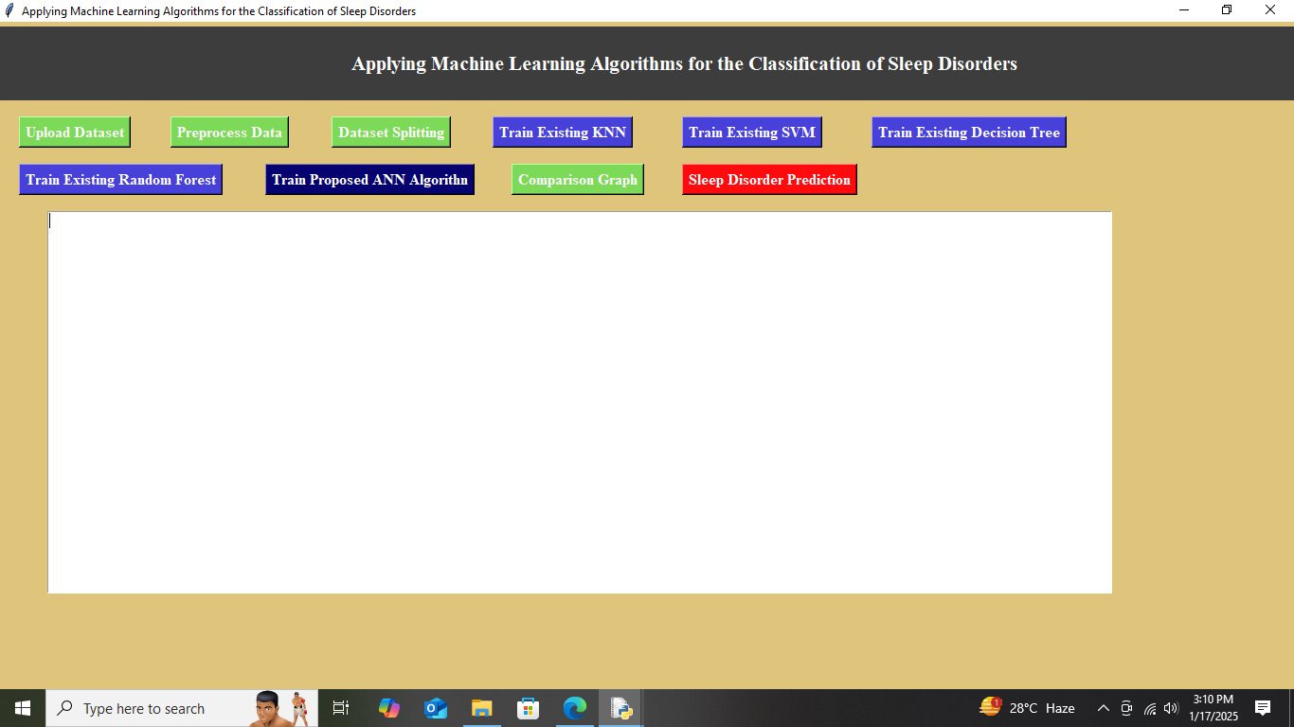
In above screen click on ‘Upload Dataset’ button to get below output
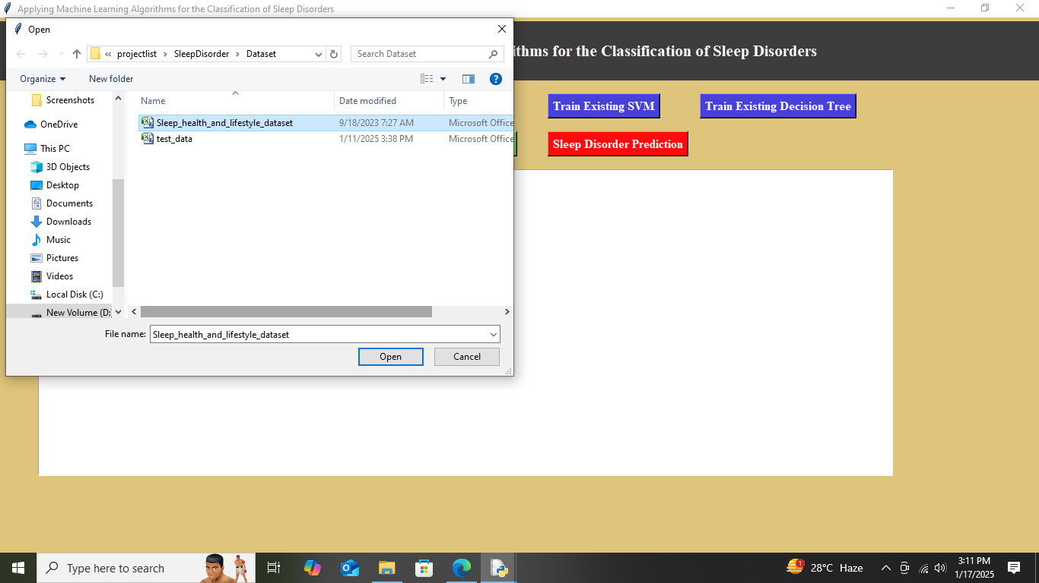
Now select the dataset file as shown in above screen and click on ‘Open’ option to upload the dataset. After uploading dataset you will get below output
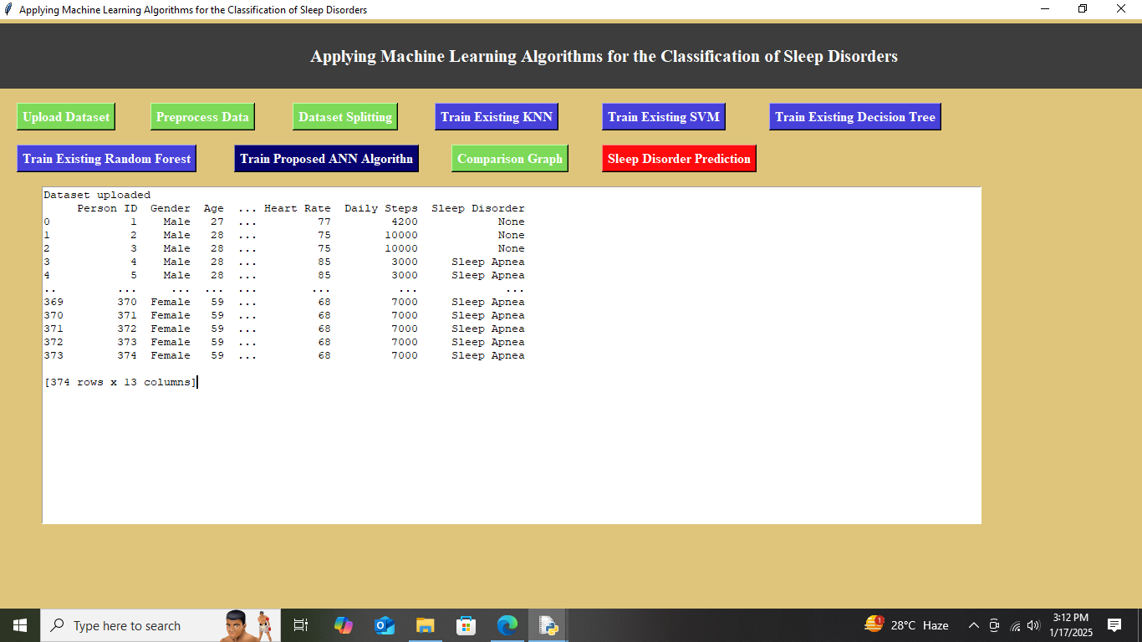
In above screen dataset uploaded. Now click on ‘Preprocess Dataset’ button to get below output
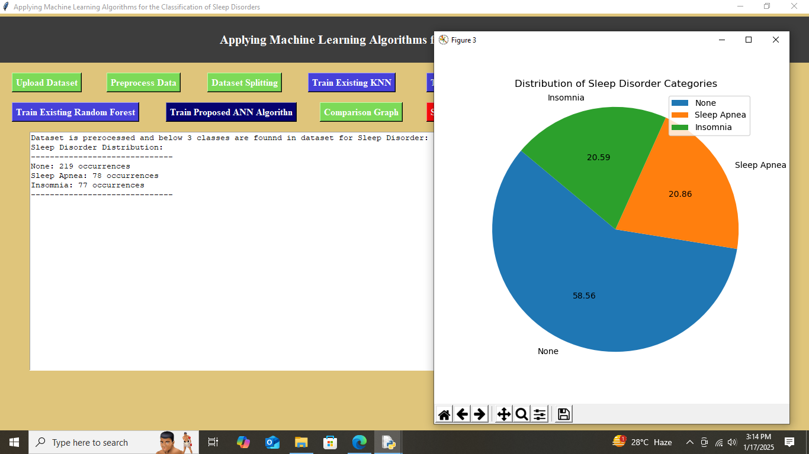
In above dataset is pre-processed and multiple graphs will generate among which the displayed graph is about the type of sleep disorders observed in the dataset. Now click on ‘Dataset Splitting’ button to split the pre-processed dataset into training and testing dataset.
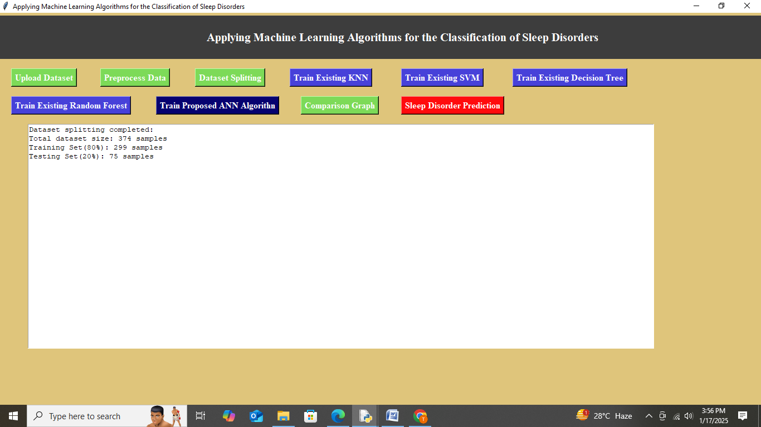
In above screen output represents that the dataset is split into 80% of training dataset and 20% testing dataset which will be used to train and evaluate the model . Now click on ‘Train Existing KNN’ button to get below output
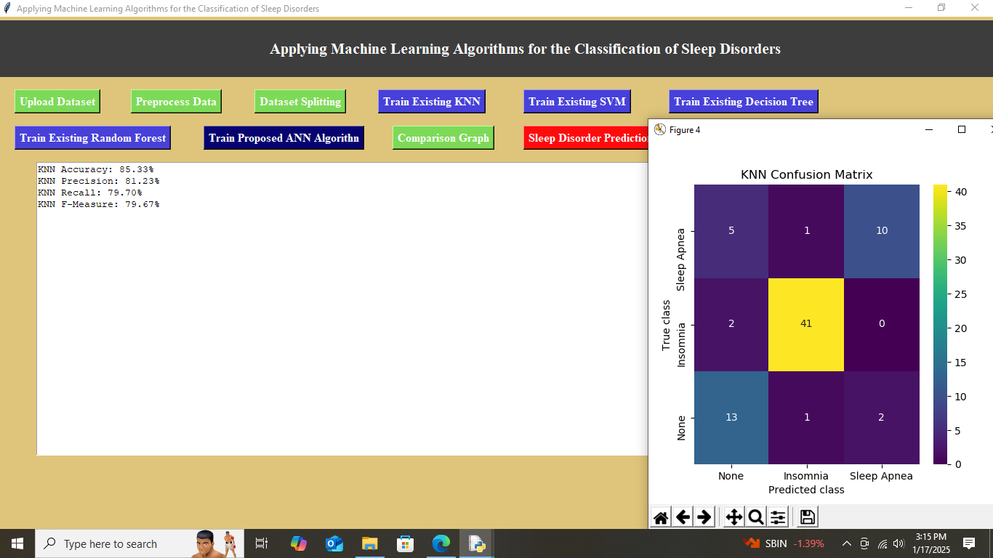
In above screen KNN algorithm is trained and its performance is represented by using different metrics like accuracy, precision, recall and f-measure. In confusion matrix graph x-axis represents Predicted Labels and y-axis represents True Labels where yellow and green boxes(diagonal) contains correct prediction count and blue and purple boxes represents incorrect prediction count. Now click on ‘Train Existing SVM’ button to get below output

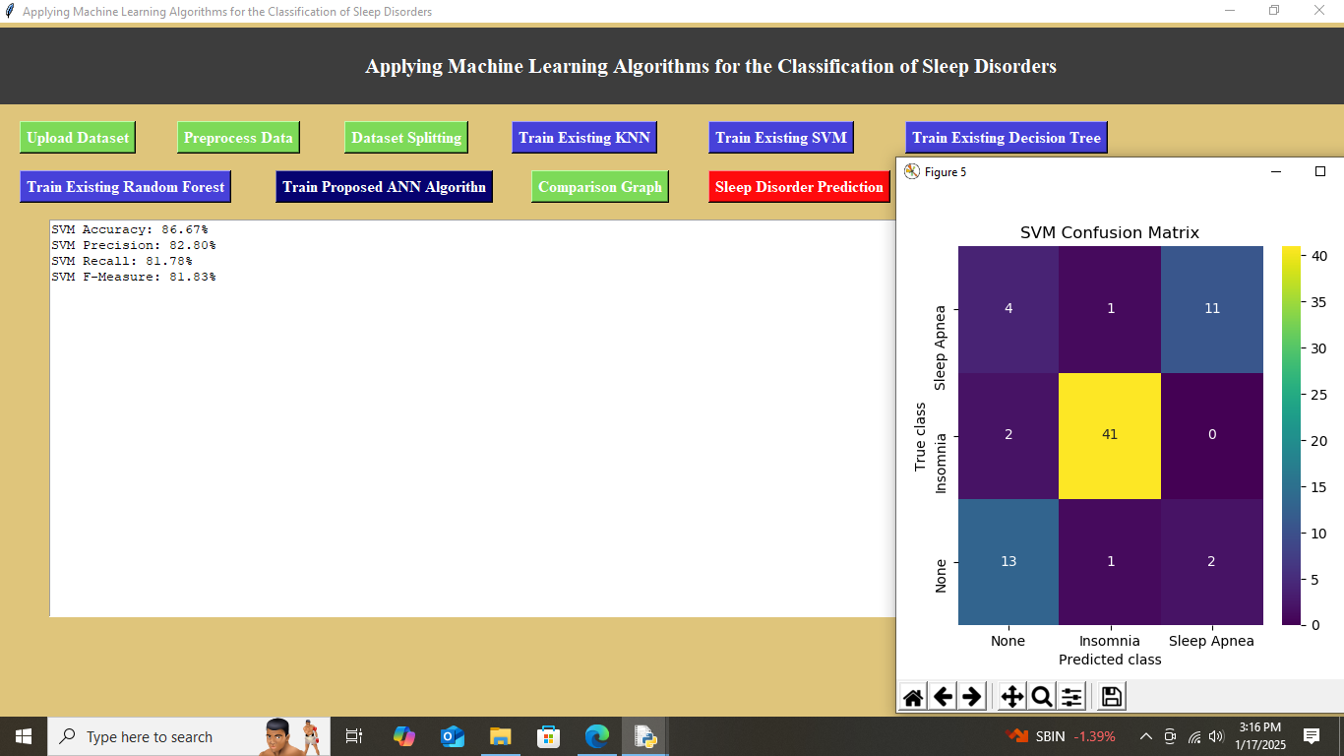
In above screen SVM algorithm is trained and its performance is represented by using different metrics like accuracy, precision, recall and f-measure, along with confusion matrix graph. Now click on ‘Train Existing Decision Tree’ to get below output
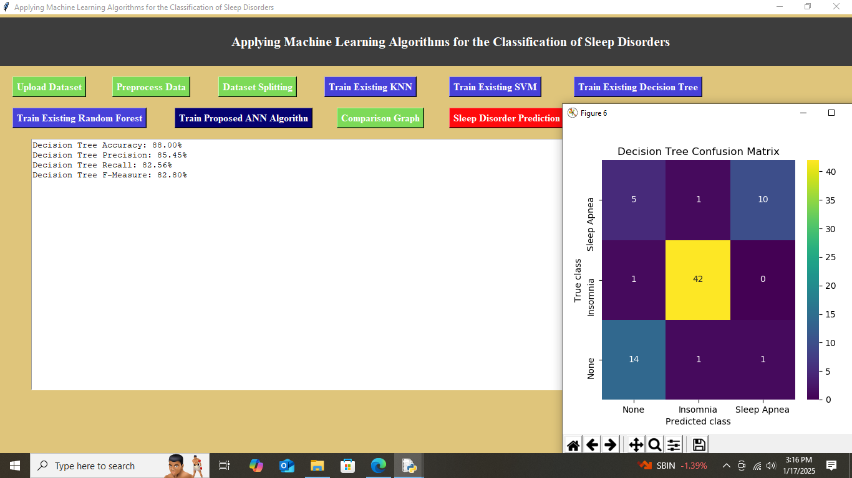
In above screen Decision Tree algorithm is trained and its performance is represented by using different metrics like accuracy, precision, recall and f-measure, along with confusion matrix graph. Now click on ‘Train Existing Random Forest’ to get below output

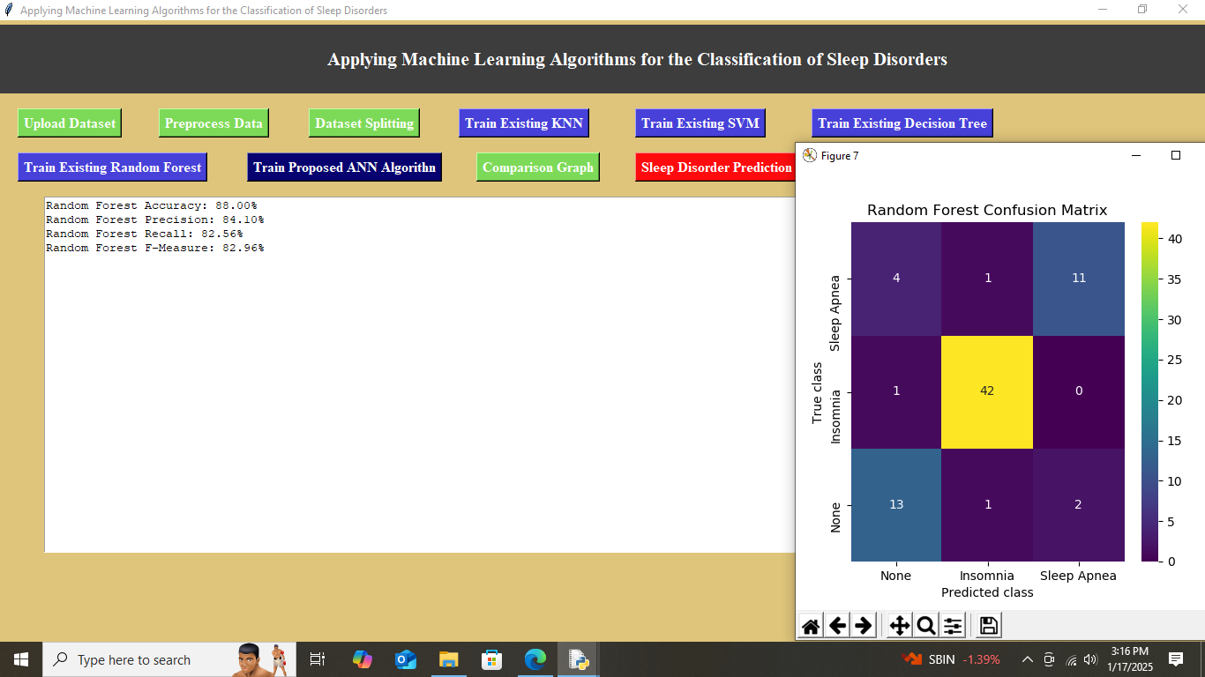
In above screen Random Forest algorithm is trained and its performance is represented by using different metrics like accuracy, precision, recall and f-measure, along with confusion matrix graph. Now click on ‘Train Proposed ANN Algorithm’ to get below output

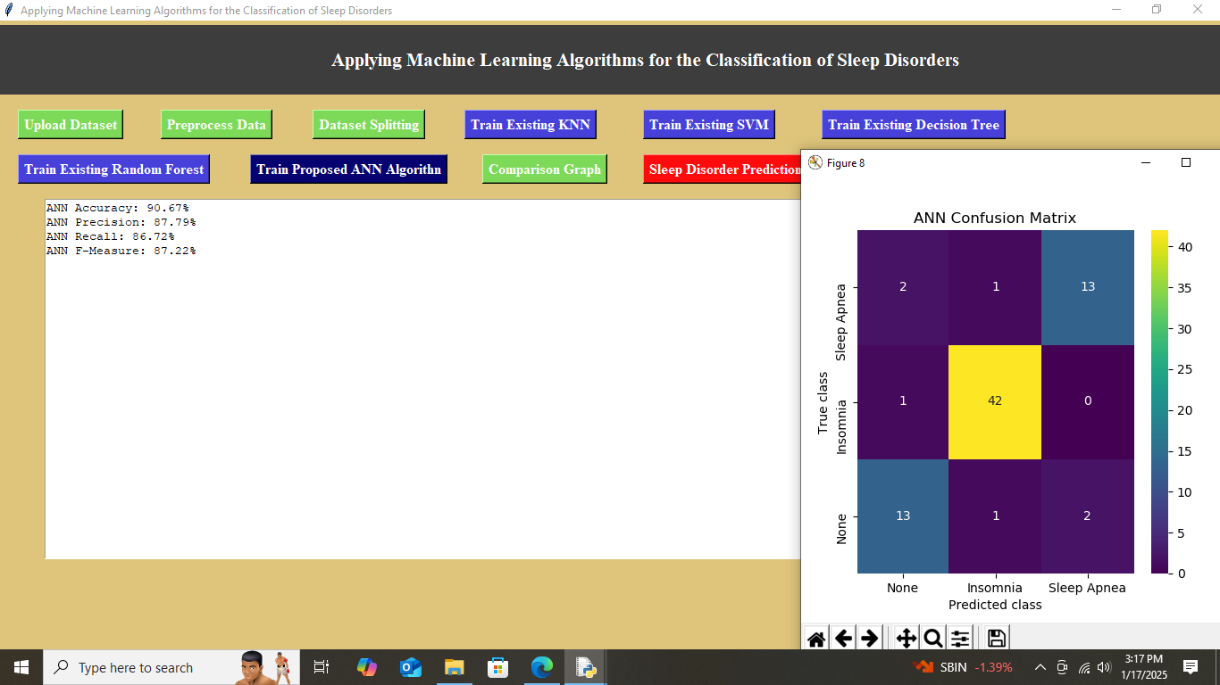
In above screen ANN algorithm is trained and its performance is represented by using different metrics like accuracy, precision, recall and f-measure, along with confusion matrix graph. Among all algorithms ANN algorithm got highest accuracy, hence taken for prediction. Now click on ‘Comparison Graph’ to get below output

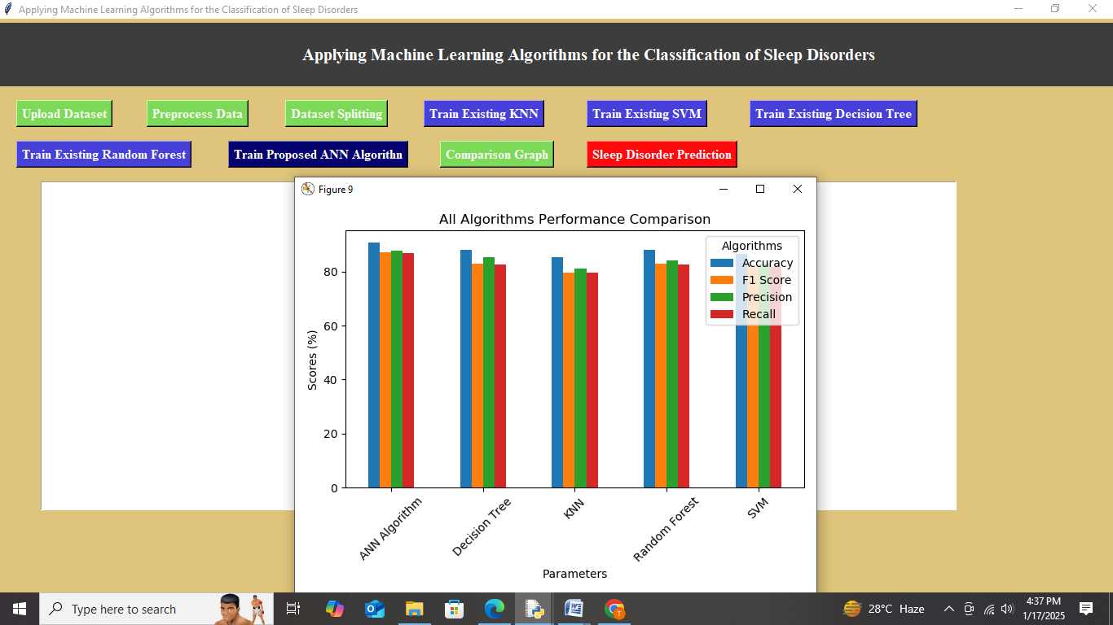
In above screen a comparison graph is represented to compare performance of KNN, SVM, Decision Tree, Random Forest and ANN in terms of accuracy(blue color bar), F1 score(orange color bar), precision (green color bar), and recall(red color bar). Now click on ‘Sleep Disorder Prediction’ button to get below output
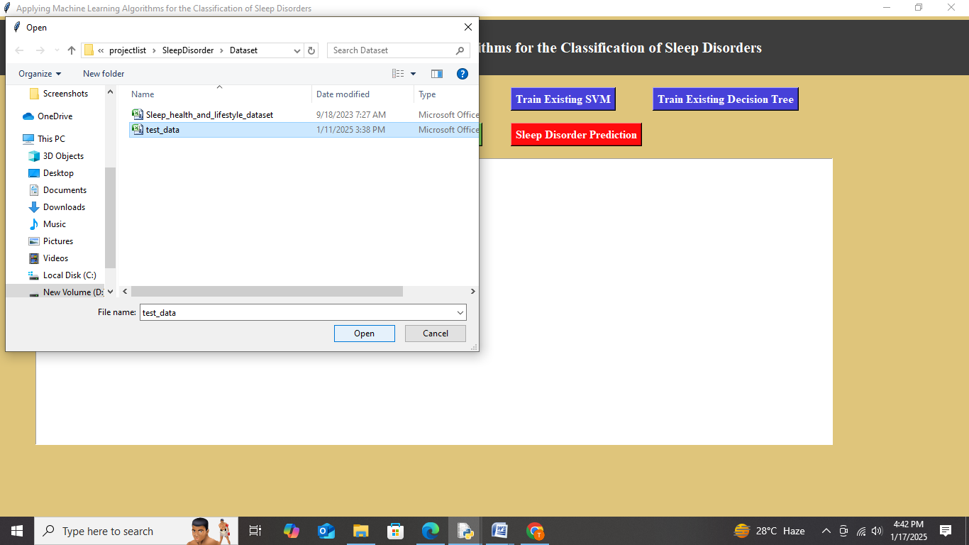
In above screen select ‘test_data.csv’ files and then click on Open option to upload test data. After uploading test data the proposed algorithm will be used for prediction of type of sleep disorder. And will get below output
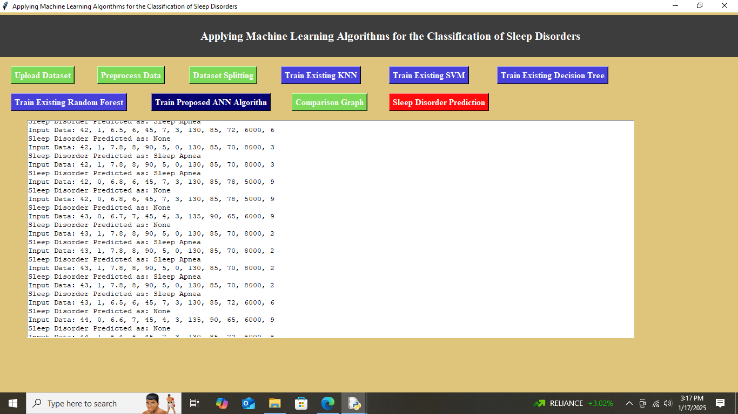
In above screen prediction is done using ANN algorithm. Here 1st line represents Input data which has values taken for prediction after pre-processing and next line represents the sleep disorder prediction.

