IOT BASED ROOM MONITIRING WITH VISITOR COUNTER

Ch.Sai Vardhan

***Abstract*: The objective of the paper is to lessen the high and steadily expanding request of power. As the innovation headways prevail in the present computerized world, we favor more tasteful and more brilliant progressions in straightforward and essential requirements of the living souls, to accomplish the objective we can introduce Programmed Room Observing in each house or workshop lobbies, etc. It utilizes infrared sensors to recognize the people entering and leaving the room and screens the room apparatuses like light, fan and climate control systems. Innovation from the reason for effortlessness has transformed into innovation and developing and generating the electricity at limited scope is a bulky cycle rather we consume less power and moderate it for an economical improvement of energy assets. The proposed model from the paper can screen and control the room machines separate individuals in the room furthermore it can likewise promptly include the quantity of people in a room. It has different applications in the field of consuming energy assets and furthermore as a bi - directional guest counter. *Keywords*: nodemcu, led, sensor,16x2 lcd display.**

# I. INTRODUCTION

The interest for the electronic gadget which have some control over the room machines has an extraordinary flood with the end goal that it tends to be executed in many constant applications like in lodgings, lounge, carport, etc. The model can follow the quantity of people going into and leaving the room and furthermore turns the lights and fans on and off if the room is engaged or vacant respectively. Employing this device in the room diminishes the difficult attempts to look for the switch to light the room immediately you enter. The people entering the room through the Infrared Sensors (shortly IR sensors) and the signal sensed is shipped off the nodemcu for handling and controlling the include in the room and explicitly monitors the lights and fan in the room

# II. HARDWARE REQUIREMENTS

The system mainly uses a nodemcu board for the process of monitoring, led for the process of external switching of the circuit, an LCD Display board to display the person in the room and finally IR Sensors. The list of the components are: used to build the model are listed below along with its perfect model number (if available).

1. Nodemcu esp8266 :-

NodeMCU is a versatile development board that provides WiFi connectivity and a range of digital and analog inputs. It’s ideal for IoT applications and other projects that require wireless communication capabilities is given in figure 1.

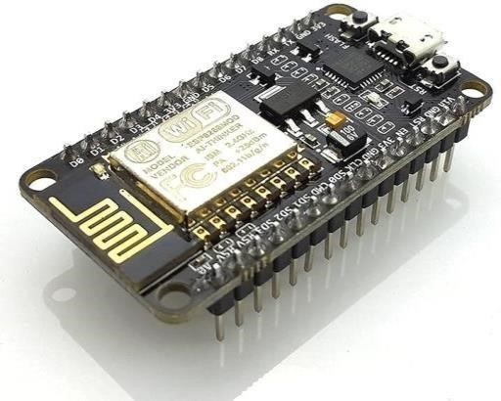

Fig.1 nodemcu

Digital pins are associated with the computerized yield and the simple pins are utilized to get fundamental info signals. It has a 32kb of blaze memory to store the program that is coded for the activity. It is associated with the framework utilizing a B-type link. The product used to code is Arduino IDE 1.8.19 as the most recent form.

1. **LCD–display board:-**

Fluid Gem Show leading body of aspect 16x2 where it can show 32 characters in two lines every one of 16 characters.

It has 16 external holes for connections as shown in figure 2. These result openings can be associated with the bread board with the assistance of male- t o - m a l e delicate pins. It seeks a voltage of 3Vfrom the source provided to the nodemcu board. It has three ground connections accordingly.

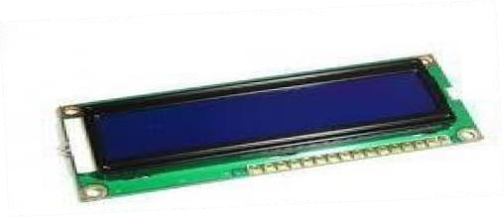

Fig.2 LCD Display Board

1. **Led lights**

An LED (light-emitting diode) is a semiconductor device that emits light when an electric current passes through it. Here’s a summary of how an LED light works and how it is controlled by nodemcu.

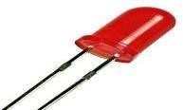

Fig.3 led light

LED is a versatile component that provides visual output in Arduino projects. It can be easily controlled by sending signals from the Nodemcu board to achieve different lighting effects.

1. Infrared sensors:-

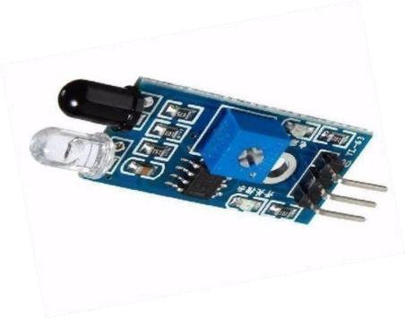

Fig.4 Infrared Sensors

Obstacle detection sensor generates a signal when any object encounters it. It has a transmitter and a receiver at its end. They send analogue signals to the nodemcu for processing. It has two extrapolations facing outwards. They are receiver and transmitter as shown in figure 4. Black colored knob is the transmitter whereas the white colored is receiver. It has three pins to get connected they are for ground, Vcc and sending output signal.

1. Power source:-

Power source for the working of Nodemcu can be given through the 9V DC battery with the assistance of force rope while the elective one is the association of Nodemcu to the PC utilizing B type link. During creating stages, it will be more straightforward to associate with B type link, however as an finished result it encouraged to utilize DC battery.

It requires a limit of 3V, in the constant model the power can be given from the air conditioner attachment by changing into DC.

1. **Potentiometer:-**

It is the device which provides the variable resistance to the circuit. In the LCD board, the third pin is facilitated for contrast adjustment by providing the necessary resistance to it along with the input voltage. It has three external pins to get connected to the circuit, one pin to the resistor terminal and other two pins are connected to both ground

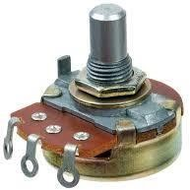

Fig 5 Potentiometer

# III. CIRCUITDIAGRAM

The circuit diagram of the proposed model is shown in figure5. The colored lines specify the wires connecting the circuit elements. To connect various elements in a single port, bread board is used.

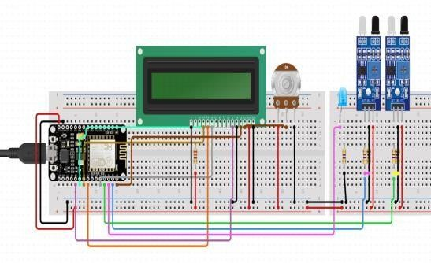

Fig 6 circuit diagram

# IV. METHODOLOGY

The flow of execution of the proposed model is shown below in the figure Micro controller refers to the nodemcu.

The NodeMCU programming involves writing embedded C/C++ code in the Arduino IDE or other supported environments. This code guides the NodeMCU board on how to handle inputs and outputs, as well as Wi-Fi connectivity, enabling a wide range of applications.

*Setup():*

The setup () part gives all the initial setups for the process to begin such as defining the input and output pins and creation of the necessary input variables for processing. This part is executed only once every time the nodemcu is booted. On the off chance that the include in the room is equivalent to zero, the transfer switch is in open mode. To keep away from disparities in including set a condition in the calculation to such an extent that the count shouldn't go before the breaking point zero. On the off chance that count goes under nothing, set the counting variable to zero once more.

*The* ***loop ():***

Part gives all the necessary instructions to the Nodemcu that is to be executed repeatedly throughout the working of the Nodemcu board. The loop () part of the program is executed repeatedlyevery0.6 microseconds. Inside the loop () part, the instructions such as receiving inputs are mentioned. Additionally, the system ensures that the count never drops below zero, maintaining accurate occupancy data and controlling connected devices like lights and fans based on the room’s occupancy status.

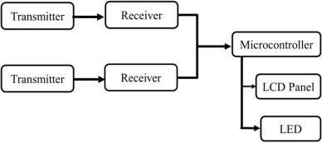

Fig 7 Flow of execution

# V. PROPOSED MODEL WORKING

The IR sensors are set at the entry of the entryway; they are positioned such that one is behind the other, allowing both sensors to detect a person sequentially. The rationale behind the working of the counting system is straightforward: when an individual crosses the sensor close to the entryway and then the sensor farther away, it recognizes this as an increment in the count. Conversely, if the individual crosses the sensor placed farther from the entryway first and then the sensor close to the entryway, it will be decremented. An increment indicates that an individual has entered the room, while a decrement signifies the individual leaving the room. It is to be noted that the two sensors should not be simultaneously detected, so the sensors should be placed apart from one another, narrowed to the entry area.

The LCD board gets refreshed at each instance as the time delay is minimal, in a few milliseconds, so that the count display is not lagged at any instance. A potentiometer is connected to the LCD to adjust the contrast of the LCD display panel. Lights and fans can be connected to the relay such that they start working as soon as the relay switch gets closed. The opening and closing of the relay are controlled by the NodeMCU board. If the count in the room is zero, the relay switch is in open mode. The relay gets closed as soon as the count is raised above zero. To avoid discrepancies in counting, a condition is set in the algorithm such that the count should not go below zero. If the count goes below zero, the counting variable is reset to zero.

This system effectively automates room occupancy monitoring by utilizing sequential IR sensor detection to track entry and exit. When the individual crosses the sensor near the entryway first and then the sensor away, the system increments the count, signifying someone has entered the room. Conversely, if the individual crosses the sensor away from the entryway first and then the sensor near the entryway, the count is decreased, indicating someone has left. The NodeMCU board processes these inputs and updates the LCD display in real-time to reflect the current occupancy. Additionally, the system ensures that the count never drops below zero, maintaining accurate occupancy data and controlling connected devices like lights and fans based on the room’s occupancy status.

VI. PSEUDOCODE FOR LOOP PART**:**

The Pseudocode printed below is with proper Code.

if((sensor1==LOW) ready_ent=1;

if(ready_ent==1&&sensor2==LOW)

##personcrossesthesensor2aftercrossingthesensor1 count=count+1

led=HIGH;

##asthepersoncrossesbothsensors,countrisesto1

else if((sensor2==LOW)

(ready_exit=1)

##personcrossesthesensor2andstandingbefores1

If(ready_exit==1&&sensor1==LOW)

##personcrossesthesensor1aftercrossingsensor2 count=count-1 if(count<=0)

led=LOW;

##person moves out, count decreases endif

endif

lcd.print(count);

# VII. FLOWCHART

The Complete flow of working is given in the flow chart below in the figure 7. It completely gives a clear-cut idea of the working and the code. It explains the case conditions for the LCD display.

Lights and fans can be associated with the relay such that they get everything rolling working at once their lay switch gets shut. The opening and shutting of the hand-off are constrained by the Nodemcu board. On the off chance that the include in the room is equivalent to zero, the transfer

switch is in open mode. The hand-off gets shut on the double the count is raised more noteworthy than 1. To keep away from disparities in including set a condition in the calculation to such an extent that the count shouldn't go before the breaking point zero. On the off chance that count goes under nothing, set the counting variable to zero once more.

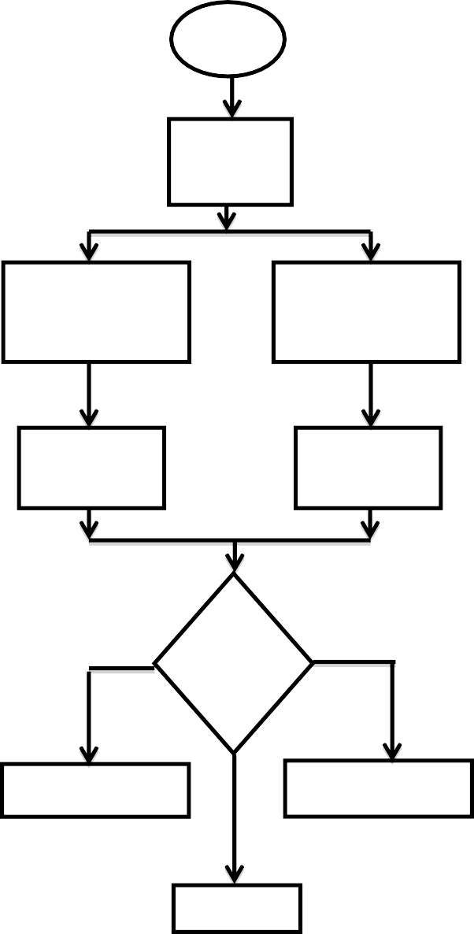

START

Object

detect

through

Cross

sensor1 &

then

sensor

2

Cross

sensor

2

&

then

sensor

1

Count

inc

Count

dec

Yes

No

Iscoun

t<=0

Switch

off

led

Switch

on

led

LCDDisplay

Fig.8 Sequential Execution of Code and the circuit connection is shown in figure 6.

# VII. EXPERIMENTAL RESULTS

The proposed paper is tested and experimented with a model, where the working is based on the IR sensor in the following cases.

The room appliances are in off state, if there is nobody in the room which implies that energy is getting conserved instead of wasting. The gives the additional transfers to the framework, it have some control over the lights of a workshop lobby at segments, with the end goal that if the count is around 10, then the initial segment alone will be lit, in the event that the count is around 50, the subsequent part will also be lit, etc. It decreases the weight of the board and helps in saving energy and Fan Control for Room, International Journal of Advanced Research in Electrical, Electronics and Instrumentation Engineering.

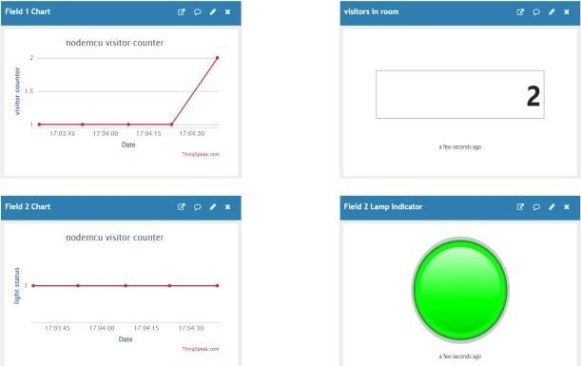

Fig 9. Thingspeak data counting

VIII. CONCLUSION

Visitor counters can be executed in non-industrial nations which are valuable for change of homes to savvy homes. To override the old act of counting the number of individuals entering and leaving the room individually VC can be carried out which watches out for the include of people in the room. In the following power limited scale energy conservation might be seen as small amount, whereas in the enormous scope business region like shopping centers, schools, clinics it is huge amount as the energy is squandered at a huge scope. Furthermore, adding

The IR sensors are set at the entry of the entryway; it is put with the end goal that one is available behind the other that is both the sensors can identify the individual sequentially. The rationale behind the working of the counting system is straightforward, when the individual crosses the sensor.

IX. REFERENCES

1. Anjali Sinha, Arpita Singh, Deepa Singh, Parul Singh , Anil Maurya and Mahesh Kumar Singh, Automatic Room Light Controller with Visitor Counter, International Journal on Emerging Technologies (Special IssueNCETST-2017) 8(1): 172-175(2017).
2. Muhammad Umar Farooq, Aamna Shakoor, Abu Bakar Siddique,

ARM based Bidirectional Visitor Counter and Automatic Room

Light Controller using PIR sensors, Advances in Science,

Technology and Engineering Systems Journal Vol. 1, No. 5, 10-15 (2016).

1. Subhankar Chattoraj, Aditya Chakraborty, Bidirectional Visitor Counter with Automatic Room Light Controller and Arduino UNO as the master controller, International Journal of Scientific and Research Publications, Volume 6, Issue 7, July 2016.
2. Mahmud Hossain Jewel, Jahid Hasan, Nazmul Islam, Automatic

Room Light Control Using Bidirectional Visitor Counter and Gas

Detection, Faculty of Sciences and Engineering, East West University.

1. <https://www.youtube.com/watch?reload=9&v=61H8pc5TAM0>
2. Mangesh Nikose, Krutika Gaikwad, Priyanka Gamne, Aaishwarya Bodke, A Survey on Bidirectional Visitor Counter with Automatic light
3. [https://circuitdigest.com/microcontroller-projects/automatic-room- lightcontroller-with-bidirectional-visitor-counter-using-Arduino](https://circuitdigest.com/microcontroller-projects/automatic-room-light-controller-with-bidirectional-visitor-counter-using-Arduino%20UNO)
4. Ying-Wen Bai and Fu-Jen, “Automatic room light intensity detection and control using a microprocessor and light sensors.”
5. Kadam Shah, Prakash Savaliya and Mitesh Patel, “Automatic Room Light Controller with Bidirectional Visitor Counter,” International Journal of ICT Research and Development (IJICTRD), Vol-1 Issue-4, ISSN: 2395-4841.
6. Gaurav Waradhar, Hitesh Ramina, Vinay Maitry, Tejasvi

Ansurkar, Asha Rawat and Parth Das, “Automatic Room Light Controller with Bidirectional Visitor Counter,” International Journal of Engineering Science and Computing (IJESC), March 2016.

1. U.N Yogakartha, S.Parking, Priyanka Gamne, Aaishwarya Bodke, A Survey on Bidirectional Visitor Counter with Automatic light.