**DATABASE ARCHITECTURE**

What is Database Architecture?

A database architecture is the design and organization of a database system, including its structure, strategy, and principles. It’s the foundation of a Database Management system and is crucial to the efficiency and effectiveness of data management. Database architecture dictates how data is stored, organized, and retrieved, and ensures efficient data handling,

Database architecture uses a programming language to design software for businesses and organizations. It focuses on the design, development, implementation, and maintenance of computer programs that store and organize information

Types of Architecture:

1. One Tire Architecture
2. Two Tire Architecture
3. Three Tire Architecture
4. N Tire Architecture

* **One Tire Architecture:**

One-tier architecture also known as single-tier architecture is a software architecture where all the components needed for an application to work are in the same environment or package. It means the application layer and database layer in the same machine

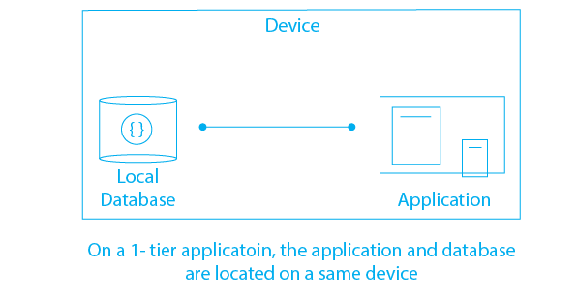

Advantages of One tier Architecture:

* It has low cost-effectiveness
* It can perform better for small to medium-sized databases
* It is simple to understand and develop because there is no separation between layers

Disadvantages of One-Tier Architecture:

* Only one user can access the system at a time
* Can’t share the information between client machine
* Can be affected by machine changes

Example: Billing system, single organization data storage like schools, colleges

* **Two-Tier Architecture:**

Two Tire Architecture, also known as client-server architecture, is a software architecture model that splits an application into two distinct parts, or tiers, called the client and server tiers.

Each tier has specific responsibilities and functions within the application, and they communicate with each other to provide the desired functionality

In a two-tier architecture, the client interacts directly with the server. The client, which is the user-side device, gives instructions, and the server, which stores all the data and information, is asked to provide the required data or make changes to the existing data.

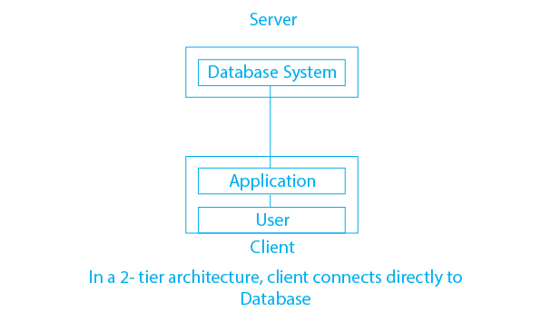

Advantages of Two-tier Architecture:

* It is simple and easy to understand
* It is less expensive to implement and maintain
* The client software can be deployed on individual machines, Making it easier to manage to update

Disadvantages of Two-tier architecture:

* As the number of user’s increases, application performance can degrade.
* It can be difficult to implement reliable security because users need login information for each data server.
* It is difficult to scale because each client requires its own database session.
* **Three Tire Architecture:**

Three-tier architecture is a software development model that organizes applications into three logical and physical computing tiers

1. Presentation tier
2. Application Tier
3. Data tier

**Presentation Tier:** It is also known as a frontend, user interface this provides a graphical user interface for users to interact with the system.

**Application Tier:** It is also known as the middle tier, this tier handles business logic and processes user inputs.

**Data Tier:** It is also known as the backend, this tier stores, manages, and retrieves the application's data.

Three-tier architecture is a fundamental design framework for modern software development. It can improve maintainability, provide greater flexibility for expansion, and ensure higher reliability. It meets business requirements effectively in complex network environments.

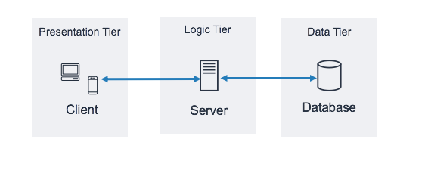

Advantages of three-tier architecture:

* It is beneficial to improve scalability
* It improves data integrity. Here, all the updated information goes through the second tier. The second tier can ensure that only important information is allowed to be updated in the database and the risk of unreliable client applications corrupting information is removed.
* Balancing of the load is much easier with the division of core business from the server of the database.
* Better to reuse
* Improve data integrity
* Improve security

Disadvantages of three-tier architecture

* It is more complex than the two-tier client-server computing model because it is more difficult to build a 3-tier application compared to a 2-tier application. The points of communication are doubled.
* A separate proxy server may be required
* Improve complexity and effort
* **N-tier architecture:**

N-tier architecture is also known as multi-tier architecture, is a software engineering approach that separates an application into logical layers and physical tiers to manage dependencies and responsibilities. The “N” in the name refers to any number of tiers involved. Each tier has a specific responsibility, and higher layers can use services in lower layers.

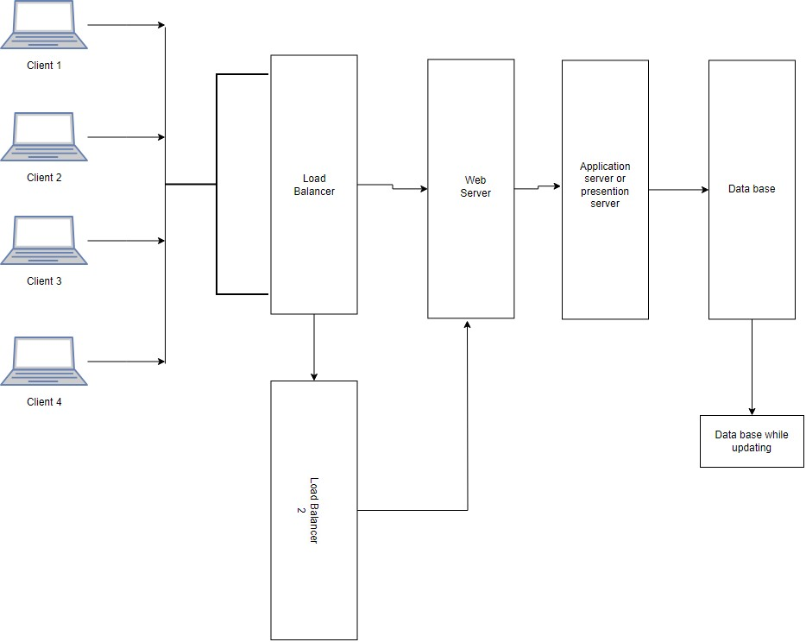

Advantages of N-tier architecture:

* Resources can be added to each tier without affecting the other tiers.
* Ease of management: Each tier can be managed separately without affecting the other tiers.
* It has a high security

Disadvantages of N-tier architecture:

* It increases the complexity and overhead of the application