Day 1 Class of DevOps

Agenda – Python

1. How to install python

* First of all we need to download the python .exe file from python.org website currently version 3.12.3 is available right now
* Once we download the file from web site we need select the PATH and user setting
* If PATH is not available at location we need to create manually by using edit environment setting at this setting we need to choose the PATH
* Python will give basic IDEL

IDE- Integrated Development Environment

1. Python Community

* Python is an open source it mean everyone can access and it is a completely free platform
* Python Community is used for to communicate every user and admin
* We can develop the new features
* But it would be update by the Community Admin, Before going to release the update they will release the Beta version for certain people for testing once it got approve version would be release, But new version would be release by collection with number of updates

1. Install IDE

* We have number of IDE like Pycharm , anaconda, Visual Studio
* Currently we are using Pycharm
* Python will provide the Default IDEL but it would Run the program line by line so we are using Python IDE like Pycharm, Anaconda, Visual Studio

1. Run Program

* First we need to type print statement to print the OUT PUT

Program- print(“Hello World”)

Out Put – Hello world

Second Program

Display the existing values

num1 = 5

Here input is taking as num1

num2 = 3

Here input is taking as num2

sum_result = num1 + num2

print(“sum result is”, sum_result)

print(sum_result)

Out Put- 8

Third program

Display the integer value as requested format

num1 = (int(input(Enter the first number \n) \n🡪 means new line

num2 = (int(input(Enter the second number \n)

sum_result =num1 + num2

print(“The sum is”, sum_result)

Out Put - Enter the first number

5

Enter the Second number

5

Answer= 10

No need to print input in new line no need to add \n

Example

num1 = (int(input(Enter the first number )

num2 = (int(input(Enter the second number )

sum_result =num1 + num2

print(“The sum is”, sum_result)

Out Put-

Enter the first number 5

Enter the first number 5

Answer = 10

* Need to break the code line we called as Comment we use hash(#) and comment

# num2 = (int(input(Enter the second number )

Example:

num1 = (int(input(Enter the first number )

#num2 = (int(input(Enter the second number )

sum_result =num1 + num2

print(“The sum is”, sum_result)

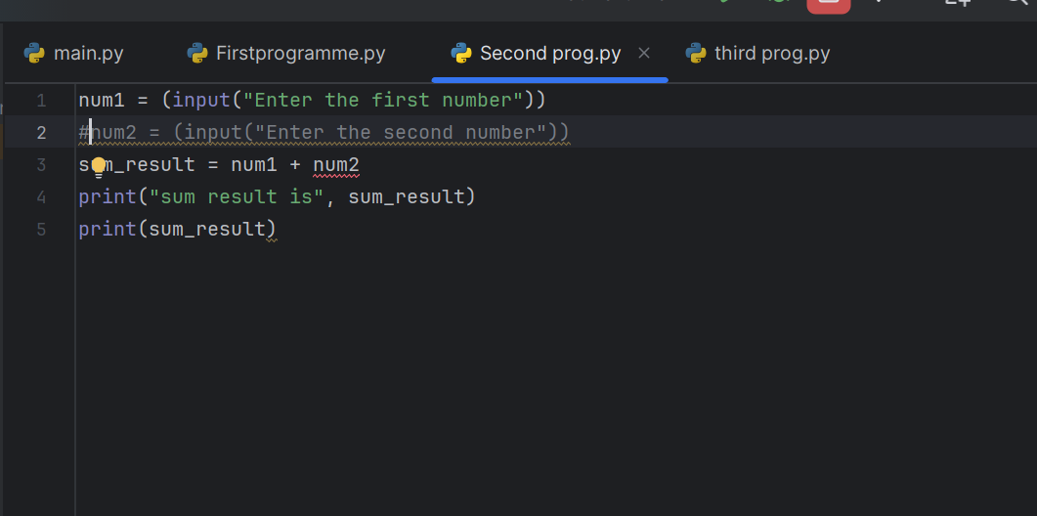

* For maximum line use three single quote from starting comment line to ending comment line