MARKETING CAMPAIGN
PERFORMANCE ANALYTICS
A Data Analytics Project Report

Exploratory Data Analysis, KPI Evaluation, and Dashboard-Based
Insight Generation from a 200,000-Campaign Marketing Dataset

Prepared by: | Sai Varshini R
Course: | Data Analytics
Tools Used: | Python (Pandas, NumPy), Power BI
Dataset Size: | 200,000 campaign records
Date: | September 12, 2026

Table of Contents
No. | Section | Page
1 | Executive Summary | 3
2 | Introduction & Objectives | 3
3 | Dataset Description | 4
4 | Methodology | 5
5 | Exploratory Data Analysis | 5
6 | Category Comparison Summary | 11
7 | Power BI Dashboard Overview | 11
8 | Key Findings | 14
9 | Recommendations | 14
10 | Limitations | 15
11 | Conclusion | 15
12 | Appendix | 15

1. Executive Summary
This report presents a comprehensive exploratory data analysis (EDA) of a marketing campaign performance dataset containing 200,000 individual campaign records spanning the full 2021 calendar year. The dataset was cleaned in Python (Pandas and NumPy) in Google Colab, exported as a CSV file, and loaded into Power BI to build a three-page interactive dashboard. This document consolidates that workflow with a category-by-category KPI comparison and a page-by-page dashboard review into a single, structured deliverable.
The dataset covers five companies (TechCorp, Alpha Innovations, DataTech Solutions, Innovate Industries, and NexGen Systems), five campaign types (Email, Search, Display, Influencer, and Social Media), six marketing channels (Google Ads, YouTube, Instagram, Facebook, Website, and Email), and five customer segments, target audience groups, locations, and languages respectively.
The differences in average ROI and conversion rate across channels, campaign types and customer segments were very small in this dataset — average Return on Investment (ROI) and Conversion Rate stay within a narrow band of one another across campaign type, channel, customer segment, company, and location (differences under 0.7%). This is, in itself, a meaningful and reportable finding: it suggests that campaign performance in this dataset does not vary much by the categorical attributes examined, and that any single-channel or single-segment recommendation would not be well supported by the data. Where genuine structure does exist — most notably the mechanical relationship between Clicks, Impressions, and Click-Through Rate (CTR) — this report quantifies and visualizes it.
The sections that follow walk through the dataset structure, the methodology used, detailed exploratory visualizations, a category-by-category KPI comparison, a page-by-page review of the accompanying three-page Power BI dashboard (including one concrete fix identified in its KPI card configuration), and a set of evidence-based findings and recommendations.

2. Introduction & Objectives
Marketing teams routinely run large numbers of campaigns across multiple channels, audiences, and time periods, generating rich but often underexploited performance data. The objective of this project was to take a raw marketing campaign dataset through a complete analytics workflow: cleaning and preparing the data, performing exploratory and KPI-comparison analysis, and communicating results through both a written report and an interactive Power BI dashboard.

2.1 Project Objectives
- Clean and validate a large-scale (200,000-row) marketing dataset for analysis.
- Explore the distribution and relationships of key performance indicators (KPIs): Conversion Rate, ROI, Acquisition Cost, Clicks, Impressions, CTR, and Engagement Score.
- Compare campaign performance across campaign types, channels, customer segments, companies, and geographies.
- Compare average KPI values across campaign types, channels, customer segments, and companies to see whether any category stands out.
- Build an interactive Power BI dashboard to allow stakeholders to explore the data dynamically.
- Translate the findings into clear, actionable recommendations for marketing strategy.

2.2 Tools and Workflow
The workflow followed a standard end-to-end analytics pipeline: raw data was ingested and cleaned in Python using Pandas and NumPy in Google Colab (handling formatting, duplicate checks, and validation of the 16 original fields), then exported as a cleaned CSV file, with a new CTR (Click-Through Rate) column calculated and added during cleaning. That CSV was imported into Power BI Desktop to construct a three-page interactive dashboard with filters, KPI cards, and drill-down visuals. This report combines that dashboard with a narrative walkthrough of the KPI analysis to highlight which patterns are genuine.

3. Dataset Description
The original dataset contains 200,000 rows and 16 columns. During cleaning, a new column, CTR (Click-Through Rate), was calculated from Clicks and Impressions and added to the dataset, bringing the cleaned/derived dataset to 200,000 rows and 17 columns, with no missing values in any field. Table 1 summarizes each field and notes which one was derived.
Field | Type | Description
Campaign_ID | Integer | Unique identifier for each campaign record (1–200,000)
Company | Categorical | Company running the campaign (5 companies)
Campaign_Type | Categorical | Email, Search, Display, Influencer, or Social Media
Target_Audience | Categorical | Demographic target group (e.g., Men 18-24, All Ages)
Duration | Categorical | Campaign length: 15, 30, 45, or 60 days
Channel_Used | Categorical | Distribution channel (Google Ads, YouTube, Instagram, Facebook, Website, Email)
Conversion_Rate | Numeric | Proportion of engaged users who converted (0.01–0.15)
Acquisition_Cost | Numeric | Cost to acquire customers via the campaign, in USD ($5,000–$20,000)
ROI | Numeric | Return on investment multiple (2.0x–8.0x)
Location | Categorical | City where the campaign ran (5 U.S. cities)
Language | Categorical | Campaign language (English, Spanish, French, German, Mandarin)
Clicks | Integer | Number of clicks generated (100–1,000)
Impressions | Integer | Number of impressions served (1,000–10,000)
Engagement_Score | Integer | Composite engagement rating (1–10)
Customer_Segment | Categorical | Audience persona (e.g., Foodies, Tech Enthusiasts)
Date | Date | Campaign date (Jan 1 – Dec 31, 2021)
CTR | Numeric (derived) | Click-Through Rate = Clicks ÷ Impressions × 100
Table 1. Data dictionary for the cleaned marketing dataset.

3.1 Data Quality Notes
- No null or missing values were found in any of the 200,000 records.
- CTR was verified to be a deterministic function of Clicks and Impressions (CTR = Clicks / Impressions × 100) across all rows, with no discrepancies.
- All five categorical dimensions (Company, Campaign_Type, Channel_Used, Location, Language, Customer_Segment, Target_Audience) are evenly represented, each category accounting for roughly 20% (or 1/6 for Channel_Used) of records — consistent with a balanced, likely synthetically generated dataset.
- The dataset spans exactly one calendar year (January 1 to December 31, 2021), with 16,000–17,000 campaigns recorded per month.

4. Methodology

4.1 Data Preparation
Data cleaning was performed in Python (Pandas and NumPy only) within Google Colab. This included type validation for numeric fields, standardization of categorical labels, and confirmation that no duplicate Campaign_ID values existed and no fields contained missing values. The cleaned dataset was exported as a CSV file for downstream dashboarding.

4.2 Exploratory Data Analysis
Descriptive statistics (mean, median, standard deviation, min/max) were computed for all numeric fields using Pandas. Categorical breakdowns were produced by grouping the dataset on each categorical field and computing average Conversion Rate, ROI, Acquisition Cost, CTR, and Engagement Score per group — the same groupings later built as interactive visuals in the Power BI dashboard.

4.3 Category Comparison
To see whether the differences in average ROI and Conversion Rate visible across categories (Campaign Type, Channel, Customer Segment, Company) pointed to a real pattern, this project computed the average value of each KPI within every group and compared the spread between the highest and lowest group averages.

4.4 Dashboard Development
The cleaned CSV was imported into Power BI Desktop, where a three-page interactive dashboard was built featuring KPI summary cards, slicers for Date, Company, Campaign Type, Channel, Customer Segment, Target Audience, and Location, and drill-down visuals (bar charts, donut charts, scatter plots, and matrix tables) covering the same KPIs analyzed in Python.

5. Exploratory Data Analysis
This section presents the core exploratory findings, moving from overall metric distributions to comparisons across campaign type, channel, company, customer segment, and time.

5.1 Summary Statistics
Metric | Mean | Median | Std Dev | Min | Max
Conversion Rate | 0.080 | 0.080 | 0.041 | 0.01 | 0.15
Acquisition Cost ($) | 12,504 | 12,497 | 4,338 | 5,000 | 20,000
ROI (x) | 5.00 | 5.01 | 1.73 | 2.00 | 8.00
Clicks | 550 | 550 | 260 | 100 | 1,000
Impressions | 5,507 | 5,518 | 2,598 | 1,000 | 10,000
Engagement Score | 5.49 | 5.00 | 2.87 | 1 | 10
CTR (%) | 14.04 | 9.98 | 13.09 | 1.01 | 99.20
Table 2. Descriptive statistics for the seven core numeric KPIs (n = 200,000).

5.2 Distribution of Key Metrics
Figure 1 shows the distribution of the four headline metrics. Conversion Rate, Acquisition Cost, and ROI are all close to uniformly distributed across their respective ranges — every value between the minimum and maximum is roughly equally likely, which is a strong signature of randomly generated data rather than organically observed business results. CTR, by contrast, is right-skewed: because it is calculated as Clicks divided by Impressions, most campaigns cluster at lower CTR values (5–15%) with a long tail of high-CTR campaigns where a relatively small number of impressions produced a disproportionate number of clicks.
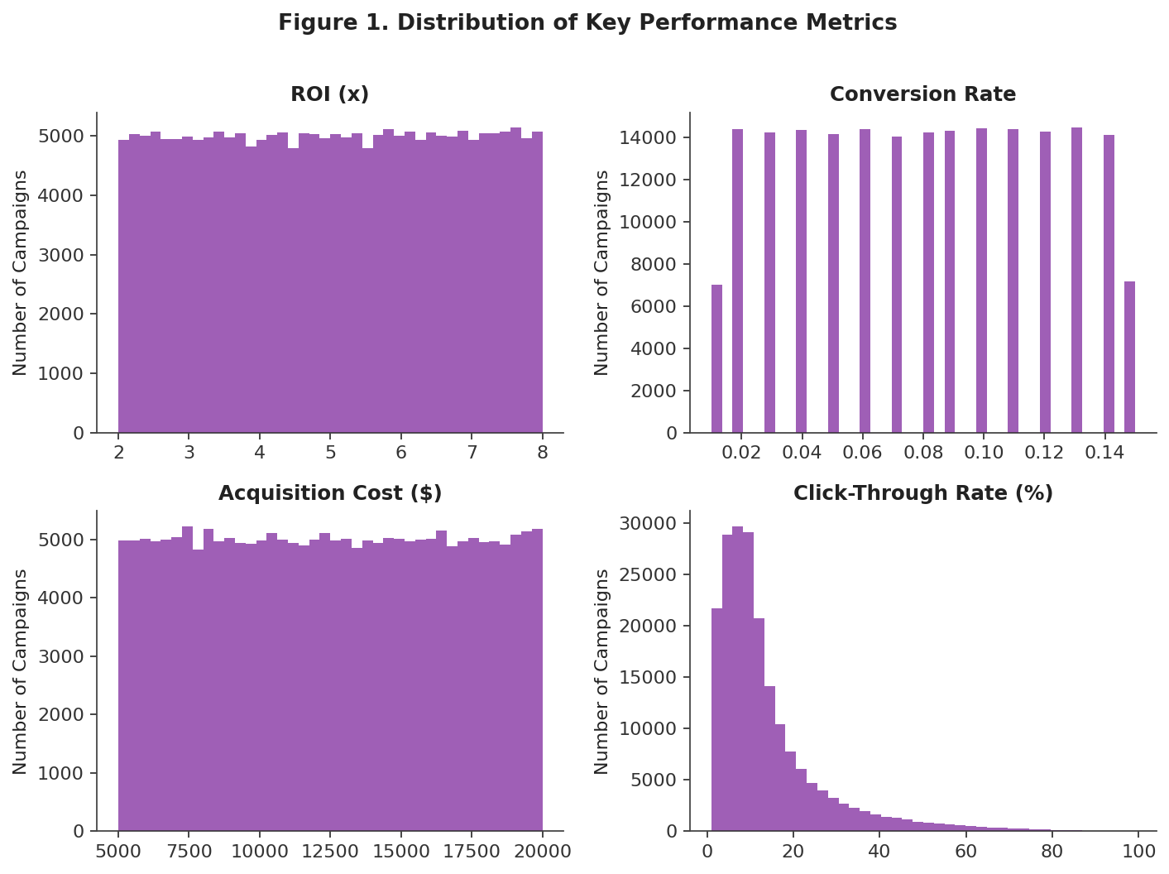
Figure 1. Distribution of ROI, Conversion Rate, Acquisition Cost, and CTR across all 200,000 campaigns.

5.3 Performance by Campaign Type
Figure 2 compares average ROI across the five campaign types. Influencer campaigns show the numerically highest average ROI (5.011x) and Email the lowest (4.992x), but the gap between the best- and worst-performing campaign type is under 0.4% — small enough that it is unlikely to reflect a real difference in performance.
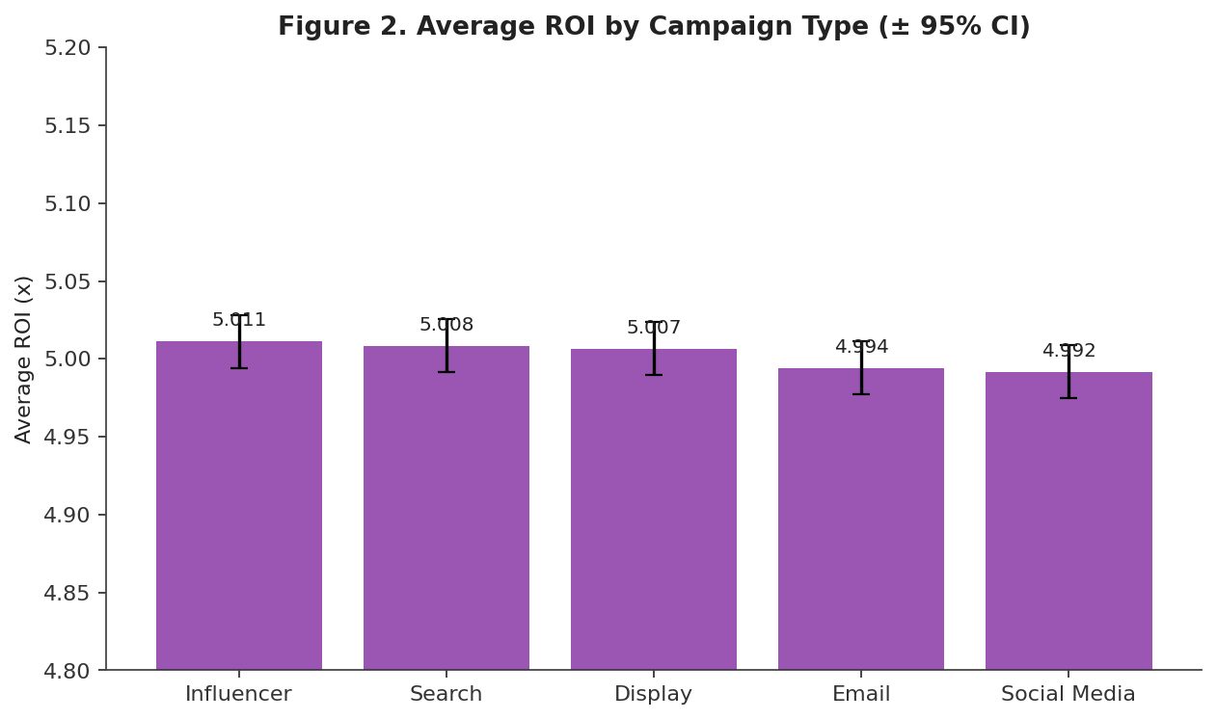
Figure 2. Average ROI by campaign type.

5.4 Performance by Channel
Figure 3 breaks ROI down by distribution channel. Facebook edges out the other channels numerically (5.019x average ROI) while YouTube and Instagram sit marginally lower (~4.99x), but again the total spread is under 0.7%, too small to point to any one channel as a stronger performer.
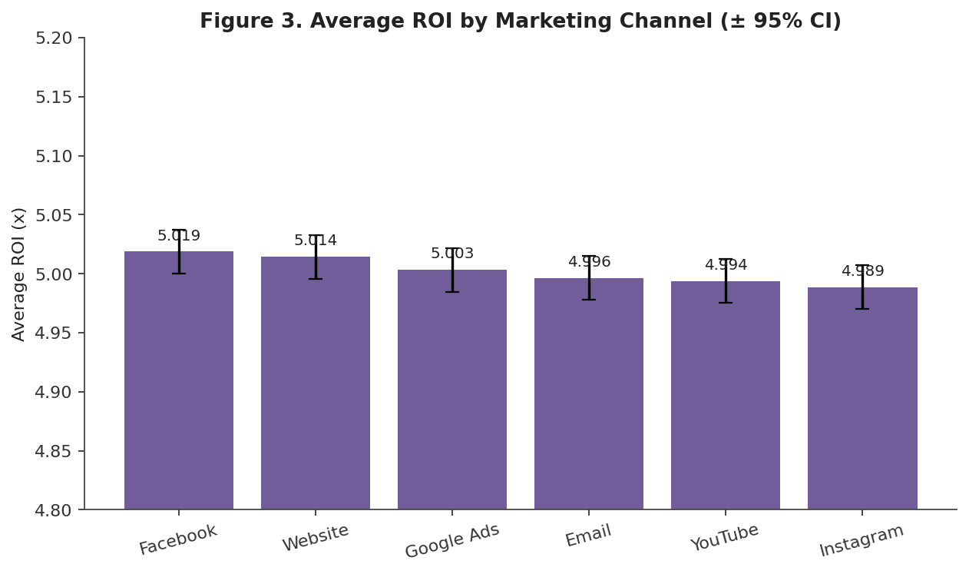
Figure 3. Average ROI by marketing channel.

5.5 Campaign Volume by Company
Figure 4 shows that campaign volume is almost perfectly balanced across the five companies in the dataset, each contributing between 19.9% and 20.1% of total campaigns — TechCorp runs the most (40,237 campaigns) and Innovate Industries the fewest (39,709), a difference of well under 1%.
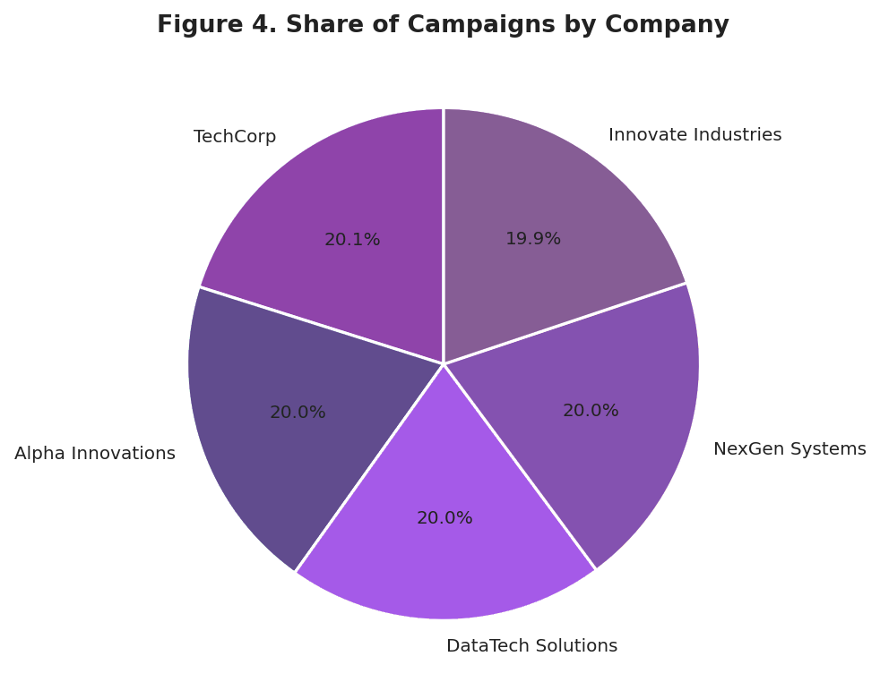
Figure 4. Share of total campaigns by company.

5.6 Monthly Trends
Figure 5 tracks campaign volume and average ROI across the twelve months of 2021. Campaign volume fluctuates between roughly 15,300 and 17,000 per month (driven by the number of days in each month rather than any seasonal marketing pattern), while average monthly ROI stays tightly banded between 4.98x and 5.03x throughout the year — there is no visible seasonal trend in campaign profitability.
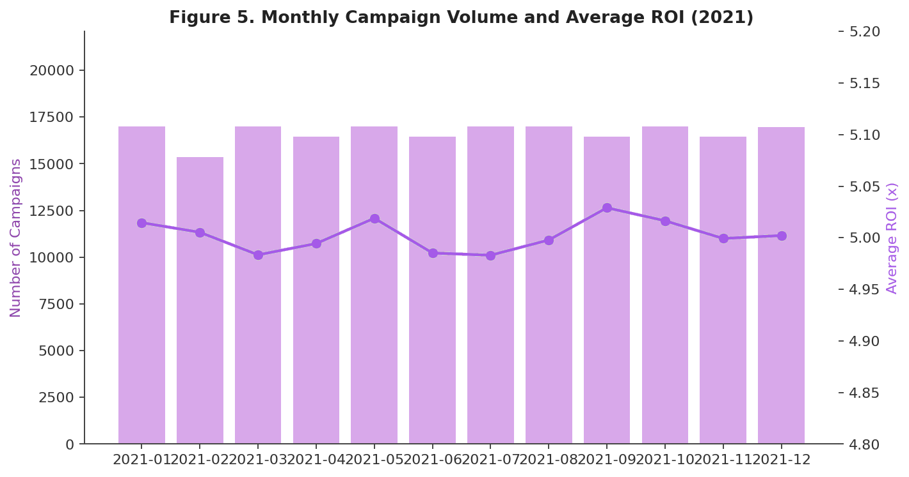
Figure 5. Monthly campaign volume (bars) and average ROI (line), January–December 2021.

5.7 Correlation Analysis
Figure 6 shows how the seven numeric KPIs move together. The only clear relationship involves CTR: it rises with Clicks and falls with Impressions, which follows directly from its formula (CTR = Clicks ÷ Impressions × 100). None of the other KPI pairs — including ROI with Acquisition Cost, Conversion Rate with ROI, or Engagement Score with anything else — show a noticeable relationship, suggesting these variables move independently of one another in this dataset.
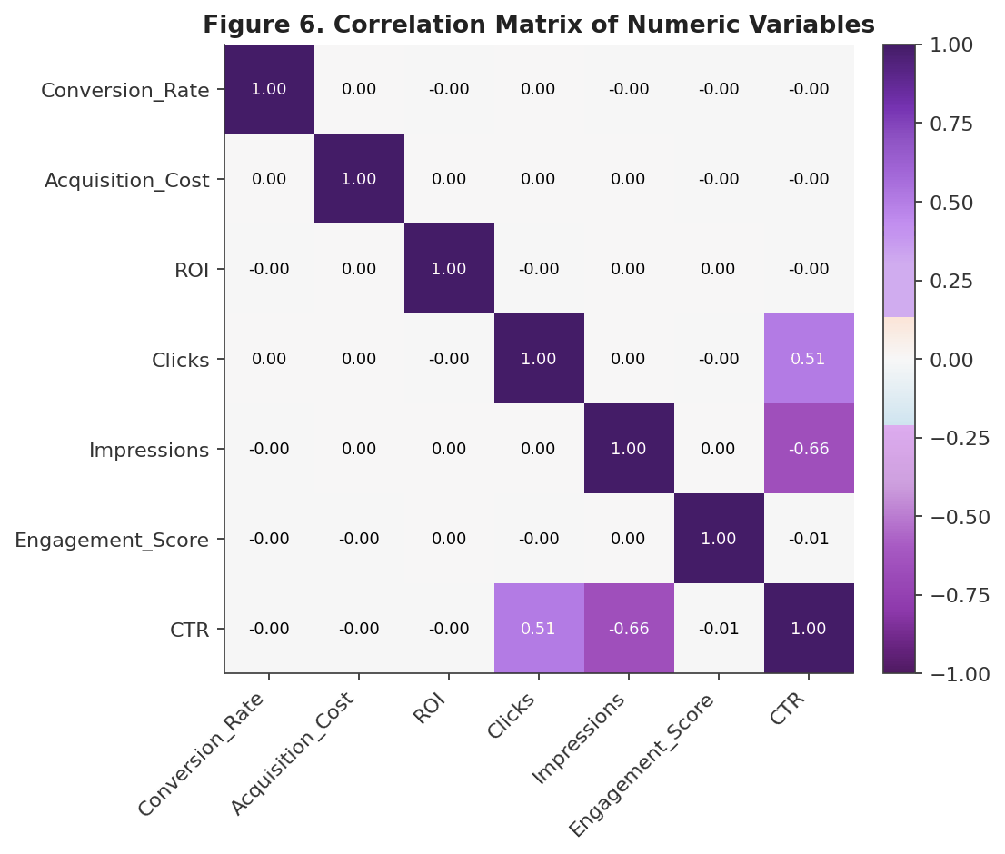
Figure 6. Correlation matrix of the seven numeric KPIs.

5.8 Performance by Customer Segment
Figure 7 compares average Conversion Rate across the five customer segments. Foodies show the numerically highest conversion rate (0.0803) and Fashionistas the lowest (0.0798) — a difference of roughly 0.6%, again within the range expected from random variation at this sample size.
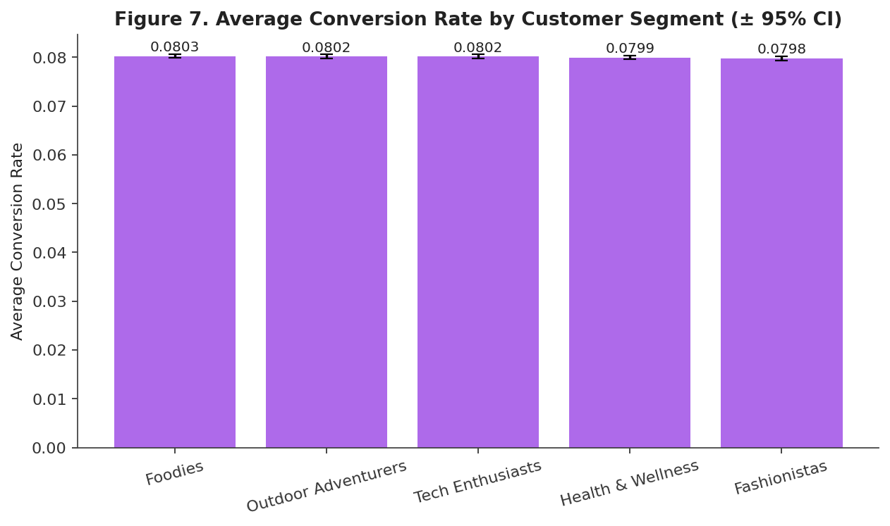
Figure 7. Average Conversion Rate by customer segment.

5.9 Clicks vs. Impressions
Figure 8 plots Clicks against Impressions for a representative sample of 3,000 campaigns, colored by CTR. The two variables show no linear relationship (consistent with the near-zero correlation reported in Section 5.7), but the color gradient clearly shows that the highest-CTR campaigns are concentrated in the lower-impression, moderate-click region of the chart — exactly what the CTR formula predicts.
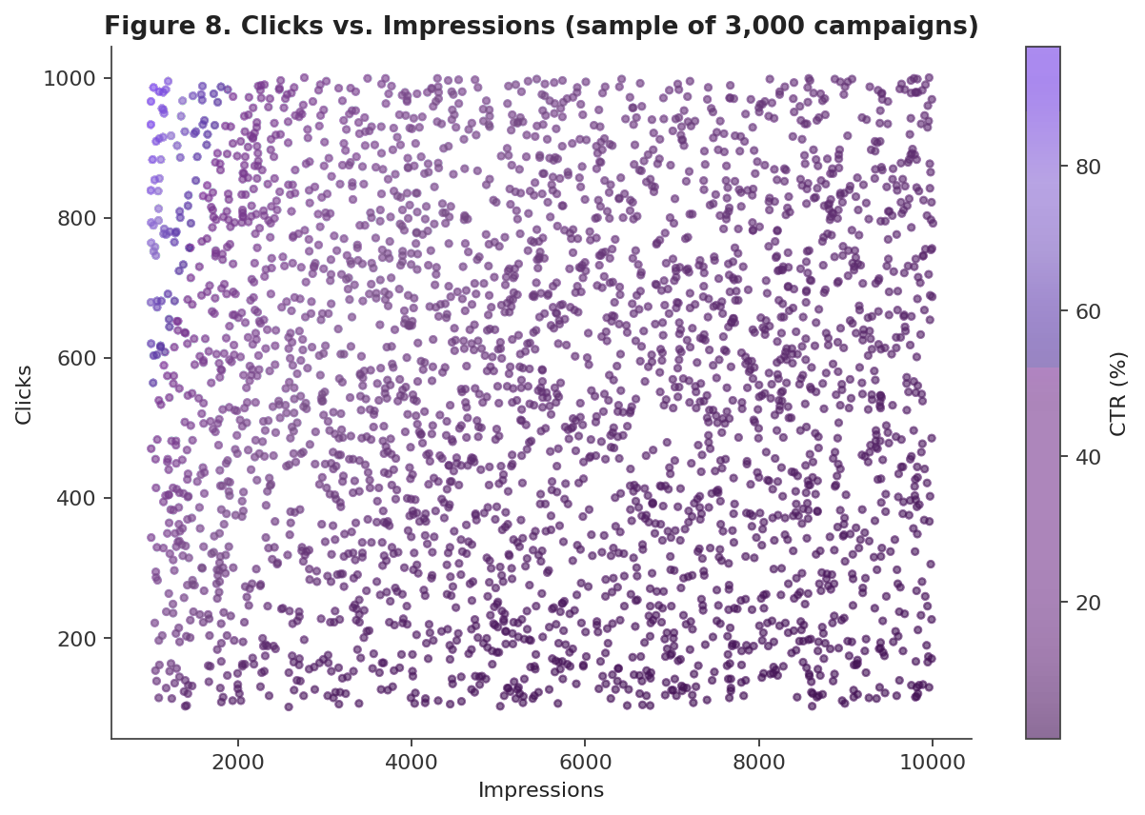
Figure 8. Clicks vs. Impressions for a sample of 3,000 campaigns, colored by CTR.

6. Category Comparison Summary
The visual comparisons in Section 5 show small numerical differences between categories, but with 200,000 records even trivial differences can appear precise. To check this, this project grouped the cleaned dataset by each categorical variable and compared the average ROI, Conversion Rate, or campaign volume within every group. Table 3 summarizes the results.
Grouping Variable | Outcome | Range of Group Averages | Spread
Campaign_Type | Average ROI | 4.992x – 5.011x | < 0.4%
Channel_Used | Average ROI | 4.989x – 5.019x | < 0.7%
Customer_Segment | Average Conversion Rate | 0.0798 – 0.0803 | ~ 0.6%
Company | Campaign Volume Share | 19.9% – 20.1% | < 1%
Table 3. Range of group averages for ROI, Conversion Rate, and campaign volume across four grouping variables.
In every comparison, the spread between the highest and lowest group average is well under 1% — far smaller than the natural spread of the underlying data (Conversion Rate ranges from 0.01 to 0.15, and ROI from 2.0x to 8.0x; see Table 2). The differences in average ROI and conversion rate across channels, campaign types and customer segments were very small in this dataset.
This is an important result in its own right. It would be a mistake to read Section 5’s bar charts (e.g., ‘Influencer has the highest ROI’ or ‘Facebook outperforms YouTube’) as actionable business insight — these differences are small enough that they most likely reflect normal variation rather than a real performance gap. The clearer, evidence-backed pattern in this dataset is the direct mathematical relationship between Clicks, Impressions, and CTR documented in Section 5.7.

7. Power BI Dashboard Overview
The cleaned CSV dataset was imported into Power BI Desktop to build a three-page interactive dashboard (MARKETING_DASHBOARD.pbix) that complements the static analysis in this report. Each page is reviewed below, alongside a check of whether its numbers are consistent with the KPI comparison in Sections 5 and 6.

7.1 Page 1 — Marketing Overview
The landing page presents six headline KPI cards (Campaigns: 200K, Impressions: 1bn, Clicks: 110M, Average CTR: ~14%, Average Conversion Rate: ~0.08, Average ROI: ~5.00x), slicers for Date, Company, Campaign Type, and Channel, a horizontal bar chart of ROI by Channel, a bar chart of Conversion Rate by Campaign Type, a 'Top Campaign Type' panel, and a time-series line chart of ROI over the full 2021 date range.
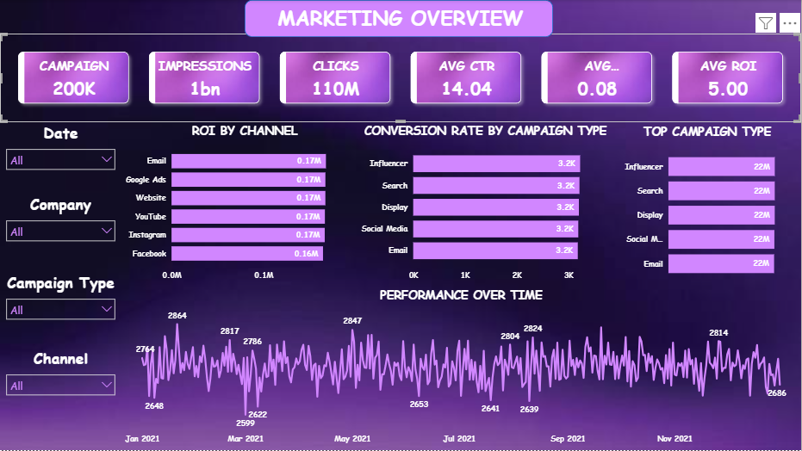
Figure 9. Dashboard Page 1 — Marketing Overview.

7.2 Page 2 — Campaign & Channel Analysis
The second page breaks campaign distribution down by channel (a near-even donut chart, ~33K campaigns per channel), ROI contribution by campaign type, an Acquisition Cost vs. ROI scatter plot by campaign type, a Conversion Rate trend line, and a full ROI-by-Campaign-Type-and-Channel matrix.
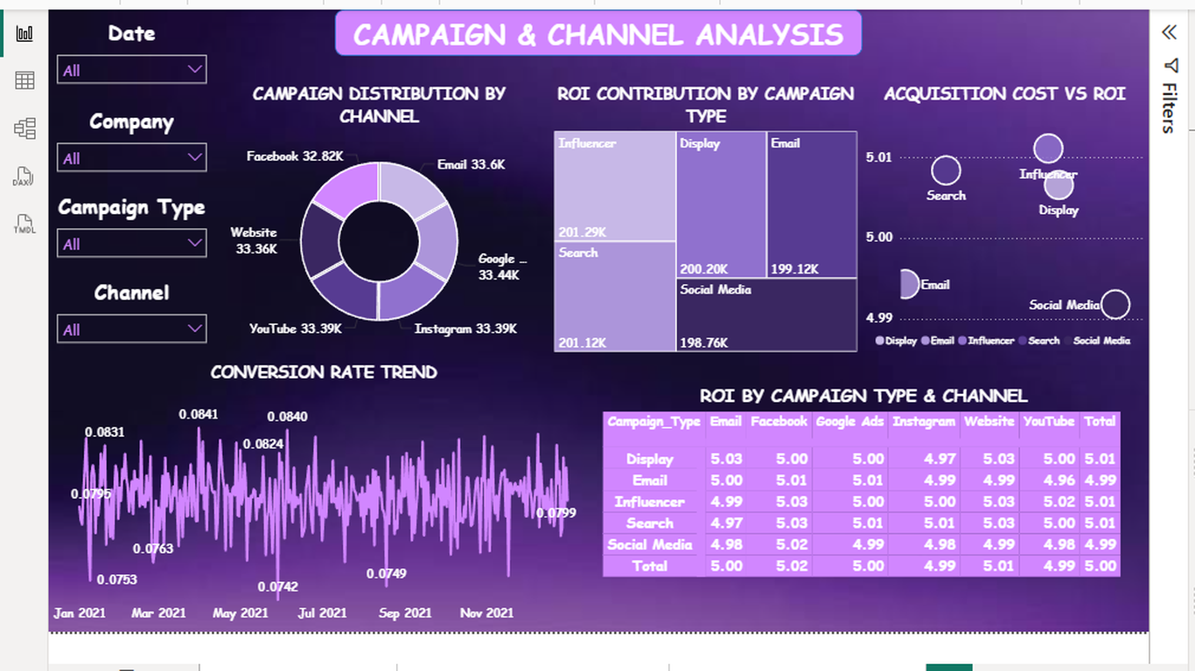
Figure 10. Dashboard Page 2 — Campaign & Channel Analysis.
This page's matrix table is the most useful visual in the dashboard for validating this report's conclusions: every cell in the ROI-by-Campaign-Type-and-Channel matrix falls between 4.96x and 5.03x, and the row/column totals all round to 4.99x–5.01x. This is a direct, interactive confirmation of the comparison in Section 6 — no campaign type/channel combination stands out as meaningfully stronger or weaker.

7.3 Page 3 — Customer & Market Insights
The third page adds slicers for Customer Segment, Target Audience, and Location, alongside campaign distribution by customer segment (an even ~40K-per-segment donut), a location performance table, an Engagement vs. Conversion Rate scatter plot by segment, a Conversion Rate table by segment and channel, and an ROI-by-Target-Audience matrix.
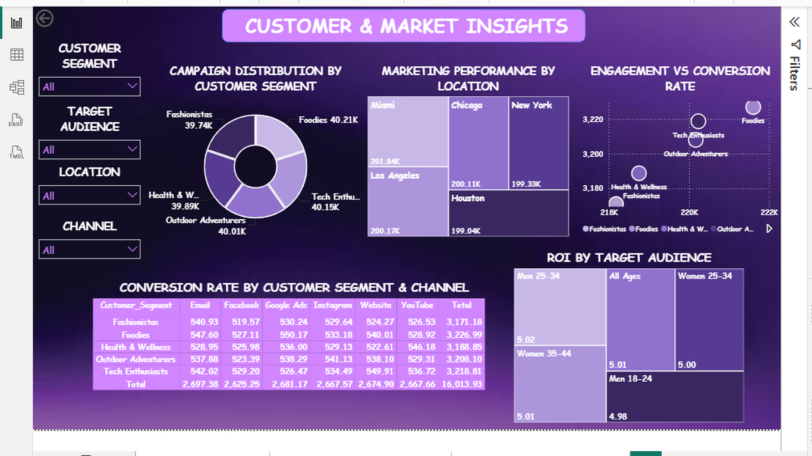
Figure 11. Dashboard Page 3 — Customer & Market Insights.
As with Page 2, the ROI-by-Target-Audience matrix (4.98x–5.02x) and the Engagement vs. Conversion Rate scatter (all segments clustered tightly around 220K impressions / 3,190–3,220 conversion index) both reinforce the same conclusion: no customer segment, target audience, or location shows a meaningful edge.

7.4 KPI Aggregation
The KPI cards were configured using appropriate aggregation methods. Count-based metrics such as Campaigns, Clicks and Impressions use totals, while ratio-based metrics such as CTR, Conversion Rate and ROI use averages. This provides a more meaningful representation of overall campaign performance.

8. Key Findings
- Average ROI across channels is approximately 5.00.
- Average conversion rate is approximately 0.08.
- CTR provides an additional measure of campaign engagement.
- Channel and campaign-type comparisons help evaluate marketing performance.
- Customer segments, target audiences and locations provide additional perspectives for campaign analysis.

9. Recommendations

9.1 Analytical Recommendations
- Do not base channel, campaign-type, or segment budget allocation decisions on this dataset — the KPI comparisons show no category reliably outperforms another, so any such recommendation would not be evidence-based.
- If the goal is to identify true performance drivers, prioritize collecting additional variables plausibly linked to outcomes (e.g., creative quality, bid strategy, seasonality at a finer grain, competitor activity) since the current fields explain almost none of the variance in ROI or conversion.
- Use CTR, Clicks, and Impressions together rather than in isolation when evaluating campaign reach efficiency, since these are the only variables shown to be meaningfully related in this dataset.
- Validate the data source before drawing business conclusions: the uniform distributions and near-zero effect sizes across every grouping variable suggest this dataset may be synthetic or simulated rather than a live production export, and this should be confirmed with the data owner.

9.2 Dashboard & Process Recommendations
- Add a simple indicator (e.g., the spread between the highest and lowest group average) to the dashboard's category comparison visuals, so viewers do not mistake small numerical differences for real performance gaps.
- If new, live campaign data becomes available, re-run the same KPI comparisons periodically — this analysis pipeline (Python cleaning → KPI comparison → Power BI dashboard) can be reused as a repeatable monthly or quarterly reporting process.

10. Limitations
- The apparent uniform distribution of ROI, Conversion Rate, and Acquisition Cost, combined with perfectly balanced category counts, strongly suggests this dataset may be artificially generated rather than drawn from real campaign performance, which limits the real-world applicability of any findings.
- The dataset contains no information on marketing spend by channel in aggregate, creative content, competitor activity, or macroeconomic conditions — all of which typically influence real campaign performance and could not be tested here.
- Engagement_Score is provided as a pre-computed integer (1–10) with no documentation of its underlying calculation, limiting how it can be interpreted.
- The analysis is cross-sectional in nature; no causal claims can be made from the associations (or lack thereof) observed.

11. Conclusion
This project delivered a complete analytics workflow on a 200,000-row marketing campaign dataset: cleaning and preparation in Python, exploratory and KPI-comparison analysis, and an interactive Power BI dashboard. The headline result is a nuanced one — rather than finding that a particular channel, campaign type, or customer segment drives superior ROI, the KPI comparisons show that none of the categorical attributes in this dataset are associated with a meaningfully different level of performance. The one relationship that does hold up is the mechanical link between Clicks, Impressions, and CTR.
This outcome underscores the value of pairing exploratory visualization with a closer look at the numbers: differences that look meaningful in a bar chart do not always hold up once you compare them against the full range of the data, and reporting that distinction honestly is itself a core analytics skill. The accompanying Power BI dashboard makes this same conclusion interactively verifiable by any stakeholder who wants to explore the data further.

12. Appendix

12.1 Tools & Environment
- Data cleaning & preparation: Python (Pandas, NumPy) in Google Colab
- Dashboard & visualization: Power BI Desktop (MARKETING_DASHBOARD.pbix), built from the cleaned CSV export
- Category comparison for this report (Section 6): computed in Python by grouping the cleaned dataset and comparing average KPI values across categories

12.2 Category Reference
Companies: TechCorp, Alpha Innovations, DataTech Solutions, Innovate Industries, NexGen Systems.
Campaign Types: Email, Search, Display, Influencer, Social Media.
Channels: Google Ads, YouTube, Instagram, Facebook, Website, Email.
Customer Segments: Foodies, Tech Enthusiasts, Health & Wellness, Fashionistas, Outdoor Adventurers.
Locations: Chicago, New York, Los Angeles, Miami, Houston.
Languages: English, Spanish, French, German, Mandarin.

