1. **Launch one EC2 using Amazon Linux 2 image and add a script in user data to install Apache.**

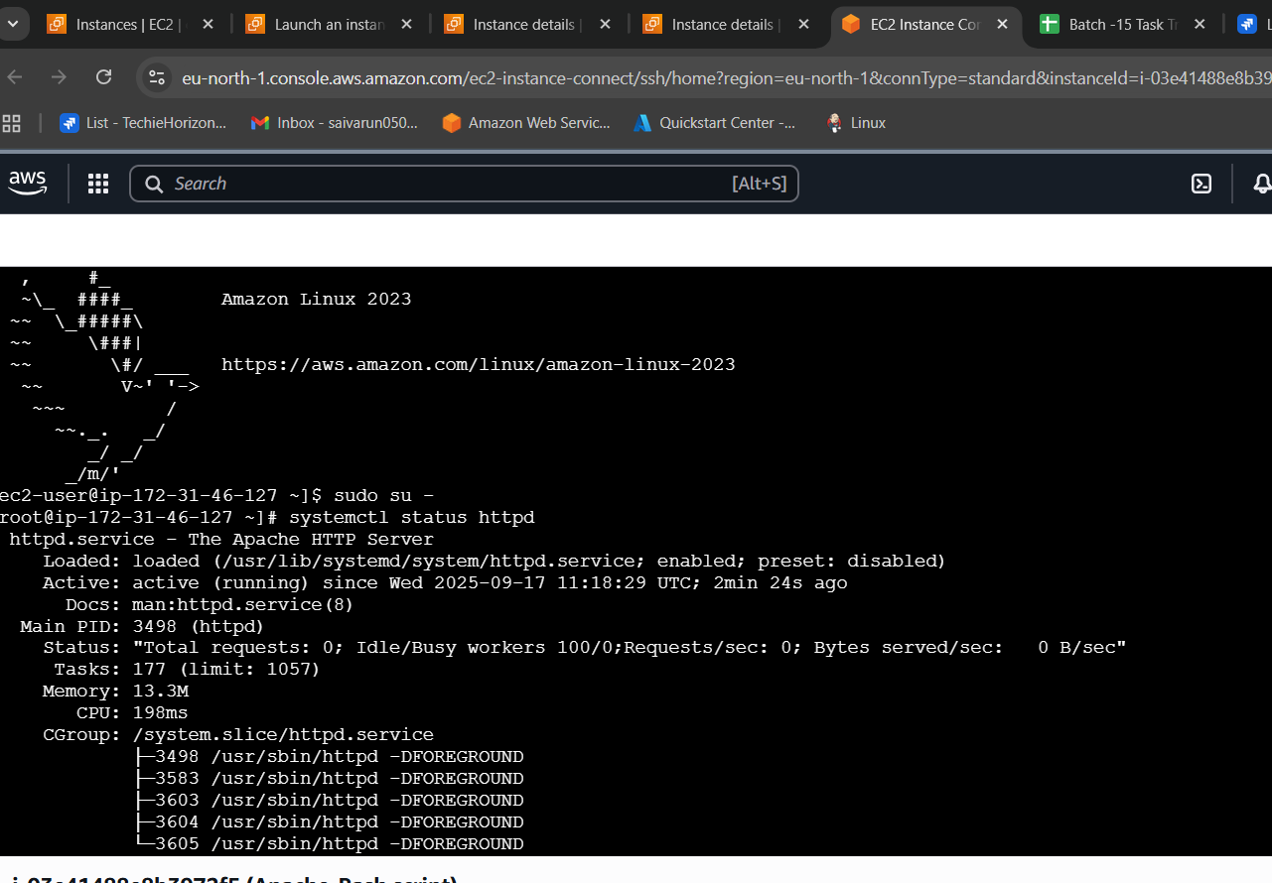

#!/bin/bash

# Update package list

sudo yum update -y

# Install Apache (called httpd on Red Hat)

sudo yum install -y httpd

# Enable Apache to start on boot

sudo systemctl enable httpd

# Start Apache service

sudo systemctl start httpd

# Show status

sudo systemctl status httpd

1. **Launch one EC2 using Ubuntu image and add a script in user data to install Nginx.**

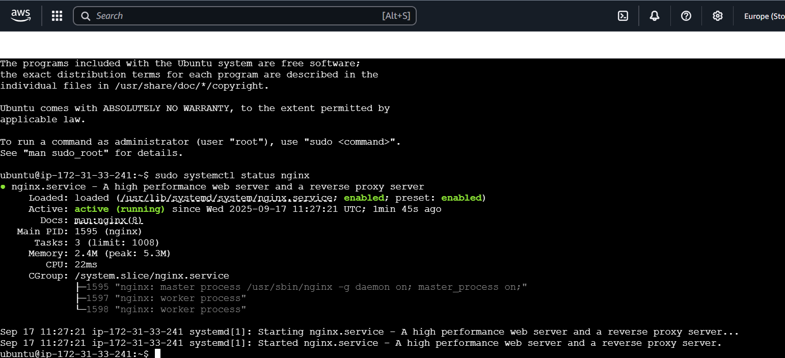

#!/bin/bash

# Update package list

sudo apt update

# Install Nginx

sudo apt install -y nginx

# Enable Nginx to start on boot

sudo systemctl enable nginx

# Start Nginx service

sudo systemctl start nginx

# Show Nginx status

sudo systemctl status nginx

1. **Launch one Windows server and install Tomcat on Windows.**
2. **Take a snapshot of the instance created in Task 1.**

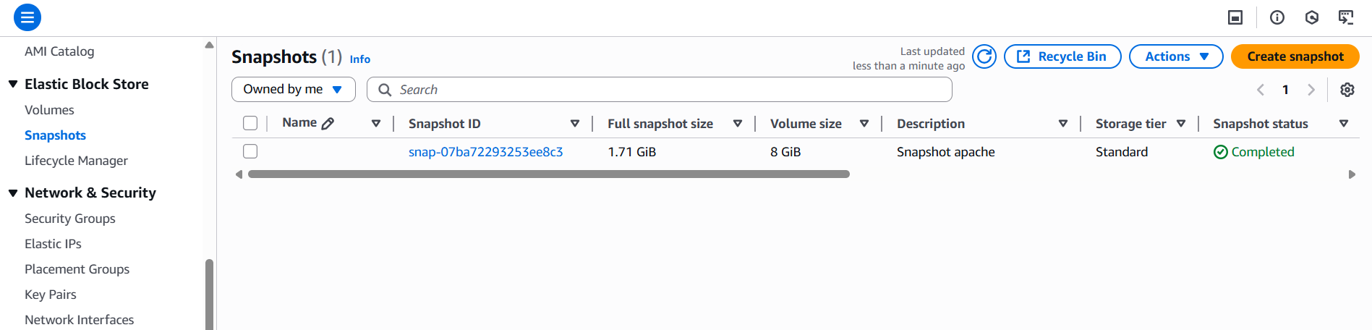

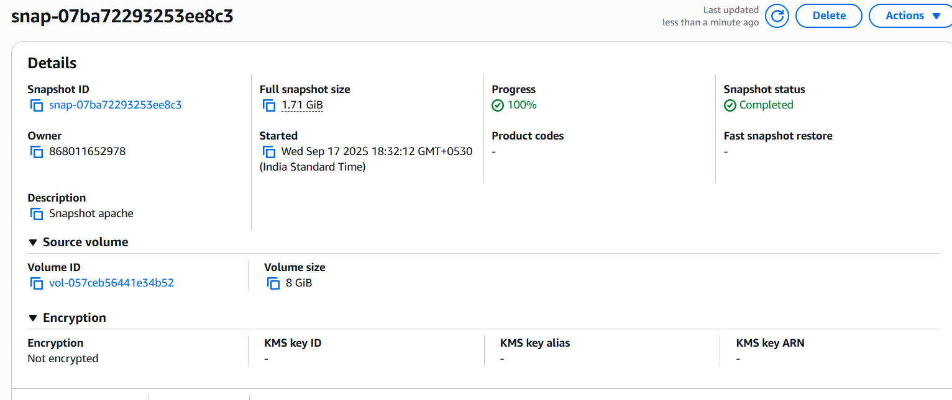

* Launch the task1 instance and go to storage and click on volume id open it in new tab.
* Click on the volume id and go to ctions and click create snapshot.
* Give description to the snapshot.
* Create snapshot.
* We can check the snapshots on EBS tab.

1. **Assign passwordless authentication for the EC2 created in Task 2.**

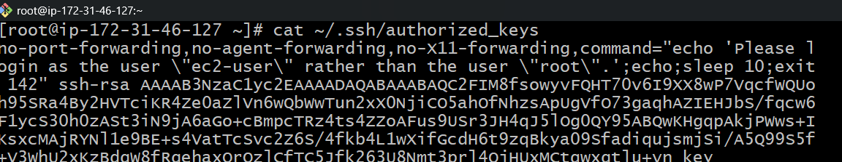

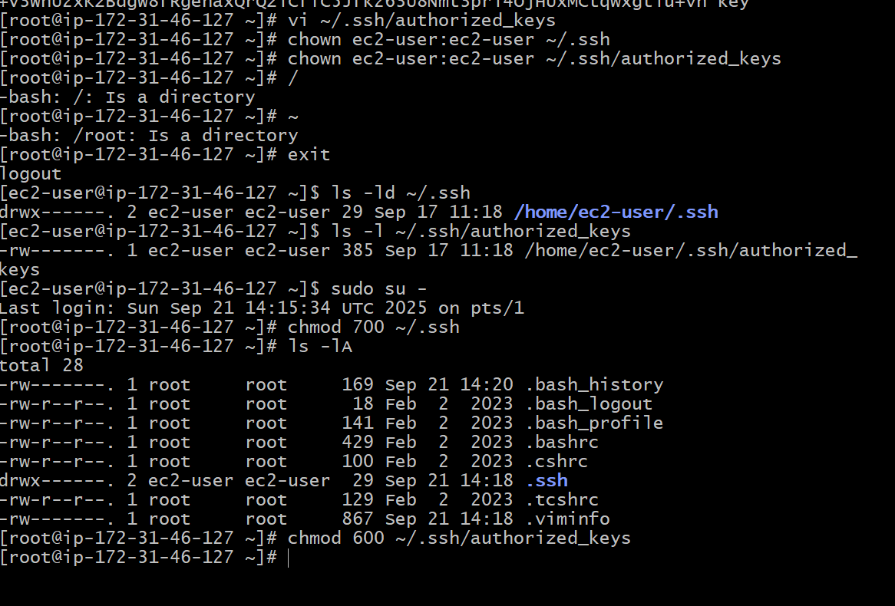

1. **Launch any EC2 using the spot purchasing option.**

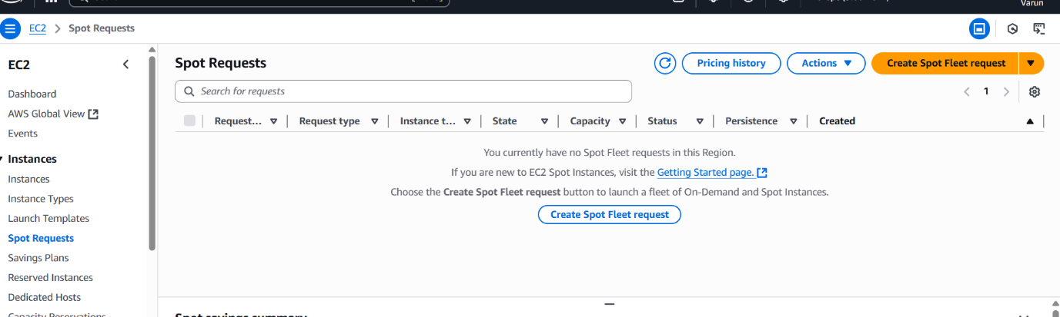

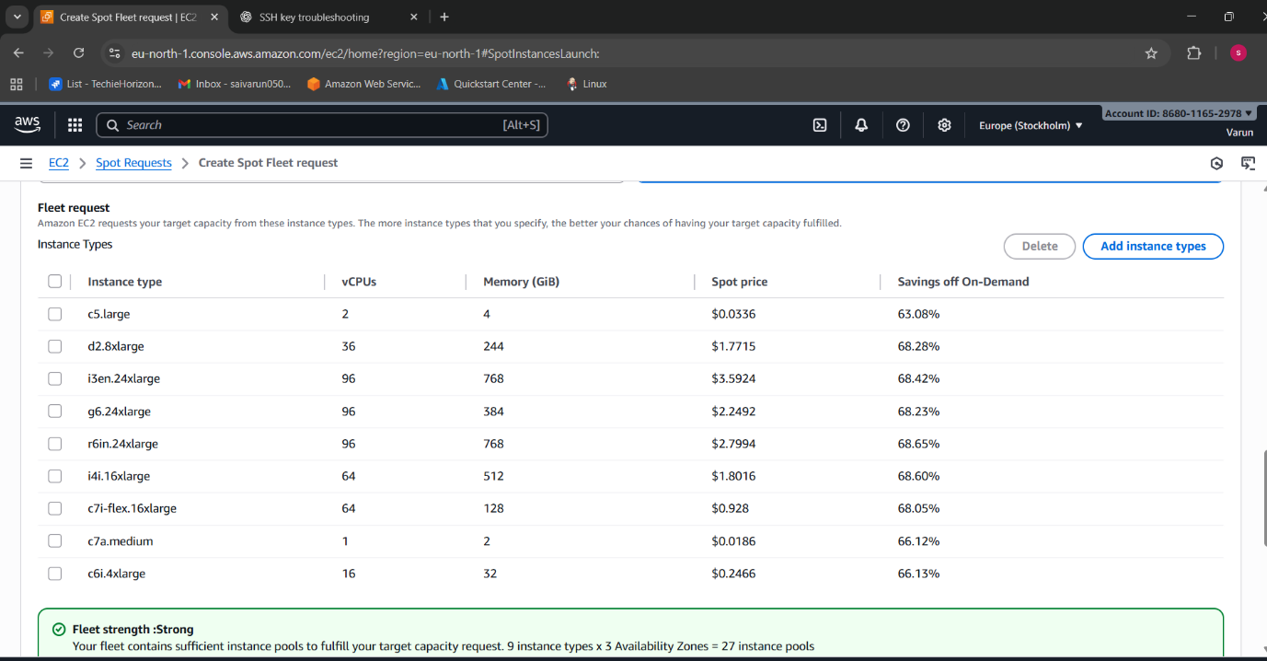

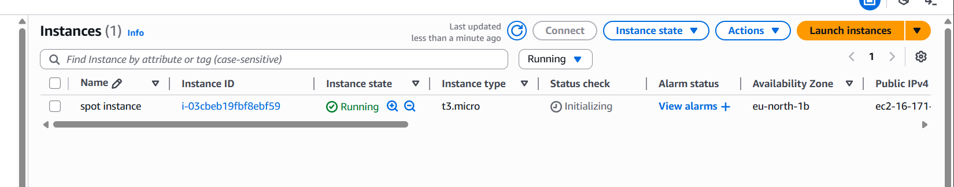

* **l**aunch an instance.
* Define all details
* Go to additional details.
* Purchasing options----select spot instance and you can define all details like expiry and standard price per hour  
  launch instance

1. **Enable termination policy on the EC2 created in Task 2.**

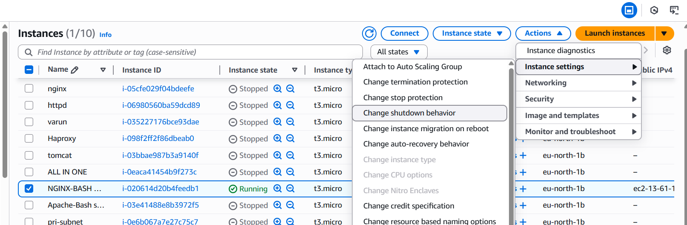

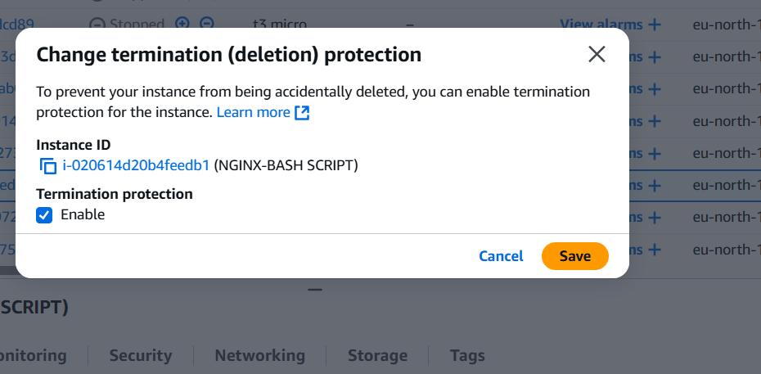

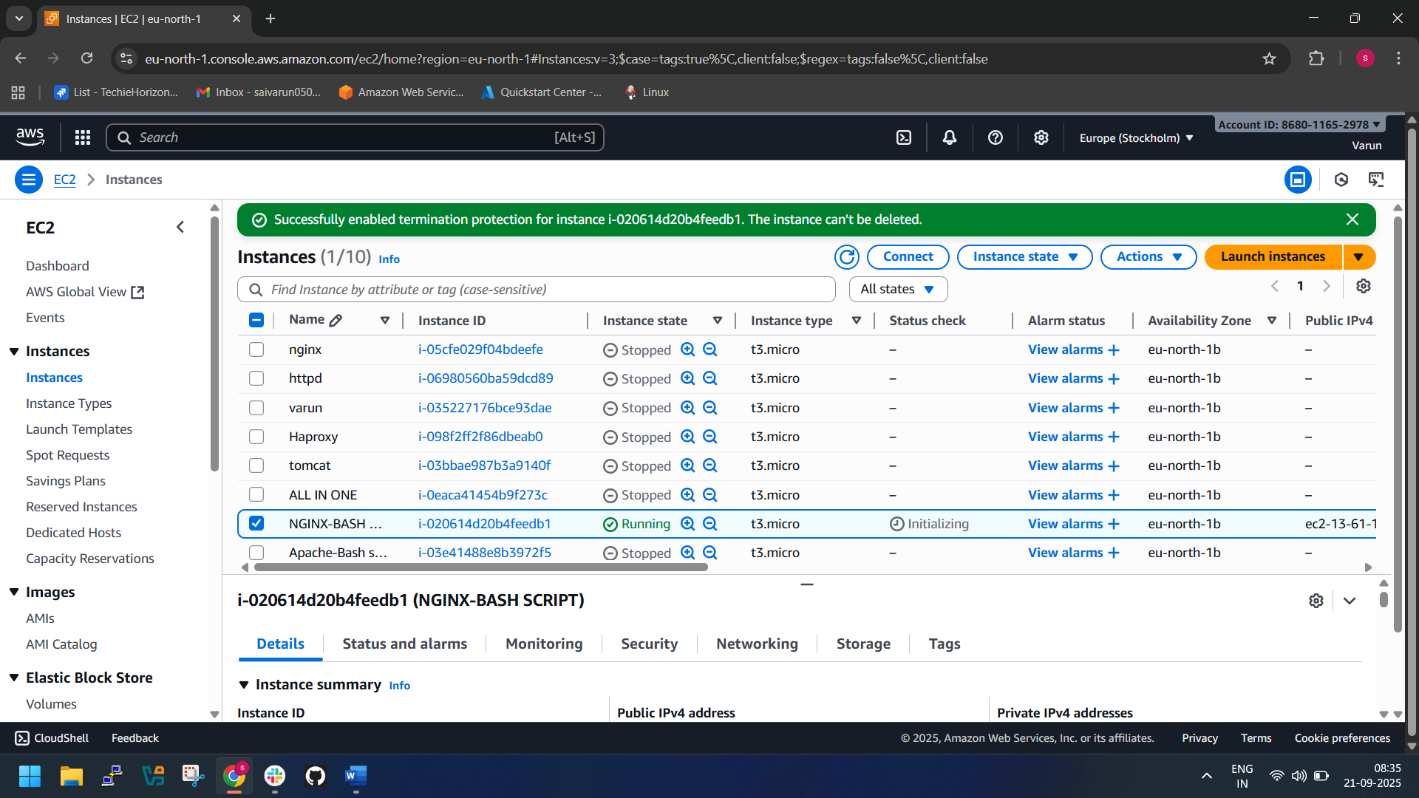

* Go to the EC2 Dashboard in AWS Console.
* Select the EC2 instance you created in Task 2.
* In the Instance settings menu, click Change termination protection.
* Select Enable and save.

1. **Launch one EC2 using AWS CLI.** 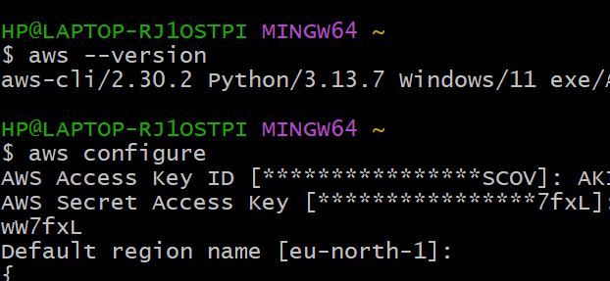

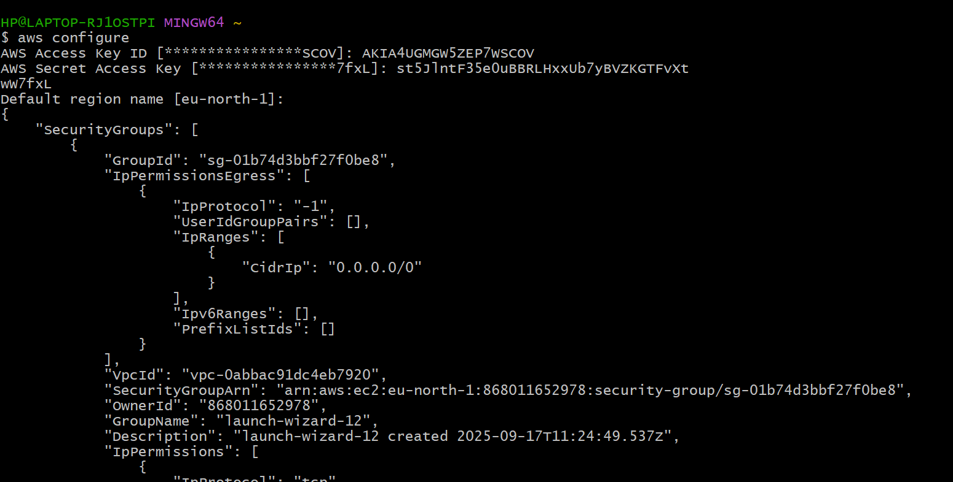

* **Download AWS CLI msiexec.exe /i** [**https://awscli.amazonaws.com/AWSCLIV2.msi**](https://awscli.amazonaws.com/AWSCLIV2.msi)
* **Get the access key and secret key by generating from IAM user**
* Provide Access Key, Secret Key, Region, Output format.
* Create the pem key using aws cli-

**aws ec2 create-key-pair --key-name MyKeyPairName --query 'KeyMaterial' --output text > MyKeyPairName.pem**

* Create an ec2 instance using aws cli-

**aws ec2 run-instances \**

**--image-id <ami-id> \**

**--instance-type t2.micro \**

**--count 1 \**

**--key-name MyKeyPair \**

**--security-group-ids <security-group-id> \**

**--subnet-id <subnet-id> \**

**--tag-specifications 'ResourceType=instance,Tags=[{Key=Name,Value=MyCLIInstance}]'**

* We can see the created instance from the aws cli-

aws ec2 describe-instances