1. Create an S3 bucket and upload some objects to S3.

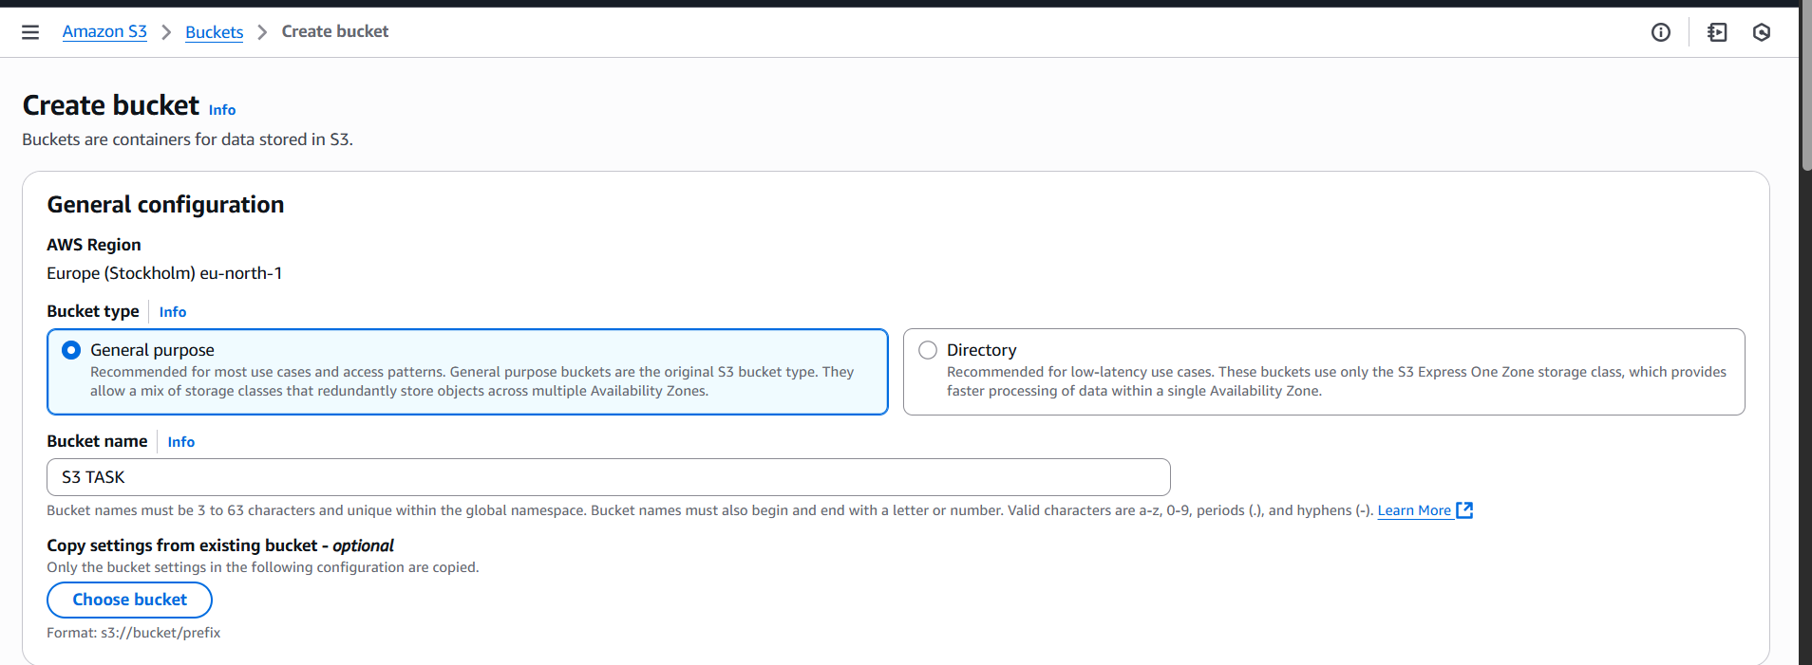

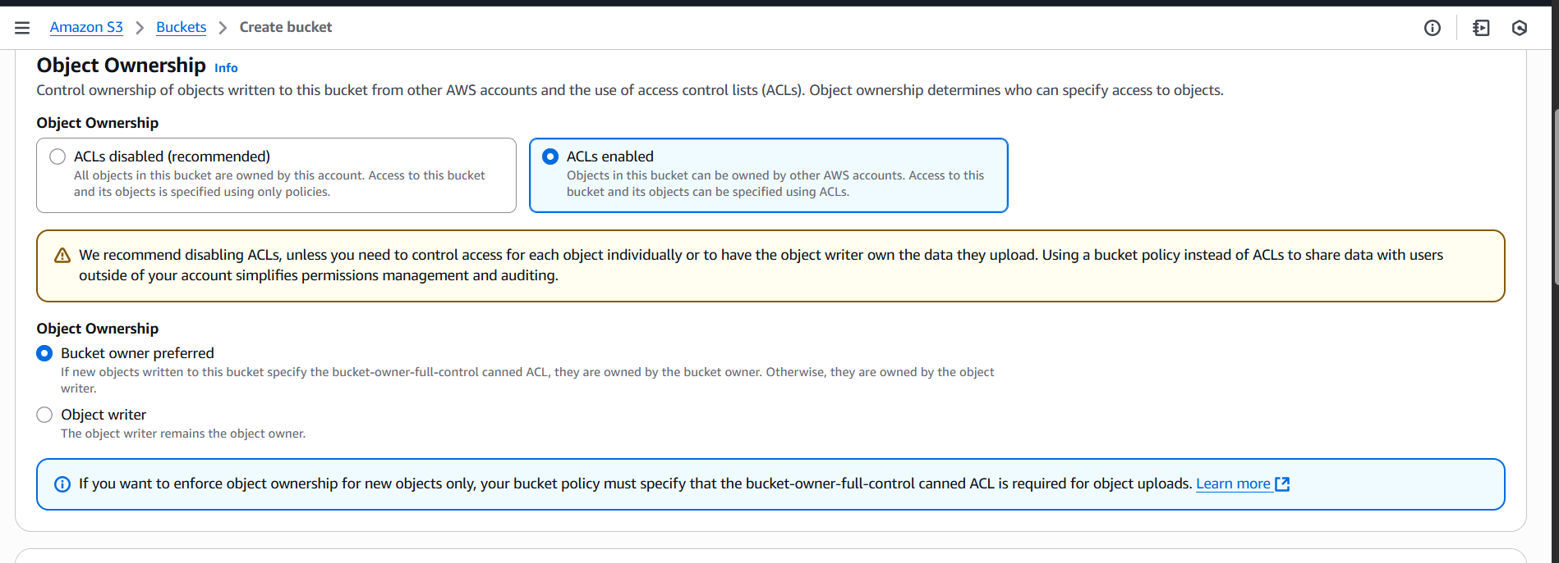

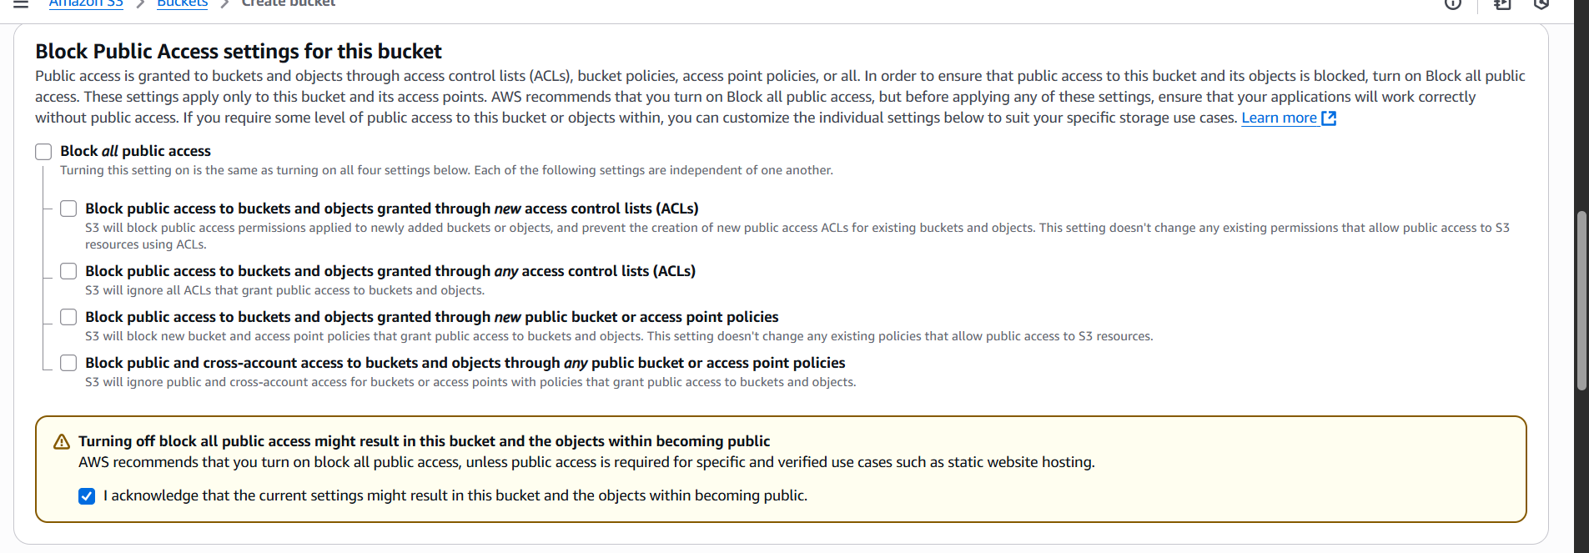

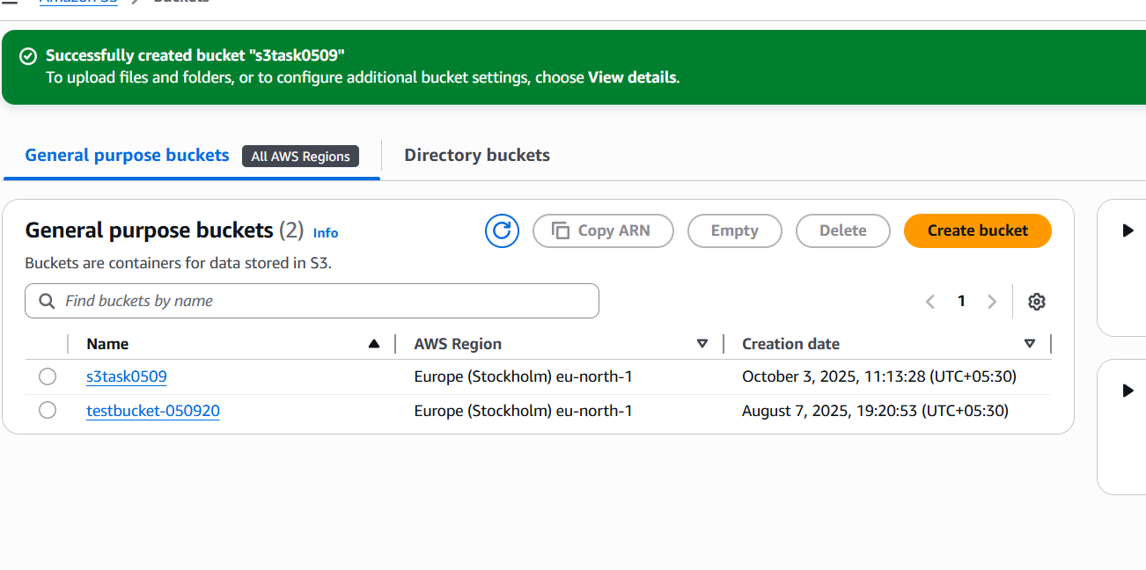

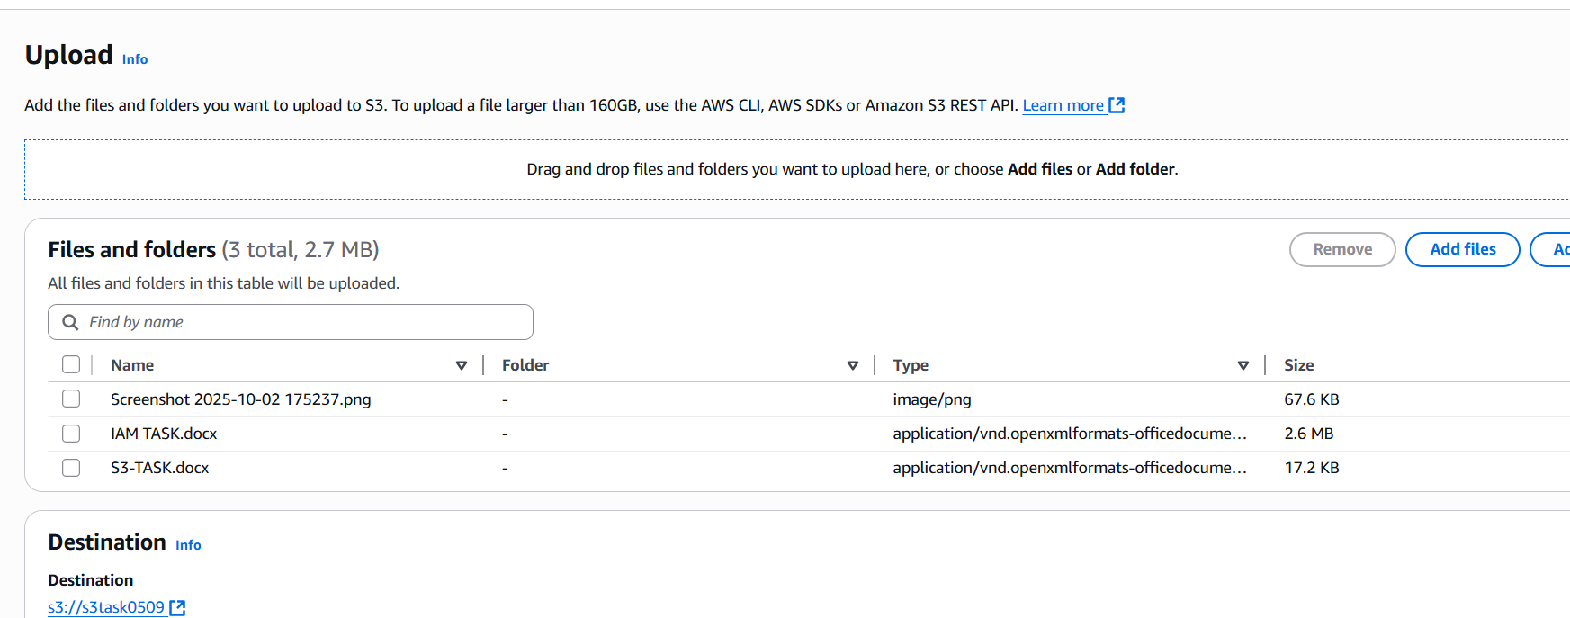

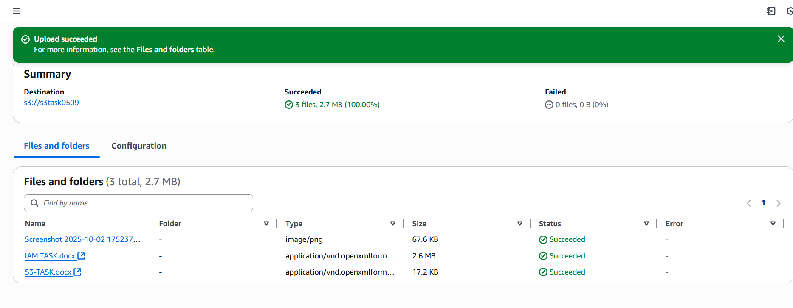

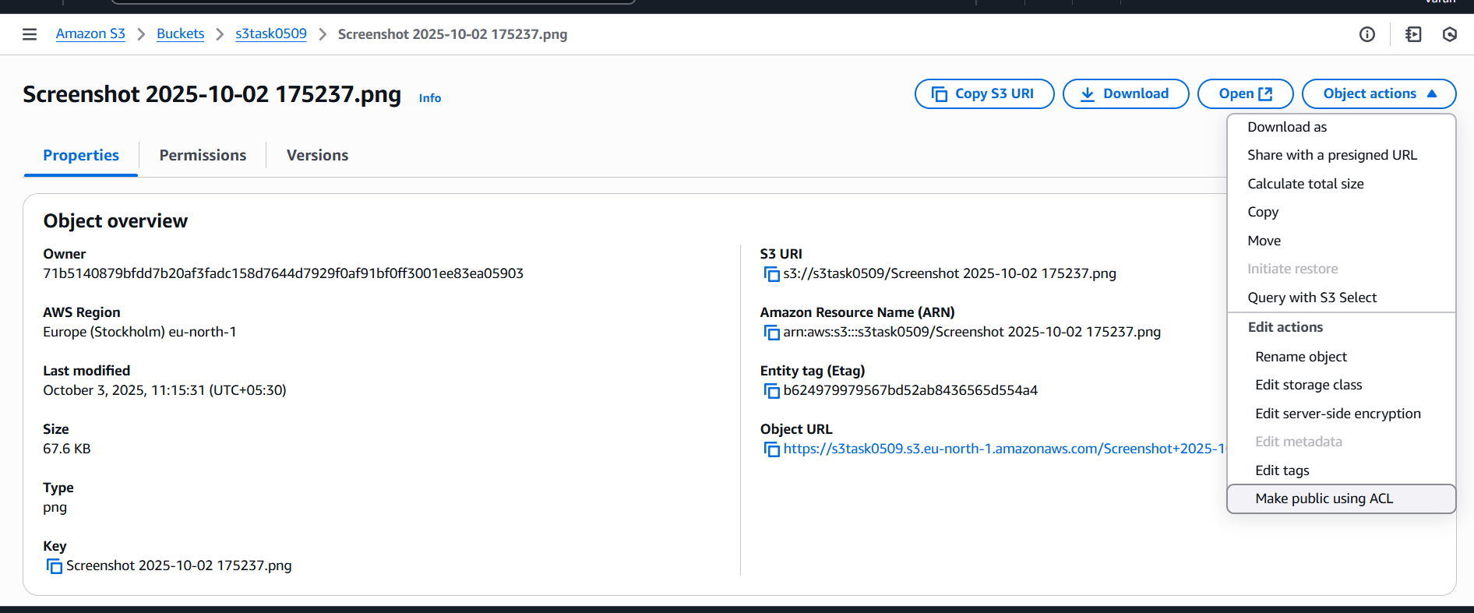

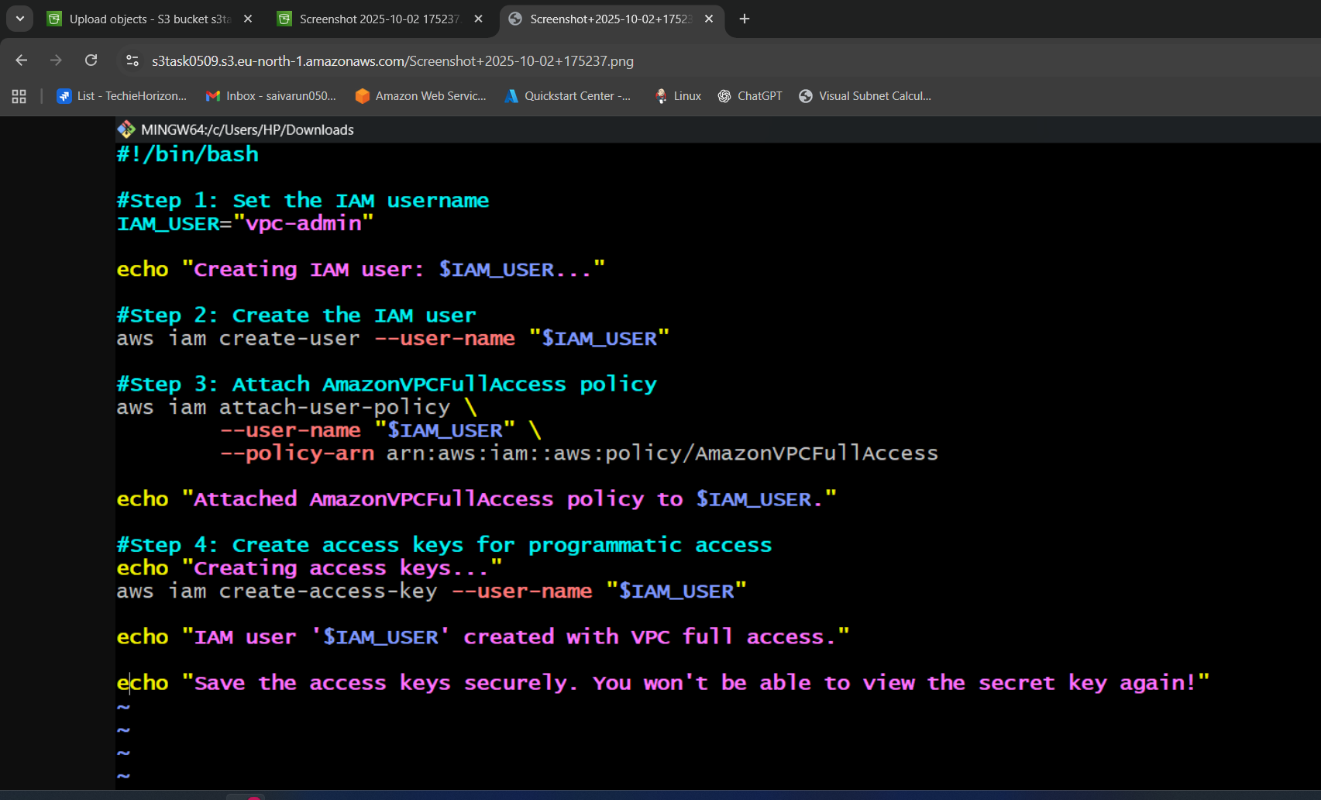

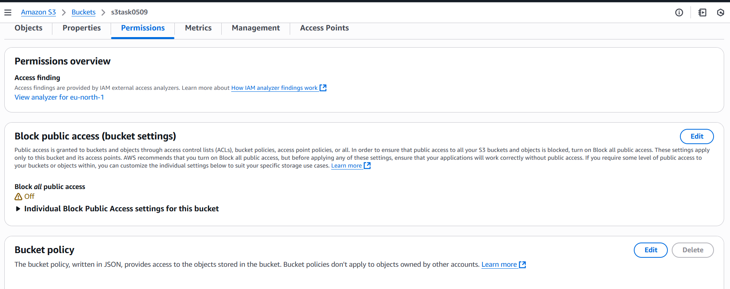

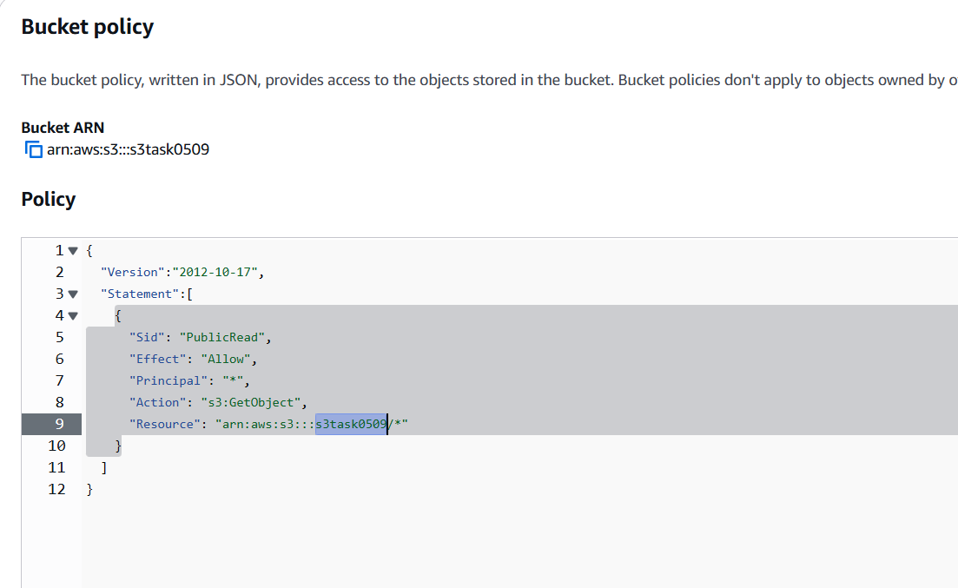

1. Deploy a static website in the S3 bucket.

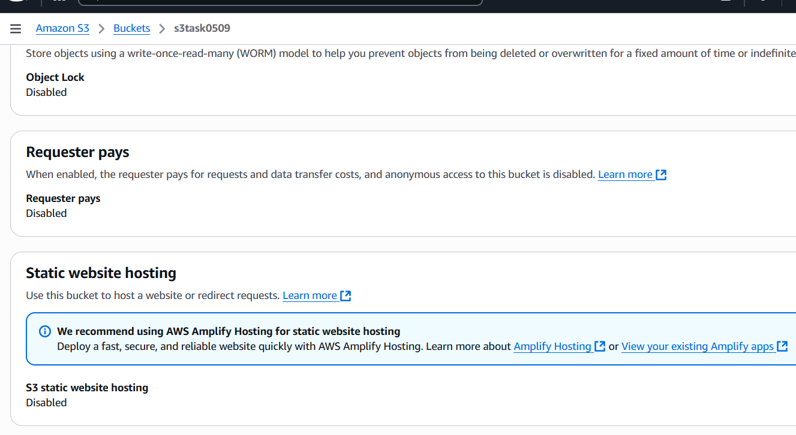

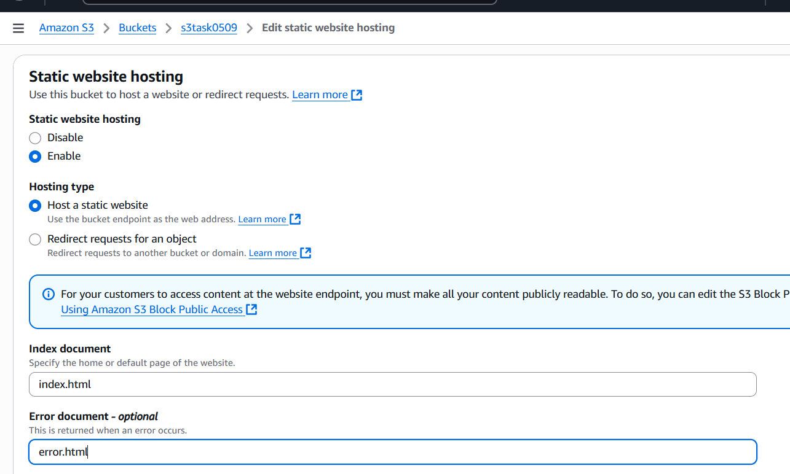

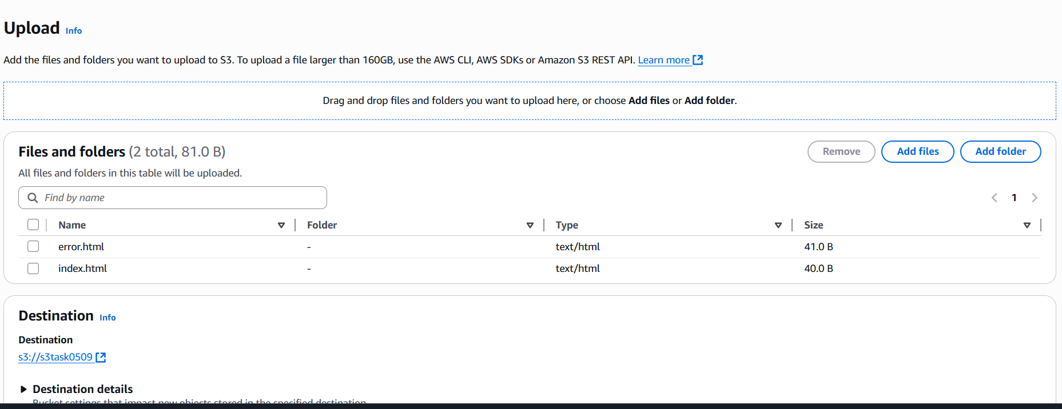

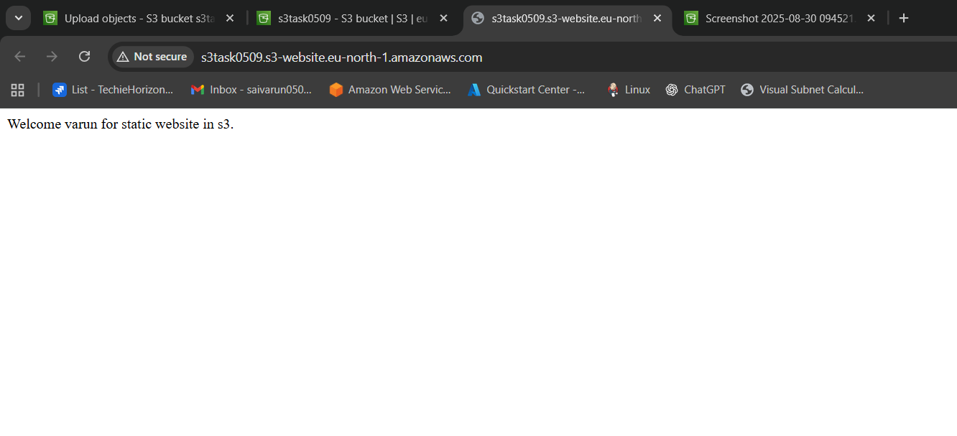

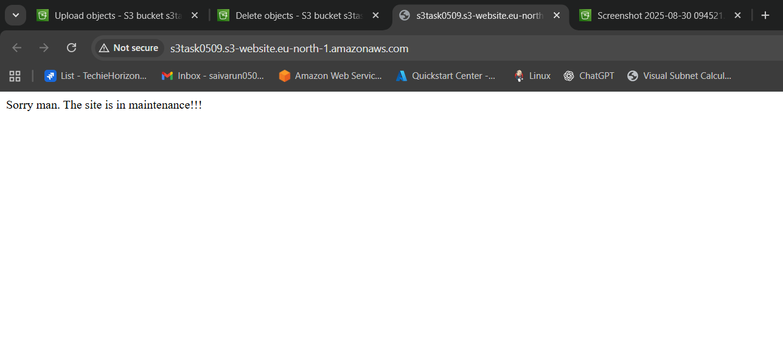

* Go to the s3 bucket.
* Properties-enable static website hosting.
* Give the files names index.html and error.html.
* Then save the website hosting.
* Upload the index.html and error.html files to the bucket make it public access.
* Copy the link generated and paste it in the browser to check.

1. Enable cross-region replication on S3 buckets.

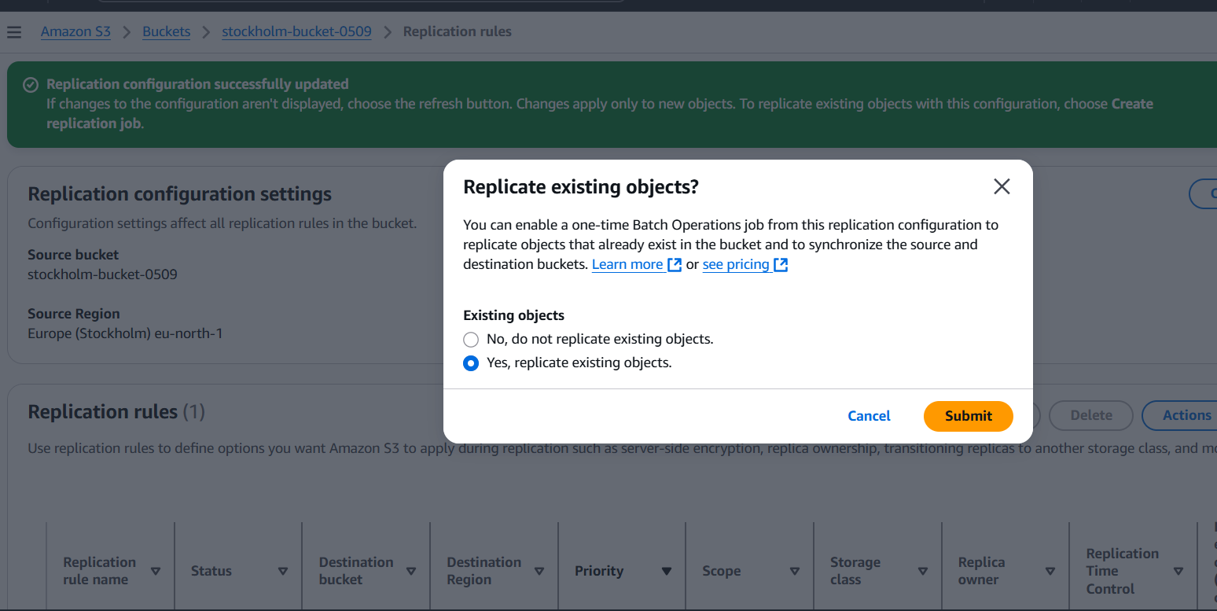

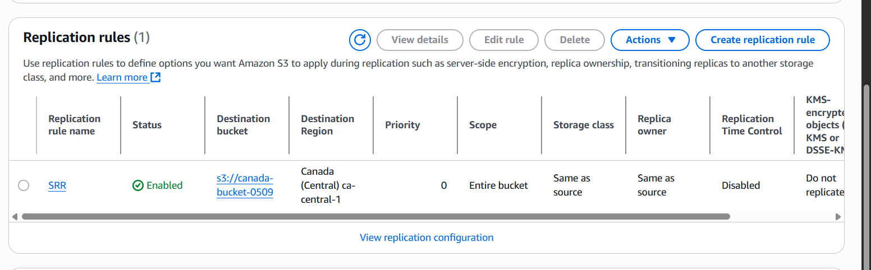

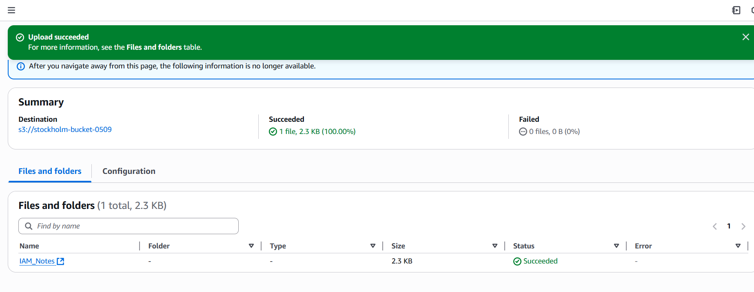

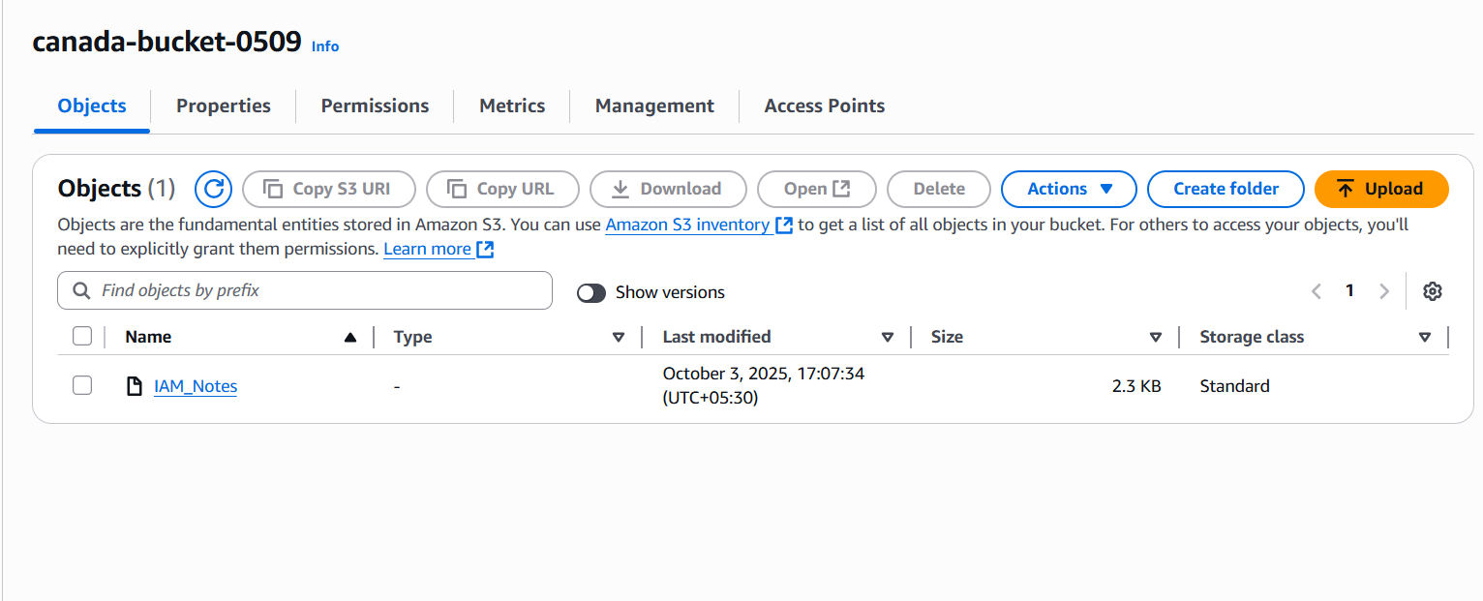

Step 1: Create & Enable Versioning on Both Buckets  
1. Go to the S3 Console.  
2. Open your source bucket → Properties tab → Bucket Versioning → Enable.  
3. Do the same for your destination bucket.

Step 2: Open Replication Settings on Source Bucket  
1. In the source bucket, go to the Management tab.  
2. Scroll to Replication rules → click Create replication rule.

Step 3: Configure the Rule  
1. Rule name → e.g. SRR-Rule.  
2. Status → Keep it enabled.  
3. Choose rule scope → Apply to all objects (or you can set prefix/tags if needed).  
4. Destination:  
o Select Choose a bucket in this account.  
o Enter your destination bucket name.  
o Make sure region is different (for cross-region).  
o Choose storage class (default: Standard).  
5. IAM role:  
o Choose Create IAM role.

Select the role you created earlier → S3ReplicationRole.

Step 4: Review and Save  
1. Review the settings.  
2. Click Save

1. Configure a bucket policy so only the Admin user can see the objects of the S3 bucket.

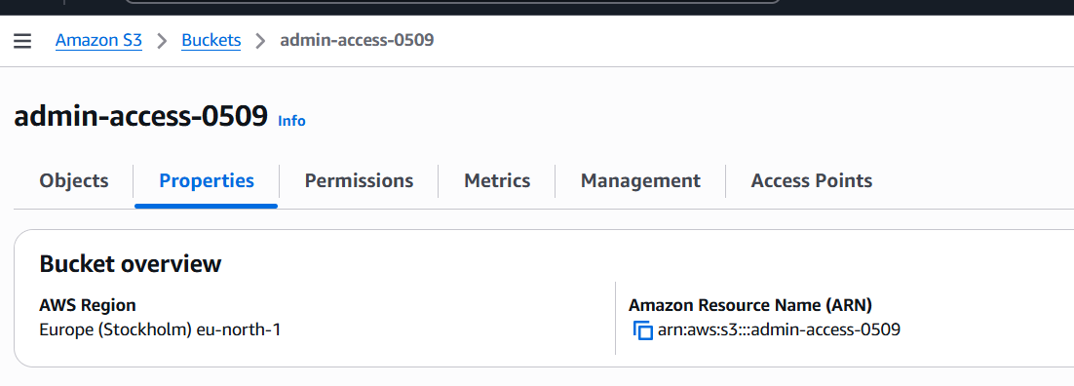

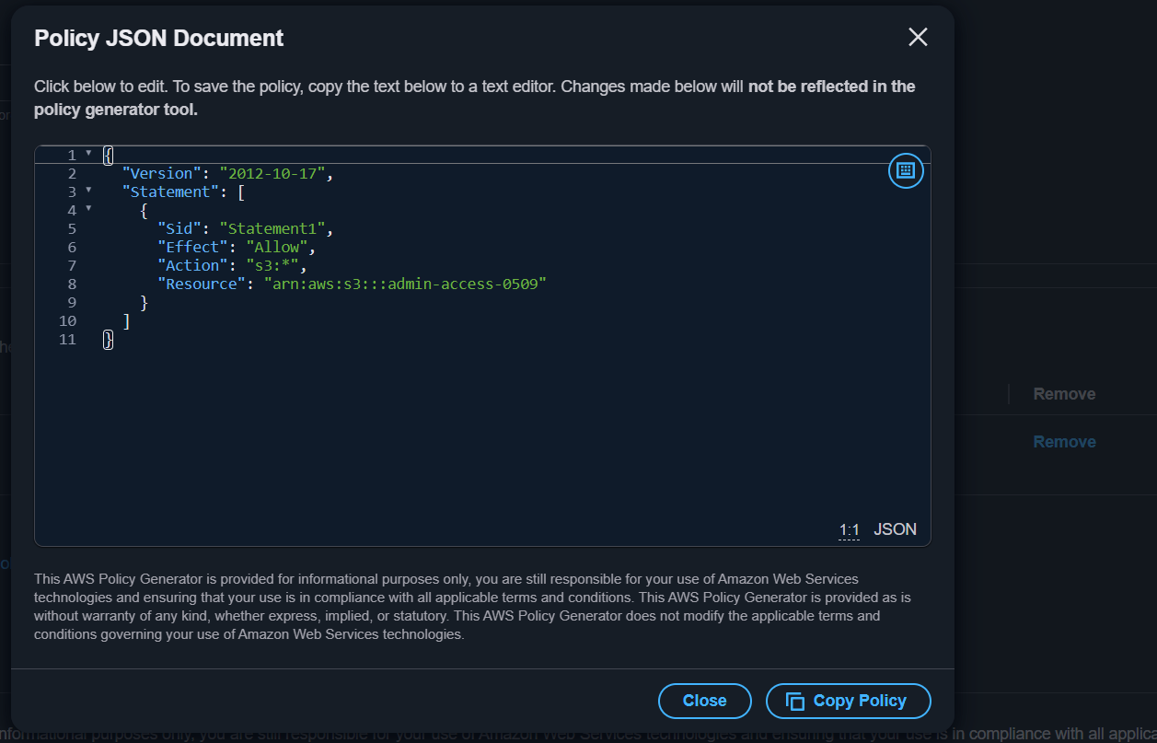

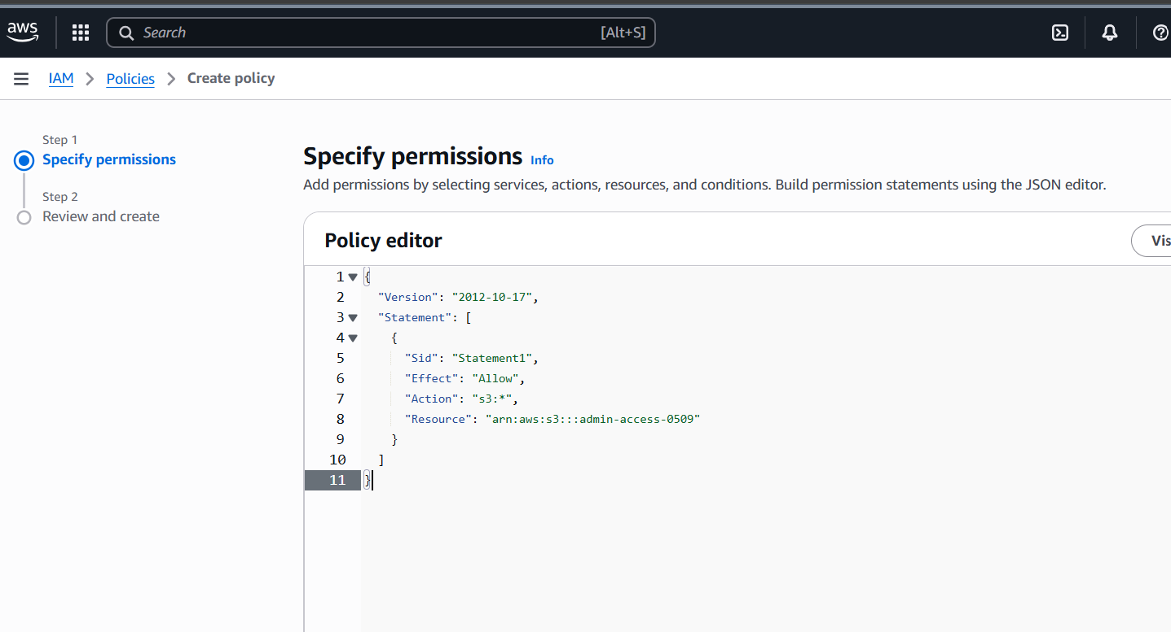

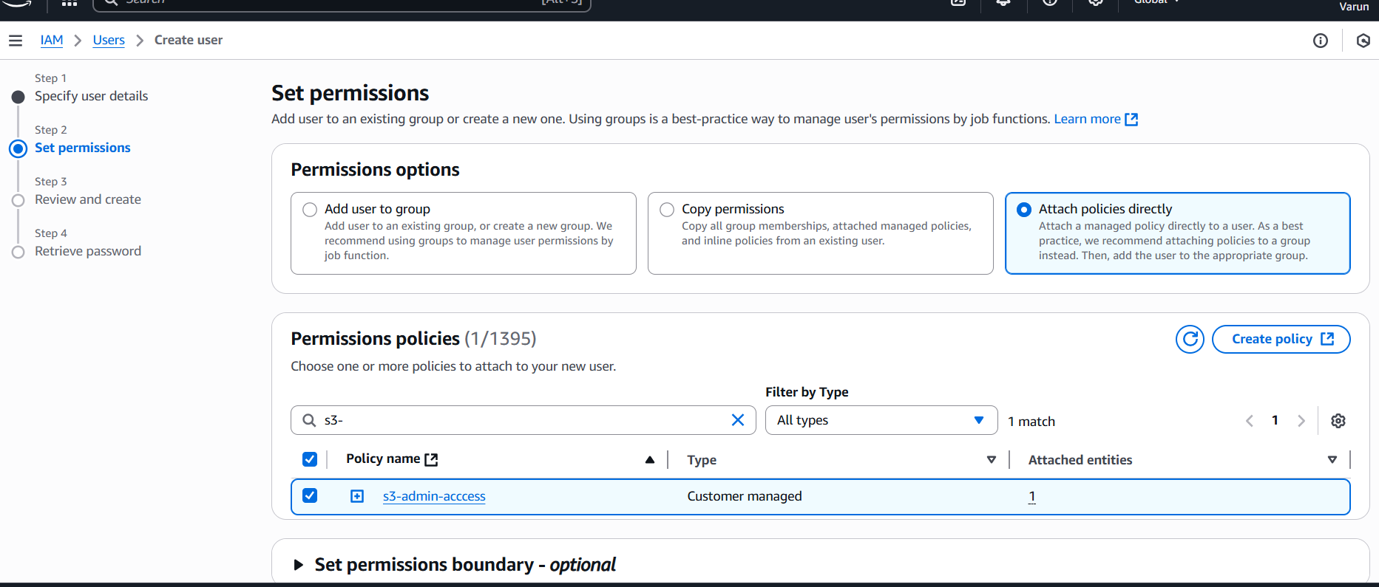

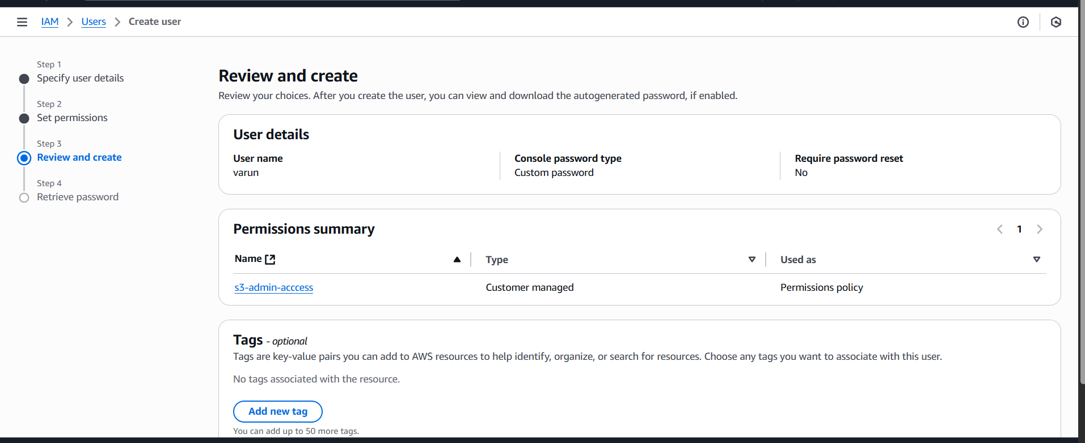

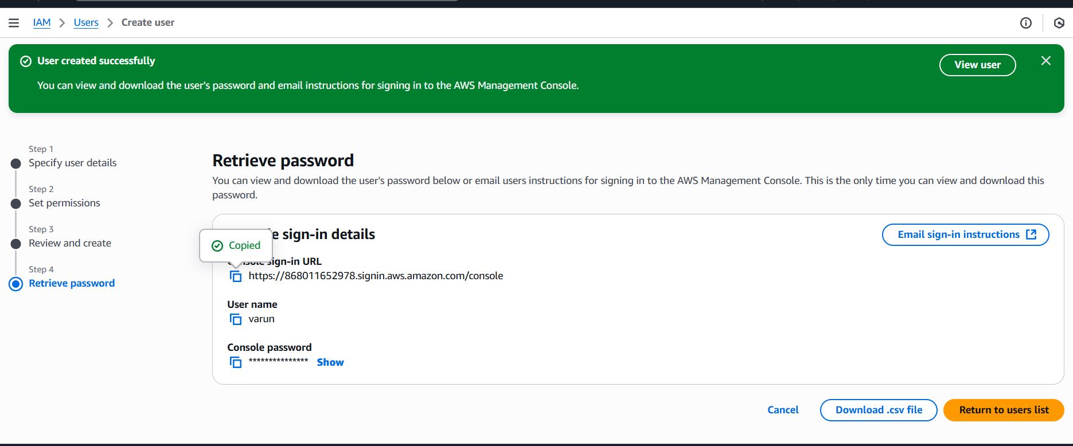

1. Set up lifecycle policies to automatically transition or delete objects based on specific criteria.

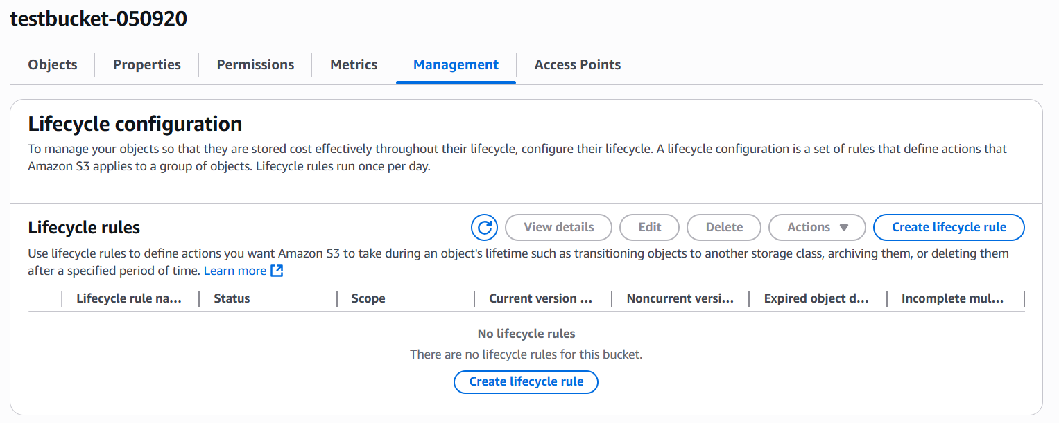

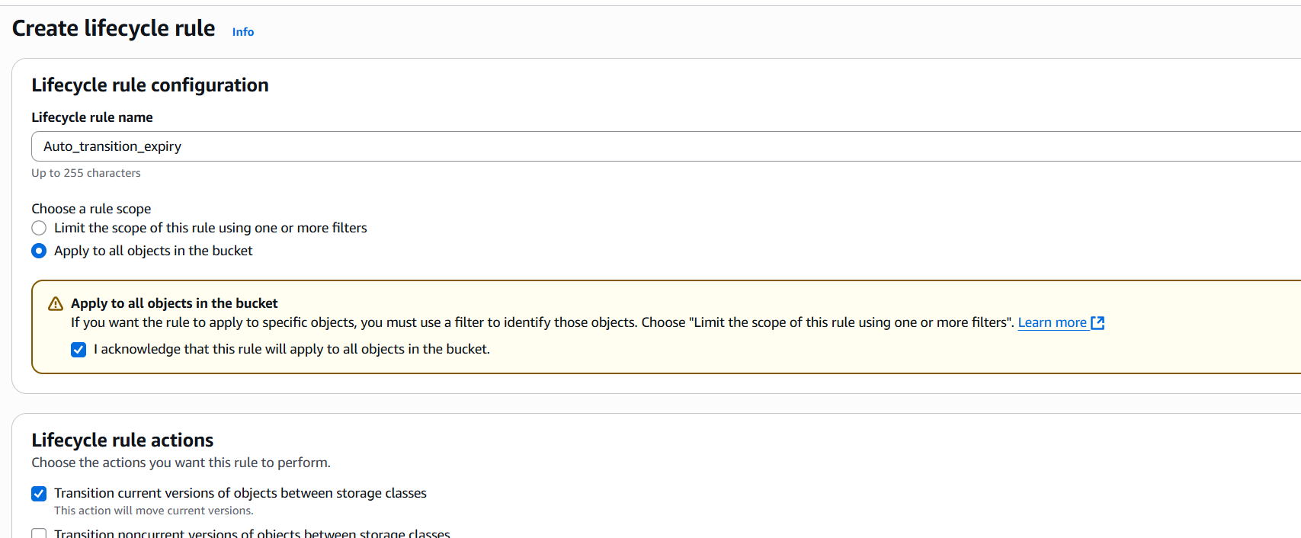

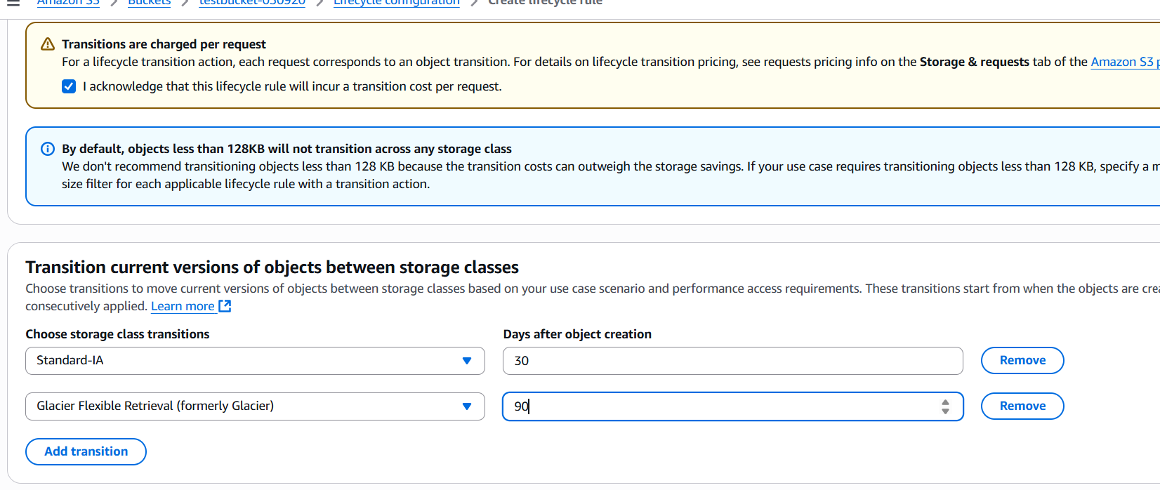

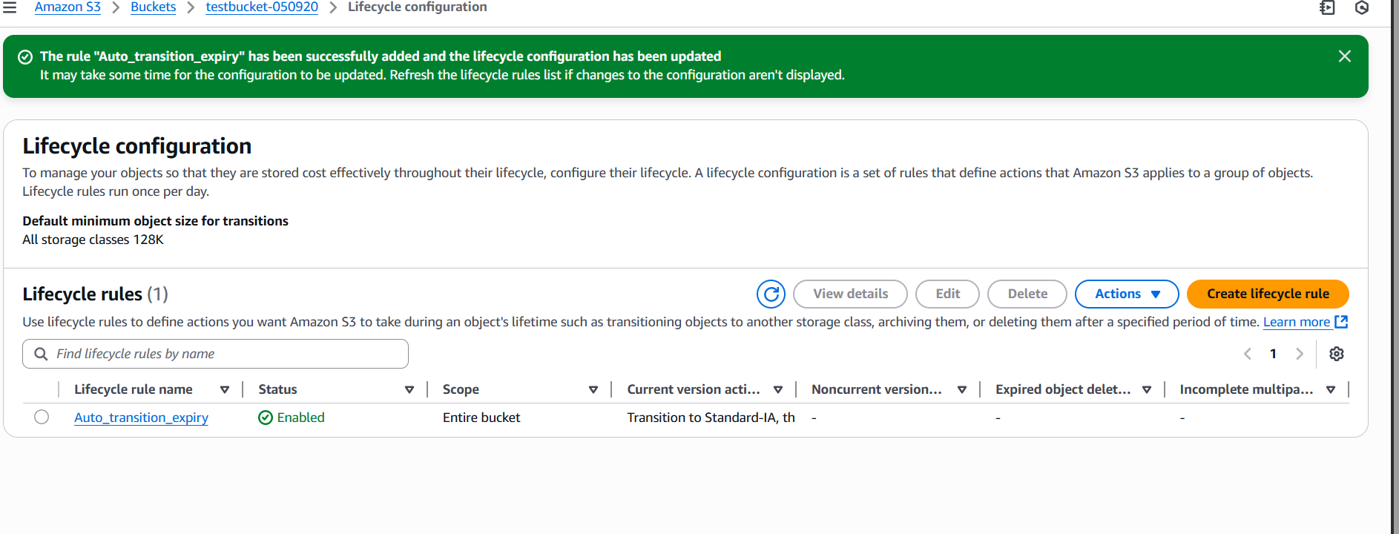

1. Access S3 Console

Navigate to the Amazon S3 Console.

2. Select Your Bucket

Click on the name of the bucket where you want to apply the lifecycle policy.

3. Go to the Management Tab

In the bucket details page, click on the Management tab.

4. Create a New Lifecycle Rule

Click on Create lifecycle rule.

5. Configure Rule Name and Scope

o Rule name: Enter a descriptive name, e.g., AutoTransitionAndExpire.

o Scope: Choose whether to apply the rule to all objects or a subset (e.g., using a

prefix or tags).

6. Set Transition Actions

o Check Transition current versions of objects between storage classes.

o Click on Add transition.

Days after object creation: Enter 30.

Storage class: Select STANDARD_IA.

o Click on Add transition again.

Days after object creation: Enter 90.

Storage class: Select GLACIER.

7. Set Expiration Actions

o Check Expire current versions of objects.

o Days after object creation: Enter 365.

8. Set Additional Options (Optional)

o Check Delete expired object delete markers or incomplete multipart uploads

to clean up expired delete markers and incomplete uploads.

9. Review and Create

o Review your settings.

o Click Create rule to apply the lifecycle policy.

✅ Summary of Actions

Transition current versions:

o To STANDARD_IA after 30 days.

o To GLACIER after 90 days.

Expire current versions:

o Delete objects after 365 days.

Additional cleanup:

o Remove expired delete markers and incomplete multipart uploads.

1. Push some objects to S3 using the AWS CLI.

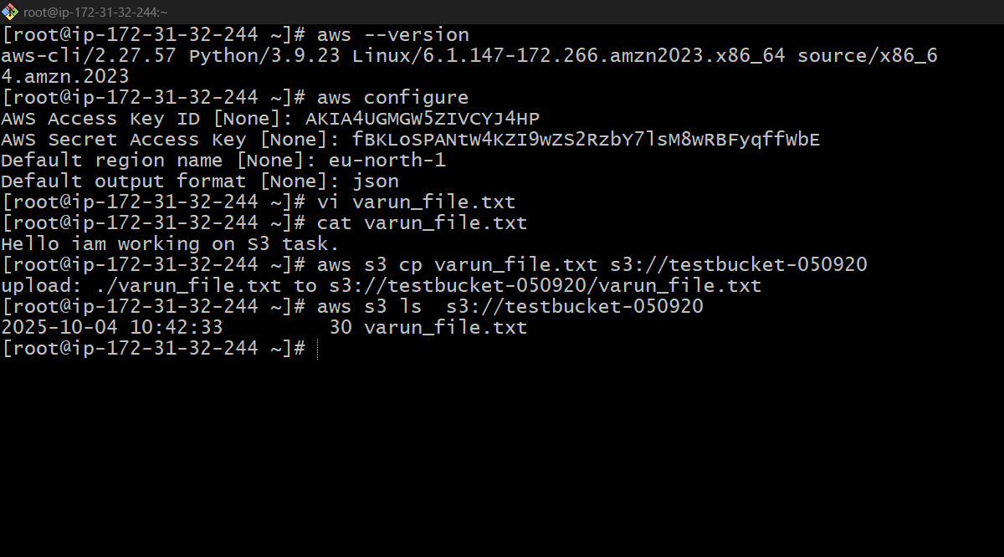

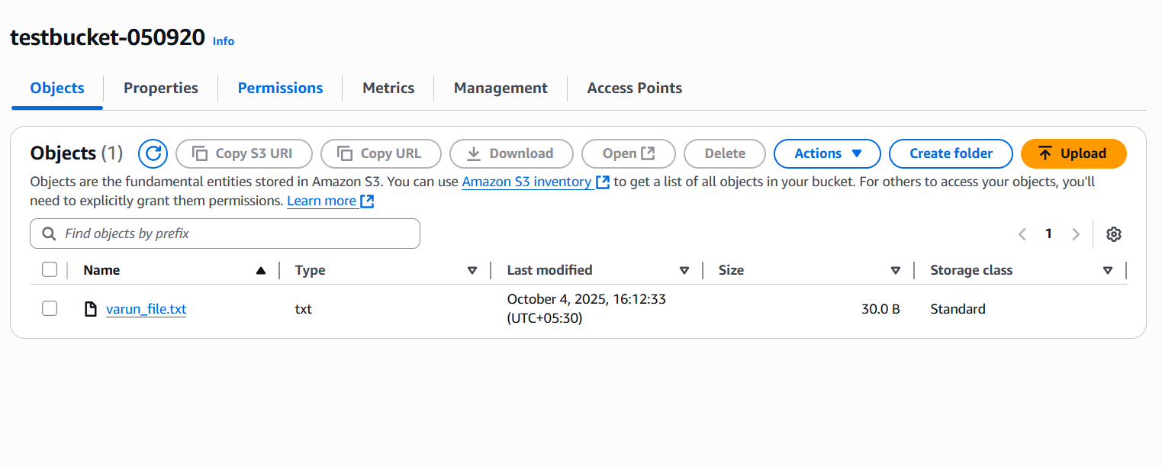

AWS CLI installed (aws --version to check).  
•Run aws configure and set:  
o Access Key ID  
o Secret Access Key  
o Default Region  
o Output format (json/table/text)  
Upload a Single File  
aws s3 cp myfile.txt s3://my-private-bucket  
Verify Objects Uploaded  
aws s3 ls s3://my-private-bucket

1. Write a Bash script to create an S3 bucket.

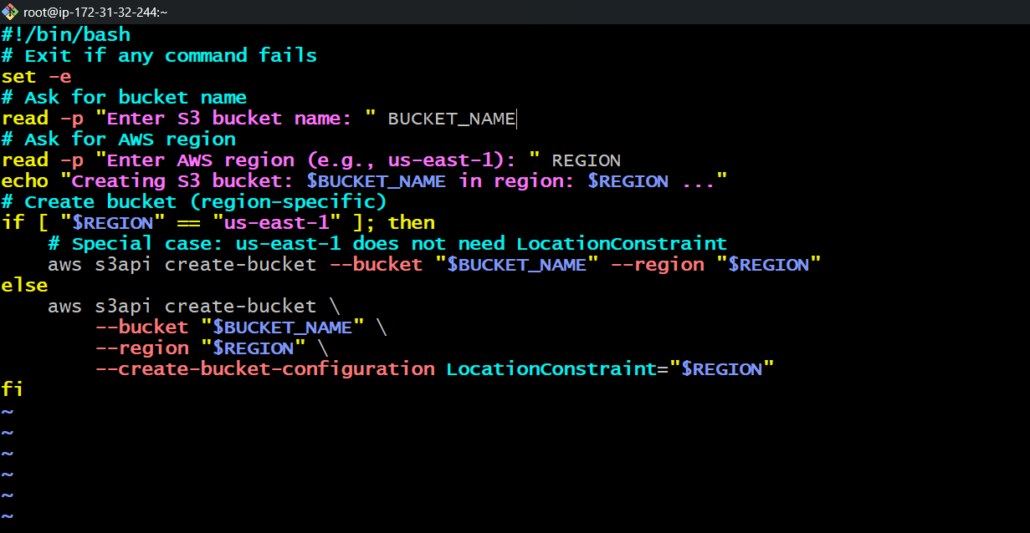

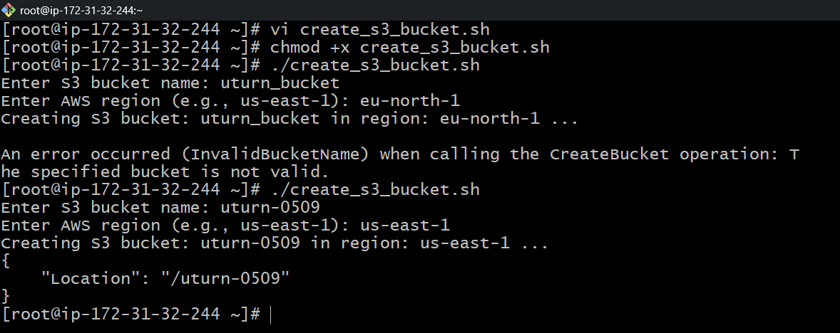

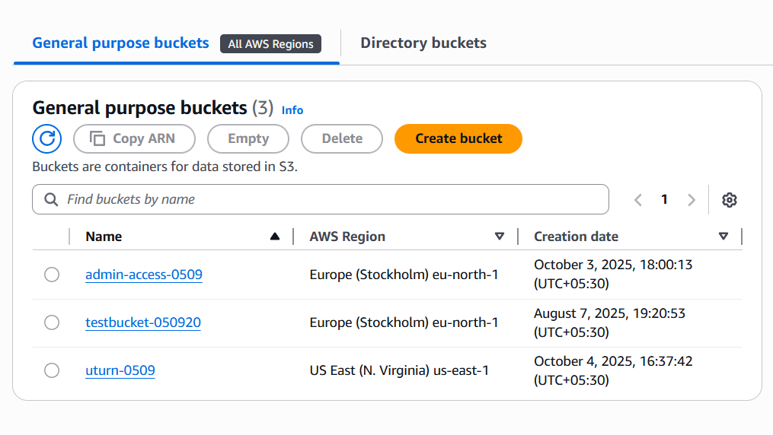

1. Save the script as create-s3-bucket.sh  
2. Make it executable:3. chmod +x create-s3-bucket.sh  
4. Run it:5. ./create-s3-bucket.sh  
6. Enter:  
o Bucket name (must be globally unique across AWS)  
o Region (e.g., us-east-1, ap-south-1, etc.)

1. Upload a 1 GB file to S3 using the CLI.

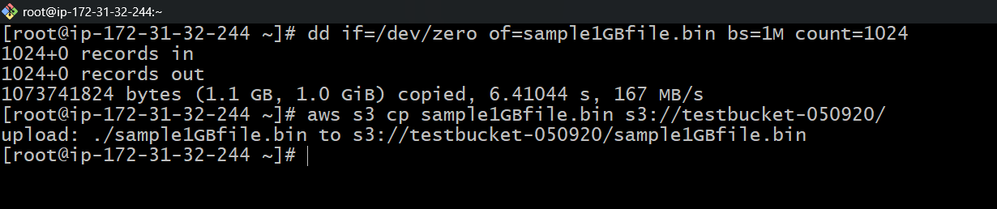

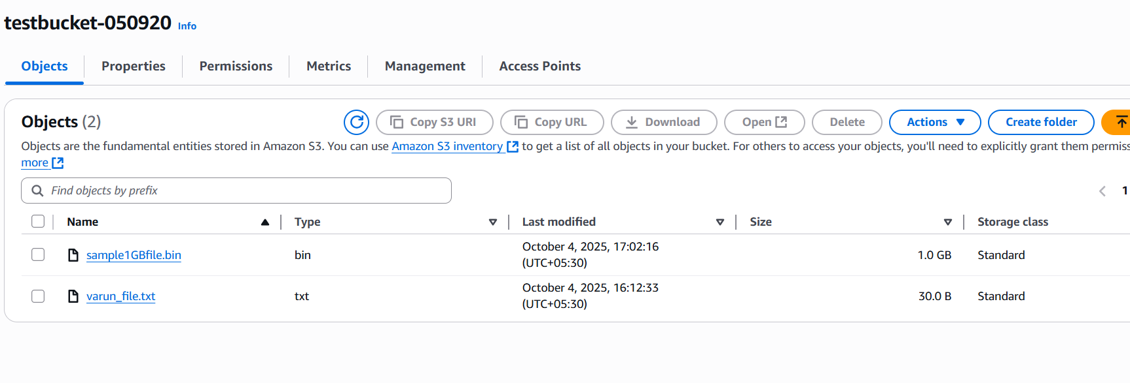

* Create a 1gb file for testing.

dd if=/dev/zero of=sample1GBfile.bin bs=1M count=1024

* Upload file to s3.

aws s3 cp sample1GBfile.bin s3://your-bucket-name/