- Install Jenkins and run Jenkins on port number 8081.

Launch an EC2 instance and connect via ssh <public ip>
sudo yum update -y
sudo yum install java-17-amazon-corretto -y
java --version
sudo wget -O /etc/yum.repos.d/jenkins.repo \ https://pkg.jenkins.io/redhat-stable/jenkins.repo
sudo rpm --import https://pkg.jenkins.io/redhat-stable/jenkins.io-2023.key
sudo yum install jenkins -y
sudo systemctl enable jenkins
sudo systemctl start jenkins
sudo systemctl status Jenkins

http://<your-ec2-public-ip>:8080
sudo cat /var/lib/jenkins/secrets/initialAdminPassword
You can Login to Jenkins with initial password.
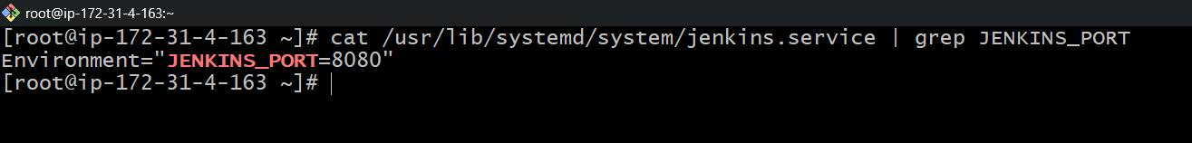
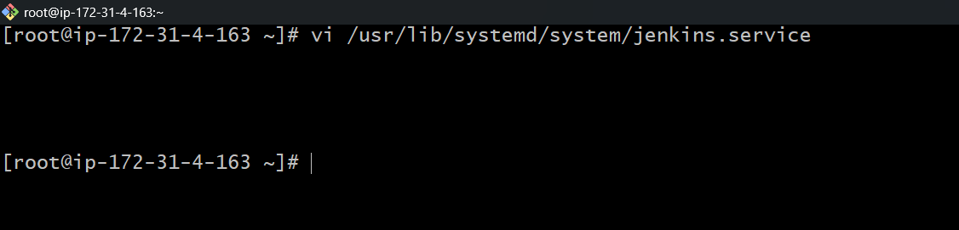
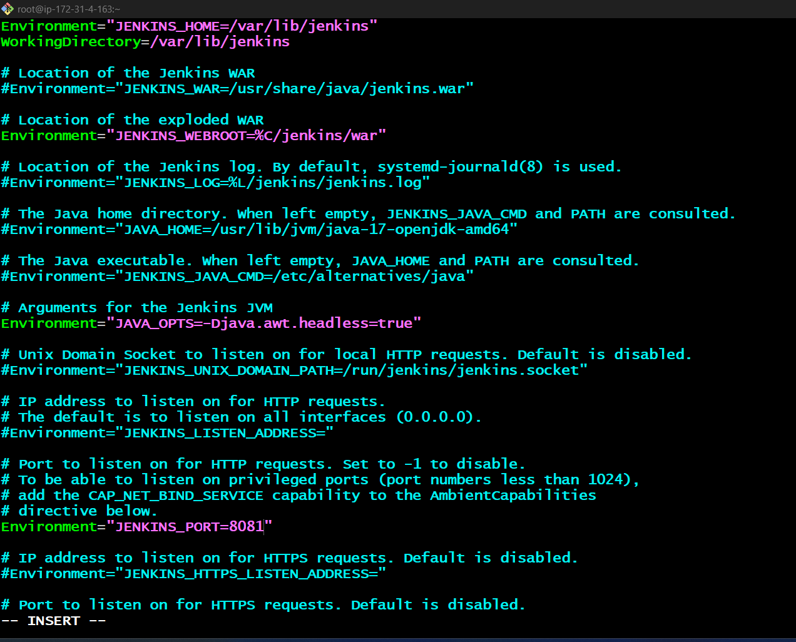
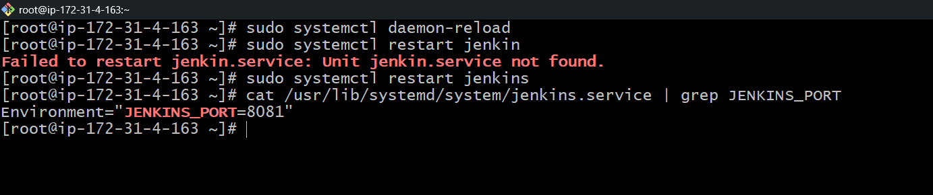
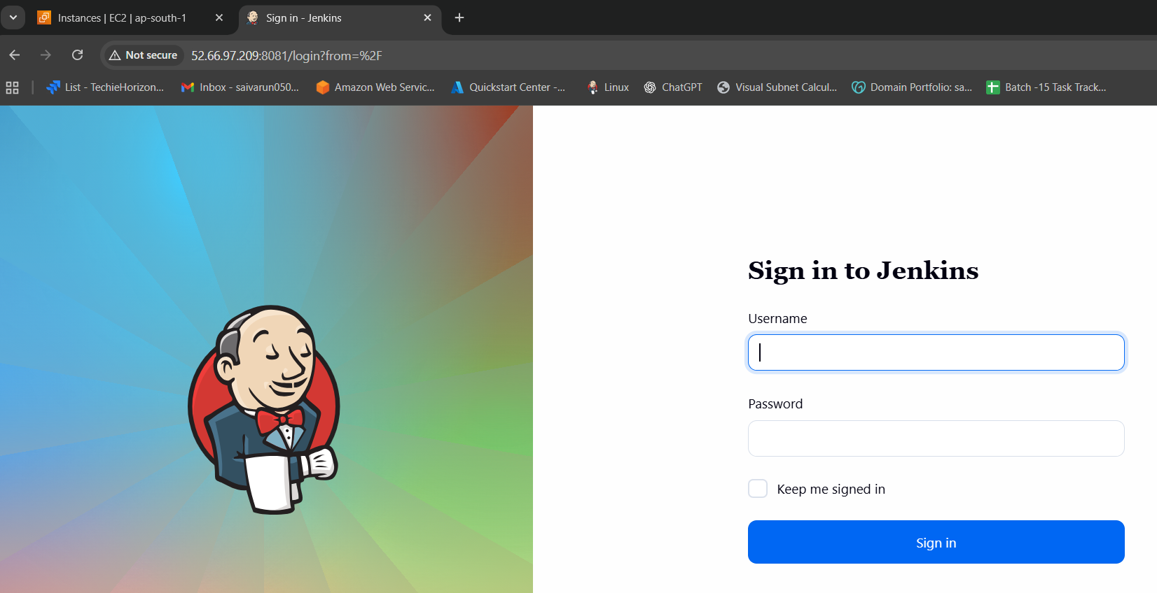

- Secure Jenkins server
- By deleting InitialAdminPassword we can secure Jenkins server.
- By creating a new user inplace of admin.
- Change the password and save it and apply.
- Make sure you delete the InitialAdminPassword too.

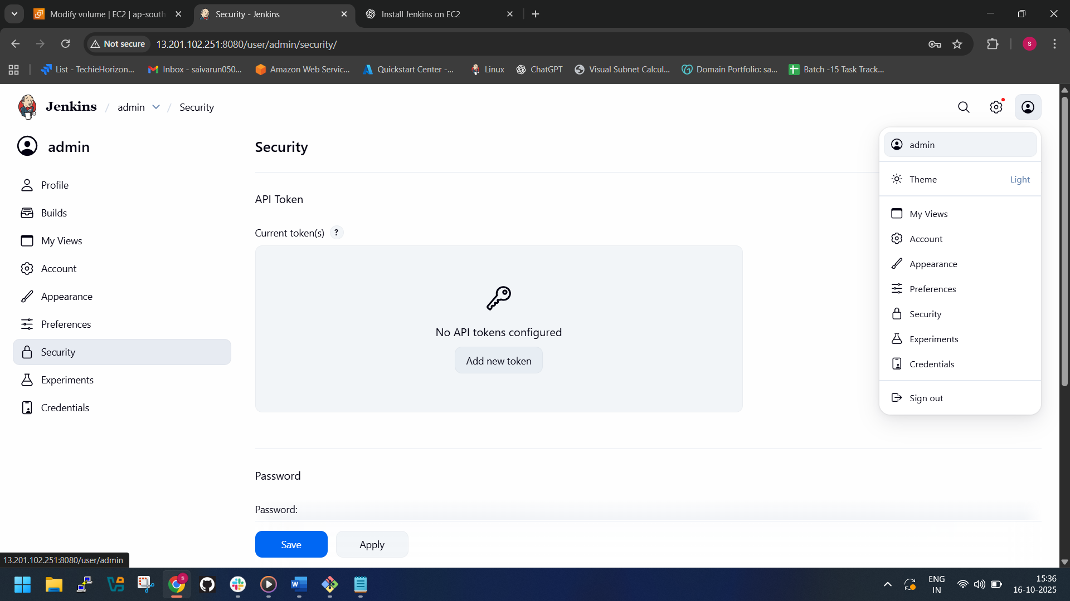

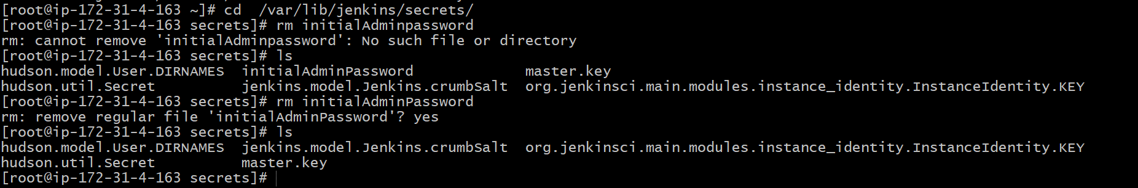

- Create users called DevOps, Testing in Jenkins with Limited access.
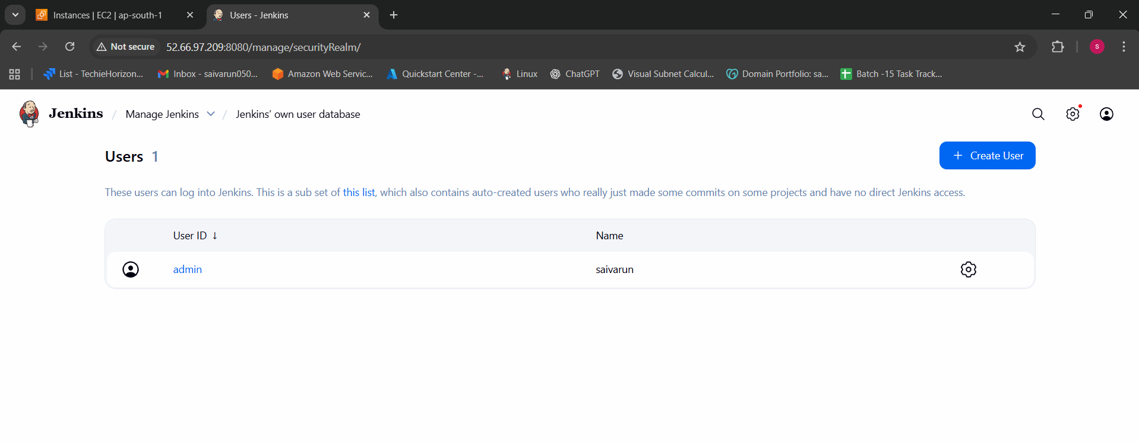
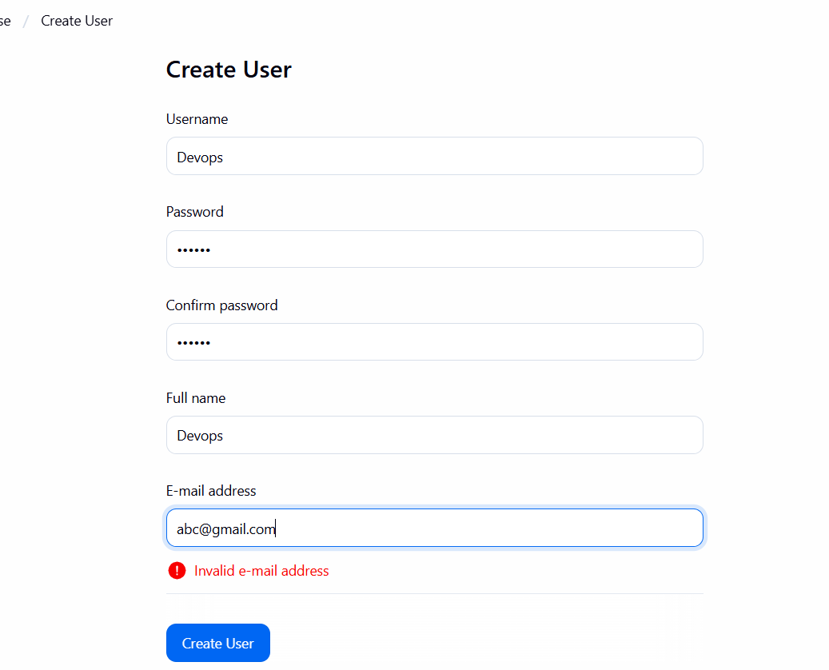
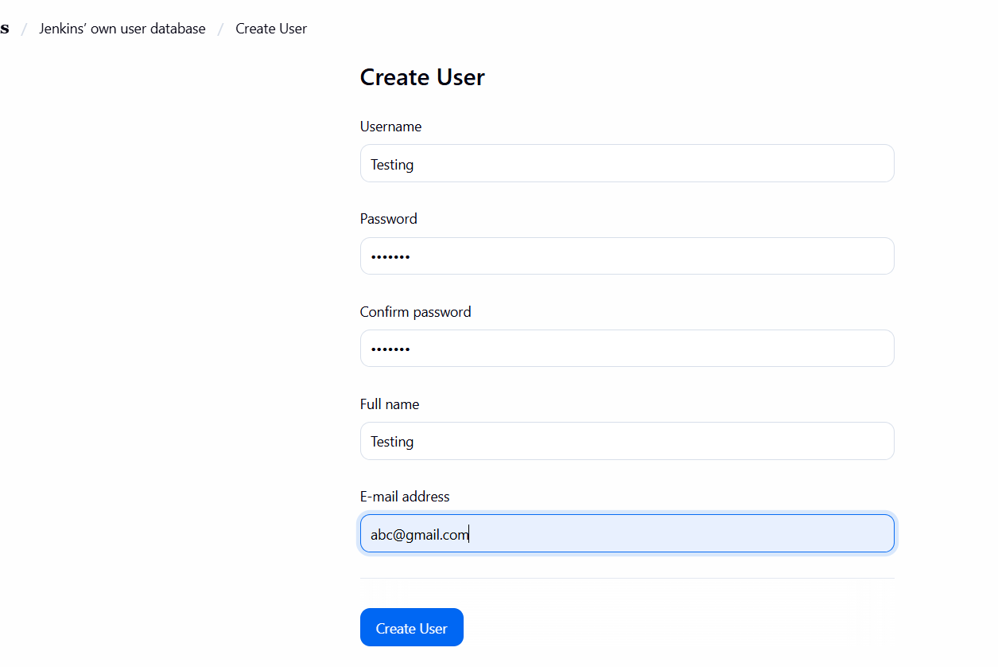
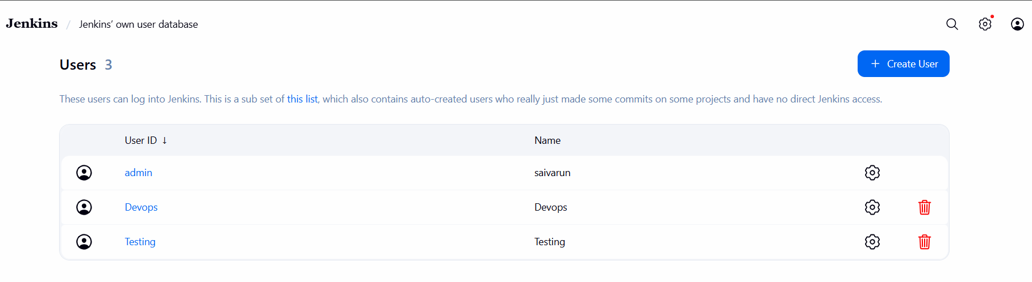
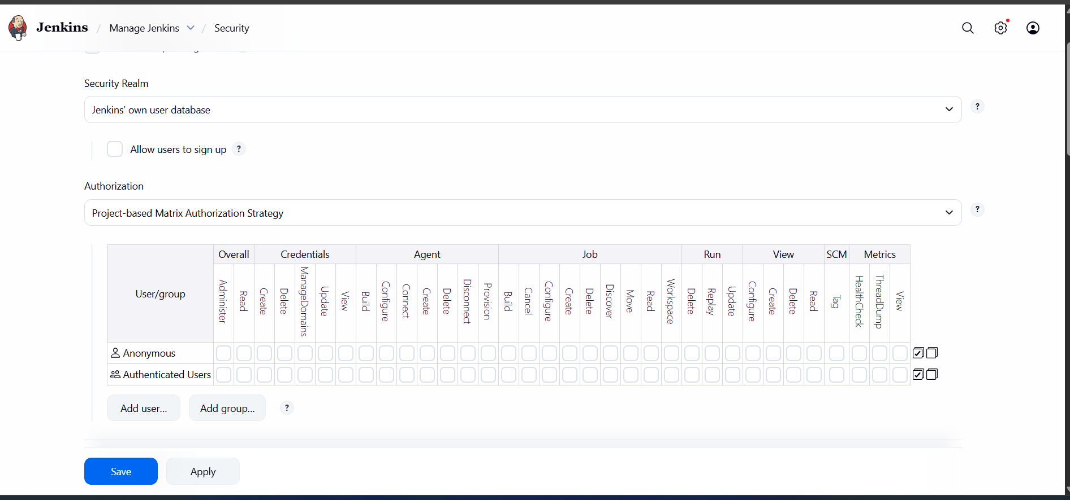
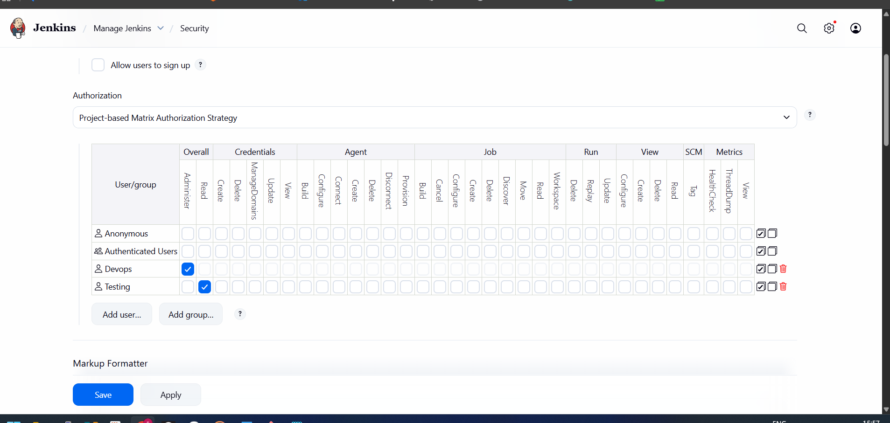
Step 1: Install the Role-Based Authorization Strategy Plugin

- Go to Jenkins Dashboard → Manage Jenkins → Manage Plugins → Available.
- Search for Role-Based Authorization Strategy.
- Install it and restart Jenkins if required.

Step 2: Enable Role-Based Authorization
- Go to Manage Jenkins → Configure Global Security.
- Under Authorization, select Role-Based Strategy.
- Save the changes.

Step 3: Create Users
- Go to Manage Jenkins → Manage Users → Create User.
- Create the following users:
- Username: DevOps
Password: (set a secure password)
Full Name: DevOps
Email: (optional)
- Username: Testing
Password: (set a secure password)
Full Name: Testing
Email: (optional)

Step 4: Define Roles
- Go to Manage Jenkins → Security → Authorization.
- Create roles for limited access. For example:
devops-role
- Overall: Read (or Build if needed)
- Job: Read/Build for specific jobs/projects
- Credentials, SCM, etc.: Restrict as per requirement
testing-role
- Overall: Read only
- Job: Read only for certain jobs
- Save roles.
- Verify access by logging in and out with the credentials of different users we added and check what access they are having.

- Configure labels and restrict the jobs to execute based on label only.
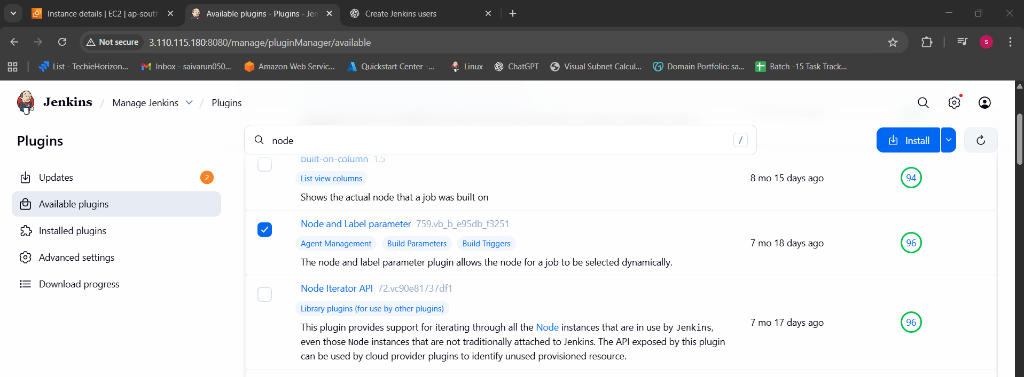
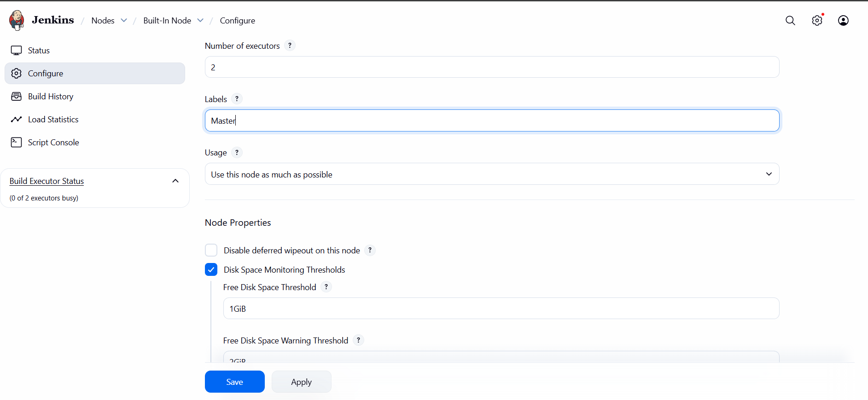
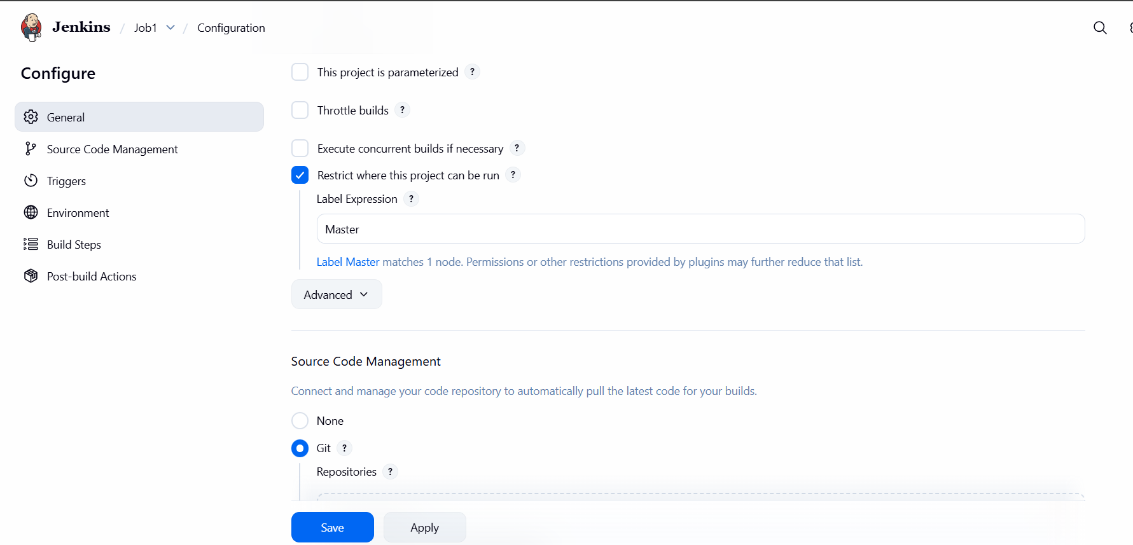

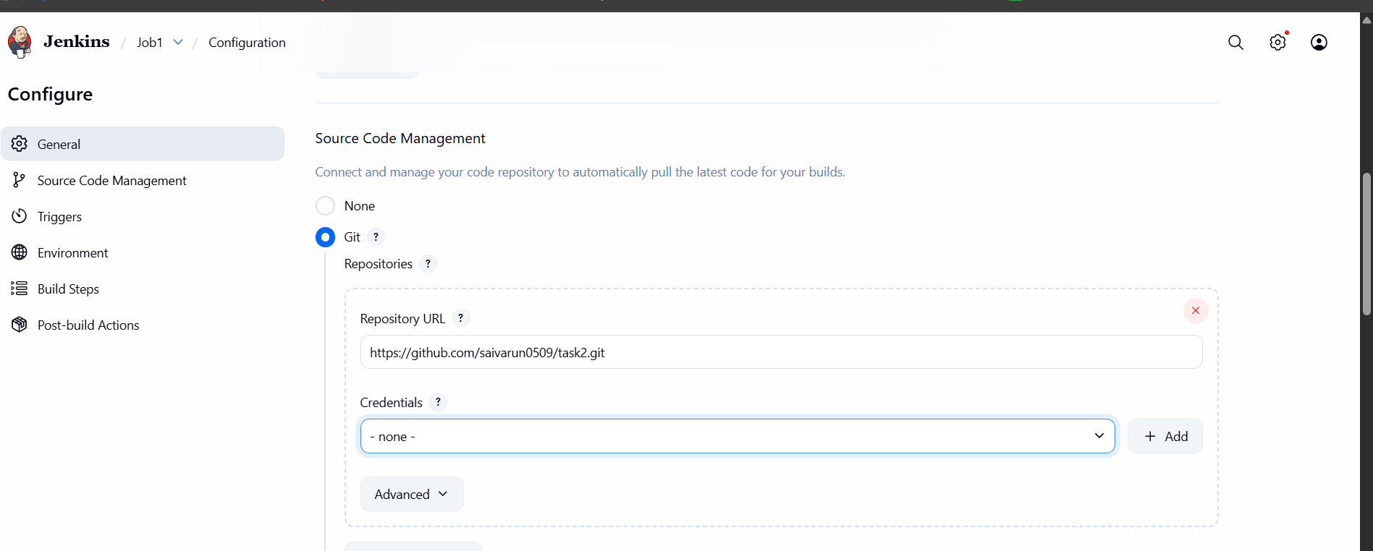
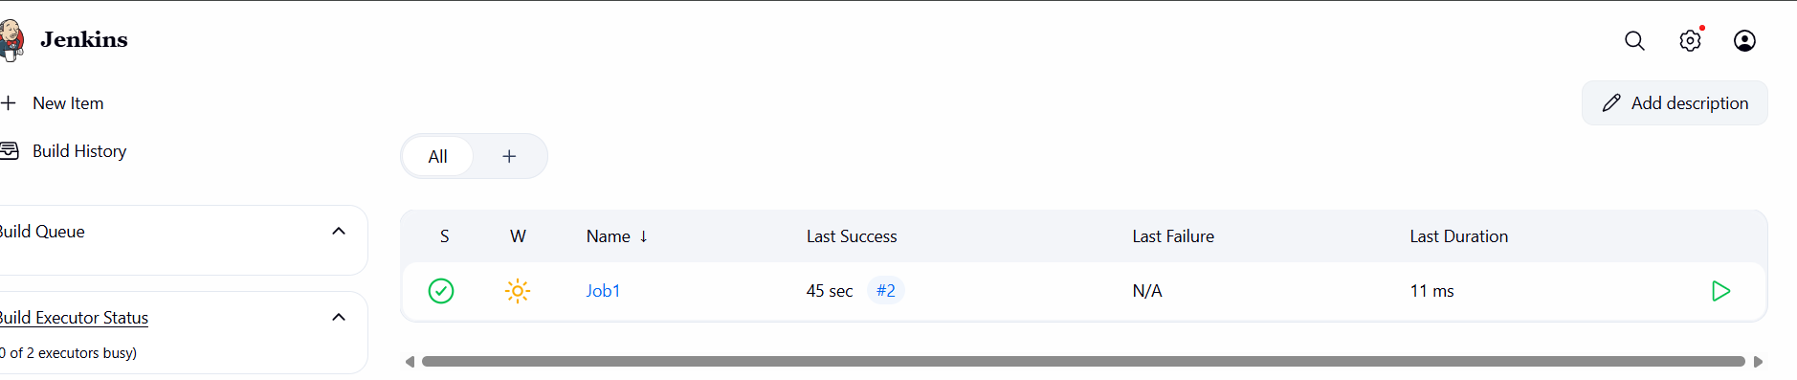
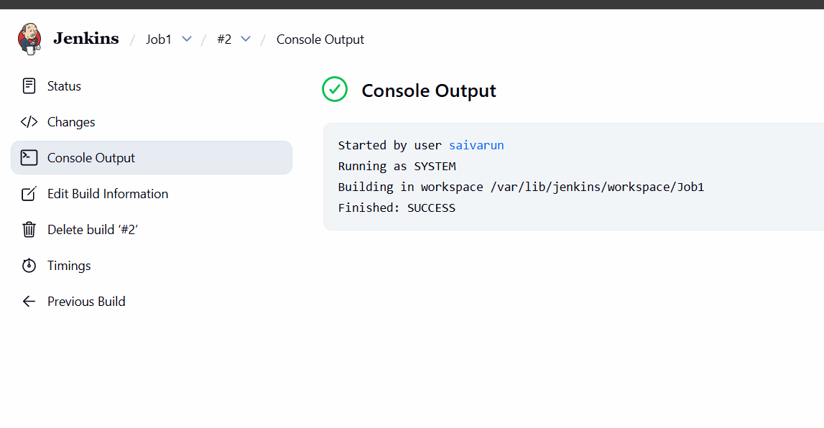
¬Go to manage Jenkins first.
¬Then go to plugins >> nd available plugins >> node label
parameter >> install.
¬Then in manage Jenkins >> node > check the node.
¬Then go to the dashboard >> create job >> gave a URL
its shows you error first.
¬Then connect to the your instance nd check the git
version.
¬If its not available then use “yum install git -y”
¬Then the error will gone.
¬If is showing some error.
¬Click the job nd check error in console output:
Then go to plugins >> nd available plugins >> node label
parameter >> install.
Then in manage Jenkins >> node > check the node

- Create Three sample jobs using the below URL. https://github.com/betawins/Techie_horizon_Login_app.git
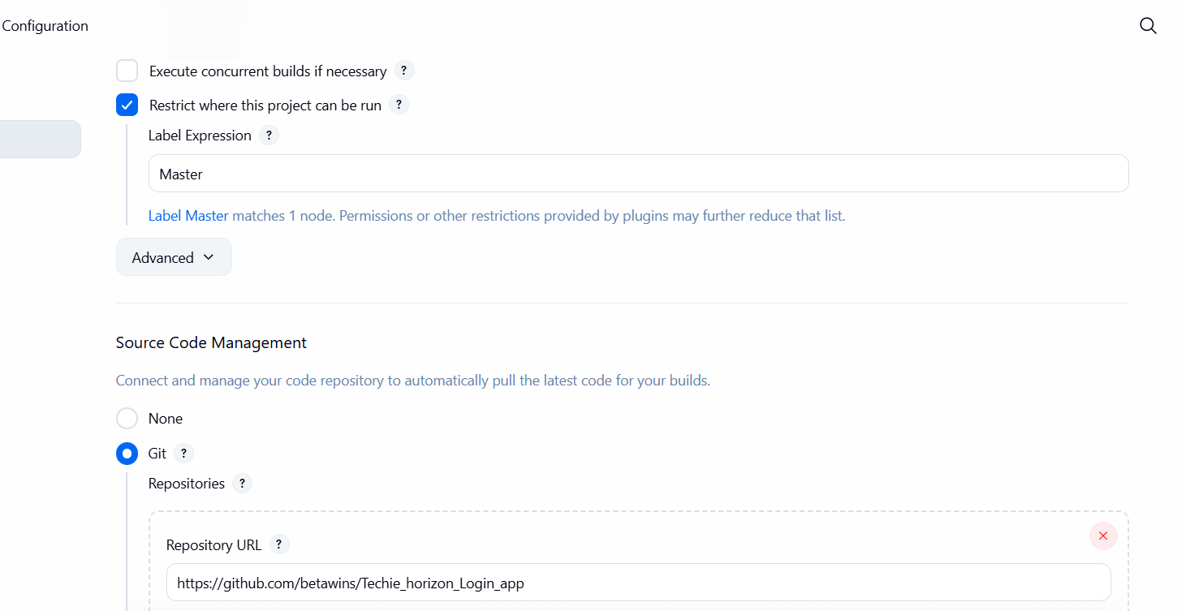
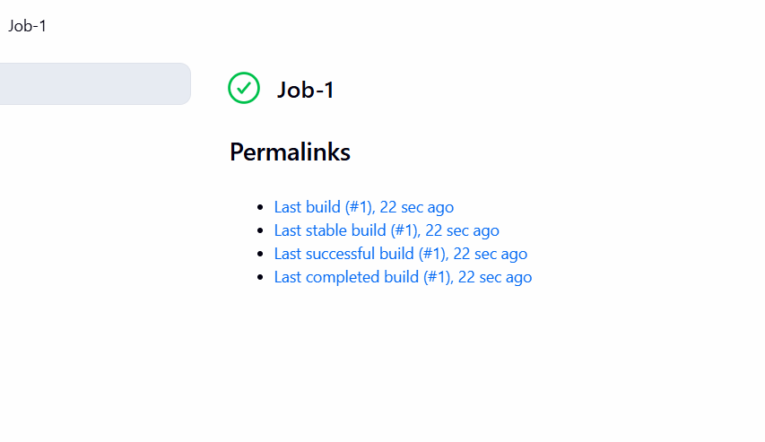
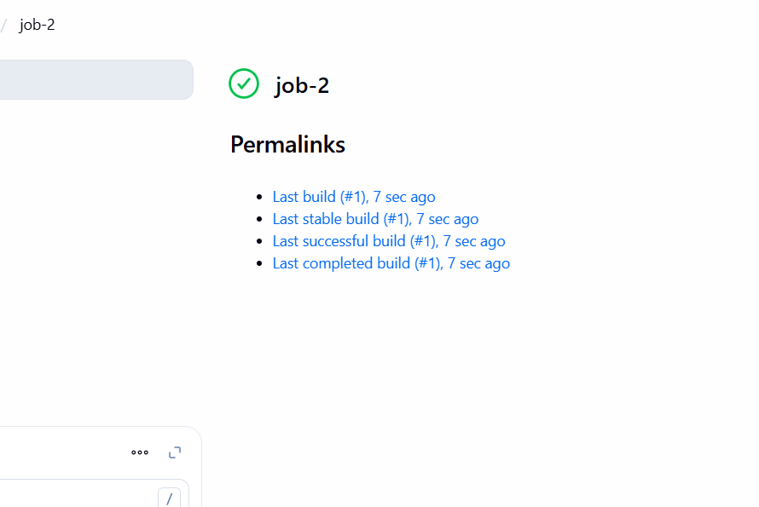
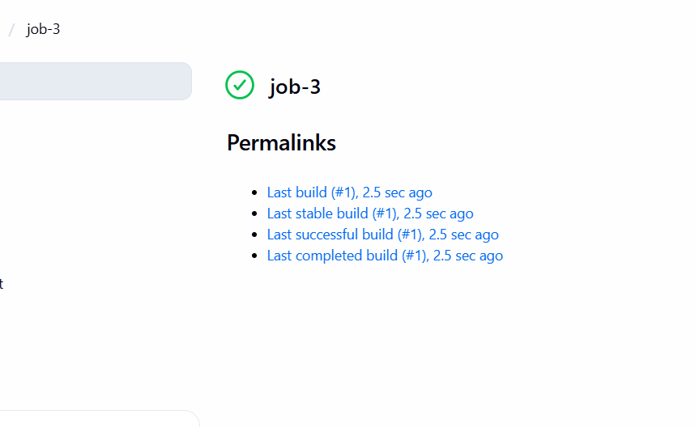
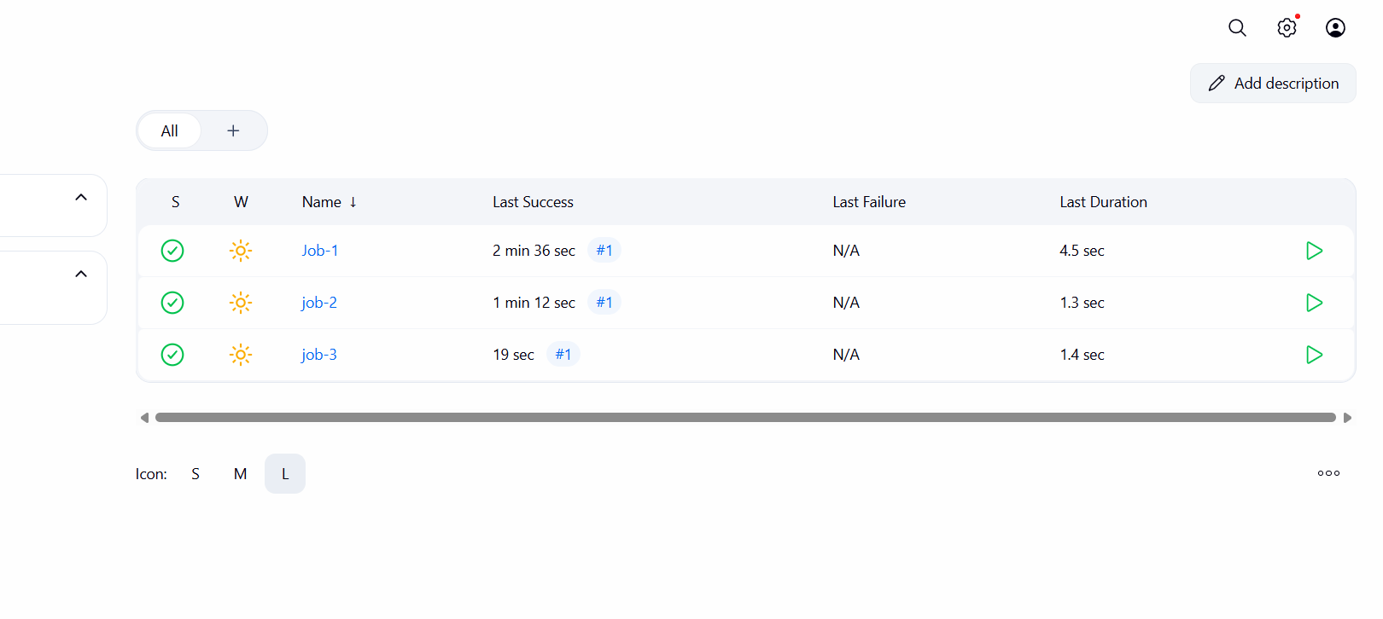
- Go to the dashboard of jenkins.
- Create a new item.
- Then gave a name of that in discription.
- And choose git nd copy the repo url and save.
- Do same thing other 2 jobs also.

- Create one Jenkins job using git hub Private repository.
