- Configure 2 slave machines in Jenkins master.
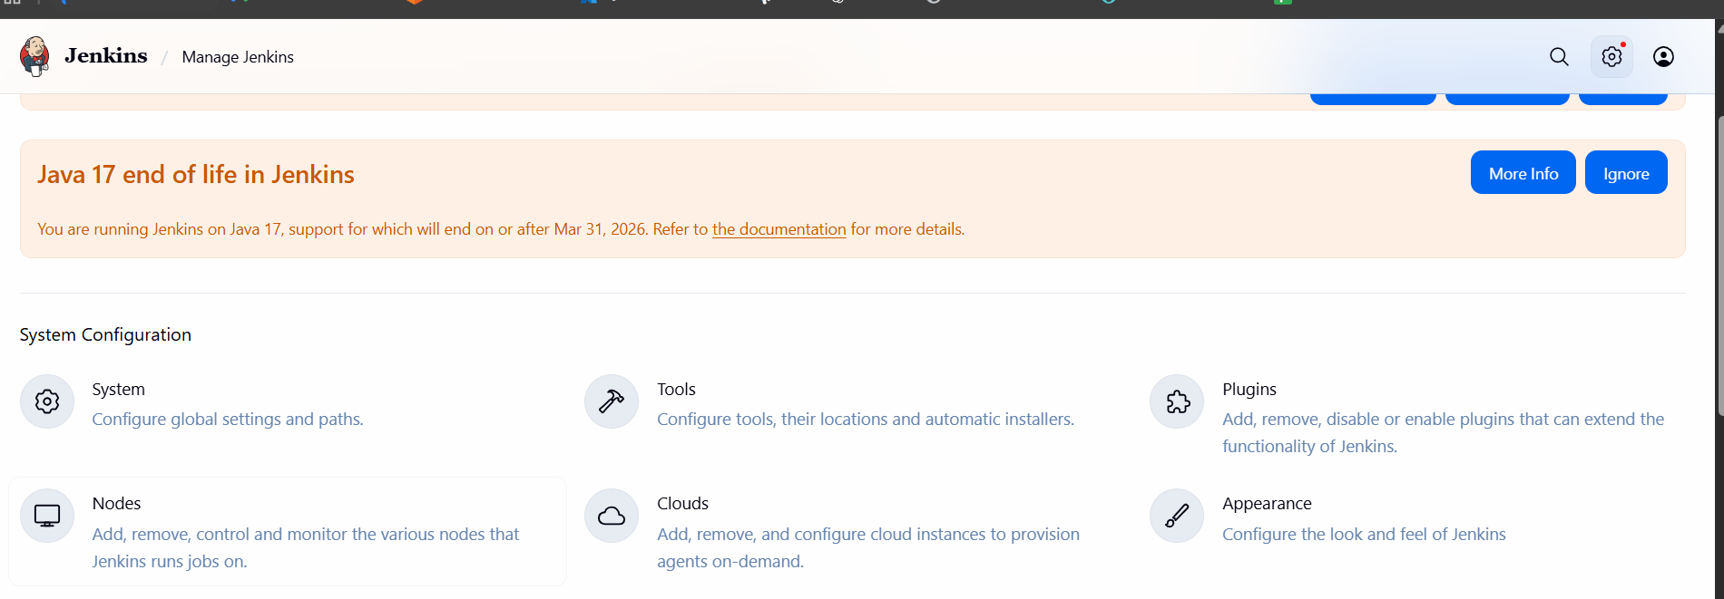
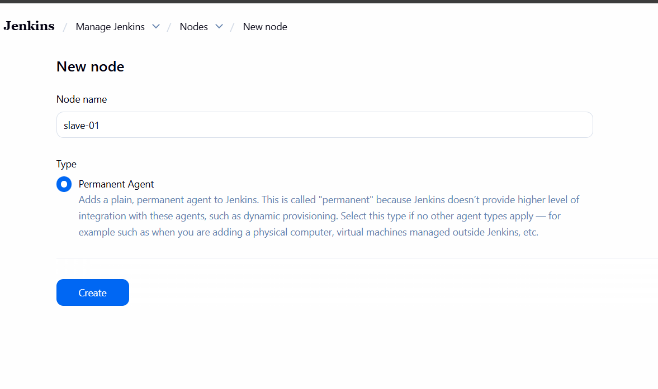
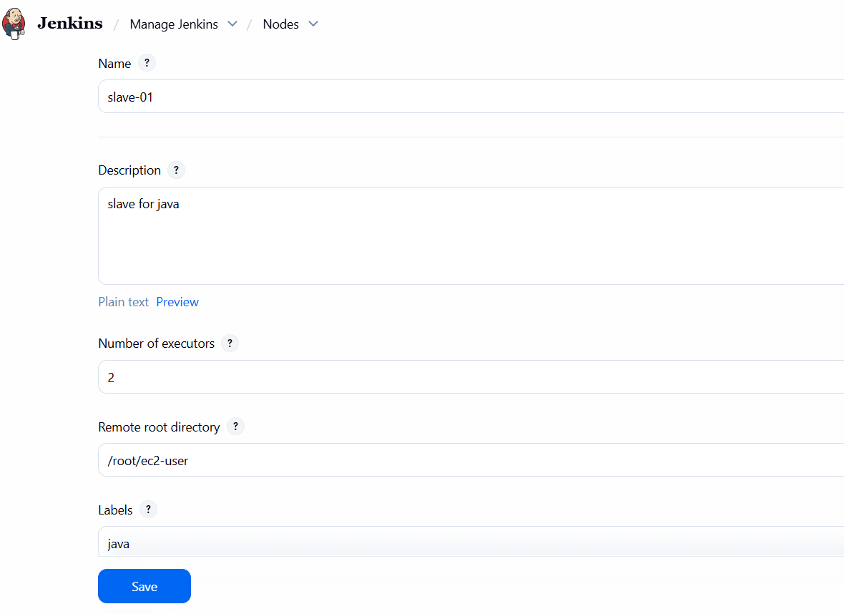
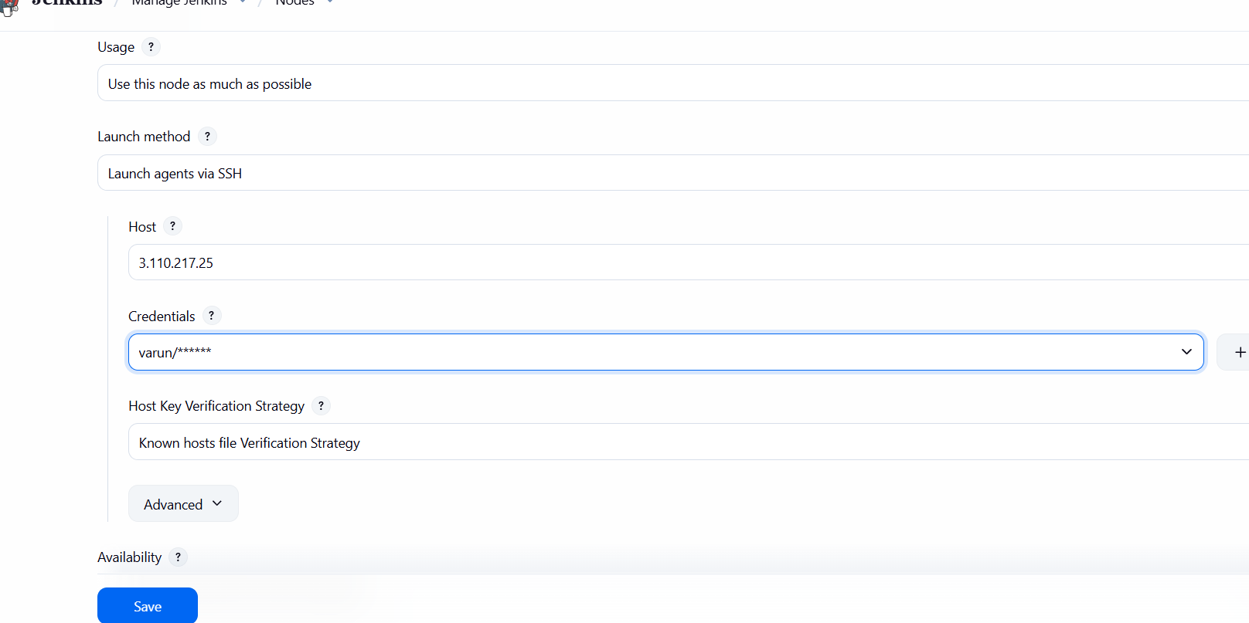
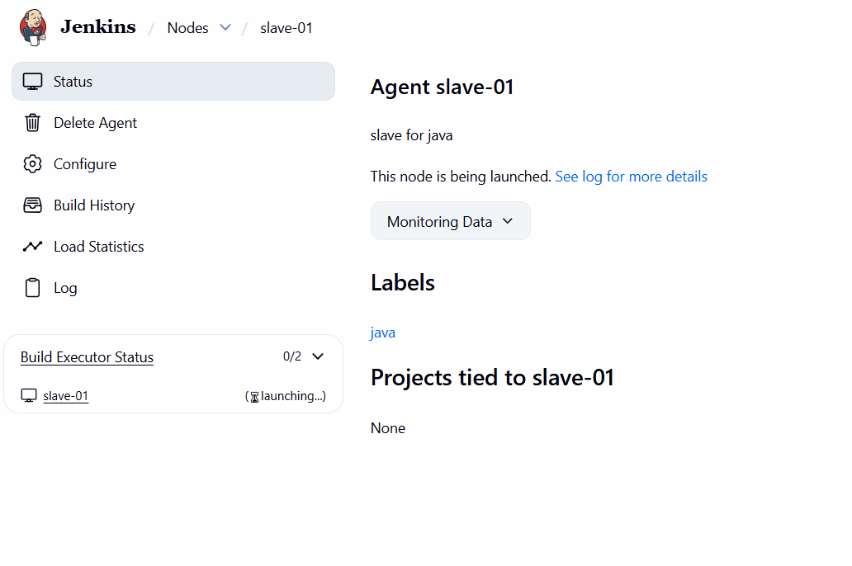
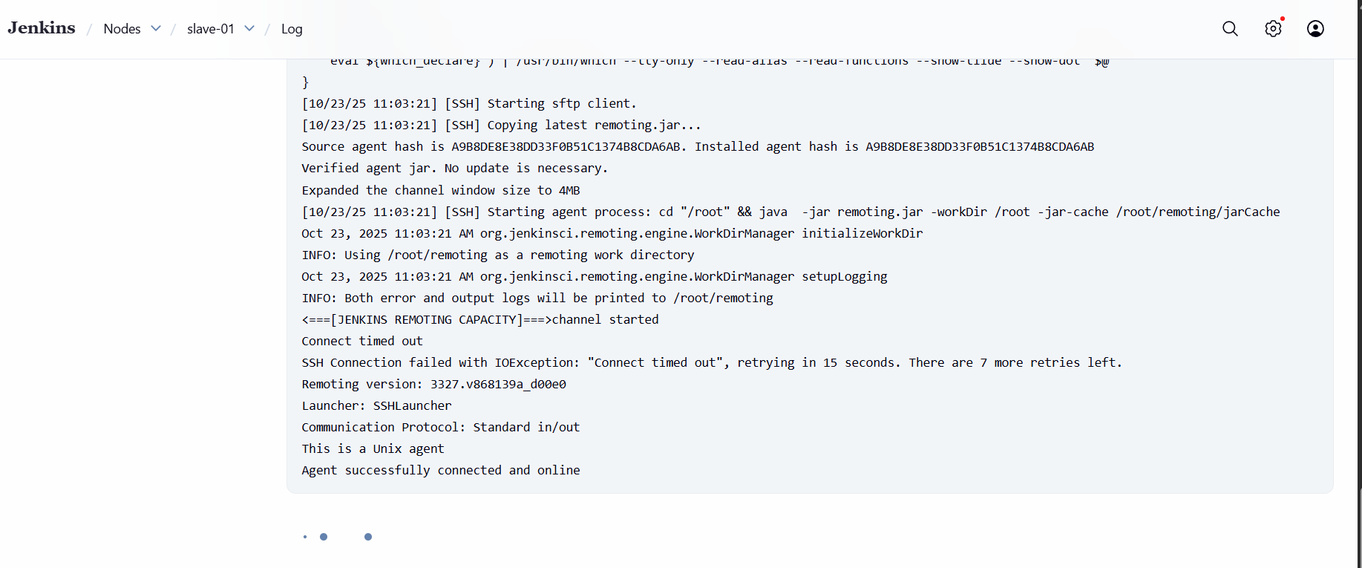
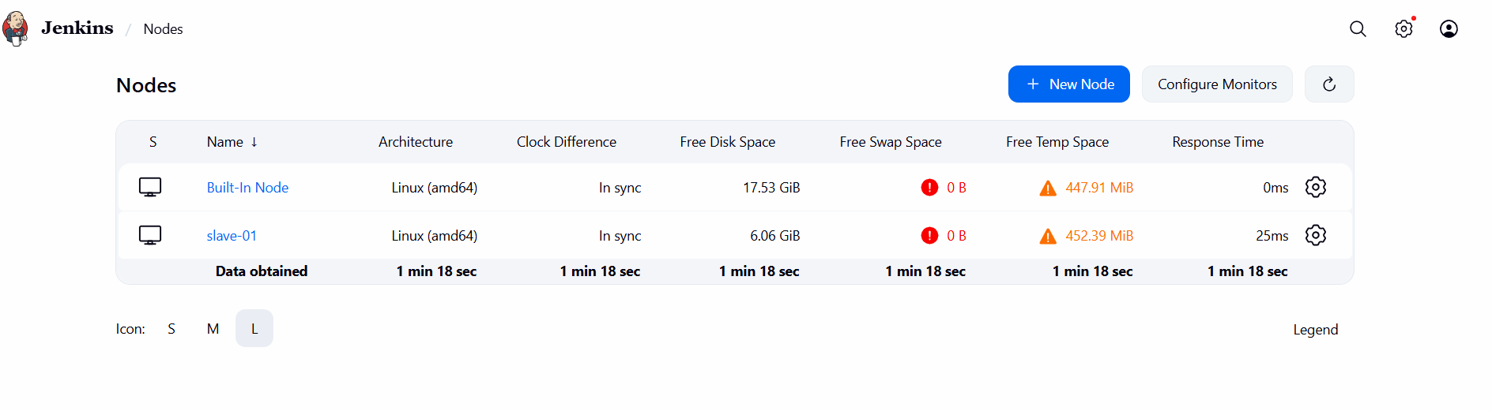
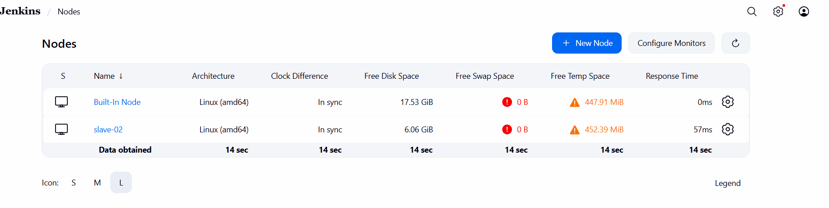

- Go to your Jenkins dashboard
- Click on “Manage Jenkins” → “ Click on Nodes ” → “New Node”
- Click on create.

- Configure webhooks to Jenkins job.
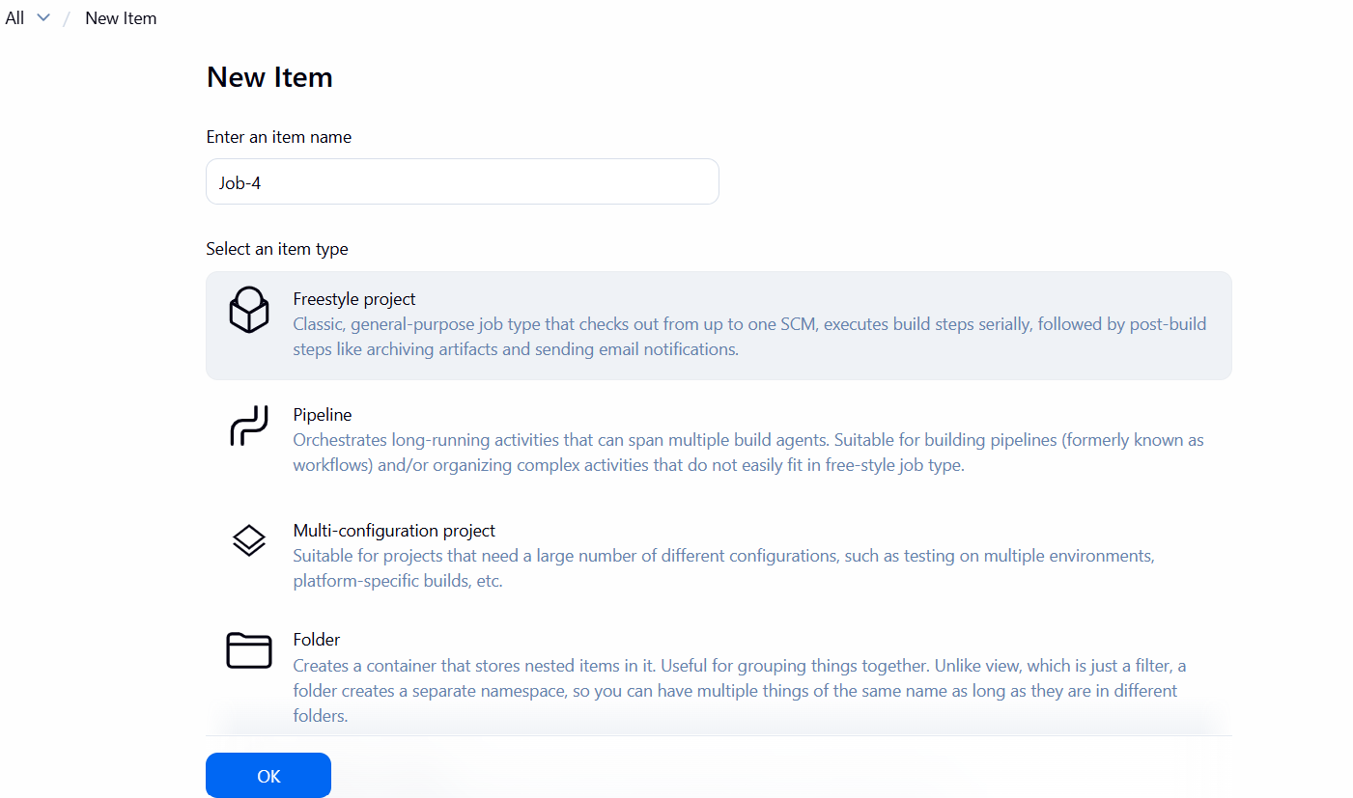
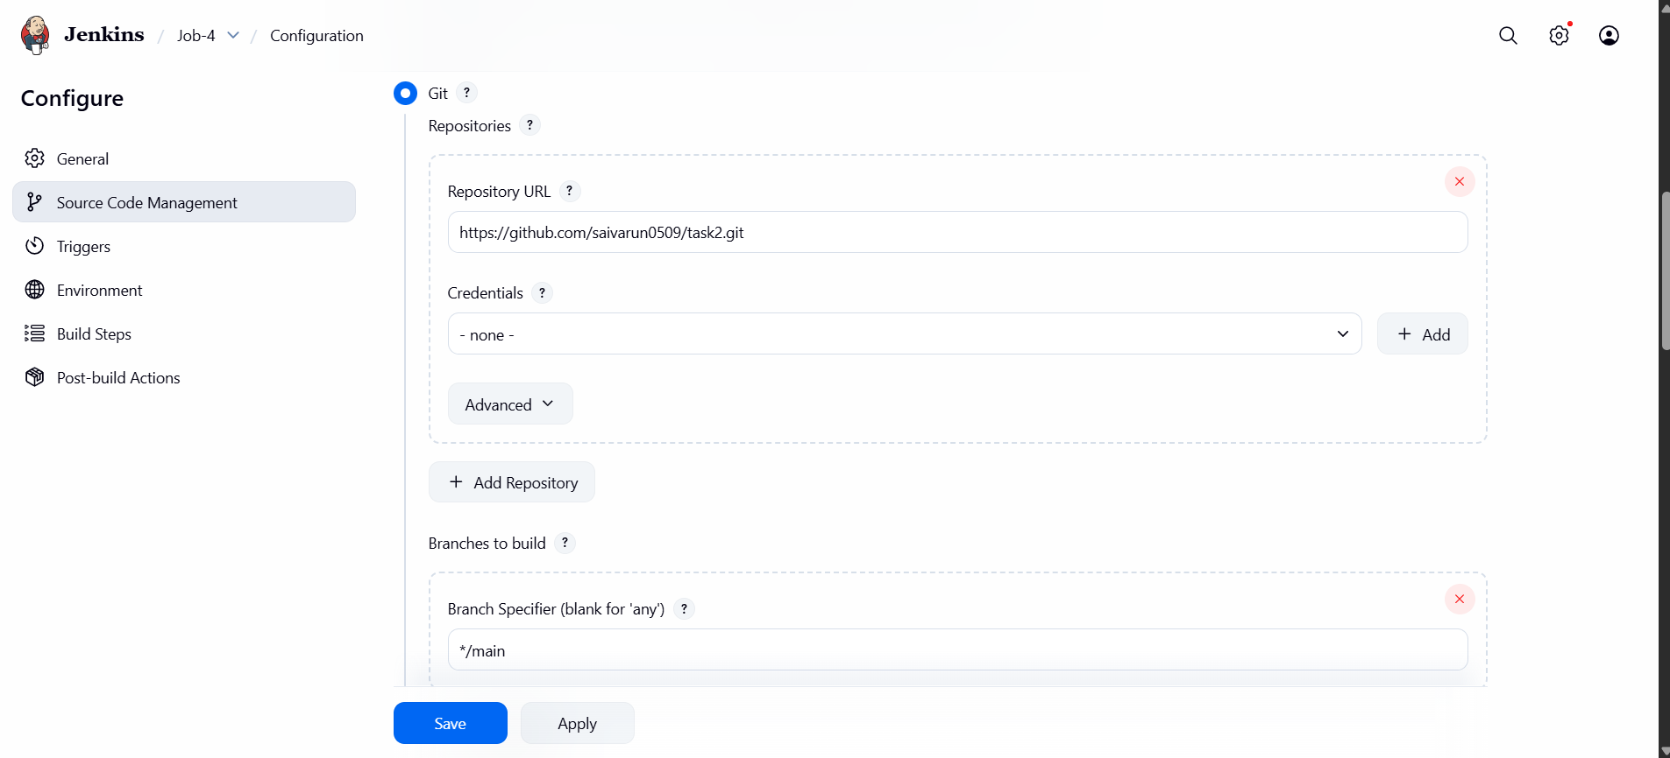
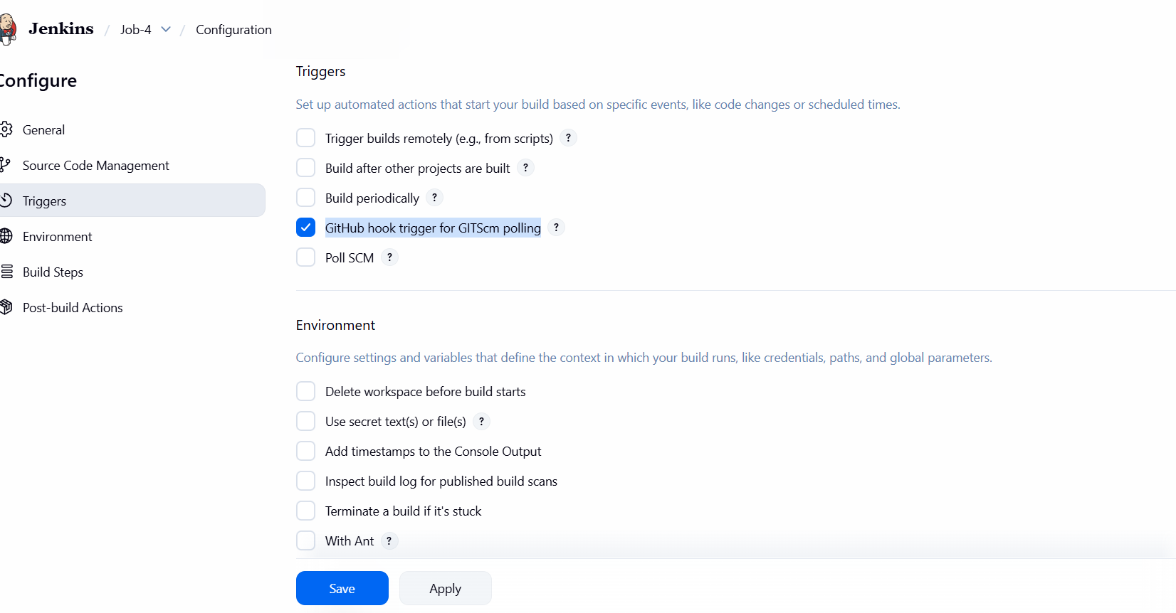
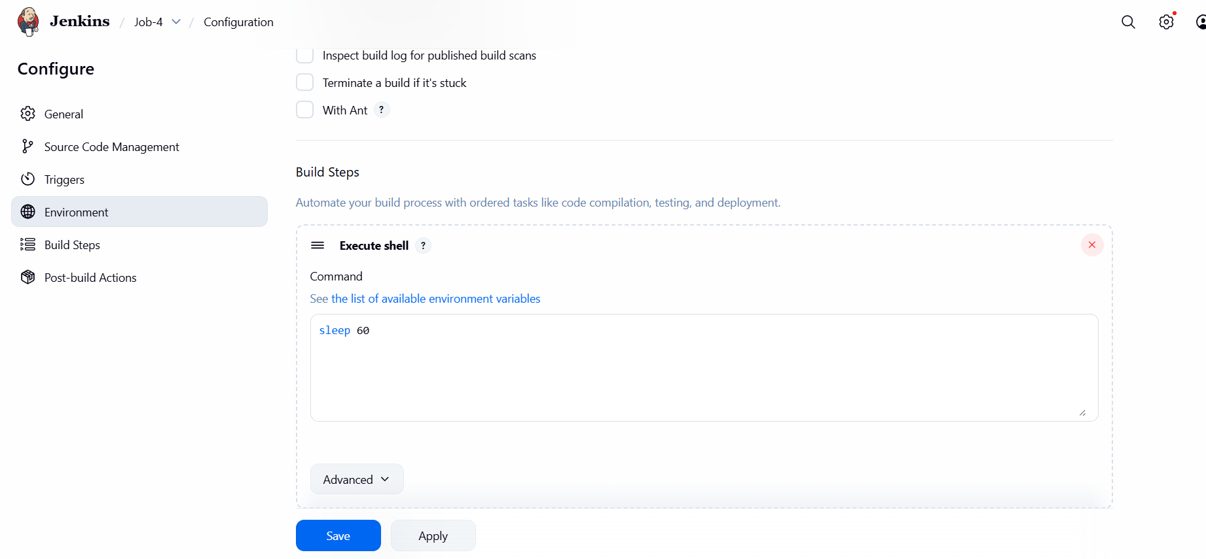

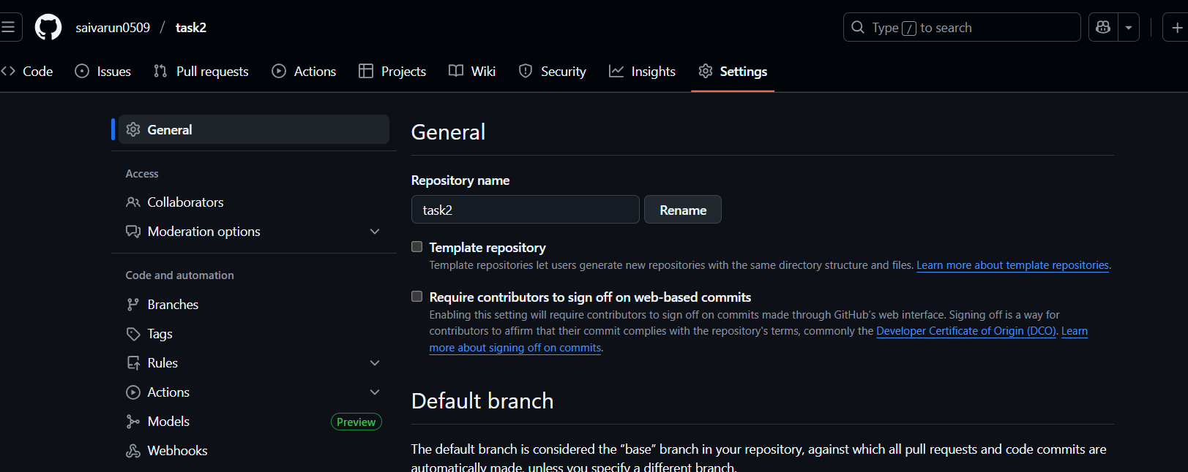
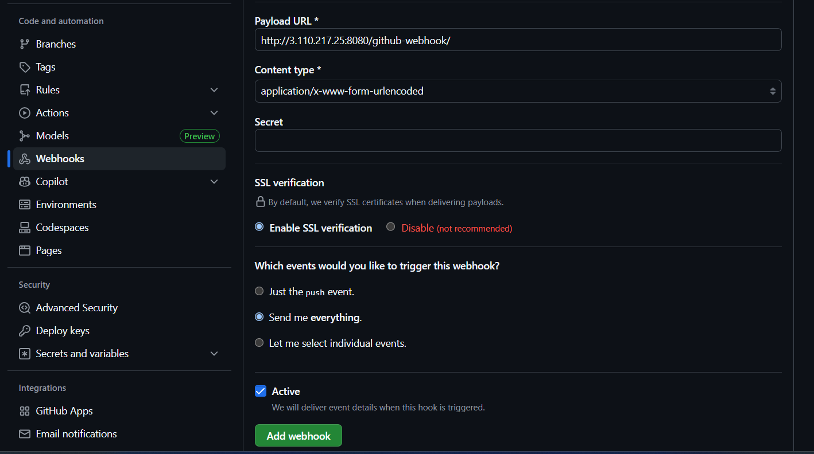
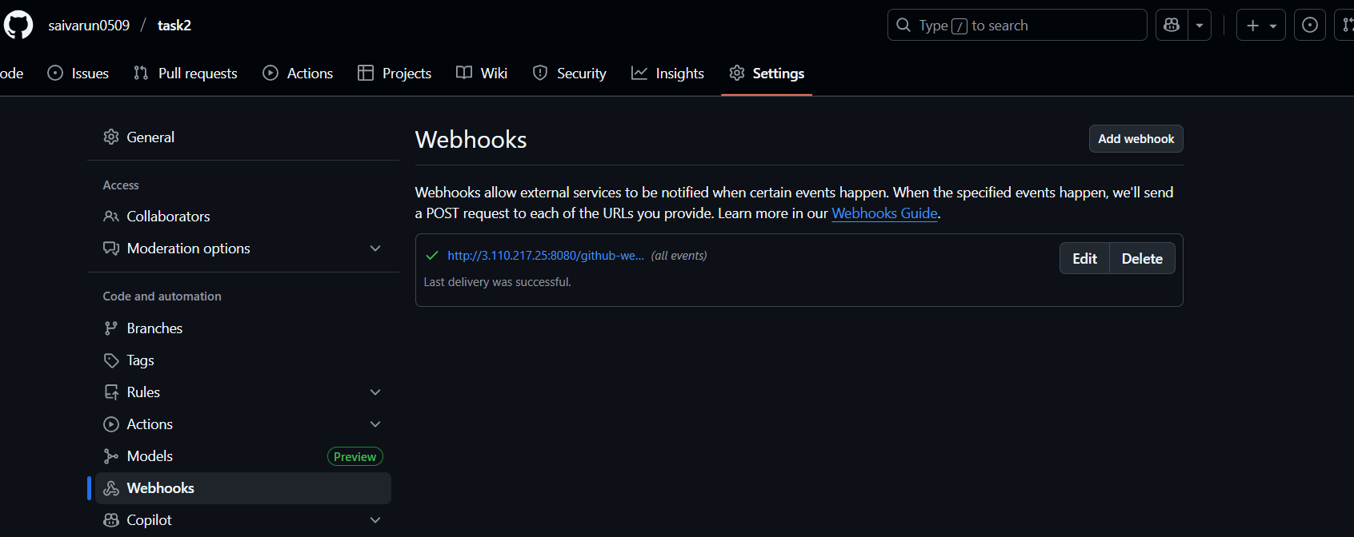
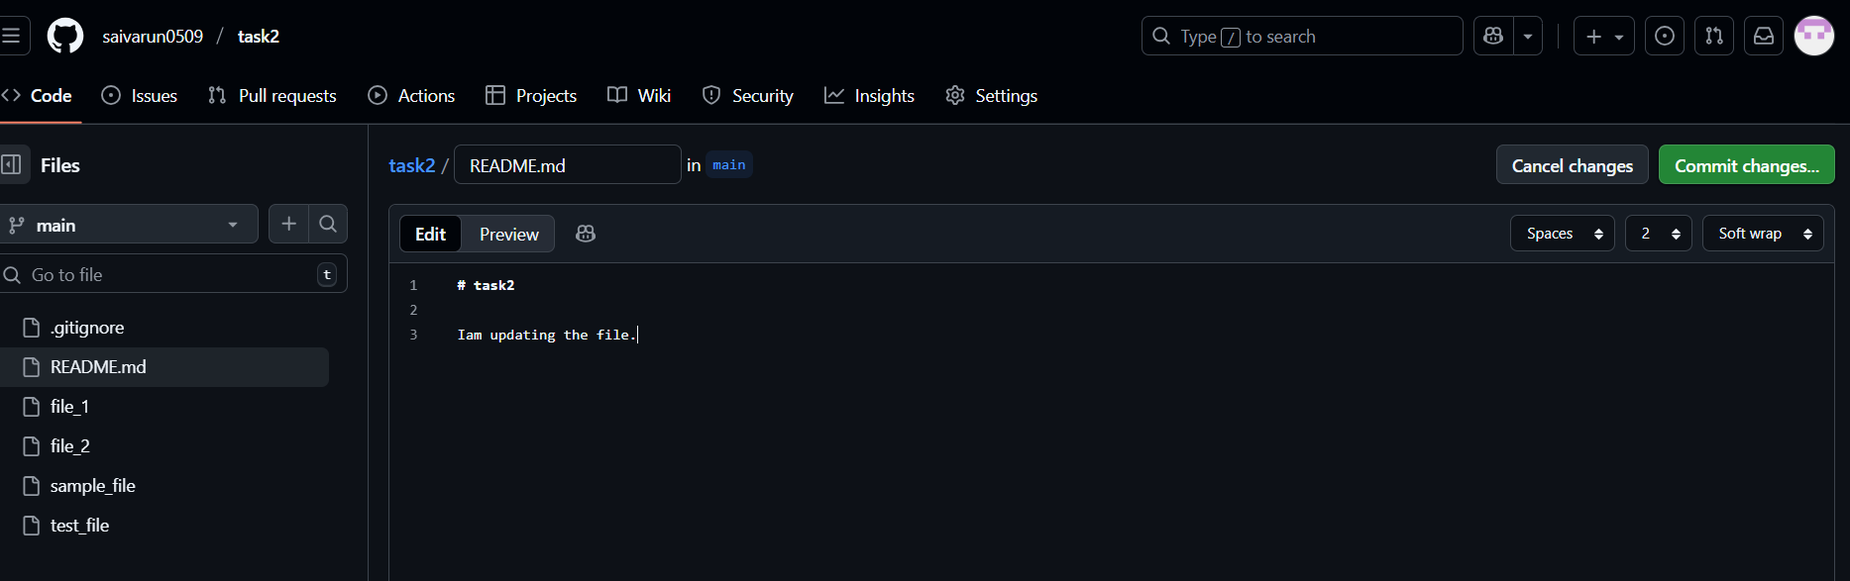
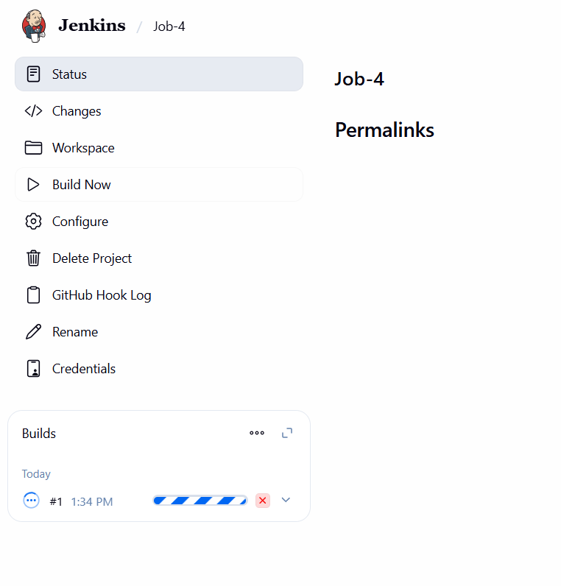
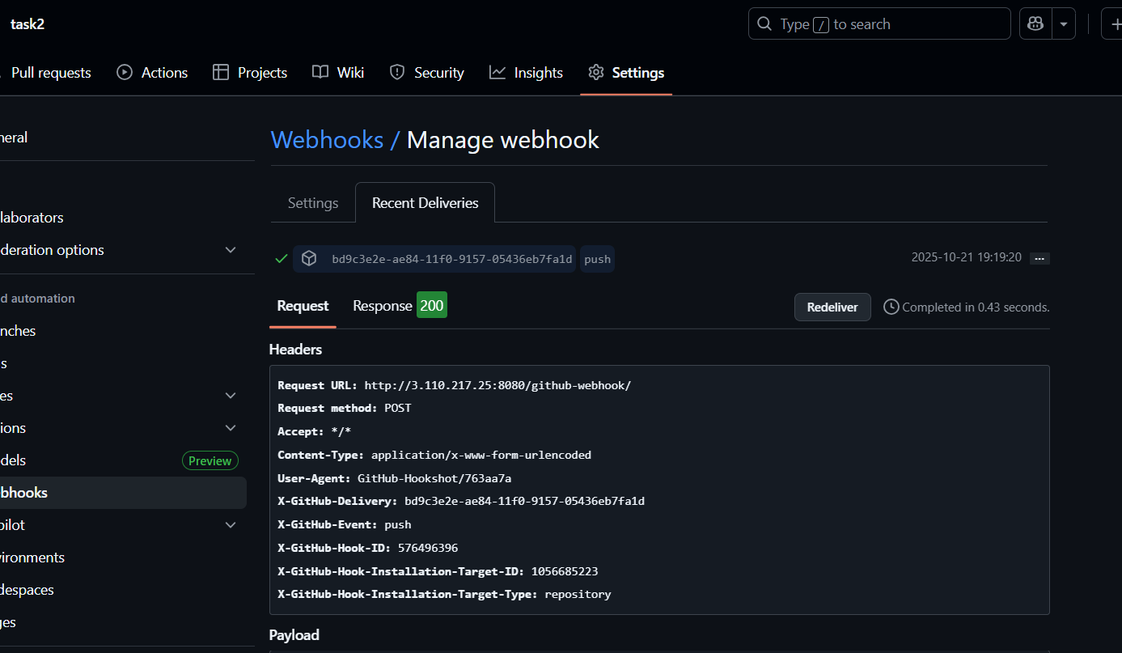
Step 1: Enable GitHub Trigger in Jenkins
- Go to Jenkins Dashboard → Your Job → Configure
- Scroll to the section “Build Triggers”
- Check the box:
Step 2: Verify Jenkins GitHub Configuration
- In the Source Code Management (Git) section:
- Repository URL: your GitHub repo (e.g., https://github.com/username/repo.git)
- Branch Specifier: usually */main
- Add credentials if it’s a private repo.
Step 3: Get Jenkins URL
- You’ll need the Jenkins public endpoint. Examples:
- For EC2 instance → http://<EC2-Public-IP>:8080/github-webhook/
Step 4: Configure Webhook in GitHub
- Go to your GitHub repository → Settings → Webhooks
- Click “Add webhook”
- Enter the details:
- Payload URL:
- http://<your-jenkins-server>:8080/github-webhook/
- Content type:
application/json
- Select event:
“Just the push event.”
- Active: ✅
- Click Add webhook
Step 5: Test the Webhook
- Go to your repo → Webhooks → Recent Deliveries
- Click on the last delivery.
- If you see Status: 200, it means GitHub successfully called Jenkins.

- Configure poll scm and build periodical options in Jenkins job.
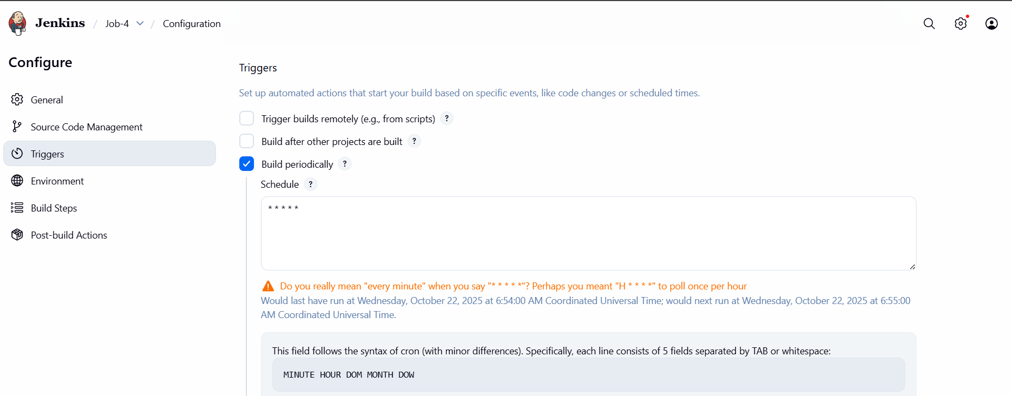
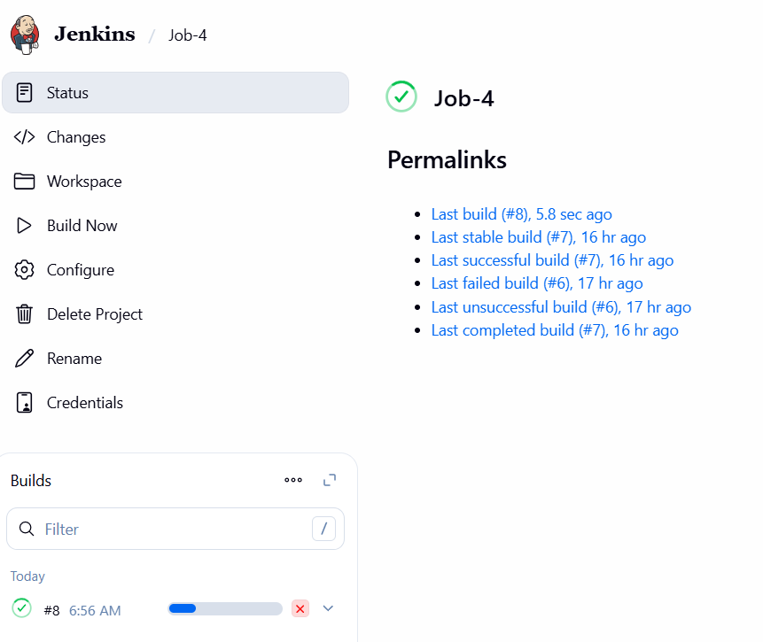
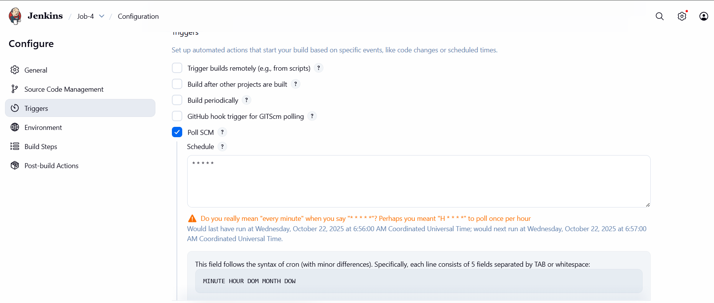

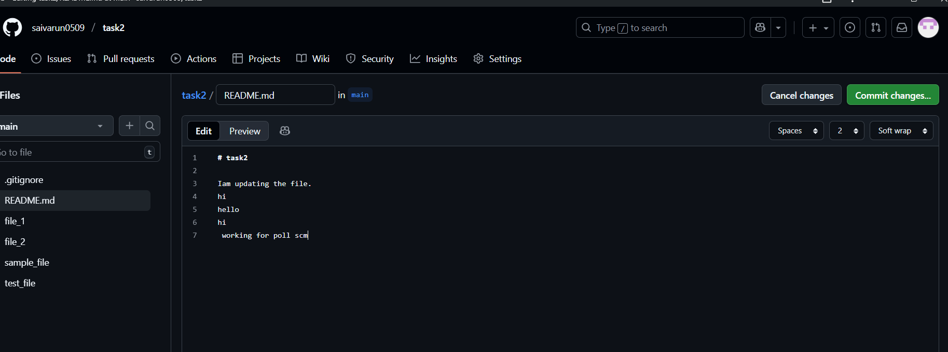

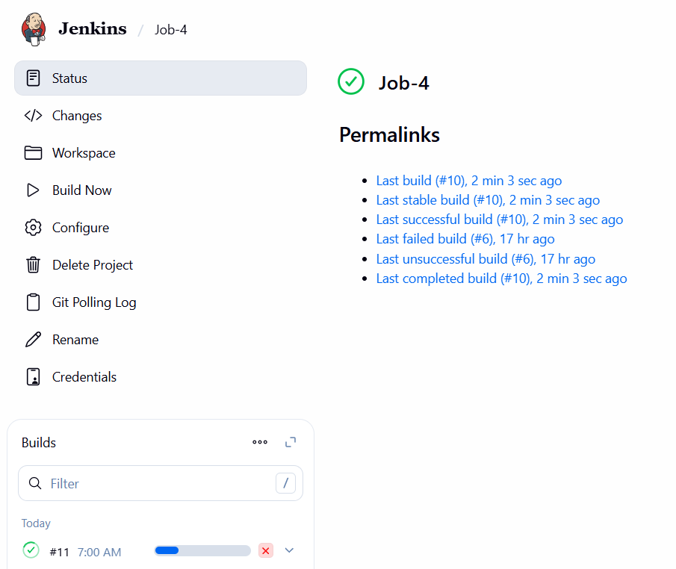

- Go to your Jenkins dashboard.
- Click on your job name.
- Click “Configure” on the left side.
- Scroll to Source Code Management section.
- Select Git and enter your repository URL
- Scroll to Build Triggers section.
- Check Poll SCM.
- In the Schedule box, enter a cron expression(* * * * *).
- This means Jenkins will check your repo every 5 minutes for changes.
- If changes are found → it will trigger a new build automatically.
- Check Build Periodically.
- In the Schedule box, enter a cron expression(* * * * *).
- Select your job and go to configure and enable option build
periodically.it will trigger based on timing we set if there is
change or not in the code it will trigger to that particular
time.

- Take backup of Jenkins server by using bash script.
#!/bin/bash

# Define Jenkins Home directory
JENKINS_HOME="/var/lib/jenkins"

# Define Backup directory
BACKUP_BASE_DIR="/backups/jenkins"

# Create a timestamp for the backup filename
TIMESTAMP=$(date +%Y%m%d_%H%M%S)

# Define the full path for the current backup
CURRENT_BACKUP_DIR="${BACKUP_BASE_DIR}/jenkins_backup_${TIMESTAMP}"

# Define the path for the compressed archive
BACKUP_ARCHIVE="${BACKUP_BASE_DIR}/jenkins_backup_${TIMESTAMP}.tar.gz"

echo "Starting Jenkins backup..."

# Stop Jenkins service for data consistency (optional but recommended)
echo "Stopping Jenkins service..."
sudo systemctl stop jenkins

# Create the backup directory if it doesn't exist
mkdir -p "${BACKUP_BASE_DIR}"

# Archive the Jenkins home directory
echo "Archiving Jenkins home directory: ${JENKINS_HOME} to ${BACKUP_ARCHIVE}"
tar -czvf "${BACKUP_ARCHIVE}" -C "$(dirname "${JENKINS_HOME}")" "$(basename "${JENKINS_HOME}")"

# Start Jenkins service
echo "Starting Jenkins service..."
sudo systemctl start jenkins

# Optional: Remove older backups (e.g., older than 7 days)
# echo "Removing backups older than 7 days..."
# find "${BACKUP_BASE_DIR}" -type f -name 'jenkins_backup_*.tar.gz' -mtime +7 -delete

echo "Jenkins backup completed successfully."
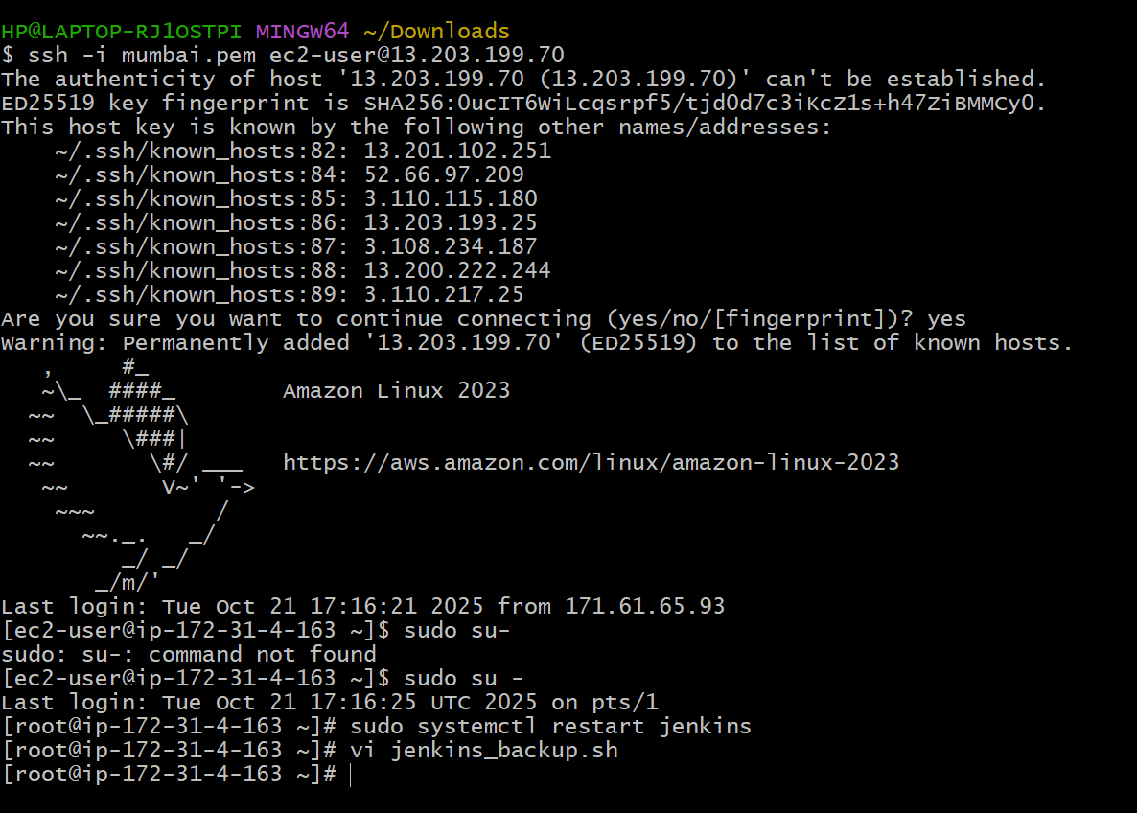
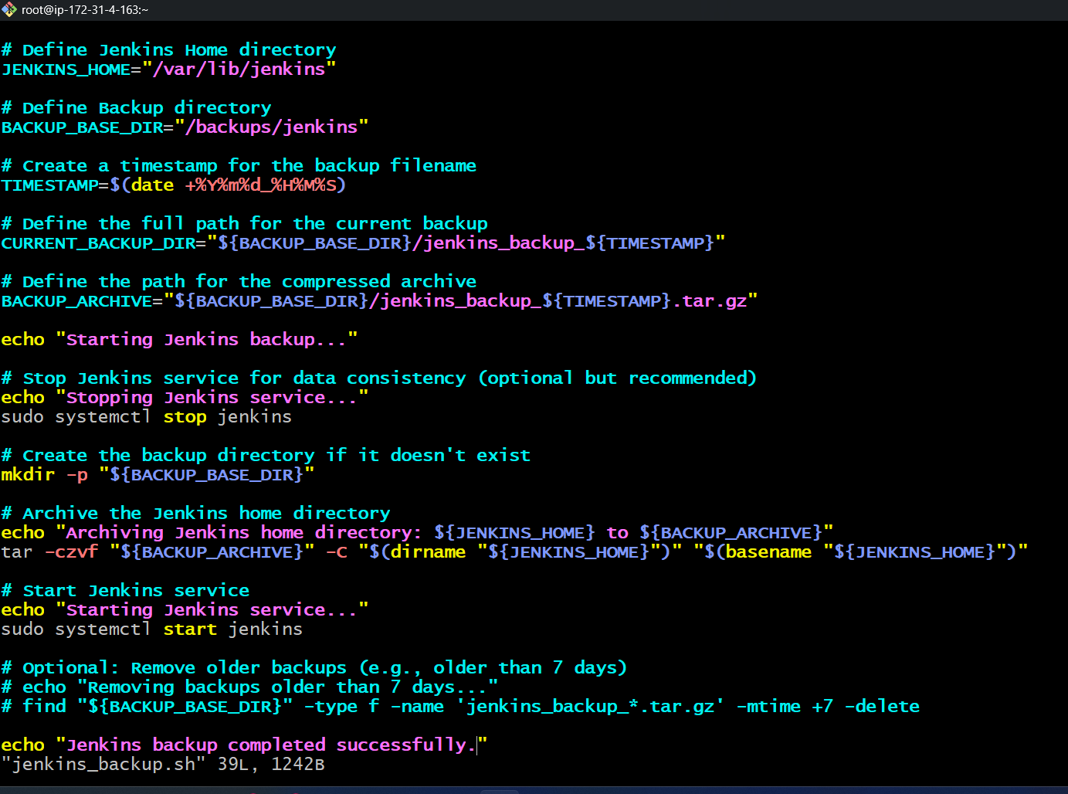
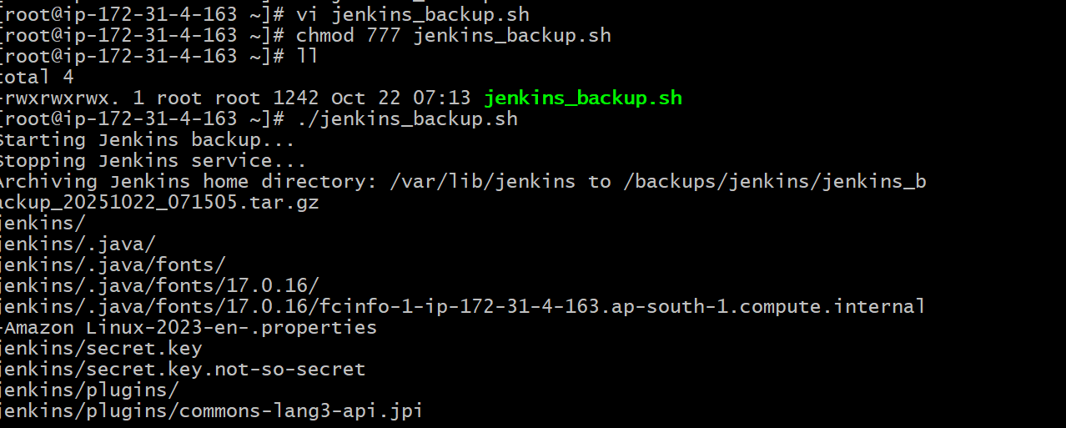
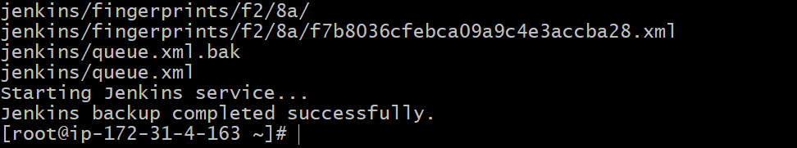
- Create one file and open that file vi[filename.sh]
- And write the code in that file.
- Provide permission to it chmod 777 filename.sh
- ./filename.sh
- Here is the result above.
- Take backup of Jenkins using thin backup plugin.
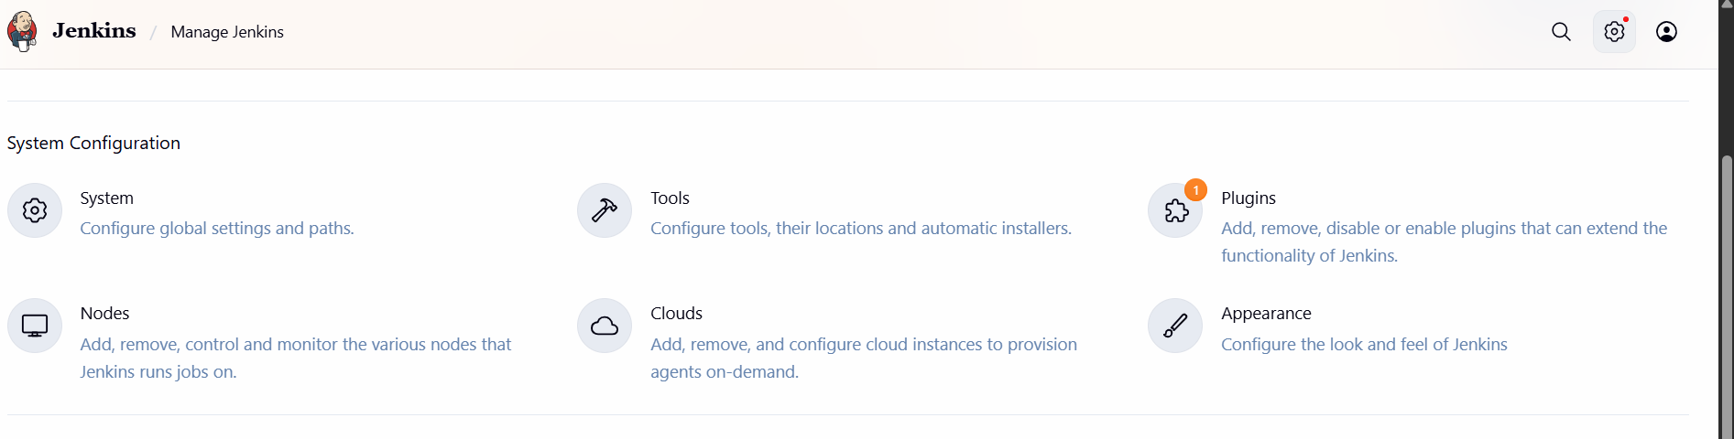
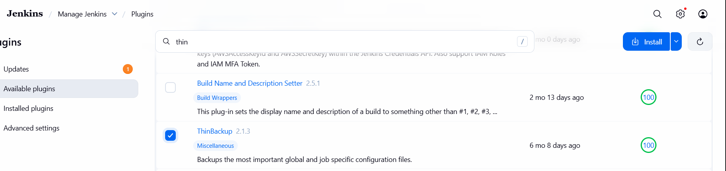
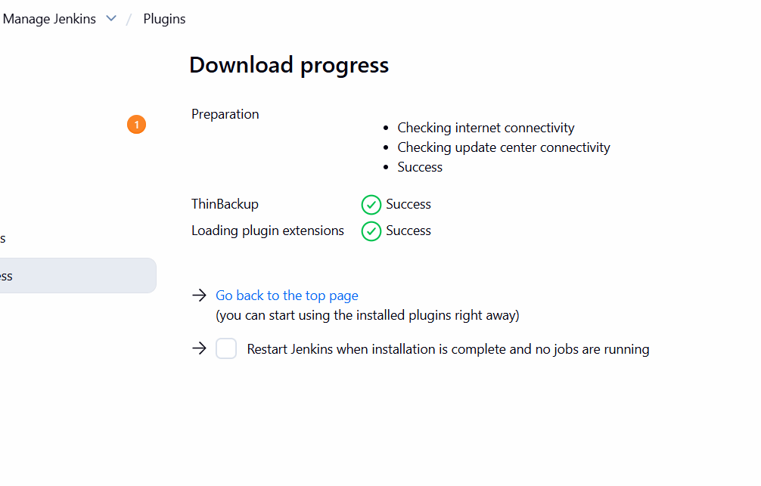
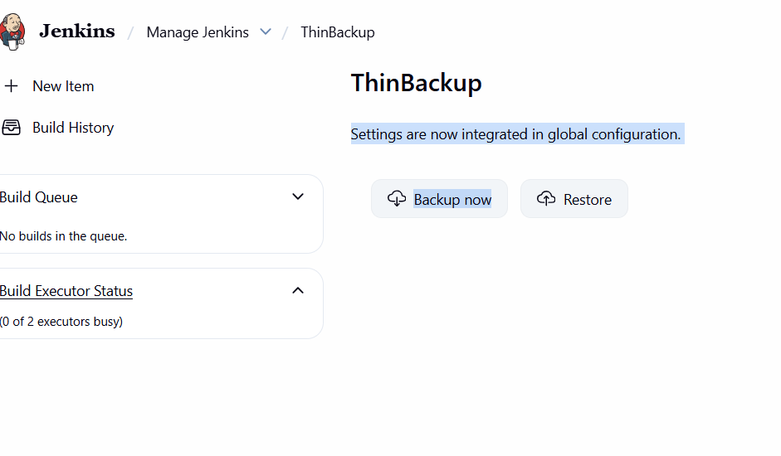
- Open Jenkins → Manage Jenkins
- Go to Plugins → Available Plugins
- Search for “ThinBackup”
- Click Install without restart
- Once installed → restart Jenkins
- Go to manage Jenkins
- Click on ThinBackup
- And you can see Backup now

- Setup a new Jenkins server and dump the backup taken in task4.
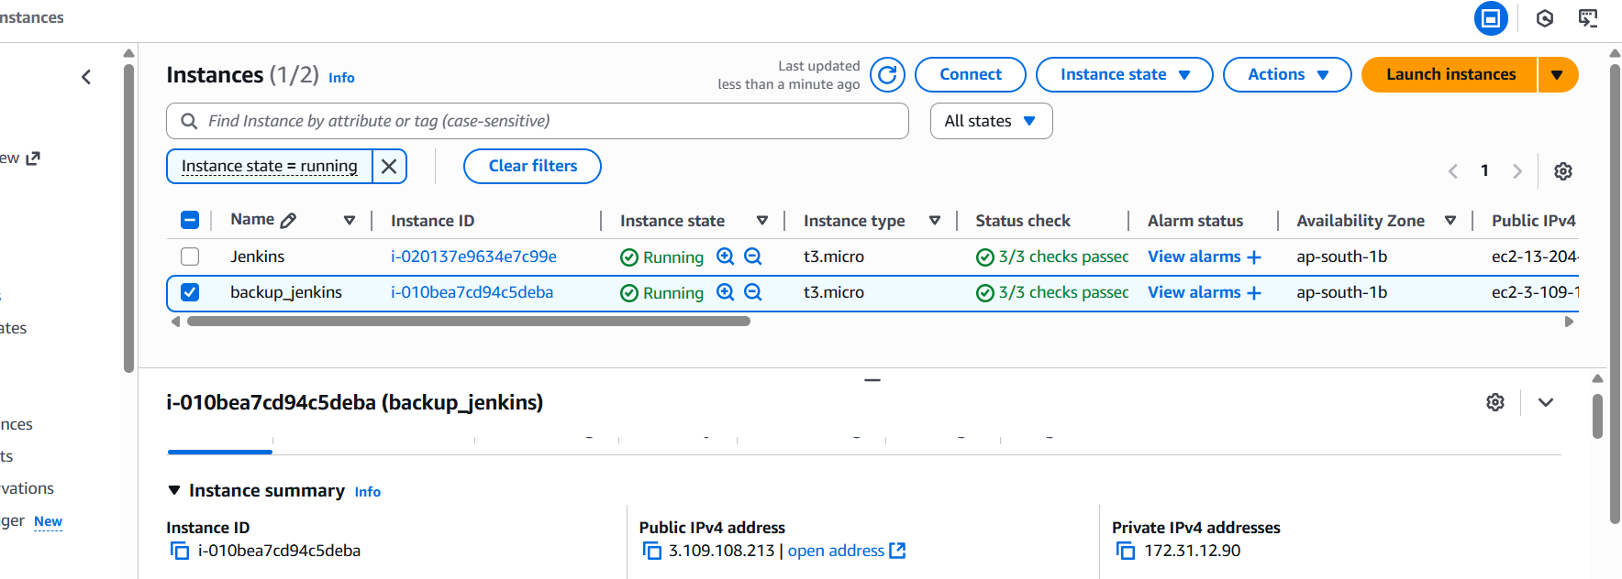
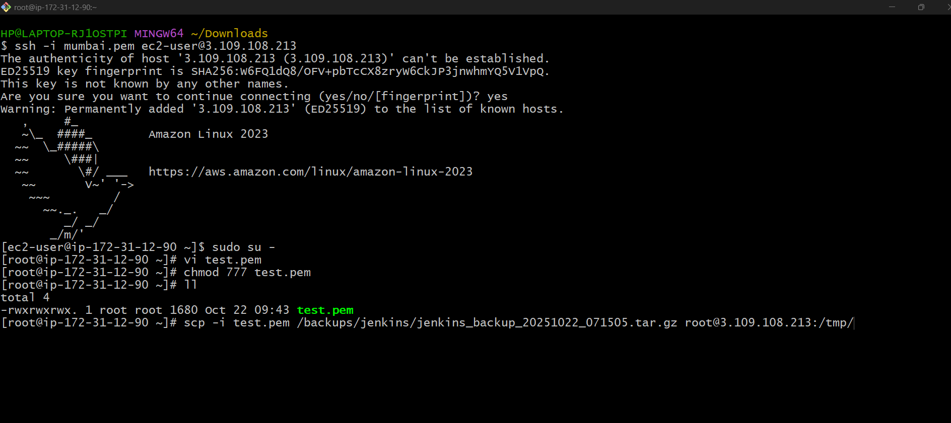
800a8ceb6b7a4600a0f83da51a2b9253
Step 1: Launch a New Jenkins Server
You can do this on: AWS EC2 (Amazon Linux )
Launch an EC2 instance and connect via ssh <public ip>
sudo yum update -y
sudo yum install java-17-amazon-corretto -y
java --version
sudo wget -O /etc/yum.repos.d/jenkins.repo \ https://pkg.jenkins.io/redhat-stable/jenkins.repo
sudo rpm --import https://pkg.jenkins.io/redhat-stable/jenkins.io-2023.key
sudo yum install jenkins -y
sudo systemctl enable jenkins
sudo systemctl start jenkins

Step 2: Verify Jenkins is Running
sudo systemctl status Jenkins
http://<your-ec2-public-ip>:8080
sudo cat /var/lib/jenkins/secrets/initialAdminPassword
You can Login to Jenkins with initial password.

Step 3: Copy Backup File to New Server
scp /var/backups/jenkins/jenkins_backup_<DATE>.tar.gz ec2-user@<new-server-ip>:/tmp/

Step 4: Stop Jenkins Before Restore
sudo systemctl stop Jenkins

Step 5: Extract Backup to Jenkins Directory
sudo tar -xzvf /tmp/jenkins_backup_<DATE>.tar.gz -C /
Step 6: Set Correct Permissions
sudo chown -R jenkins:jenkins /var/lib/Jenkins

Step 7: Start Jenkins
Sudo systemctl start Jenkins

Step 8: Verify Restoration
http://<your-server-ip>:8080

