Linux System Diagnostics Toolkit
A Project Based Learning Report Submitted in partial fulfilment of the requirements for the award of the degree

of

Bachelor of Technology
in The Department of Electronics and Communication Engineering
Operating Systems (Course Code: 25CS2104E)

Submitted by
2510030370: HARSHIL
2510030021: M. SAI VARUN
2510030366: MOHAMMED AFFAN
2510030027: PAVAN

Under the guidance of
Dr. Srinivas Malladi



Department of Electronics and Communication Engineering
Koneru Lakshmaiah Education Foundation, Aziz Nagar
Aziz Nagar – 500075
OCT - 2026.
Abstract
Checking the health of a Linux machine normally means remembering and combining several separate commands: one for the processor, another for memory, others for disks, processes and the network. This project presents the Linux System Diagnostics Toolkit, a menu-driven command-line application written in C that brings these checks together in a single program. The toolkit offers ten options: CPU information, memory, disk, running processes, network, uptime, system information, diagnostic alerts, report generation and a complete diagnostic that runs every module in sequence.
Wherever possible the program reads data natively from the kernel's /proc interface and the statvfs() system call; shell utilities such as top, ps and ip are used only where their output is already well formatted. Memory and disk usage are calculated as percentages and compared against threshold constants (80 %), which produces OK, WARNING or CRITICAL messages, and a text report, diagnostic_report.txt, can be saved for documentation. All planned modules were implemented in one integrated program with input validation. The known limitations, namely root-file-system-only disk checks, dependence on external commands for CPU usage and the process list, and a report whose process, network and warning sections are still basic, are discussed together with the planned improvements. The project demonstrates practical Operating Systems concepts such as the /proc virtual file system, system calls, file I/O and resource monitoring.
Keywords: Linux, Operating Systems, /proc file system, system monitoring, diagnostics, C programming
List of Figures
Fig. 1. Workflow of the toolkit, from the menu choice to the final output. 7
Fig. 2. Modular architecture: input loop, dispatcher, the ten menu functions and their data sources. 8
Fig. 3. Flowchart of the main input loop and menu dispatcher. 10
Fig. 4. Main menu of the Linux System Diagnostics Toolkit. 12
Fig. 5. Memory information (option 2) and diagnostic alerts (option 8), sample values. 13
Fig. 6. Disk information (option 3) and system uptime (option 6) from a test run. 13
Fig. 7. Memory and disk usage compared with the 80 % alert threshold (sample values). 14
List of Tables
TABLE I. Header files used in diagnostics.c 7
TABLE II. Data sources and techniques used by each module 8
TABLE III. Alert rules implemented in show_alerts() 9
TABLE IV. Test cases and observed results 11
TABLE V. Implementation status of the modules 11
TABLE VI. Known limitations and planned improvements 15
Table of Contents
1. Introduction 6
a. Problem Statement 6
b. Objectives 6
c. Scope of the Project 6
2. Methodology 7
a. Overall Design and Workflow 7
b. Technology Stack 7
c. Program Structure 7
d. Data Sources and Linux Interfaces 8
e. Module Design 9
f. Alerts and Thresholds 9
g. Report Generation 10
h. Menu-Driven Interface and Input Validation 10
3. Experiments 10
a. Experimental Setup 10
b. Test Plan 10
c. Evaluation Criteria 11
4. Results 11
a. Implementation Status 11
b. Console Output 11
c. Alert Behaviour 13
d. Diagnostic Report 14
e. Observations and Limitations 14
5. Conclusion and Future Work 15
References 15
Appendix A: Source Code (diagnostics.c) 16
Linux System Diagnostics Toolkit

Introduction
An operating system manages the processor, memory, storage, processes and network interfaces of a computer, and the people who use or administer that computer regularly need to look at these resources. A user whose machine has become slow wants to know whether the processor is saturated or memory is exhausted; an administrator wants to know whether a disk is about to fill up; a student learning Operating Systems wants to see how the kernel exposes this information [1], [2]. Linux makes this possible through the /proc virtual file system, through system calls such as statvfs(), and through a large set of command-line utilities including top, ps, ip, uname and who [3], [5].
The difficulty is that each resource is examined with a different tool, and each tool prints its result in a different format. Important information is spread across kernel interfaces and utilities, beginners find the many commands hard to remember, and there is no single, simple view of the current condition of the system. Diagnosing a problem therefore turns into a sequence of manual steps that must be repeated every time.
This project addresses that problem with the Linux System Diagnostics Toolkit, a single C program driven by one menu. Instead of calling many separate commands, the user chooses an option and the toolkit collects the data, formats it consistently, compares usage against warning thresholds and, if requested, saves everything to a diagnostic report. The tool is built as one function per module, so each part (CPU, memory, disk, processes, network, uptime, system information, alerts and report) can be understood, tested and extended independently. Because most of the data is read directly from /proc and from system calls, the project also serves as a practical exercise in Operating Systems concepts: virtual file systems, file I/O, system calls and resource accounting [3], [7].

Problem Statement
Linux provides many commands to inspect system resources, but they are separate, differently formatted and difficult for beginners to remember, and nothing gives a quick, standardised overview of the system's health. The problem is to build one simple interface that collects the common diagnostics, highlights abnormal resource usage and can document the result.

Objectives
- Resource monitoring: show CPU, memory and disk usage.
- Process inspection: list running processes with their process IDs.
- System information: display uptime, logged-in users, operating system details and network information.
- Problem detection: flag high usage of memory and disk against configurable thresholds.
- Reporting: generate a consolidated diagnostic report as a text file.

Scope of the Project
The toolkit targets a single Linux machine and is read-only: it observes the system but never changes it. It is written in standard C, compiled with GCC and operated from a terminal through a numbered menu. Disk statistics are reported for the root file system (/). Remote monitoring, a graphical interface, historical logging and per-process resource statistics are outside the present scope and are listed as future work.

Methodology

Overall Design and Workflow
The toolkit is a single C program with one menu and one function per module. Every request follows the five-stage path shown in Fig. 1. The menu accepts a number and validates it; the dispatcher, a switch statement in main(), calls the function for the chosen module; that function collects data from /proc files, from the statvfs() system call or from a shell command; the analysis stage converts raw numbers into units and usage percentages and checks them against the thresholds; and the output stage prints the result to the console or writes it to diagnostic_report.txt.
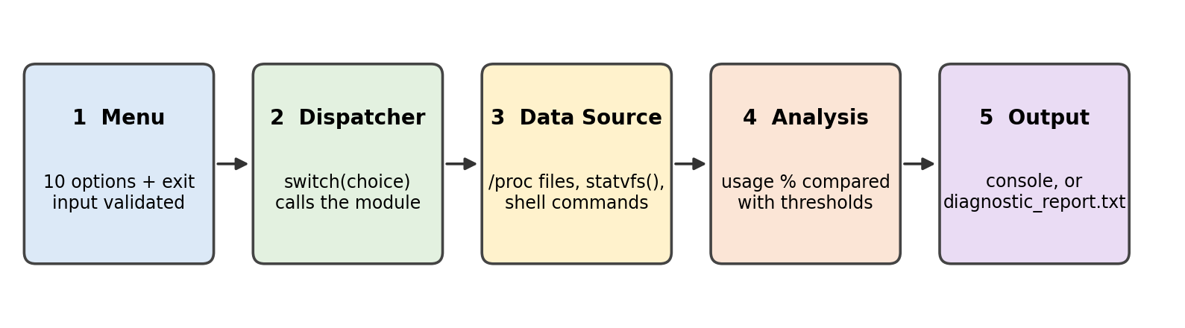
- Workflow of the toolkit, from the menu choice to the final output.

Technology Stack
The program is implemented in C and compiled with GCC; the target platform is Linux (Ubuntu), and the source was written in Visual Studio Code. The program is built and run with the following commands [8]:
gcc diagnostics.c -o diagnostics
./diagnostics

Program Structure
The source file diagnostics.c uses the standard and POSIX header files listed in Table I, defines three threshold macros, and is organised into twelve functions. The macros CPU_WARNING, MEMORY_WARNING and DISK_WARNING are all set to 80.0 (percent); changing one value changes the alert limit everywhere it is used. Fig. 2 shows how the functions relate to each other and to the data sources they read.
- Header files used in diagnostics.c
Header | Purpose / functions used
<stdio.h> | printf, scanf, fopen, fgets, fclose, fprintf, sscanf, fscanf, fflush, perror, getchar
<stdlib.h> | system() to run shell commands
<string.h> | strncmp, strcmp, strchr, strcpy, strcspn
<unistd.h> | POSIX / Unix system API
<sys/statvfs.h> | statvfs() for file-system statistics
<time.h> | time-related declarations (included, not used by the current code)

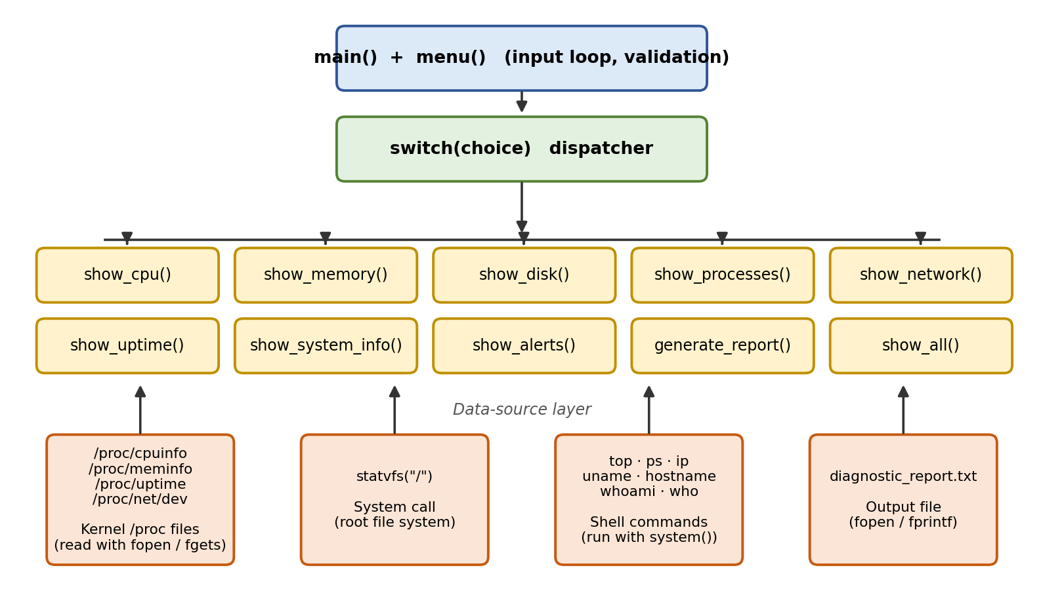
- Modular architecture: input loop, dispatcher, the ten menu functions and their data sources.
The twelve functions are: show_cpu() (CPU model, cores and usage), show_memory() (RAM total, used and available), show_disk() (root file-system usage), show_processes() (running process list), show_network() (interfaces and statistics), show_uptime() (time since boot), show_system_info() (operating system, kernel, host name and users), show_alerts() (threshold warnings), generate_report() (writes the report file), show_all() (runs every module), menu() (prints the menu) and main() (input loop and dispatch).

Data Sources and Linux Interfaces
Native reads of kernel files were preferred for CPU details, memory and uptime, statvfs() is used for the disk, and shell commands are used where their output is already formatted for humans. Table II summarises the source and technique used by each module [5], [6], [7].
- Data sources and techniques used by each module
Module | Data source | Technique
CPU | /proc/cpuinfo, top | Reads the first model name line and counts processor lines; usage is taken from top -bn1 | grep 'Cpu(s)' | awk '{print 100 - $8"%"}' (100 minus idle)
Memory | /proc/meminfo | Reads MemTotal and MemAvailable (kB); used = total minus available; shown in GB
Disk | statvfs("/") | Block count multiplied by fragment size gives total and free bytes; usage % = used / total
Processes | ps | ps -eo pid,comm,state --sort=-pid | head -n 16 (header plus 15 rows)
Network | ip, /proc/net/dev | ip -br addr for interface addresses; cat /proc/net/dev for per-interface counters
Uptime | /proc/uptime | Seconds since boot converted to days, hours, minutes and seconds
System info | uname, hostname, whoami, who | Operating system, kernel version, host name, current user and logged-in users
Report | diagnostic_report.txt | Written with fopen(..., "w") and fprintf()

Module Design
CPU. show_cpu() opens /proc/cpuinfo and reads it line by line with fgets(). The text after the colon on the first model name line is stored as the CPU model (the trailing newline is removed with strcspn()), and every line beginning with processor increments the core counter. Current usage is obtained by running top once in batch mode; awk prints 100 minus the idle percentage.
Memory. show_memory() reads MemTotal and MemAvailable from /proc/meminfo with sscanf(). The kernel reports both in kilobytes, so the values are divided by 1024 × 1024 to give gigabytes. The usage percentage is computed as follows, and if it reaches MEMORY_WARNING a warning is printed instead of the normal status line.
used = MemTotal − MemAvailable Memory usage (%) = (used ÷ MemTotal) × 100
long used = total - available;
double usage = ((double)used / total) * 100.0;
if (usage >= MEMORY_WARNING)
printf("WARNING: High memory usage detected!\n");

Disk. show_disk() calls statvfs("/", &stat). Total bytes are f_blocks × f_frsize, free bytes are f_bfree × f_frsize, used bytes are the difference, and the values are shown in GB (division by 1024³). Because free space is taken from f_bfree, which includes blocks reserved for the superuser, the percentage can differ slightly from the figure printed by df, which uses the blocks available to ordinary users [6].
Processes. show_processes() runs ps -eo pid,comm,state --sort=-pid | head -n 16, which prints the column header and 15 processes with the highest process IDs (the most recently started), showing PID, command name and state.
Network. show_network() prints the interfaces and their addresses with ip -br addr and then the receive and transmit counters from /proc/net/dev.
Uptime and system information. show_uptime() reads the first number of /proc/uptime and converts it with integer arithmetic: days = s ÷ 86400, hours = (s mod 86400) ÷ 3600, minutes = (s mod 3600) ÷ 60 and seconds = s mod 60, printed as d days HH:MM:SS. show_system_info() calls uname -o, uname -r, hostname, whoami and who.

Alerts and Thresholds
show_alerts() recomputes memory and disk usage and compares each with its threshold constant. The rules are given in Table III. At the proposal stage a three-level scheme (normal, warning, critical) was described; the implemented version uses one 80 % limit per resource, with a WARNING label for memory and a CRITICAL label for disk. CPU_WARNING is already defined so that CPU alerts can be added without changing the structure of the program.
- Alert rules implemented in show_alerts()
Resource | Threshold | Condition | Message printed
Memory | 80 % (MEMORY_WARNING) | usage ≥ 80 % | [WARNING] High memory usage detected!
Memory | 80 % (MEMORY_WARNING) | usage < 80 % | [OK] Memory usage is normal.
Disk | 80 % (DISK_WARNING) | usage ≥ 80 % | [CRITICAL] Very high disk usage detected!
Disk | 80 % (DISK_WARNING) | usage < 80 % | [OK] Disk usage is normal.

Report Generation
generate_report() creates diagnostic_report.txt with fopen("diagnostic_report.txt", "w") and writes a titled report with fprintf(). The report contains the first five lines of /proc/cpuinfo, the first five lines of /proc/meminfo, the total, used and free disk space, the uptime in seconds, a pointer to the ip -br addr command for network details and a closing line. Sections for running processes and warnings exist as headings, and their content is planned for a later version. If the file cannot be created, perror() reports the cause and the function returns without crashing the program.

Menu-Driven Interface and Input Validation
main() repeatedly prints the menu and reads the choice with scanf("%d"). If the input is not a number, the program prints Invalid input. and discards the rest of the line with getchar() so that the loop cannot get stuck; if the number is not on the menu, the default branch prints Invalid choice. Please try again. Options 1 to 10 call the corresponding function, and 0 prints an exit message and ends the program (Fig. 3). Option 10, show_all(), runs the CPU, memory, disk, process, network, uptime, system-information and alert modules in that order, giving a complete snapshot of the system in one run.
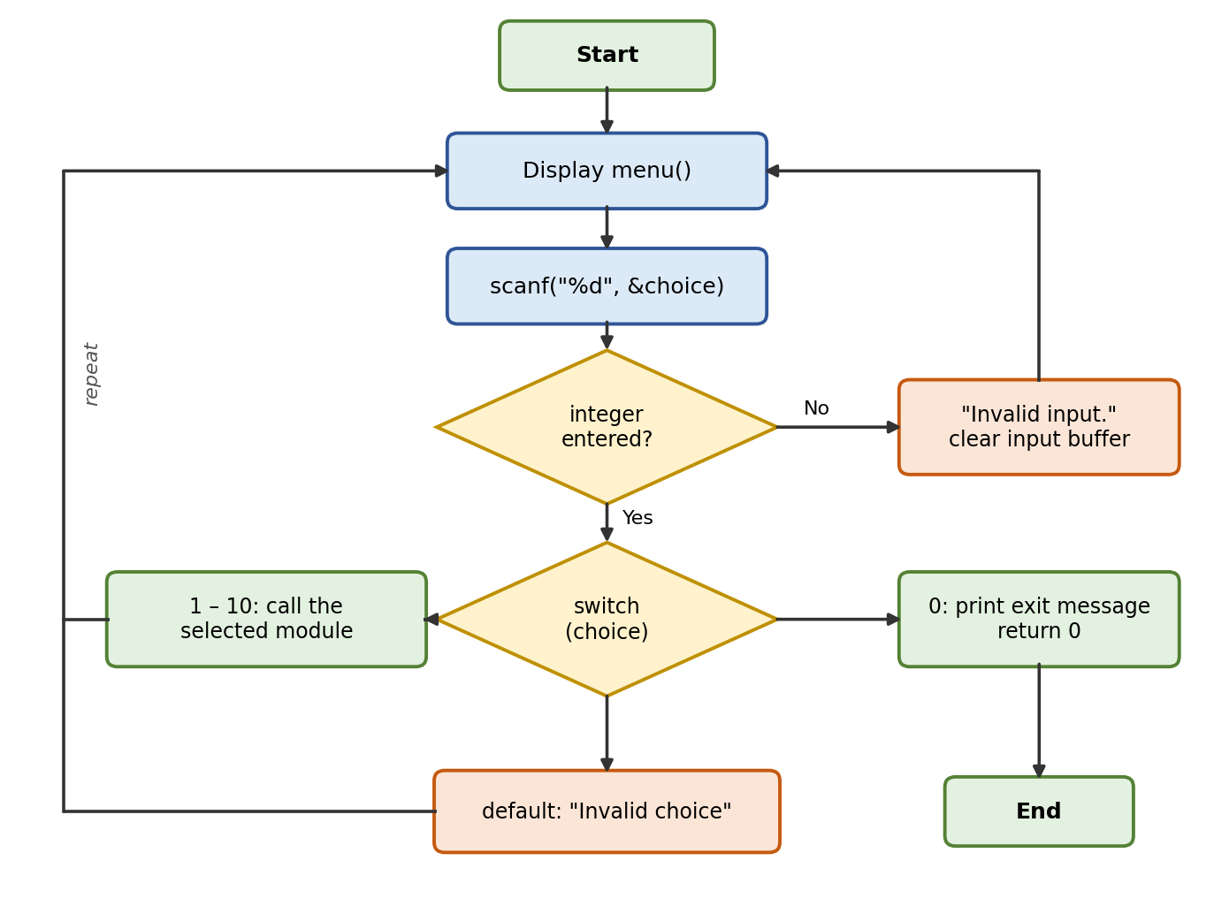
- Flowchart of the main input loop and menu dispatcher.

Experiments

Experimental Setup
The program was compiled with GCC on an Ubuntu Linux system using gcc -Wall diagnostics.c -o diagnostics, which produced no warnings, and was then run from a terminal. Each menu option was exercised individually, followed by the complete diagnostic (option 10). The goal of the experiments was to check that every module produces correctly formatted output, that the alert logic follows the thresholds, that the report file is created, and that the program survives wrong input and missing system tools.

Test Plan
The test cases in Table IV cover the normal behaviour of the modules, the generated report and the error handling of the menu. The expected behaviour was derived from the program design described in the methodology.
- Test cases and observed results
ID | Test | Input | Expected behaviour | Observed
T1 | Menu display | Start program | Menu with options 1–10 and 0 is printed | Pass
T2 | CPU information | 1 | CPU model, core count and a usage percentage are shown | Pass
T3 | Memory information | 2 | Total, used and available memory in GB, usage %, and a status line | Pass
T4 | Disk information | 3 | Total, used and free space of / in GB, usage %, and a status line | Pass
T5 | System uptime | 6 | Uptime printed as d days HH:MM:SS | Pass
T6 | Diagnostic alerts | 8 | Memory and disk usage with [OK] or [WARNING]/[CRITICAL] messages | Pass
T7 | Report generation | 9 | diagnostic_report.txt is created and a success message is printed | Pass
T8 | Complete diagnostic | 10 | All eight modules run in order and DIAGNOSTIC COMPLETED is printed | Pass
T9 | Non-numeric input | abc | Invalid input. and the menu is shown again | Pass
T10 | Out-of-range choice | 99 | Invalid choice. Please try again. and the menu is shown again | Pass
T11 | Exit | 0 | Exit message is printed and the program ends | Pass
T12 | Missing system tool | Option 5 without ip installed | Shell prints an error for the tool, the program continues and returns to the menu | Pass

Evaluation Criteria
The results are judged on four criteria: correctness of the figures (units and percentages), consistency of the output format across modules, usefulness of the warnings, and robustness against invalid input and missing tools.

Results

Implementation Status
All planned modules were implemented and integrated into one menu-driven program. Table V gives the status of each module at the second review. Every module is complete except the report, whose text file is generated but whose process, network and warning sections are still basic.
- Implementation status of the modules
Module | Status | Notes
CPU | Done | Model, core count, live usage
Memory | Done | Total / used / available + warning
Disk | Done | Root file system via statvfs()
Processes | Done | PID, name, state
Network | Done | Interface addresses + /proc/net/dev
Uptime and system info | Done | Days/hh:mm:ss, OS, kernel, users
Alerts | Done | Threshold check at 80 %
Report | Partial | Text file; some sections still basic

Console Output
Fig. 4 shows the main menu. Fig. 5 shows the memory module and the alert module; the values in this figure are sample values (a machine with 15.40 GB of RAM and a root file system that is 62.40 % full), and real values depend on the machine. Fig. 6 shows the disk and uptime modules from a test run. In every module the title line, the aligned labels and the closing rule are the same, which keeps the output consistent and easy to read.
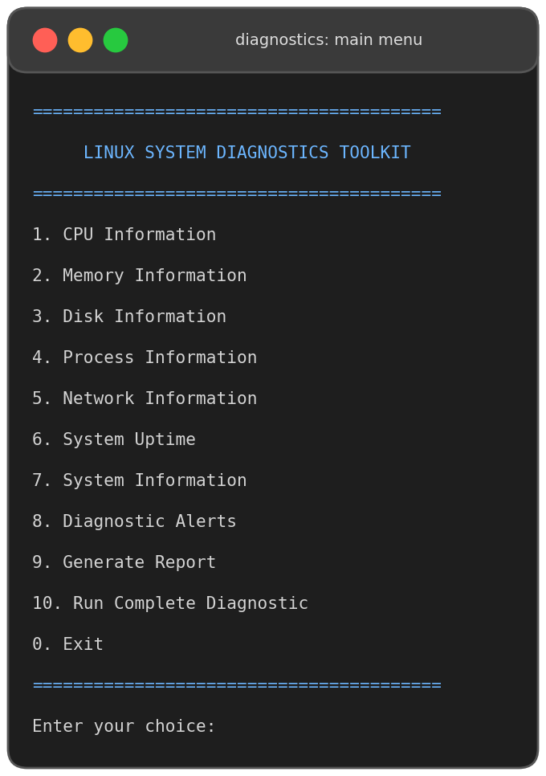
- Main menu of the Linux System Diagnostics Toolkit.
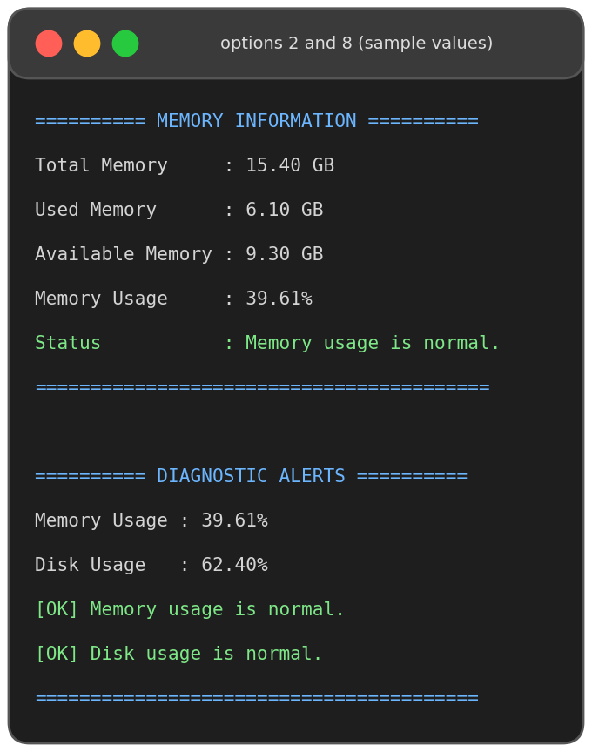
- Memory information (option 2) and diagnostic alerts (option 8), sample values.
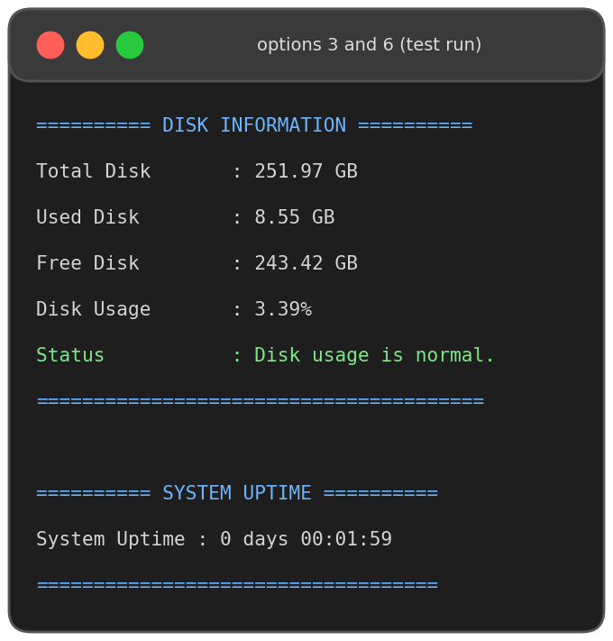
- Disk information (option 3) and system uptime (option 6) from a test run.

Alert Behaviour
With the sample values of Fig. 5, memory usage is 39.61 % and disk usage is 62.40 %. Both are below the 80 % threshold, so show_alerts() prints [OK] for each resource, as the bar chart in Fig. 7 illustrates. If either value were to reach 80 %, the program would print the WARNING (memory) or CRITICAL (disk) message of Table III; because the comparison uses >=, a value of exactly 80 % already triggers the alert.
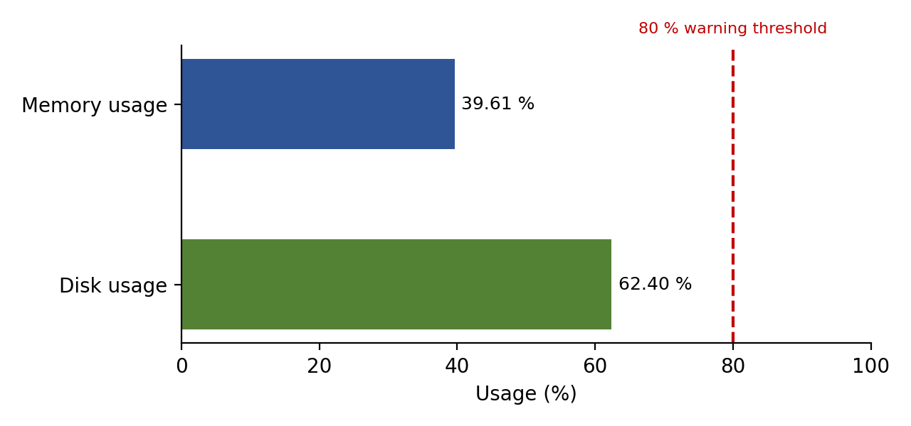
- Memory and disk usage compared with the 80 % alert threshold (sample values).

Diagnostic Report
Option 9 writes diagnostic_report.txt to the current directory. A report produced during testing is shown below. The CPU and memory sections contain the first lines of the corresponding /proc files, and the disk and uptime sections contain the computed values.
========================================
LINUX DIAGNOSTIC REPORT
========================================

CPU INFORMATION
----------------
processor : 0
vendor_id : GenuineIntel
cpu family : 6
model : 207
model name : Intel(R) Xeon(R) Processor @ 2.10GHz

MEMORY INFORMATION
------------------
MemTotal: 4093768 kB
MemFree: 3600532 kB
MemAvailable: 3819452 kB
Buffers: 14048 kB
Cached: 418964 kB

DISK INFORMATION
----------------
Total Disk : 251.97 GB
Used Disk : 8.55 GB
Free Disk : 243.42 GB

RUNNING PROCESSES
-----------------

SYSTEM UPTIME
--------------
Uptime: 119 seconds

NETWORK INFORMATION
-------------------
Network information can be viewed using:
ip -br addr

WARNINGS
--------
Report generated by Linux System Diagnostics Toolkit.

========================================

Observations and Limitations
During development and testing the main challenges were parsing the /proc formats reliably, obtaining CPU usage without extra libraries, and keeping the output consistent across modules. Testing also showed that the CPU, process, network and system-information modules depend on external utilities (top, ps, ip, uname, who): when one of them is missing, the shell prints an error and the corresponding section is empty, but the program itself continues normally (test T12). The limitations that were identified, with the planned improvement for each, are listed in Table VI.
- Known limitations and planned improvements
Limitation | Planned improvement
Disk check covers the root file system (/) only | Report multiple disks and mount points
CPU usage and the process list rely on system() calls; CPU usage is a single top snapshot | Read /proc/stat directly for CPU usage; sort processes by CPU or memory
Report: process and network sections are minimal and no warnings are listed | Include processes, network details and alerts in the report
Thresholds are fixed constants, and CPU_WARNING is defined but not yet used in the alerts | Use a real, configurable threshold setting and add CPU alerts
Several modules depend on external shell commands | Replace shell calls with native /proc code; test on different distributions

Conclusion and Future Work
This project delivered a single, menu-driven Linux System Diagnostics Toolkit in C that replaces a set of separate commands with one consistent interface. All planned modules (CPU, memory, disk, processes, network, uptime, system information, alerts and report) were implemented in one integrated program with input validation, threshold-based warnings, a text report and a complete diagnostic that runs in a single step. The work demonstrates practical Operating Systems concepts: reading the /proc virtual file system, using the statvfs() system call, file I/O, and process and resource monitoring. Its modular structure, with one function per module, makes incremental development straightforward, and the final toolkit helps users identify basic resource-related problems such as high memory use or a nearly full disk.
In the future, the work will concentrate on the points identified in Table VI: completing the report content, replacing shell calls with native code (for example reading /proc/stat for CPU usage), making the thresholds configurable, adding multiple-disk and per-process statistics, sorting processes by CPU or memory use, and testing the toolkit on different Linux distributions.

References
- A. Silberschatz, P. B. Galvin, and G. Gagne, Operating System Concepts, 10th ed. Hoboken, NJ, USA: Wiley, 2018.
- A. S. Tanenbaum and H. Bos, Modern Operating Systems, 4th ed. Upper Saddle River, NJ, USA: Pearson, 2015.
- M. Kerrisk, The Linux Programming Interface. San Francisco, CA, USA: No Starch Press, 2010.
- B. W. Kernighan and D. M. Ritchie, The C Programming Language, 2nd ed. Englewood Cliffs, NJ, USA: Prentice Hall, 1988.
- "proc(5) – process information pseudo-filesystem," Linux man-pages. [Online]. Available: https://man7.org/linux/man-pages/man5/proc.5.html
- "statvfs(3) – get filesystem statistics," Linux man-pages. [Online]. Available: https://man7.org/linux/man-pages/man3/statvfs.3.html
- "The /proc filesystem," The Linux Kernel documentation. [Online]. Available: https://docs.kernel.org/filesystems/proc.html
- "GCC, the GNU Compiler Collection," GNU Project. [Online]. Available: https://gcc.gnu.org/onlinedocs/

Appendix A: Source Code (diagnostics.c)
This appendix lists the complete source file. Each part is preceded by a short explanation of what the code does and which design decision it reflects.
A.1 Header files and threshold macros
The program includes stdio.h for console and file I/O, stdlib.h for system(), string.h for text parsing, unistd.h for the POSIX API and sys/statvfs.h for disk statistics. The three macros set the alert limit to 80 % for CPU, memory and disk, so a limit can be changed in one place.
#include <stdio.h>
#include <stdlib.h>
#include <string.h>
#include <unistd.h>
#include <sys/statvfs.h>
#include <time.h>

#define CPU_WARNING 80.0
#define MEMORY_WARNING 80.0
#define DISK_WARNING 80.0
A.2 show_cpu(): CPU model, cores and usage
The function scans /proc/cpuinfo line by line. It copies the text after the colon on the first model name line and counts every processor line to get the number of cores. Current usage is printed by running top once and letting awk compute 100 minus the idle percentage.
/* ---------- CPU ---------- */

void show_cpu()
{
FILE *fp;
char line[256];
char model[256] = "Unknown";
int processors = 0;

fp = fopen("/proc/cpuinfo", "r");

if (fp == NULL)
{
perror("Cannot open /proc/cpuinfo");
return;
}

while (fgets(line, sizeof(line), fp))
{
if (strncmp(line, "model name", 10) == 0 && strcmp(model, "Unknown") == 0)
{
char *colon = strchr(line, ':');

if (colon != NULL)
{
strcpy(model, colon + 2);
model[strcspn(model, "\n")] = '\0';
}
}

if (strncmp(line, "processor", 9) == 0)
processors++;
}

fclose(fp);

printf("\n========== CPU INFORMATION ==========\n");
printf("CPU Model : %s\n", model);
printf("CPU Cores : %d\n", processors);

/* Get CPU usage using top */
printf("CPU Usage : ");

fflush(stdout);

system("top -bn1 | grep 'Cpu(s)' | awk '{print 100 - $8\"%\"}'");

printf("=====================================\n");
}
A.3 show_memory(): RAM statistics
MemTotal and MemAvailable are read from /proc/meminfo with sscanf(). Used memory is total minus available, the usage percentage is used divided by total, and the kilobyte values are converted to GB. A warning is printed when usage reaches MEMORY_WARNING; if /proc/meminfo gives no total, the function reports that the information is unavailable.
/* ---------- MEMORY ---------- */

void show_memory()
{
FILE *fp;
char line[256];

long total = 0;
long available = 0;

fp = fopen("/proc/meminfo", "r");

if (fp == NULL)
{
perror("Cannot open /proc/meminfo");
return;
}

while (fgets(line, sizeof(line), fp))
{
if (sscanf(line, "MemTotal: %ld kB", &total) == 1)
{
continue;
}

if (sscanf(line, "MemAvailable: %ld kB", &available) == 1)
{
continue;
}
}

fclose(fp);

if (total == 0)
{
printf("Memory information unavailable.\n");
return;
}

long used = total - available;

double usage = ((double)used / total) * 100.0;

printf("\n========== MEMORY INFORMATION ==========\n");

printf("Total Memory : %.2f GB\n",
total / (1024.0 * 1024.0));

printf("Used Memory : %.2f GB\n",
used / (1024.0 * 1024.0));

printf("Available Memory : %.2f GB\n",
available / (1024.0 * 1024.0));

printf("Memory Usage : %.2f%%\n", usage);

if (usage >= MEMORY_WARNING)
{
printf("WARNING: High memory usage detected!\n");
}
else
{
printf("Status : Memory usage is normal.\n");
}

printf("=========================================\n");
}
A.4 show_disk(): root file-system usage
statvfs("/") fills a structure with the block count, free blocks and fragment size. Multiplying blocks by the fragment size gives bytes, which are shown in GB together with the usage percentage and a status or warning line.
/* ---------- DISK ---------- */

void show_disk()
{
struct statvfs stat;

if (statvfs("/", &stat) != 0)
{
perror("Cannot read disk information");
return;
}

unsigned long long total =
(unsigned long long)stat.f_blocks * stat.f_frsize;

unsigned long long free_space =
(unsigned long long)stat.f_bfree * stat.f_frsize;

unsigned long long used =
total - free_space;

double usage = ((double)used / total) * 100.0;

printf("\n========== DISK INFORMATION ==========\n");

printf("Total Disk : %.2f GB\n",
total / (1024.0 * 1024.0 * 1024.0));

printf("Used Disk : %.2f GB\n",
used / (1024.0 * 1024.0 * 1024.0));

printf("Free Disk : %.2f GB\n",
free_space / (1024.0 * 1024.0 * 1024.0));

printf("Disk Usage : %.2f%%\n", usage);

if (usage >= DISK_WARNING)
{
printf("WARNING: Very high disk usage detected!\n");
}
else
{
printf("Status : Disk usage is normal.\n");
}

printf("=======================================\n");
}
A.5 show_processes(): process list
The function delegates to ps -eo pid,comm,state --sort=-pid | head -n 16, which prints the header and 15 processes (PID, command name and state), starting from the highest PID.
/* ---------- PROCESS ---------- */

void show_processes()
{
printf("\n========== RUNNING PROCESSES ==========\n");

printf("Showing top running processes:\n\n");

system("ps -eo pid,comm,state --sort=-pid | head -n 16");

printf("\n=======================================\n");
}
A.6 show_network(): interfaces and statistics
ip -br addr prints a brief list of interfaces and addresses, and cat /proc/net/dev prints the receive and transmit counters for each interface.
/* ---------- NETWORK ---------- */

void show_network()
{
printf("\n========== NETWORK INFORMATION ==========\n");

system("ip -br addr");

printf("\nNetwork Statistics:\n");

system("cat /proc/net/dev");

printf("=========================================\n");
}
A.7 show_uptime(): time since boot
The first value of /proc/uptime is the number of seconds since boot. Integer division and the modulo operator split it into days, hours, minutes and seconds, which are printed as days and HH:MM:SS.
/* ---------- UPTIME ---------- */

void show_uptime()
{
FILE *fp;
double uptime;

fp = fopen("/proc/uptime", "r");

if (fp == NULL)
{
perror("Cannot open /proc/uptime");
return;
}

fscanf(fp, "%lf", &uptime);

fclose(fp);

int days = uptime / 86400;
int hours = ((int)uptime % 86400) / 3600;
int minutes = ((int)uptime % 3600) / 60;
int seconds = (int)uptime % 60;

printf("\n========== SYSTEM UPTIME ==========\n");

printf("System Uptime : %d days %02d:%02d:%02d\n",
days,
hours,
minutes,
seconds);

printf("===================================\n");
}
A.8 show_system_info(): operating system and users
This function prints the operating system (uname -o), kernel version (uname -r), host name, current user and the users logged in, by calling the matching shell commands.
/* ---------- SYSTEM INFORMATION ---------- */

void show_system_info()
{
printf("\n========== SYSTEM INFORMATION ==========\n");

printf("\nOperating System:\n");
system("uname -o");

printf("\nKernel Version:\n");
system("uname -r");

printf("\nHostname:\n");
system("hostname");

printf("\nCurrent User:\n");
system("whoami");

printf("\nLogged-in Users:\n");
system("who");

printf("========================================\n");
}
A.9 show_alerts(): threshold checks
Memory and disk usage are recalculated with the same formulas as in the individual modules and compared with MEMORY_WARNING and DISK_WARNING. Each resource prints [OK] when below the limit, and [WARNING] (memory) or [CRITICAL] (disk) when the limit is reached.
/* ---------- ALERTS ---------- */

void show_alerts()
{
FILE *fp;
char line[256];

long total = 0;
long available = 0;

fp = fopen("/proc/meminfo", "r");

if (fp != NULL)
{
while (fgets(line, sizeof(line), fp))
{
sscanf(line, "MemTotal: %ld kB", &total);
sscanf(line, "MemAvailable: %ld kB", &available);
}

fclose(fp);
}

double memory_usage = 0;

if (total > 0)
{
memory_usage =
((double)(total - available) / total) * 100;
}

struct statvfs stat;

double disk_usage = 0;

if (statvfs("/", &stat) == 0)
{
unsigned long long total_disk =
(unsigned long long)stat.f_blocks * stat.f_frsize;

unsigned long long free_disk =
(unsigned long long)stat.f_bfree * stat.f_frsize;

unsigned long long used_disk =
total_disk - free_disk;

disk_usage =
((double)used_disk / total_disk) * 100;
}

printf("\n========== DIAGNOSTIC ALERTS ==========\n");

printf("Memory Usage : %.2f%%\n", memory_usage);
printf("Disk Usage : %.2f%%\n", disk_usage);

if (memory_usage >= MEMORY_WARNING)
{
printf("[WARNING] High memory usage detected!\n");
}
else
{
printf("[OK] Memory usage is normal.\n");
}

if (disk_usage >= DISK_WARNING)
{
printf("[CRITICAL] Very high disk usage detected!\n");
}
else
{
printf("[OK] Disk usage is normal.\n");
}

printf("========================================\n");
}
A.10 generate_report(): diagnostic_report.txt
The report file is opened with fopen(..., "w") and filled with fprintf(): a title, the first five lines of /proc/cpuinfo and /proc/meminfo, disk totals, uptime in seconds, a network hint and a closing line. If the file cannot be created, perror() prints the reason and the function returns.
/* ---------- REPORT ---------- */

void generate_report()
{
FILE *report;

report = fopen("diagnostic_report.txt", "w");

if (report == NULL)
{
perror("Cannot create report");
return;
}

fprintf(report,
"========================================\n");
fprintf(report,
" LINUX DIAGNOSTIC REPORT\n");
fprintf(report,
"========================================\n\n");

fprintf(report, "CPU INFORMATION\n");
fprintf(report, "----------------\n");

fflush(report);

/* CPU information */
FILE *cpuinfo = fopen("/proc/cpuinfo", "r");

if (cpuinfo != NULL)
{
char line[256];
int count = 0;

while (fgets(line, sizeof(line), cpuinfo) && count < 5)
{
fprintf(report, "%s", line);
count++;
}

fclose(cpuinfo);
}

fprintf(report, "\nMEMORY INFORMATION\n");
fprintf(report, "------------------\n");

FILE *meminfo = fopen("/proc/meminfo", "r");

if (meminfo != NULL)
{
char line[256];
int count = 0;

while (fgets(line, sizeof(line), meminfo) &&
count < 5)
{
fprintf(report, "%s", line);
count++;
}

fclose(meminfo);
}

fprintf(report, "\nDISK INFORMATION\n");
fprintf(report, "----------------\n");

struct statvfs stat;

if (statvfs("/", &stat) == 0)
{
unsigned long long total =
(unsigned long long)stat.f_blocks * stat.f_frsize;

unsigned long long free_space =
(unsigned long long)stat.f_bfree * stat.f_frsize;

unsigned long long used =
total - free_space;

fprintf(report,
"Total Disk : %.2f GB\n",
total / (1024.0 * 1024.0 * 1024.0));

fprintf(report,
"Used Disk : %.2f GB\n",
used / (1024.0 * 1024.0 * 1024.0));

fprintf(report,
"Free Disk : %.2f GB\n",
free_space / (1024.0 * 1024.0 * 1024.0));
}

fprintf(report, "\nRUNNING PROCESSES\n");
fprintf(report, "-----------------\n");

fflush(report);

fprintf(report,
"\nSYSTEM UPTIME\n");
fprintf(report,
"--------------\n");

FILE *up = fopen("/proc/uptime", "r");

if (up != NULL)
{
double uptime;

fscanf(up, "%lf", &uptime);

fprintf(report,
"Uptime: %.0f seconds\n",
uptime);

fclose(up);
}

fprintf(report,
"\nNETWORK INFORMATION\n");
fprintf(report,
"-------------------\n");

fprintf(report,
"Network information can be viewed using:\n");
fprintf(report,
"ip -br addr\n");

fprintf(report,
"\nWARNINGS\n");
fprintf(report,
"--------\n");

fprintf(report,
"Report generated by Linux System Diagnostics Toolkit.\n");

fprintf(report,
"\n========================================\n");

fclose(report);

printf("\nReport generated successfully!\n");
printf("File: diagnostic_report.txt\n");
}
A.11 show_all(): complete diagnostic
show_all() prints a banner and then calls the CPU, memory, disk, process, network, uptime, system-information and alert functions in order, giving a full snapshot in one run.
/* ---------- COMPLETE DIAGNOSTIC ---------- */

void show_all()
{
printf("\n");
printf("========================================\n");
printf(" LINUX SYSTEM DIAGNOSTICS TOOLKIT\n");
printf("========================================\n");

show_cpu();
show_memory();
show_disk();
show_processes();
show_network();
show_uptime();
show_system_info();
show_alerts();

printf("\n========================================\n");
printf(" DIAGNOSTIC COMPLETED\n");
printf("========================================\n");
}
A.12 menu(): user interface
menu() prints the numbered list of ten options plus Exit and the input prompt. It is called at the start of every loop iteration in main().
/* ---------- MENU ---------- */

void menu()
{
printf("\n");
printf("========================================\n");
printf(" LINUX SYSTEM DIAGNOSTICS TOOLKIT\n");
printf("========================================\n");

printf("1. CPU Information\n");
printf("2. Memory Information\n");
printf("3. Disk Information\n");
printf("4. Process Information\n");
printf("5. Network Information\n");
printf("6. System Uptime\n");
printf("7. System Information\n");
printf("8. Diagnostic Alerts\n");
printf("9. Generate Report\n");
printf("10. Run Complete Diagnostic\n");
printf("0. Exit\n");

printf("========================================\n");
printf("Enter your choice: ");
}
A.13 main(): input loop and dispatcher
main() loops until the user chooses 0. If scanf() does not read a number, the program prints an error and discards the rest of the line with getchar(). A switch statement calls the function for options 1 to 10, and the default branch reports an invalid choice.
/* ---------- MAIN ---------- */

int main()
{
int choice;

while (1)
{
menu();

if (scanf("%d", &choice) != 1)
{
printf("Invalid input.\n");

while (getchar() != '\n');

continue;
}

switch (choice)
{
case 1:
show_cpu();
break;

case 2:
show_memory();
break;

case 3:
show_disk();
break;

case 4:
show_processes();
break;

case 5:
show_network();
break;

case 6:
show_uptime();
break;

case 7:
show_system_info();
break;

case 8:
show_alerts();
break;

case 9:
generate_report();
break;

case 10:
show_all();
break;

case 0:
printf("\nExiting Linux Diagnostics Toolkit...\n");
return 0;

default:
printf("\nInvalid choice. Please try again.\n");
}
}

return 0;
}

