WEEK 2
AWS Compute & Networking

Cloud Infrastructure Training Program
Technical Lab Guide & Reference Record

Table of Contents

1. Introduction
2. Overview of Week 2 Scope
2.1 Daily Breakdown
3. Learning Objectives
4. Step-by-Step Implementation
4.1 Task 2.1 — Web Server on EC2
4.1.1 Launch a t2/t3.micro Instance
4.1.2 Connect via SSH Using the Key Pair
4.1.3 Install and Configure a Web Server
4.1.4 Attach an Elastic IP and Confirm Reachability
4.2 Task 2.2 — Custom VPC Design
4.2.1 Create the VPC and Subnets
4.2.2 Add an Internet Gateway
4.2.3 Add a NAT Gateway
4.2.4 Place the Web Server and Verify Connectivity
4.3 Task 2.3 — Storage Exploration (S3 and EBS)
4.3.1 Host a Static Website on S3
4.3.2 Create and Attach an EBS Volume
4.3.3 Take a Snapshot and Restore It
4.3.4 Object Storage vs. Block Storage — Summary Comparison
4.4 Task 2.4 — Architecture Diagram
5. Conclusion

1. Introduction
This document serves as the official lab guide and reference record for Week 2 of the Cloud Infrastructure Training Program, focused on Amazon Web Services (AWS) Compute and Networking fundamentals. The guide is intended to support trainees in building cloud infrastructure manually before progressing to automation in subsequent weeks.

The central theme of Week 2 is hands-on construction of core AWS building blocks: a virtual server (EC2), a custom private network (VPC), and object and block storage services (S3 and EBS). The rationale for manual configuration is straightforward: a practitioner who understands what each console action does is better equipped to automate that same action sensibly using Infrastructure as Code in Week 3.

This document is structured to guide a trainee from initial setup through to a validated, documented architecture, with clearly marked locations for screenshot evidence to support submission and review.

2. Overview of Week 2 Scope
Week 2 builds directly on the foundational AWS account setup completed in Week 1. The work is organized into four sequential tasks, each producing a discrete, verifiable deliverable. Together, these tasks result in a small but complete cloud environment consisting of a custom network, a publicly reachable web server, and supporting storage resources.

2.1 Daily Breakdown
The week is intended to be paced across five working days, allowing time for troubleshooting network configuration, which is typically the most conceptually demanding portion of the module.

Day | Focus Area
Day 1 | EC2 instance launch, key pair setup, SSH access, and web server installation (Task 2.1)
Day 2 | Elastic IP allocation and association; confirm public reachability (Task 2.1 continued)
Day 3 | Custom VPC design — subnets, Internet Gateway, NAT Gateway, route tables (Task 2.2)
Day 4 | Storage exploration — S3 static website hosting, EBS volume and snapshot lifecycle (Task 2.3)
Day 5 | Architecture diagramming and README documentation (Task 2.4); final review

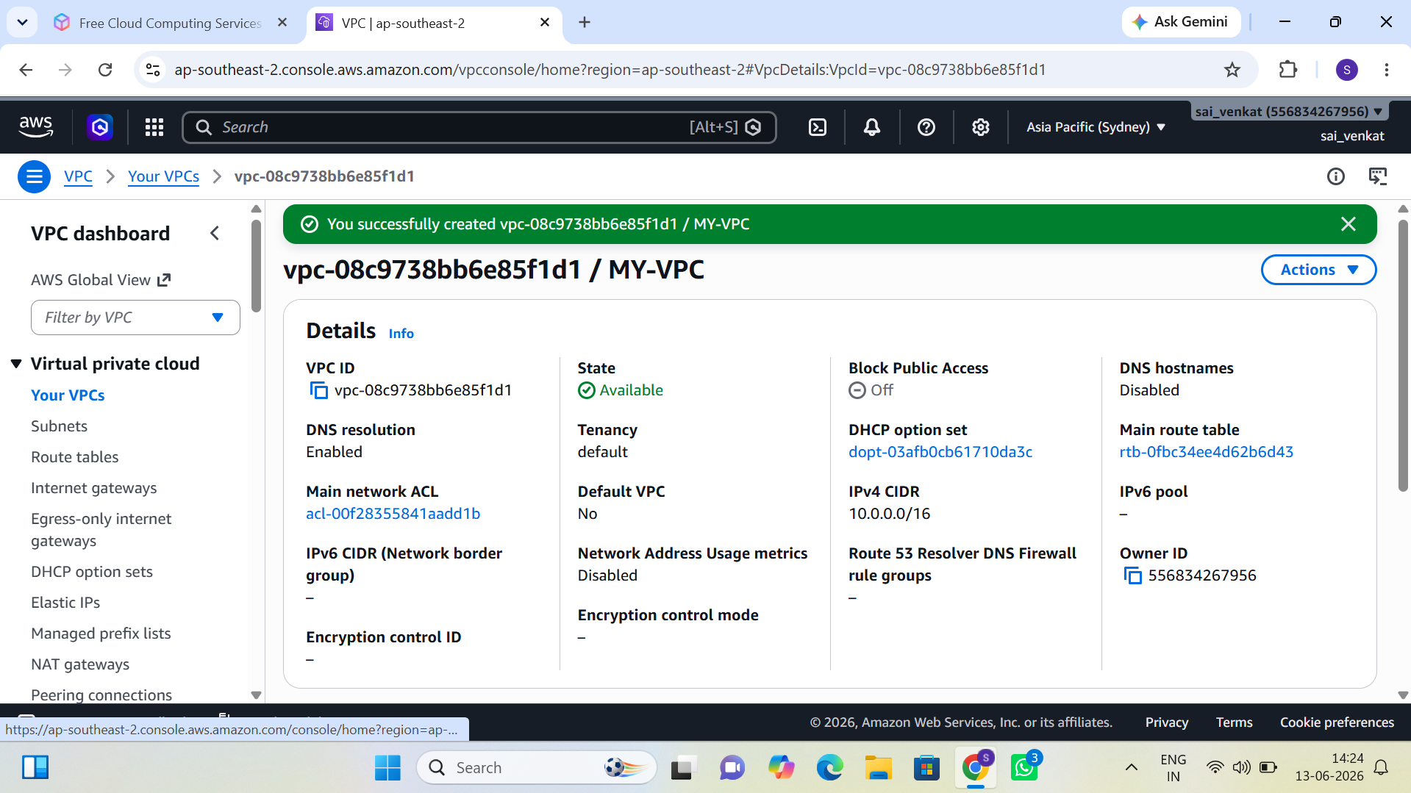
Figure 1: Weekly Schedule — Daily Breakdown Overview

3. Learning Objectives
By the conclusion of Week 2, the trainee is expected to be able to:

- Launch and connect to EC2 instances securely using SSH key pairs.
- Design a custom VPC containing both public and private subnets.
- Configure security groups, route tables, gateways, and Elastic IP addresses.
- Host static content on Amazon S3 and articulate the distinction between object storage and block storage (EBS).
- Produce a clear, accurate cloud architecture diagram suitable for technical review.

4. Step-by-Step Implementation
The following sections walk through each of the four Week 2 tasks in implementation order. Each task includes numbered procedural steps and clearly marked locations for supporting screenshot evidence.

4.1 Task 2.1 — Web Server on EC2
This task establishes the compute layer of the environment: a single EC2 instance running a lightweight web server, made reachable from the public internet via an Elastic IP address.

4.1.1 Launch a t2/t3.micro Instance
- Navigate to the EC2 service console and select "Launch Instance."
- Choose an Amazon Machine Image (AMI), typically Amazon Linux 2023 or Ubuntu Server LTS.
- Select the t2.micro or t3.micro instance type to remain within the AWS Free Tier where applicable.
- Create a new key pair (or select an existing one) and download the private key file (.pem). Store this file securely, as it cannot be re-downloaded.
- Configure the network settings, initially using the default VPC, and allow SSH (port 22) and HTTP (port 80) traffic in the security group.
- Review the configuration and launch the instance.

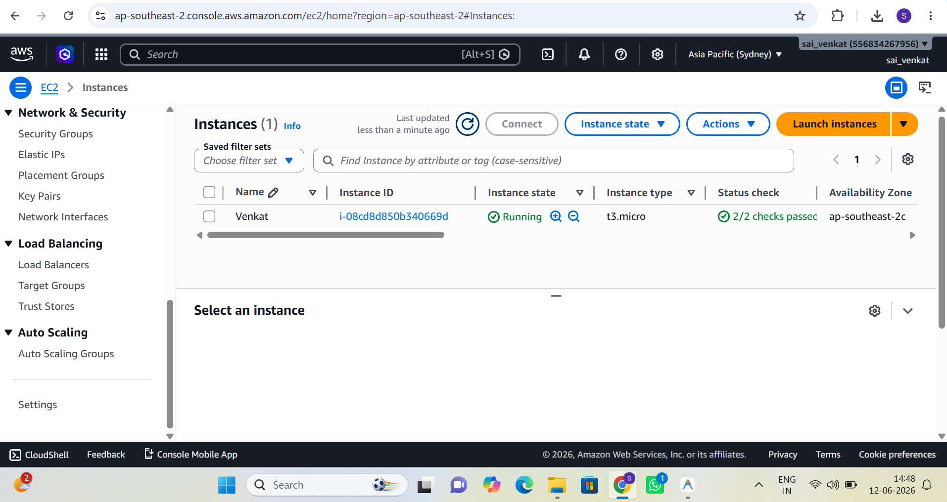
Figure 2: EC2 Instance Launch — Configuration and AMI Selection

4.1.2 Connect via SSH Using the Key Pair
Once the instance reaches a running state, connect from a local terminal using the downloaded private key.
- Set restrictive file permissions on the key file (on Linux/macOS): chmod 400 key-name.pem.
- Connect using the public DNS or public IP address of the instance: ssh -i key-name.pem ec2-user@<public-ip>.
- Confirm the host fingerprint prompt and accept the connection.

4.1.3 Install and Configure a Web Server
- Update the package index: sudo yum update -y (Amazon Linux) or sudo apt update (Ubuntu).
- Install Nginx or Apache: sudo yum install nginx -y or sudo apt install apache2 -y.
- Start and enable the service: sudo systemctl start nginx and sudo systemctl enable nginx.
- Replace the default index page with a simple static HTML page identifying the instance.

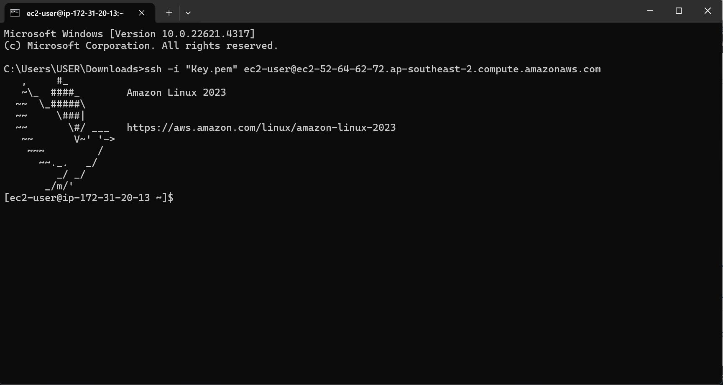
Figure 3: Web Server Installation — Nginx/Apache Configuration
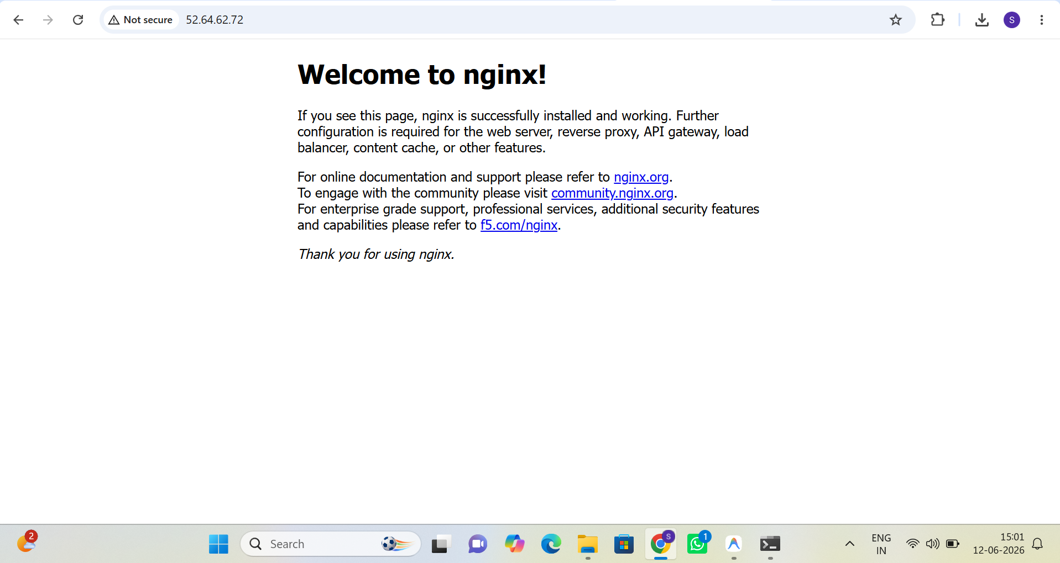
Figure 4: Web Server Running — Service Status Confirmation
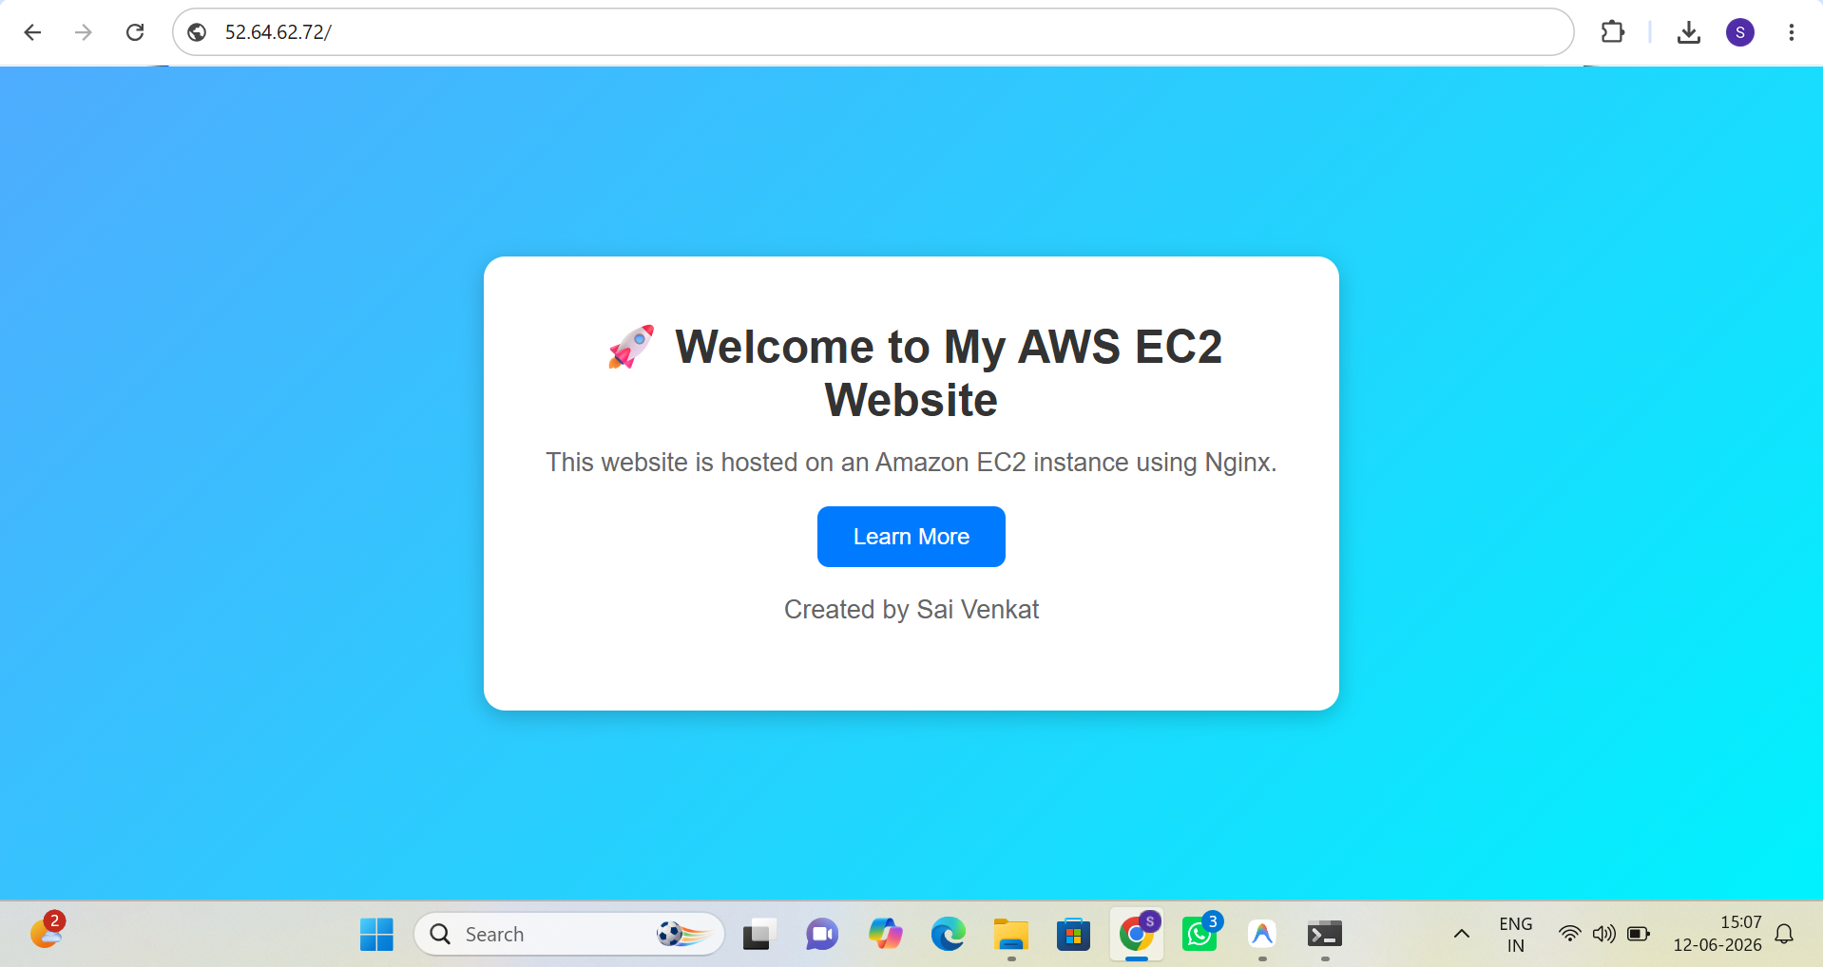
Figure 5: Static Page Served — Browser Verification

4.1.4 Attach an Elastic IP and Confirm Reachability
- In the EC2 console, navigate to Elastic IPs and allocate a new Elastic IP address.
- Associate the Elastic IP with the running instance.
- Open a web browser and navigate to http://<elastic-ip> to confirm the static page loads correctly.

4.2 Task 2.2 — Custom VPC Design
This task replaces reliance on the AWS default VPC with a purpose-built network, demonstrating control over subnetting, routing, and internet access paths for both public and private resources.

4.2.1 Create the VPC and Subnets
- Navigate to the VPC console and create a new VPC with an appropriately sized CIDR block, for example 10.0.0.0/16.
- Create a public subnet within a single Availability Zone, for example 10.0.1.0/24.
- Create a private subnet within the same Availability Zone, for example 10.0.2.0/24.


Figure 6: VPC Console — VPC and Subnet Creation

4.2.2 Add an Internet Gateway
- Create an Internet Gateway and attach it to the custom VPC.
- Create or edit a route table associated with the public subnet.
- Add a route directing 0.0.0.0/0 traffic to the Internet Gateway.
- Associate this route table explicitly with the public subnet.

4.2.3 Add a NAT Gateway
- Allocate a new Elastic IP to be used by the NAT Gateway.
- Create a NAT Gateway placed inside the public subnet, associated with the allocated Elastic IP.
- Create or edit the route table associated with the private subnet.
- Add a route directing 0.0.0.0/0 traffic to the NAT Gateway.
- Associate this route table explicitly with the private subnet.

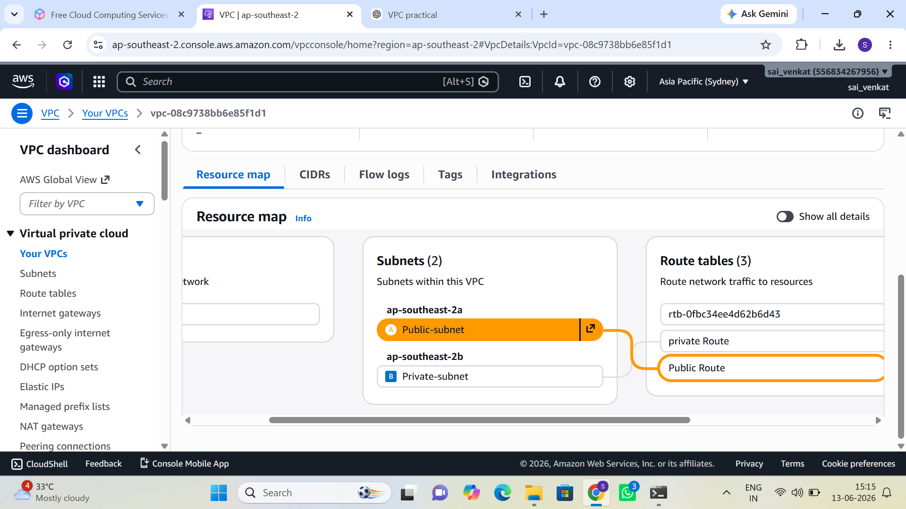
Figure 7: Route Tables — Public and Private Subnet Routing Configuration

4.2.4 Place the Web Server and Verify Connectivity
- Launch (or migrate) the EC2 web server instance into the public subnet of the custom VPC, with a security group permitting HTTP and SSH.
- Launch a second, minimal EC2 instance into the private subnet for verification purposes only.
- From the public-subnet instance, connect via SSH to the private-subnet instance using its private IP address.
- From within the private-subnet instance, confirm outbound internet access (for example, running sudo yum update) to verify NAT Gateway egress.

4.3 Task 2.3 — Storage Exploration (S3 and EBS)
This task contrasts two distinct AWS storage models: Amazon S3, an object storage service accessed over HTTP/HTTPS, and Amazon EBS, a block storage service attached directly to an EC2 instance as a virtual disk.

4.3.1 Host a Static Website on S3
- Create a new S3 bucket with a globally unique name.
- Disable "Block all public access" for this bucket (required for public static website hosting).
- Upload an index.html file (and optionally an error.html file) to the bucket.
- Enable "Static website hosting" under the bucket's Properties tab, specifying the index and error documents.
- Attach a bucket policy granting public read (s3:GetObject) access to bucket contents.
- Access the website endpoint URL provided by S3 to confirm the page loads.

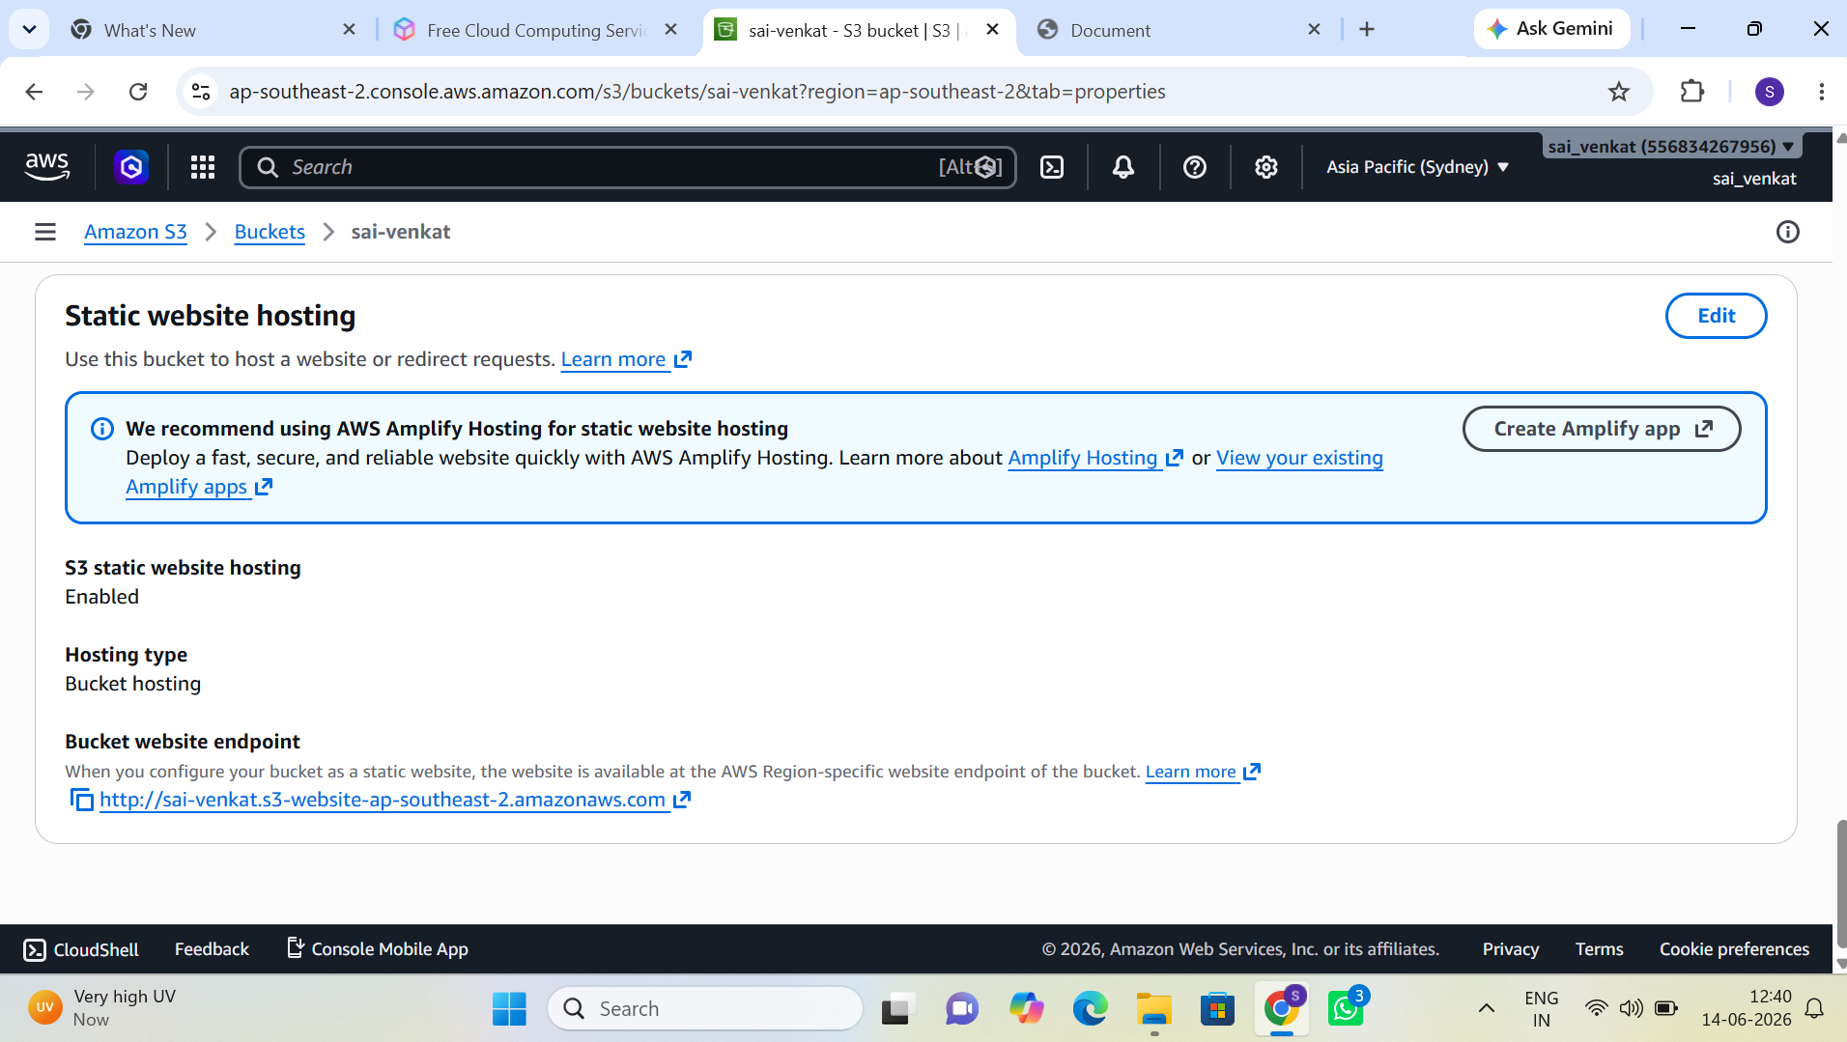
Figure 8: S3 Bucket — Static Website Hosting Configuration
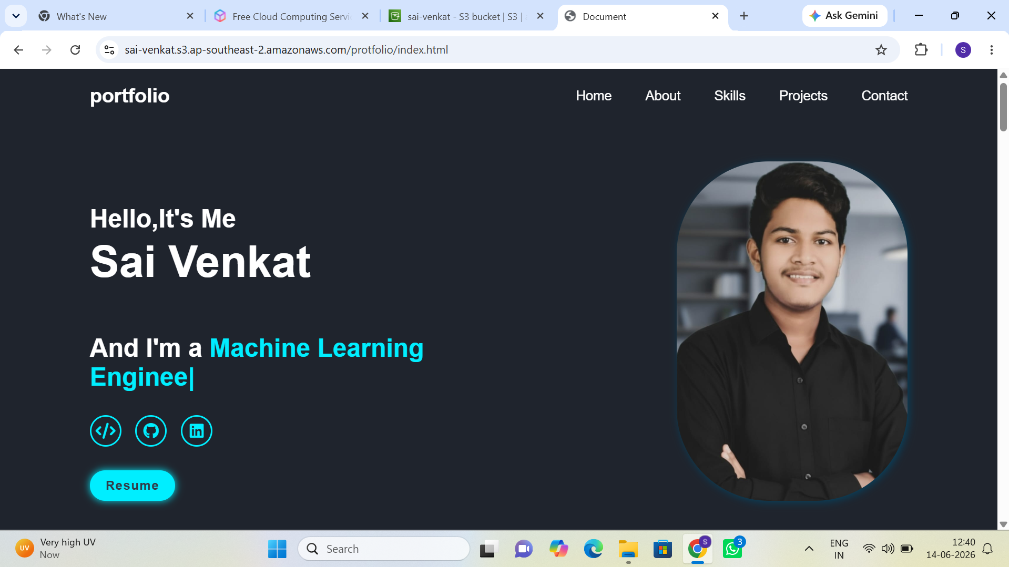
Figure 9: S3 Console — Bucket Policy and Public Access Settings
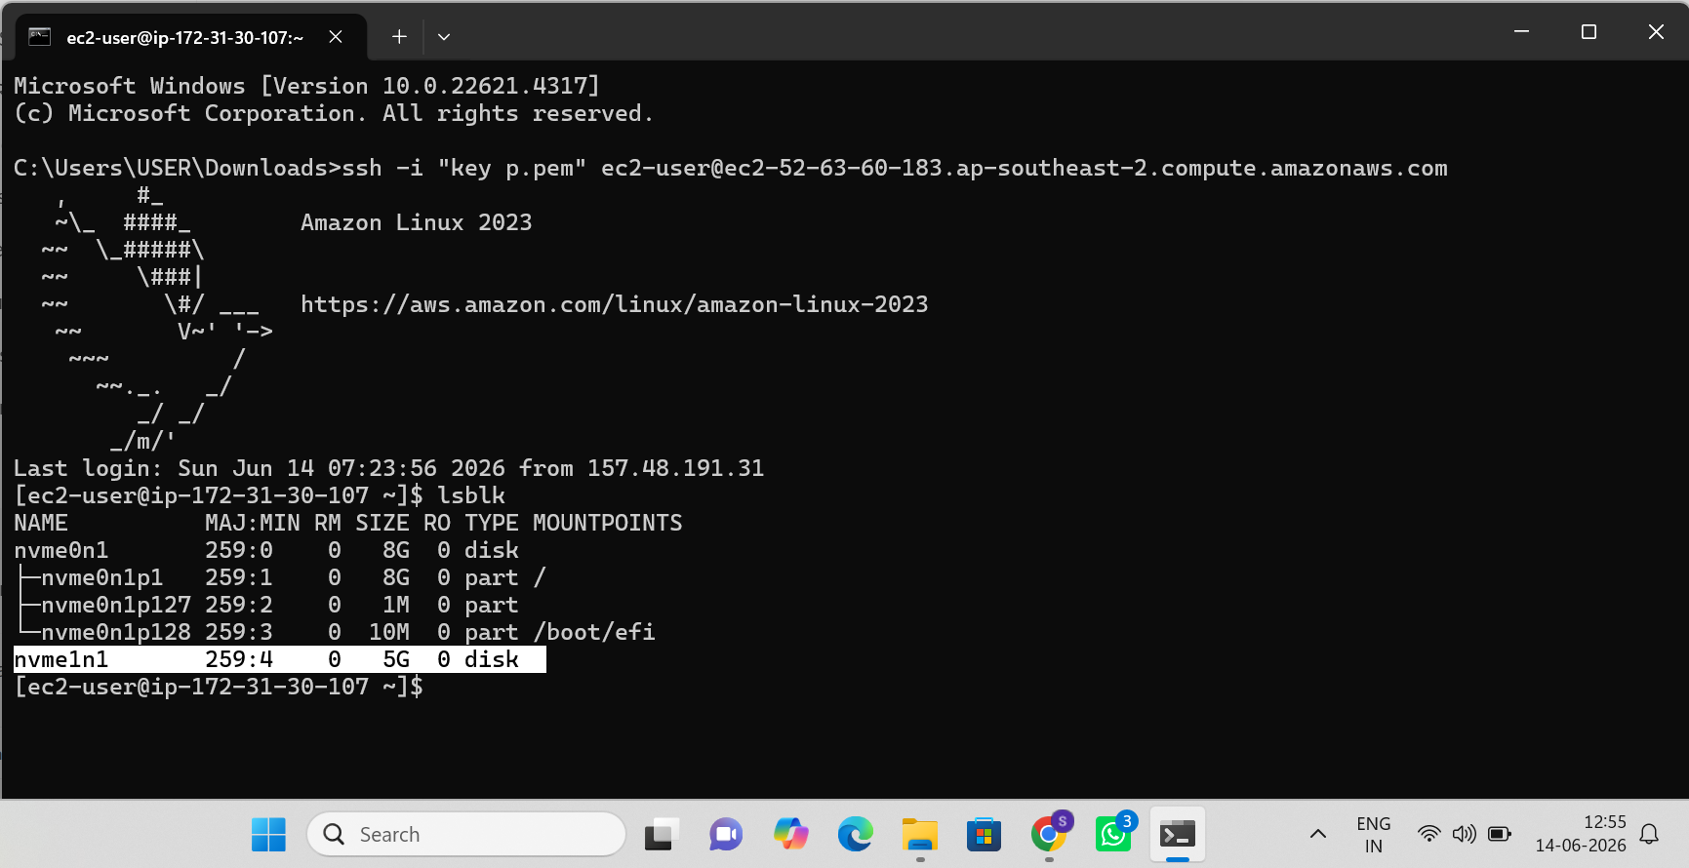
Figure 10: S3 Static Website — Browser Verification

4.3.2 Create and Attach an EBS Volume
- Navigate to the EBS section of the EC2 console and create a new volume in the same Availability Zone as the target instance.
- Attach the volume to the running EC2 instance.
- Connect to the instance via SSH and confirm the new block device is visible (for example, using lsblk).
- Format the volume with a filesystem and mount it to a directory.

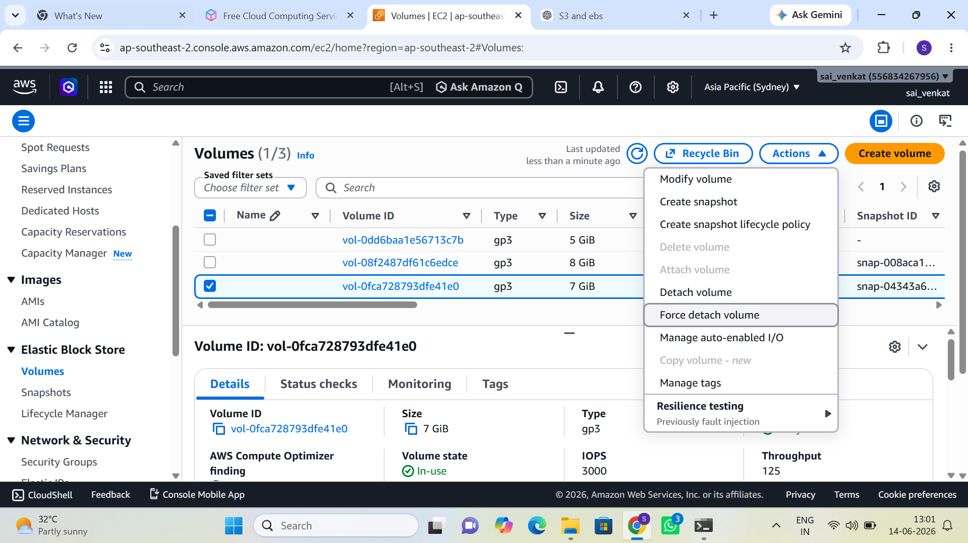
Figure 11: EBS Console — Volume Creation and Attachment
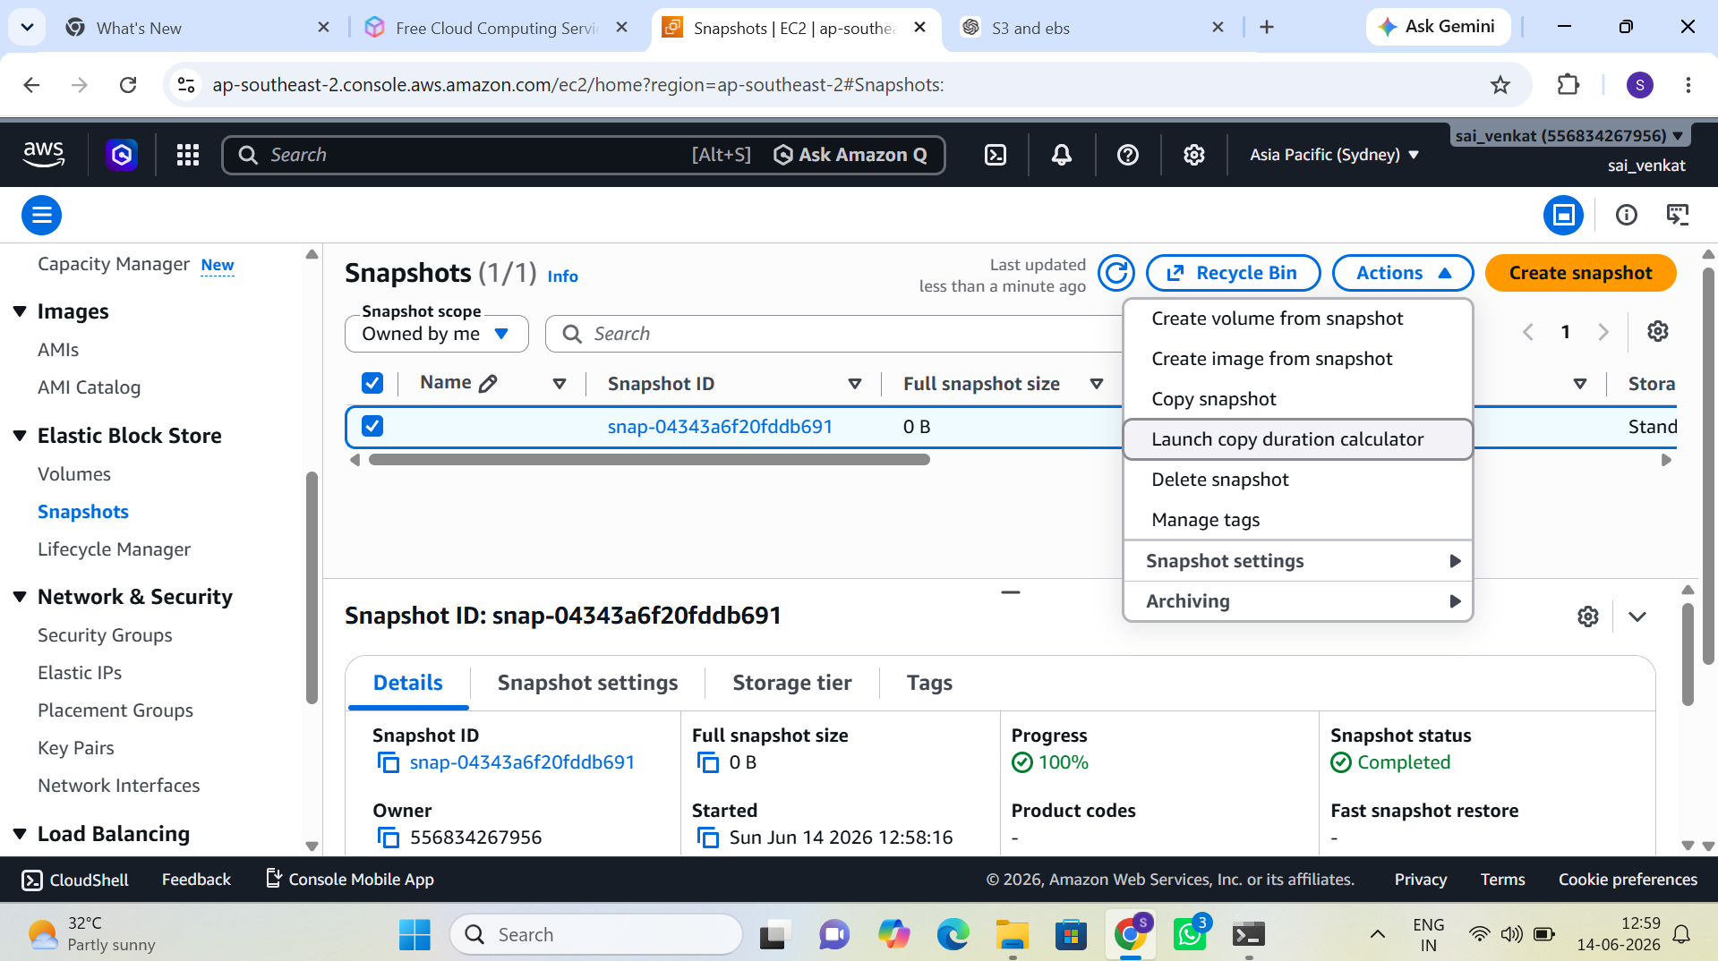
Figure 12: EC2 SSH — Block Device Verification (lsblk output)
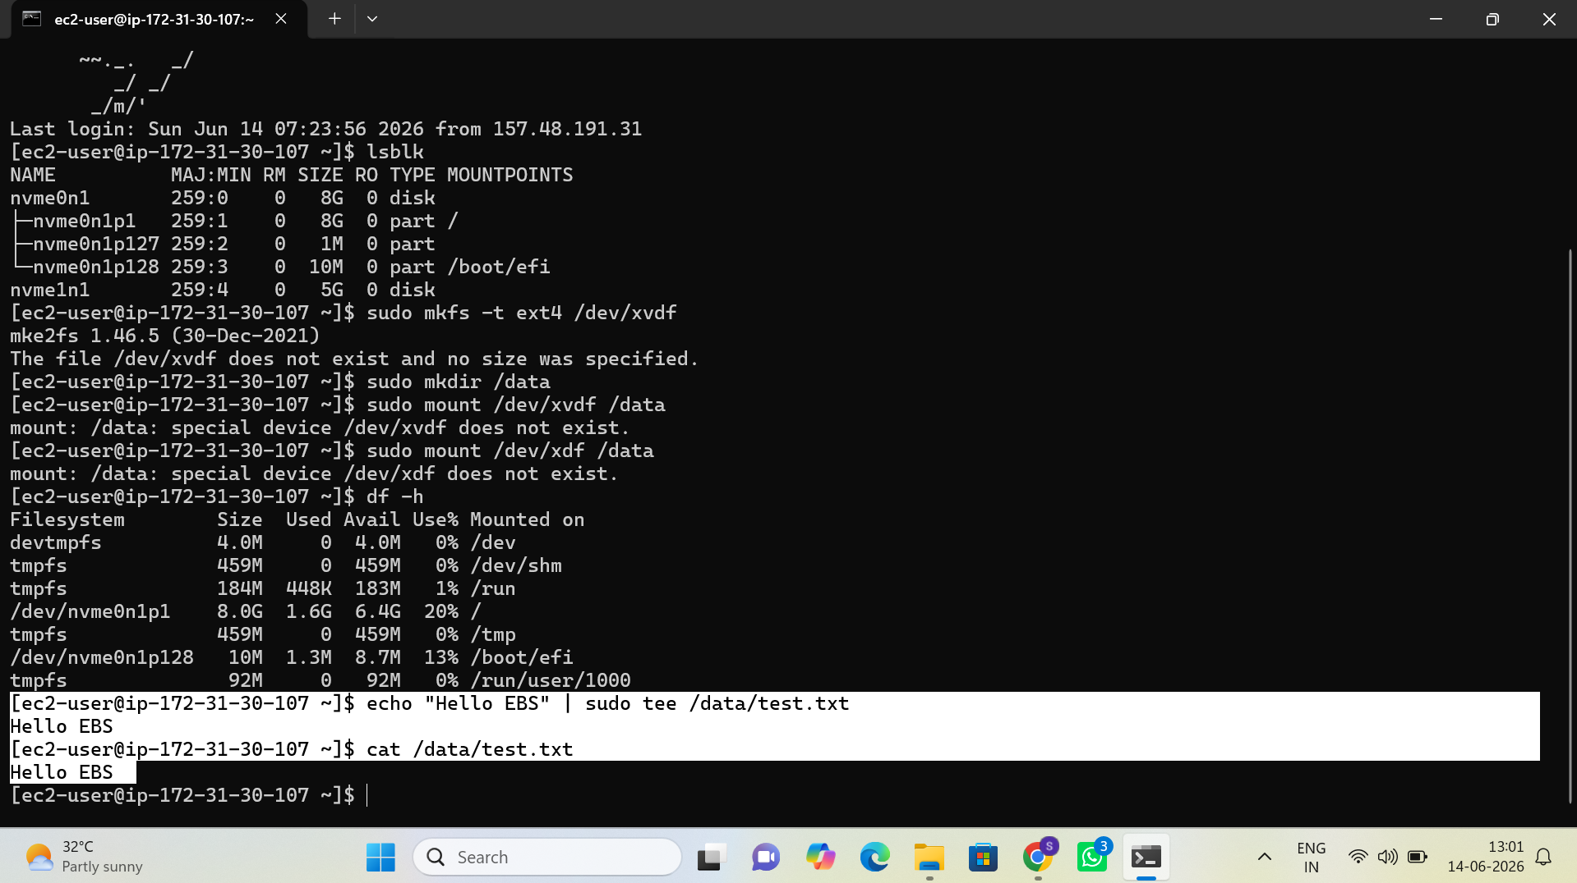
Figure 13: EBS Volume — Filesystem Formatting and Mount

4.3.3 Take a Snapshot and Restore It
- From the EBS console, select the attached volume and choose "Create Snapshot."
- Wait for the snapshot status to change to "completed."
- Create a new volume from the snapshot.
- Attach the restored volume to an instance and confirm that the original data is present.

4.3.4 Object Storage vs. Block Storage — Summary Comparison

Characteristic | S3 (Object Storage) | EBS (Block Storage)
Access method | HTTP/HTTPS API and web endpoint | Mounted as a local block device
Typical use case | Static assets, backups, data lakes | Operating system and application disks
Attachment scope | Accessible from anywhere with permissions | Attached to one EC2 instance at a time (per AZ)
Durability model | 11 nines durability, multi-AZ by default | Replicated within a single AZ; snapshots add durability
Billing basis | Per GB stored plus requests | Per GB provisioned regardless of usage

4.4 Task 2.4 — Architecture Diagram
The final task consolidates all prior work into a single visual artifact and an accompanying written explanation, intended to demonstrate clear communication of the resulting architecture.

4.4.1 Diagram Requirements
Using draw.io (or an equivalent diagramming tool) with official AWS architecture icons, produce a diagram that clearly shows the following elements:

- The custom VPC boundary, labeled with its CIDR block.
- The public subnet and private subnet, each labeled with its CIDR block and Availability Zone.
- The Internet Gateway and its connection to the public subnet route table.
- The NAT Gateway, positioned in the public subnet, and its connection to the private subnet route table.
- The EC2 web server instance in the public subnet, including its attached Elastic IP.
- The verification instance in the private subnet.
- Directional arrows indicating the flow of inbound traffic (internet to web server) and outbound traffic (private subnet to NAT Gateway to Internet Gateway).

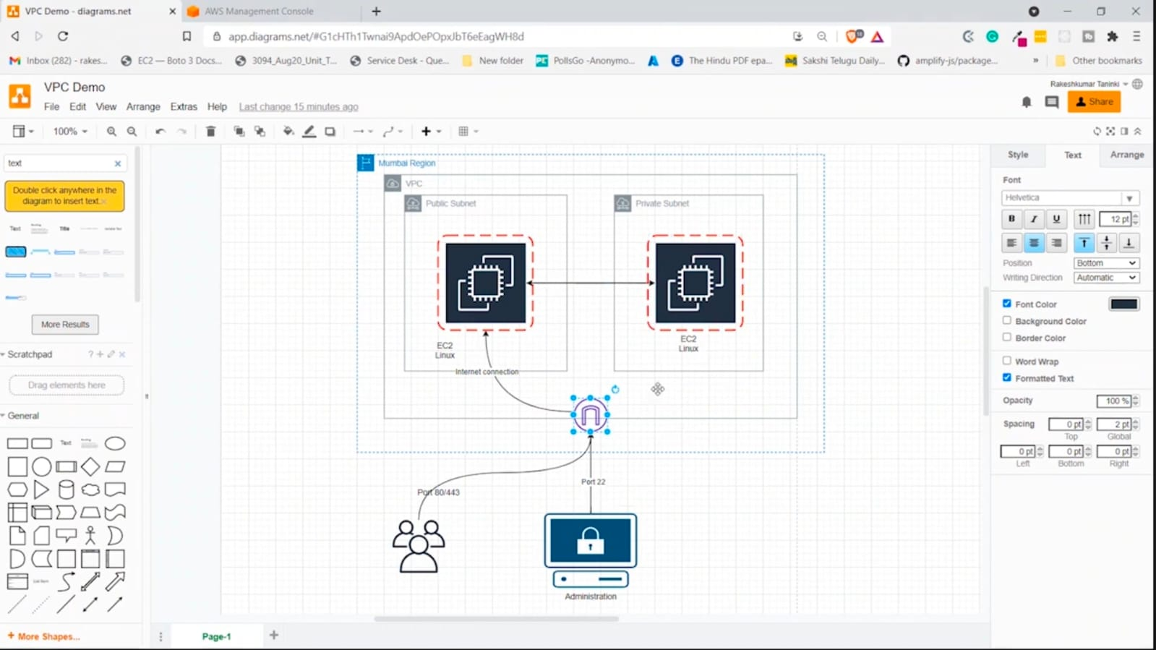
Figure 14: Architecture Diagram — Custom VPC with Public and Private Subnets
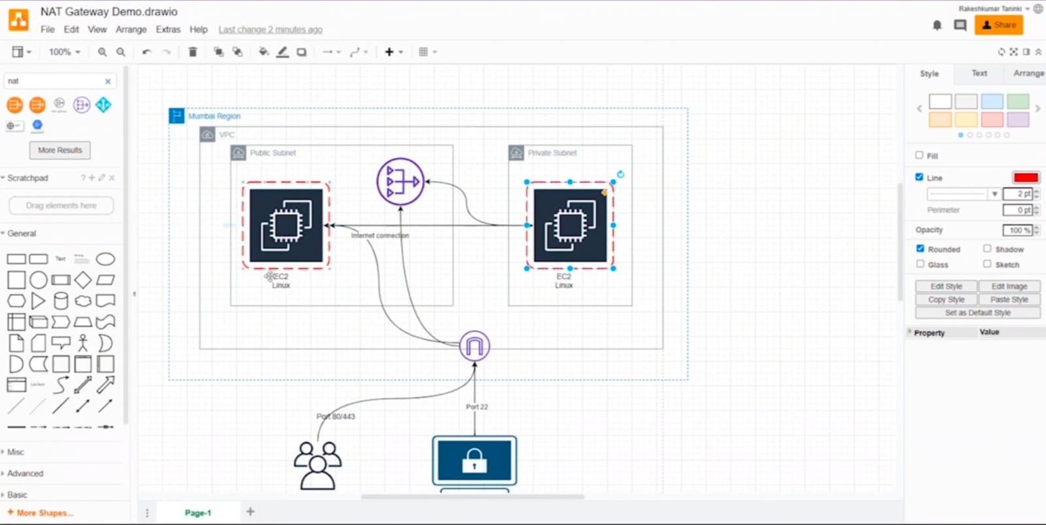
Figure 15: Traffic Flow Diagram — Inbound and Outbound Routing Paths

5. Conclusion
Week 2 moves the trainee from a single isolated server to a structured, networked environment that mirrors the shape of production cloud architectures. By manually configuring subnets, gateways, route tables, and storage resources, the trainee gains a working mental model of how traffic flows through a VPC and how compute and storage services interact.

This manual foundation is intentional. Infrastructure as Code tools introduced in Week 3 will automate the exact steps performed here; familiarity with the underlying console actions and their effects is what allows that automation to be reviewed critically rather than treated as an opaque black box.

Completion of this week's tasks, along with the accompanying architecture diagram and README walkthrough, forms the basis for validation in the next scheduled review meeting.

End of Week 2 Lab Guide

