INTERNSHIP TECHNICAL REPORT
Week 2 Extension
Advanced AWS Compute & Networking

Prepared by: Sai Venkat
AWS Account ID: 556834267956
Region: Asia Pacific (Sydney) — ap-southeast-2
Date: June 14 & June 22–23, 2026

Learning Objectives

- Design a highly available VPC across multiple Availability Zones.
- Deploy scalable web applications using Load Balancers and Auto Scaling.
- Implement secure access patterns for private resources.
- Explore advanced S3 and EBS capabilities.
- Monitor and troubleshoot AWS networking and compute resources.
- Document and diagram production-style architectures.

Day 1 — Multi-AZ VPC Design

1.1 Reading Topics
- CIDR notation and subnetting
- Availability Zones
- Route Tables
- Internet Gateway
- NAT Gateway
- Security Groups vs Network ACLs

1.2 Implementation Tasks

Task 1: Create a VPC (CIDR 10.0.0.0/16)
A new Virtual Private Cloud named Venkat-VPC was created with CIDR block 10.0.0.0/16 in the ap-southeast-2 (Sydney) region. DNS resolution was enabled and the VPC was assigned ID vpc-0cdd8e18511086210.

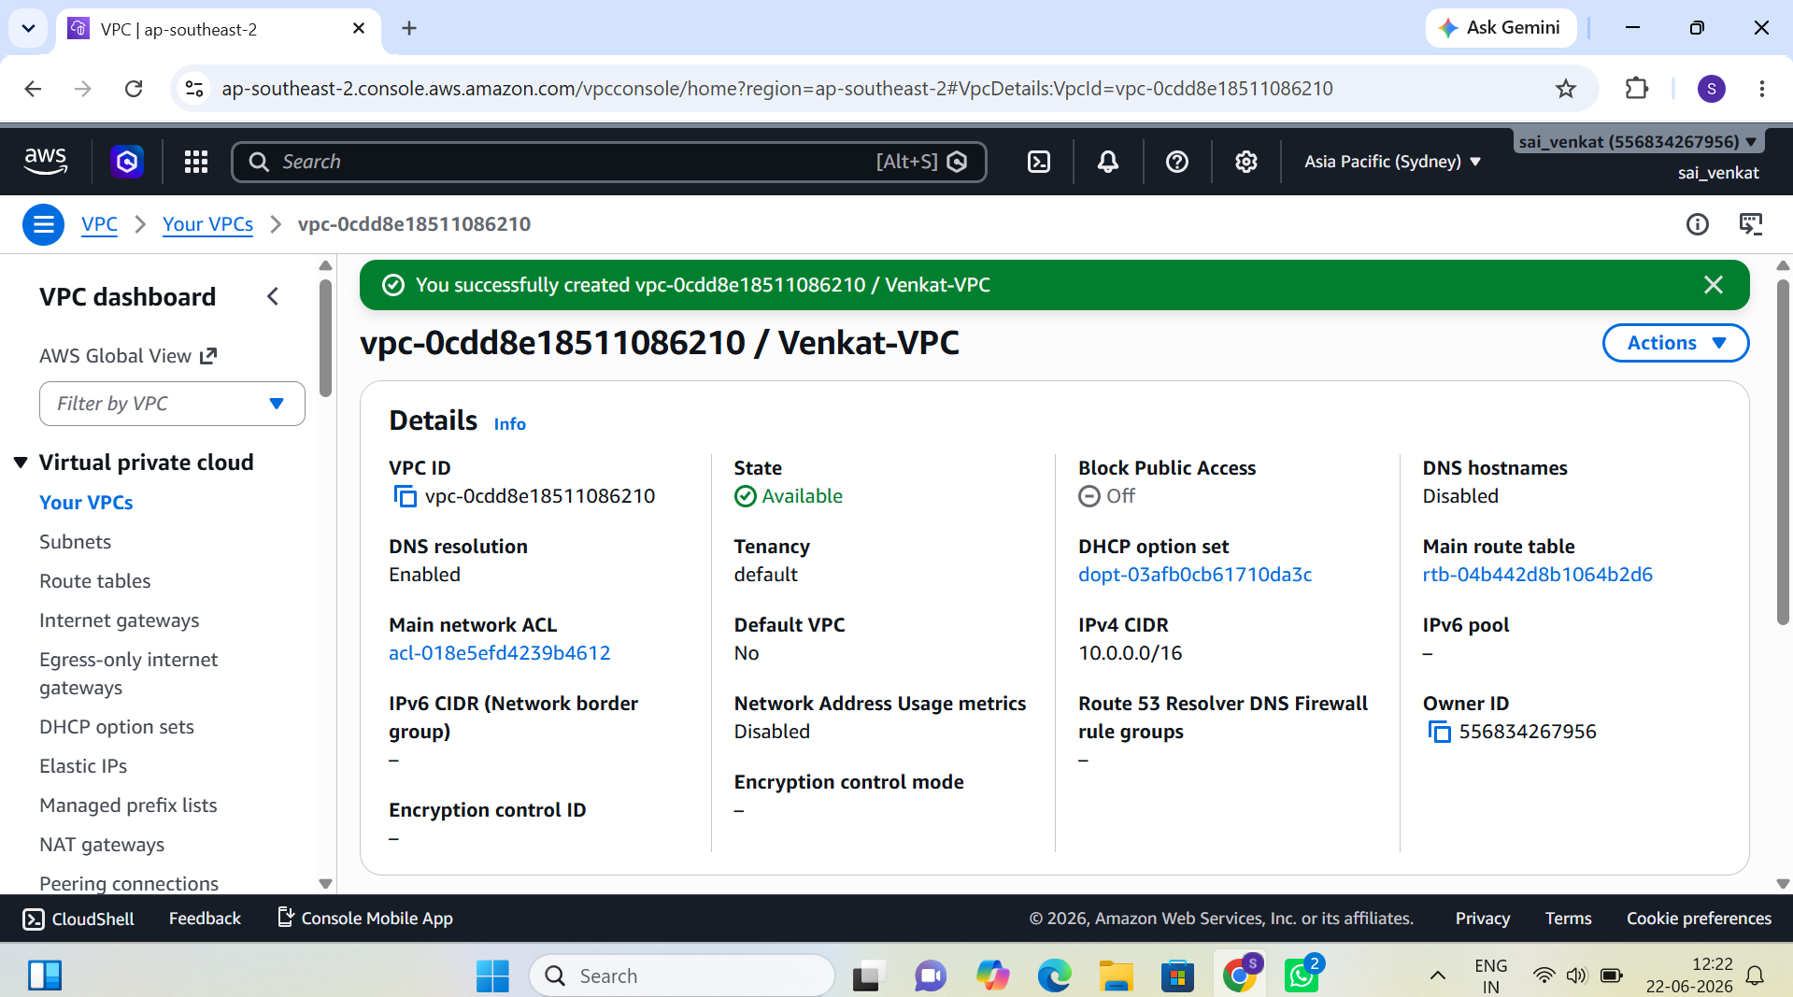
Figure 1: Venkat-VPC successfully created (vpc-0cdd8e18511086210) with CIDR 10.0.0.0/16

Task 2: Create Public and Private Subnets across AZs
Two public subnets (Public-A and Public-B) and two private subnets (Private-A and Private-B) were provisioned across separate Availability Zones within Venkat-VPC, ensuring multi-AZ high availability.

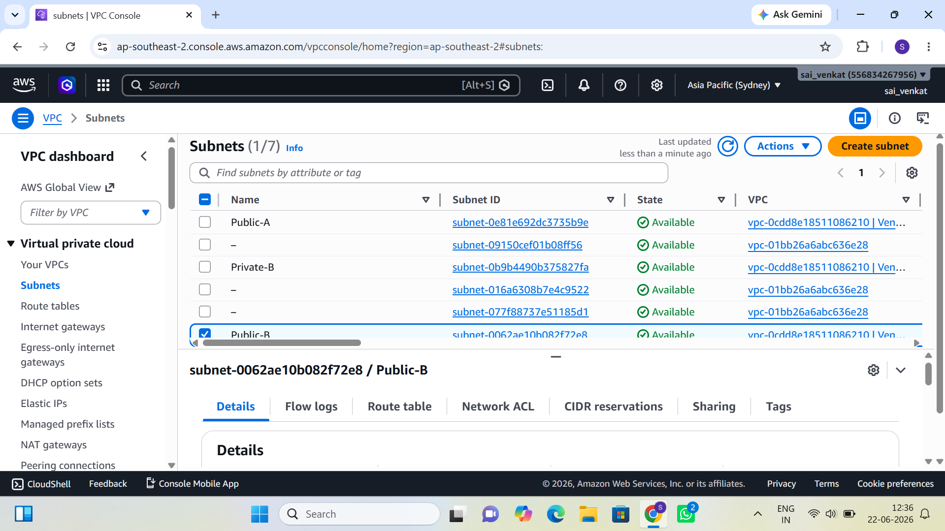
Figure 2: Subnet listing showing Public-A, Public-B, and Private-B subnets associated with Venkat-VPC

Task 3: Attach an Internet Gateway
An Internet Gateway named Venkat-IGW (igw-044432dca951d6106) was created and successfully attached to Venkat-VPC. This enables inbound and outbound internet connectivity for resources placed in public subnets.

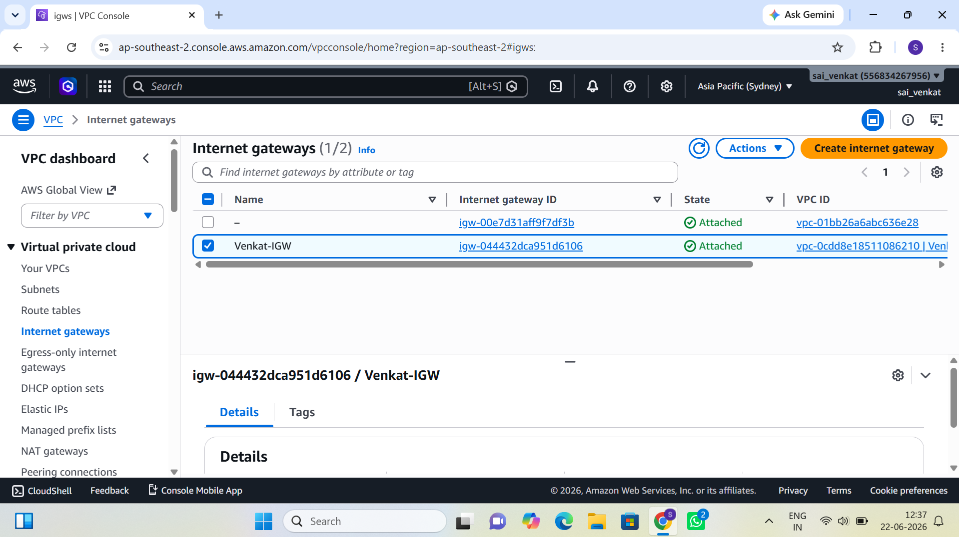
Figure 3: Venkat-IGW (igw-044432dca951d6106) attached to Venkat-VPC

Task 4: Configure Route Tables
Route tables were configured to manage traffic routing. A Public route table was created with an explicit association to the two public subnets, routing internet-bound traffic (0.0.0.0/0) through Venkat-IGW. A Private route table was created for private subnets, routing outbound traffic via the NAT Gateway.

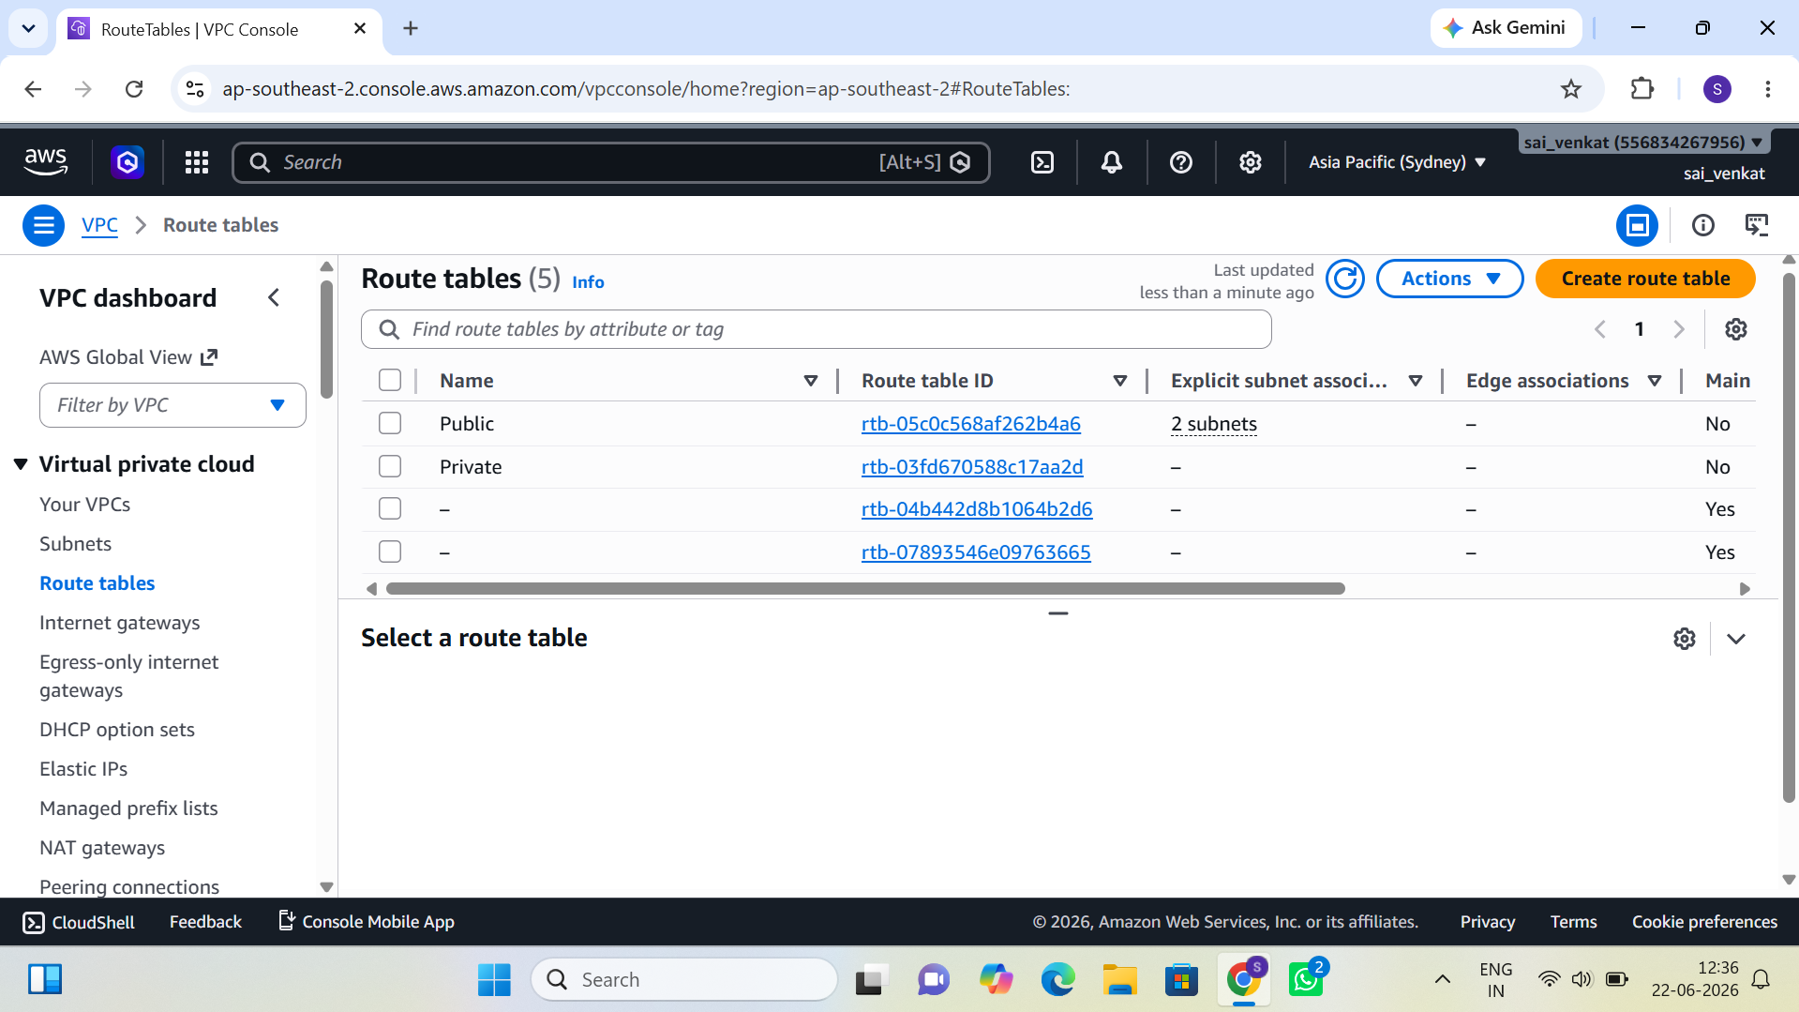
Figure 4: Route tables — Public (2 subnet associations) and Private, plus the main VPC route tables

Task 5: Allocate Elastic IPs for NAT Gateway
Three Elastic IP addresses were allocated from the AWS pool for use with the NAT Gateway and other resources. Elastic IPs provide static public IP addresses that remain associated with the account.

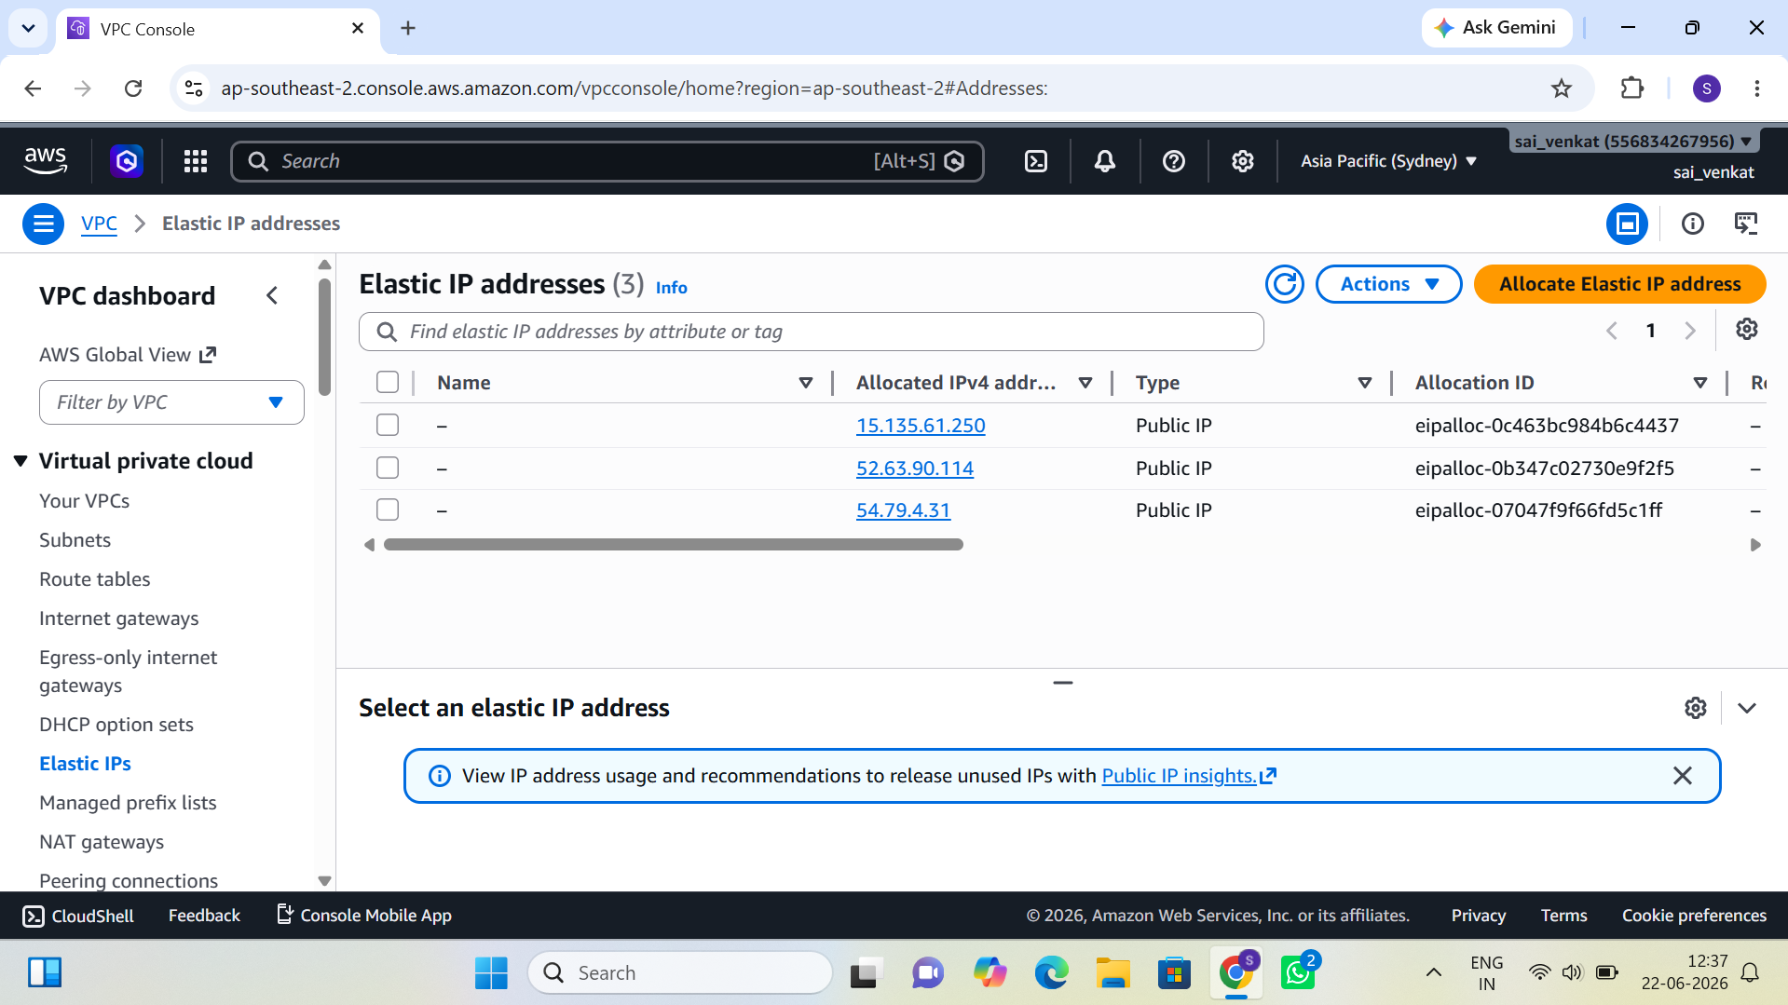
Figure 5: Elastic IP addresses (15.135.61.250, 52.63.90.114, 54.79.4.31) allocated in ap-southeast-2

Day 2 — Automated EC2 Provisioning

2.1 Reading Topics
- EC2 User Data
- Instance Metadata Service (IMDS)
- IAM Roles for EC2
- Security Group best practices

2.2 Implementation Tasks

Task 1: Create IAM Role — EC2-S3-ReadOnly
An IAM role named EC2-S3-ReadOnly was created to grant EC2 instances read-only access to Amazon S3 without embedding long-term credentials on the instances. The role ARN is arn:aws:iam::556834267956:role/EC2-S3-ReadOnly and was created on June 23, 2026 with a maximum session duration of 1 hour. One permissions policy is attached.

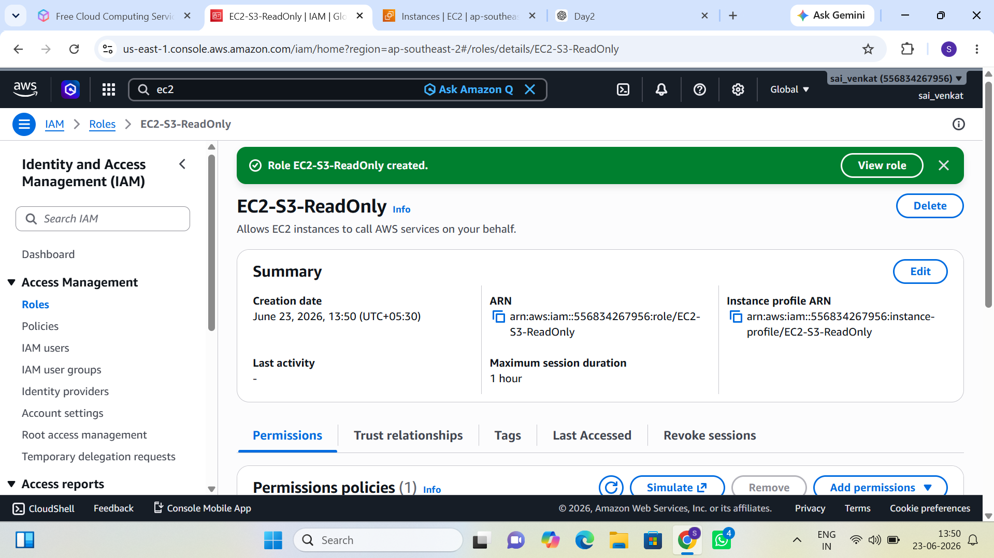
Figure 6: IAM Role EC2-S3-ReadOnly created — ARN, instance profile, and permissions policy visible

Task 2: Launch EC2 Instance with User Data
An EC2 instance named venkat (i-0a7b1c879ec0b5c5d) was launched using a User Data bootstrap script that automatically installed and started the Nginx web server. The instance runs on t3.micro with public IPv4 address 3.26.8.242 and private IP 172.31.20.122. Instance state is Running in ap-southeast-2.

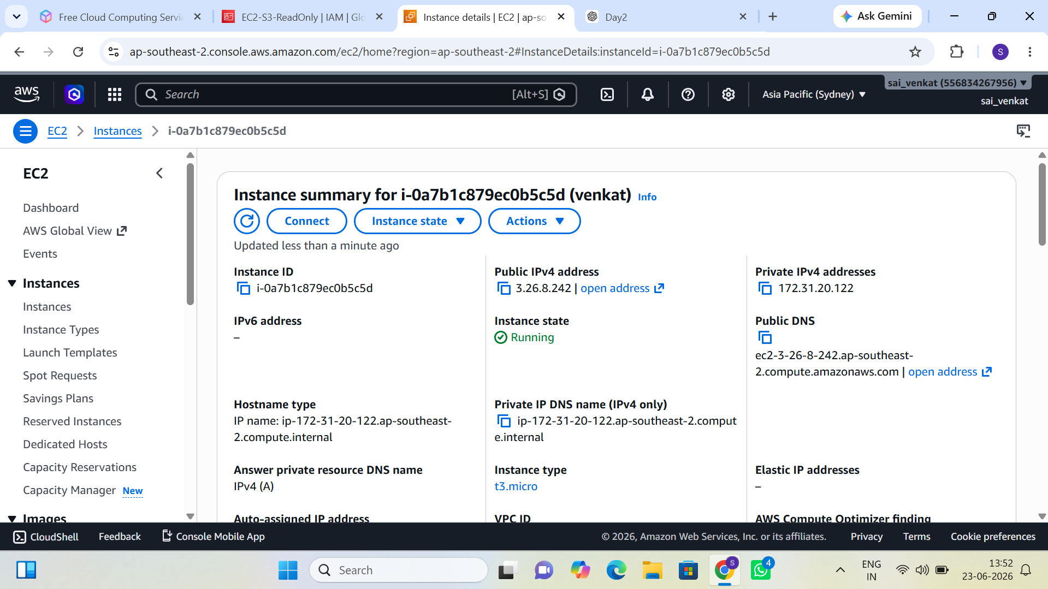
Figure 7: EC2 instance "venkat" (i-0a7b1c879ec0b5c5d) — Running, t3.micro, Public IP 3.26.8.242

Task 3: Restrict SSH and Verify Web Access
The Security Group was configured to allow SSH (port 22) only from the specific workstation public IP. HTTP (port 80) was opened to allow web browser verification. The Nginx web server was confirmed accessible at http://3.26.8.242 from a browser, validating successful User Data execution.

Day 3 — Load Balancing and Auto Scaling

3.1 Reading Topics
- Application Load Balancer (ALB)
- Target Groups
- Health Checks
- Launch Templates
- Auto Scaling Groups

3.2 Implementation Tasks

Task 1: Create a Target Group
A Target Group named WEB-target was created with the following configuration: target type Instance, protocol HTTP on port 80, protocol version HTTP1, and IPv4 address type. The target group was associated with the default VPC (vpc-01bb26a6abc636e28) pending ALB association.

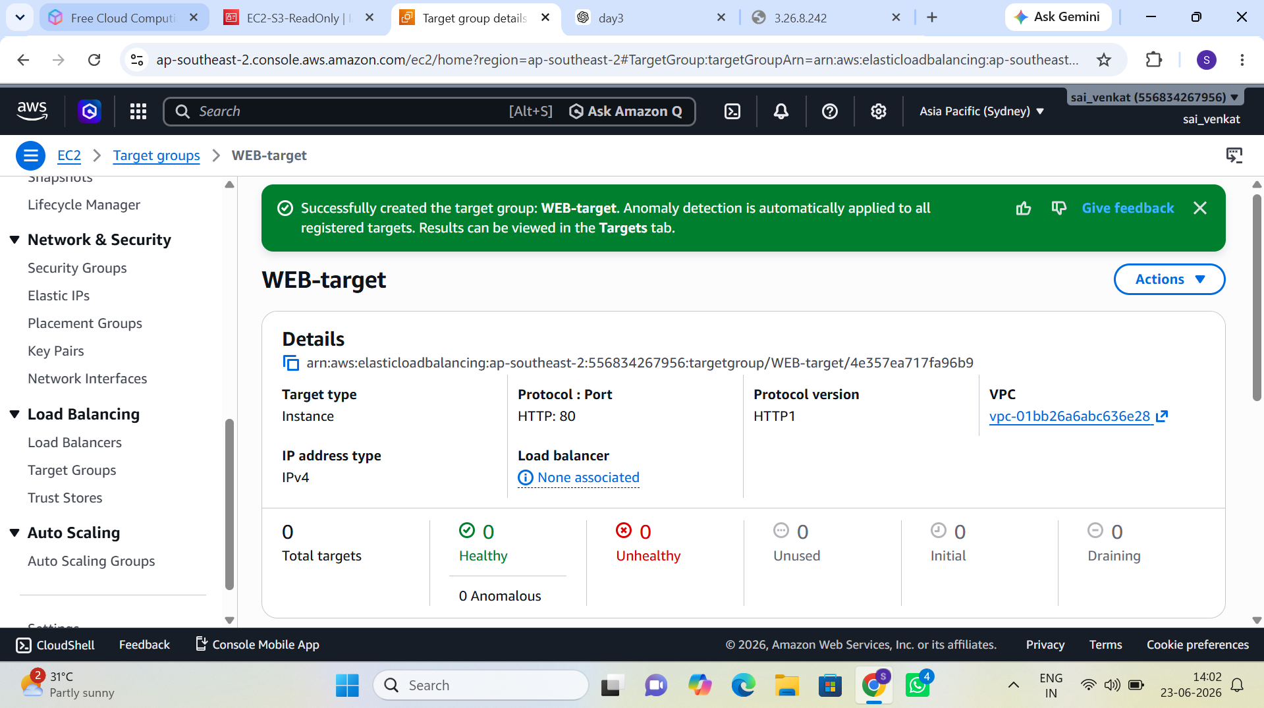
Figure 8: WEB-target Target Group successfully created — HTTP:80, Instance type, 0 registered targets

Task 2: Configure Health Checks
Health check settings were configured on the WEB-target group to monitor instance health on the /health endpoint. The configuration ensures rapid detection of unhealthy instances while tolerating brief startup delays.

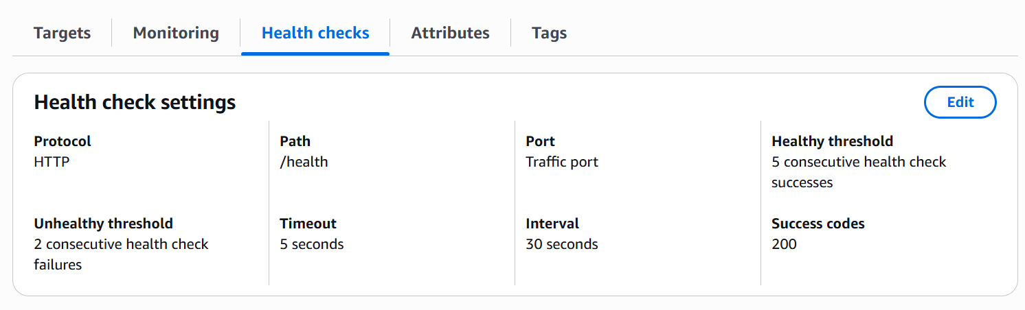
Figure 9: Health check settings — HTTP /health, 5s timeout, 30s interval, 5 healthy / 2 unhealthy threshold

Task 3: Create an Application Load Balancer
An Application Load Balancer named alb was created with internet-facing scheme and IPv4 address type. The ALB was deployed across two Availability Zones (ap-southeast-2a and ap-southeast-2b) using two public subnets for redundancy.

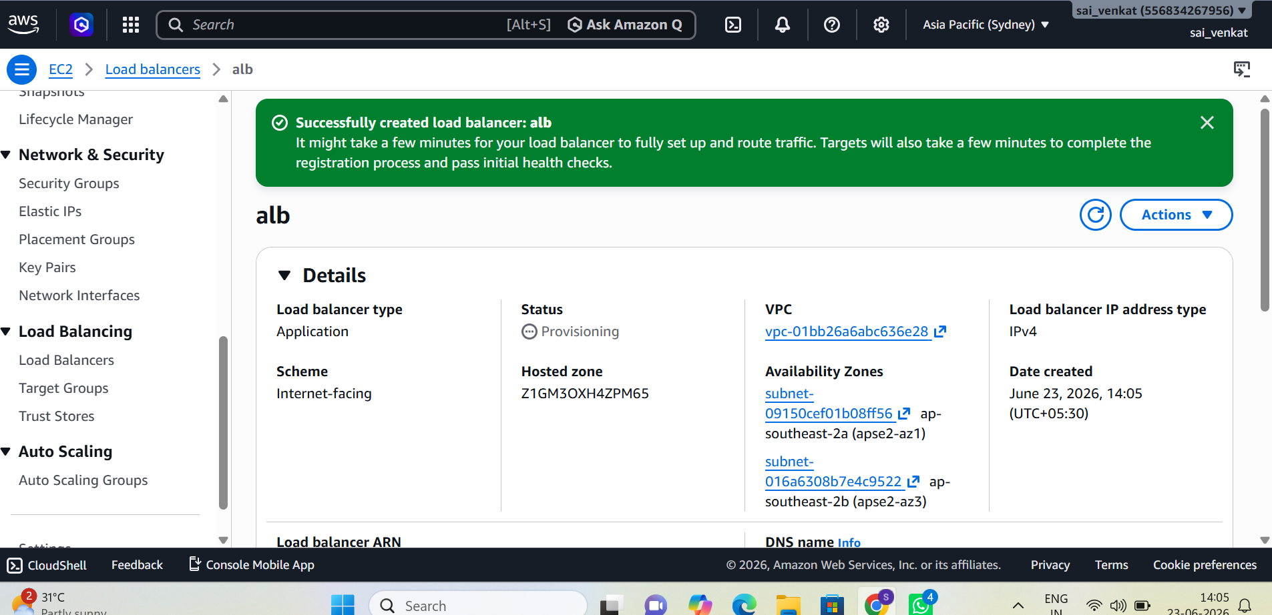
Figure 10: Application Load Balancer "alb" created — internet-facing, spanning apse2-az1 and apse2-az3

Task 4: Create a Launch Template
A Launch Template named my-template (lt-01d2c5099757085e1) was created to define the EC2 instance configuration used by the Auto Scaling Group. The template captures AMI, instance type, security groups, key pair, and User Data to ensure consistent instance launches.

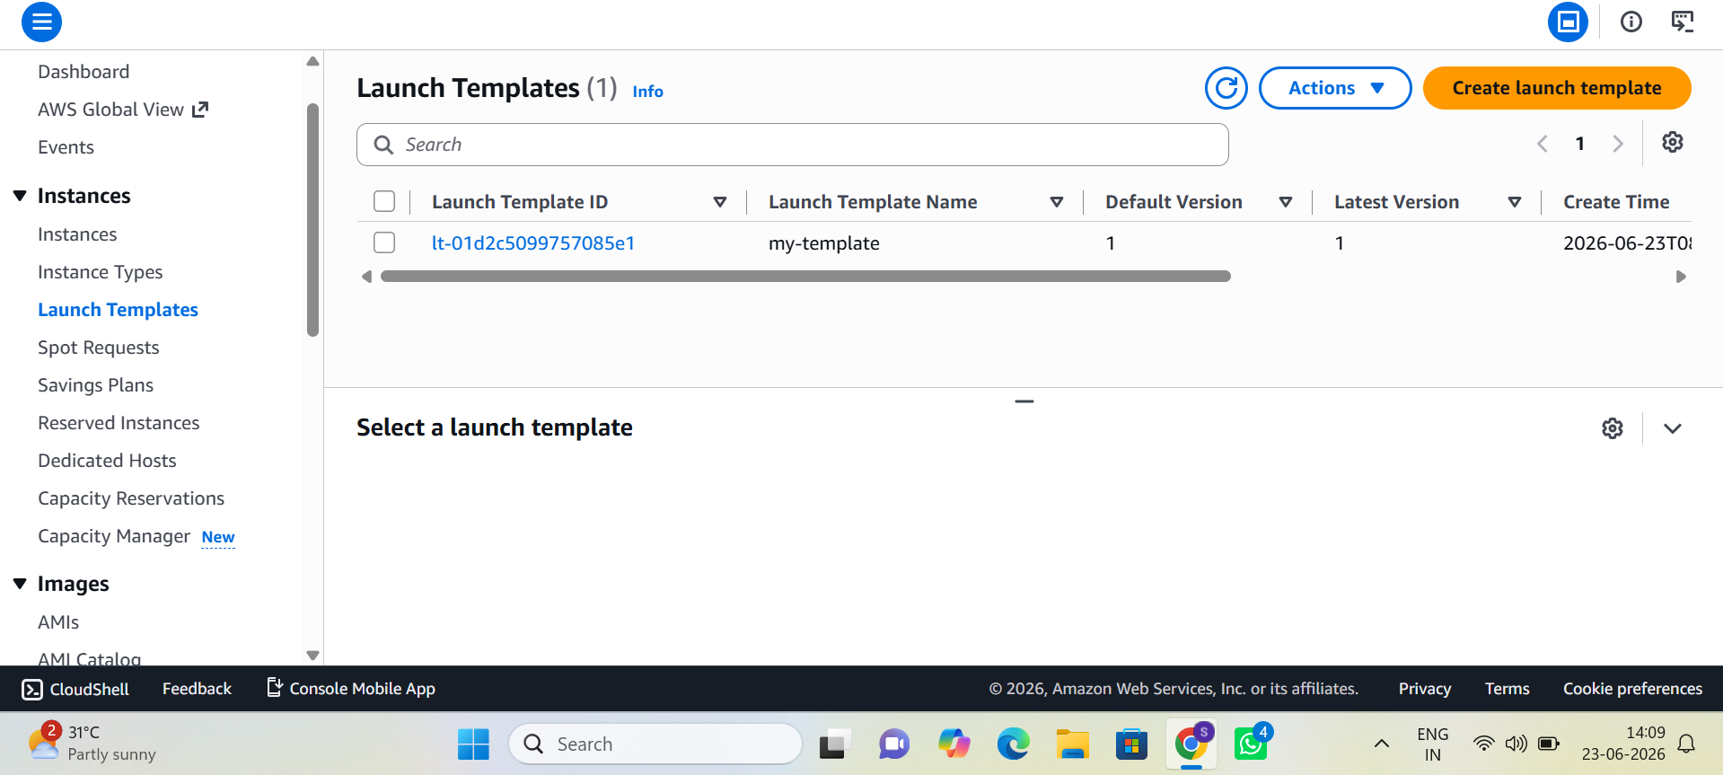
Figure 11: Launch Template "my-template" (lt-01d2c5099757085e1) — Version 1, Default Version 1

Task 5: Create an Auto Scaling Group
An Auto Scaling Group named asg was created referencing my-template (Version Default). The ASG was configured with a desired capacity of 1, spanning two Availability Zones. At creation, the ASG was in "Updating capacity" state as it launched the initial instance.

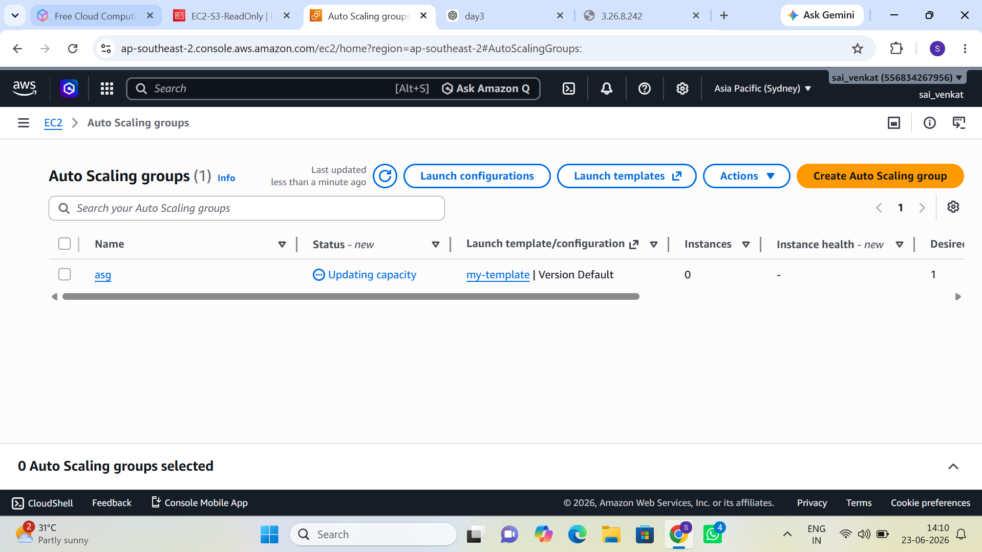
Figure 12: Auto Scaling Group "asg" — Updating capacity, 0 running instances (initial launch), Desired: 1

Day 4 — Private Connectivity

4.1 Reading Topics
- Bastion Hosts
- AWS Systems Manager Session Manager
- SSH Agent Forwarding

4.2 Implementation Tasks
The following tasks were completed during Day 4:
- Deployed a Bastion Host EC2 instance in a public subnet with a public IP.
- Launched a target EC2 instance in a private subnet with no direct internet access.
- Configured Security Groups: the private instance SG allows SSH (port 22) only from the Bastion Host Security Group.
- Successfully connected to the private instance by first SSH-ing to the Bastion Host, then forwarding the connection.
- Repeated the private instance connection using AWS Systems Manager Session Manager, eliminating the need to open port 22.

Session Manager provides secure, auditable shell access without requiring SSH keys or open inbound ports, significantly improving the security posture of private resources.

Day 5 — Advanced Storage

5.1 Reading Topics
- EBS volume types (gp2, gp3, io1, sc1, st1)
- EBS snapshots and cross-region restore
- S3 Versioning
- S3 Lifecycle Policies
- S3 Storage Classes

5.2 Implementation Tasks

Task 1: Create and Attach an Additional EBS Volume
A new gp3 EBS volume (vol-0fca728793dfe41e0, 7 GiB) was created and attached to the running EC2 instance. The volume is In-use with 3000 IOPS and 125 MB/s throughput. Two additional volumes are also visible: a 5 GiB and an 8 GiB gp3 volume used for testing.

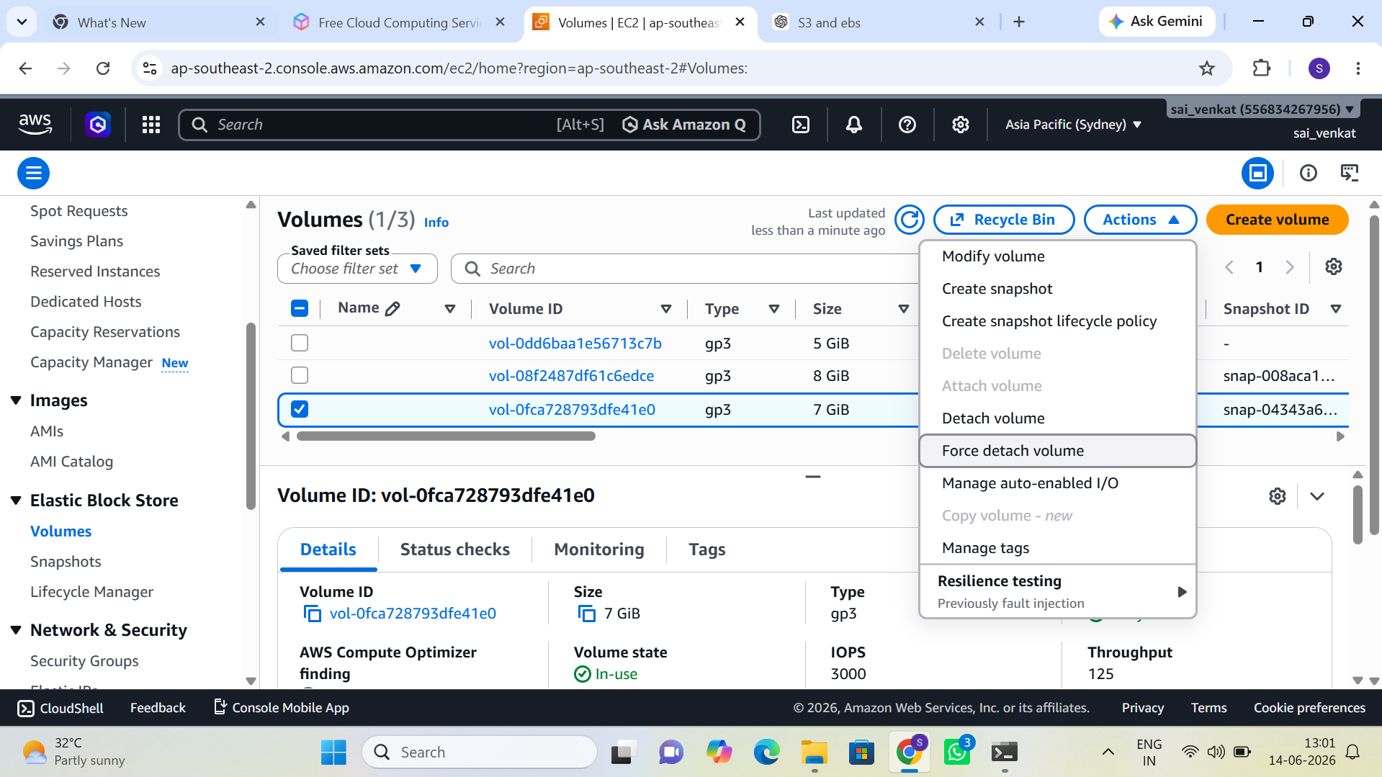
Figure 13: EBS Volumes — three gp3 volumes including 7 GiB vol-0fca728793dfe41e0 (In-use), with volume actions menu open

Task 2: Format, Mount, and Persist the Volume
The attached volume was formatted using mkfs.ext4, mounted to the /data directory, and the mount entry was added to /etc/fstab to ensure persistence across reboots. Verification with df -h confirmed the volume was mounted and accessible.

Task 3: Create an EBS Snapshot
An EBS snapshot (snap-04343a6f20fddb691) was successfully created from the attached volume. The snapshot reached 100% progress and Completed status. The snapshot was taken on June 14, 2026 at 12:58:16 UTC. The Actions menu shows options including "Create volume from snapshot" for restore operations.

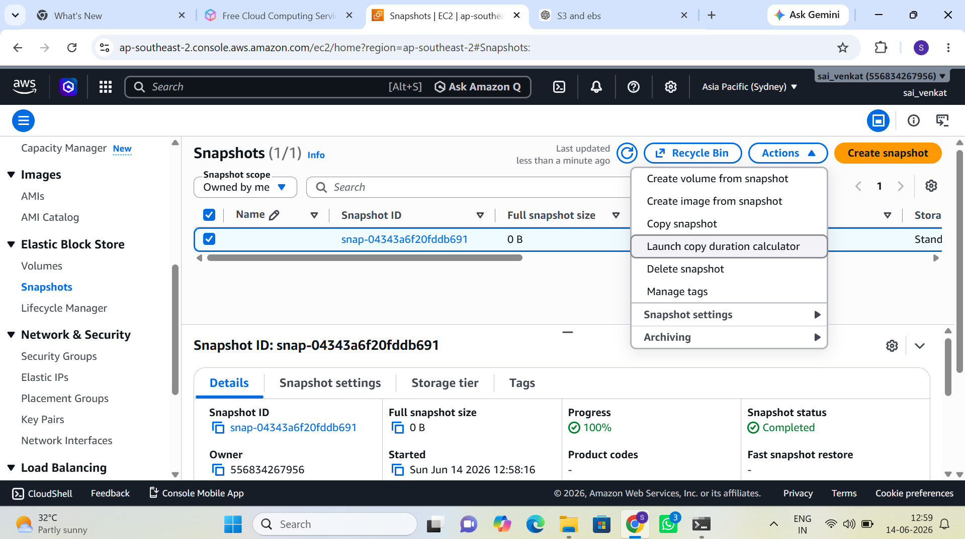
Figure 14: EBS Snapshot snap-04343a6f20fddb691 — 100% Completed, with Actions menu showing restore options

Task 4: S3 Static Website Hosting
An S3 bucket named sai-venkat was configured for static website hosting. S3 static website hosting was enabled with hosting type "Bucket hosting". The bucket website endpoint is http://sai-venkat.s3-website-ap-southeast-2.amazonaws.com, making the portfolio website publicly accessible.

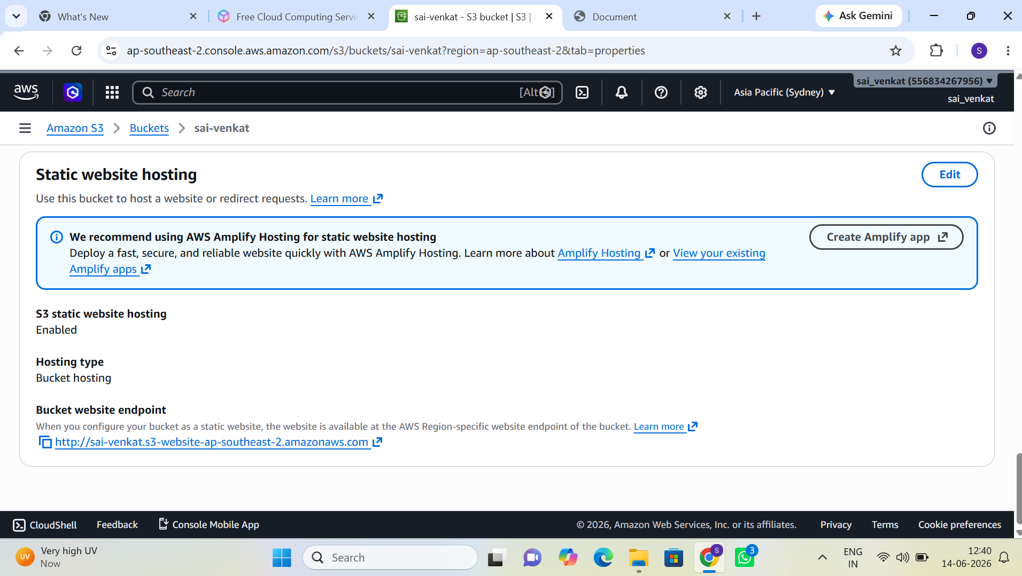
Figure 15: S3 bucket "sai-venkat" — Static website hosting enabled, bucket endpoint configured

Task 5: Portfolio Website Deployed
A personal portfolio website was deployed to the S3 static website. The site is accessible at the bucket endpoint and displays the portfolio homepage with navigation links (Home, About, Skills, Projects, Contact) and identifies Sai Venkat as a Machine Learning Engineer.

Task 6: S3 Versioning and Lifecycle Policy
S3 versioning was enabled on the bucket to maintain multiple file versions. Multiple versions of a test file were uploaded, and a previous version was successfully restored via the console. A Lifecycle rule was configured to transition objects to S3 Standard-IA after 30 days and to S3 Glacier after 90 days.

Day 6 — Monitoring and Private AWS Access

6.1 Reading Topics
- VPC Endpoints (Gateway and Interface types)
- CloudWatch Metrics
- CloudWatch Logs and Log Groups
- VPC Flow Logs

6.2 Implementation Tasks

Task 1: Create a VPC Gateway Endpoint for S3
A Gateway VPC Endpoint named ep (vpce-0270afb4c96108c73) was created for the com.amazonaws.ap-southeast-2.s3 service. The endpoint status is Available, allowing private EC2 instances in Venkat-VPC to access S3 without routing traffic through the NAT Gateway or public internet.

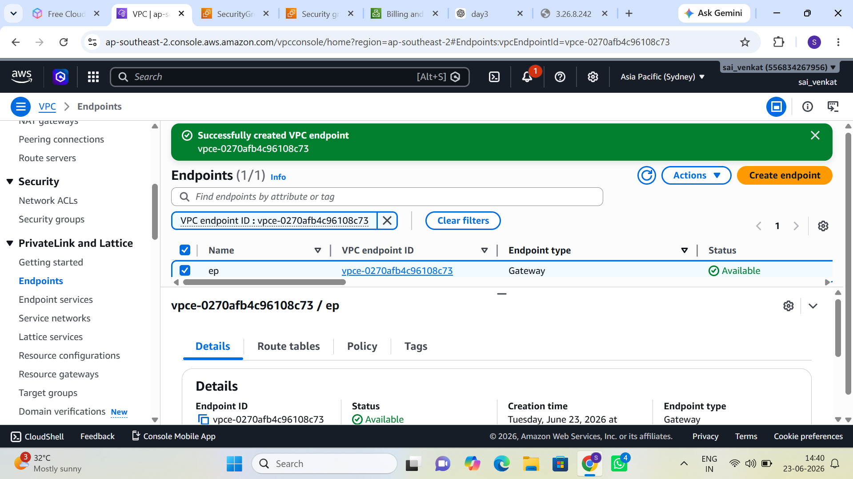
Figure 16: VPC Gateway Endpoint "ep" (vpce-0270afb4c96108c73) — Available, Gateway type for S3

Task 2: Enable VPC Flow Logs
VPC Flow Logs were enabled on the default VPC (vpc-01bb26a6abc636e28), capturing all traffic (Traffic Type: All) and delivering logs to a CloudWatch Logs destination named vpc. The flow log fl-0f7363dd522cccba9 is in Active state with a 10-minute max aggregation interval.

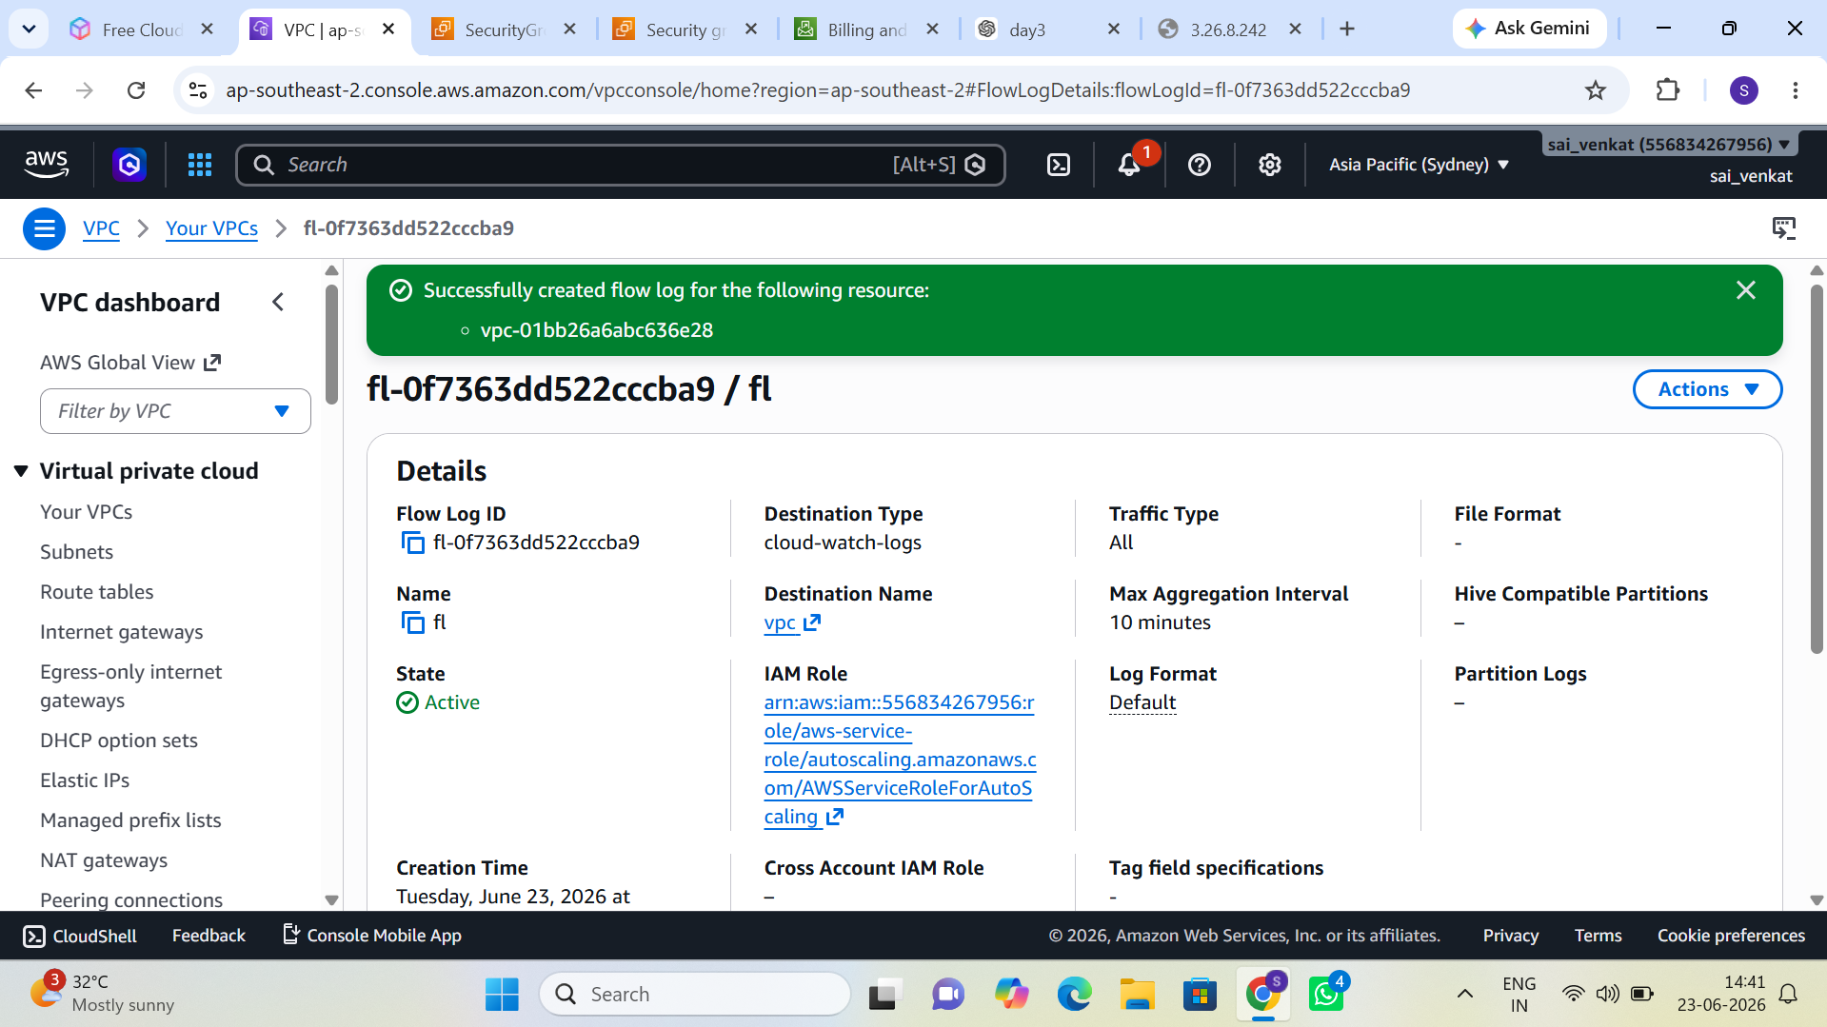
Figure 17: VPC Flow Log "fl" (fl-0f7363dd522cccba9) — Active, capturing all traffic to CloudWatch Logs

Task 3: CloudWatch Agent Configuration
The CloudWatch Unified Agent was installed and configured on EC2 instances to collect the following custom metrics beyond the default EC2 metrics:
- CPU utilization per core
- Memory utilization (mem_used_percent)
- Disk utilization (disk_used_percent) for the root and /data volumes
Log files from Nginx (/var/log/nginx/access.log and error.log) were also streamed to CloudWatch Logs for centralized monitoring.

Day 7 — Architecture Documentation

7.1 Reading Topics
- AWS Well-Architected Framework (WAF)
- Reliability Pillar
- Security Pillar
- Cost Optimization Pillar

7.2 Architecture Components
The final production-style architecture diagram encompasses the following components:
- VPC (Venkat-VPC) — 10.0.0.0/16, ap-southeast-2
- Public Subnets — Public-A (AZ-a) and Public-B (AZ-b)
- Private Subnets — Private-A (AZ-a) and Private-B (AZ-b)
- Internet Gateway — Venkat-IGW, attached to Venkat-VPC
- NAT Gateway — deployed in Public-A subnet with Elastic IP
- Application Load Balancer — internet-facing, spanning both public subnets
- Auto Scaling Group — 1–4 instances across both AZs using my-template
- EC2 Instances — Nginx web servers launched via ASG in private subnets
- S3 Bucket (sai-venkat) — static website hosting + versioning + lifecycle policy
- EBS Volumes — gp3, formatted and mounted to /data, with snapshots
- VPC Endpoint — Gateway endpoint for private S3 access
- CloudWatch — metrics, logs, and dashboards for monitoring

7.3 Traffic Flow Description

Inbound Traffic
External user requests reach the internet-facing Application Load Balancer via the Internet Gateway. The ALB evaluates listener rules and forwards HTTP traffic on port 80 to registered targets in the WEB-target Target Group. Health checks on /health ensure only healthy instances receive traffic.

Outbound Traffic from Private Subnets
EC2 instances in private subnets do not have public IPs. Outbound internet traffic (software updates, API calls) is routed to the NAT Gateway in the public subnet, which translates the source address to its Elastic IP before forwarding to the internet.

Private S3 Access
S3 API calls from private instances are routed through the Gateway VPC Endpoint, bypassing the NAT Gateway entirely. This reduces data transfer costs and keeps S3 traffic within the AWS network backbone.

7.4 Security Controls
- Public subnets: Security Groups allow HTTP (80) and HTTPS (443) from 0.0.0.0/0; SSH (22) restricted to known IP only.
- Private subnets: Security Groups allow HTTP traffic only from the ALB Security Group; SSH only from the Bastion Host Security Group.
- Network ACLs: stateless rules at subnet boundary provide an additional layer of traffic filtering.
- IAM Roles: EC2 instances carry EC2-S3-ReadOnly role; no long-term credentials are stored on instances.
- VPC Flow Logs: all accepted and rejected traffic is logged to CloudWatch for audit and forensic purposes.
- Session Manager: administrative access to private instances requires no open SSH port, reducing attack surface.

7.5 Scaling Behavior
The Auto Scaling Group monitors ALB request count per target and average CPU utilization. When either metric exceeds the configured threshold:
- ASG launches a new instance using my-template (includes User Data to install and start Nginx automatically).
- The new instance registers with the WEB-target Target Group.
- The ALB health check verifies the instance on /health before routing live traffic.
- At scale-in, ASG drains connections from the instance before termination (connection draining).

Minimum capacity is set to 1 (to maintain availability), desired to 2, and maximum to 4 (to cap costs). This configuration survives a single AZ failure while remaining within budget constraints.

Observations and Key Learnings

- Multi-AZ VPC design is the foundational pattern for high-availability AWS architectures; the cost of NAT Gateways per AZ must be balanced against resiliency requirements.
- IAM Roles attached to EC2 instances eliminate the need for embedded credentials; the EC2-S3-ReadOnly role exemplifies least-privilege access.
- Application Load Balancers decouple the scaling layer from clients, enabling seamless instance replacement without user-visible downtime.
- S3 static website hosting provides a cost-effective way to serve portfolio and static content globally without managing web servers.
- EBS snapshots enable point-in-time recovery; the snap-04343a6f20fddb691 snapshot completed at 100% and can be used to restore or clone volumes.
- Gateway VPC Endpoints for S3 provide free private connectivity and eliminate NAT Gateway data processing fees for S3-heavy workloads.
- VPC Flow Logs combined with CloudWatch Logs Insights enable rapid root-cause analysis of connectivity issues without requiring packet capture tools on instances.
- Session Manager eliminates the operational overhead of maintaining bastion hosts and rotating SSH keys while providing a full audit trail in AWS CloudTrail.

All configurations performed in AWS Account 556834267956 | Region: ap-southeast-2 | June 2026

