WEEK 6 - INTERNSHIP TECHNICAL REPORT
Mini End-to-End App Deployment
Deploying a Two-Tier Application via EC2, GitHub Actions, and Kubernetes

Prepared by: Kankipati Sai Venkat
Program: PGSN Internship
Report Date: 18 July 2026

Table of Contents
Project Overview 3
Day 1 - Build and Containerize the Application 4
Day 2 - Deploy on AWS with Terraform 5
Day 3 - Automate with GitHub Actions 8
Day 4 - Redeploy the Same App on Kubernetes 9
Day 5 - Documentation and Demo 10
Conclusion 11

Project Overview
Goal: Take a simple two-tier application (web frontend and database) and deploy it three different ways, using techniques already covered in prior weeks - no new concepts, just combining and applying existing skills.
This report documents a five-day mini project that progressively deploys the same containerized application using three deployment paths: a manually provisioned AWS EC2 instance, an automated GitHub Actions CI/CD pipeline, and a local Kubernetes cluster (Minikube/Kind). Each day builds on the previous day's output, culminating in a side-by-side comparison of the EC2 and Kubernetes deployment models.
Project Timeline
- Day 1 - Build and containerize the application
- Day 2 - Deploy on AWS using Terraform
- Day 3 - Automate the build with GitHub Actions
- Day 4 - Redeploy the same application on Kubernetes
- Day 5 - Documentation and demo

Day 1 - Build and Containerize the Application

Recap
Docker basics and Dockerfile fundamentals, as covered in the prior track sessions.

Implementation
- Selected a simple sample application - a static "Hello from PGSN Intern" page - to keep the focus on the deployment pipeline rather than application complexity.
- Wrote a Dockerfile to containerize the application.
- Built the Docker image and ran it locally to confirm it served correctly.
- Pushed the built image to Docker Hub, following the same process used in Week 3, Day 3.

Verification
The containerized application was run locally and accessed at localhost:3000, confirming the container served the expected page before being pushed to Docker Hub.
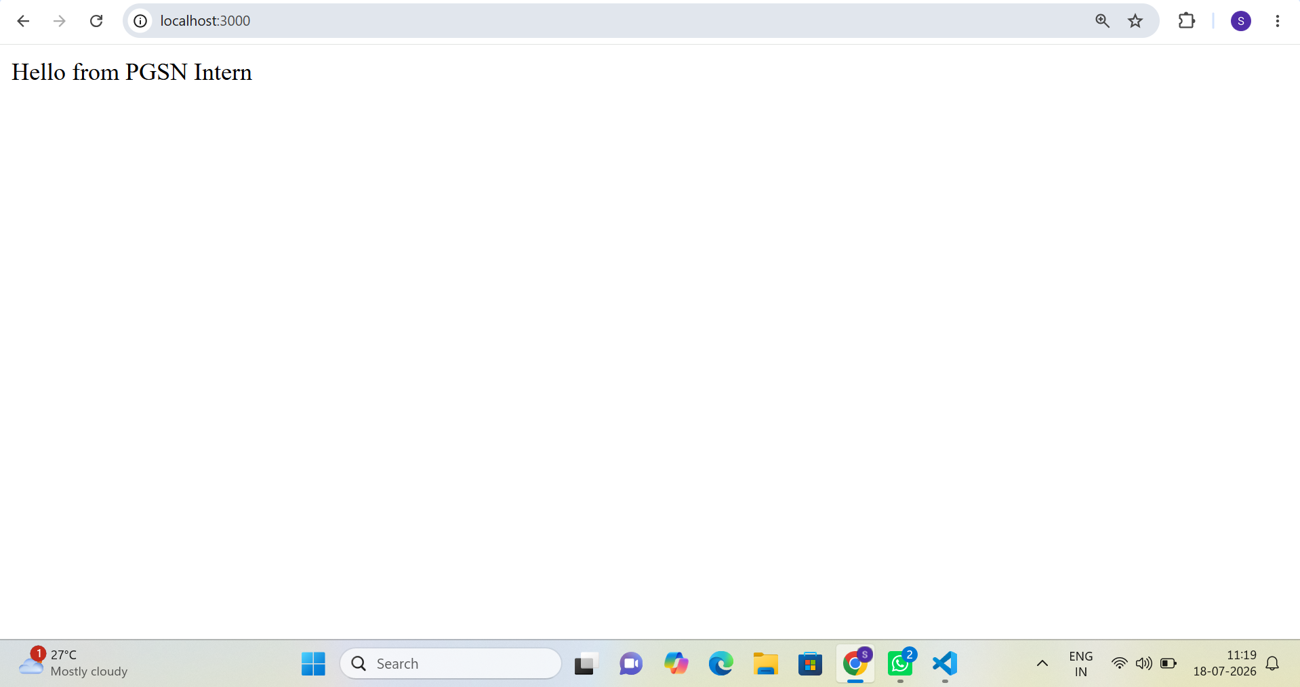
Figure 1: Containerized application running locally at localhost:3000

Day 2 - Deploy on AWS with Terraform

Recap
Terraform resources and variables, as covered in the prior track sessions.

Implementation
- Reused the Week 3 Terraform configuration to launch a single EC2 instance in a public subnet.
- Configured User Data to automatically install Docker and pull the application image from Docker Hub on instance boot.
- Defined a Terraform output to expose the EC2 instance's public IP address.
- Verified the application was reachable from a browser using the public IP.

Terraform Initialization
The Terraform working directory was initialized, downloading the required AWS provider and setting up the backend.
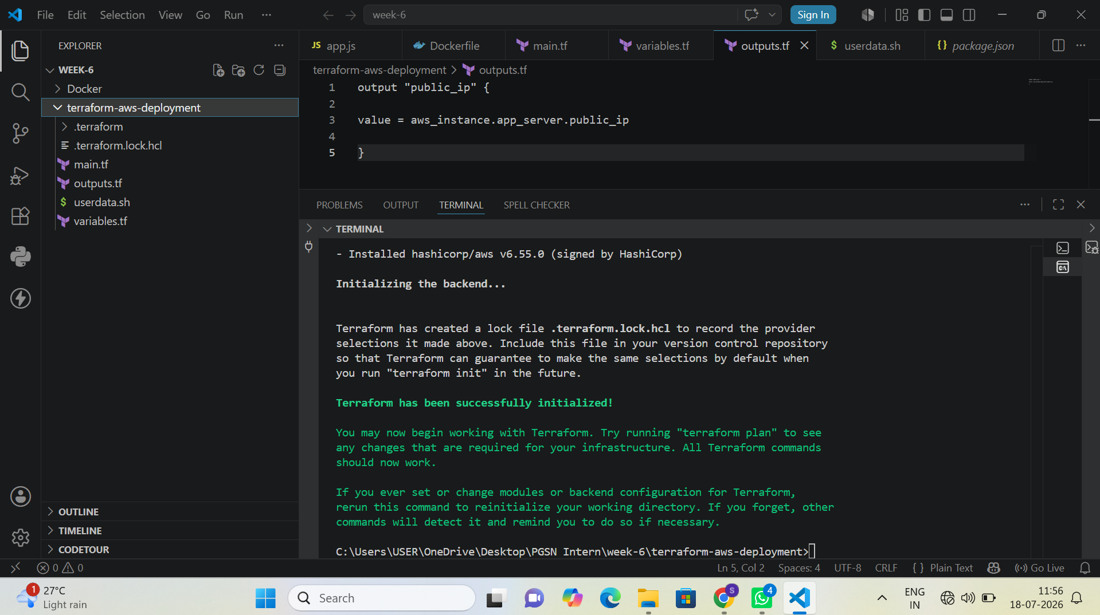
Figure 2: Terraform initialization output (terraform init)

Terraform Plan
A Terraform plan was generated to preview the infrastructure changes prior to applying them - seven resources were scheduled to be created, including the VPC, subnet, security group, and EC2 instance.
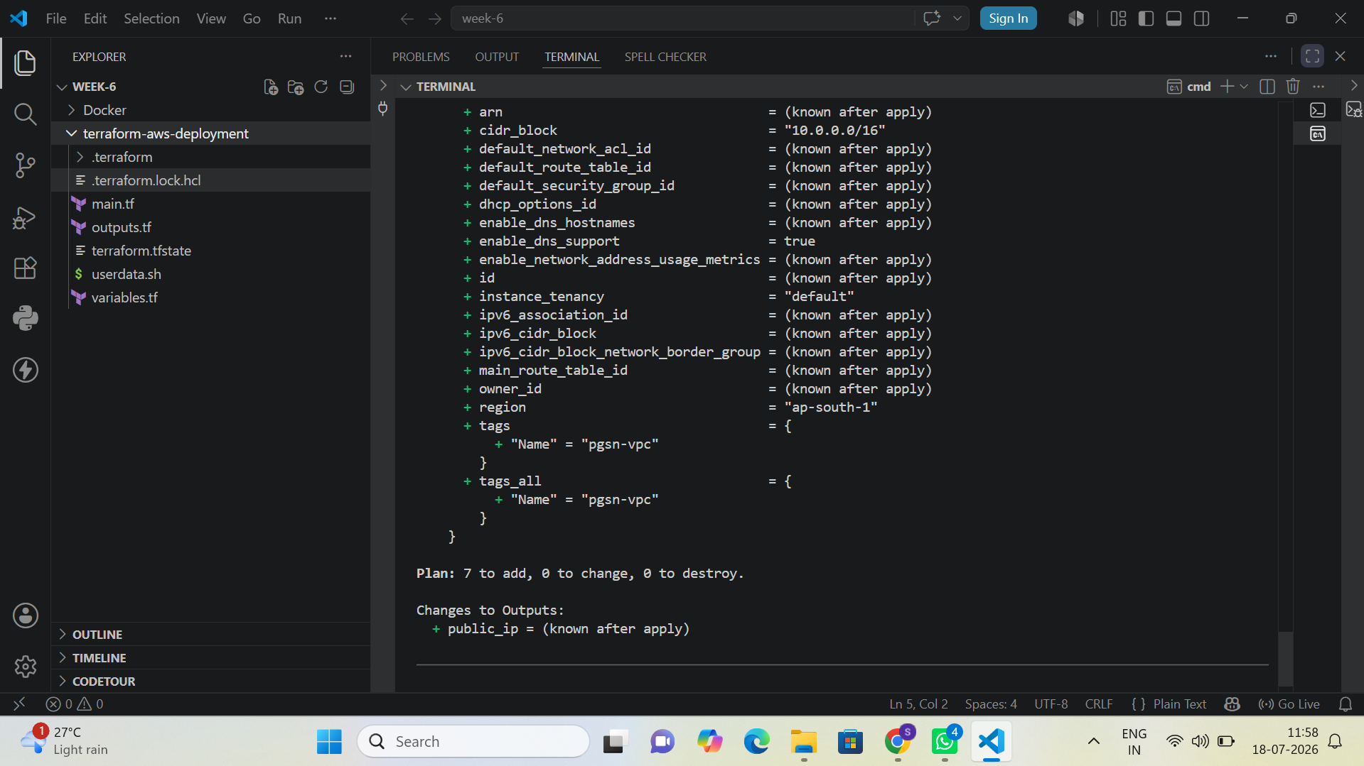
Figure 3: Terraform plan output showing resources to be added

Terraform Apply
The plan was applied, provisioning the VPC, internet gateway, subnet, route table, security group, and EC2 instance. Terraform completed with seven resources added and output the instance's public IP address.
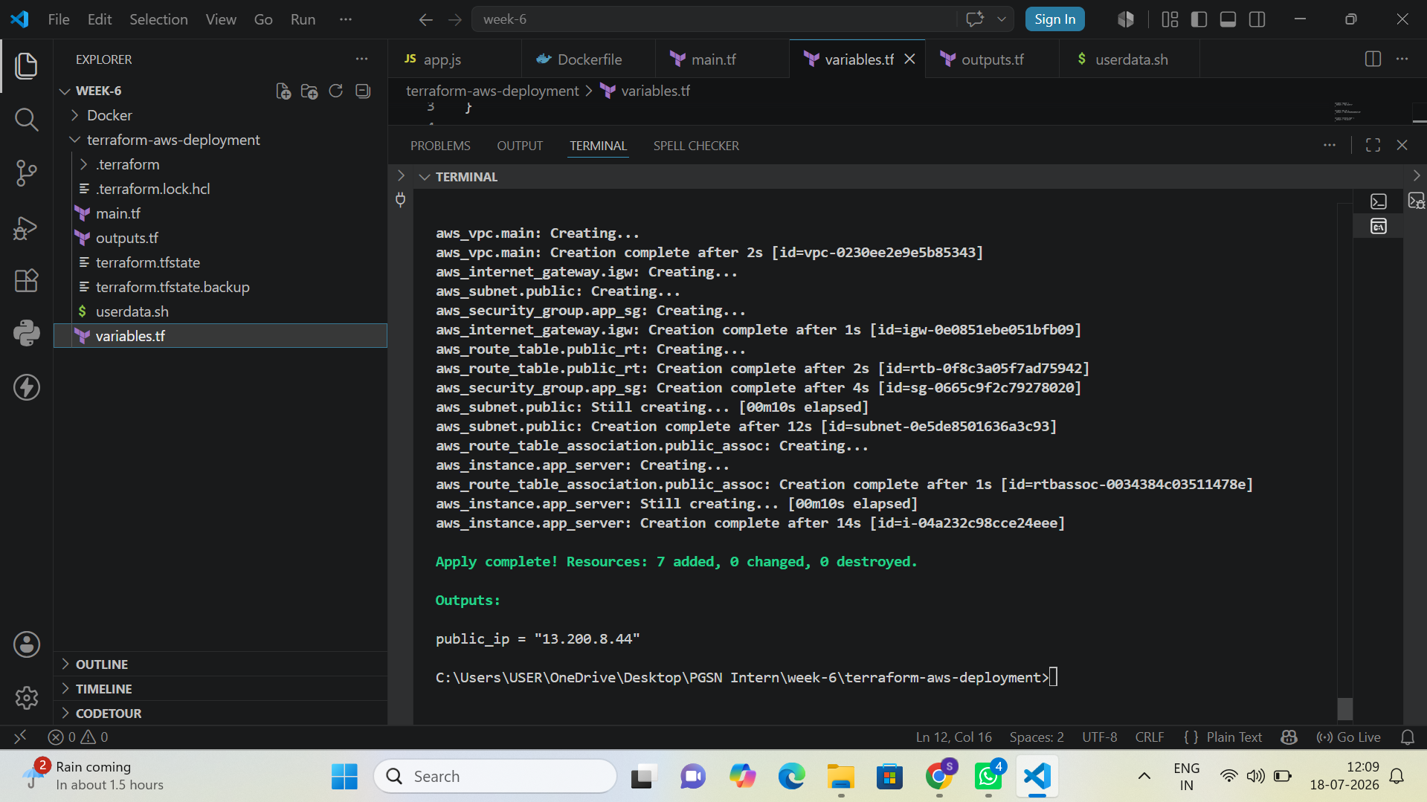
Figure 4: Terraform apply output confirming successful resource creation and public IP

Application Verification on EC2
With the infrastructure provisioned and Docker installed via User Data, the application was confirmed reachable in a browser using the EC2 instance's public IP address.
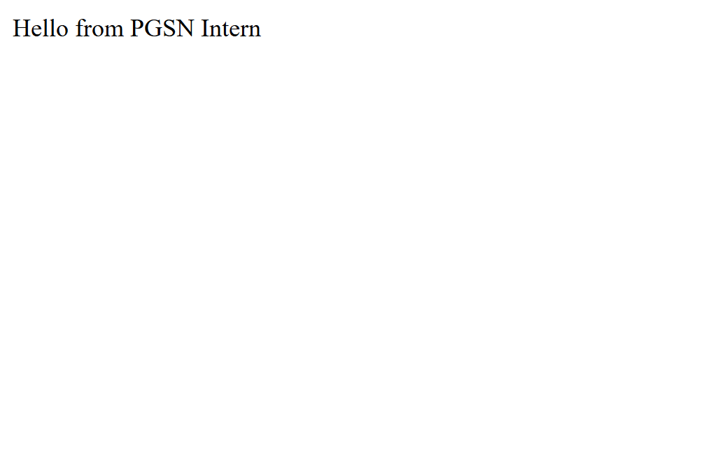
Figure 5: Application verified reachable via the EC2 instance public IP

Day 3 - Automate with GitHub Actions

Recap
GitHub Actions workflow files, as covered in the prior track sessions.

Implementation
- Created a GitHub Actions workflow that builds the Docker image on every push and pushes it to Docker Hub automatically.
- Demonstrated a manual redeploy on the EC2 instance by pulling the latest image and restarting the container - the flow was validated manually rather than fully automated.

Workflow Run
The build-test workflow executed successfully, completing all jobs - checkout, dependency installation, tests, Docker image build, Docker Hub login, and image push - in under a minute.
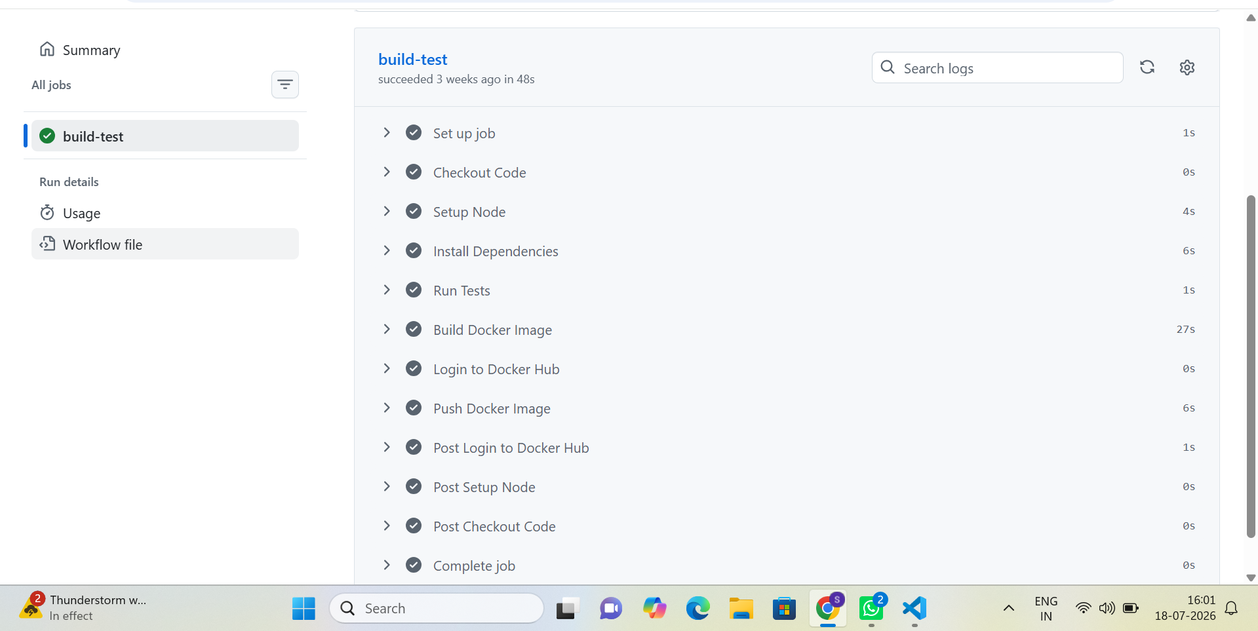
Figure 6: GitHub Actions workflow (build-test) completed successfully

Day 4 - Redeploy the Same App on Kubernetes

Recap
Kubernetes Deployments and Services, as covered in the prior track sessions.

Implementation
- Used Minikube/Kind (local Kubernetes track) to create a Deployment with two replicas of the same Docker image used on Day 1 and Day 2.
- Exposed the Deployment using a NodePort Service, making it reachable outside the cluster.
- Compared the same application running on plain EC2 versus running on Kubernetes.

EC2 vs. Kubernetes: Comparison
The table below summarizes the key differences observed between running the application directly on an EC2 instance and running it as a Kubernetes Deployment.

Key takeaway: On EC2, the operator is the orchestrator - every replica, restart, and traffic-routing decision is manual or scripted by hand. On Kubernetes, the desired state (two replicas, exposed via NodePort, with health checks) is declared, and the control plane continuously works to keep the actual state matching it. The same Docker image runs in both cases; what changes is who is responsible for keeping it running, healthy, and reachable.

Day 5 - Documentation and Demo

Planned Deliverables
- A simple architecture diagram showing both deployment paths (EC2 route and Kubernetes route).
- Short demo / screenshots showing the application running both ways.
- A five-minute walkthrough presentation, matching the final seminar presentation format used in Hackathon 1.

Overall Deliverables Status

Conclusion
Across the five days of this mini project, the same containerized application was deployed and validated through three complementary paths: a manually provisioned EC2 instance configured via Terraform, an automated CI/CD pipeline using GitHub Actions, and a self-healing, horizontally scaled deployment on Kubernetes. Each stage reused concepts already introduced in prior weeks - Docker, Terraform, GitHub Actions, and Kubernetes - demonstrating how these tools combine into a coherent end-to-end deployment workflow, and highlighting the operational trade-offs between a single-VM deployment and a container-orchestrated one.

