Assignment 2

Sai Venkat Rayavarapu ID: 16336228

a) set a seed (to ensure work reproducibility) and take a random sample of 25 observations and find the mean Glucose and highest Glucose values of this sample and compare these statistics with the population statistics of the same variable. You should use charts for this comparison.

Mean value comparision

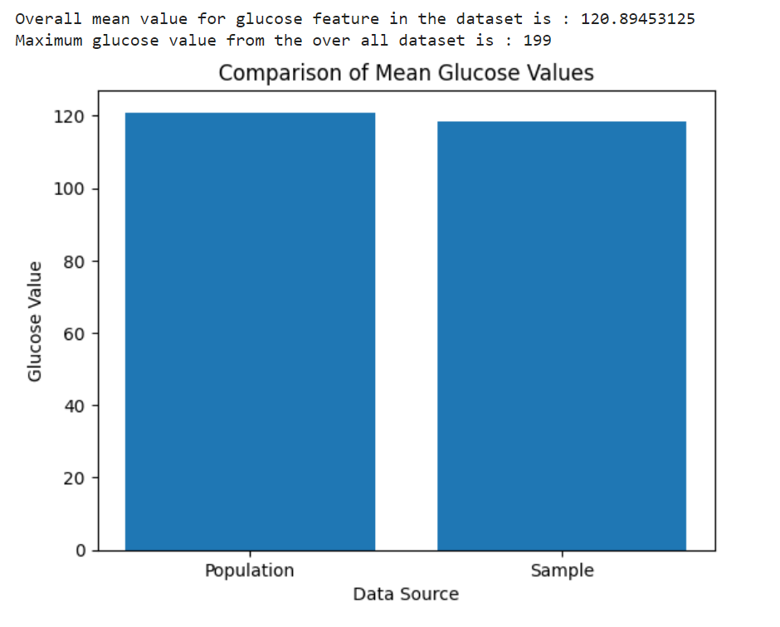

Highest Value comparision

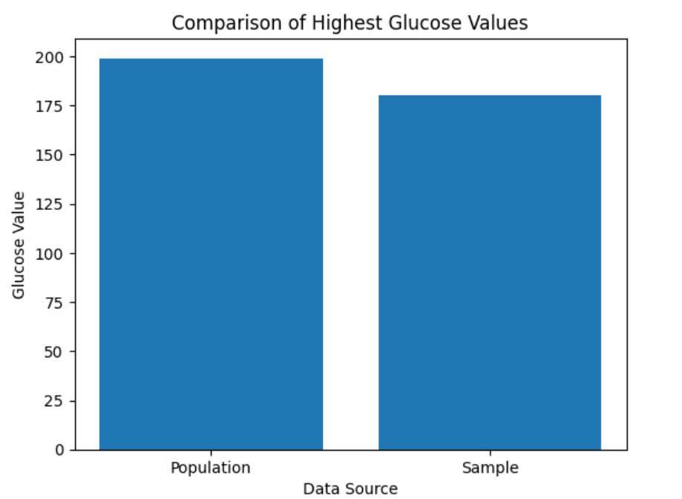

b) Find the 98th percentile of BMI of your sample and the population and compare the results using charts.

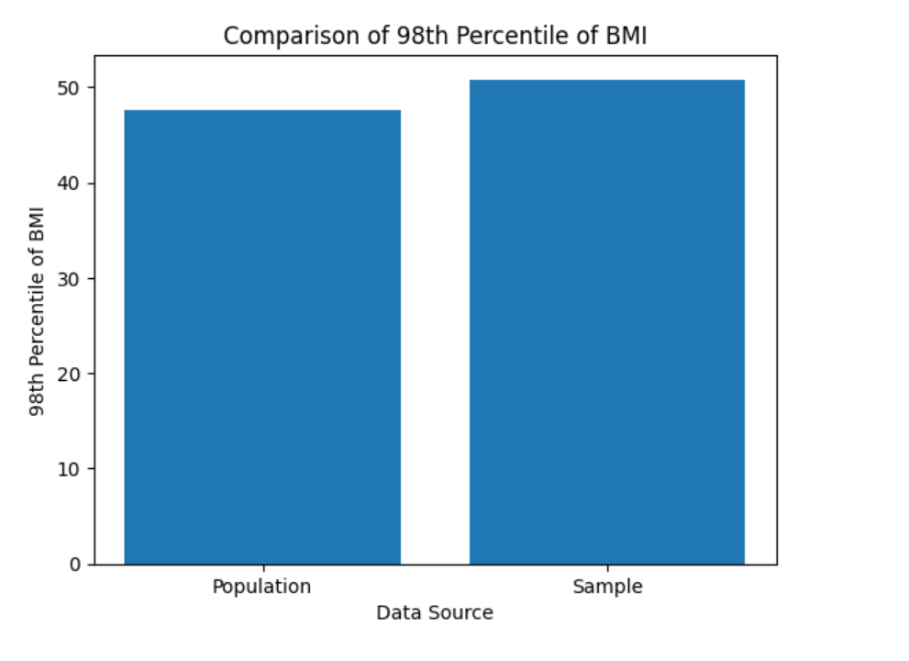

c) Using bootstrap (replace= True), create 500 samples (of 150 observation each) from the population and find the average mean, standard deviation and percentile for BloodPressure and compare this with these statistics from the population for the same variable. Again, you should create charts for this comparison. Report on your findings

