Assignment 3

Convert the text corpus into tokens.

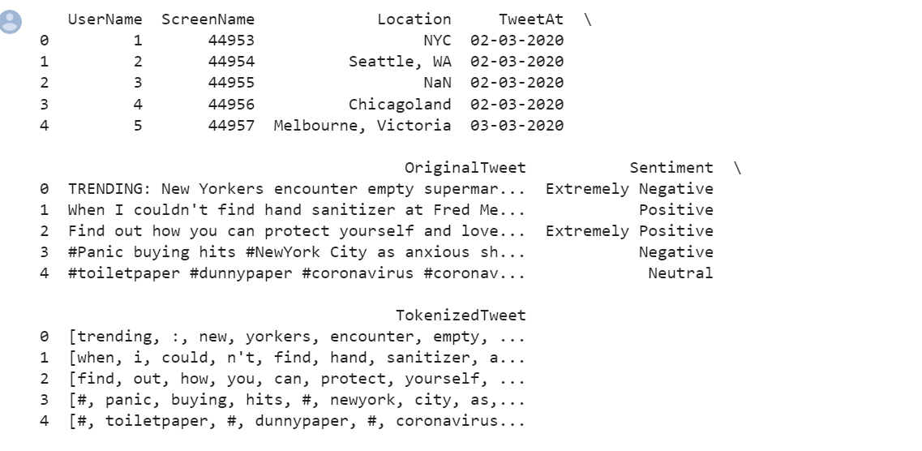

Perform stop word removal.

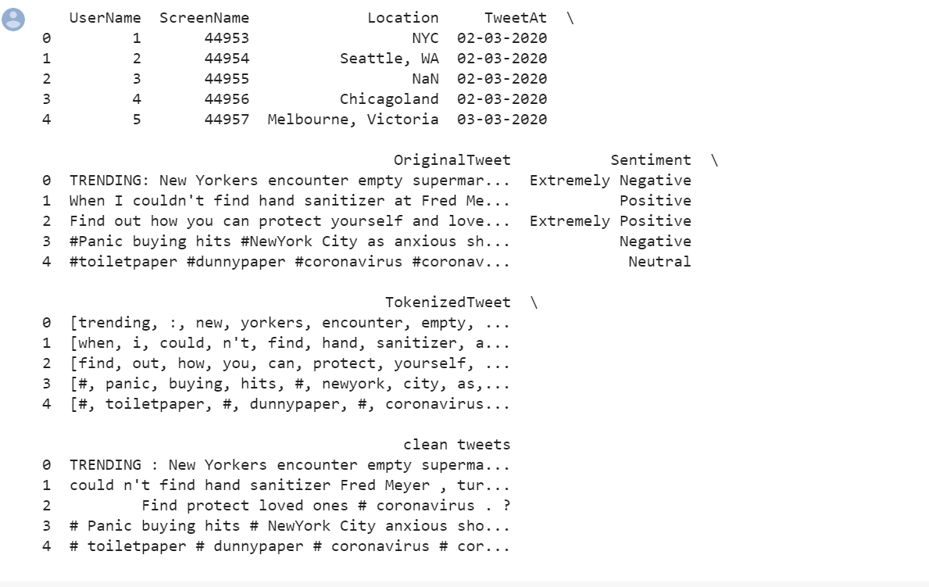

Count Word frequencies

[('#', 7857), ('.', 4896), (',', 3528), ('?', 2597), (':', 2413), ('https', 1824), ('covid_19', 1541), ('coronavirus', 1516), ('food', 1332), ('@', 1242)]

Create word clouds.

