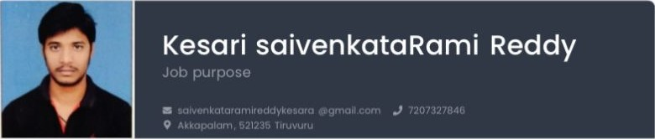

|  |  |  |
| --- | --- | --- |
| Education |  | Personal details |
| B tech | Jun 2009 - Mar 2019 | Date of birth |
| Nagarajunq Tiruvuru |  | september24, 2003  Place of birth  Tiruvuru |
| Courses |  | Gender |
| Cse  Certificates | Present | Male  Nationality  India |
| Achievements  State Cricket team in under16 | sep 2022 | Skills python,C, language,HTML,CSS,Javascript,  ExceI |

Languages

Telugu English

# Hobbies

 Redding Books

# Qualities

 Quick Learner