**OBJECT DETECTION**

The Dataset for the project is present in the following url .

<https://drive.google.com/drive/folders/1MFFDrZdp_4mWbm4aEqQURNy7T0_8g1lf?usp=sharing>

You will observe the following:

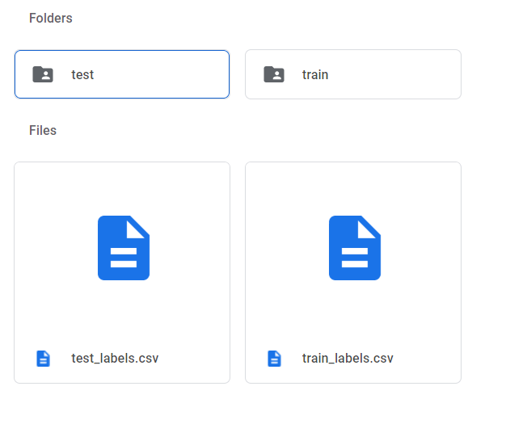

In the **test** and **train** folders you will be able to see all the images in **.jpg** with respective **annotation in XML**

**Note:-** If you want to view my **project folder** you can click on the following link

<https://drive.google.com/drive/folders/16-FG_NHhRQcBvsjAiwnu7eLWY3HGJNGh?usp=sharing>