General tips for the Task below.
Task Title
Jenkins
Objective
Worked on pre-requisite, as I watched Jenkins-01 video posted in DevOps group in slack as a requirement to work on Objectives, Prerequisites and execution steps for all tasks.
Prerequisites
List all requirements before starting:
- AWS-Ec2
- Git
- GitHub
- Jenkins
Issues Faced: Briefly mention issues and how you fixed them. Posted below in the last.
Conclusion
Conclusion has been provided for every task at the end.

Jenkins


What is Jenkins?
Ans. Jenkins is an open-source platform, which will help us to create Continuous Integration (CI) and Continuous Delivery/Continuous Deployment.
How the continuous integration happens?
Ans. Jenkins will perform the continuous integration Maven, SonarQube which will help us to compile the source codes and do the quality checks and push to Nexus.

What is Nexus?
Ans. Nexus is a artifactory which will help us to store the packages.
Once the package is ready and continuous delivery will make sure the package is ready for deployment and deployment will happen automatically without any manual intervention.

- Jenkins will run on Port-8080
- Default location- /var/lib/Jenkins
- Pre-requisites- Java to be installed.
Plugins-
- Plugins is a predefined set of programs to integrate between Jenkins and GitHub.
- Plugins will help us a lot because no need to write codes, instead download plugins, push the URL and work on the jobs.
- Before creating jobs, ensuring to download the required plugins will ease our work.

Different components in Jenkins below.
- Build Executor status- Once the Job has been created, then will build now and execution starts to deploy.
- Execution is where; we can verify our actions are being performed as a final stage in Jenkins.
- Number of executors depends upon ec2 instance type. If the ec2 instance type is t2.micro and if we have 10 executors, the CPU load will =be too much and it might be hard to process the jobs, instead they wait in the queue.

Jenkins supports two types of jobs:
- Plugin based jobs
- Pipeline based jobs
Plugin based jobs- This is a freestyle project, where as per our requirement, we can download and work on our jobs.
Pipeline based jobs- This has specific requirements and need to work on integration and deploy to servers where our application is installed.

Labels- Labels is where it is linked to name and path to GitHub and nodes.

Access Management:

- To provide access to team members, navigate to Manage Jenkins Plugins Role-based Authorization strategy.
- The other way is to - manage Jenkins Jenkins own user database create user.
- If we want to limit the user configurations settings and configurations.

Tasks on Jenkins
- Install Jenkins and run it on port 8081
- Secure Jenkins server
- Create limited users (DevOps, Testing)
- Configure labels and restrict jobs using labels
- Create 3 sample jobs from a public GitHub repo- https://github.com/betawins/Techie_horizon_Login_app.git
- Create 1 job from a private GitHub repo

Task-1: Install Jenkins and run Jenkins on port number 8081.

Objective:
The objective of this task is to Install Jenkins, change the port number from 8080 to 8081.

Prerequisites:
- Ec2
- Jenkins package
- Java-17

Step by step Implementation:

Step 1: Navigate to ec2 in aws and launch a instance.
- Instance type is t2-xlarge to have a large memory.
- New key pair added.

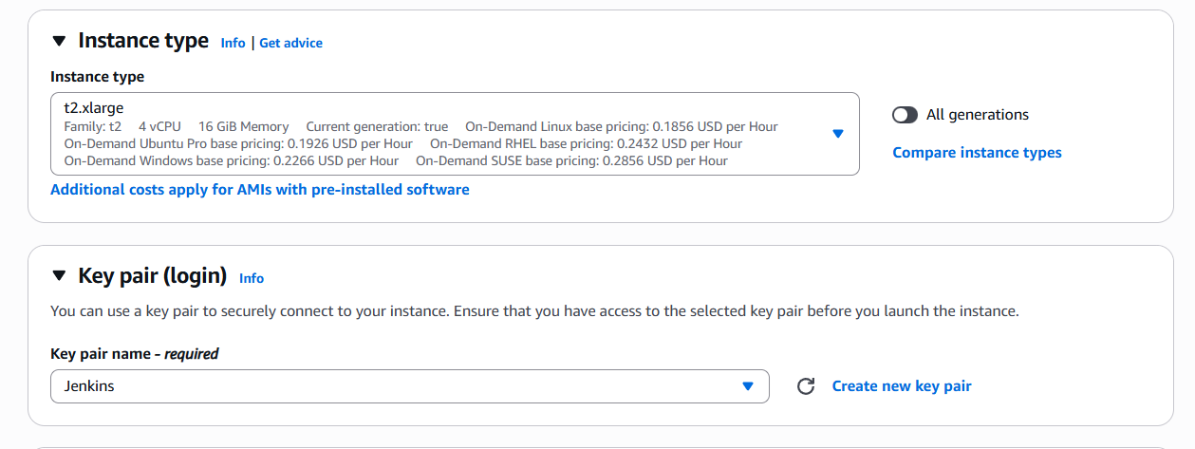

- VPC is default and existing security groups updated as well.
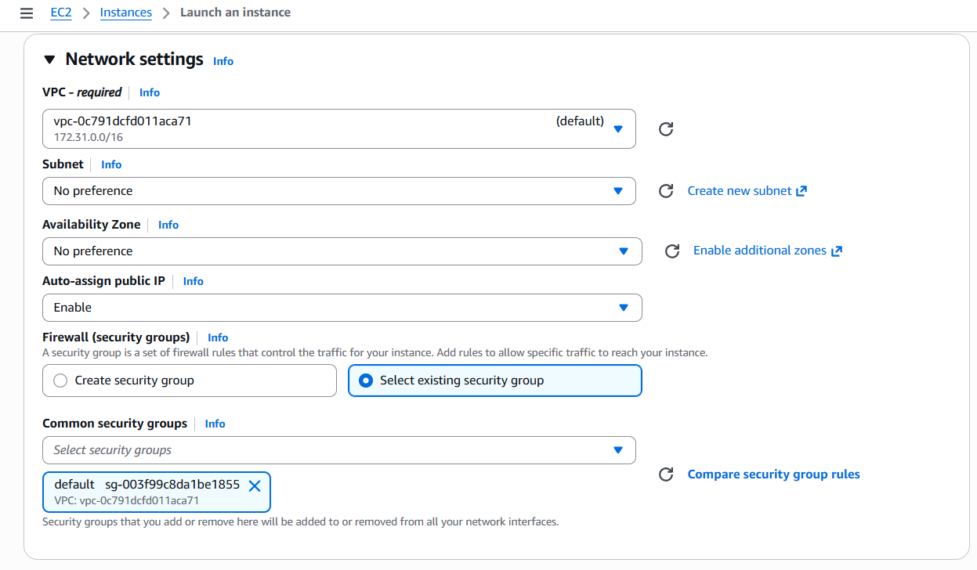

- I have updated my EBS as 20 GB for my storage.
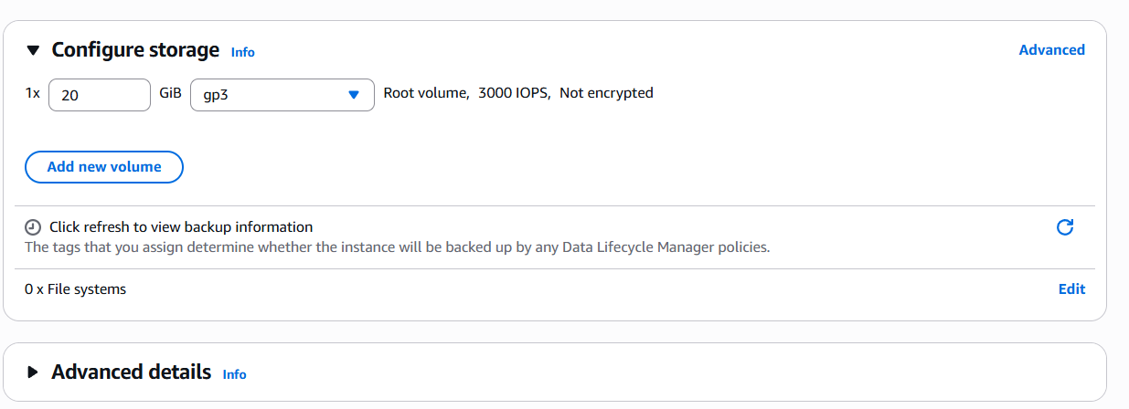

- Instance launched successfully.
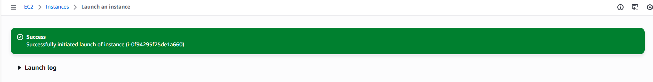

Step 2: Let’s connect to cli through Public ip and install java-17 version.
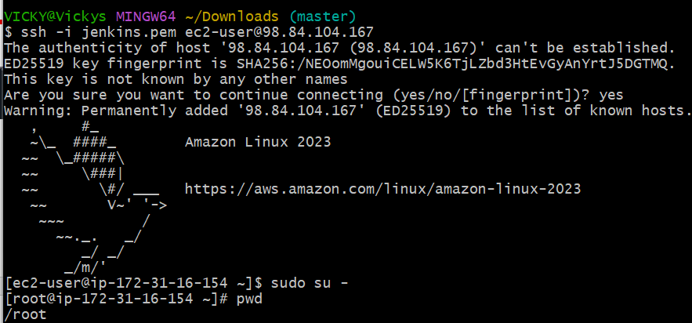

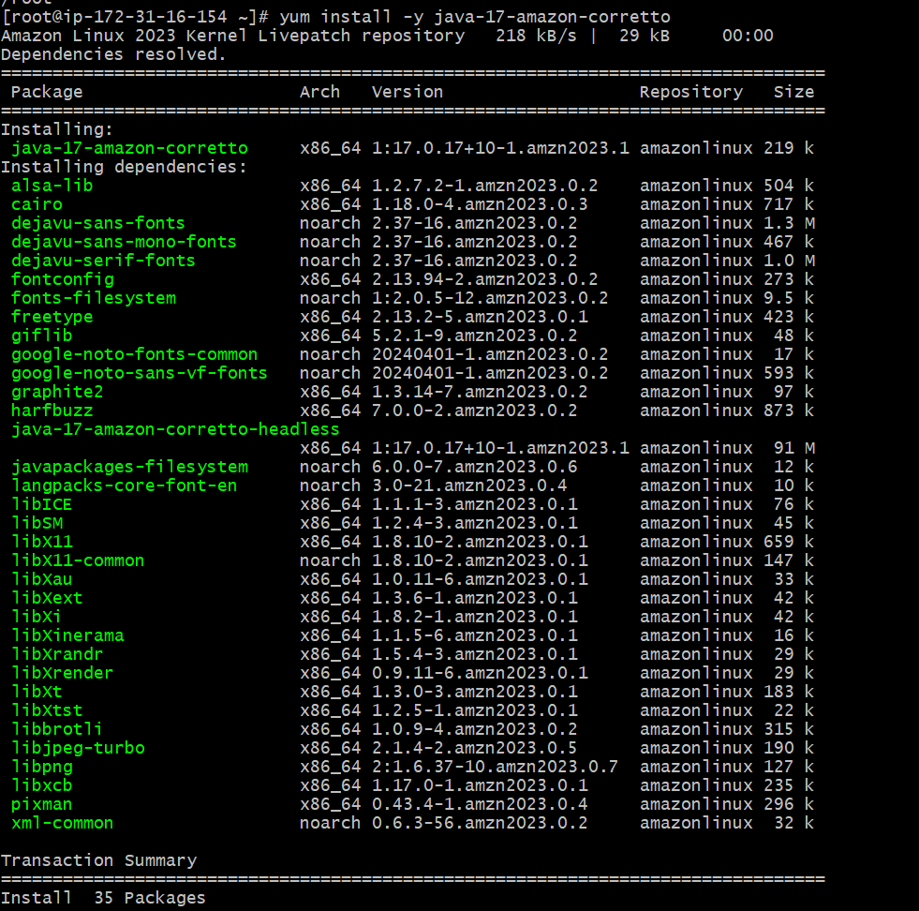
Step 3: Install the Jenkins package and rpm keys. Use the command below.
sudo wget -O /etc/yum.repos.d/jenkins.repo https://pkg.jenkins.io/redhat-stable/jenkins.repo
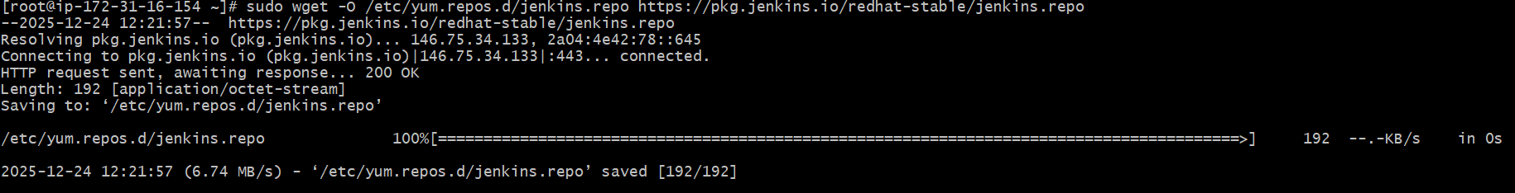

Step 4: Installation of Jenkins package and rpm keys are done and we need to import keys. Use command below.
sudo rpm --import https://pkg.jenkins.io/redhat-stable/jenkins.io-2023.key
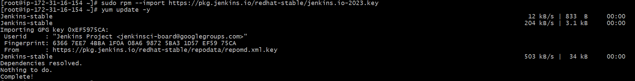

Step 5: Now, we shall proceed with installing Jenkins
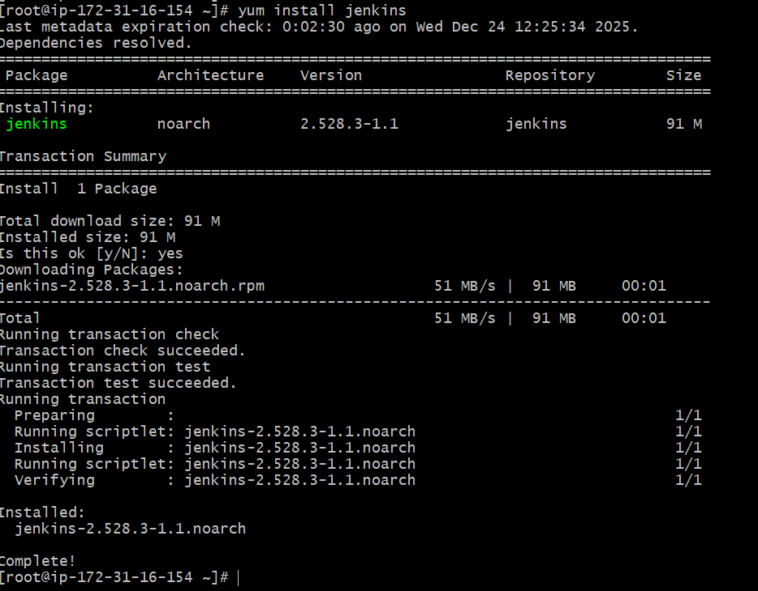
Step 6: Installation is successful. We shall start and enable the package.
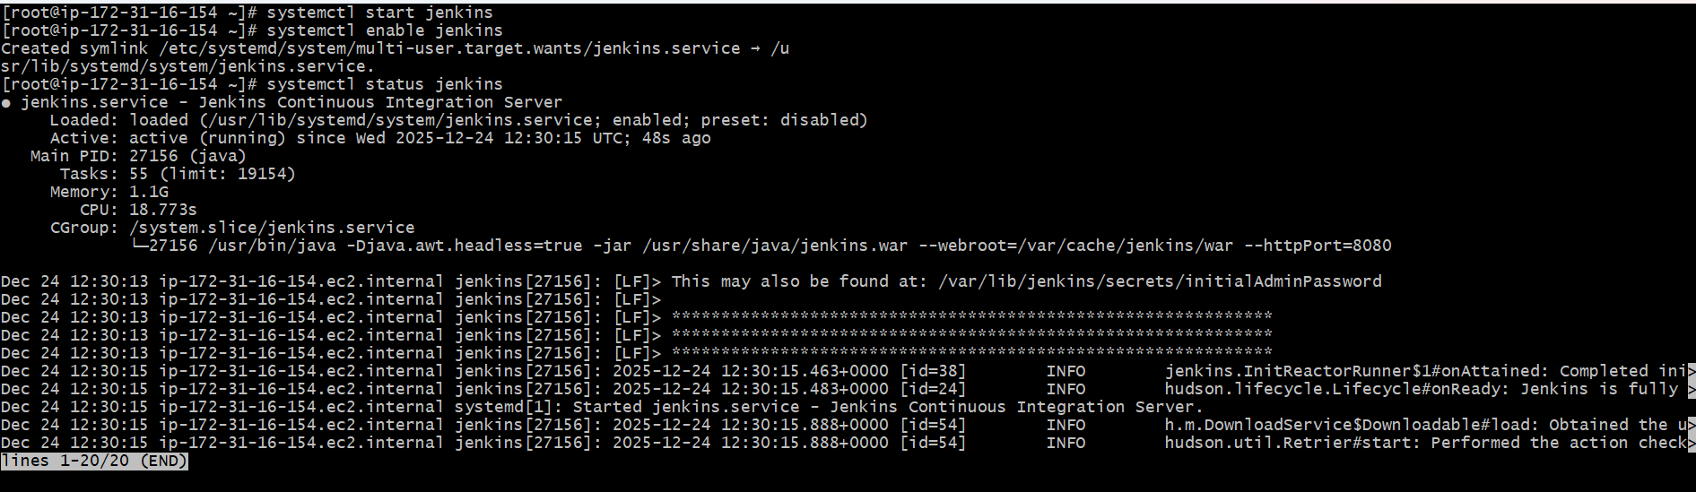

Success- Now Jenkins is active and shall verify if the port is working as excepted.
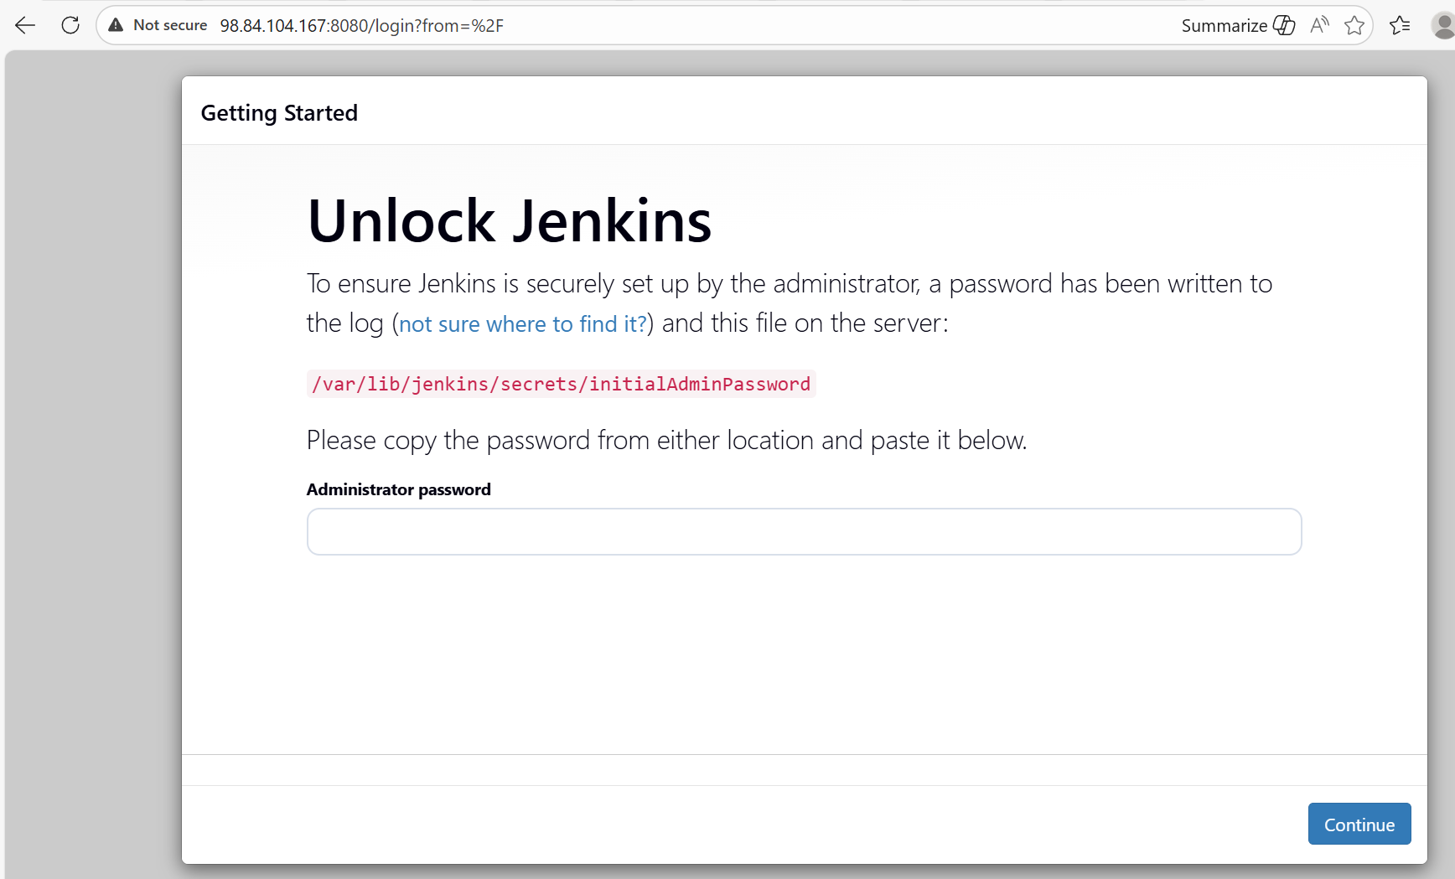

Step 7: Deployment location of Jenkins is /var/lib/Jenkins
We require the password to login into Jenkins, so we need to change directory to Secrets and cat the initial password and we’ll be able to login.

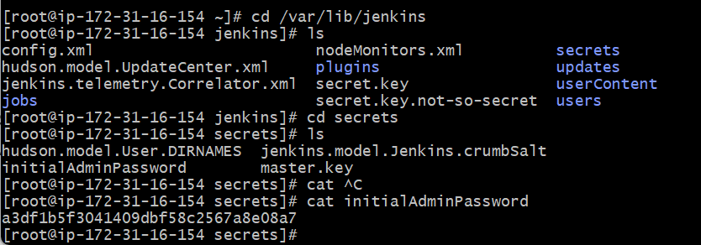
- Password updated and logged in successfully.
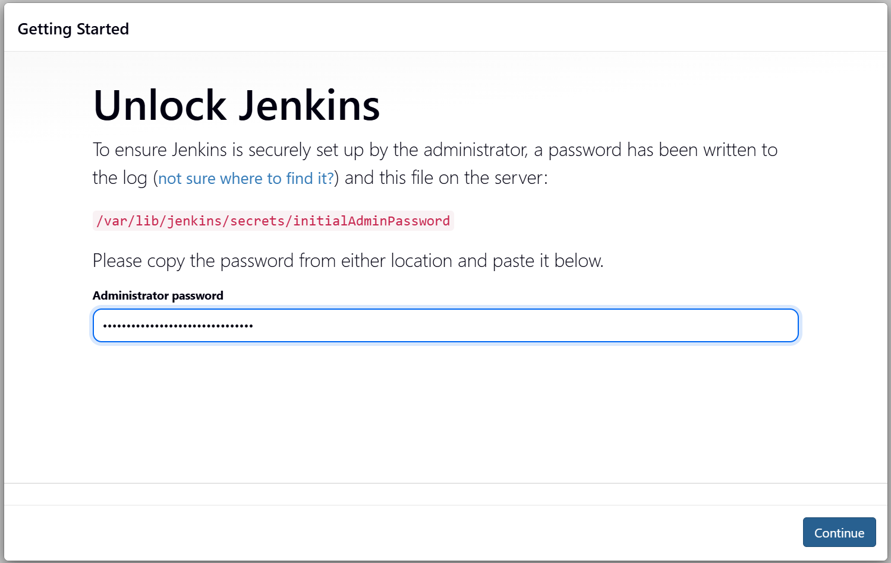
Step 8: Now, this is the last part of this task- to change the port number and verify if 8080 to 8081 port number works on browser?
Default location of file is /usr/lib/systemd/system/Jenkins.service
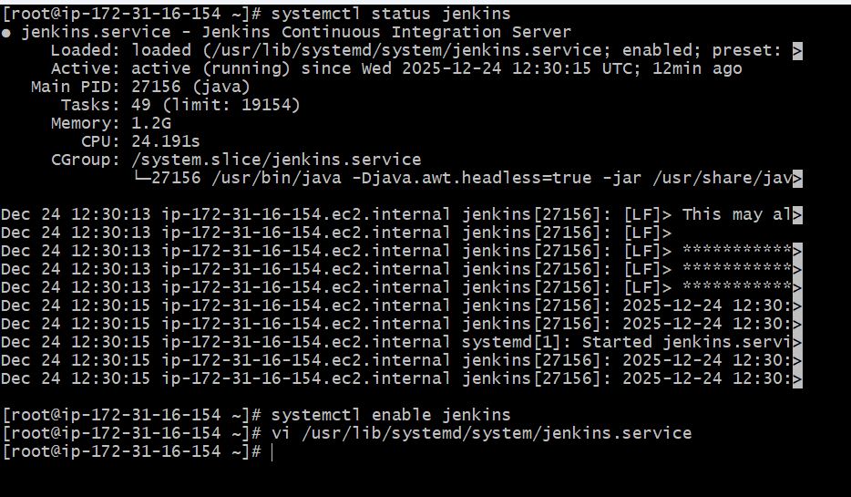
- Changed the port number and updated the vi.
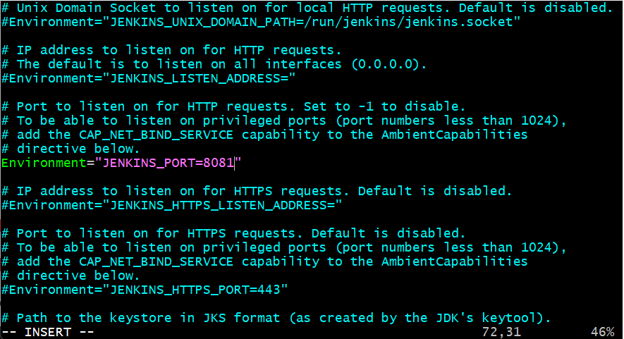

Issues faced:
I faced an issue when changing the port number from 8080 to 8081. I couldn’t vi the location file, so later I checked the status, start and enable the Jenkins. Then when I did vi /usr/lib/systemd/system/Jenkins.service.
The other main problem I faced is I couldn’t verify with changed port 8081 in browser. After R & D, I got to know that, we cannot make the change port number after starting the service.
So, we should never start the service until we change the port.
So, now, I killed the process using command- Kill -9 PID and did use command- systemctl Daemon-reload and started the service.
Now, the port number changed to 8081 and verified in browser. We were able to login and updated the credentials and logged in.

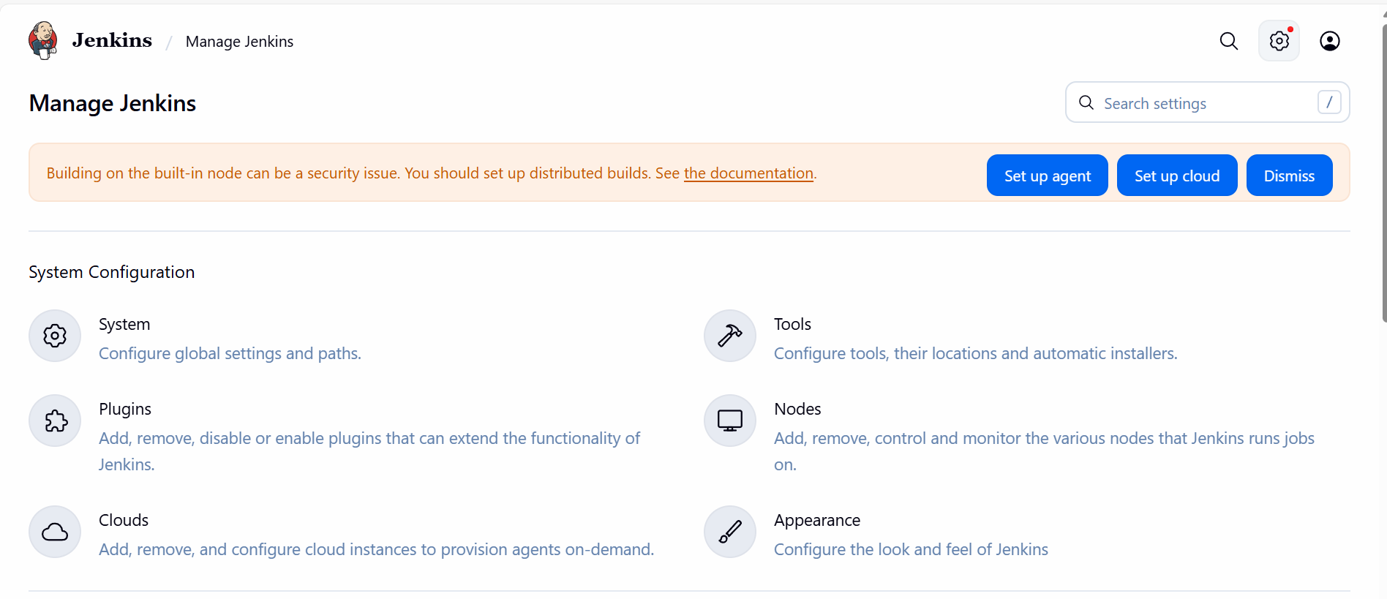

Conclusion: Jenkins is successfully running on port 8080. We changed the port back to 8080 from 8081.
Once, we update back the port number in vi service file, we need to kill the process and do systemctl daemon-reload. So that, the port number will get changed.

Task-2: Secure Jenkins server

Objective:
The objective of this task is to secure the Jenkins by restricting unauthorized access and protecting sensitive credentials to ensure safe and reliable C/CD operations.

Prerequisites:
- Jenkins
- Ec2

Step by step Implementation:

Step 1: This is the 1st step once connected to port 8080 in website. Click on suggested plugins and continue.
- Create a username password provide an email address and continue.

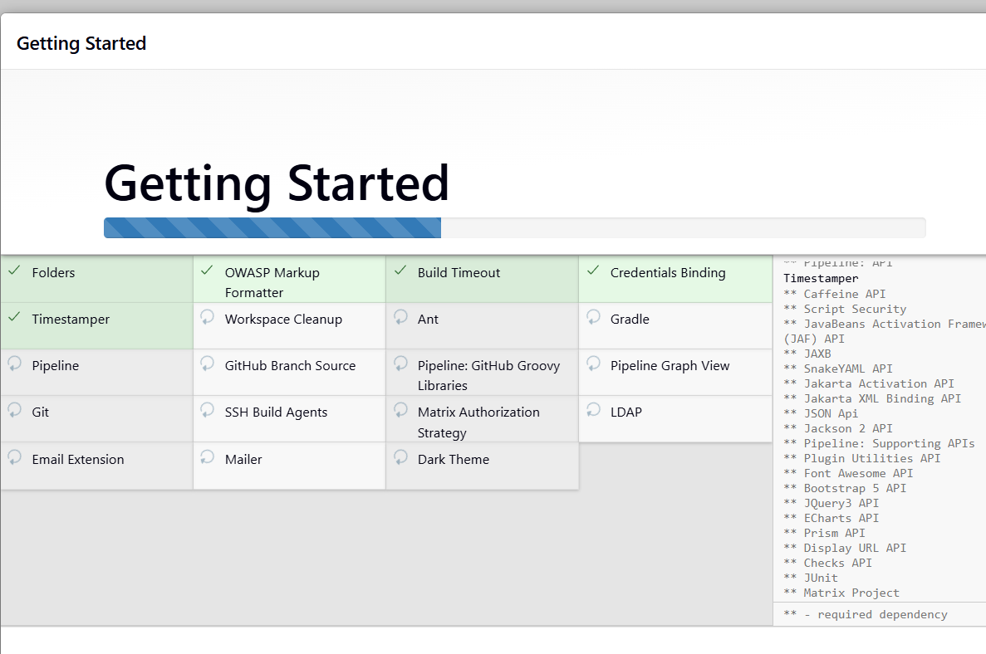
- Now we can securely login into the Jenkins finally.
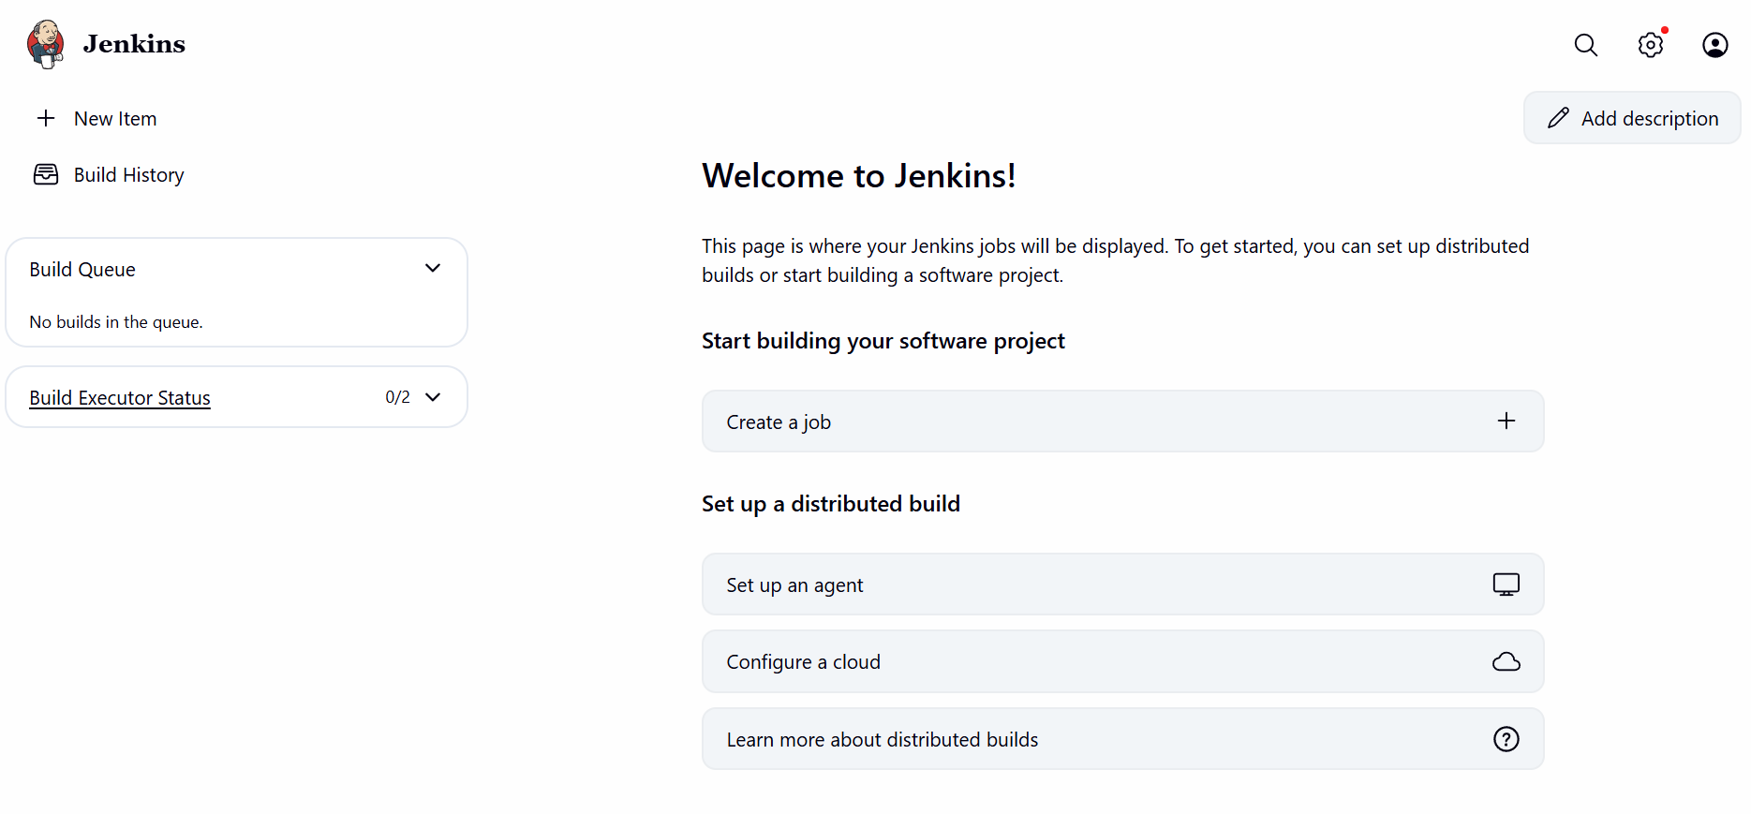

Step 2: Let’s verify if the initial password is automatically deleted from the deployment location.
Deployment location is: var/lib/Jenkins

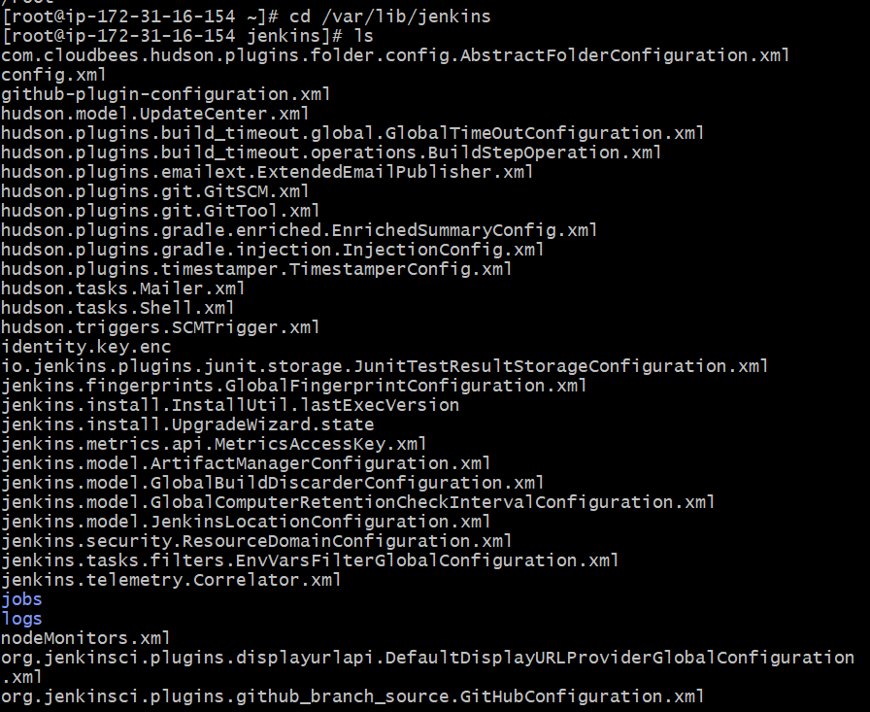

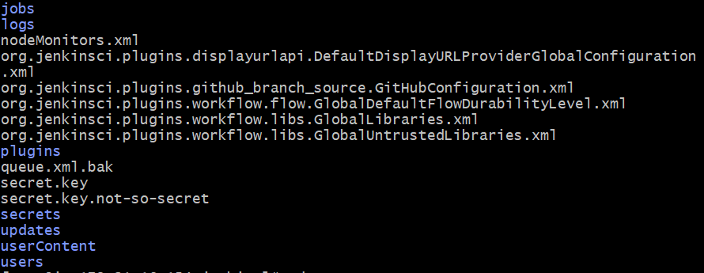

Step 3: Now change directory to cd secrets to verify if the intial password is avaialble!!

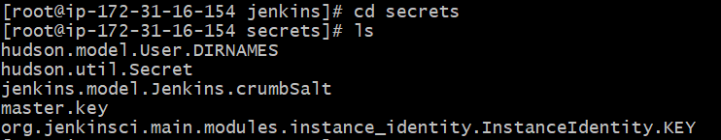

Success- The initial password is automatically removed.

Conclusion: Successfully, secured the Jenkins.

Task-3: Create users called DevOps, Testing in Jenkins with Limited access

Objective:
The objective of this task is to create users called Devops and Testing to ensure they have actions to perform only limited tasks in Jenkins.
Reason for providing limited access is they shouldn’t be provided all access which they will not be utilizing.
For example, Developer will not be requiring to create users and managing access management.

Prerequisites:
- Jenkins
- Plugins
- Manage Jenkins- Jenkins own user data.

Step by step Implementation:

Step 1: Navigate to Jenkins Manage Jenkins and select “Users”

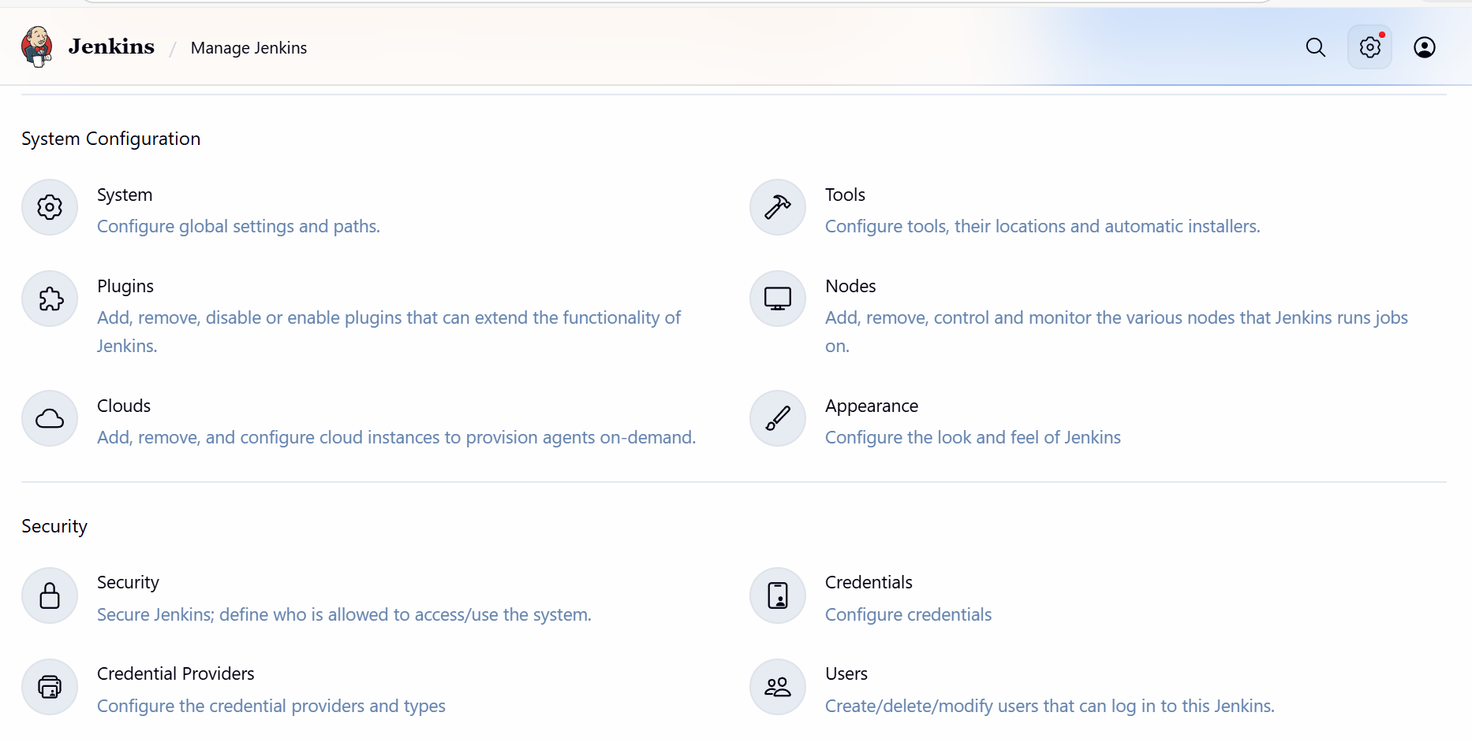

Step 2: Click on the “Create User”

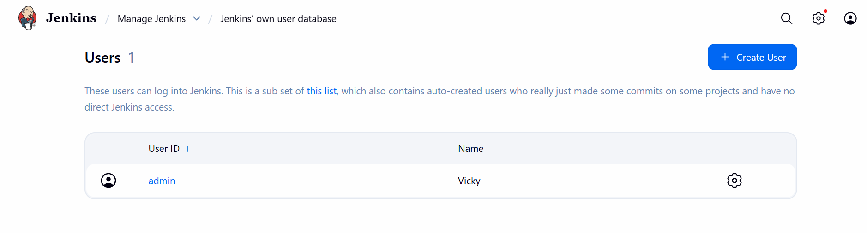

Step 3: Create our 1st user- Devops

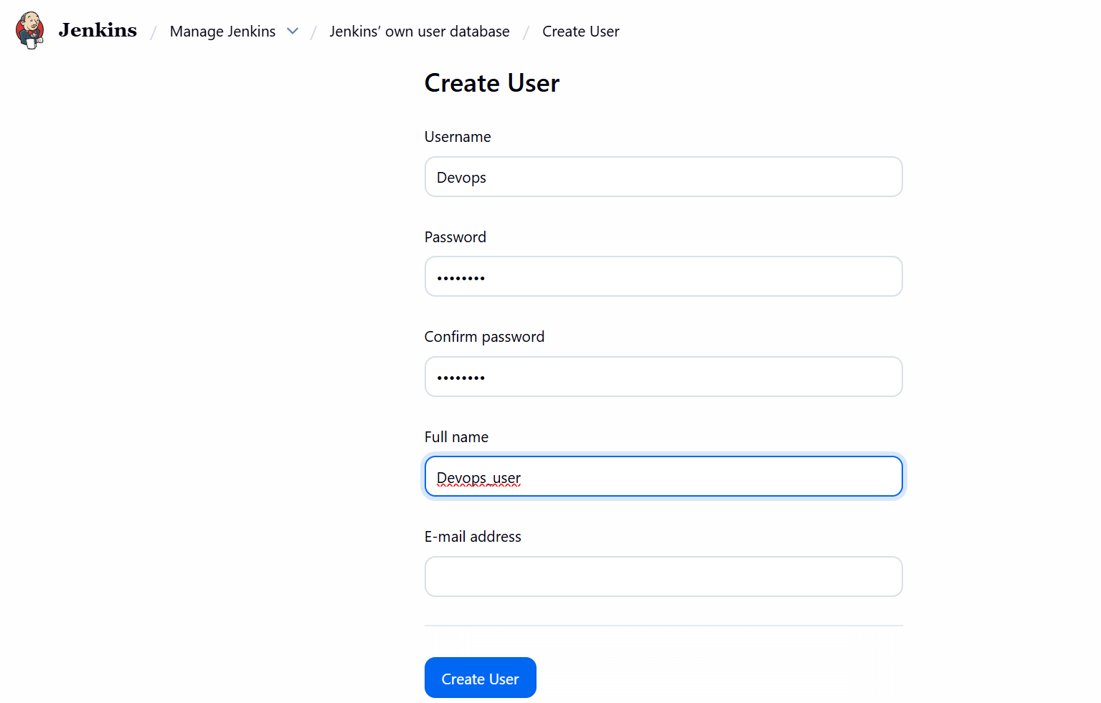
- Devops user created.

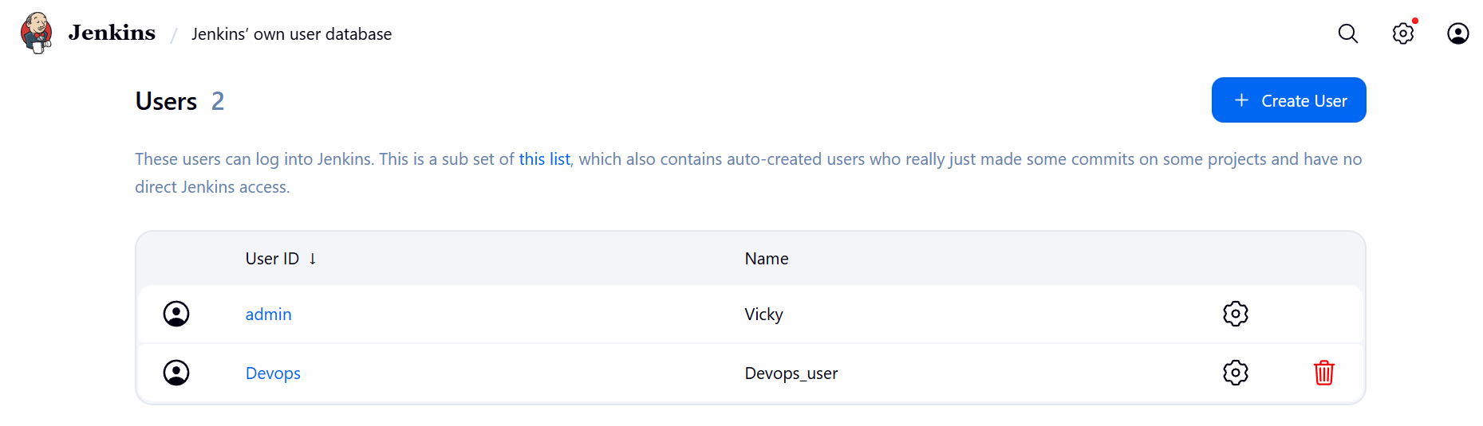

Step 4: Create our 2nd user

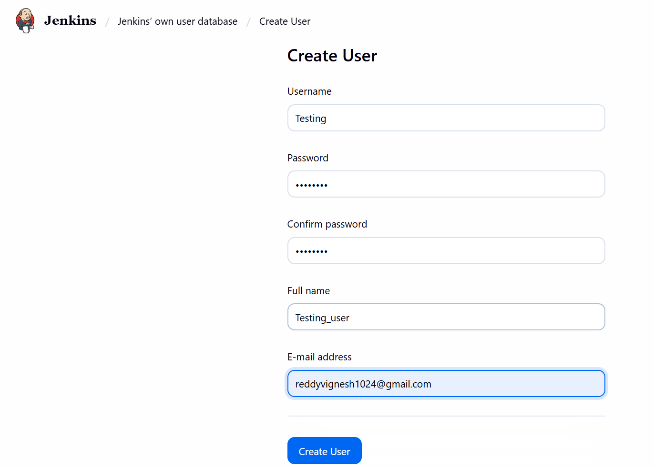
- Created our 2nd user- Testing successfully.

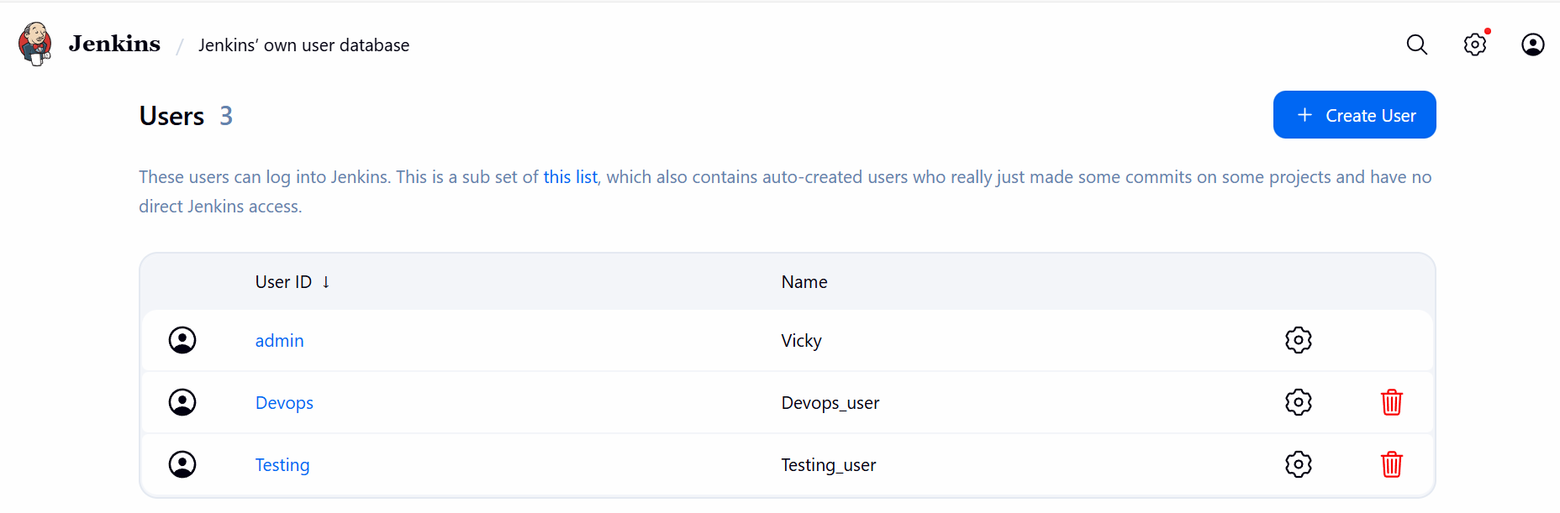

Step 5: Now, we shall Install plugins to provide limited access to Devops and Testing.

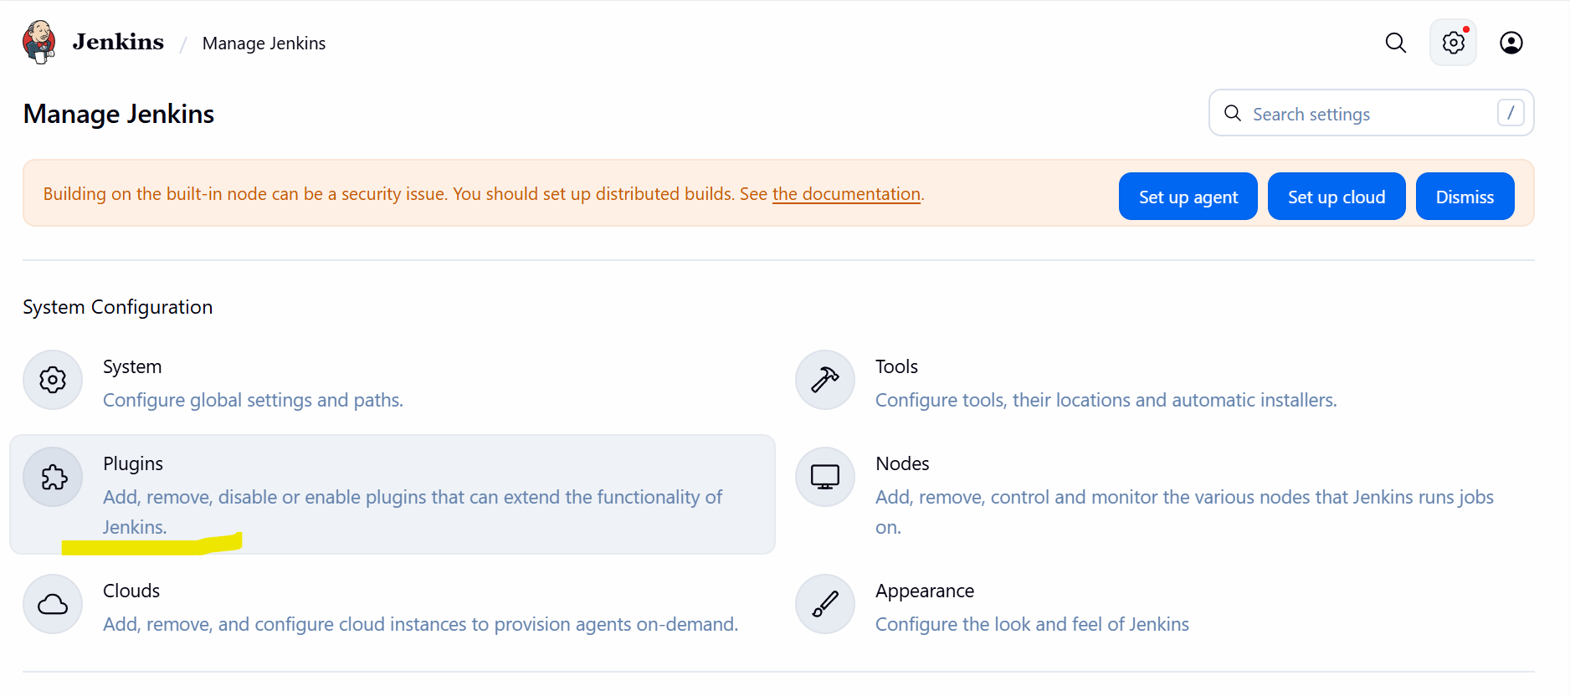

- Search for- Role-based Authorization Strategy and Install.

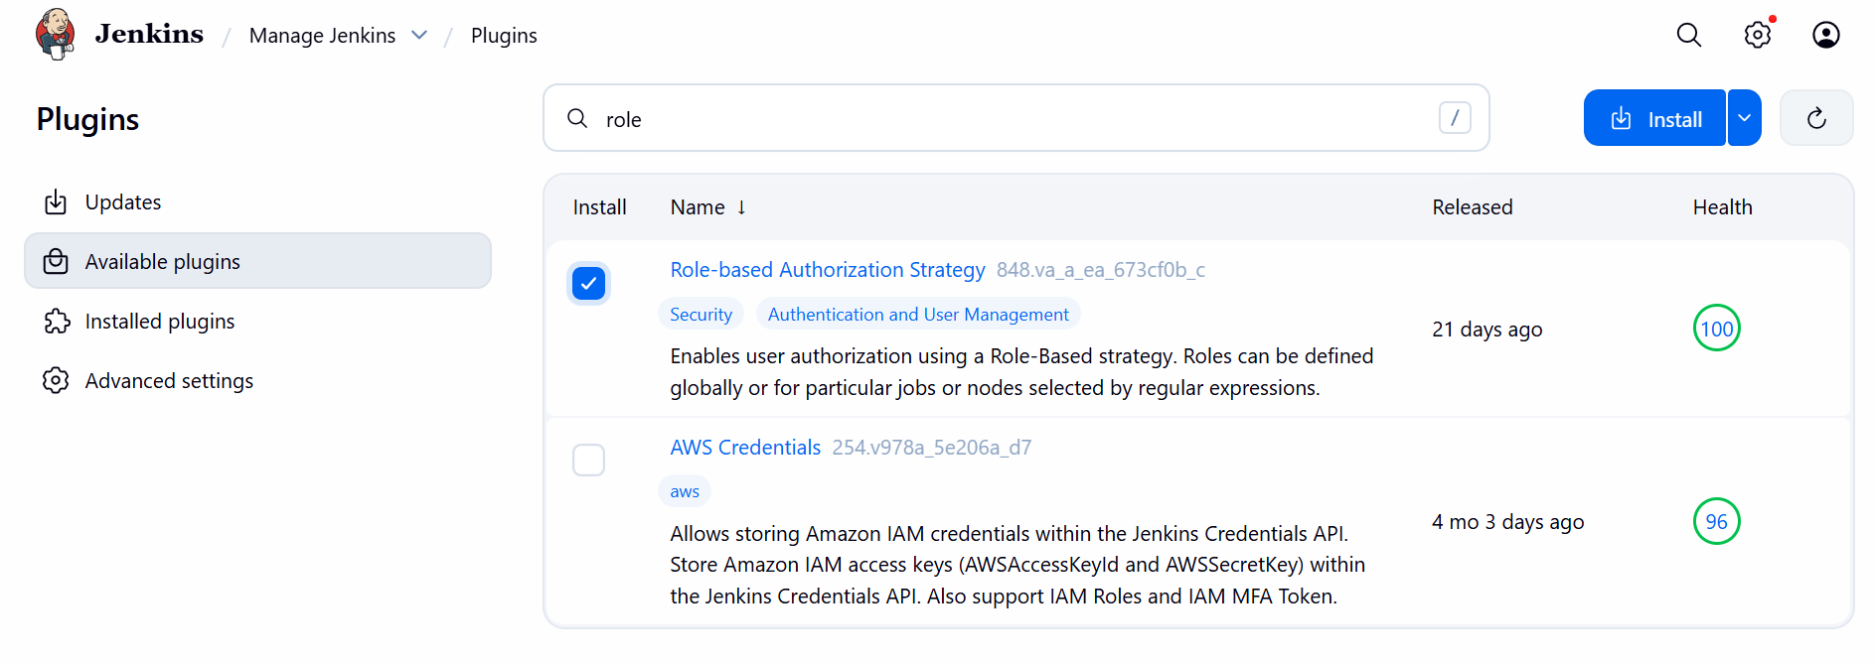

- Always, go back to the top page, do not restart Jenkins.

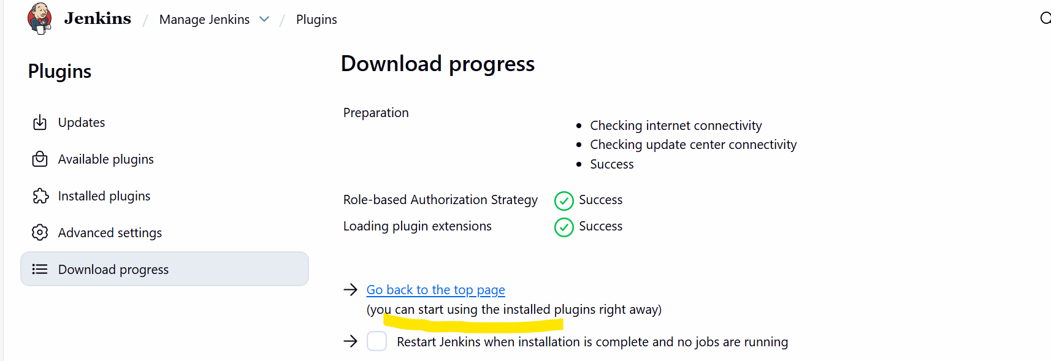

- Verified by going back to the plugins and search under Installed Plugins

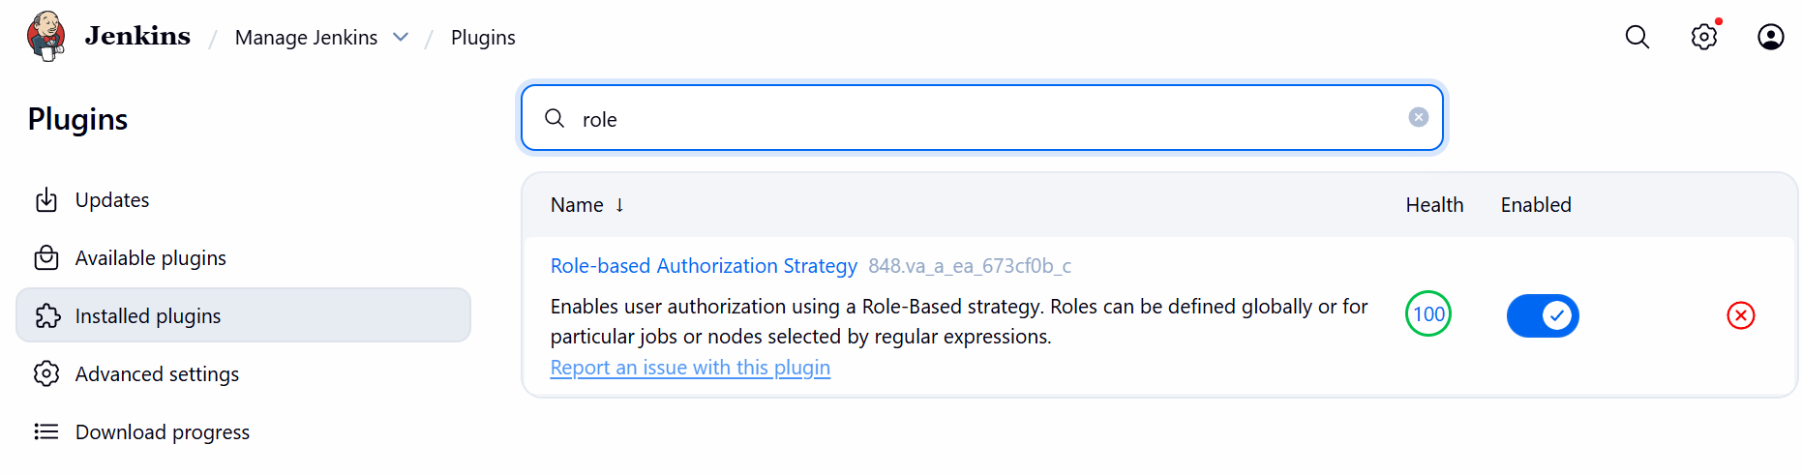

Step 6: Navigate to Manage Jenkins select Security Authorization and select Project-based Matrix Authorization Strategy.

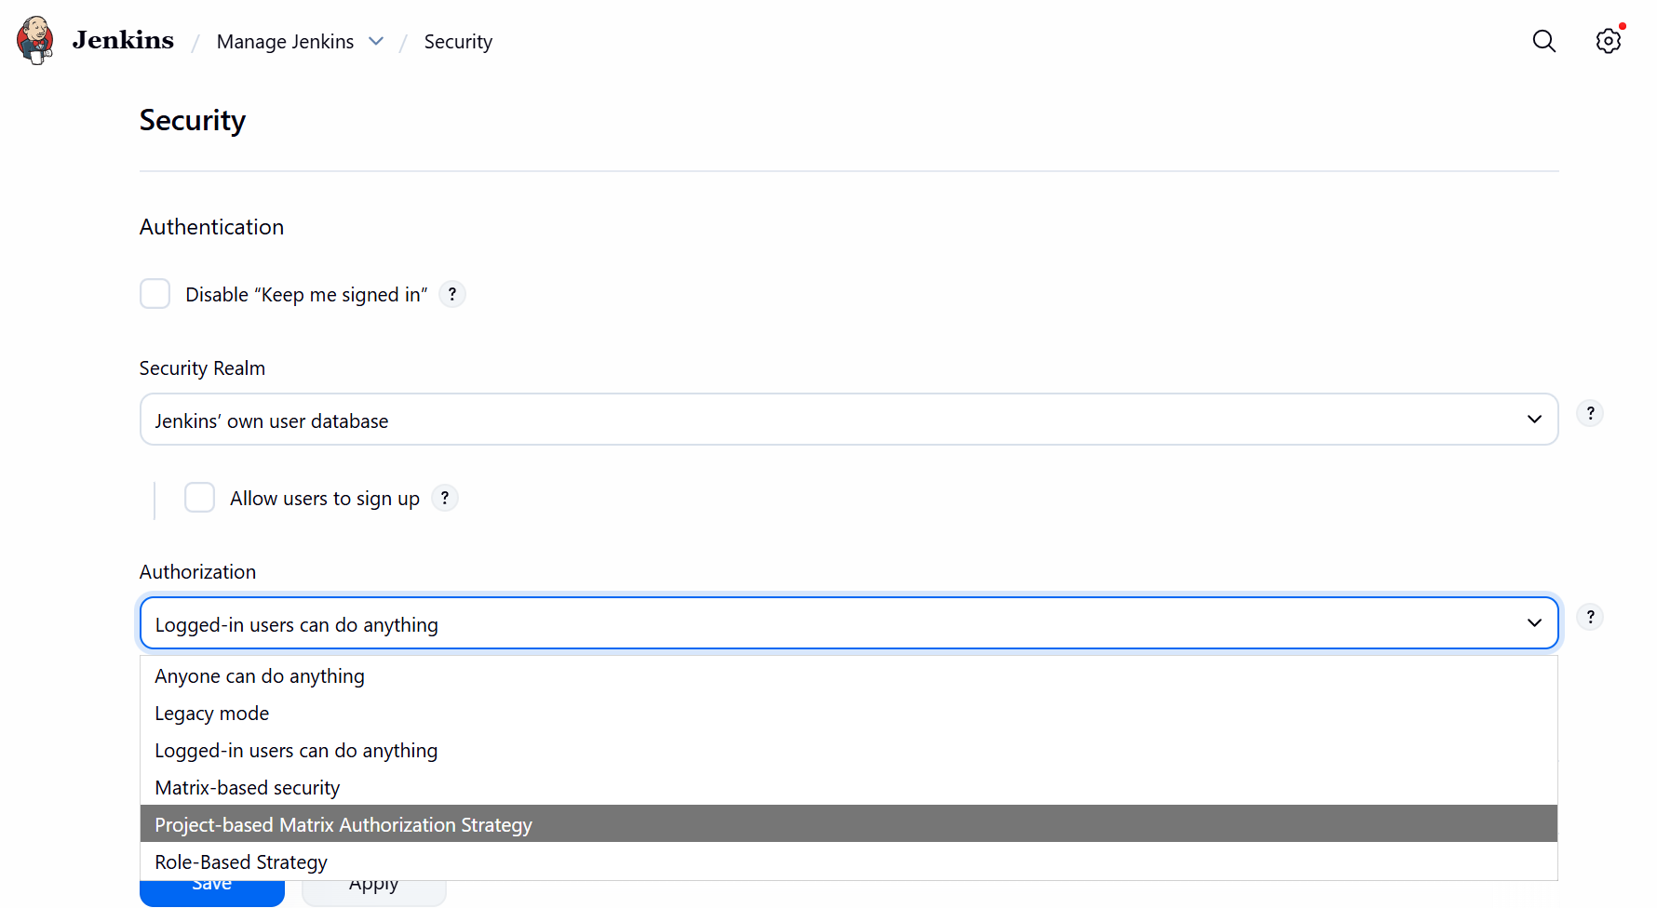
Step 7: Now, we added 2 users to the Project-based Matrix Authorization Strategy and provided just access to “Job” except delete option.

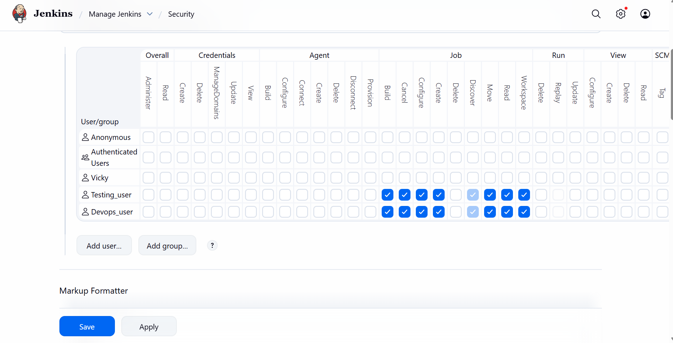

Conclusion: Always provide permissions correctly to ensure, we do not need to have a error at some stage that, someone working at a wrong place might result in Jenkins server issue.

Task-4: Configure labels and restrict the jobs to execute based on label only.

Objective:

The objective of this task is to configure labels via nodes and restrict the jobs by nodes and execute jobs by enabling only by node condition.

Prerequisites:

- Plugins
- Jenkins
- GitHub

Step by step Implementation:

Step 1: Navigate to Plugins and select available plugins.
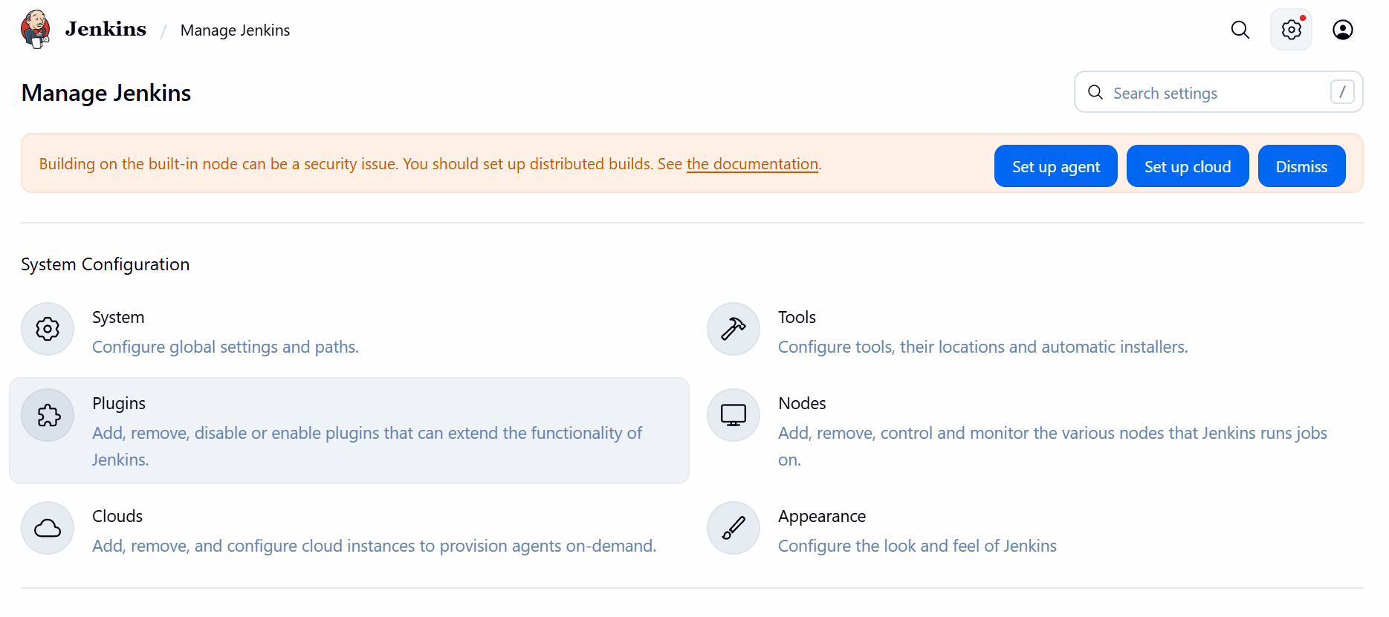
- Search for Node and Label parameter Install

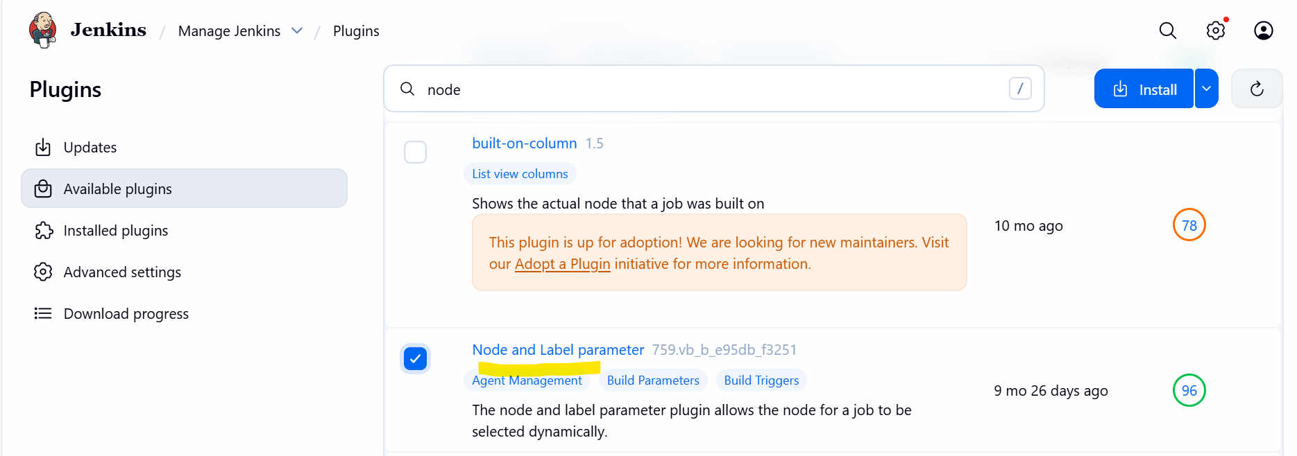

- Installed successfully.

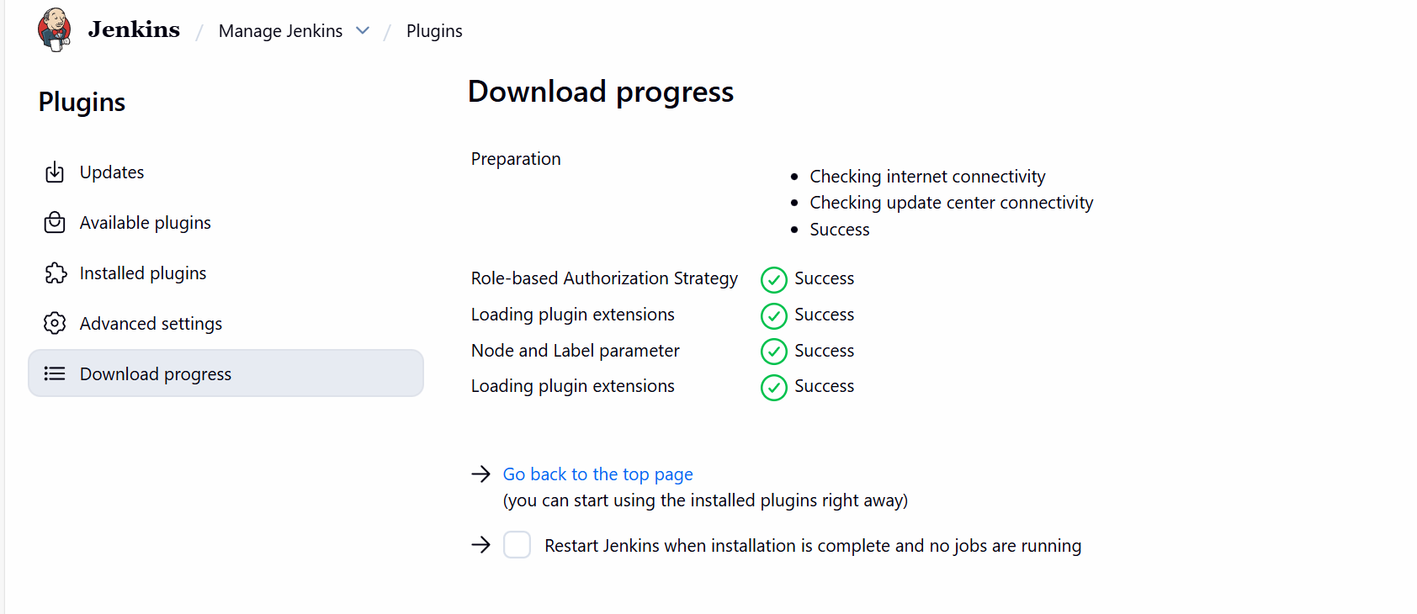

Step 2: Navigate to System Edit a message- Devops

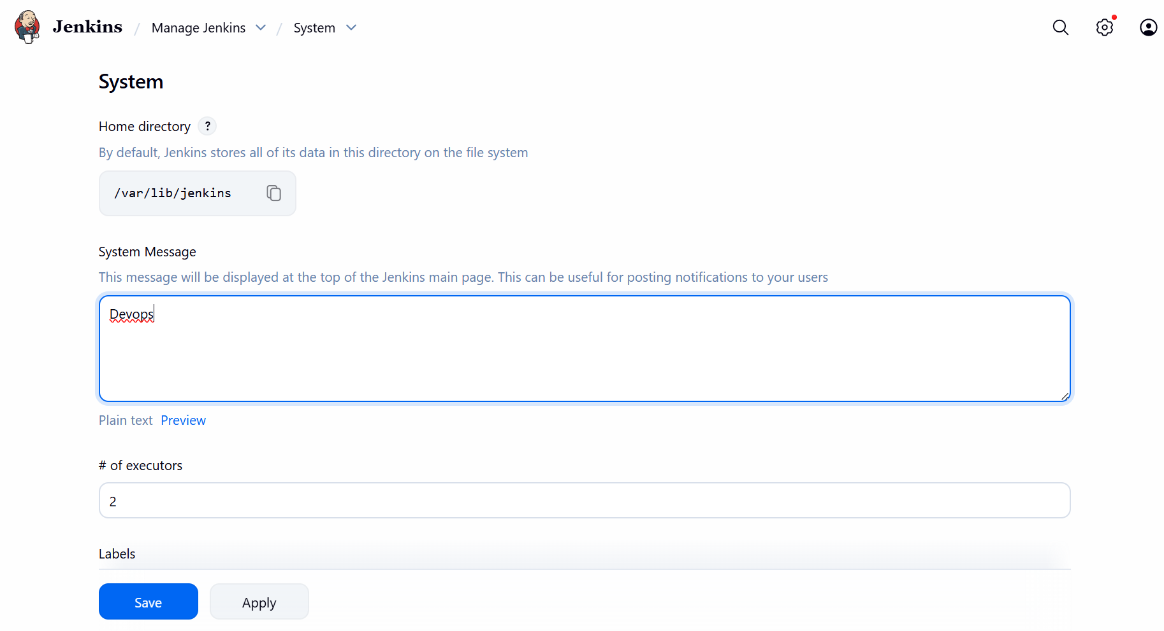

- Select the option as “Only build jobs with label expression matching this node.
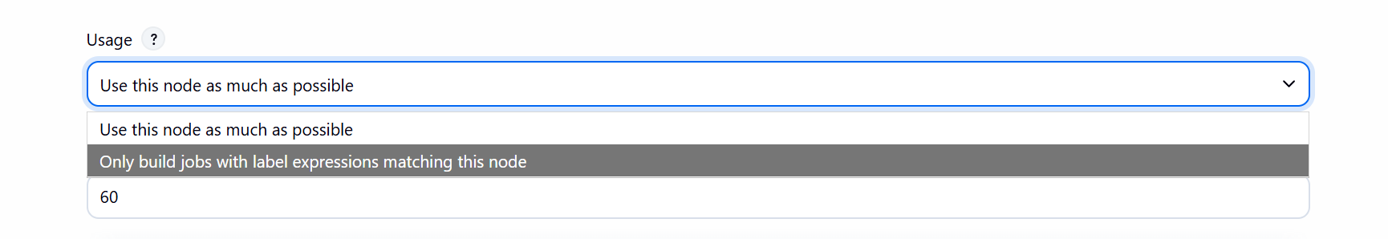

Step 3: Remember- always, we need to install the plugin before creating a job as per requirement.

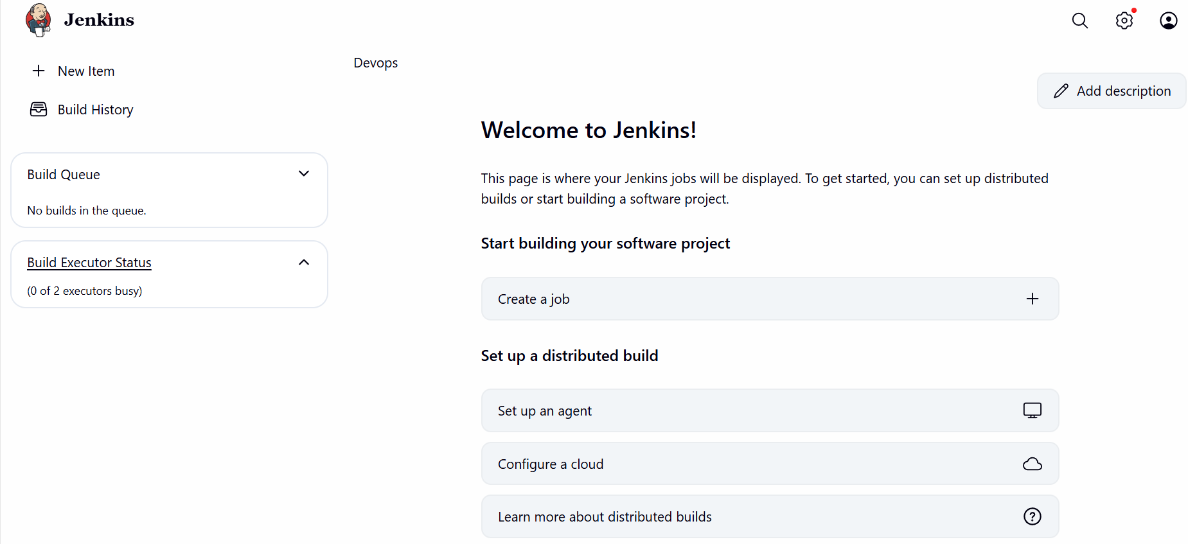

- Create a job now and enter a item name- Devops_Team and choose Freestyle Project.
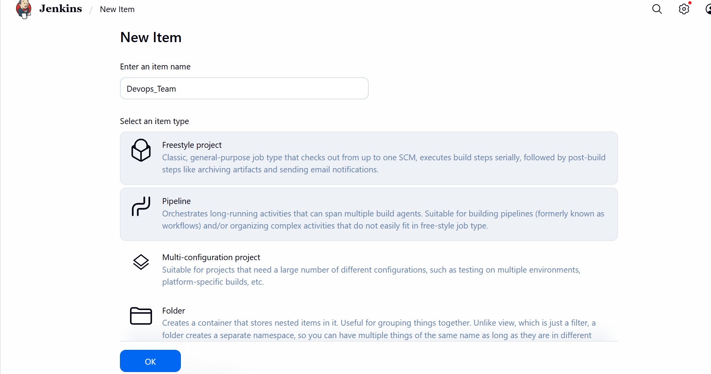

- Update the Label as Devops as we updated earlier in Security under Nodes.

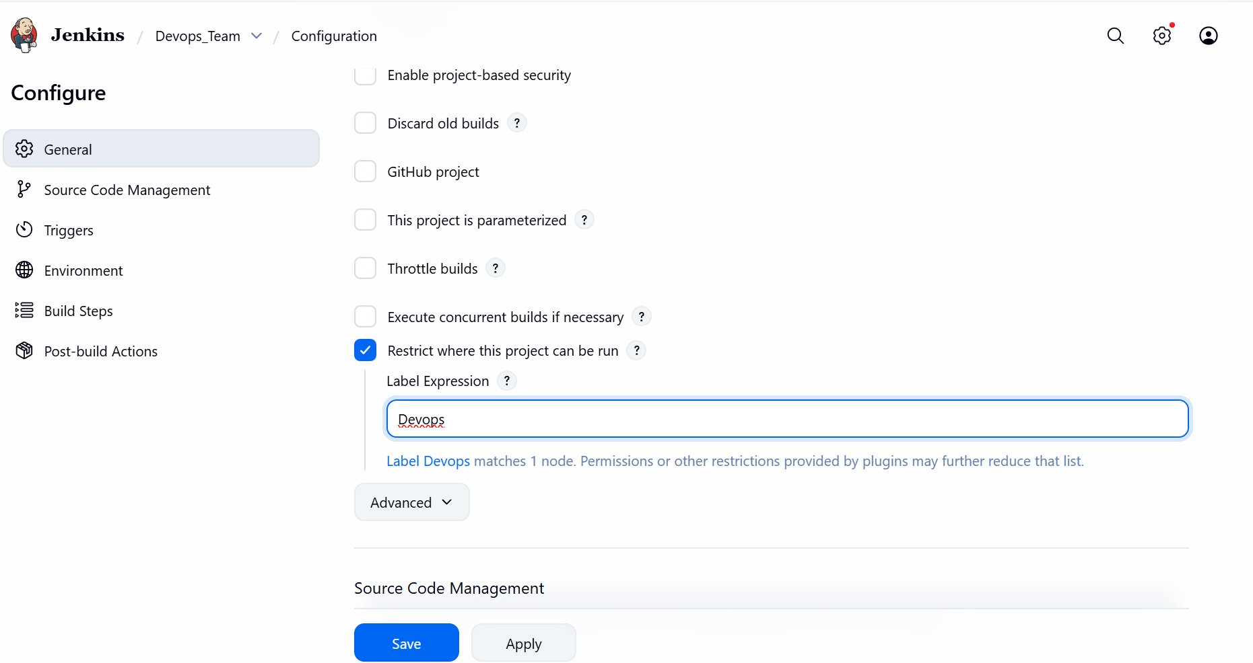

Step 4: Navigate to GitHub and search for sabear_simplecutomerapp and copy the ssh and paste in the Repository URL.
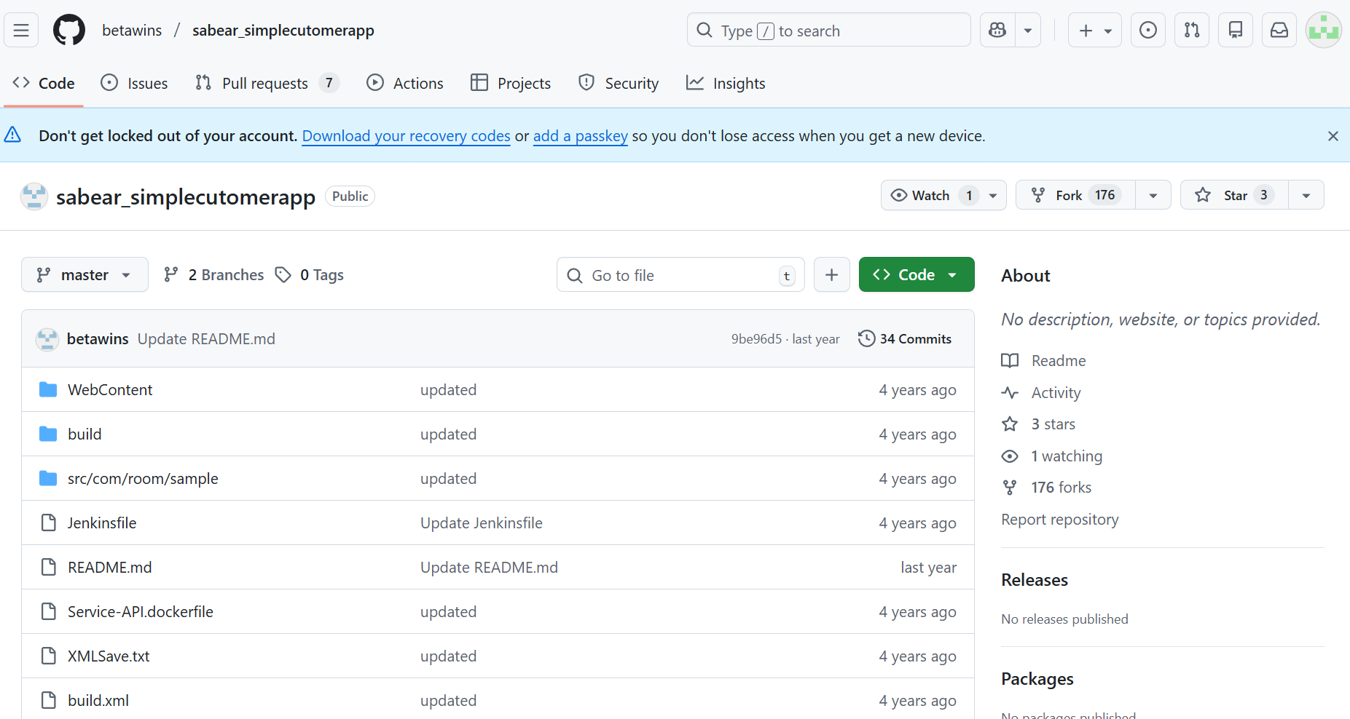

- Yet, got an error Failed to connect, because git is not installed in ec2 server where we have Jenkins installed.
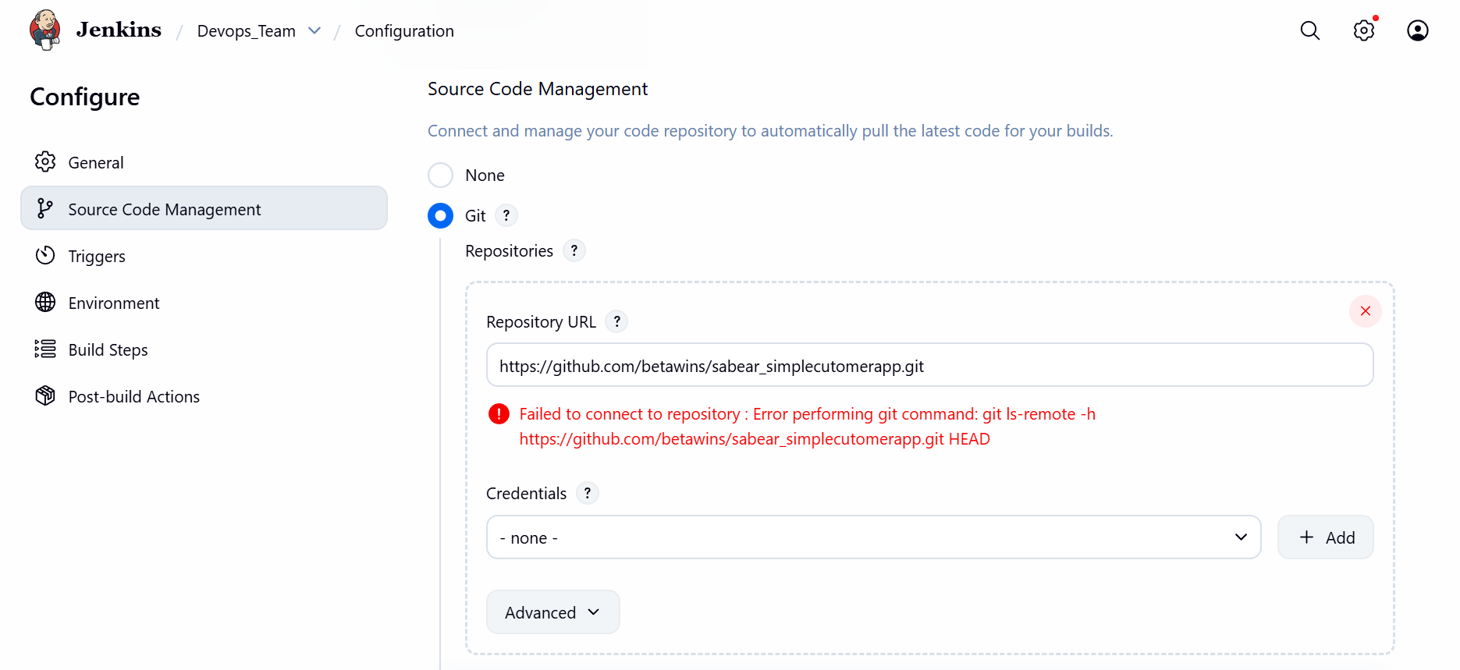

Step 5: Let’s install git by using command- yum install -y git
Success- We can see the git is installed.

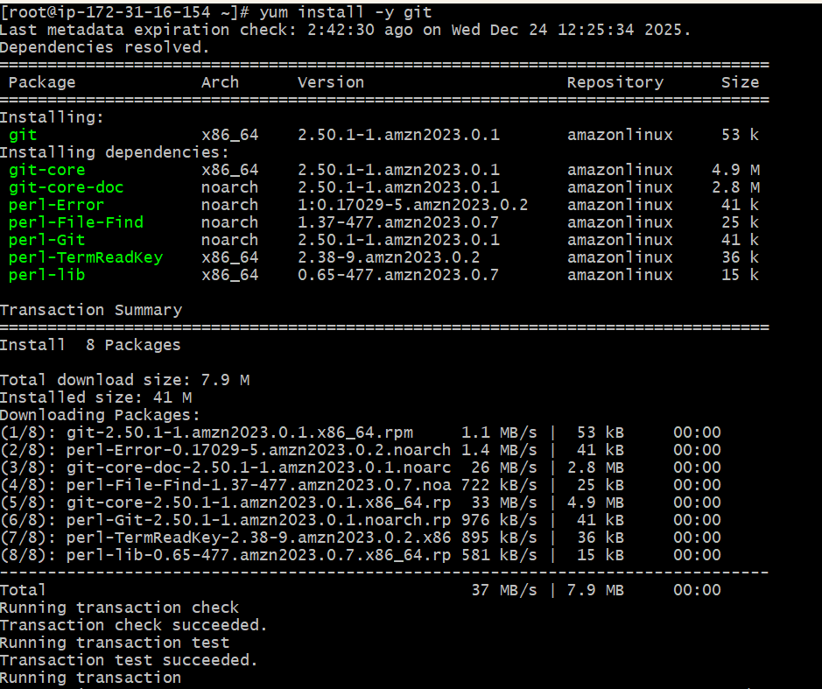

Step 6: Now the error is not appearing once git installed and Save

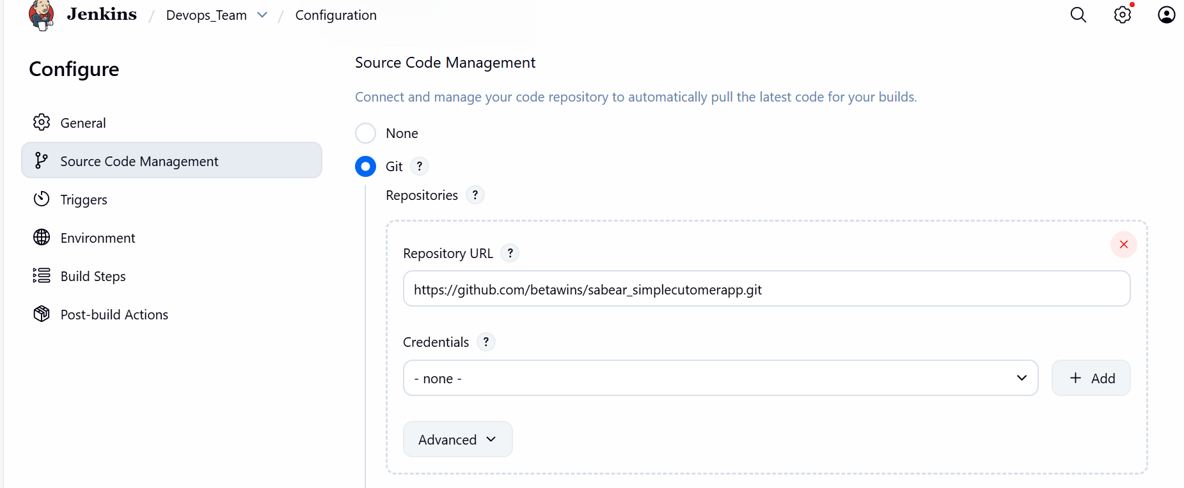

Step 7: We shall now start Build and check the status.
Success- now the console output says Success.
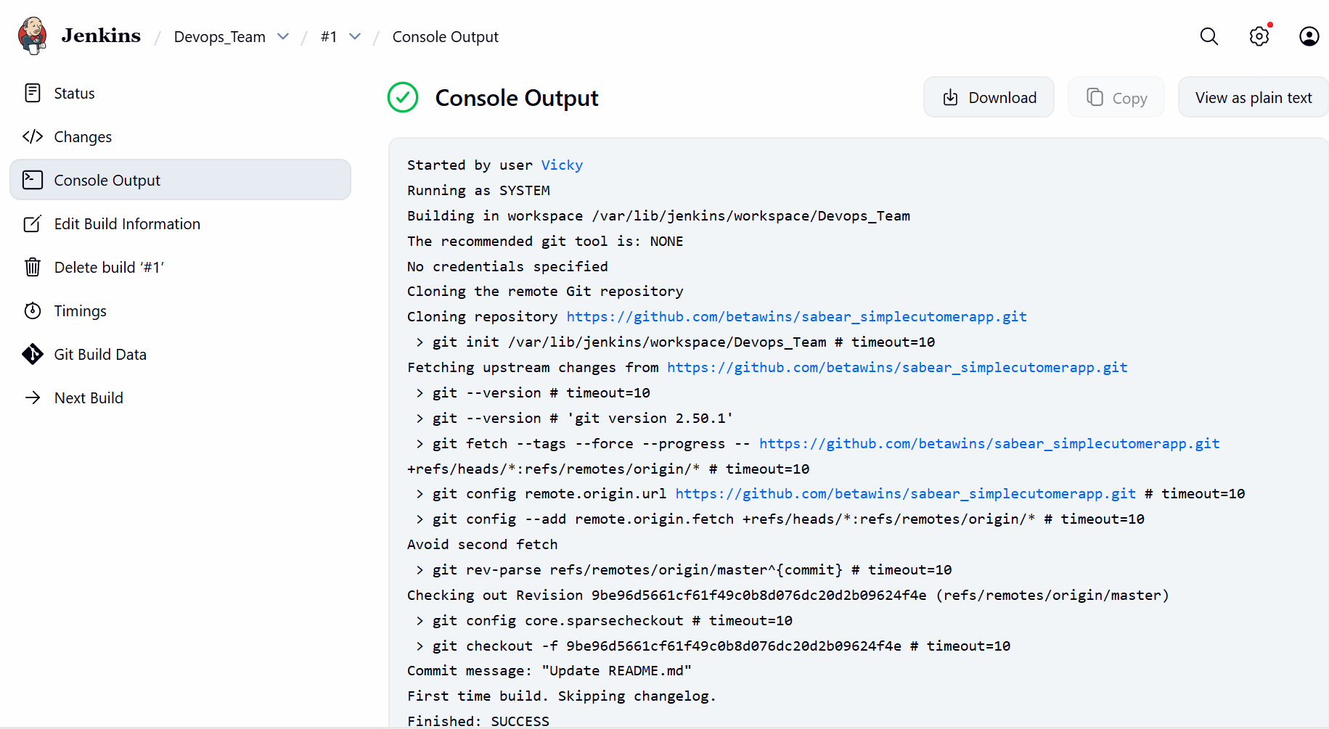

- Status is good and run time is displayed.
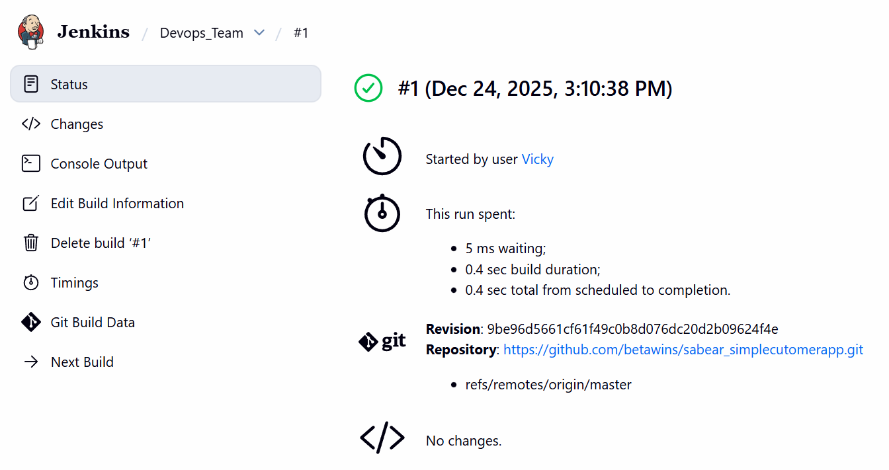

Step 8: We can verify the node is working as expected.
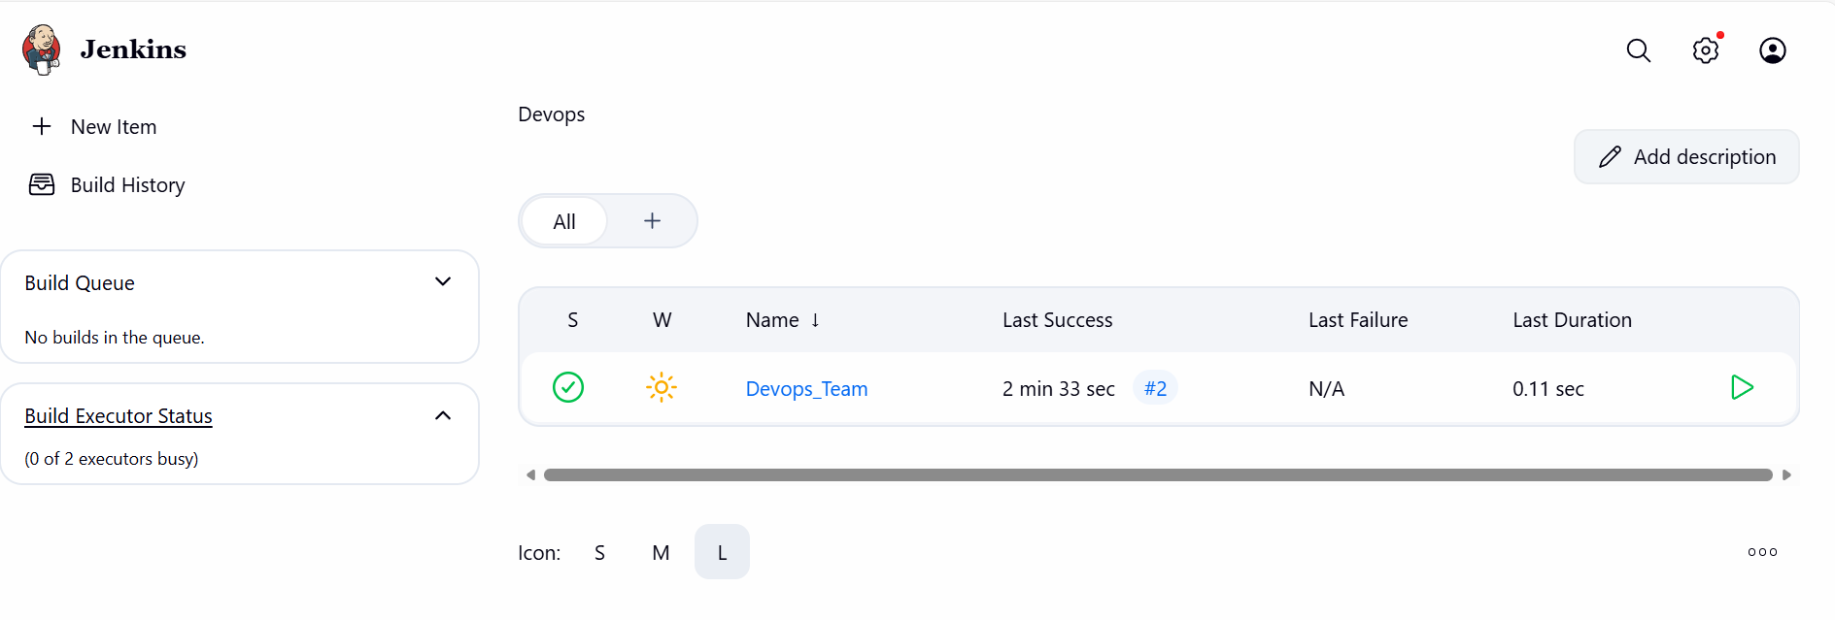

Conclusion: Node labels were successfully configured in Jenkins and jobs were restricted to run only specified Label- Devops.

Task-5: Create Three sample jobs using the below URL. https://github.com/betawins/Techie_horizon_Login_app.git

Objective:
Create 3 sample jobs in order to create, configure and execute them accordingly.

Prerequisites:
- Jenkins

Step by step Implementation:

Step 1: Create 3 jobs to configure and execute.
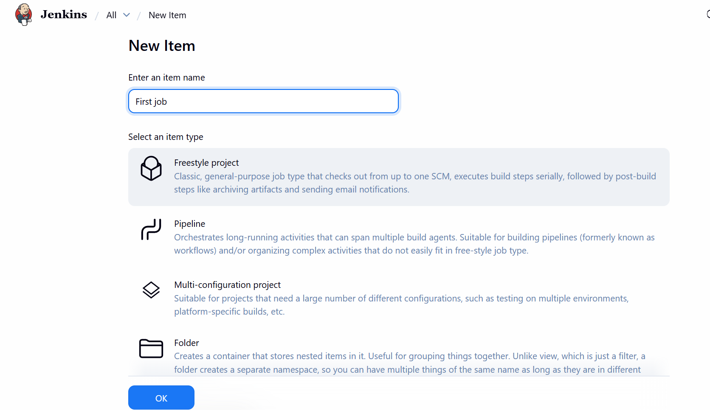
- Attached the repo link to the Job and save.
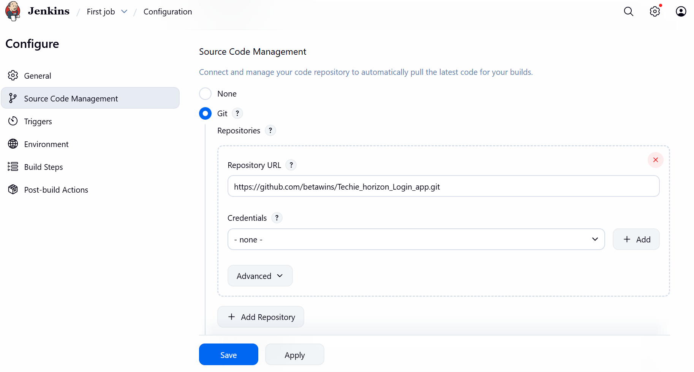

- Verified in the status- Ready for execute.
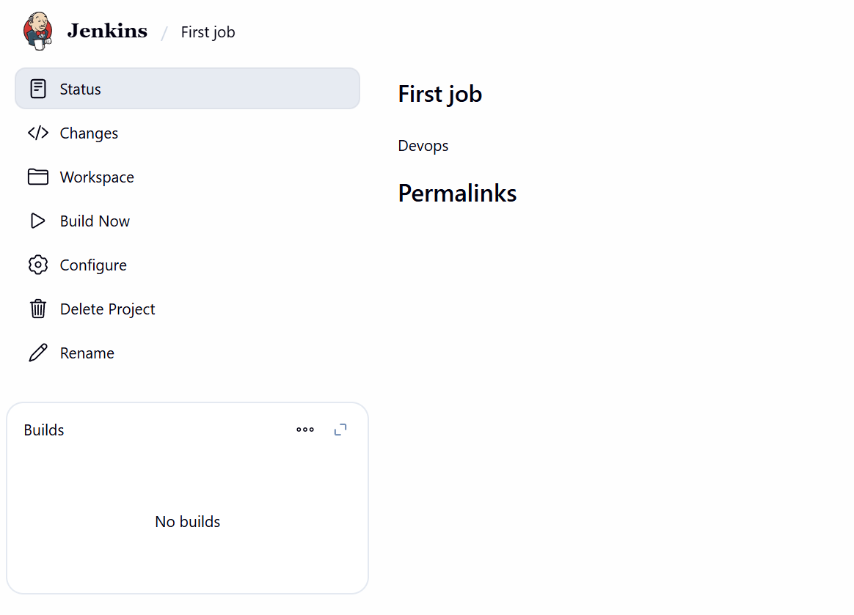
- Second job ready.
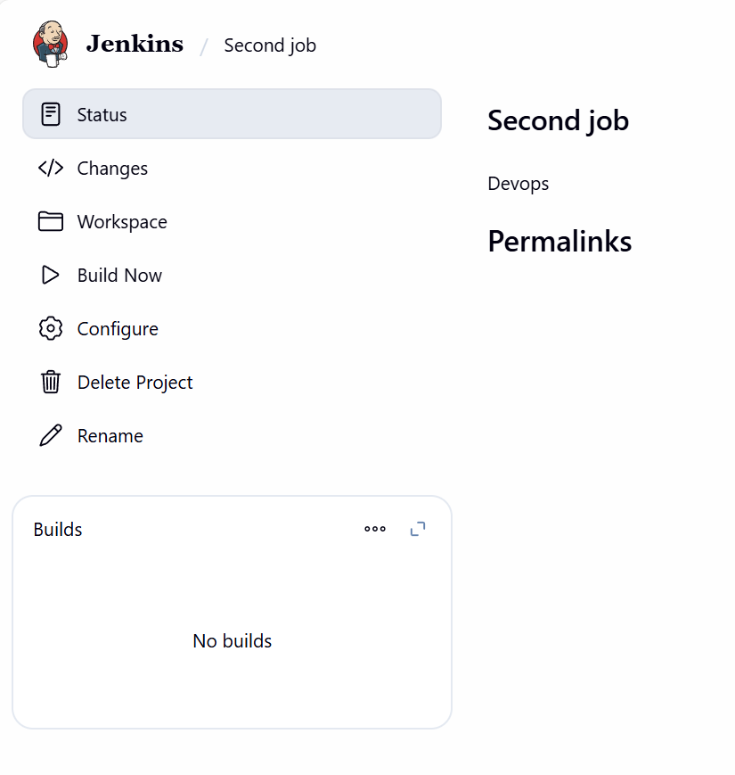

- Third Job ready
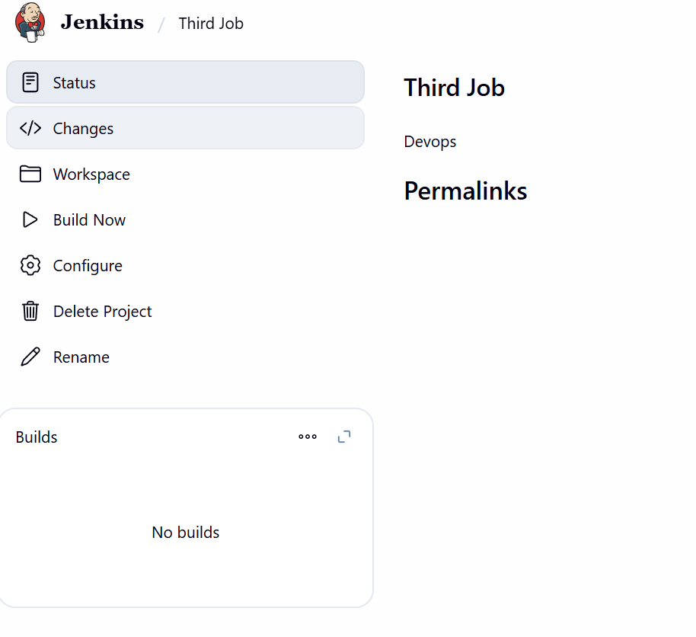

Step 2: All jobs are created and ready for build. For first and second job, I have labelled correct and Third job label is incorrect for validation purpose.
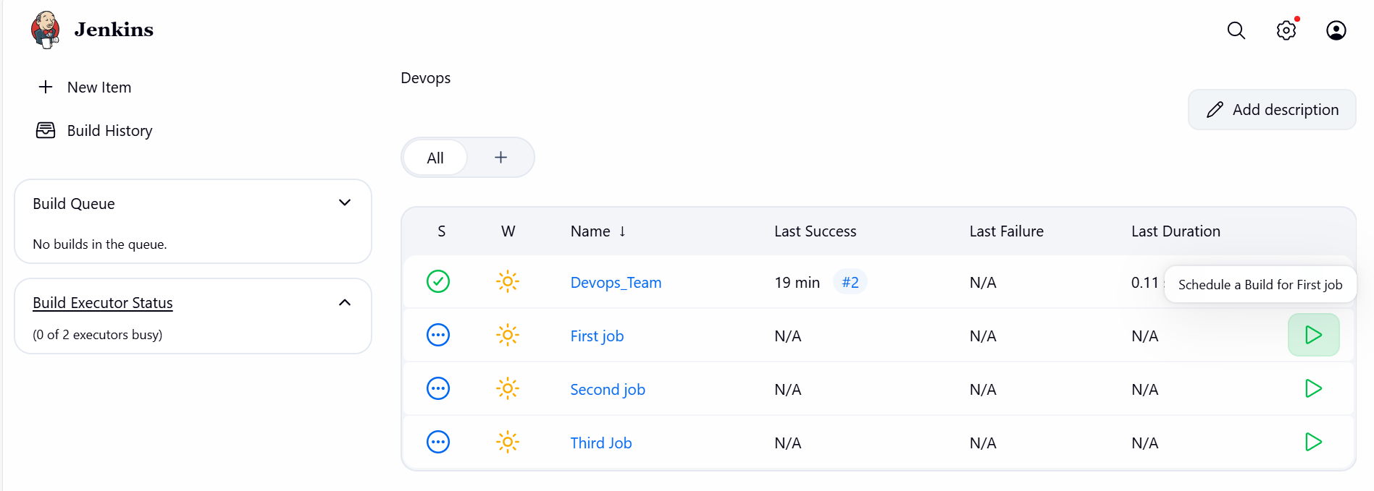
- We can see the second job is still in Queue, because the label is incorrect.
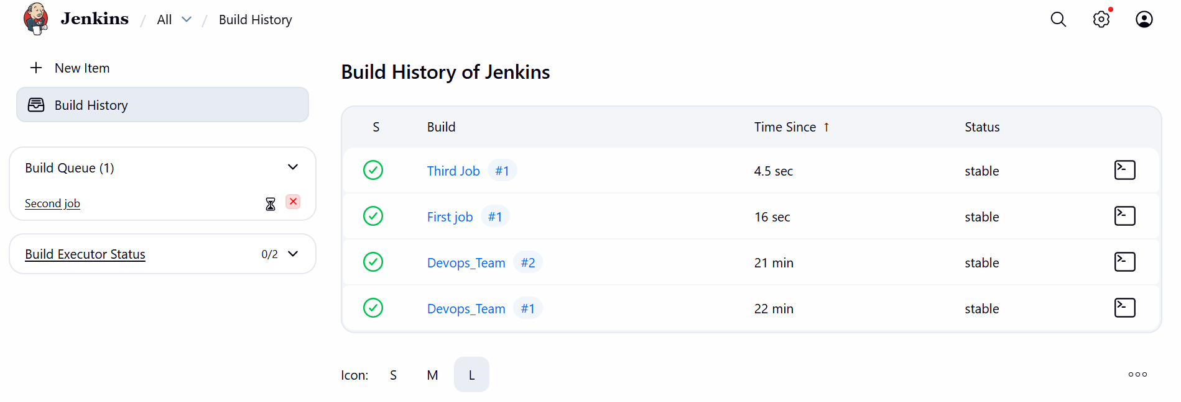
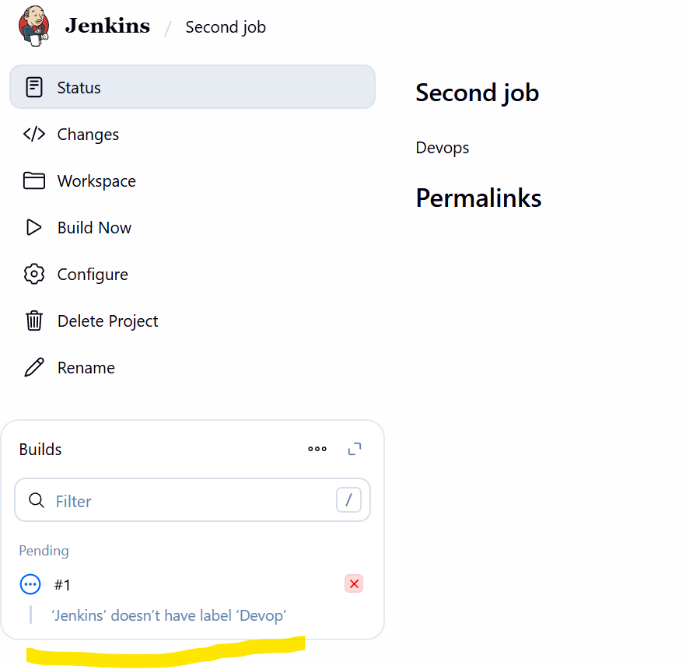

Last step: We can see the jobs are successful.
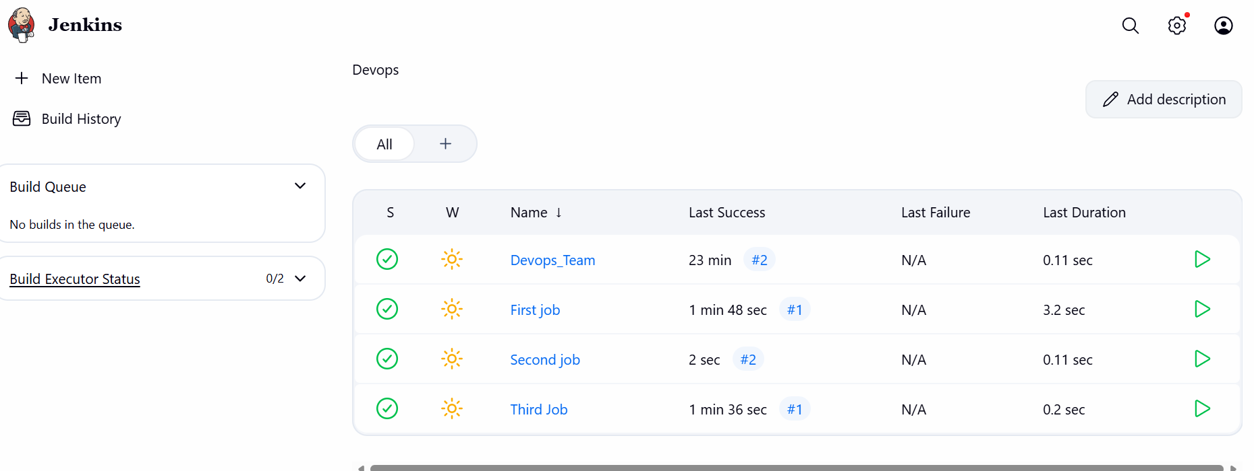

Conclusion: We took 3 sample jobs in Free style, configures with Labels which we created earlier and validated with one of the job incorrect and made sure its working well and validated.

