Docker-01

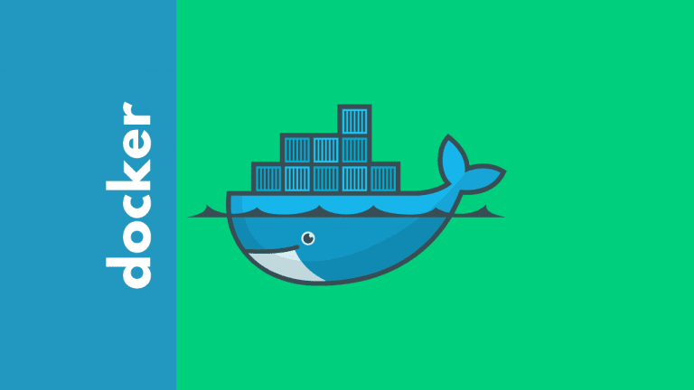

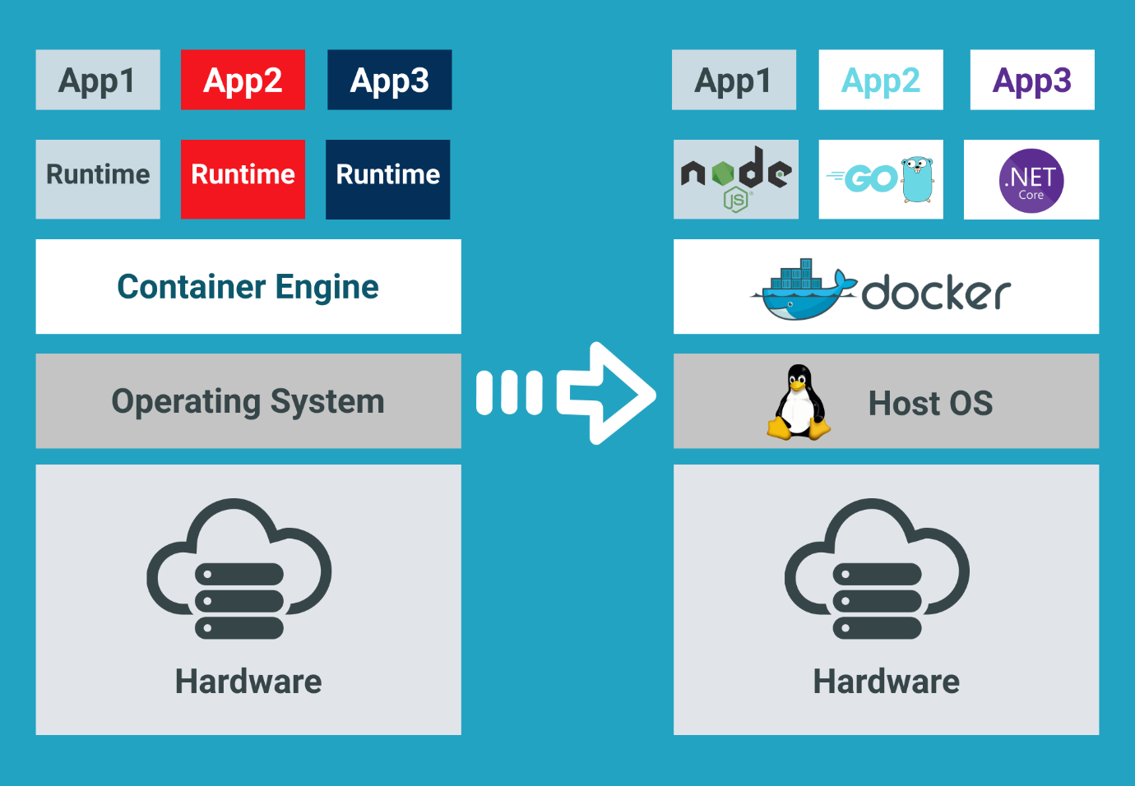

Task Title
Docker-01
Objective
The objective of this task is to watch the Docker-01 video posted on slack and worked on executing the initializing Ansible shown in video.
Prerequisites
List all requirements before starting:
- Virtualization
- Containerization
- Infrastructure
- Hypervisor
- Operation system (O.S) – Windows, Linux, Ubuntu
- Bins/libraries
- Applications

Issues Faced: Briefly mention issues and how you fixed them. Posted below in the last.
Conclusion
Conclusion has been provided for every task at the end.

Docker:
Docker is a powerful tool for containerization.

What is containerization? And similar to containerization?
Ans. Alternative tools:
- LXC (Linux container)
- Docker
- Podman

Difference between Containerization and Virtualization?

Virtualization:
- Virtual machines are dependent on operating system
- Virtual machines will take long time to start up & shutdown.
- Virtual machines size is very high and it is not flexible to move from one environment to another environment.

Containerization:
- Containers are independent of O.S
- Container will be very fast to start up and to shut down.
- Containers size will be very low making them flexible to move from one environment to another env.

Virtualization

App1 | App2 | App3
bins/libraries | bins/libraries | bins/libraries
o.s (Ubuntu) Guest | o.s (Ubuntu) Guest | o.s (Ubuntu) Guest
 | Hypervisor
 | Infrastructure

Containerization
App1 | App2 | App3
bins/libraries | bins/libraries | bins/libraries
 | Containerization (Docker, Podman, LXC)
 | Host Operating system
 | Infrastructure

Infrastructure- CPU, RAM etc.
Hypervisor- is a software which will us to create virtual machine.
Operating system: Will help us to deploy our application

O.S in containerization: We do not require Operating system in Containerization, instead, we can download the image and test.

When there is no dependencies between O.S and Containerization, the O.S which has kernels will be shared with bins/libraries.

Tasks:
- Setup a virtual machine using Ubuntu image.

Step by step Implementation:
Step 1: Install a virtual machine in ec2 and select Ubuntu image

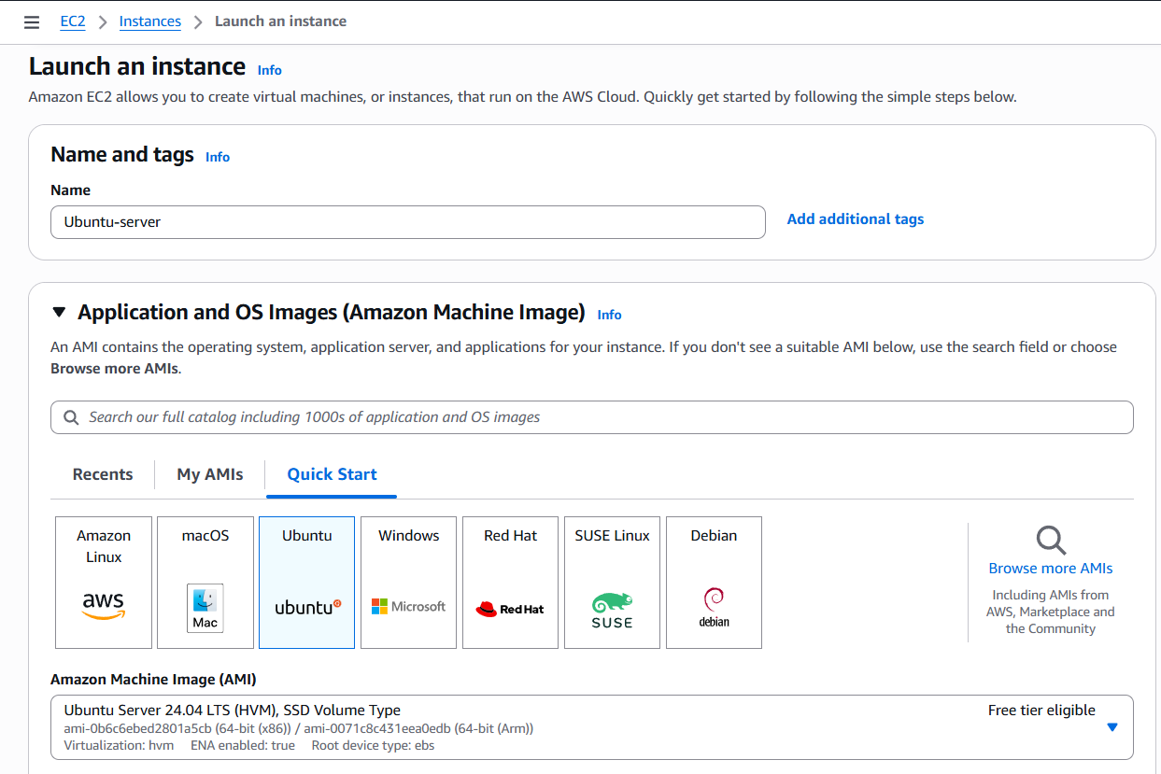

We took m7-large for further tasks and created a new keypair- Docker
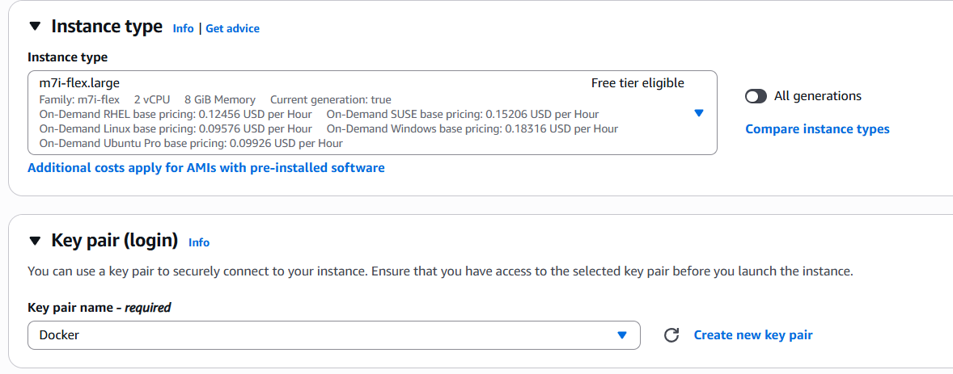

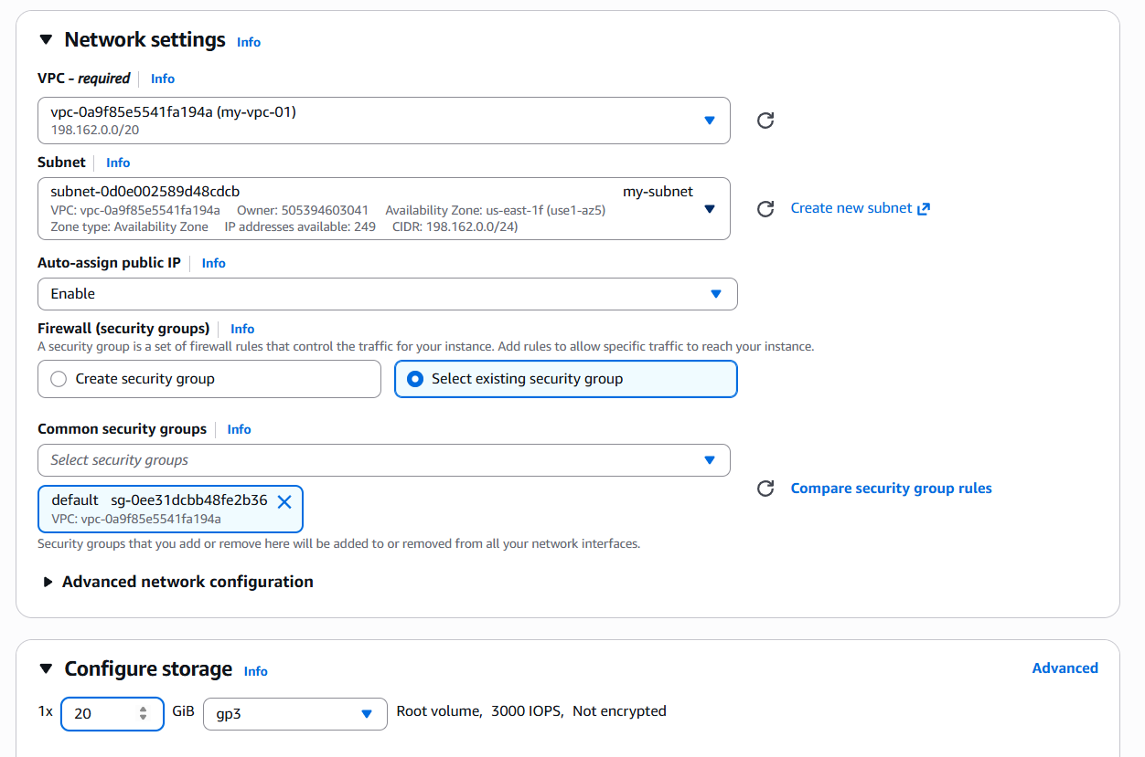
Instance launched

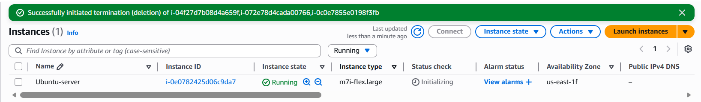

- Install docker on ec2.

Step 1:
update the packages using command- apt update -y
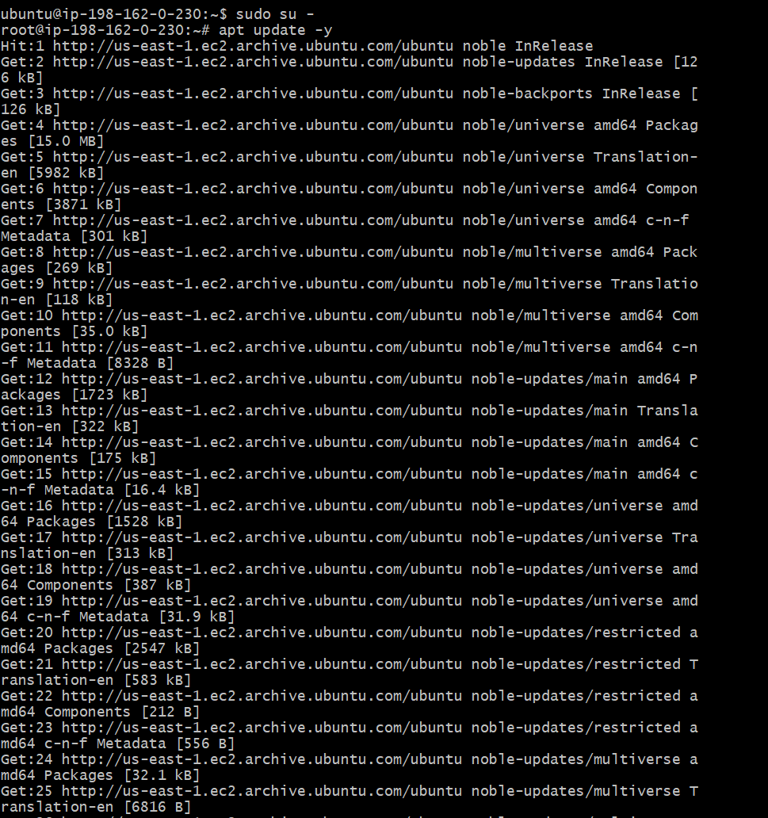

Step 2:
apt list --upgradable
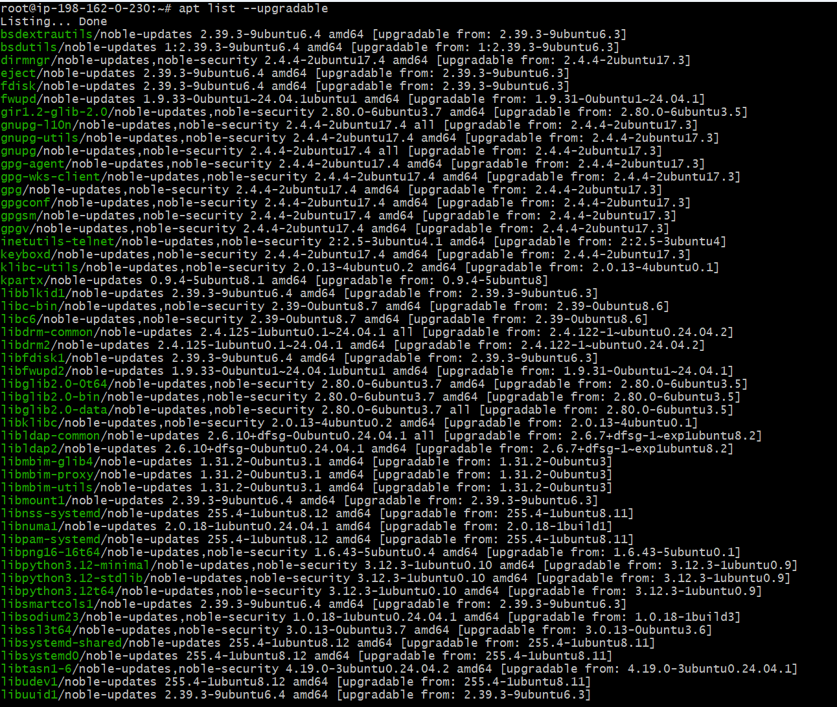

Step 3:
Install Docker using command- yum -y install docker
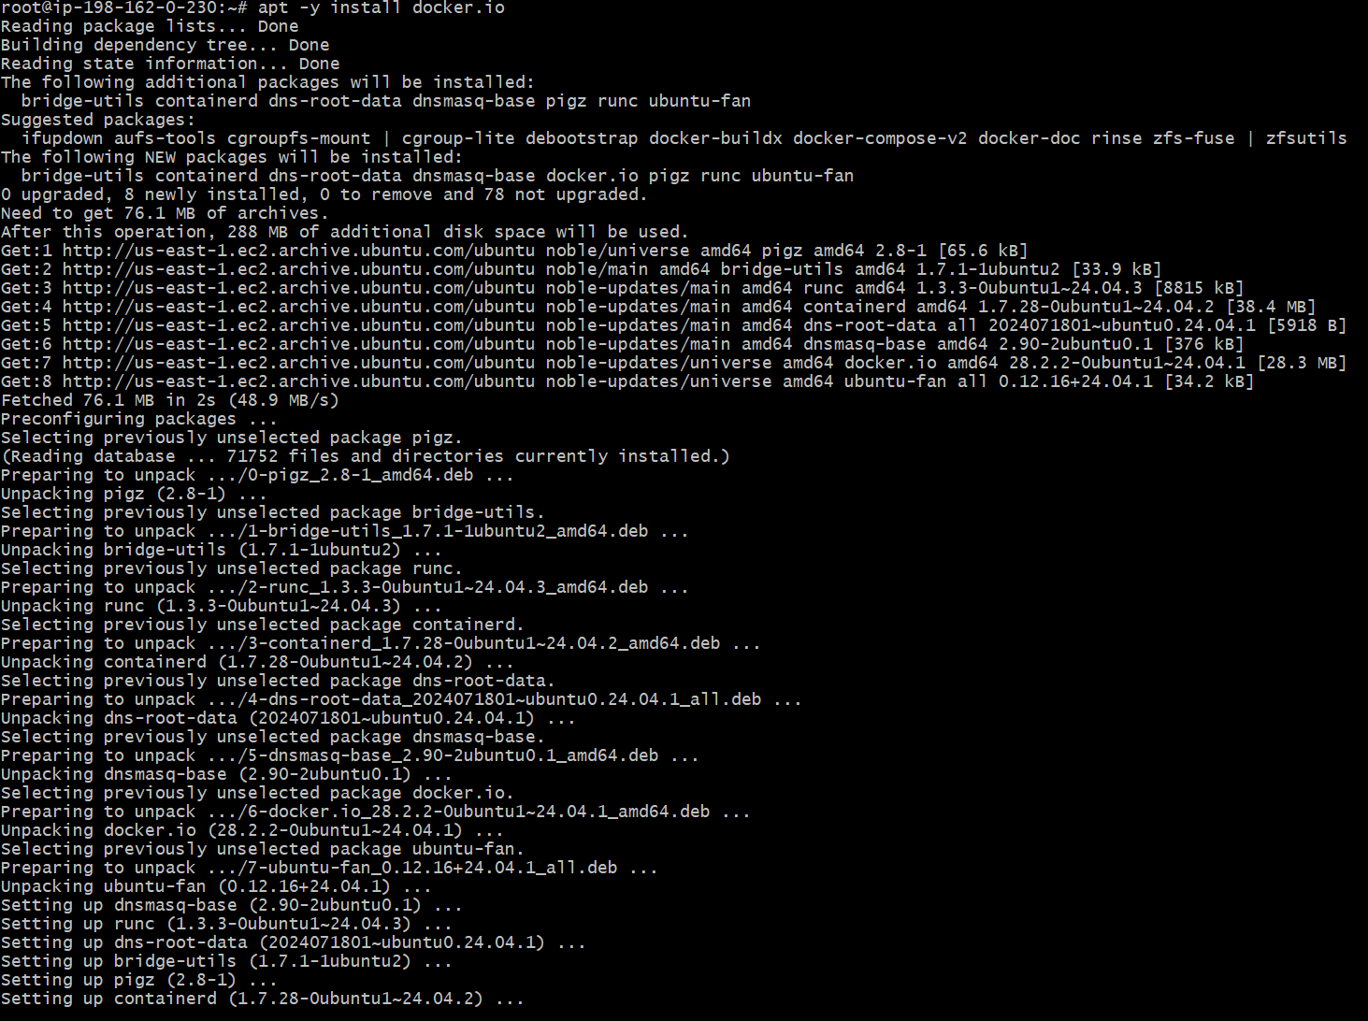
Step 4: Started the service and status is active
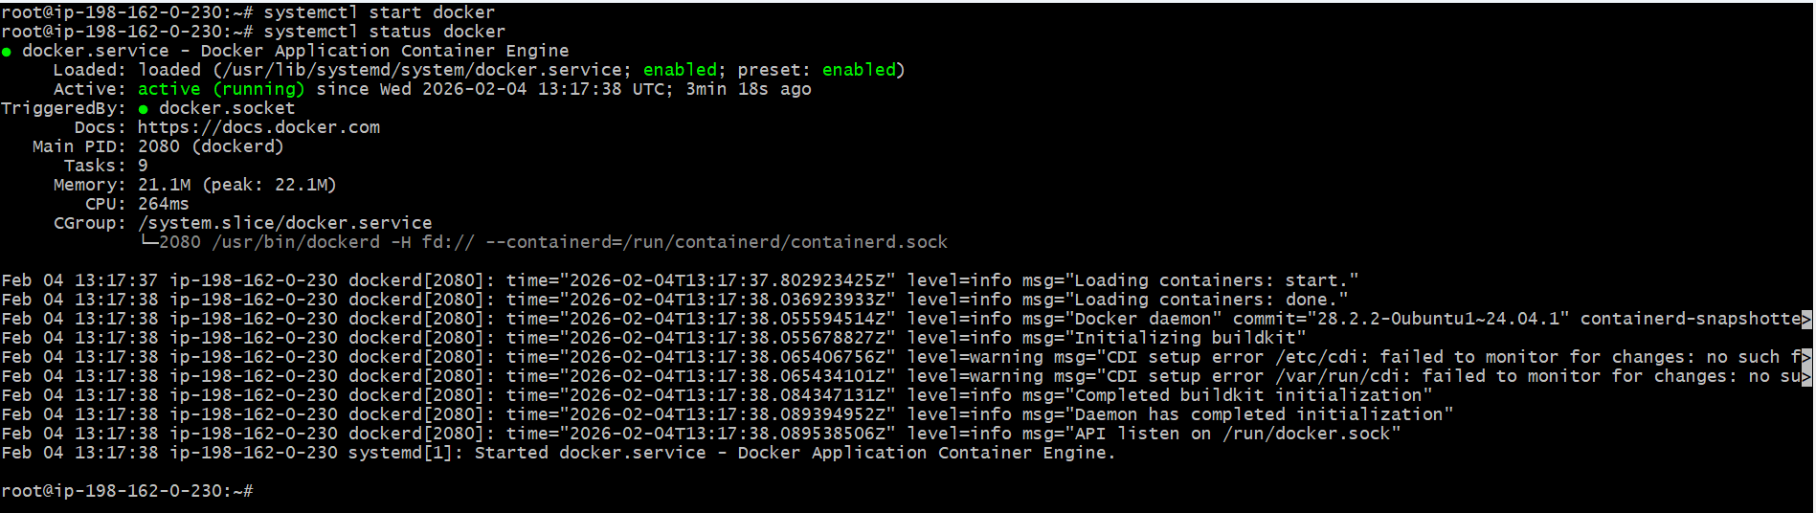

Task completed

- Pull 5 docker images (nginx, apache tomcat, ubuntu, jenkins, sonarqube)

Step 1: Service is active let’s check few commands below
Docker pull nginx this image has been pulled from Docker Hub
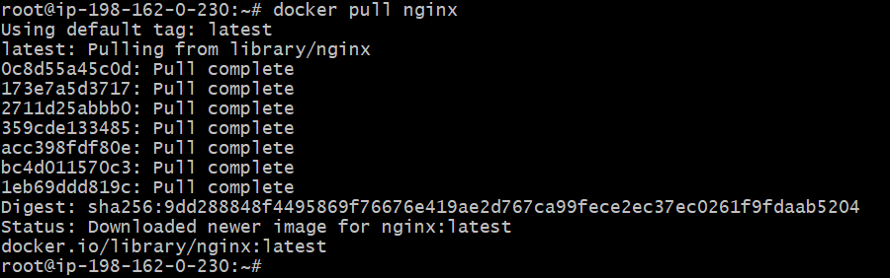
Docker pull apache this image has been pulled from Docker Hub
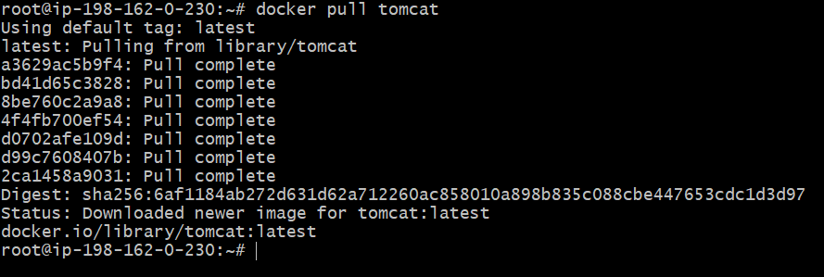
Docker pull Ubuntu this image has been pulled from Docker Hub
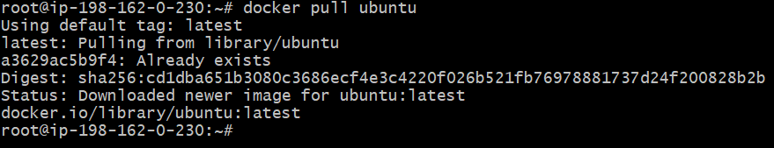

Docker pull jenkins this image has been pulled from Docker Hub – tags 2.60.3
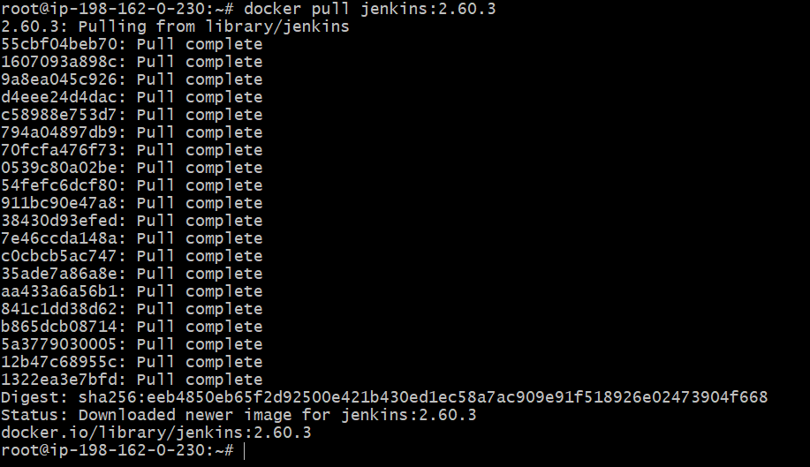
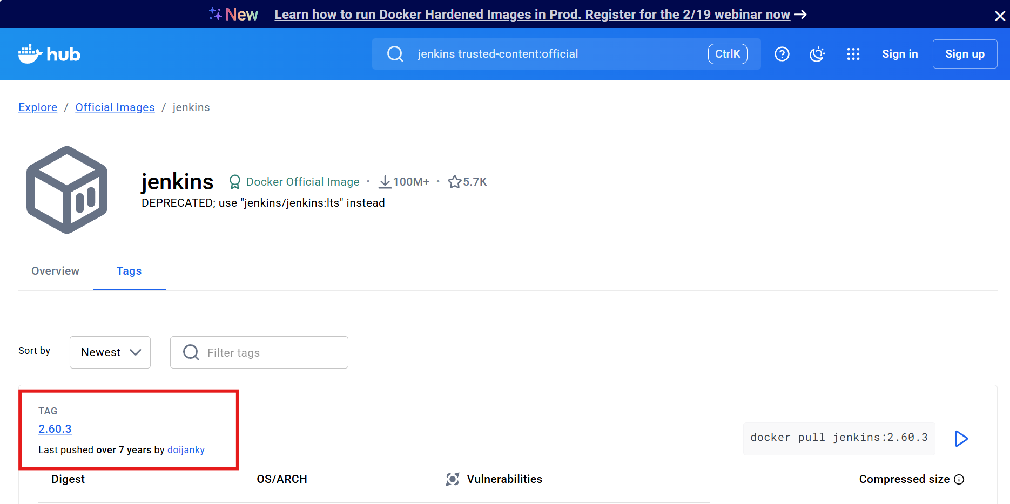

Docker pull sonarqube this image has been pulled from Docker Hub
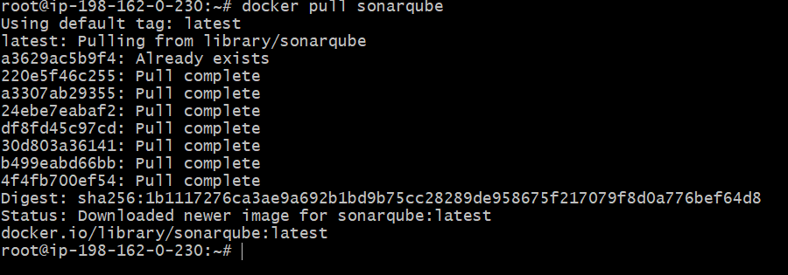

Task completed

- Run nginx container and expose on port 81.

Step 1: Use command- docker container run -itd -p 81:80 nginx

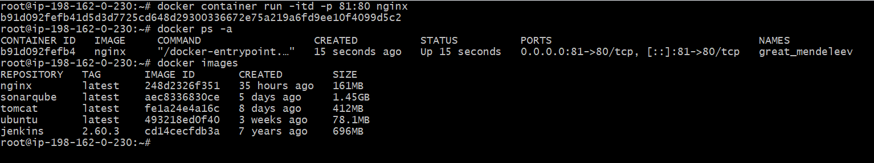

Run
• Creates a new container
• Starts it immediately
👉 If the image is not present, Docker downloads it first.
🔹 -d
Detached mode
• Runs the container in the background
• Your terminal stays free
Without -d, nginx logs would block your terminal.
🔹 -p 81:80
Port mapping (most important part)
Format:
-host-port: container-port
So:
• 81 → your machine / server port
• 80 → nginx port inside the container
Meaning:
When someone accesses port 81 on the host, traffic is sent to port 80 inside the nginx container.
What happens after running this command?
• nginx runs inside a container
• nginx listens on port 80 internally
• Docker exposes it on port 81 externally

Step 2: Update security groups to include port 81 under custom TCP.
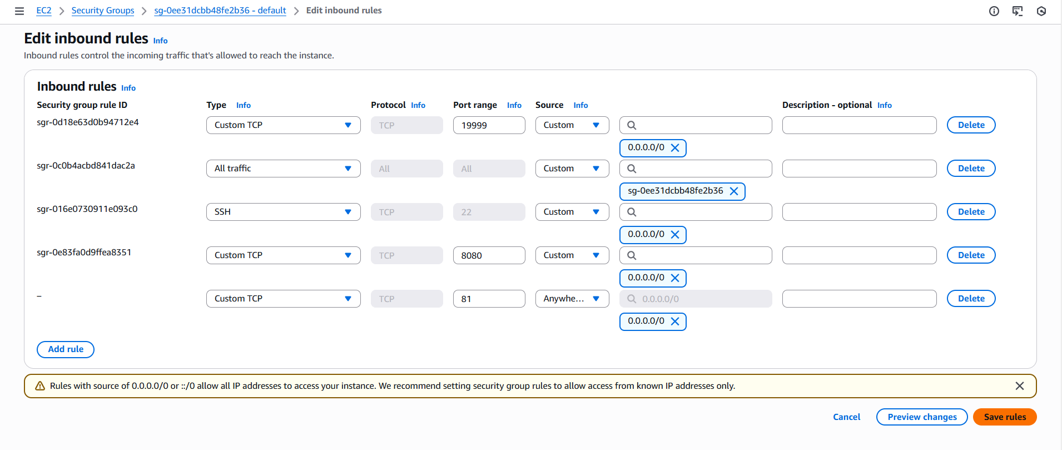
Step 3: Verify in the browser.
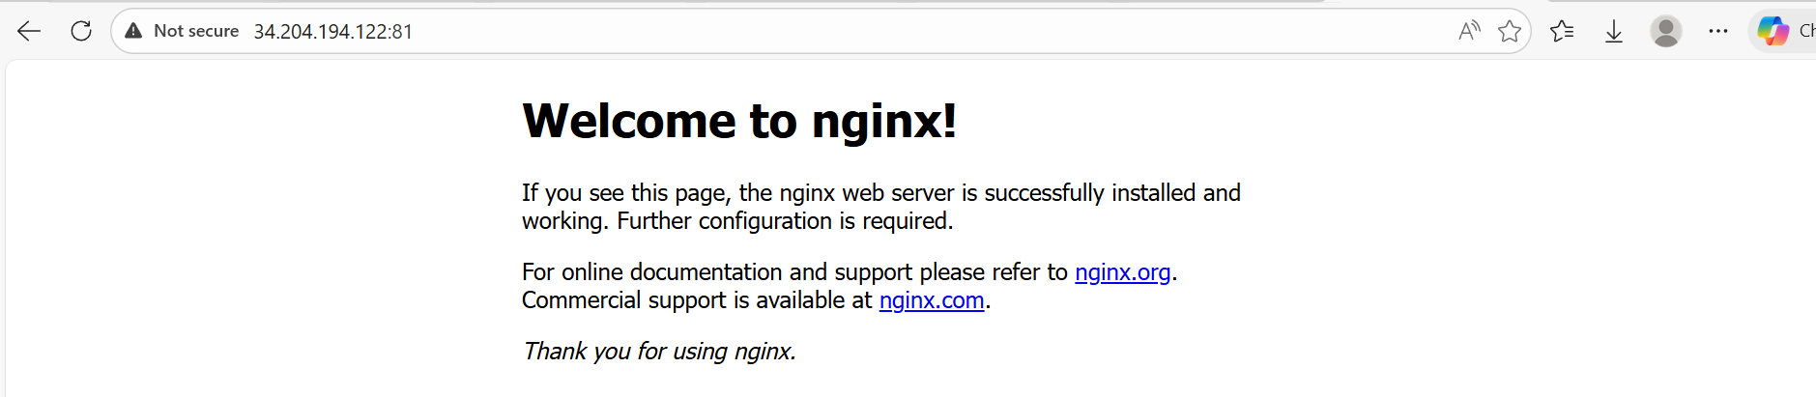
- Delete the apache tomcat image from local.

Step 1: use command- docker ps -a
- Use command- docker images to verify if Tomcat is present
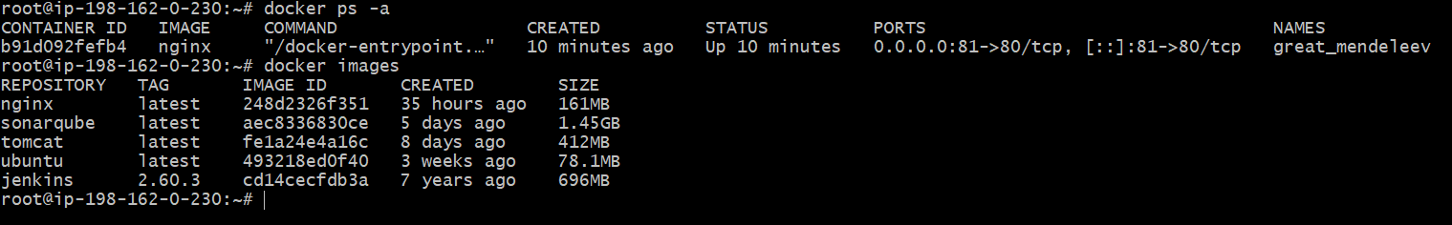

Step 2: Remove tomcat using command- docker image rmi tomcat
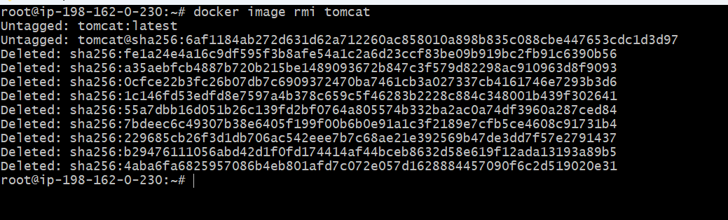

Task completed

- Inspect the jenkins image, sonarqube image.

Step 1: Use command- docker image inspect jenkins:2.30.6

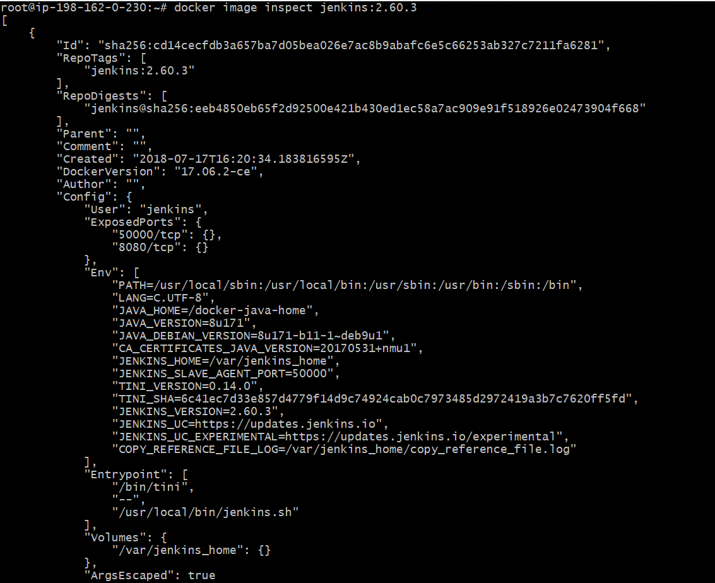

Step 2: Inspect sonarqube- docker image inspect sonarqube
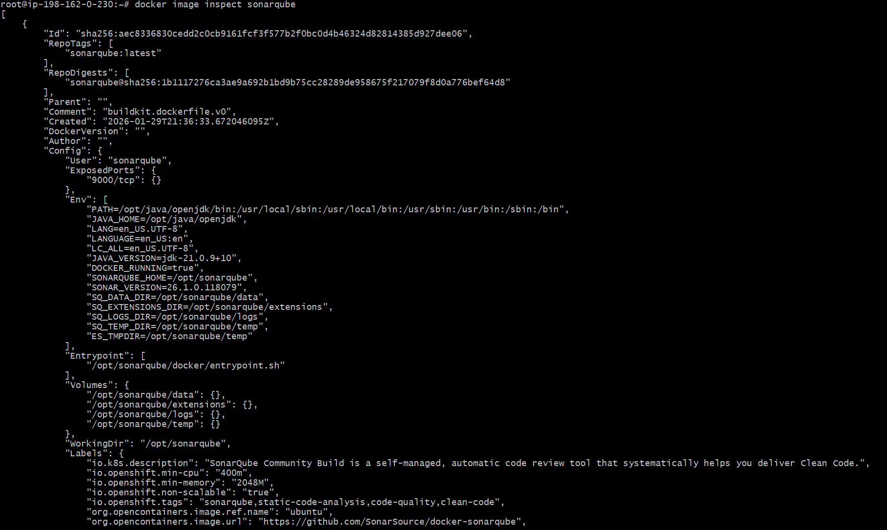

7) Run jenkins container and run one sample job.

Step 1: Use command- docker container run -itd -p 8080:8080 jenkins:2.30.6

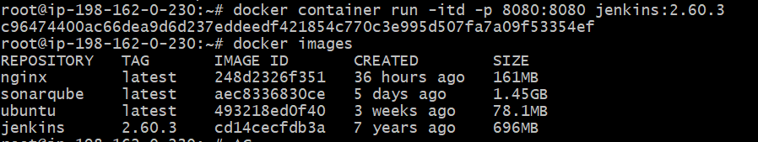

Step 2: verify the port number with IP to get started with Jenkins GUI
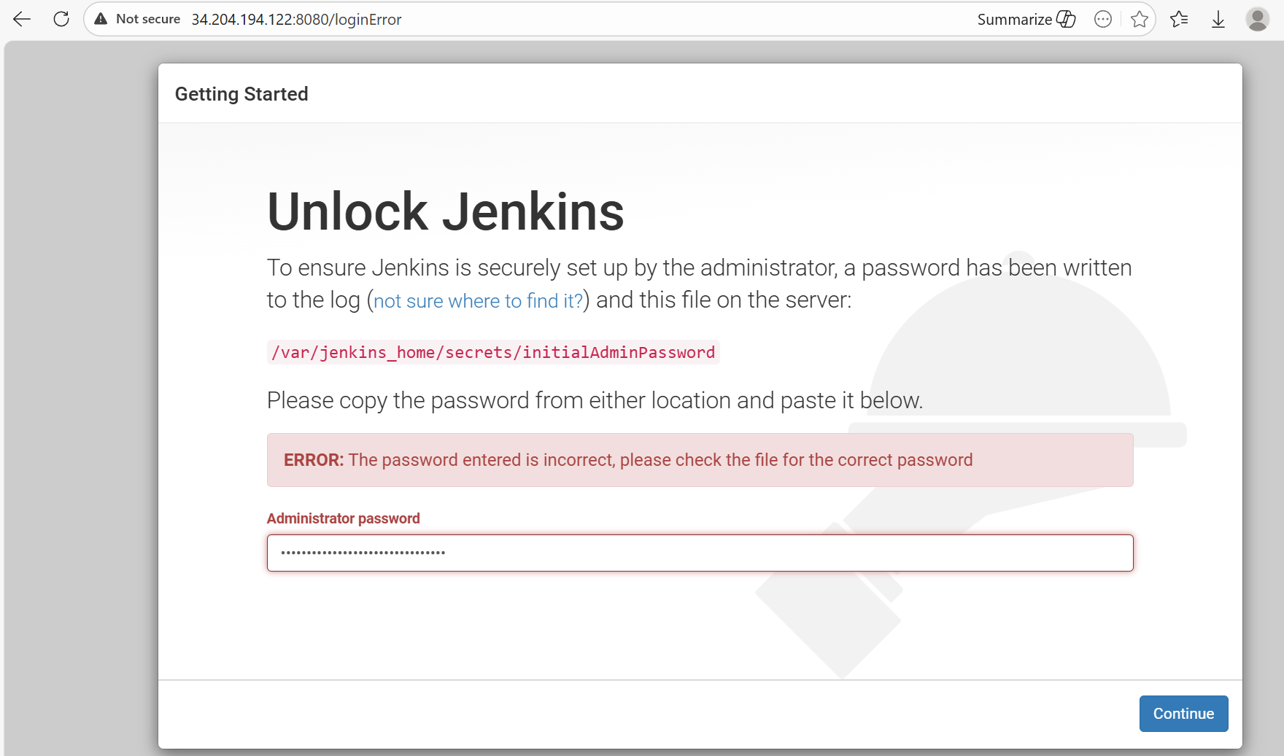

Step 3: run command- docker exec <jenkins container id> cat /var/jenkins_home/secrets/initialAdminPassword
To get the initial password for Jenkins GUI

Step 4:
Install suggested plugins
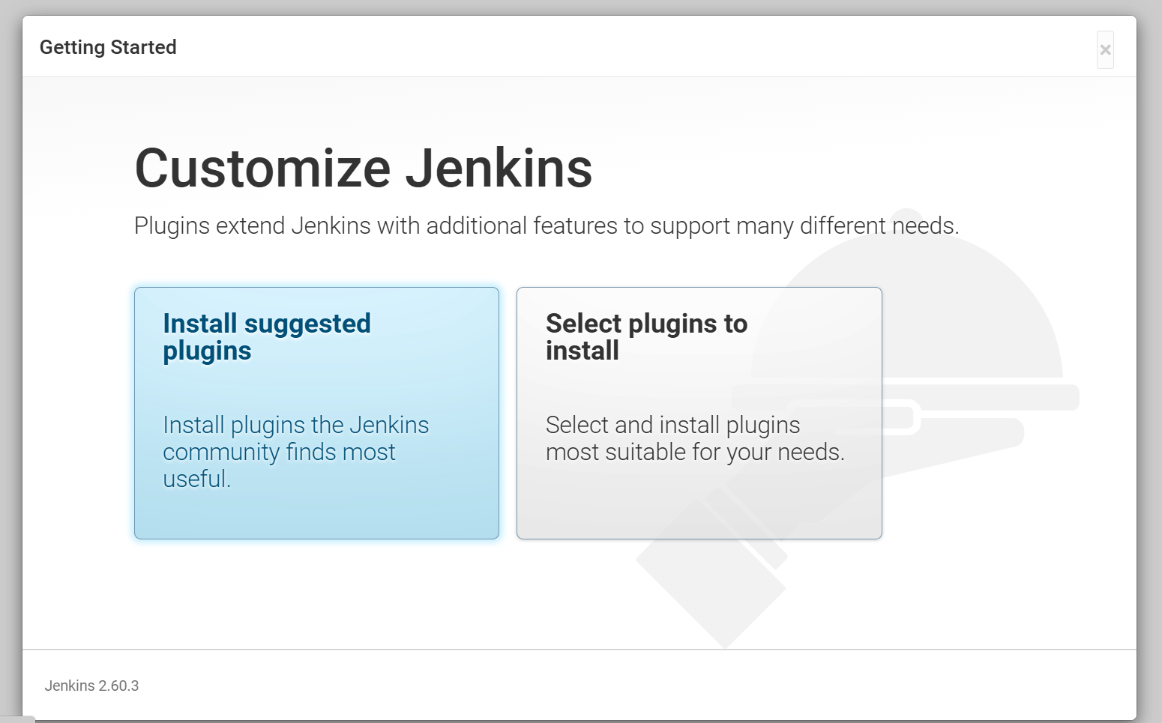

Step 5: Create a job with freestyle project
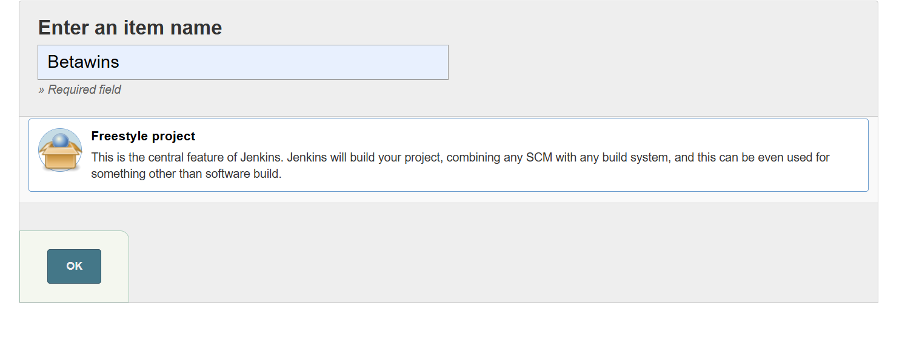

Step 6: Navigate into the job under Build add the below script to execute

#!/bin/bash
set -e

echo "Starting build..."
echo "Workspace: $WORKSPACE"
echo "Build number: $BUILD_NUMBER"

# Basic commands
date
uname -a
whoami

echo "Build completed"

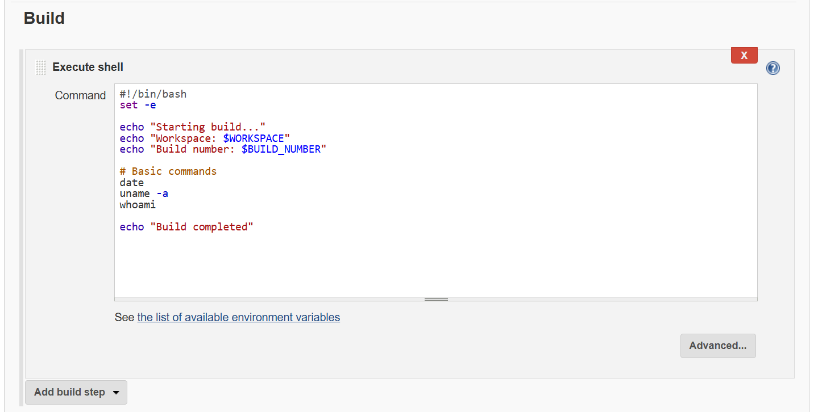

Step 7: Ready for build Build Now
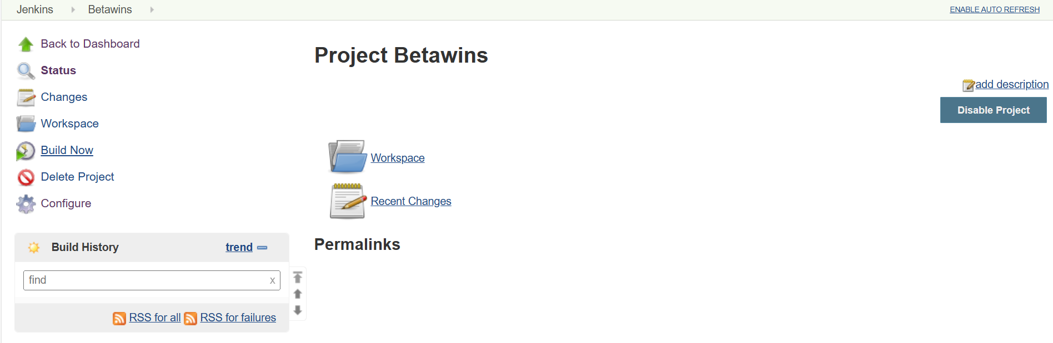
Step 8: Successfully ran one job using Jenkins container

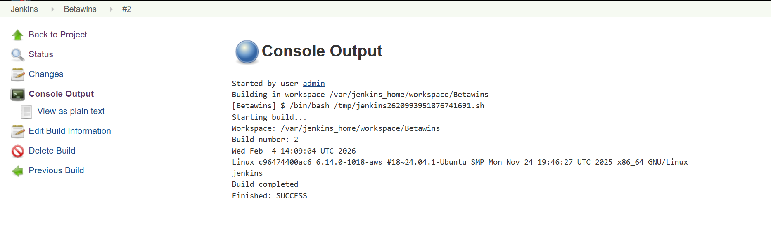

Docker Hub Account creation

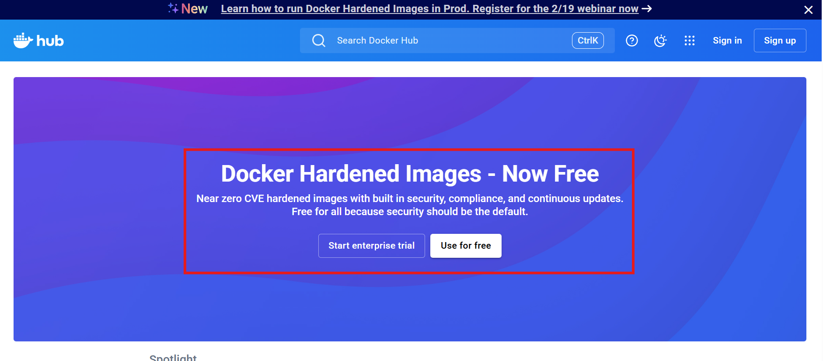

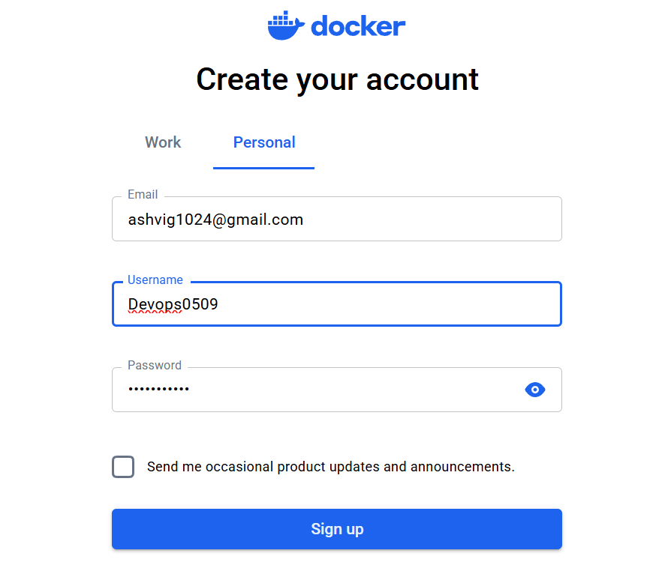

Username- Devops0509
Password- Same as username

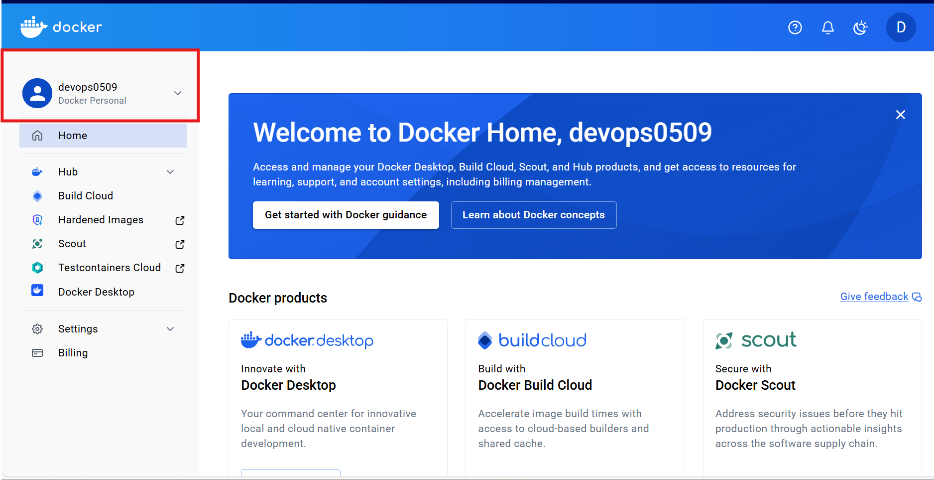

Docker Hub account created

