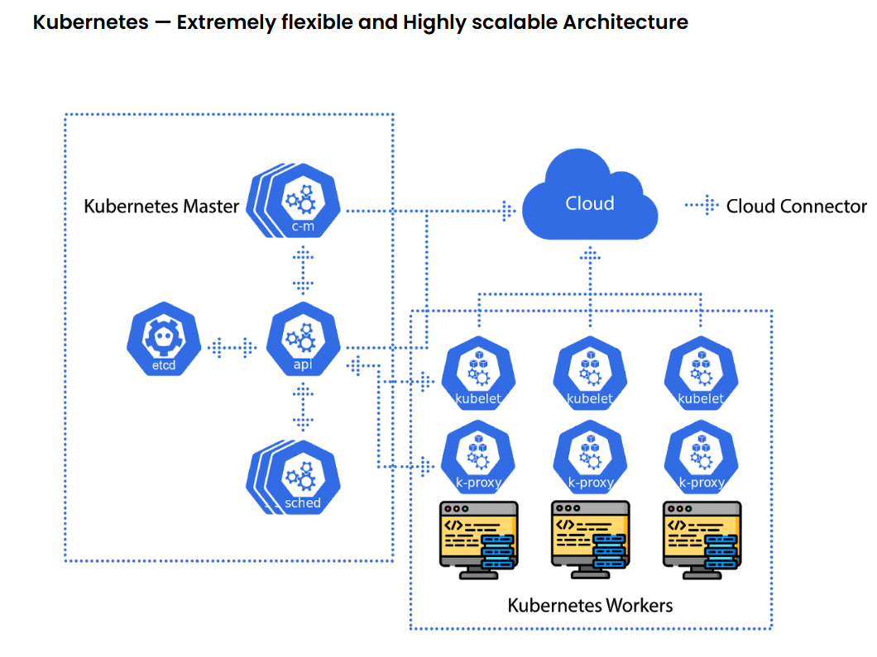
Task Title
Kubernetes
Objective
The objective of this task is to watch the K8s video posted on slack and worked on executing the initializing K8s shown in video.
Prerequisites
List all requirements before starting:
- Minikube set-up
- K8s Master and 2 Worker nodes set-up
- Run one nginx pod
Issues Faced: Briefly mention issues and how you fixed them. Posted below in the last.
Conclusion
Conclusion has been provided for every task at the end.
Tasks

- Setup Minikube in your local machine.
Objective:
To set up Minikube on our local machine, we need to install the tool, start a local Kubernetes cluster, and verify it’s running.
Minikube runs a single-node Kubernetes cluster inside a VM or container on our laptop — perfect for learning, testing, and demos.
Minikube:
========
Minikube is a single cluster with all k8s component.
Minikube is used for learning and development purposes.

Prerequisites:
- A hypervisor or container runtime like Docker
- At least 2 CPUs, 2 GB RAM (4 GB recommended)
- Internet access

Step by step Implementation:
Step 1: Install Minikube on windows
Install Docker on windows- We are using Gitbash here to install Docker on windows
Docker Desktop is already installed prior to this task.
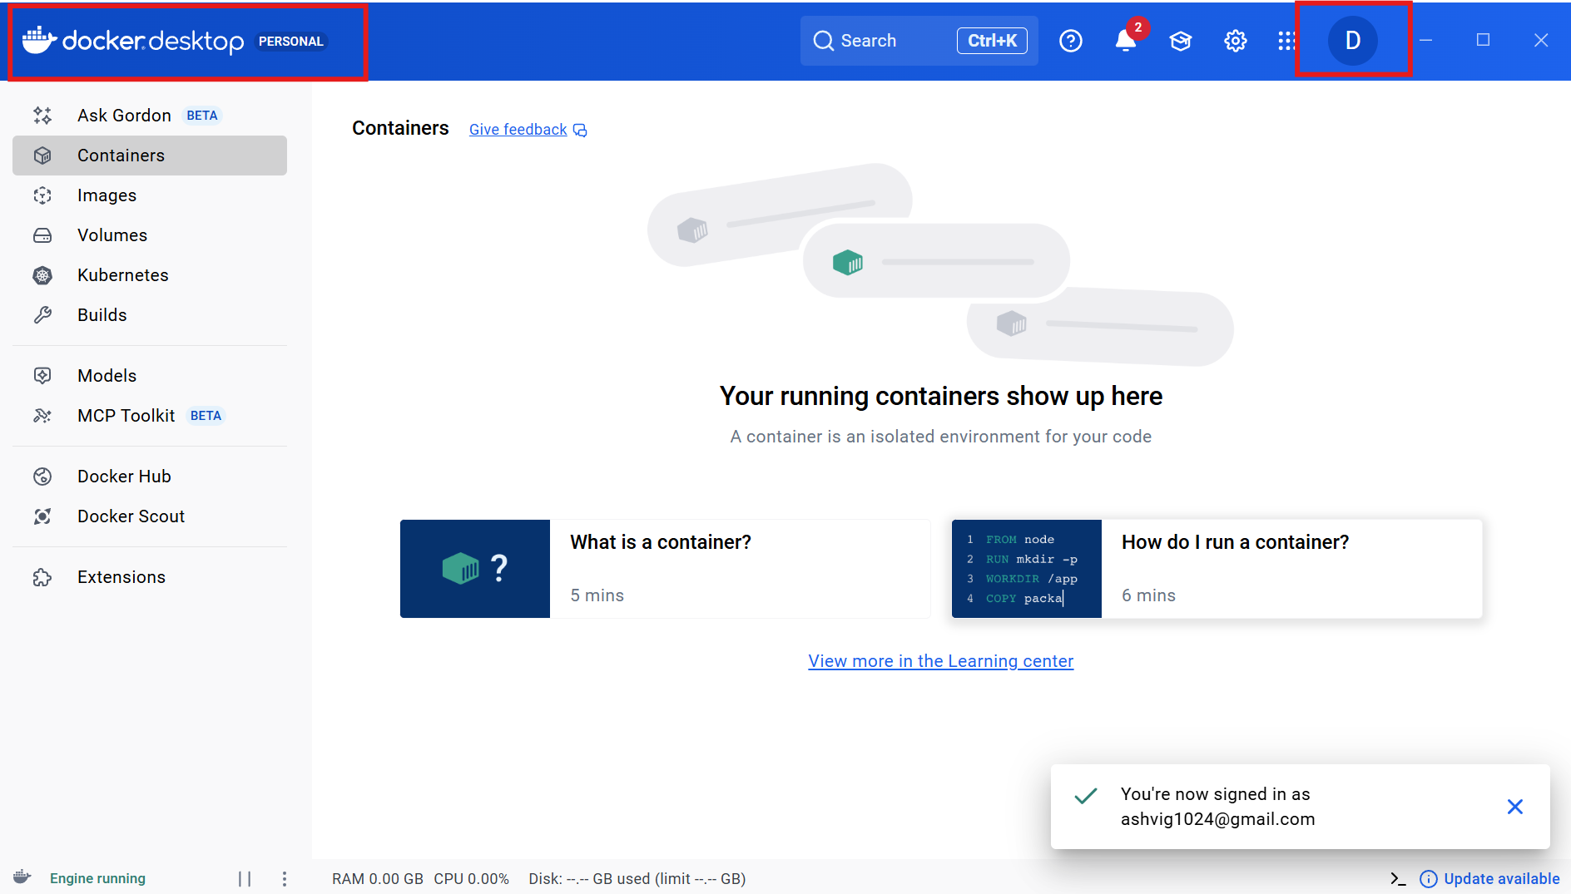

Step 2: Install Oracle box on windows
Oracle Virtual Machine is already installed on my laptop.
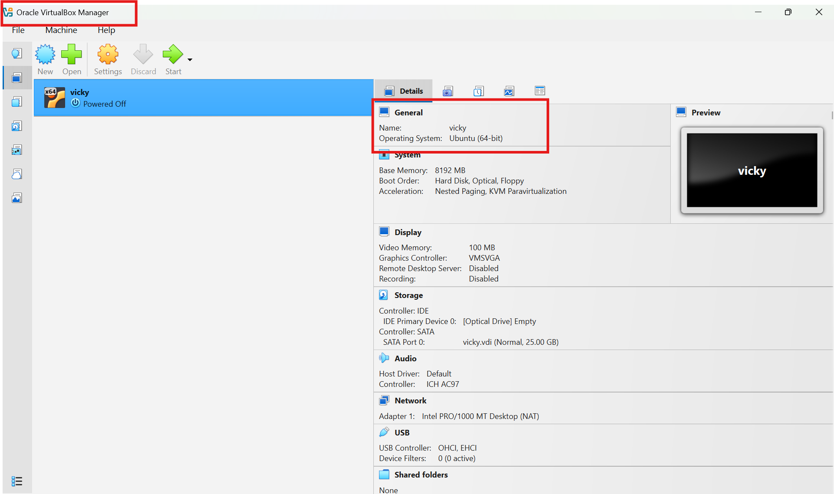

Step 3: Systeminfo
Hypervisor has been detected because we have our Virtual machine installed in laptop
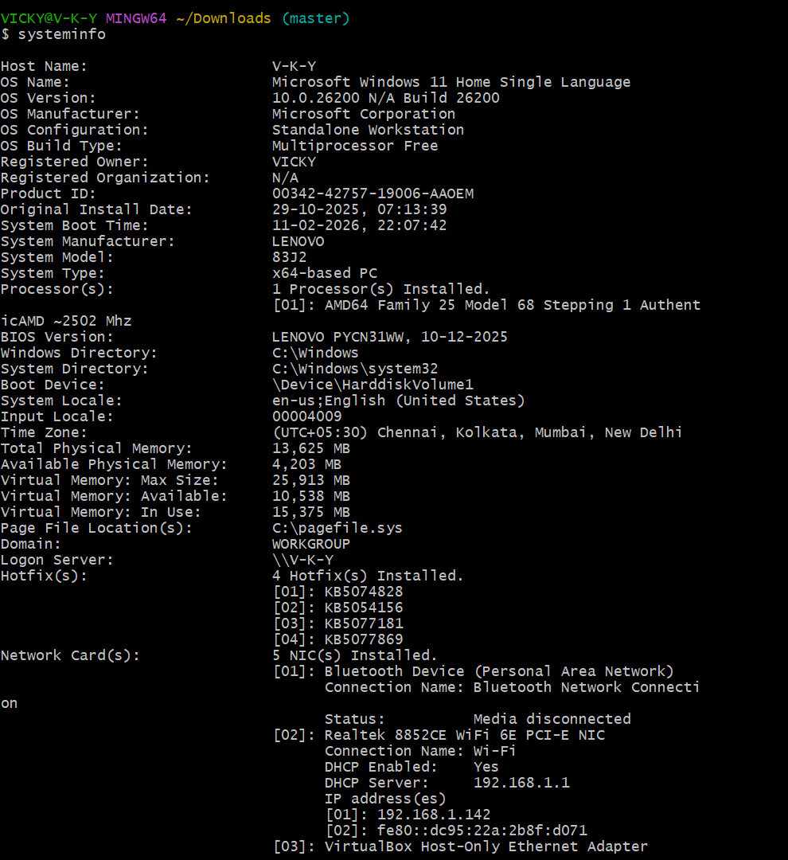

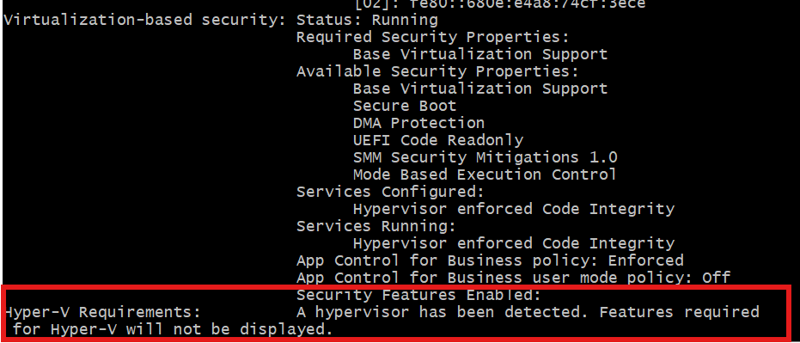

Step 4: Install Minikube using PowerShell
https://minikube.sigs.k8s.io/docs/start/

Docker is required because Minikube runs Kubernetes inside a container

Docker –version

Start https://minikube.sigs.k8s.io/docs/start/

New-Item -Path 'c:\' -Name 'minikube' -ItemType Directory -Force
$ProgressPreference = 'SilentlyContinue'; Invoke-WebRequest -OutFile 'c:\minikube\minikube.exe' -Uri 'https://github.com/kubernetes/minikube/releases/latest/download/minikube-windows-amd64.exe' -UseBasicParsing

$oldPath = [Environment]::GetEnvironmentVariable('Path', [EnvironmentVariableTarget]::Machine)
if ($oldPath.Split(';') -inotcontains 'C:\minikube'){
[Environment]::SetEnvironmentVariable('Path', $('{0};C:\minikube' -f $oldPath), [EnvironmentVariableTarget]::Machine)
}

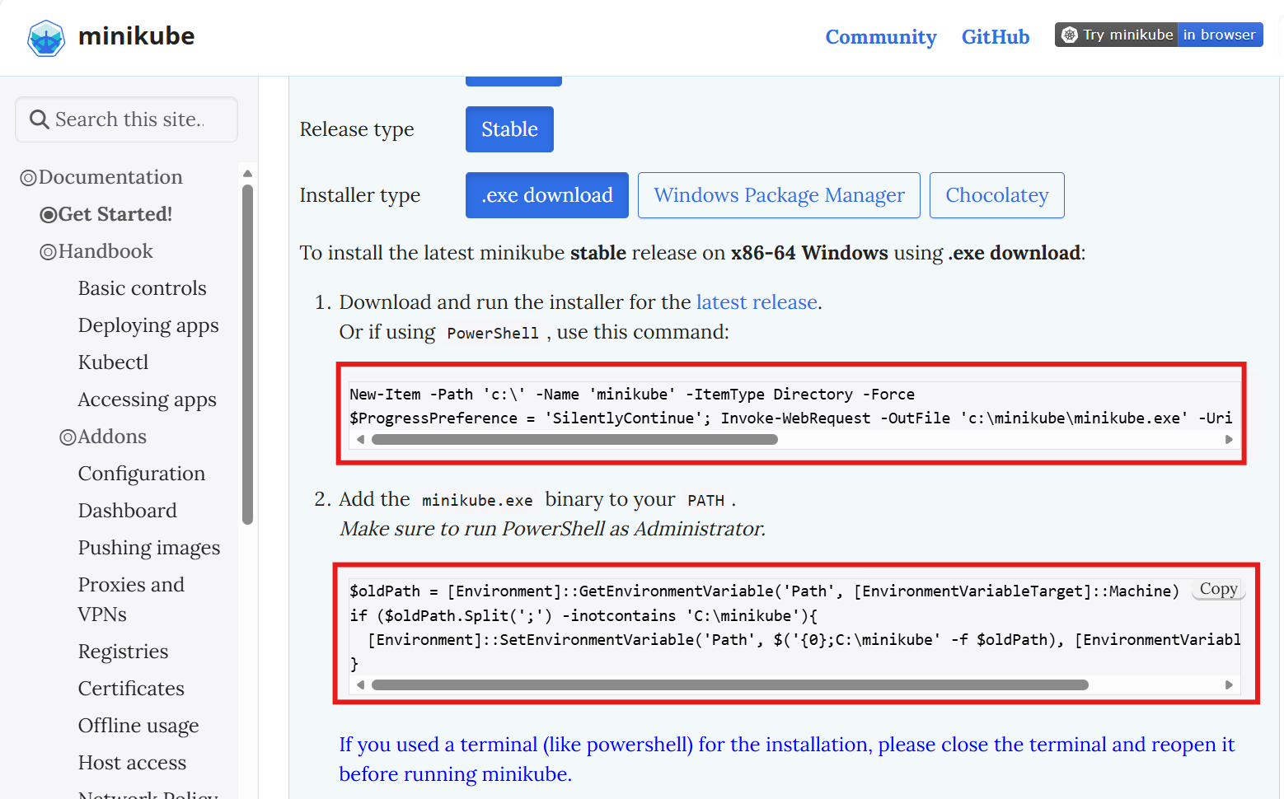

Windows Powershell
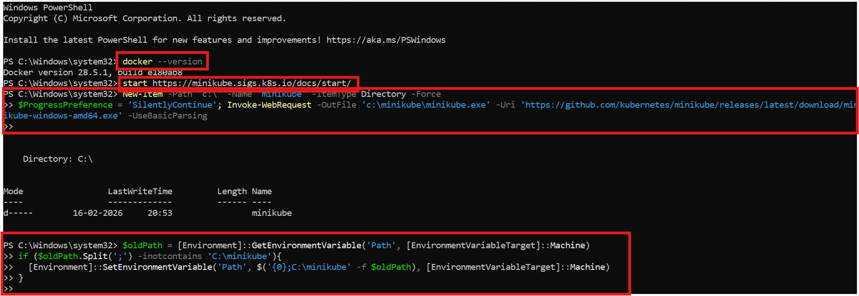

Step 5: Now, we have our Minikube installed navigate to properties and copy the path.
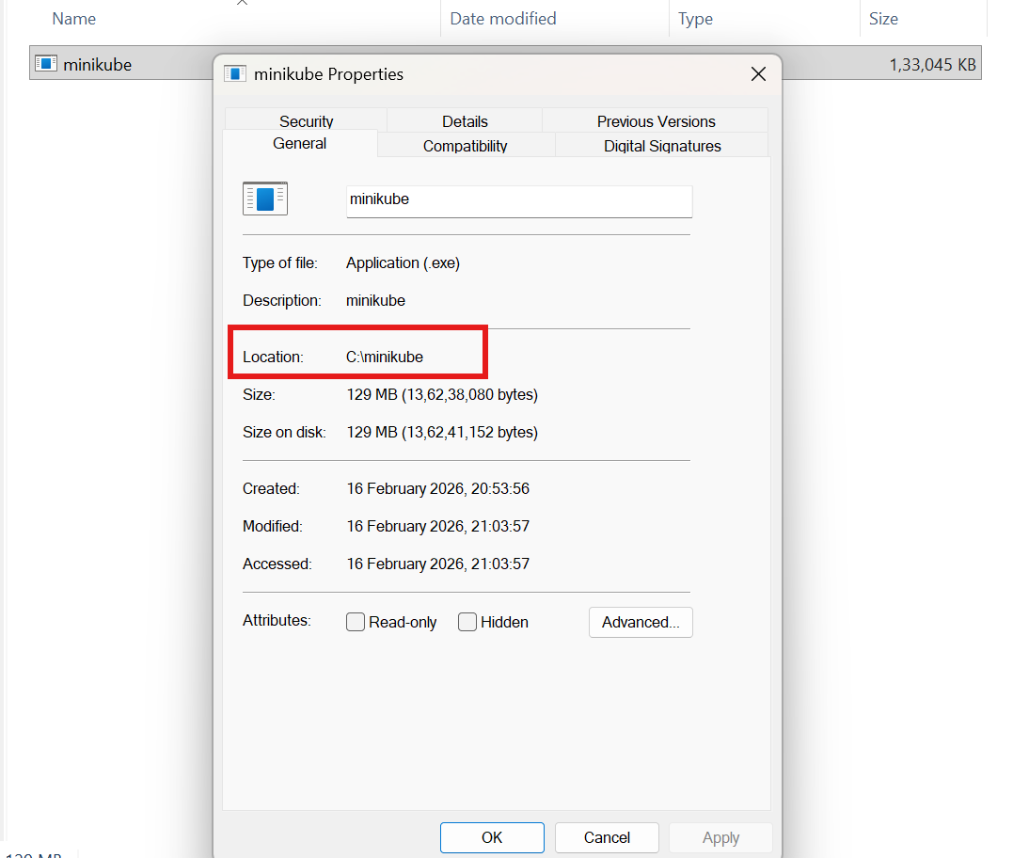

===Minikube version
===Minikube start
===Minikube ip

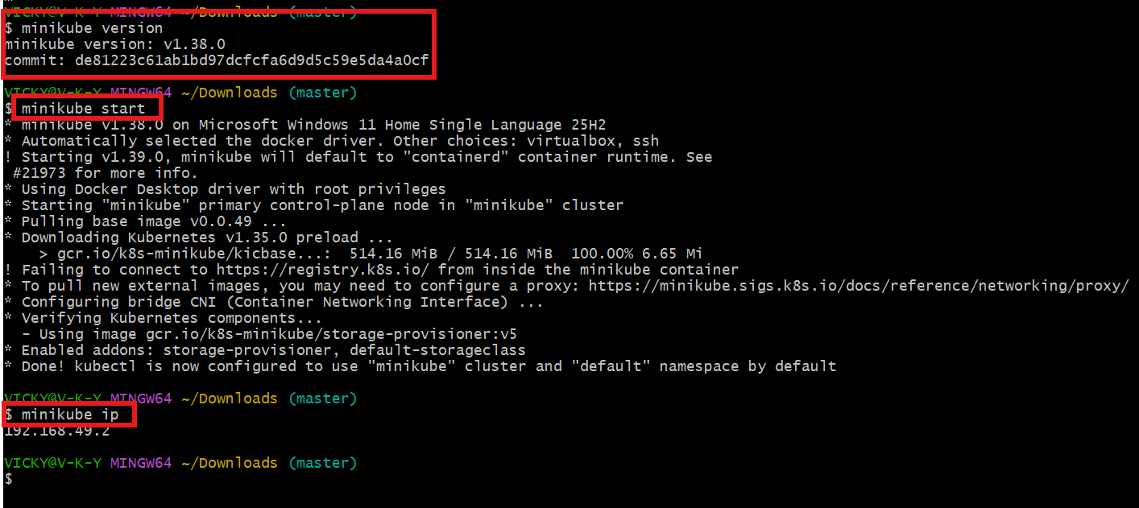
Step 6: Verify Kubernetes Components
- Minikube ssh
- Docker ps
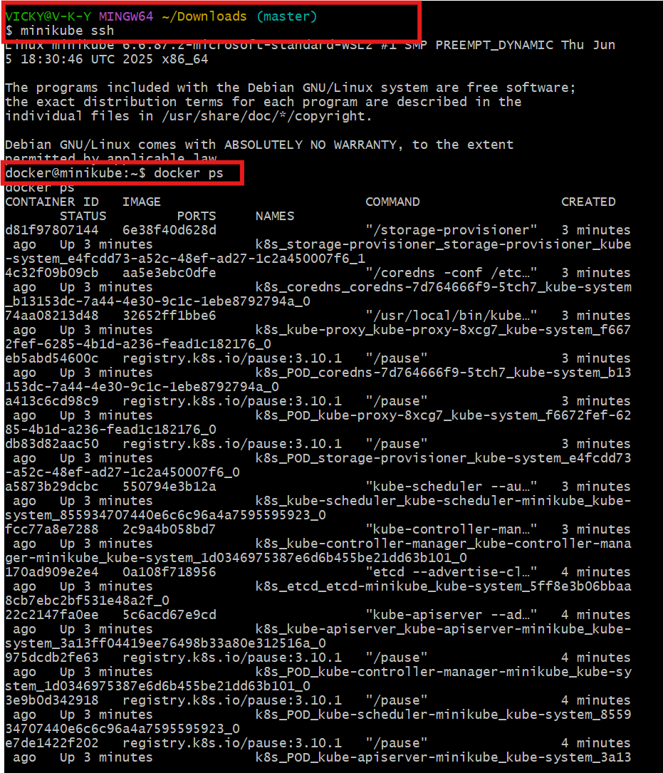

Docker images
Docker ps
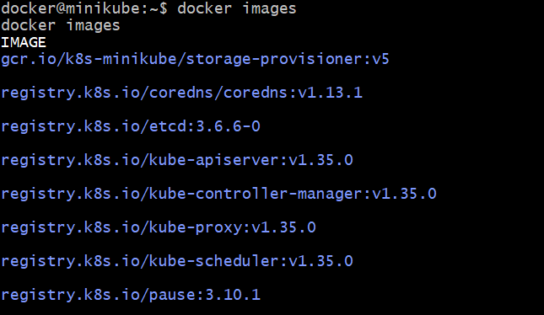

Result
Minikube single-node Kubernetes cluster successfully installed and verified on local machine.

- Setup k8s master and two worker nodes on ubuntu.

Setup Steps:
- Prepare Ubuntu servers
  - Update packages, disable swap, configure hostname.
- Install dependencies
  - Docker/container runtime, kubeadm, kubelet, kubectl.
- Initialize master node
  - Run kubeadm init and configure kubectl access.
- Deploy networking plugin
  - Example: Calico or Flannel for pod communication.
- Join worker nodes
  - Use the kubeadm join command with token from master.
- Verify cluster
  - Run kubectl get nodes → should show 1 master + 2 workers in Ready state.

Step by step Implementation
Step 1:
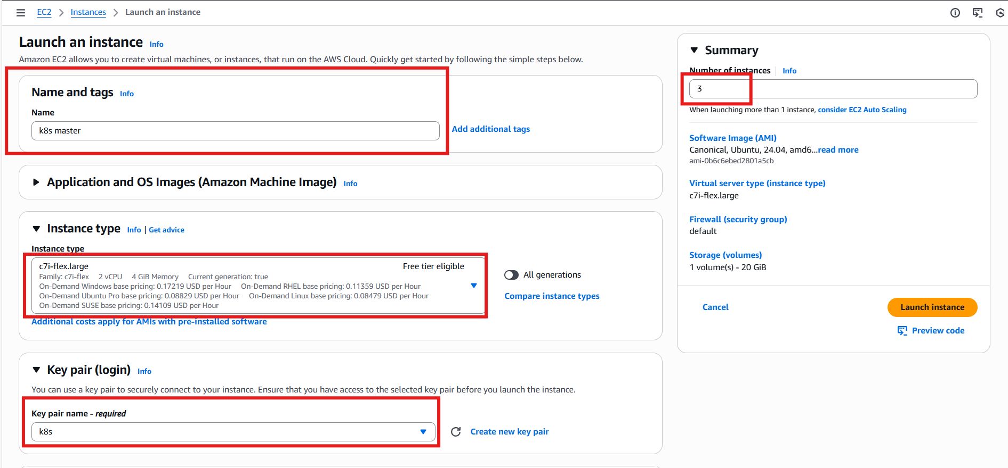

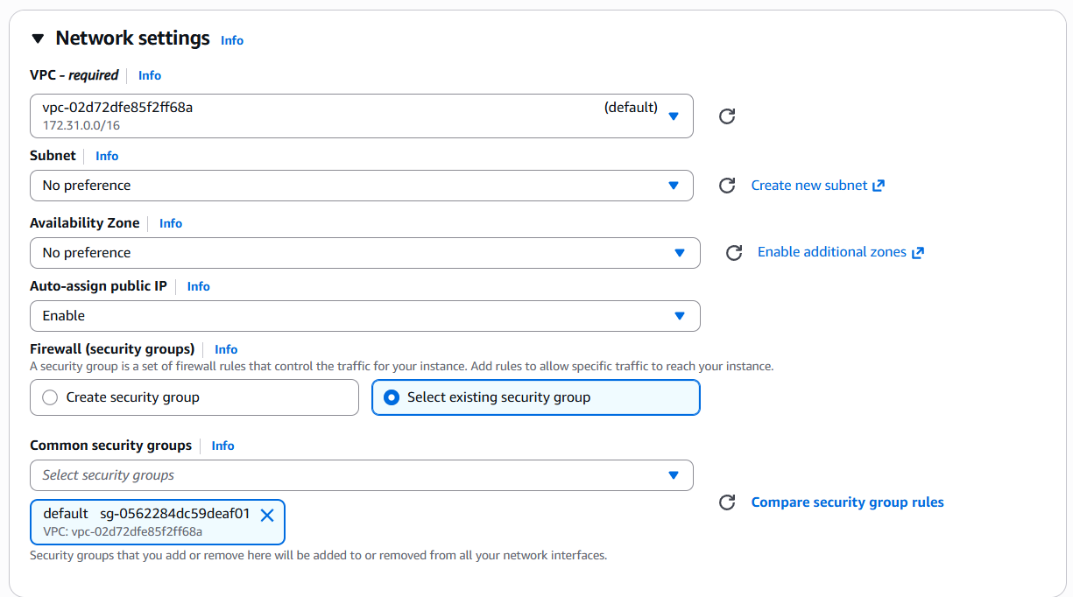

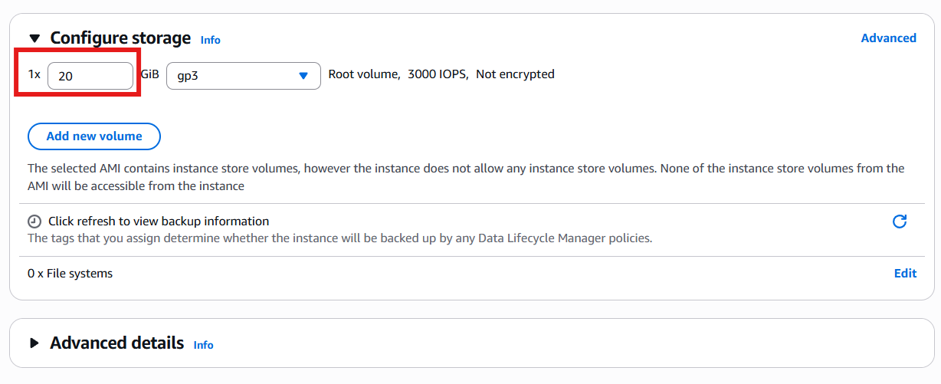
- All 3 servers launched
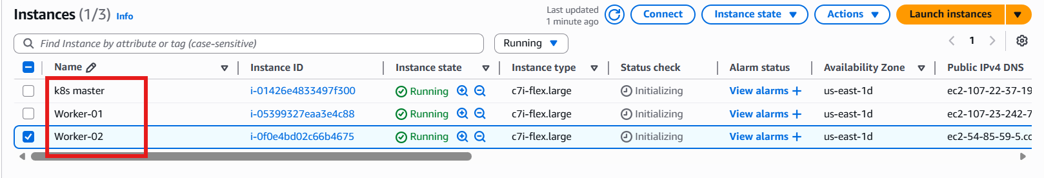

Step 2: Configure Hostnames (All Nodes)
On Master:
sudo hostnamectl set-hostname k8s-master
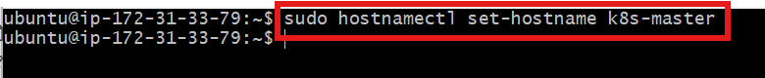
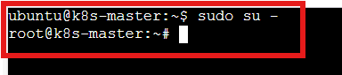
On Worker-01:
sudo hostnamectl set-hostname worker01
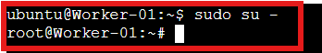
On Worker-02:
sudo hostnamectl set-hostname worker02
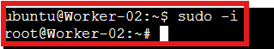

Step 3: Update /etc/hosts (All Nodes)
added private IP mappings for internal communication.
Example:
sudo vi/etc/hosts
Added:
107.22.37.194 k8s-master
107.23.242.73 Worker-01
54.85.59.5 Worker-02

K8s-master
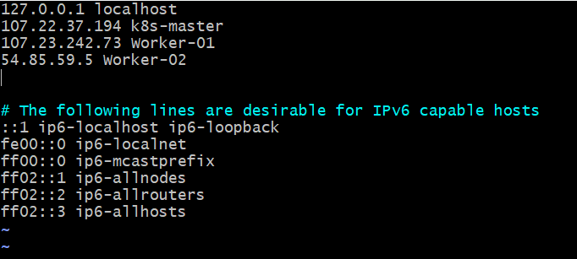
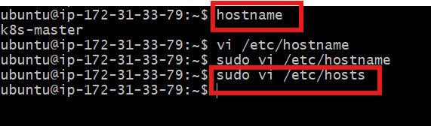

Worker-01
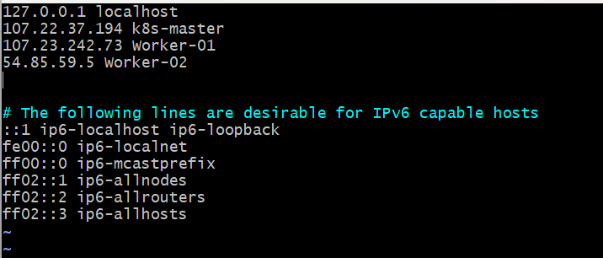

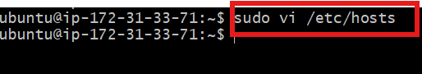

Worker-02
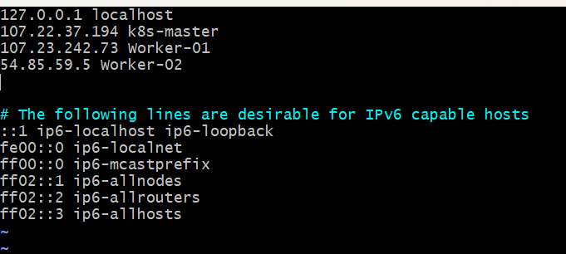

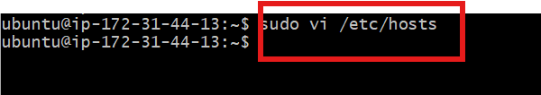

Step 4: Login to server and switch to root and execute the command to free swap memory from usage on all 3 machines
sudo swapoff -a
free -h

k8s-master
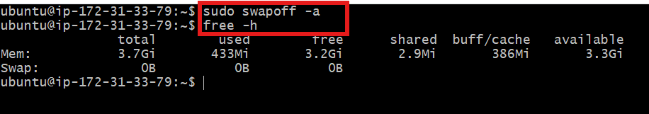

Worker-01
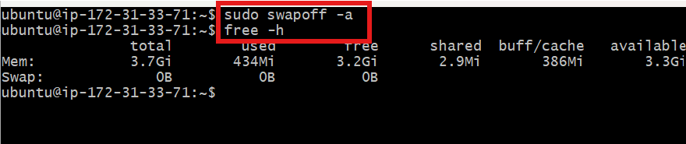

Worker-02
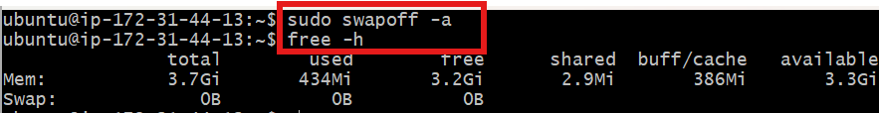

Step 5: Verify the hosts and verify using ping on all 3 machines

K8s Master
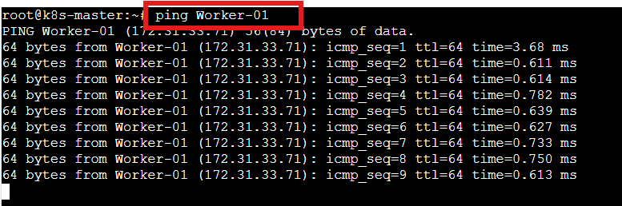
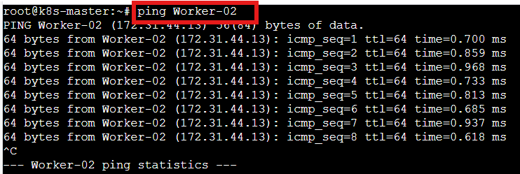

Worker-01
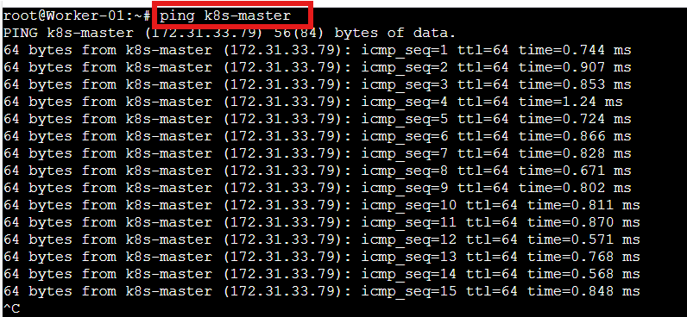
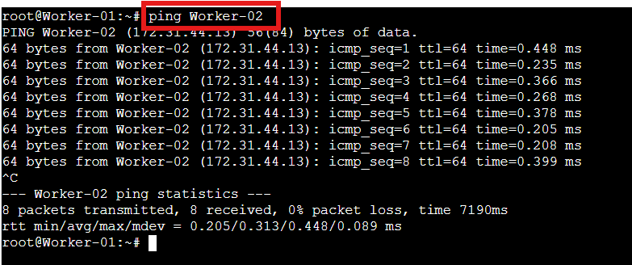

Worker-02
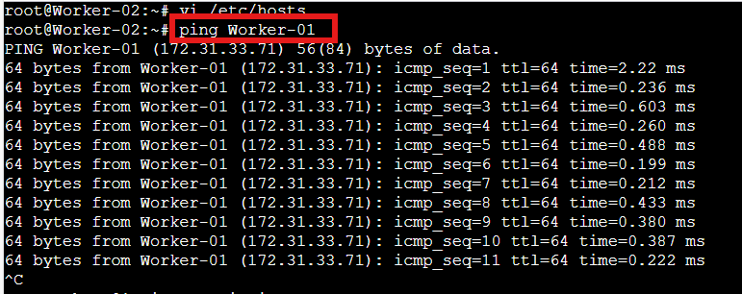
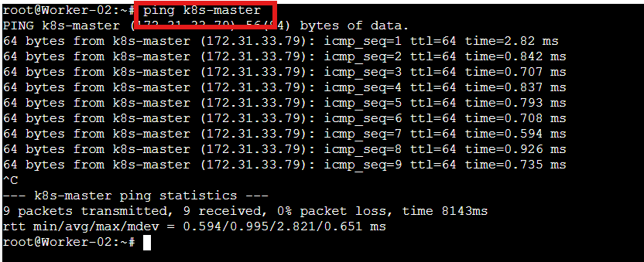

Step 6: Execute the below commands on all 3 machines
cat <<EOF | sudo tee /etc/modules-load.d/k8s.conf
overlay
br_netfilter
EOF
sudo modprobe overlay
sudo modprobe br_netfilter
# sysctl params required by setup, params persist across reboots
cat <<EOF | sudo tee /etc/sysctl.d/k8s.conf
net.bridge.bridge-nf-call-iptables = 1
net.bridge.bridge-nf-call-ip6tables = 1
net.ipv4.ip_forward = 1
EOF
# Apply sysctl params without reboot
sudo sysctl --system

k8s-master
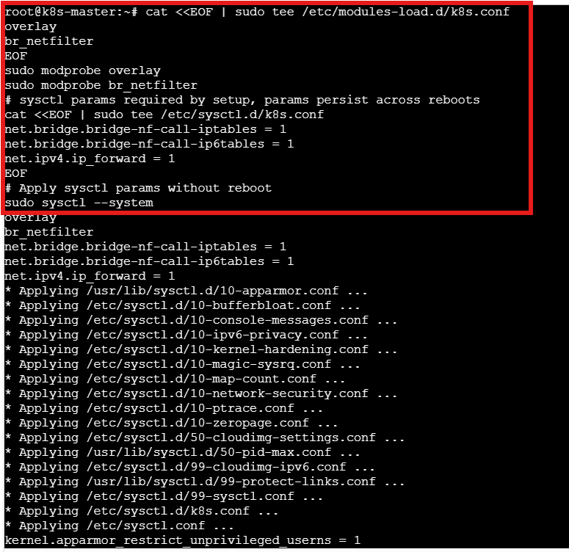

Worker-01
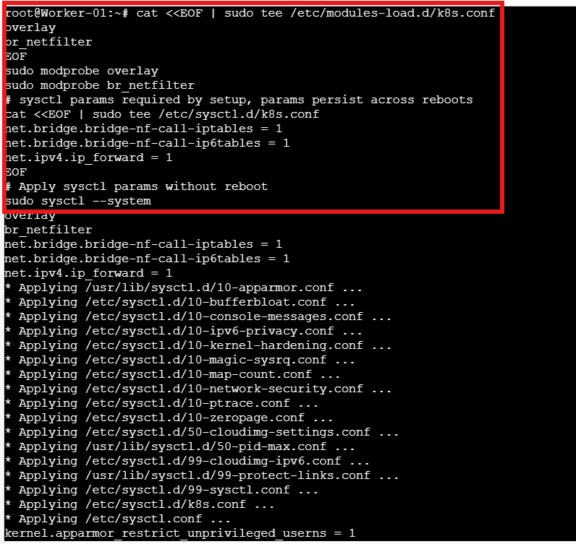

Worker-02
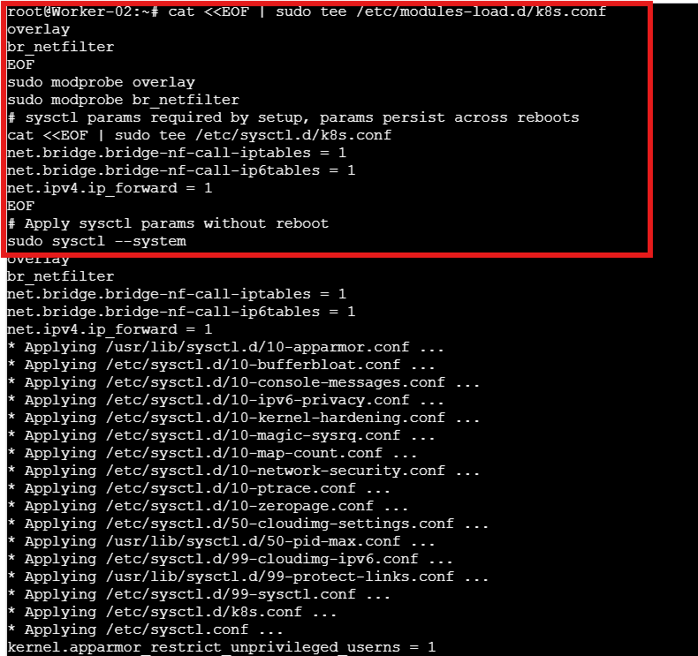

Step 7: execute all the commands in all 3 servers
sudo apt update
sudo apt install -y apt-transport-https ca-certificates curl gpg

sudo mkdir -p /etc/apt/keyrings

curl -fsSL https://pkgs.k8s.io/core:/stable:/v1.29/deb/Release.key | \
sudo gpg --dearmor -o /etc/apt/keyrings/kubernetes-apt-keyring.gpg

echo 'deb [signed-by=/etc/apt/keyrings/kubernetes-apt-keyring.gpg] https://pkgs.k8s.io/core:/stable:/v1.29/deb/ /' | \
sudo tee /etc/apt/sources.list.d/kubernetes.list

sudo apt update
sudo apt install -y kubelet kubeadm kubectl
sudo apt-mark hold kubelet kubeadm kubectl

k8s-master
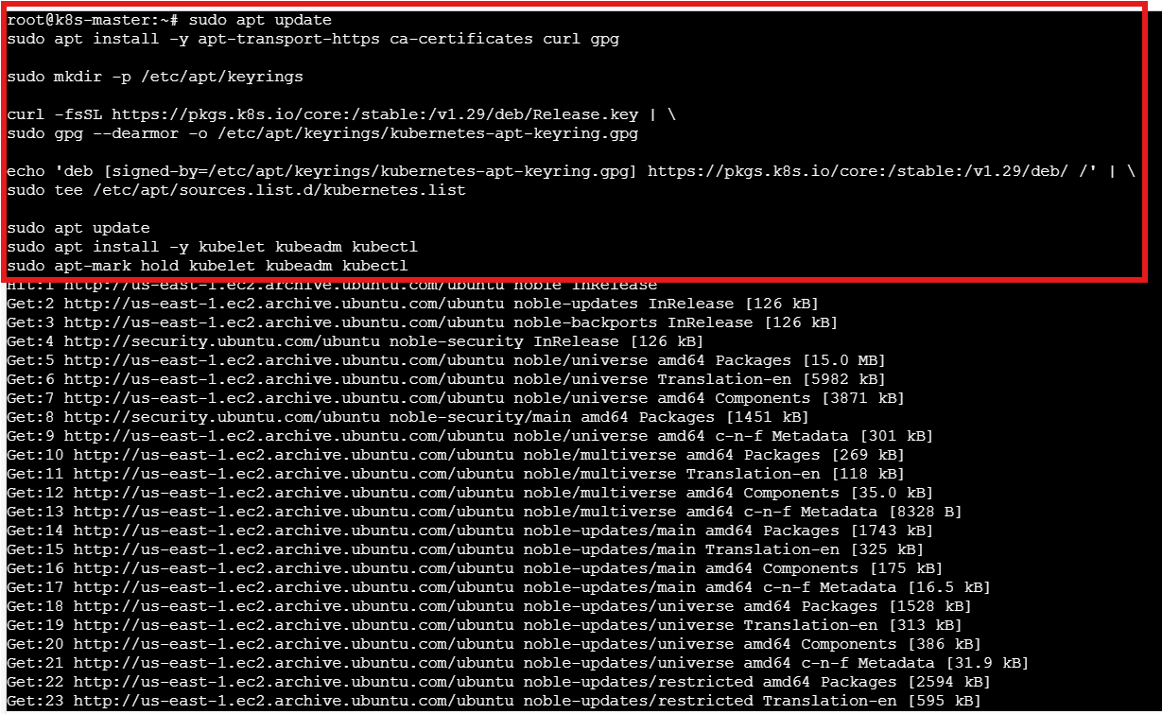
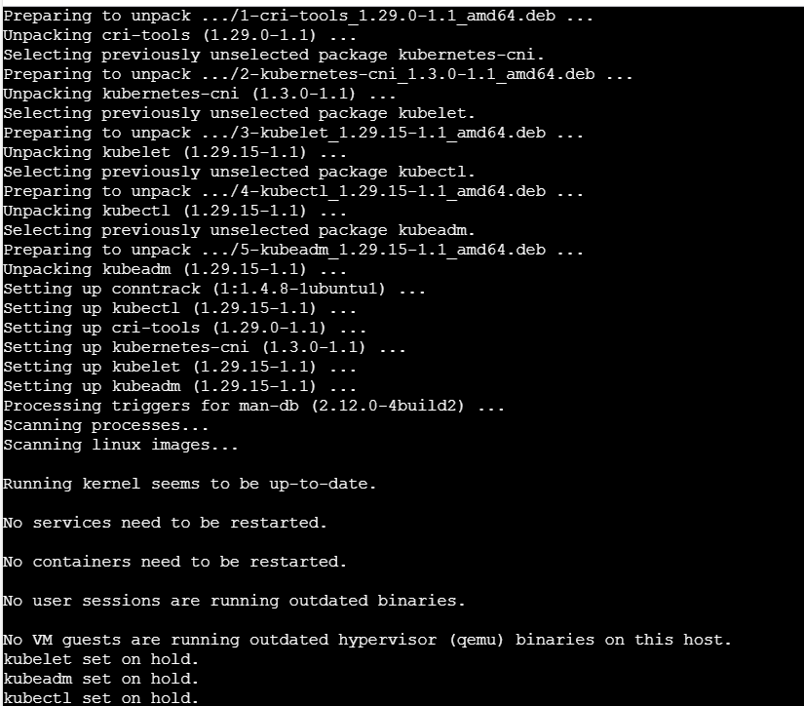

Worker-01
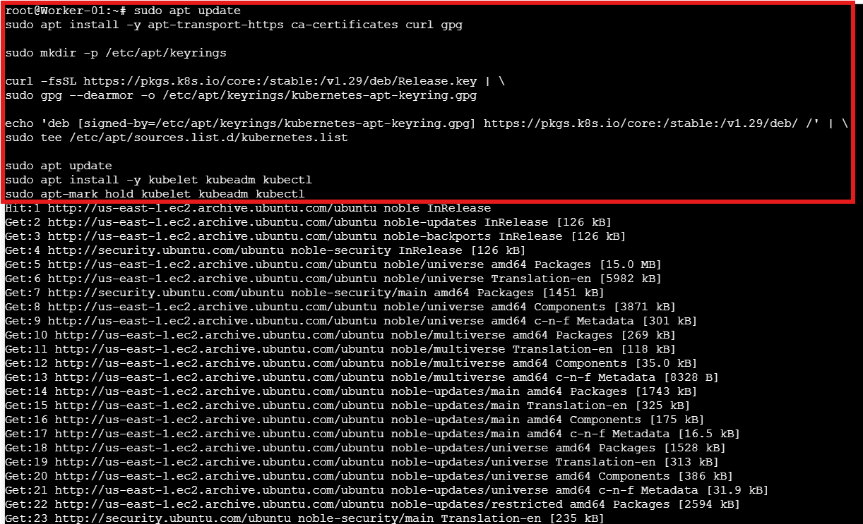
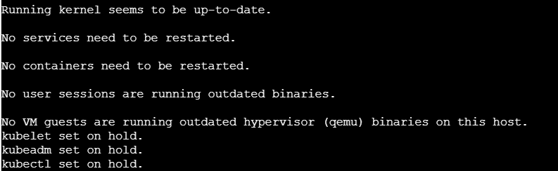

Worker-02
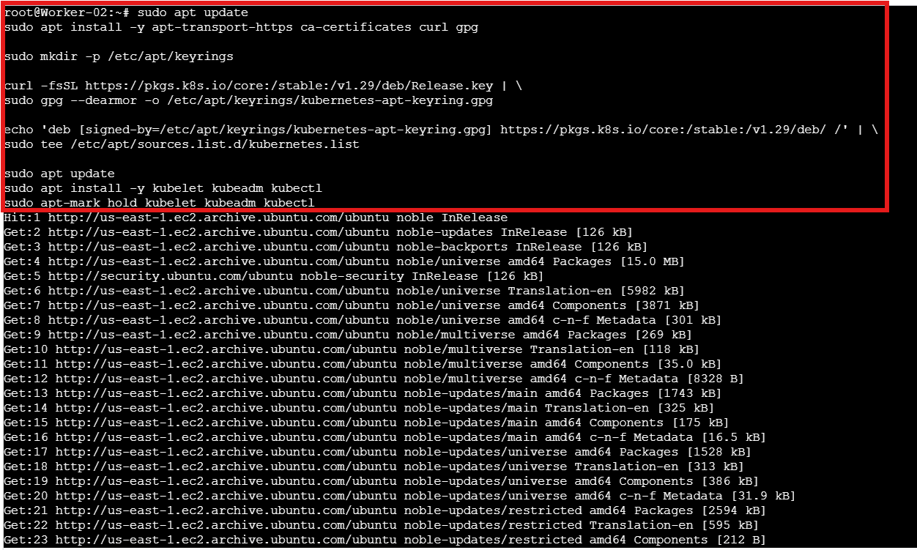
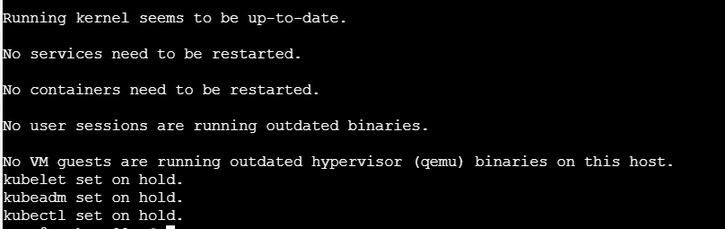

Step 8: execute the below command on all 3 machines
sudo apt install -y containerd

sudo mkdir -p /etc/containerd

sudo containerd config default | sudo tee /etc/containerd/config.toml

sudo sed -i 's/SystemdCgroup = false/SystemdCgroup = true/' /etc/containerd/config.toml

sudo systemctl restart containerd

sudo systemctl enable containerd

k8s-master
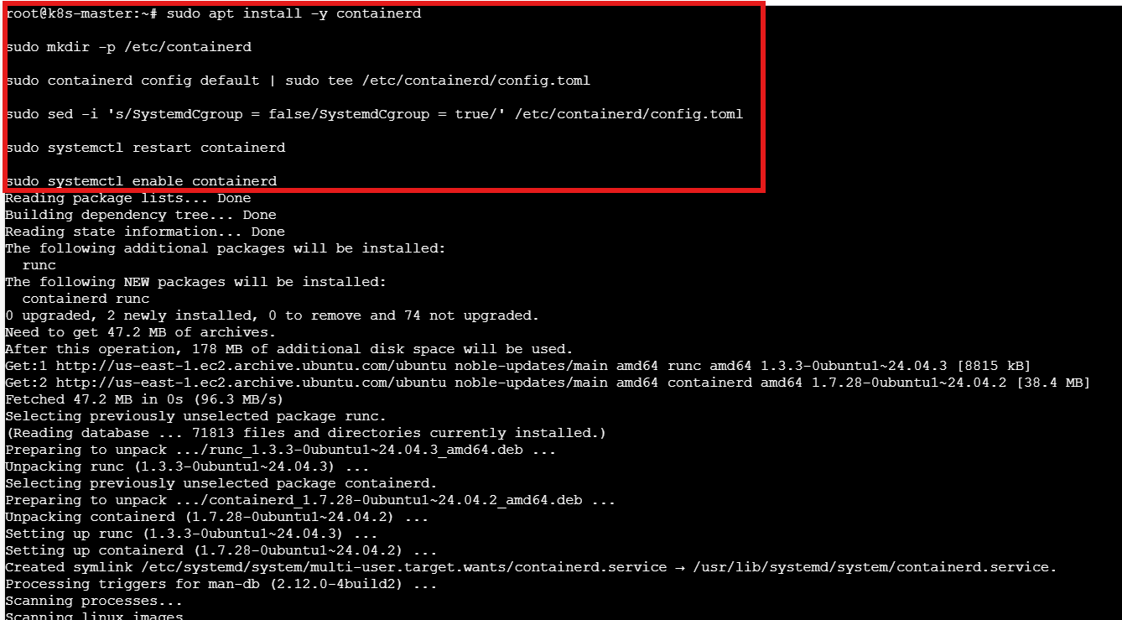

Worker-01
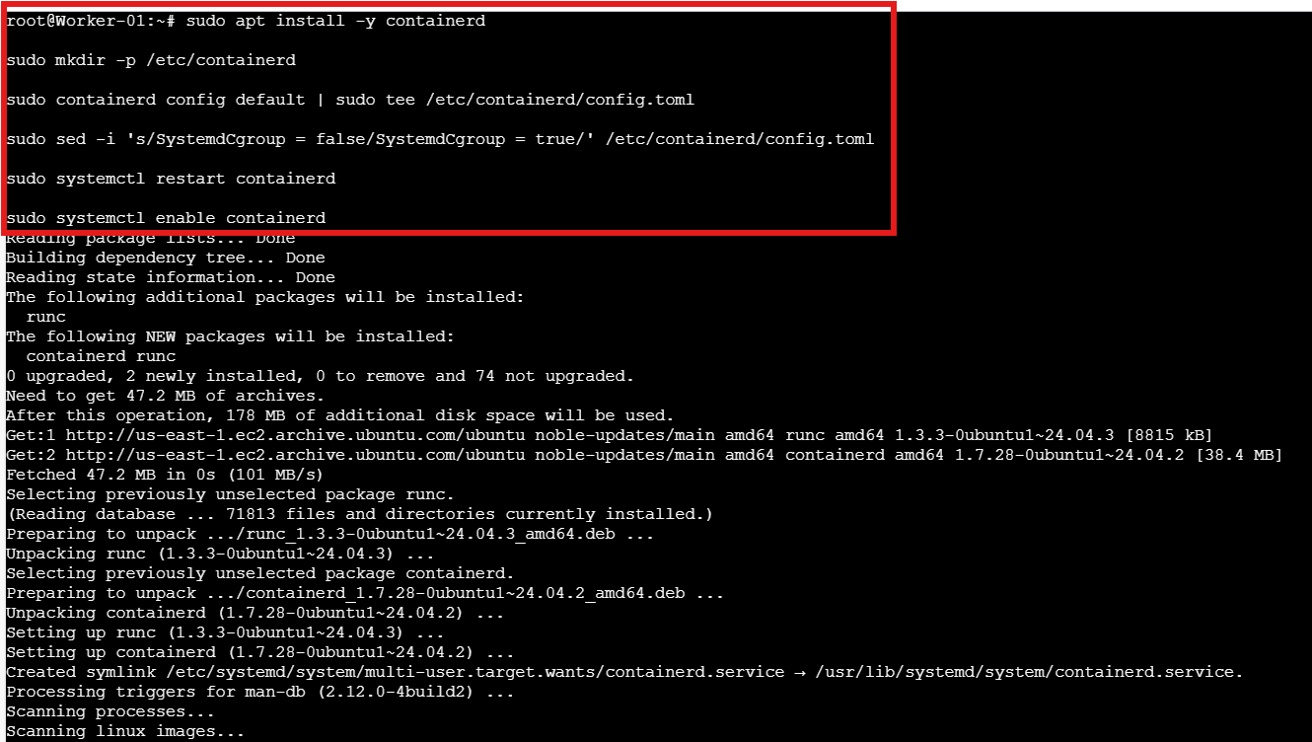

Worker-02
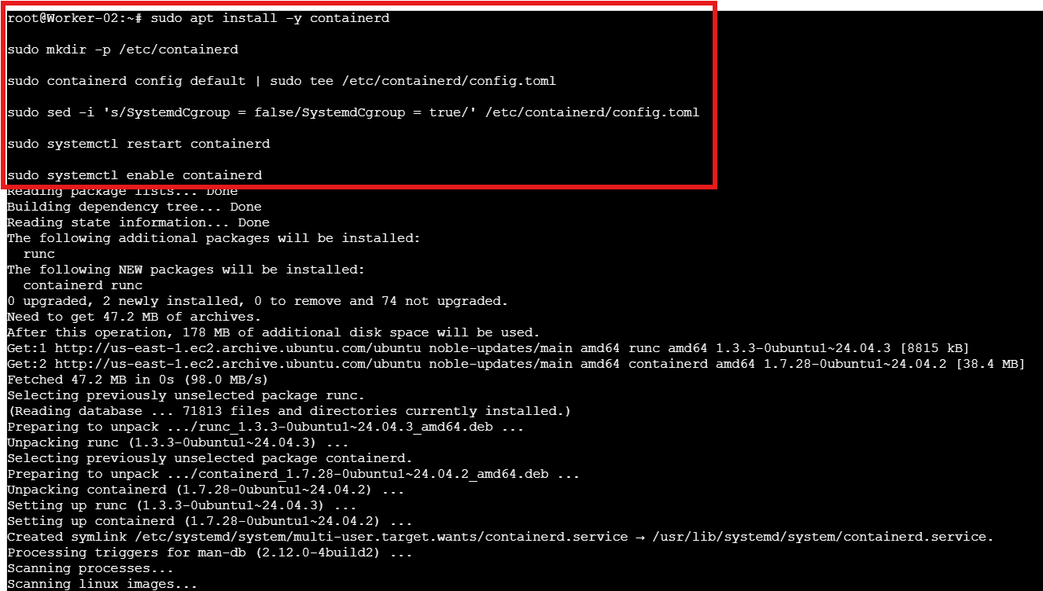

Step 9: Execute the below commands only on Master machine
sudo kubeadm config images pull

sudo kubeadm init --pod-network-cidr=10.10.0.0/16

mkdir -p $HOME/.kube
sudo cp -i /etc/kubernetes/admin.conf $HOME/.kube/config
sudo chown $(id -u):$(id -g) $HOME/.kube/config

kubectl get nodes
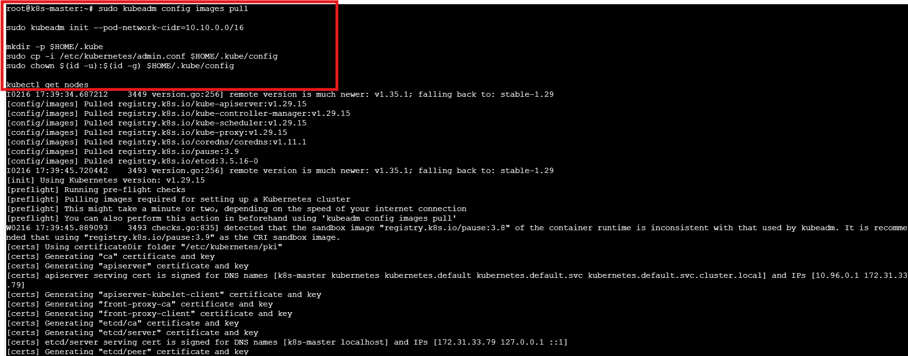
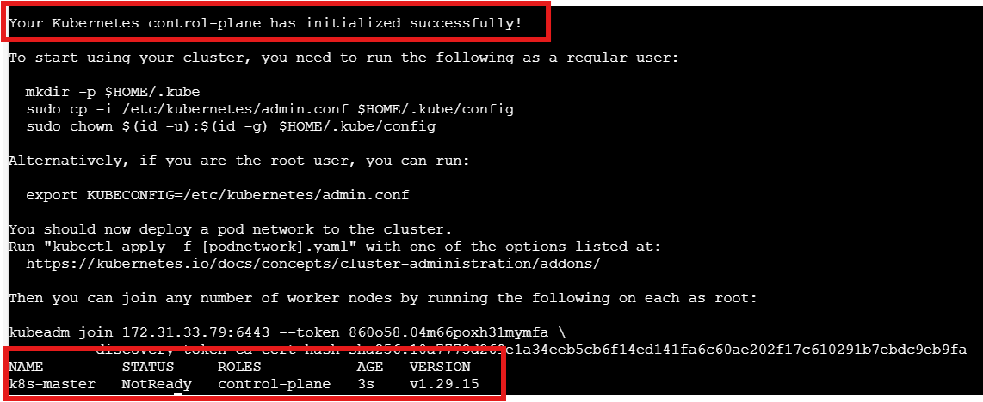

Step 10: Execute the commands on Master machine
kubectl create -f https://raw.githubusercontent.com/projectcalico/calico/v3.26.1/manifests/tigera-operator.yaml

curl https://raw.githubusercontent.com/projectcalico/calico/v3.26.1/manifests/custom-resources.yaml -O

sed -i 's/192.168.0.0\/16/10.10.0.0\/16/g' custom-resources.yaml

kubectl create -f custom-resources.yaml

kubectl get nodes

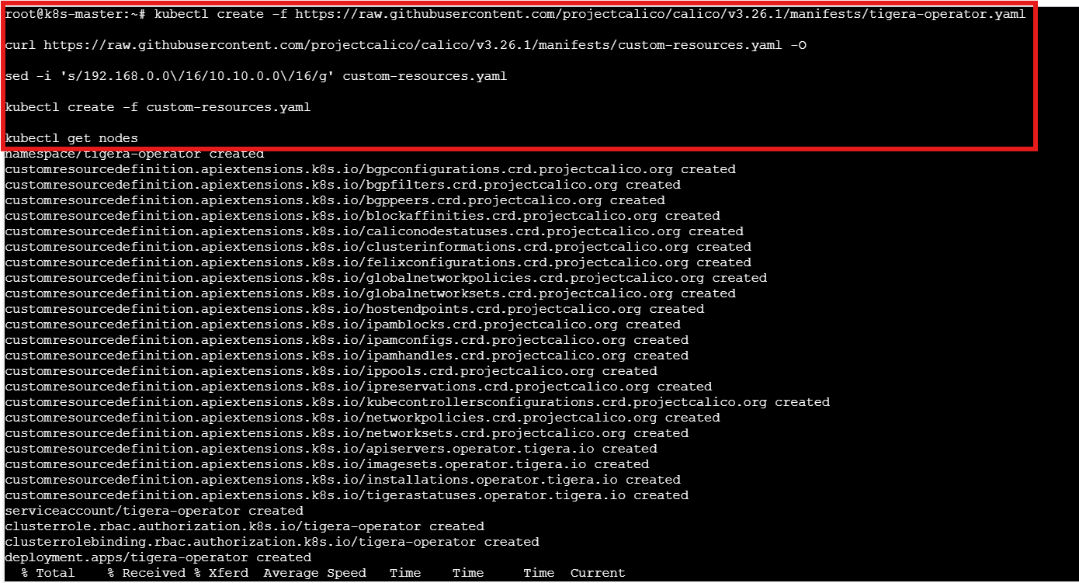

After that check the status using kubectl get nodes
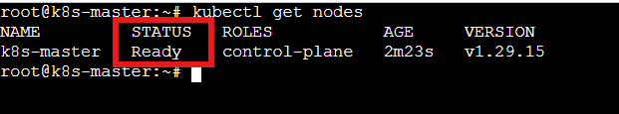

Step 11: Generate the token on master machine
kubeadm token create --print-join-command

Customize the command as per your token and paste It over on worker machines
kubeadm join 172.31.33.79:6443 –token z8zzag.cx1qhxbf4ur3ohu9 –discovery-token-ca-cert-hash sha256:10a7773d269e1a34eeb5cb6f14ed141fa6c60ae202f17c610291b7ebdc9eb9fa

Worker-01
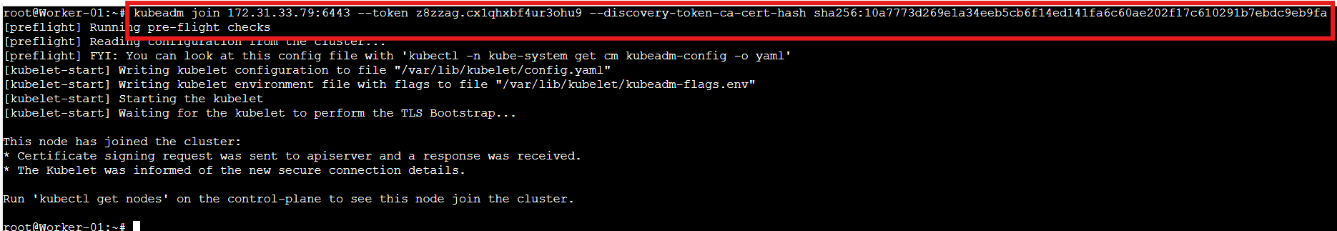

Worker-02
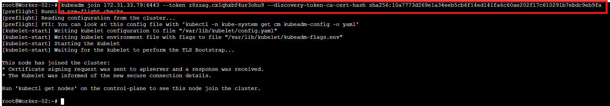

Then Verify the status of worker nodes

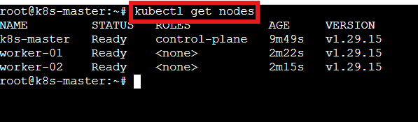

Conclusion
You now have a functional Kubernetes cluster on Ubuntu with one master and two worker nodes. The master manages cluster state, while the workers run containerized applications. This setup provides a scalable foundation for deploying and orchestrating workloads.

- Run one nginx pod.

Objective
To deploy and verify a single containerized application (NGINX) running inside the Kubernetes cluster.
Step by step implementation:
Step 1:
Run one NGINX Pod (on master)
kubectl run nginx --image=nginx --restart=Never
Step 2:
Check pod:
kubectl get pods -o wide

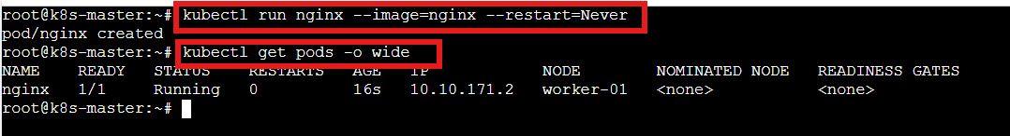

Conclusion
The NGINX pod was successfully created and scheduled on a worker node, confirming that the Kubernetes cluster, networking, and container runtime are functioning correctly.

4. Mugup Master and slave components on k8s.
1. Control Plane (Master Node)
The control plane manages the entire Kubernetes cluster. It makes scheduling decisions and maintains the desired state.
Components:
1) kube-apiserver
- Entry point of the cluster
- All kubectl commands go through it
- Validates and processes API requests
- Communicates with etcd

2) etcd
- Key-value database
- Stores cluster state
- Stores:
  - Pods
  - Services
  - Secrets
  - ConfigMaps
  - Node information

3) kube-scheduler
- Assigns Pods to worker nodes
- Decides based on:
  - CPU and memory availability
  - Taints and tolerations
  - Node selectors and affinity rules

4) kube-controller-manager
Runs multiple controllers, such as:
- Node Controller
- ReplicaSet Controller
- Deployment Controller
- Job Controller
Ensures actual state matches desired state.

2. Worker Node (Slave Node)
Worker nodes run the application workloads.
Components:
1) kubelet
- Agent running on each worker node
- Receives instructions from control plane
- Ensures containers are running
- Reports node status to control plane

2) kube-proxy
- Handles networking rules
- Maintains iptables rules
- Enables communication between services and pods

3) Container Runtime
- containers (recommended)
- Responsible for running containers
- Pulls images and starts containers

Architecture Flow
- User runs kubectl command
- Request goes to kube-apiserver
- Scheduler selects a worker node
- kubelet on that node creates the Pod
- Container runtime runs the container

In Your Current Cluster
Master node:
- Runs control plane components:
  - kube-apiserver
  - etcd
  - scheduler
  - controller-manager

Worker nodes:
- Run:
  - kubelet
  - kube-proxy
  - containers
Host application Pods

