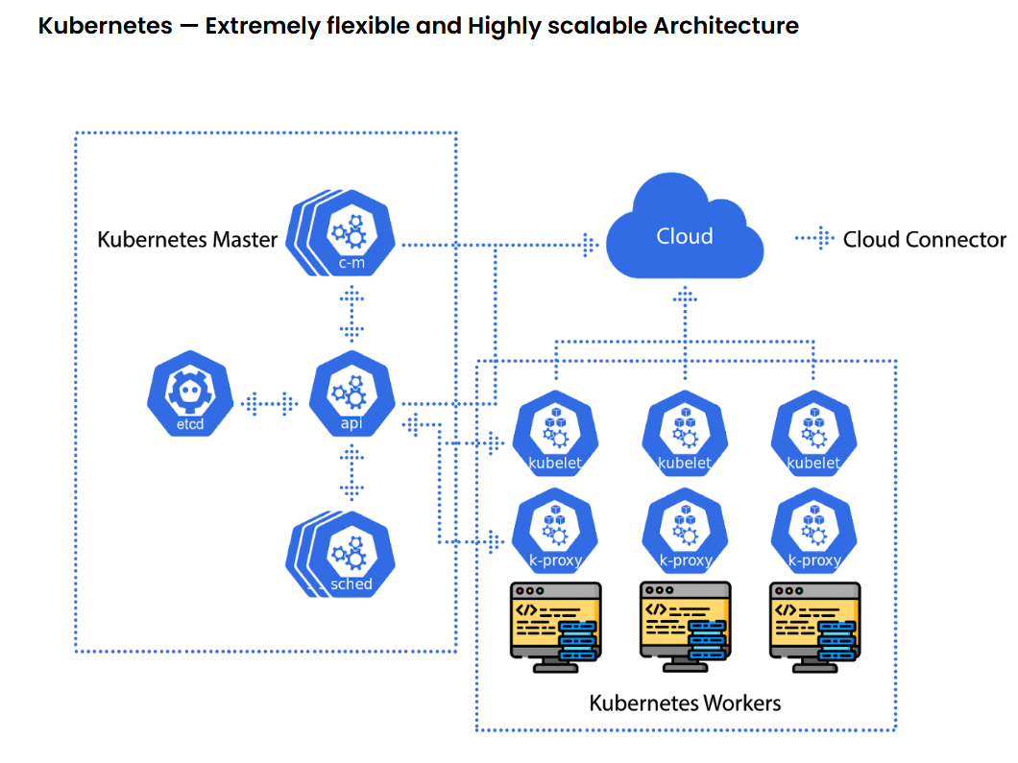
Task Title
Kubernetes-02
Objective
The objective of this task is to watch the K8s video-02 posted on slack and worked on executing the initializing K8s shown in video.
Prerequisites
List all requirements before starting:
- YAML
- Kubectl
- Environment Variables
- Args
- Init Container
- Dry Run
- kubectl apply vs kubectl create
- edit pod
- ClusterIP

Issues Faced: Briefly mention issues and how you fixed them. Posted below in the last.
Conclusion
Conclusion has been provided for every task at the end.
Tasks

- Create a Simple Pod Using YAML Task: Write a YAML file to create a Pod named firstpod with an nginx container. Verify the Pod creation using kubectl get pods and check the logs of the container using kubectl logs firstpod.

Objective: The requirements of this task is to create a simple pod using YAML file. The pod will be named as first pod with an nginx container in it.

Step by step Implementation
Step 1: Create a Pod YAML File- firstpod.yaml
apiVersion: v1
kind: Pod
metadata:
name: firstpod
labels:
app: nginx
spec:
containers:
- name: nginx-container
image: nginx:latest
ports:
- containerPort: 80
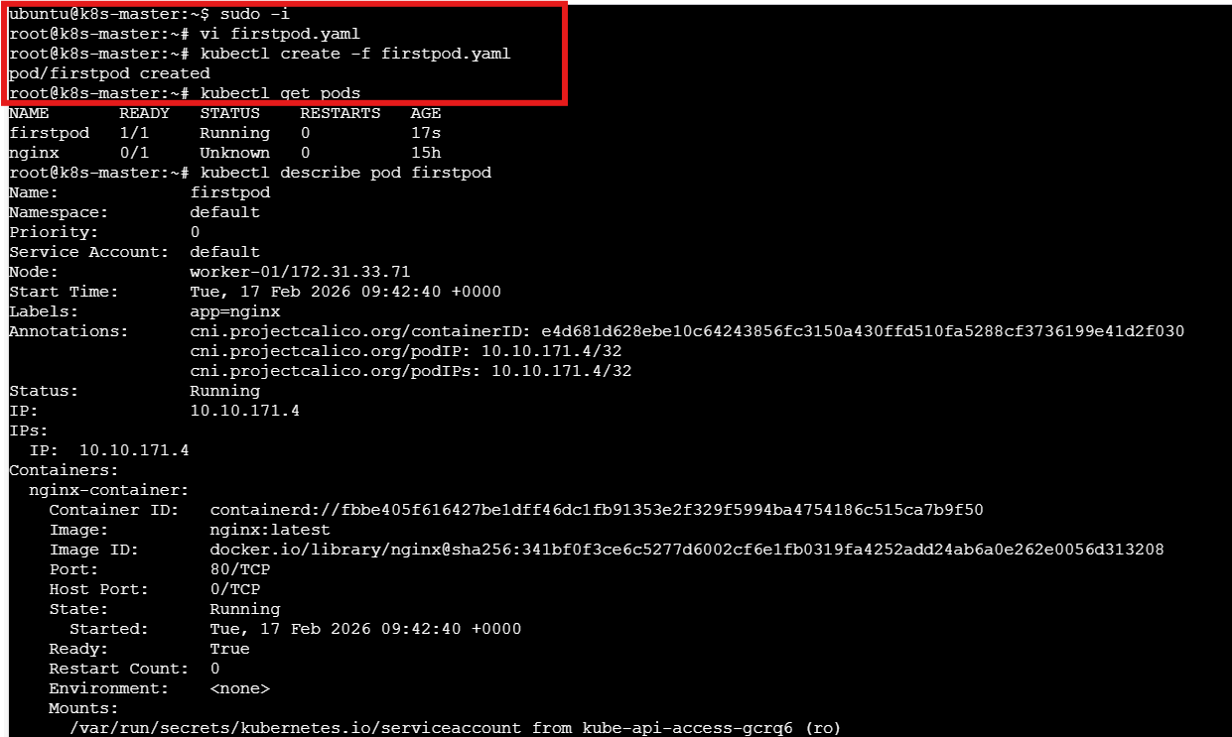
Vi firstpod.yaml
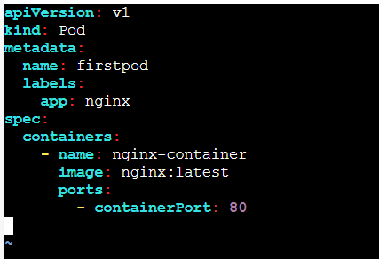

Step 2: Create the firstpod using command- kubectl create -f firstpod.yaml
- Kubectl get pods


Step 3: To check logs- command- kubectl logs firstpod
- Verify Nginx is Running Inside the Pod- kubectl exec -it firstpod -- /bin/bash
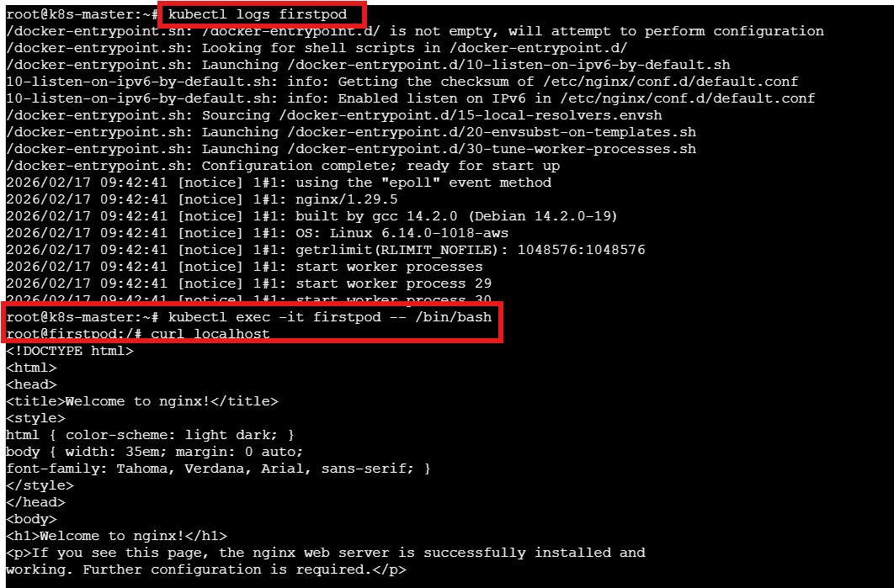

Task Completed

- Set Environment Variables in a Pod Task: Modify the YAML file to include environment variables myname: Sabair and City: Hyderabad. Deploy the Pod and use kubectl exec <pod_name> -- env to check if the environment variables are set properly.

Objective: In the existing YAML file we need to modify and add the environment variables and deploy.

Step by step Implementation
Step 1: Let’s modify the existing yaml file – vi firstpod.yaml

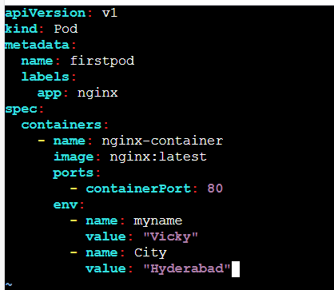

apiVersion: v1
kind: Pod
metadata:
name: firstpod
labels:
app: nginx
spec:
containers:
- name: nginx-container
image: nginx:latest
ports:
- containerPort: 80
env:
- name: myname
value: "Vicky"
- name: City
value: "Hyderabad"

Step 2: Pods are meant to be temporary so we have to delete the existing pod and use command- kubectl apply -f <podname>.yaml

- Using command- kubectl exec firstpod –env, we can verify if the environment variables are set properly.
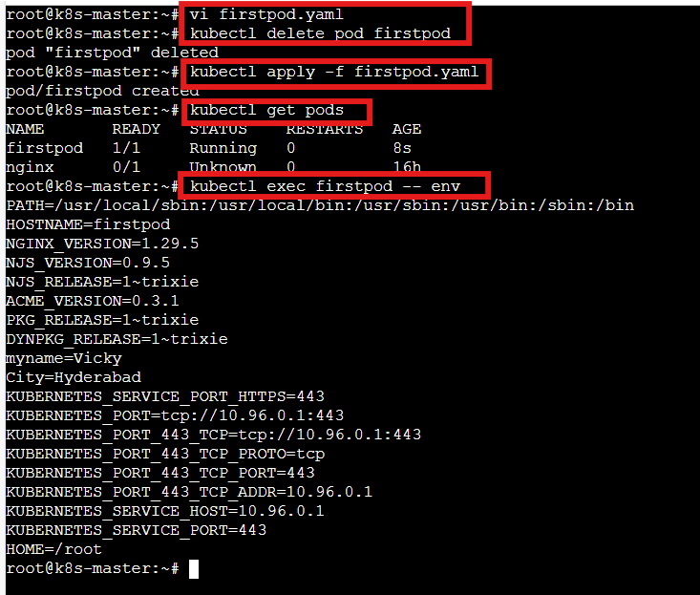
Task completed

- Deploy a Pod with Commands (Args) in YAML Task: Modify the YAML file to add args that instruct the container to sleep for 50 seconds. Deploy the Pod and use kubectl describe pod to verify the args are correctly passed to the container.

Objective: Using Args, we can make container sleep for 50 seconds as per requirement.

Step by step Implementation
Step 1: Update the yaml file- vi firstpod.yaml

apiVersion: v1
kind: Pod
metadata:
name: firstpod
labels:
app: nginx
spec:
containers:
- name: nginx-container
image: nginx:latest
command: ["/bin/sh"]
args: ["-c", "sleep 50"]
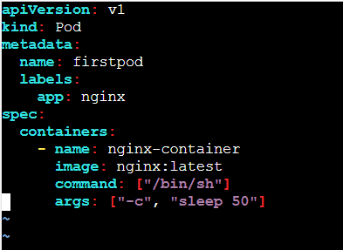

Step 2: If firstpod already exists, delete it first
- We used command- apply to update the yaml file.
- Verified the pods available- kubectl get pods
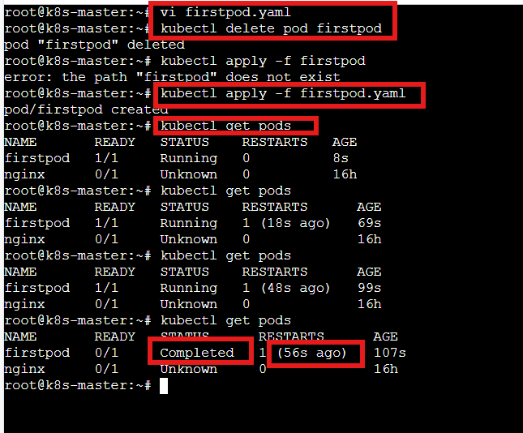

Step 3: Use command- kubectl describe pod firstpod to verify if sleep 50 passed correctly.
Success- sleep using “args” worked perfectly.
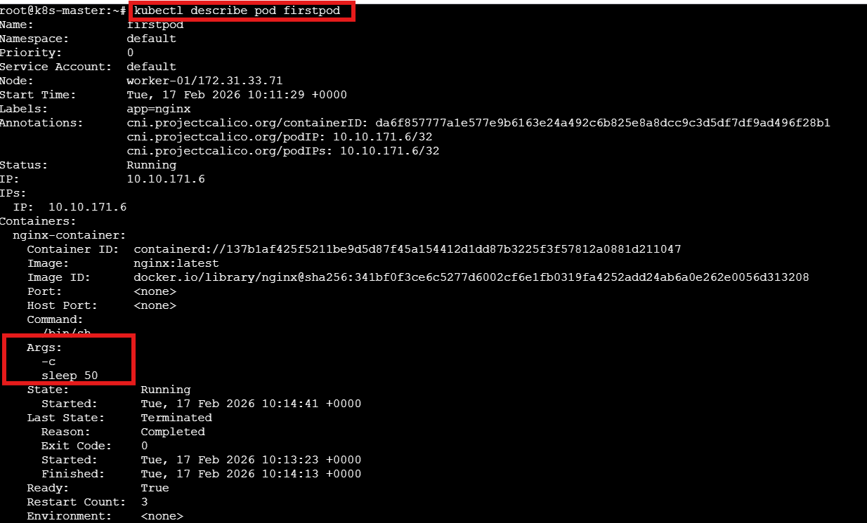
Task completed

- Create a Pod with Two Containers Task: Create a YAML file to define a Pod with two nginx containers inside. Use kubectl exec to access both containers and verify that both containers can communicate through the same network (e.g., using telnet between them).

Objective: The requirement is to create a YAML file to define a pod with 2 nginx containers inside. These scenarios are to communicate with same network.

Step by step Implementation
Step 1: Let’s create a file- vi twonginx.yaml

apiVersion: v1
kind: Pod
metadata:
name: twonginx
spec:
containers:
- name: nginx1
image: nginx:latest
ports:
- containerPort: 80

- name: nginx2
image: nginx:latest
ports:
- containerPort: 8080

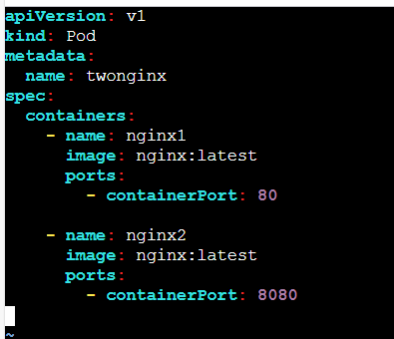

Step 2:
- Both containers cannot use the same port inside the same Pod.
They share the same network namespace.
- So, we must change nginx2 to run on a different port.
- Let’s override nginx2 config to run on port 8080

apiVersion: v1
kind: Pod
metadata:
name: twonginx
spec:
containers:
- name: nginx1
image: nginx:latest
ports:
- containerPort: 80

- name: nginx2
image: nginx:latest
command: ["/bin/sh"]
args:
- "-c"
- "sed -i 's/80/8080/g' /etc/nginx/conf.d/default.conf && nginx -g 'daemon off;'"
ports:
- containerPort: 8080
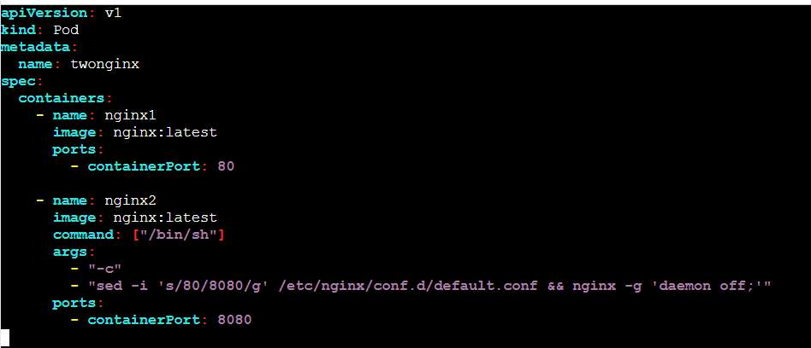

Step 3: Now, we need to execute the pod using command- kubectl apply -f twonginx.yaml
- Verify the pod exists- kubectl get pods
- To login into the container Exec into First Container – kubectl exec -it twonginx1 -c nginx -- /bin/bash
- Verify if both communication is successful- curl localhost:8080
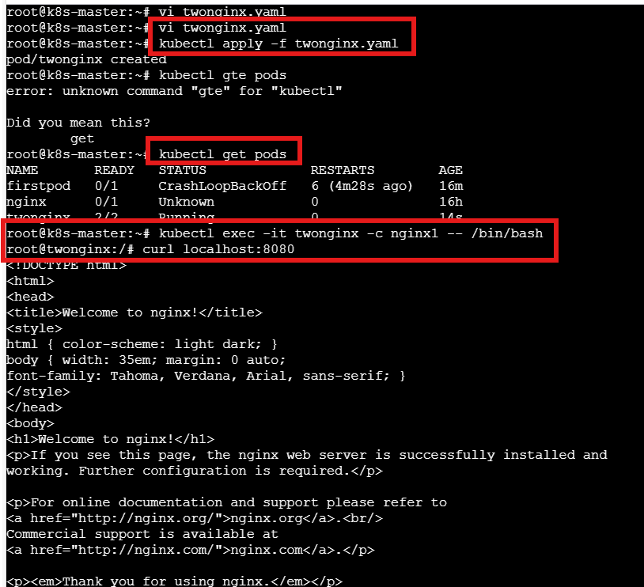

- Exec Into Second Container- kubectl exec -it twonginx -c nginx2 -- /bin/bash
- Curl localhost:80

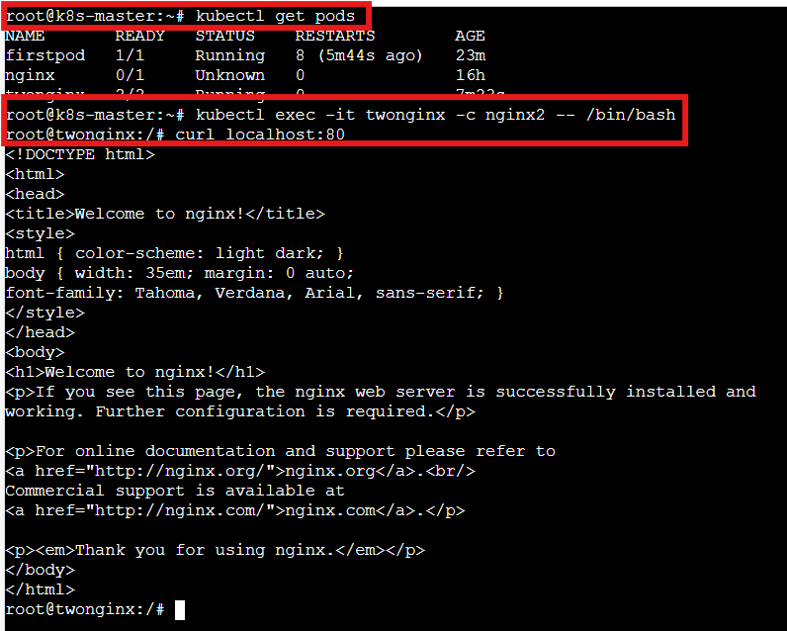
Task Completed

- Set Up an Init Container in a Pod Task: Modify the YAML to include an init container that sleeps for 30 seconds before the main containers start. Verify the init container's execution using kubectl describe pod and check the logs to confirm its completion.

Objective: The requirement of this task is to set up a Init Container. The reason to implement Init container is to run multiple containers according to the dependency.
Here, the dependency is init container should sleep for 30 seconds before the main containers start.

Step by step Implementation
Step 1: Create an initpod.yaml file and update the below code

apiVersion: v1
kind: Pod
metadata:
name: initpod
spec:
initContainers:
- name: init-sleep
image: busybox
command: ["sh", "-c", "echo Init container started; sleep 30; echo Init container completed"]

containers:
- name: nginx-container
image: nginx:latest
ports:
- containerPort: 80
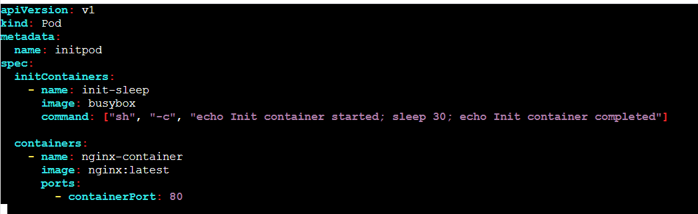

Step 2: Deploy the Pod using command- kubectl apply -f initpod.yaml
- Verify if pod exists- kubectl get pods
- Wait for 30 seconds and use command again- now the status will change to 1/1
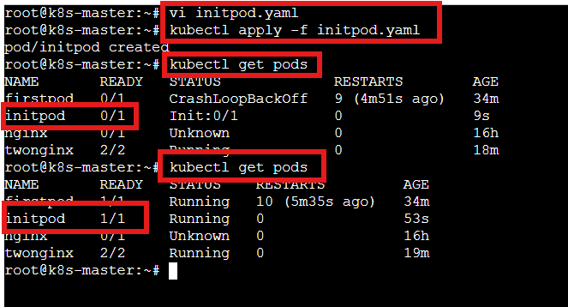

Step 3: Verify Init Container Using Describe
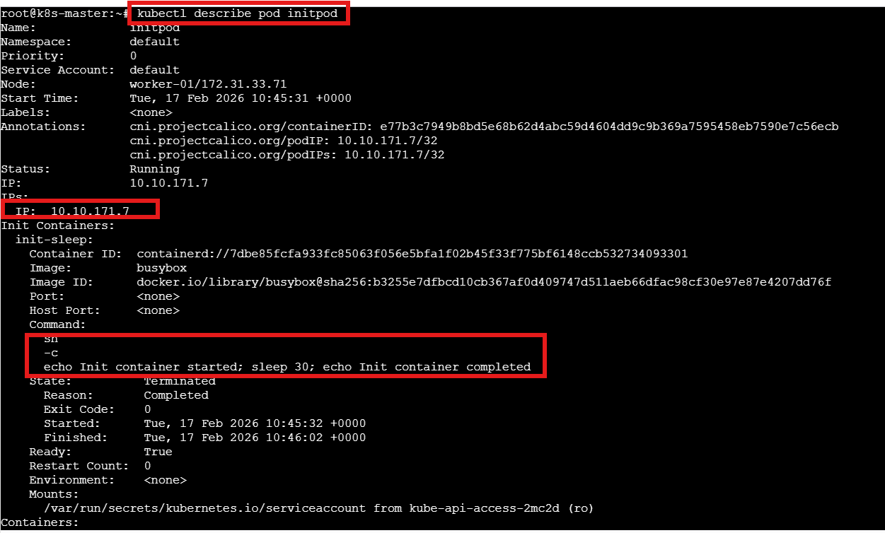
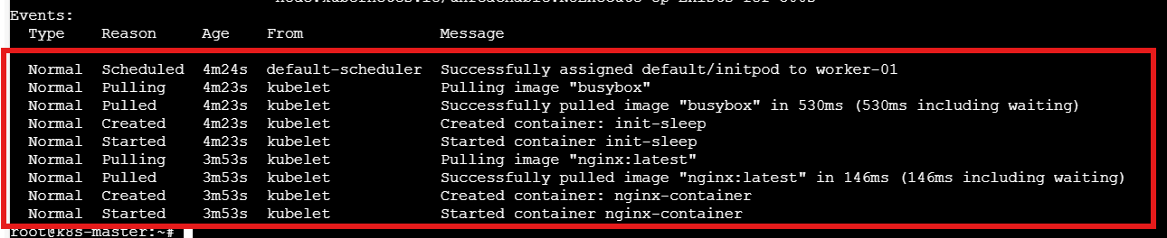

Step 4: Check Init Container Logs
Kubectl logs initpod -c init-sleep
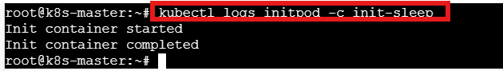

Step 5: Check Main Container Logs
kubectl logs initpod -c nginx-container
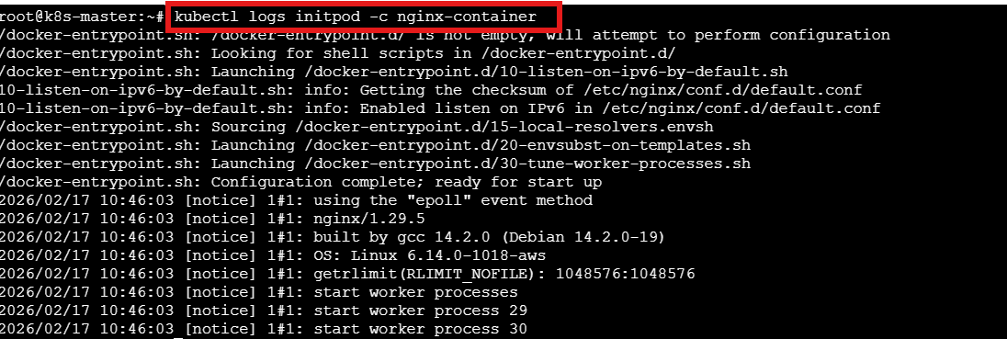

Task completed

- Run a Dry Run Command to Generate YAML Task: Use the kubectl run nginx --image=nginx --dry-run=client -o yaml command to generate a Pod YAML definition. Modify the generated YAML to suit specific requirements (e.g., labels or environment variables) and deploy it.

Objective: This task requirement is to run a dry run and modify the generate YAML task to suit specific requirements such as (labels/environment variables)

Step by step Implementation
Step 1: Generate YAML Using Dry Run
kubectl run nginx --image=nginx --dry-run=client -o yaml

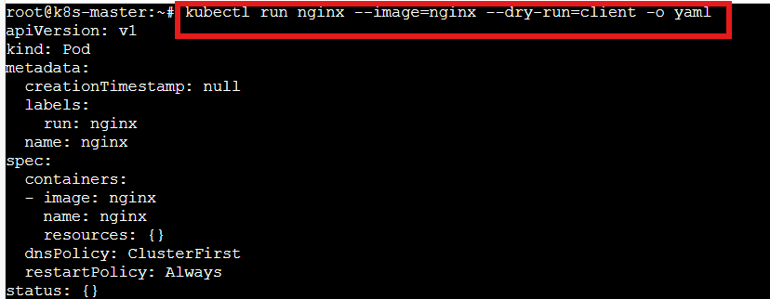

Step 2: Save Output to File- nginx.yaml

Step 3: Modify YAML (Add Labels + Environment Variables)
vi nginx.yaml
The below is the auto generated file from K8s
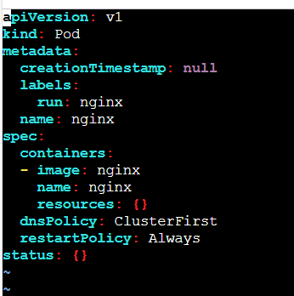

We shall update to our requirements to include Environment variables and add Labels)

apiVersion: v1
kind: Pod
metadata:
name: nginx
labels:
app: web
spec:
containers:
- name: nginx
image: nginx:1.25
ports:
- containerPort: 80
env:
- name: ENV
value: "production"
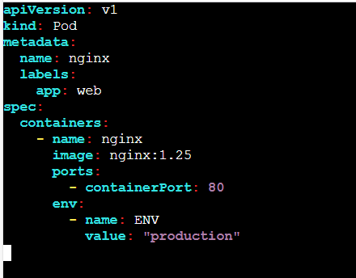

Step 4: Deploy the Modified YAML
Kubectl apply -f nginx.yaml
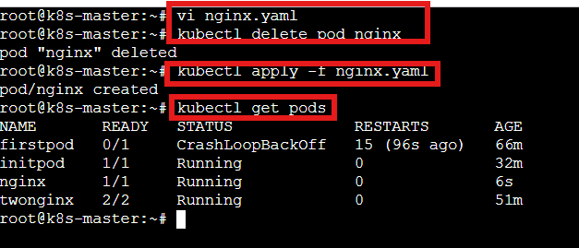

Step 5: Verify Labels
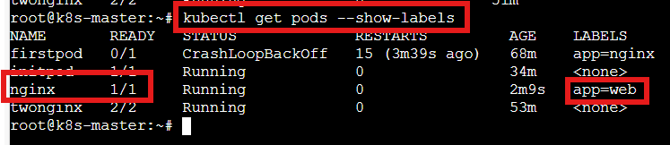

Task Completed

- Use kubectl apply vs kubectl create Task: Create a YAML file to define a Pod. First, deploy it using kubectl create -f <file_name>.yml and then modify the YAML (e.g., change the image version). Use kubectl apply to redeploy and verify the difference between both commands.

Objective: This is a excellent task to verify the difference between create vs apply in K8s YAML file. We shall define a Pod create the pod, then modify the pod and verify the differences.

Step by step Implementation
Step 1: Create a Pod YAML

apiVersion: v1
kind: Pod
metadata:
name: mypod
spec:
containers:
- name: nginx
image: nginx:1.24
ports:
- containerPort: 80

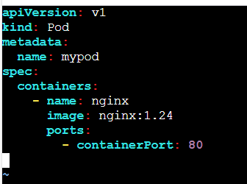

Step 2: Deploy Using kubectl create
kubectl create -f mypod.yaml
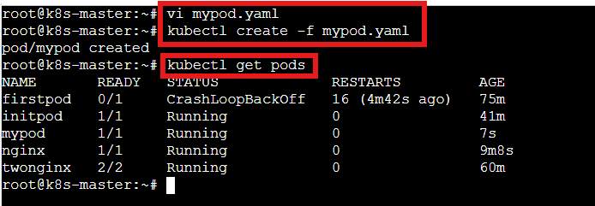

Step 3: Modify YAML (Change Image Version)
Changed nginx version to 1.25
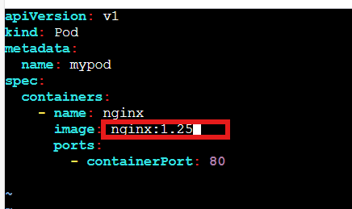

Step 4: Try kubectl apply
Kubectl apply -f mypod.yaml

We will see:
Warning: resource pods/mypod is missing the kubectl.kubernetes.io/last-applied-configuration annotation
The Pod "mypod" is invalid: spec: Forbidden...

Why?
Because:
- Pod spec is immutable
- apply tries to PATCH it
- Kubernetes does not allow container spec changes in a Pod

Important Learning
- If this was a Deployment, apply would work.
- Pods are immutable.
Deployments are mutable (rolling update).

Task Completed

- Edit an Existing Pod Configuration Task: Use kubectl edit pod <pod_name> to modify the running Pod's environment variables or image. After making the changes, verify if they took effect by checking the container logs or environment variables using kubectl exec.

Step by step Implementation
Step 1: Create a Sample Pod

apiVersion: v1
kind: Pod
metadata:
name: editpod
spec:
containers:
- name: nginx
image: nginx:1.24
env:
- name: ENV
value: "dev"
ports:
- containerPort: 80

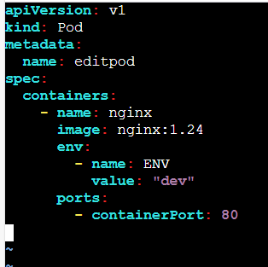

Deploy
Kubectl apply -f editpod.yaml
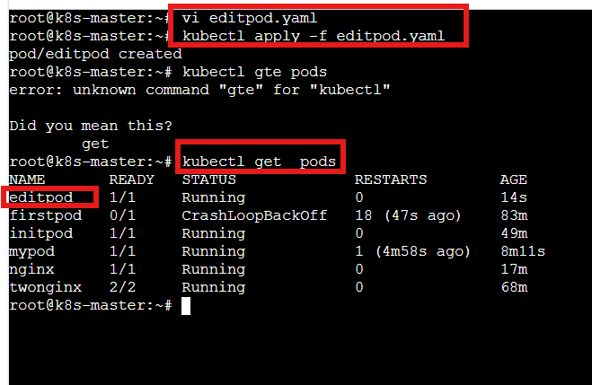

Step 2: Try Editing the Pod
kubectl edit pod editpod
Changed version of nginx from 1.24 to 1.25
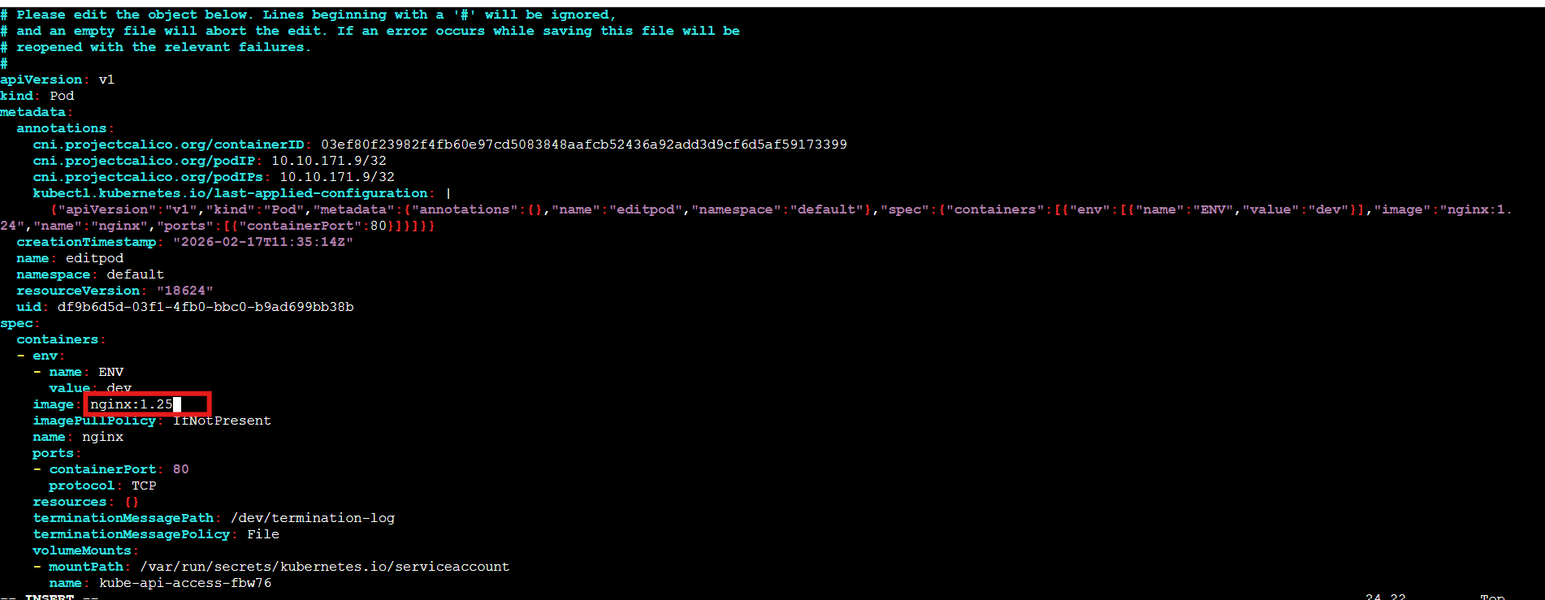
Try Changing Environment Variable
- Tried changing env variable from dev to prod
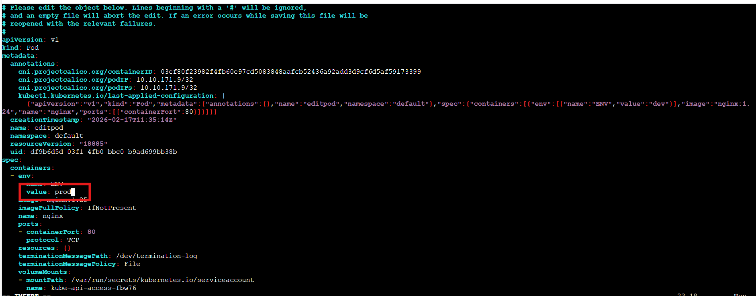

We will get:
The Pod "editpod" is invalid:
spec: Forbidden: pod updates may not change fields other than...

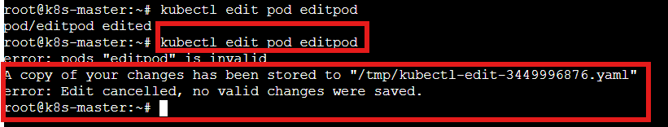

Proper Way to Modify Image or Env
Option 1: Delete & Recreate
kubectl delete pod editpod
kubectl apply -f editpod.yaml

Option 2 (Correct Production Way): Use Deployment
Create deployment:
kubectl create deployment editdeploy --image=nginx:1.24

Edit deployment:
kubectl edit deployment editdeploy

Change image → Save → It works

Check rollout:
kubectl rollout status deployment editdeploy

Task Completed

