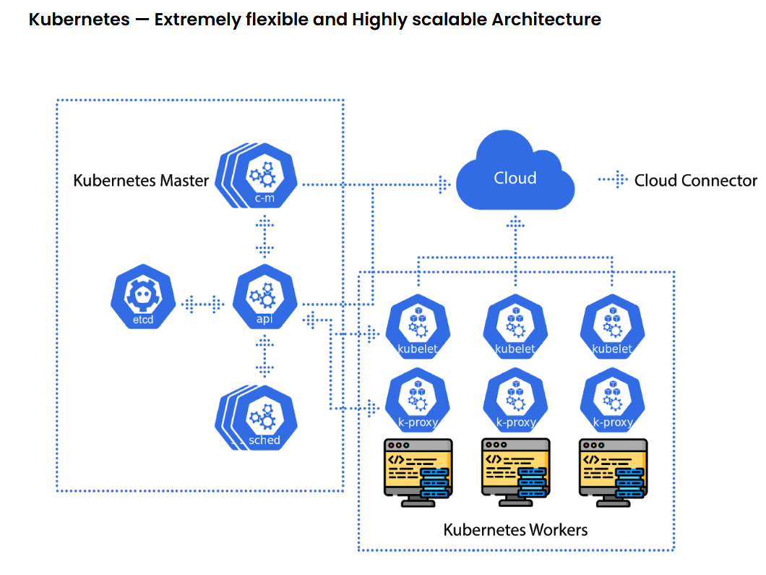
Task Title
Kubernetes-03
Objective
The objective of this task is to watch the K8s video-03 posted on slack and worked on executing the initializing K8s shown in video.
Prerequisites
List all requirements before starting:
- ClusterIP
- NortPort Service
- ReplicationController
- ReplicaSet
- Labels
- load balancing

Issues Faced: Briefly mention issues and how you fixed them. Posted below in the last.
Conclusion
Conclusion has been provided for every task at the end.

Tasks
- Create a ClusterIP service for an Apache web server pod.

Objective: Creating a ClusterIP service for an Apache web server pod. In general, if we haven’t passed any labels in the pod, then by default ClusterIP service will be created.

Step by step Implementation
Step 1: vi apache-pod.yaml

apiVersion: v1
kind: Pod
metadata:
name: apache-pod
labels:
app: apache
spec:
containers:
- name: apache-container
image: httpd:latest
ports:
- containerPort: 80

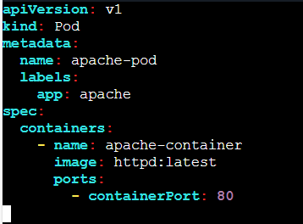

Step 2: Deploy the Pod
Kubectl apply -f apache-pod.yaml

Step 3: Verify
Kubectl get pods

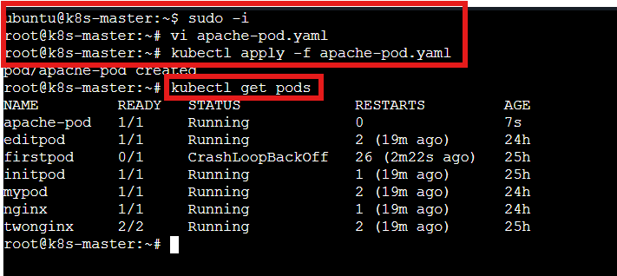

Step 4: Create a ClusterIP Service
By default, Kubernetes creates ClusterIP service type if not specified.

vi apache-service.yaml

apiVersion: v1
kind: Service
metadata:
name: apache-service
spec:
selector:
app: apache
ports:
- protocol: TCP
port: 80
targetPort: 80
type: ClusterIP

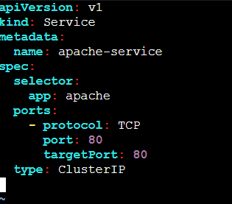

Step 5: Deploy the service and verify
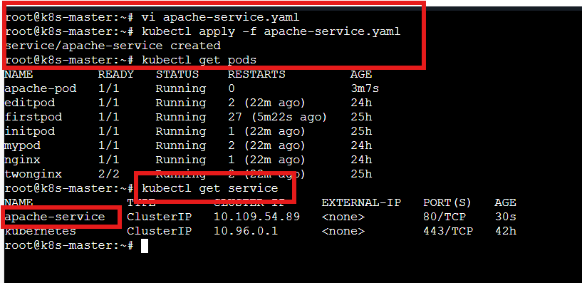

Task Completed

- Expose a Nginx pod externally using a NodePort service.

Objective: The requirement of this task is to expose the Nginx pod to Public using a NordPort service.
NordPort service is to expose the pod to public, whereas, ClusterIP is to execute privately.

Step by step Implementation
Step 1: Create a pod- vi nginx-pod.yaml

apiVersion: v1
kind: Pod
metadata:
name: nginx-pod
labels:
app: nginx
spec:
containers:
- name: nginx-container
image: nginx:latest
ports:
- containerPort: 80

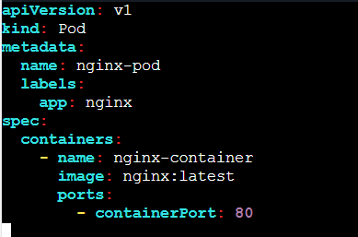

Step 2: Deploy the pod and Verify
Kubectl apply -f nginx-pod.yaml
Kubectl get pods

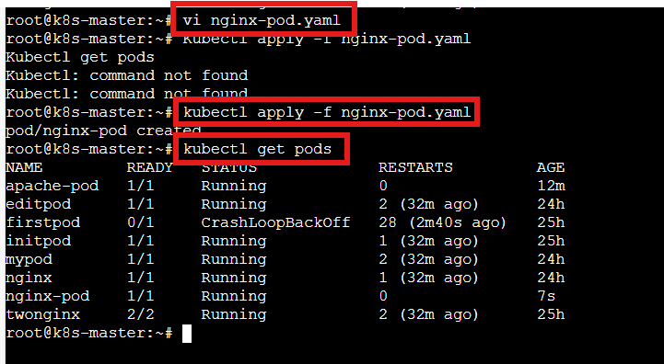

Step 3: Create NodePort Service

vi nginx-nodeport.yaml

apiVersion: v1
kind: Service
metadata:
name: nginx-nodeport-service
spec:
type: NodePort
selector:
app: nginx
ports:
- port: 80
targetPort: 80
nodePort: 30007 # Must be between 30000–32767
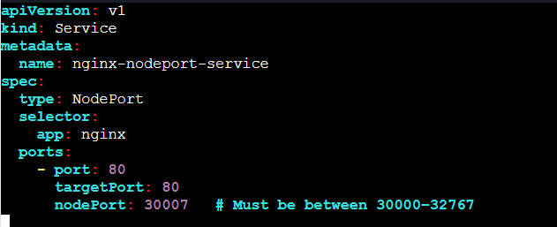

Step 4: Deploy the app and verify
kubectl apply -f nginx-nodeport.yaml
kubectl get pods

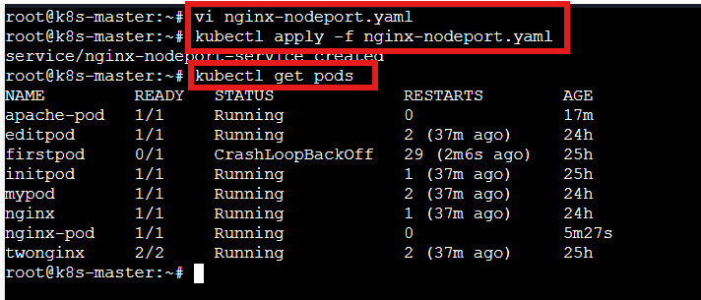

Step 5: Access From Browser
kubectl get nodes -o wide

Open in browser: Use public IP of Worker-01:30007
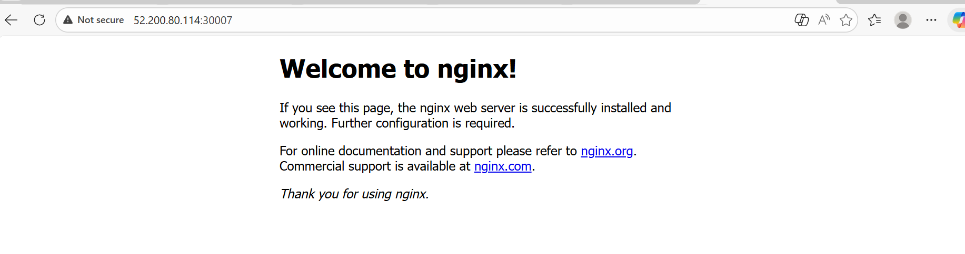

Task completed

- Deploy a ReplicationController to maintain 3 replicas of a Nginx pod.
Objective: Deploy a ReplicationController with 3 Nginx Replicas. The reason for using Replication controller is to make sure, even if pods are getting removed, new pods should be getting automatically to make sure high availability.
Similar to Auto Scaling Groups

Step by step Implementation
Step 1: Create YAML File

vi nginx-rc.yaml

apiVersion: v1
kind: ReplicationController
metadata:
name: nginx-rc
spec:
replicas: 3
selector:
app: nginx
template:
metadata:
labels:
app: nginx
spec:
containers:
- name: nginx-container
image: nginx:latest
ports:
- containerPort: 80

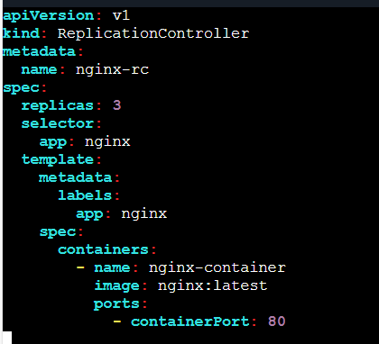

Step 2: Apply It and Verify

kubectl -f apply nginx-rc.yaml
kubectl get rc
kubectl get pods

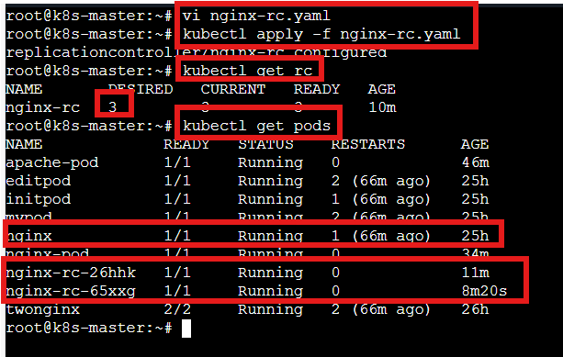

- If we verify above a nginx pod with same label was already available
- App=nginx
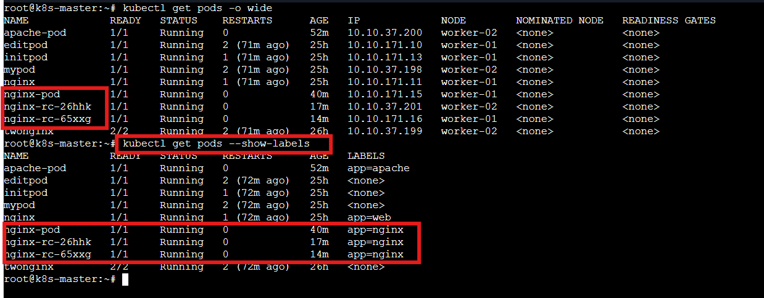

Step 3: Test Self-Healing

Delete one pod and we should get a new pod added automatically
kubectl delete pod nginx-pod

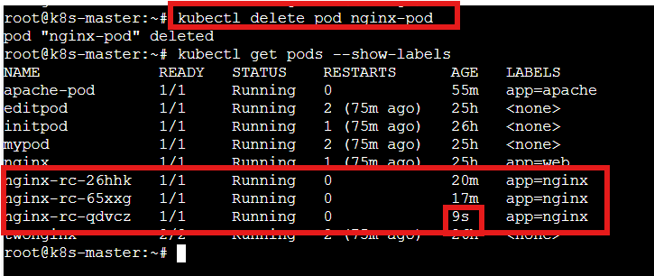

In the above screenshot we can see that, a nginx pod has been automatically created 9s ago when we deleted existing nginx-pod

Task completed

- Scale the ReplicationController from 3 replicas to 5 replicas.

Objective: The requirement of this task is to scale the RC from 3 replicas to 5 replicas.
We have 2 methods 1 is using command line and 2nd is we can use edit method

Step by step Implementation
Step 1: We shall use the edit method its straight forward and traditional method as well.

Kubectl get rc
kubectl edit rc nginx-rc
kubectl get pods

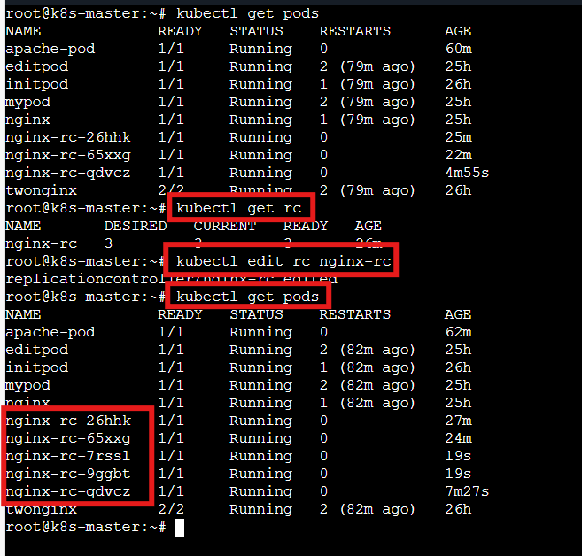

Step 2: kubectl edit rc nginx-rc
Change the Replicas from 3 to 5
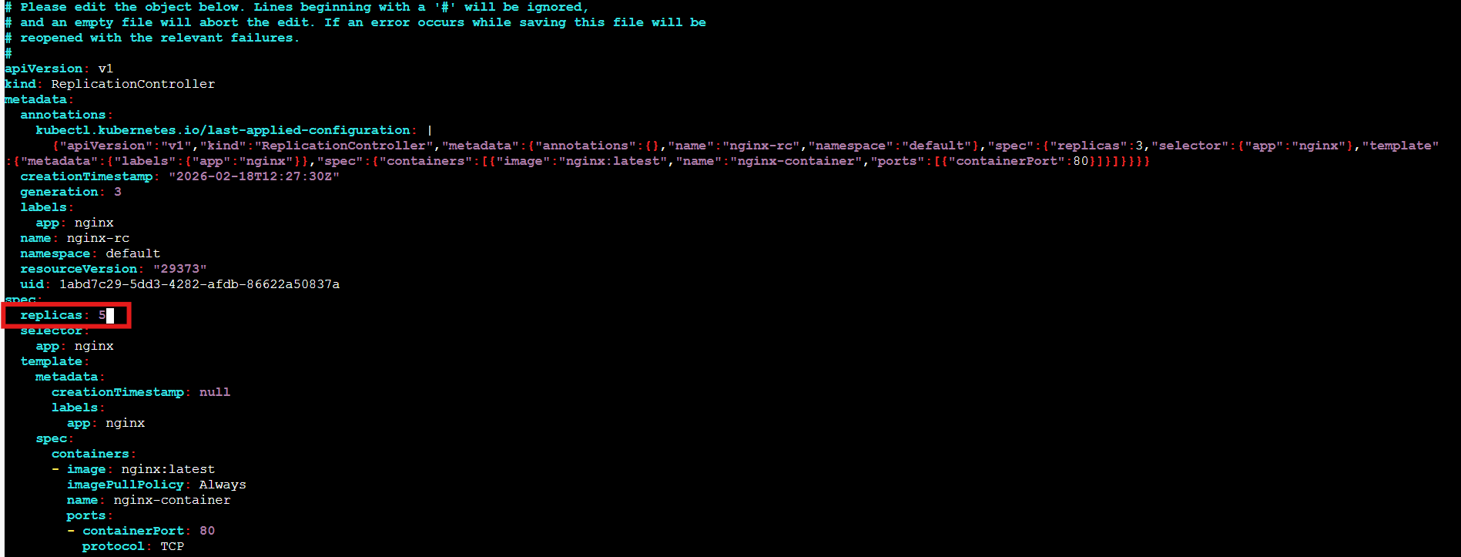

Task Completed

- Create a ReplicaSet to manage pods based on multiple labels (prod and test).

Objective: The requirement of this task is to create a ReplicaSet to manage pods based on multiple labels.
The difference between ReplicationController and ReplicaSet are to manage labels, where RC will work on 1 label, whereas, RS will work with multiple labels.

Step by step Implementation
Step 1: Create ReplicaSet YAML

vi nginx-rs-multilabel.yaml

apiVersion: apps/v1
kind: ReplicaSet
metadata:
name: nginx-rs-multi
spec:
replicas: 3
selector:
matchLabels:
env: prod
tier: test
template:
metadata:
labels:
env: prod
tier: test
spec:
containers:
- name: nginx-container
image: nginx:latest
ports:
- containerPort: 80

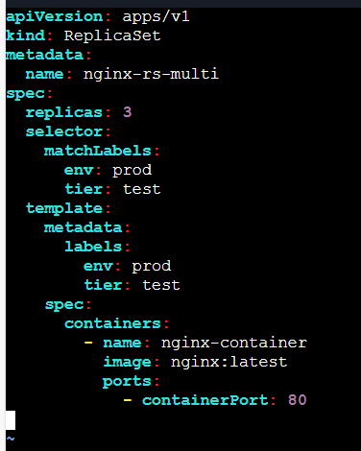

Step 2: Apply It and verify

kubectl apply -f nginx-rs-multilabel.yaml
kubectl get rs
kubectl get pods –show-labels
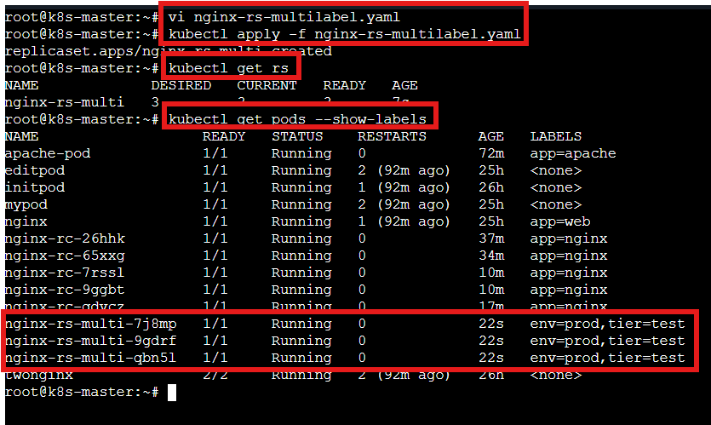

Step 3: How Multiple Labels Work

matchLabels:
env: prod
tier: test
Deleted a pod we verified a pod got added automatically with RS
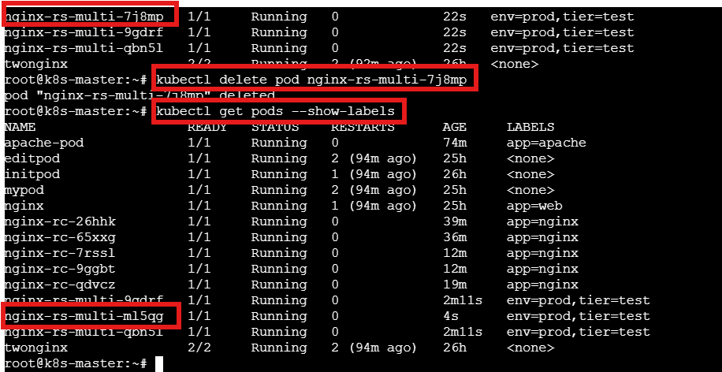
Task Completed
- Deploy a ReplicaSet that excludes pods with the label backend.

Objective: Deploying a RS that excludes pods with label backend. this tests set-based label selectors using NotIn

Step by step Implementation
Step 1: Solution Using matchExpressions (NotIn Operator)

vi nginx-rs-exclude-backend.yaml

apiVersion: apps/v1
kind: ReplicaSet
metadata:
name: nginx-rs-exclude-backend
spec:
replicas: 3
selector:
matchExpressions:
- key: role
operator: NotIn
values:
- backend
template:
metadata:
labels:
role: frontend # Important: Must NOT be backend
spec:
containers:
- name: nginx-container
image: nginx:latest
ports:
- containerPort: 80

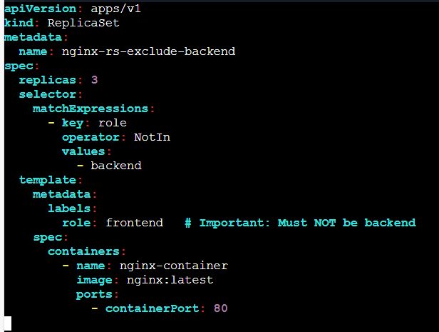

Step 2: Apply It and verify

kubectl apply -f nginx-rs-exclude-backend.yaml
kubectl get rs
kubectl get pods –show-labels

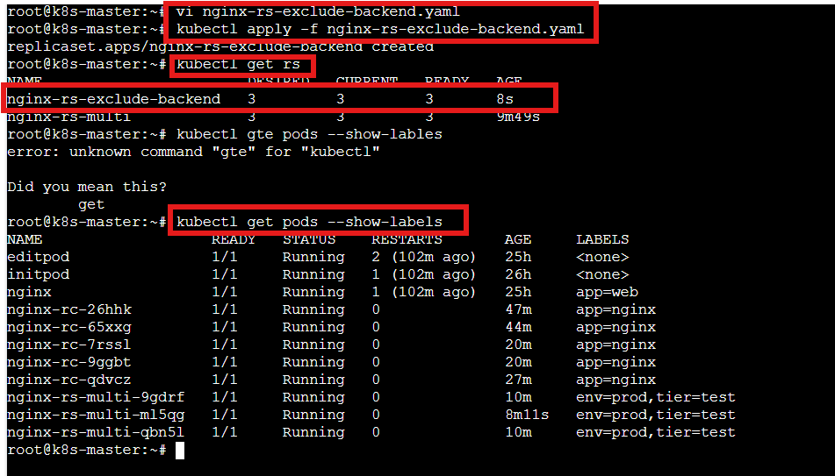

Step 3: What This Selector Means

matchExpressions:
- key: role
operator: NotIn
values:
- backend

Select pods where role is NOT backend
✔ Includes pods with:
- role=frontend
- role=api
- role=anything-else
- even pods without role label
❌ Excludes pods with:
- role=backend
Step 4: Create a backend pod manually
kubectl run backend-pod --image=nginx --labels="role=backend"

Step 5: Remove label from one RS pod
kubectl label pod nginx-rs-exclude-backend.yaml role=backend --overwrite

Immediately:
- That pod becomes invalid for RS
- ReplicaSet creates a new valid pod
- Total desired replicas maintained
This is reconciliation in action.

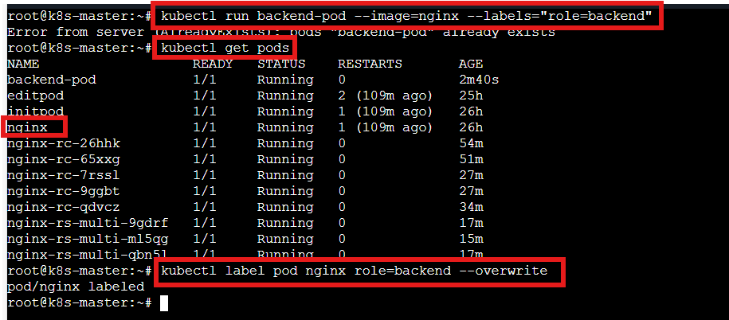

Task Completed

- Test load balancing across multiple pods using a NodePort service.
Objective: We shall test a load balancing service across multiple pods which is existing using a NordPort service

Step by step Implementation
Step 1: Create a Deployment- vi lb-nginx.yaml

apiVersion: apps/v1
kind: Deployment
metadata:
name: nginx-deploy
spec:
replicas: 3
selector:
matchLabels:
app: lb-nginx
template:
metadata:
labels:
app: lb-nginx
spec:
containers:
- name: nginx
image: nginx
ports:
- containerPort: 80
---
apiVersion: v1
kind: Service
metadata:
name: lb-service
spec:
type: NodePort
selector:
app: lb-nginx
ports:
- port: 80
targetPort: 80
nodePort: 30008
Step 2: Verify
kubectl apply -f lb-nginx.yaml
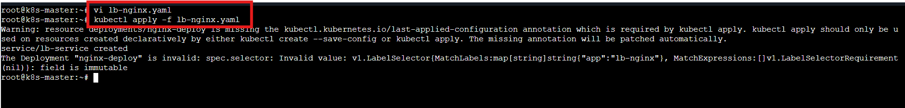

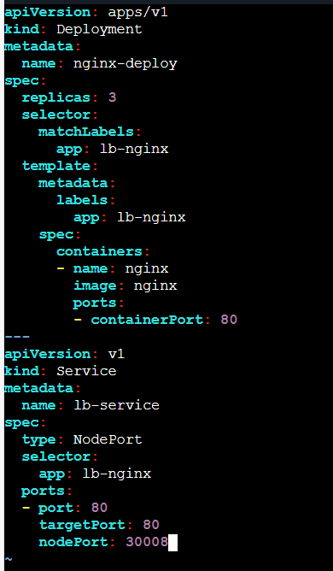

Step 3:
kubectl get deploy
kubectl get pods -o wide
kubectl get services
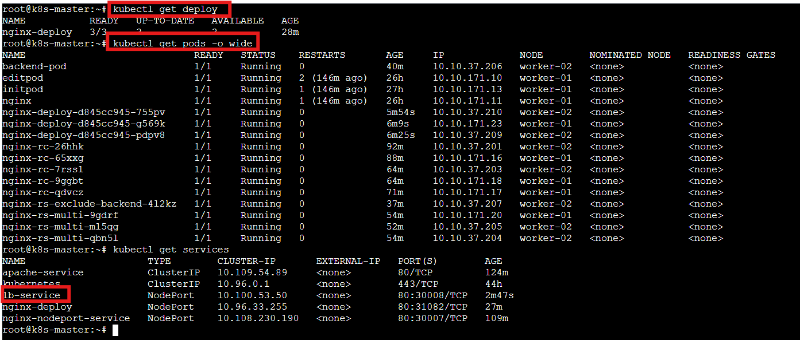

Step 4: Verify in browser
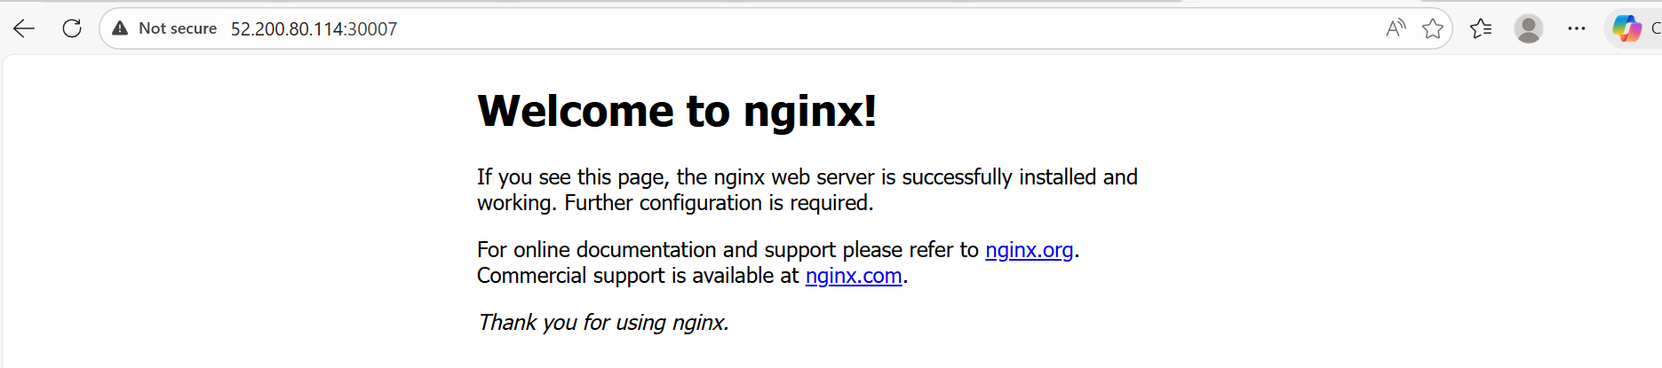
Task Completed

- Delete a ReplicationController without affecting the running pods.
Objective: This is an easy task, where we need to delete rc with using a command having the pods running.

Step by step Implementation
Step 1: We need to verify the existing RC’s and pods
Check RC and Pods
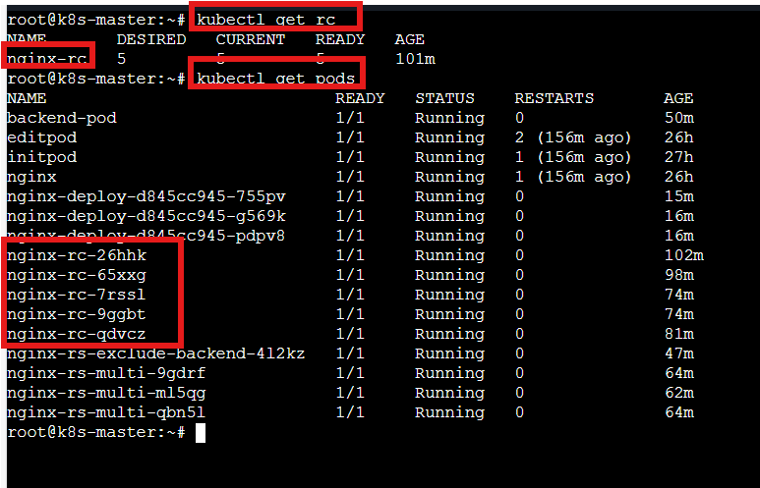

Step 2: Delete RC but Keep Pods
kubectl delete rc nginx-rc --cascade=orphan

Step 3: Verify
Now, we verified that, rc is deleted now.
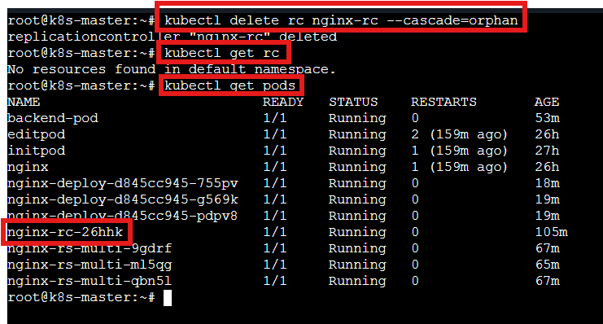

Task completed

