- Create user with name Techie and provide sudo access to user.
Sudo adduser: User created as techies and provided sudo access.
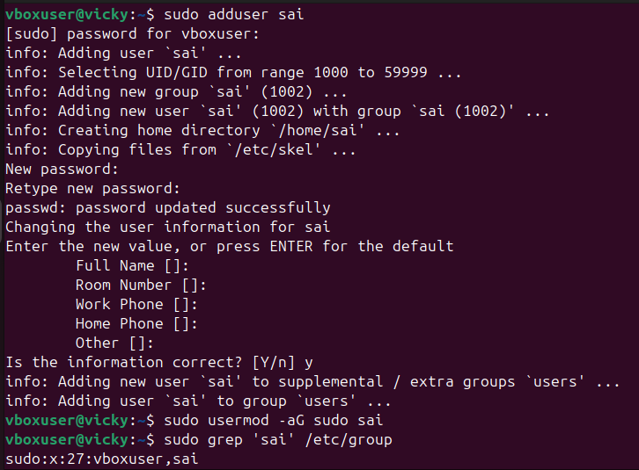
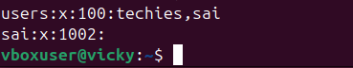
- Navigate to the home directory.
~: Navigated to home directory
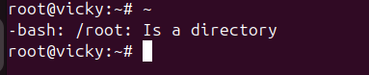
- Create a new directory.
Mkdir: created the directory
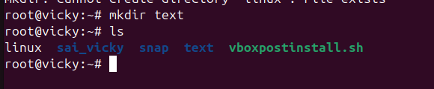
- List the contents of a directory.
Ls: listed the contents
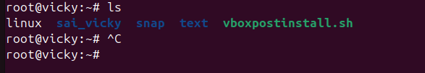
- Change the current directory.
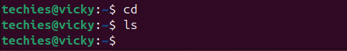
- Create a new empty file.
Touch: created the file
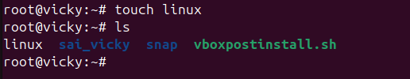
- View the contents of a file.
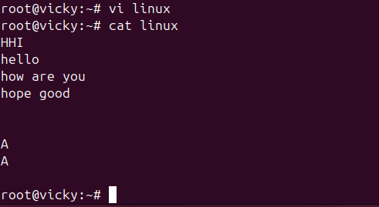
- Copy a file to another location.
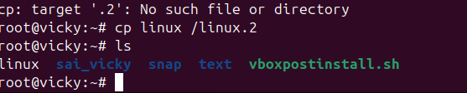
- Move a file to another location.
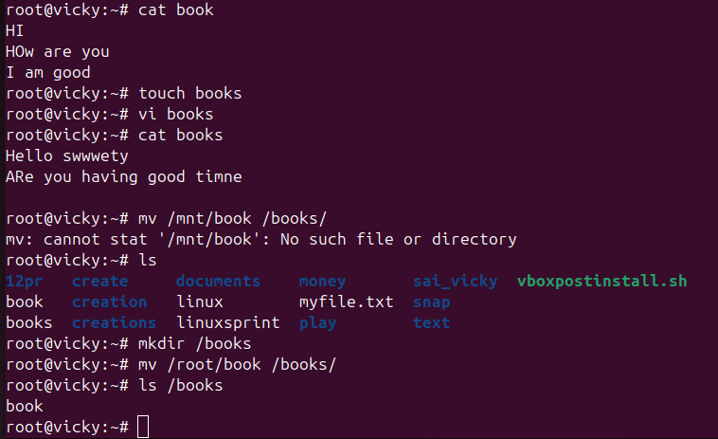

- Rename a file.
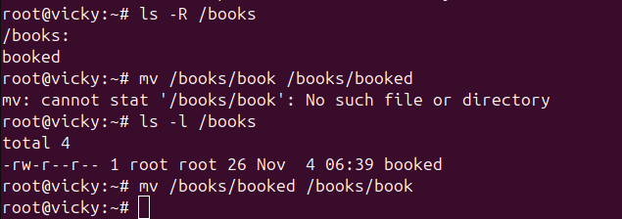
- Delete a file.
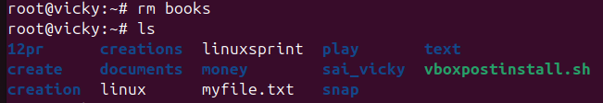
- Grant or revoke permissions on a file or directory.
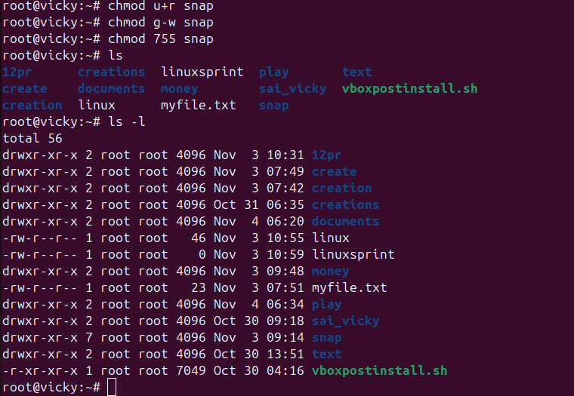
- View the current date and time.
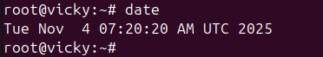
- Check the system uptime.
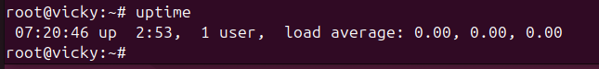

- View the running processes.
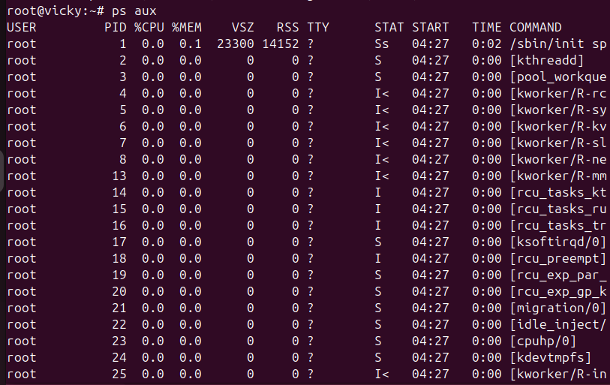
- Kill a running process.
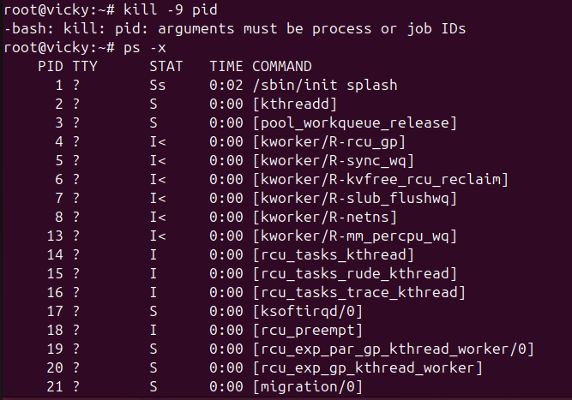
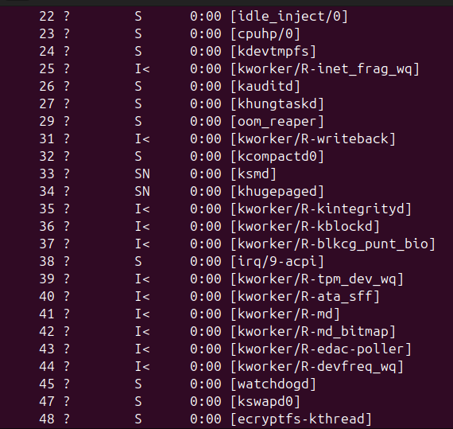
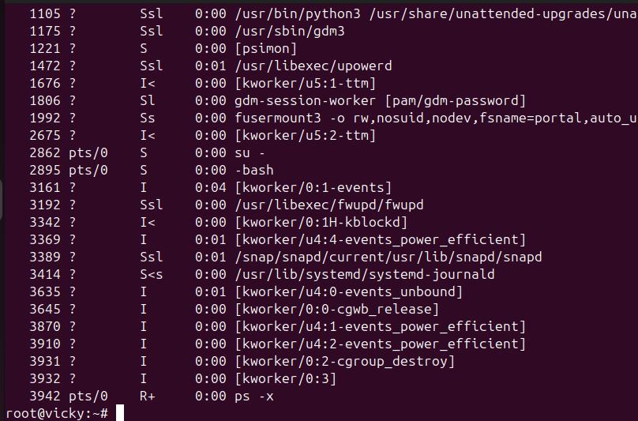
- Install a package using the package manager (e.g., apt or yum).
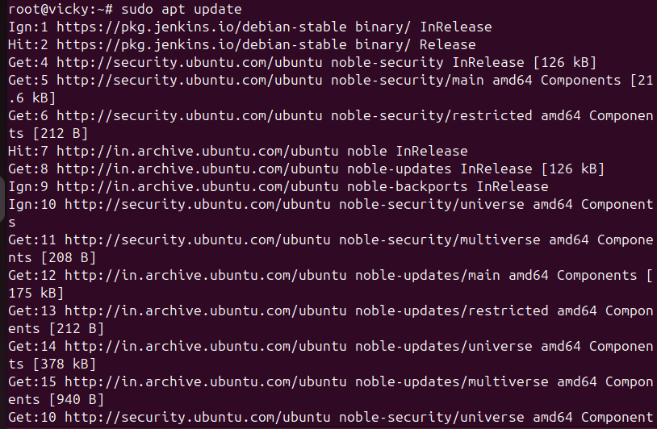
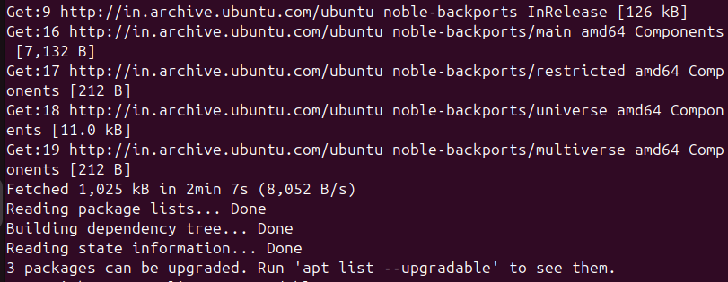
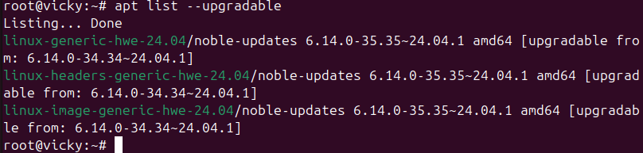
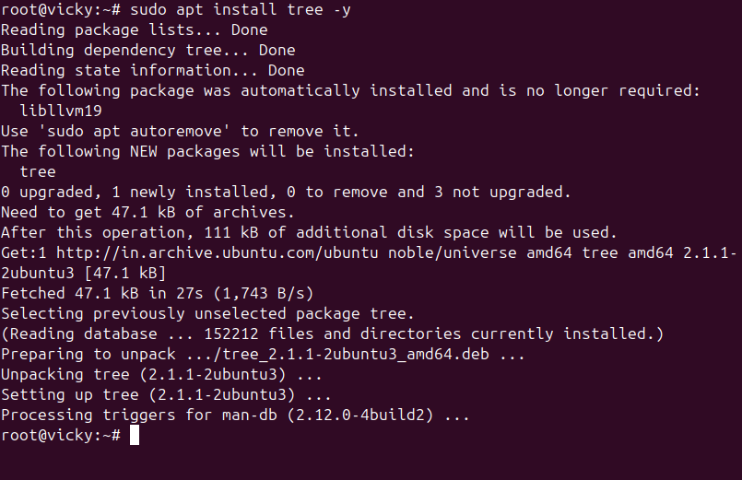
- Update the system packages.
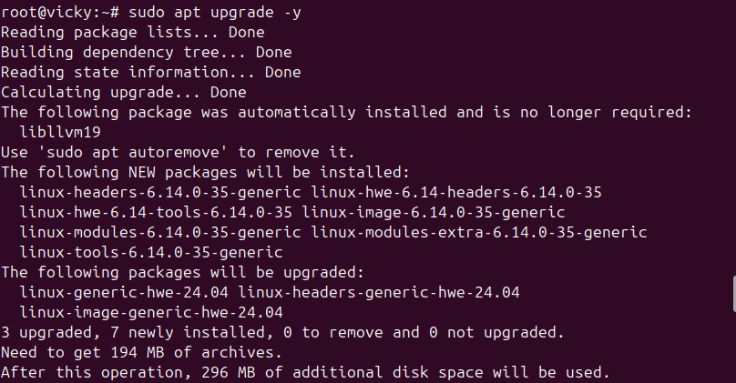
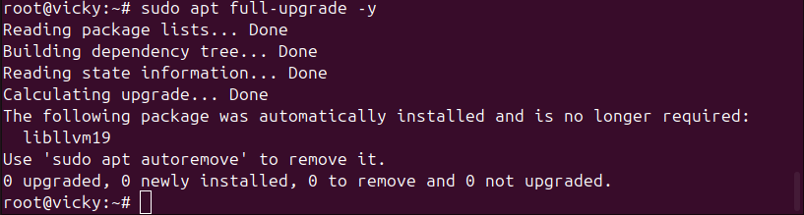
- Create a symbolic link.
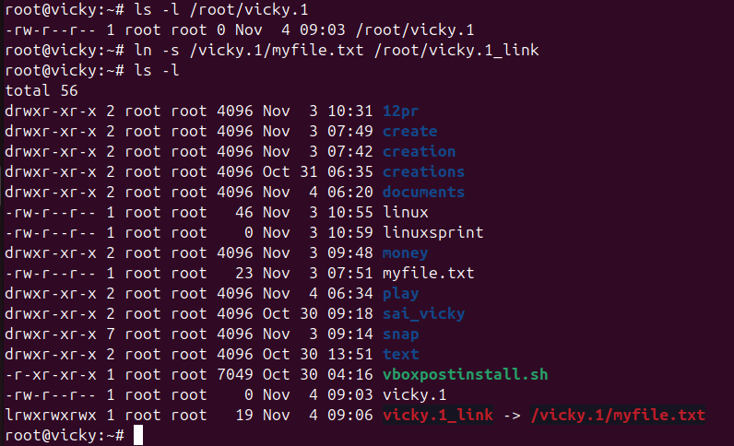
- Search for files using the find command.
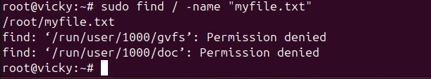
- Compress and decompress files using tar.
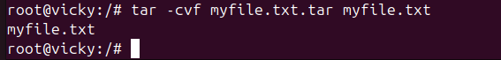
- Monitor system resources with top or htop.
Top: It will help to monitor the resources
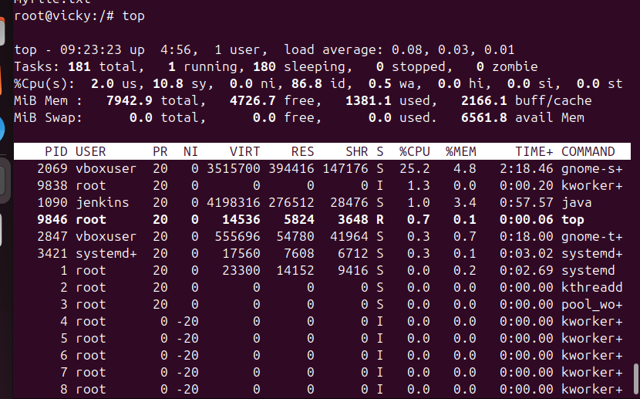
- Create and manage user groups.
Groupadd techie-grp : this commend will help to create the group
Usermod -Ag : this commend is help to manage
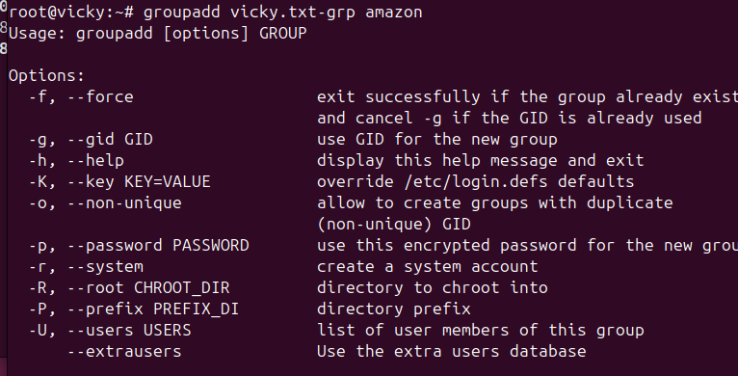
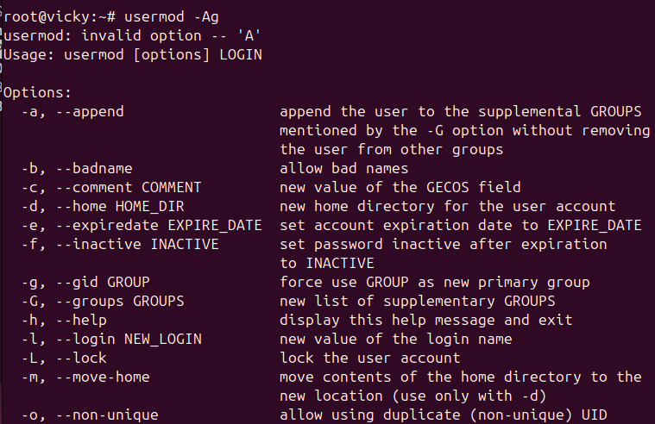
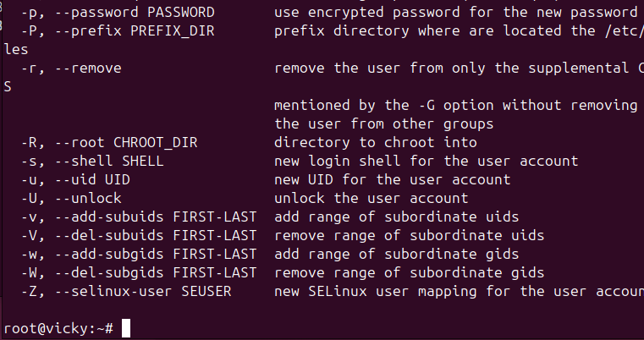
- Monitor log files using tail or grep.
View last 10 lines: tail tech
View last 50 lines: tech -n 50 tech
Monitor a file in real time: tail -f tech
Search for a specific text: grep “error” tech
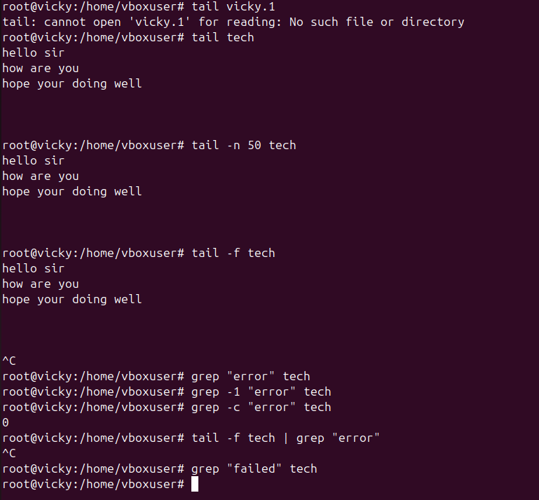
- Set up a web server (e.g., Apache or Nginx).
Install nginx
Start: sudo systemctl start nginx
Enable: sudo systemctl enable nginx
Status- sudo systemctl status nginx
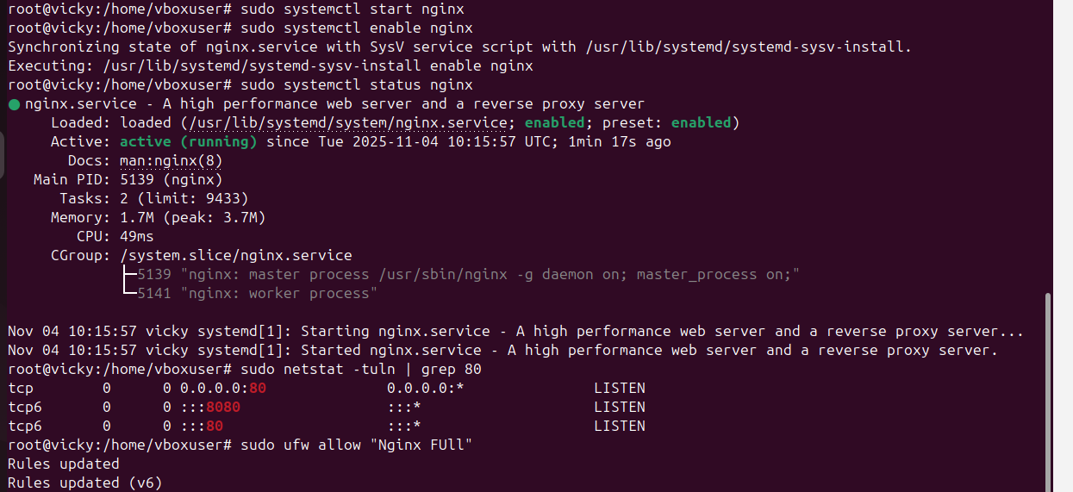
Launch EC2 server in AWS> edit inbound rules in security groups to 80? Copy the IPV4 address and paste in ubuntu for the below screenshot.
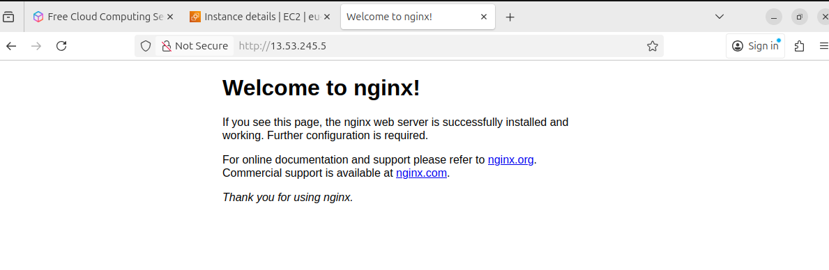

- Configure and secure a MySQL Database.
Install MySQL: sudo apt update> sudo apt install -y mysql server
Start and Enable: sudo systemctl enable – now mysql
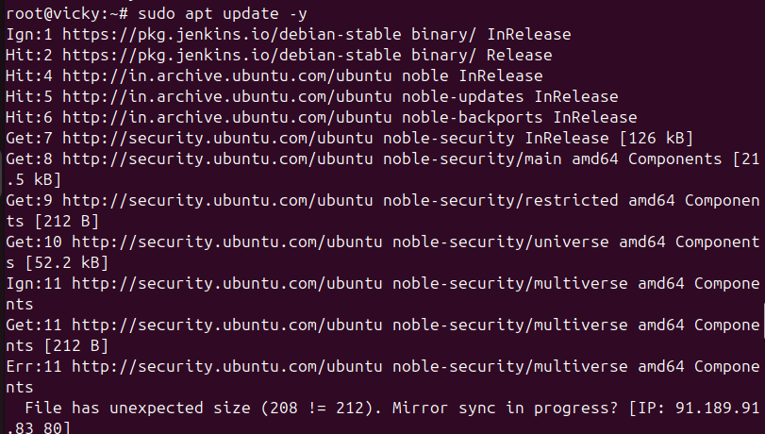

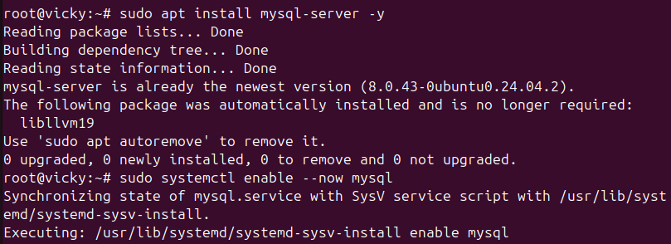

Run mysql secure installation: sudo mysql_secure_installation
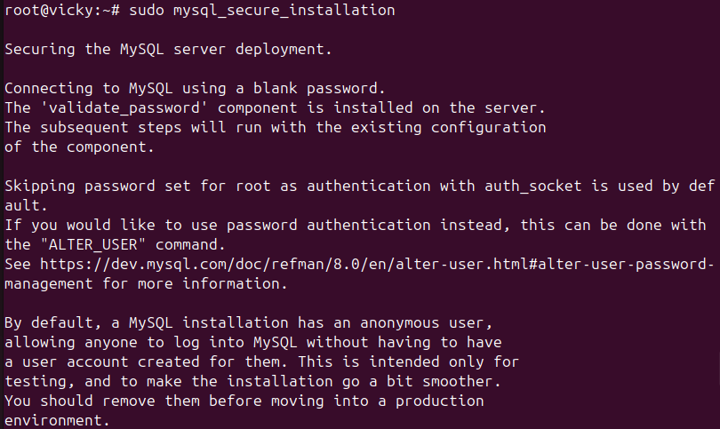
Restart: sudo systemctl restart mysql
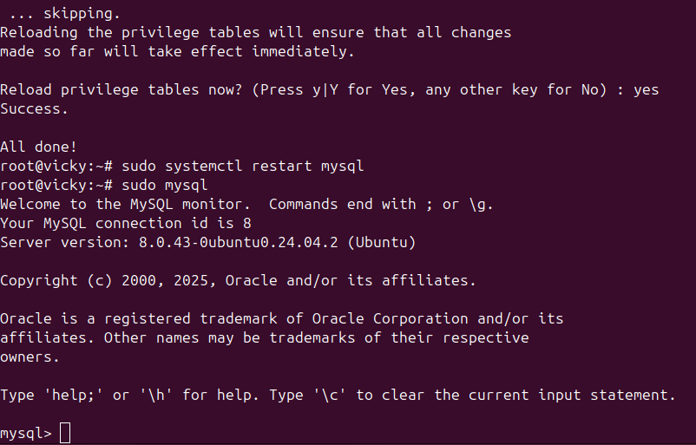
- Set up a Application Server (e.g., Apache Tomcat)
- Update system- sudo apt update -y
- Install Java- sudo apt install openjdk-17-jdk -y
- Create Tomcat user- sudo useradd -m -U -d /opt/tomcat -s /bin/false tomcat
- Download Tomcat- cd /tmp
- wget https://downloads.apache.org/tomcat/tomcat-10/v10.1.31/bin/apache-tomcat-10.1.31.tar.gz
- Extract Tomcat- sudo mkdir /opt/tomcat
- sudo tar - xvzf apache-tomcat-10.1.31.tar.gz -C /opt/tomcat --strip-components=1
- Give permissions- sudo chown -R tomcat: /opt/tomcat
sudo chmod +x /opt/tomcat/bin/*.sh
- Start Tomcat- /opt/tomcat/bin/startup.sh

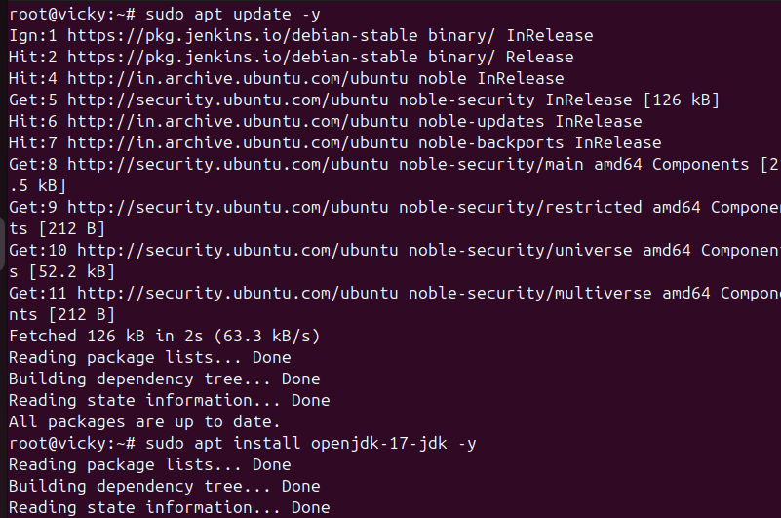
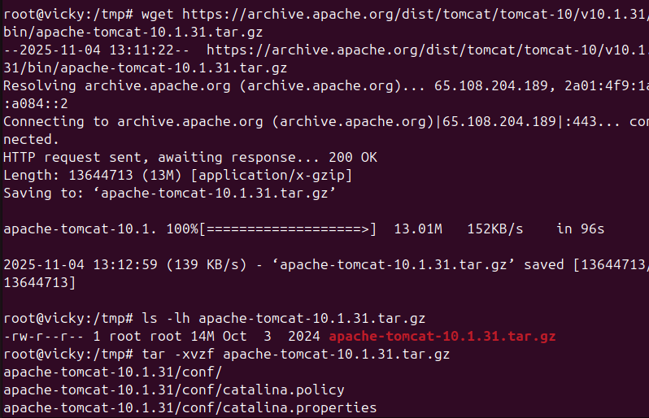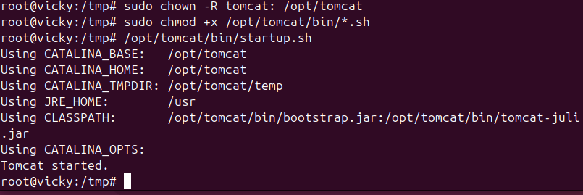

- Print specific columns from a delimited file.
Created data.csv for 3 profiles using the command- echo “” >data.csv
To verify the entered data- cat data.csv
Delimited Age using command- cut -d’,’ -f1,3 data.csv
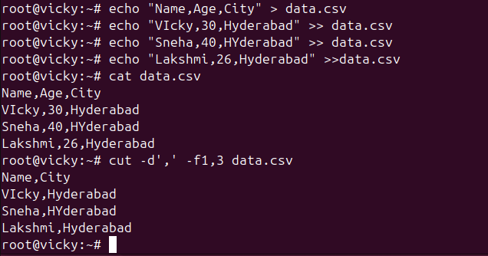
- Filter and print lines based on a specific pattern or condition.
To filter Hyderabad and print use Command: grep “Hyderabad” data.csv
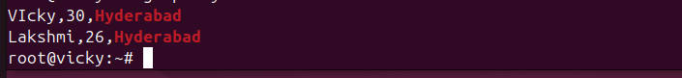
- Calculate and print the average, sum, or other statistics of a column.
For Average and Sum command: awk -F’,’ ‘NR>1 {sum += $3} END {print “Total Salary:”, sum}’ data.txt
-F’,’ – tells awk the delimiter is a comma
NR>1 – skips the header line (Name, Role, Salary)
Sum +=$3 – adds the third column (salary)
End {print “Total Salary:”, sum} – prints total after reading all lines
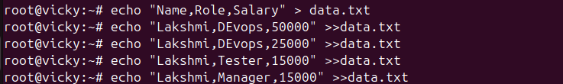
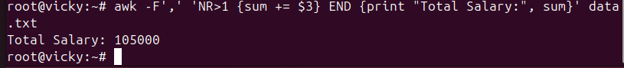
- Perform string manipulation, such as extracting substrings or changing case.

- Count the occurrences of a specific pattern in a file.
Command- Used echo “cities” >cities.txt for entry
Command- grep -c “Bengaluru” cities.txt
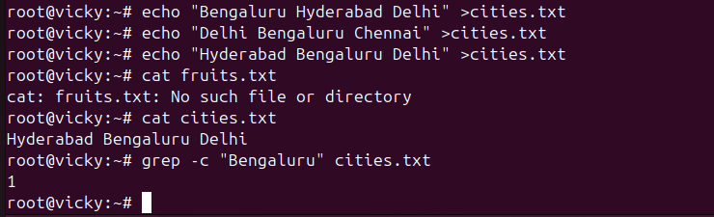
- Sort lines based on a specific field or column.
I would like to sort lines which I created in the past using command echo “Name, Age, City” > data.csv
Verified the lines using command- cat data.csv
Used command to sort lines: sort -k1,1 data.csv
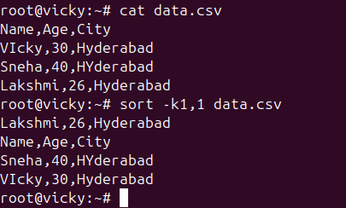
- Merge multiple files based on a common field or column.
Created 2 different files using echo “” > >> register.txt and echo “” > >>marks.txt and combined them using command- join register.txt marks.txt
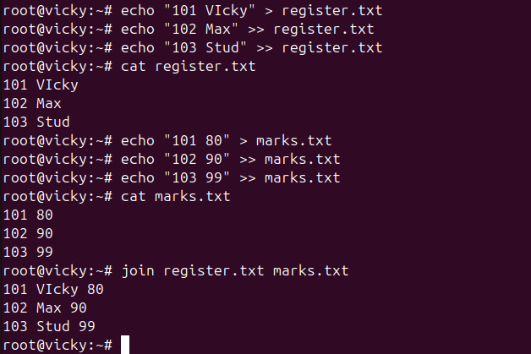
- Substitute text in a file using search and replace.
Created a file named- demo
Updated text in Vi
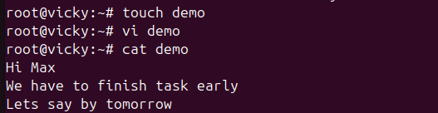

Renamed the texts in the file using vi
To verify the changed wordings in the file- sed ‘s/linux/ubuntu/’ demo
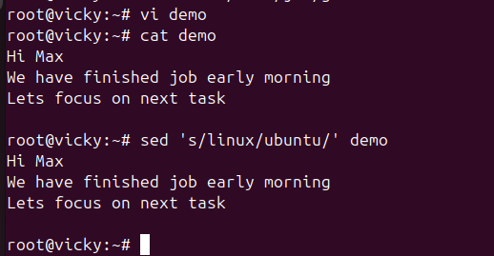
- Delete specific lines based on a pattern or line number.
Created file name as “Demo” and updated file contents using vi
Deleted a line using vi editor and verified by command- sed ‘3d’ demo
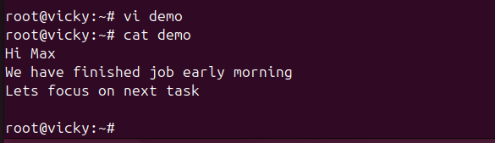
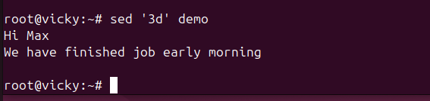
- Append or insert text before or after a specific pattern or line.
Entered file contents using command- echo “” > data.txt
Updated file using command- sed ‘ /last line in file/I where line needs to be updated’ data.txt
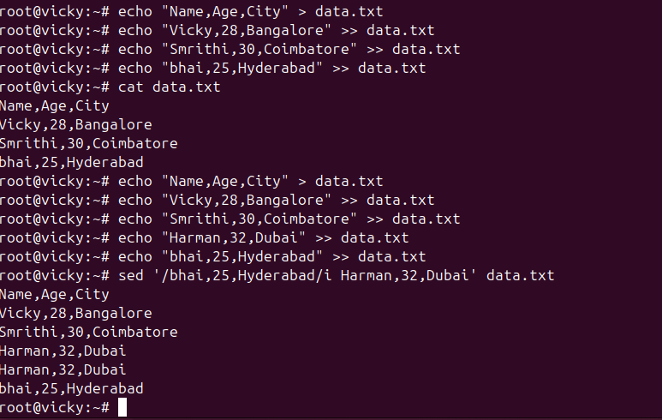
- Print only specific lines from a file.
Previously created a file with command echo “,,,” > data.txt
Used command- sed -n ‘ep’ data.txt for printing only 3rd line from the file.

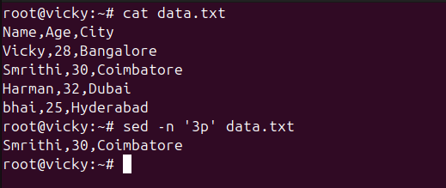
- Copy file from linux to windows machine

Copy file or directory from linux server to own windows machine-
:SCP -I pem.key ec2-user@ip/filelocation/filename~/destination/>
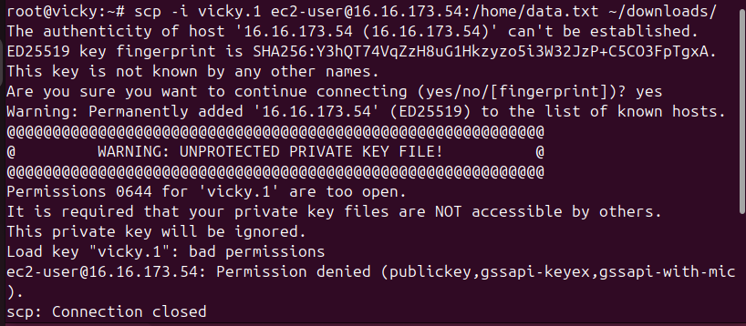
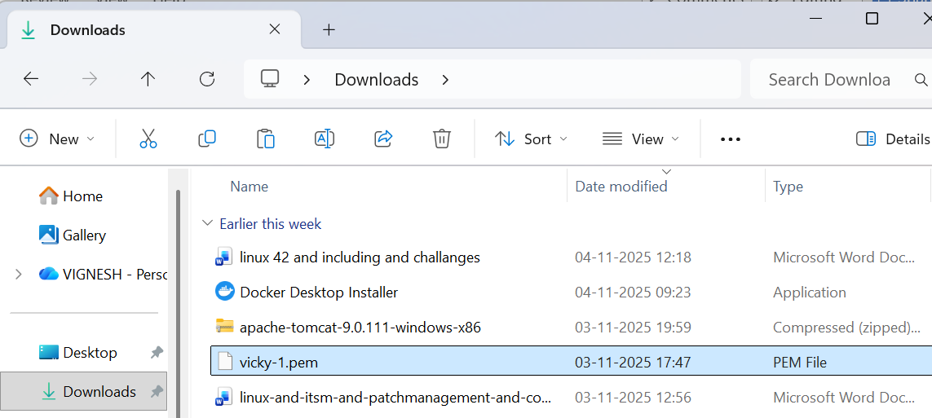
- 5 use cases for AWK and 5 use cases for sed
Used sed command to print specific lines below.
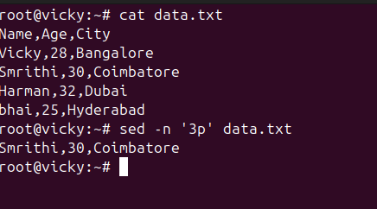
Used awk command
-F’,’ – tells awk the delimiter is a comma
NR>1 – skips the header line (Name, Role, Salary)
Sum +=$3 – adds the third column (salary)
End {print “Total Salary:”, sum} – prints total after reading all lines

