Docker-02

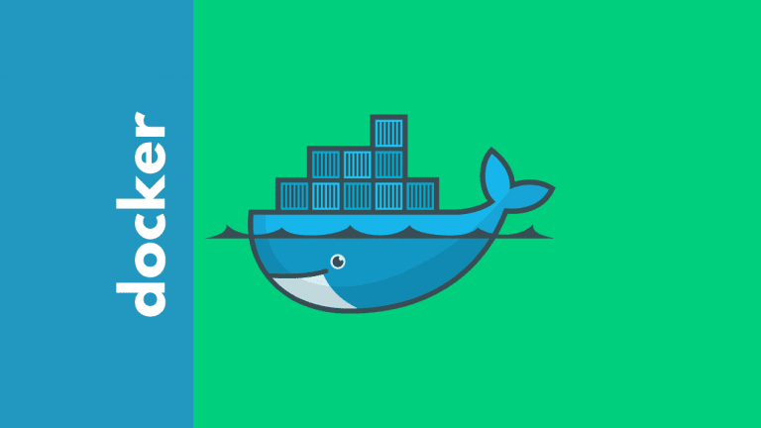

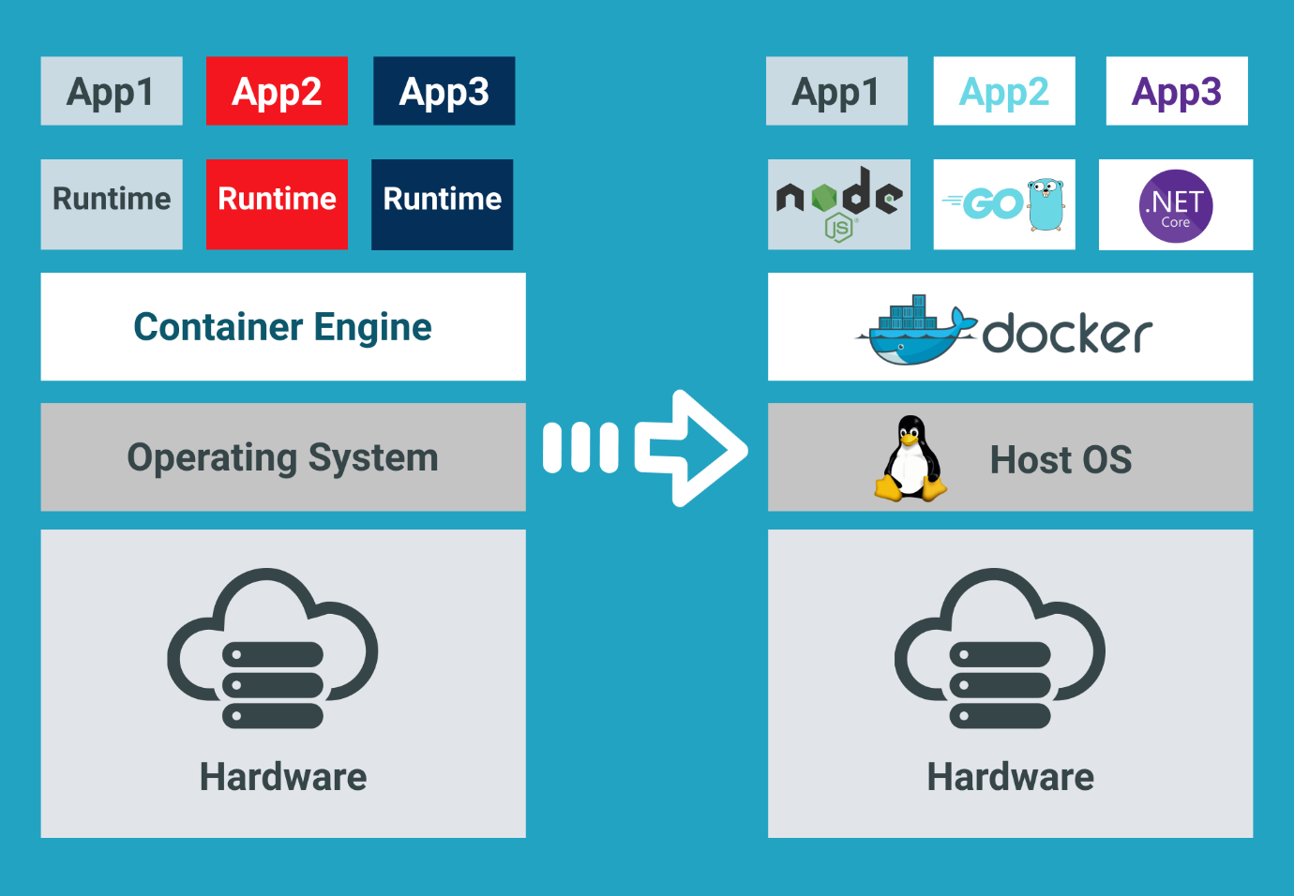

Task Title
Docker-02
Objective
The objective of this task is to watch the Docker-02 video posted on slack and worked on executing the initializing Ansible shown in video.
Prerequisites
List all requirements before starting:
- Virtualization
- Containerization
- Infrastructure
- Hypervisor
- Operation system (O.S) – Windows, Linux, Ubuntu
- Bins/libraries
- Applications

Issues Faced: Briefly mention issues and how you fixed them. Posted below in the last.
Conclusion
Conclusion has been provided for every task at the end.

Tasks

- Create a tomcat container on 8080 and deploy sample application in tomcat.
Step by step Implementation:
Step 1:
Launch server and start the docker service
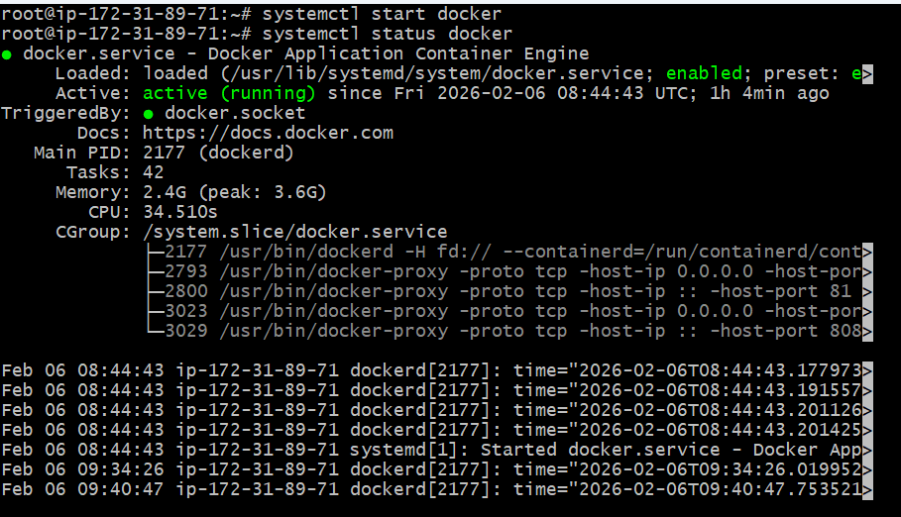

Step 2: Verify docker images if tomcat is available. If not use command- docker pull tomcat
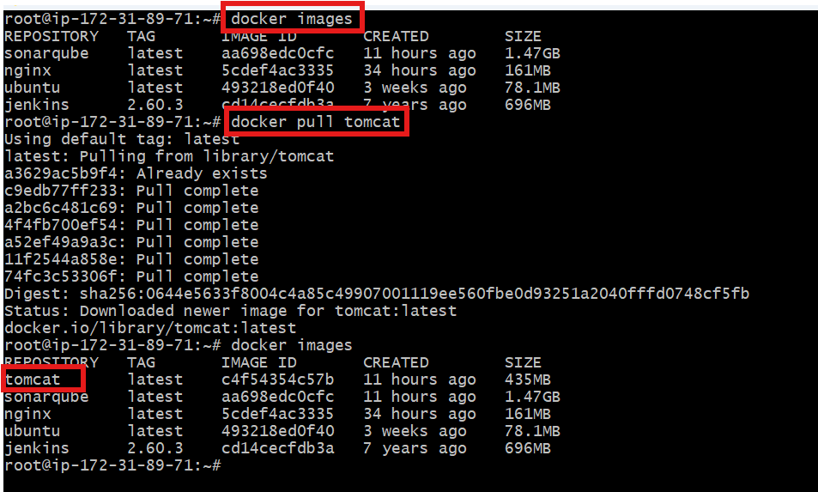

Step 3: Requirement is to run tomcat on port 8080
Port 8080 is already allocated, so we shall try for 8081

8081 was successful
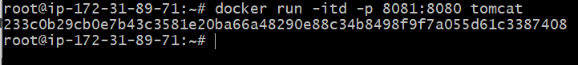

Step 4: Now, we shall verify on browser if IP with 8081 port number.
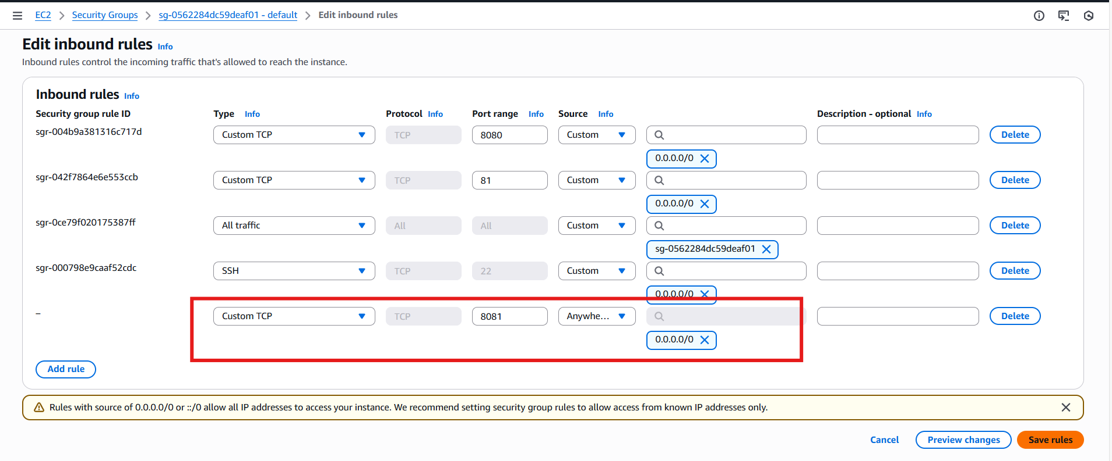

Here we got an error like 404 not found it because there is no sample file available for deployment
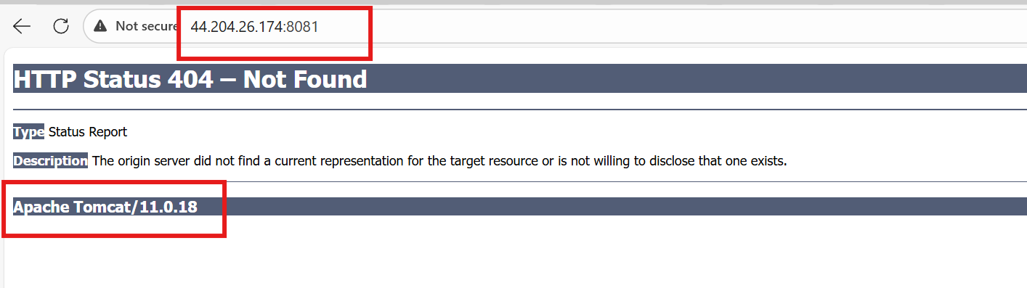

Step 5: Let’s download a sample.war file from tomcat website
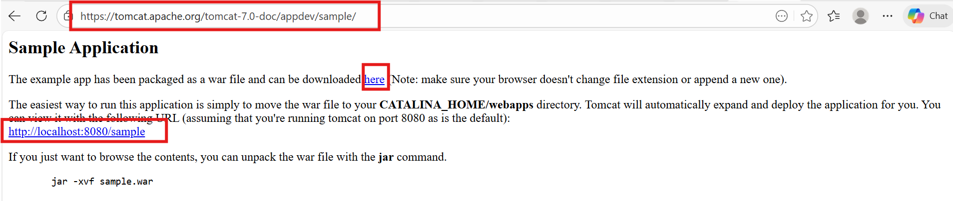

Get inside of tomcat container and perform the actions

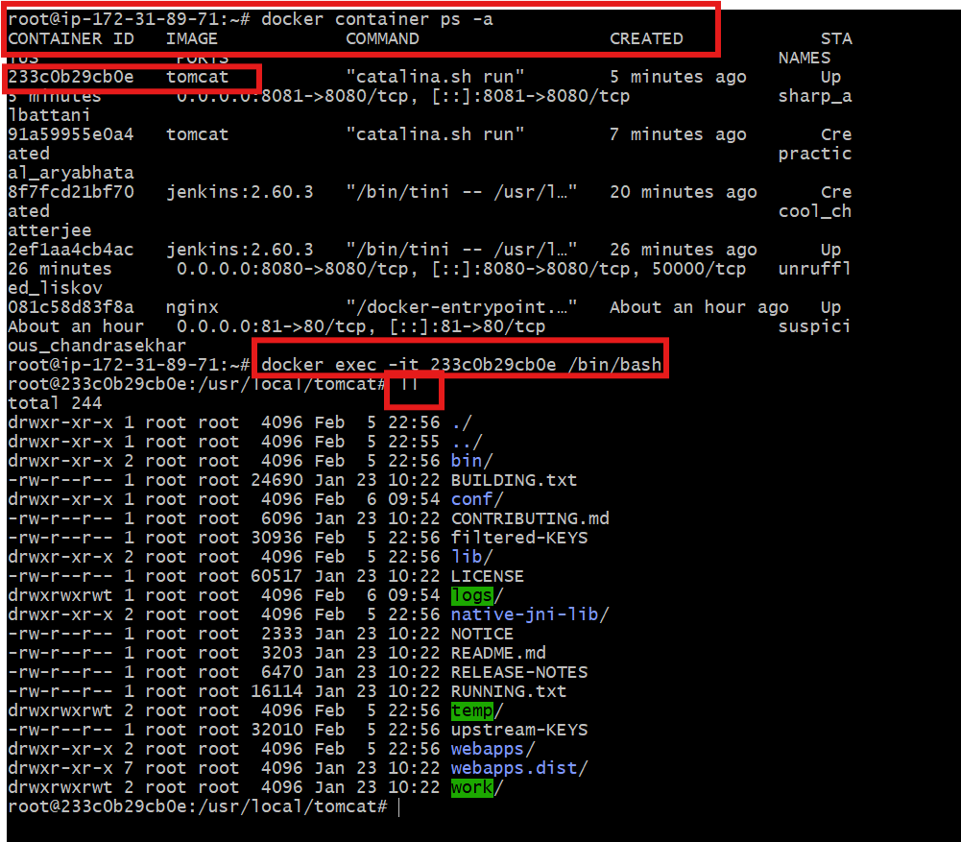

Step 6: Then download the sample.war file and wait for few seconds to unzip the file it automatically does. apt update -y
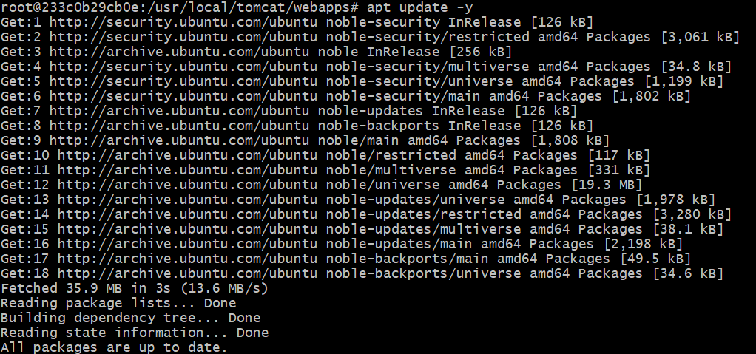
Issues faced:
I got an error when I tried to use wget command to download the sample.war.
So, we need to install wget using command- apt install wget -y
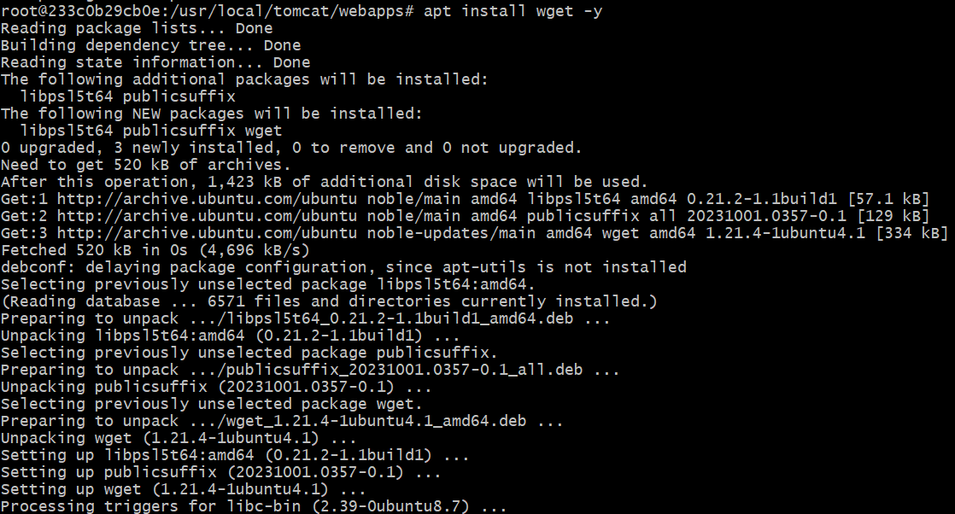
wget https://tomcat.apache.org/tomcat-7.0-doc/appdev/sample/sample.war
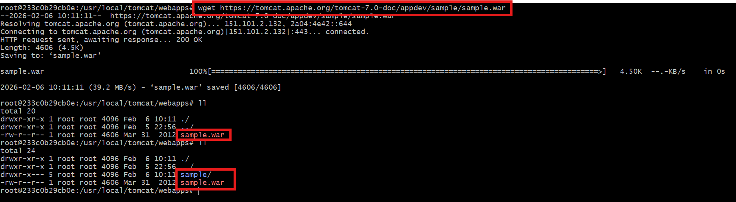

Step 7: Later verify on web using /sample
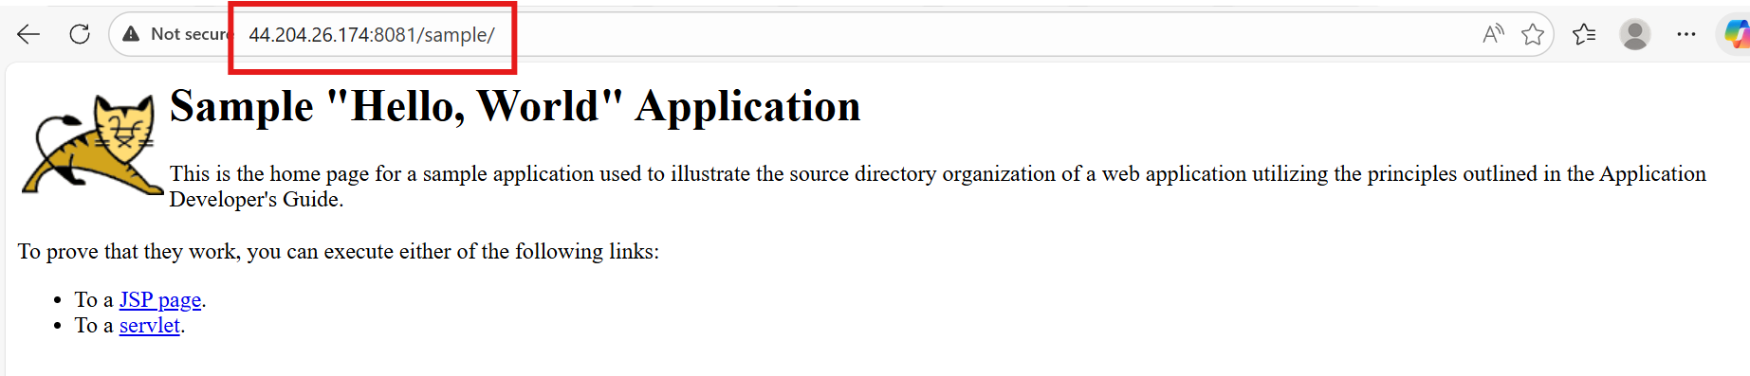

Task completed
- Create volume and deploy tomcat container on port 8081.

Step by step Implementation:
Step 1: We have already deployed a sample.war file in the container itself.
Instead of having in the container, alternatively, we can create a volume and store the sample.war file in the volume.

- Create a volume naming as prod
- And verify the volumes using ls command
- Get into the dir using default path of volumes and get inside of it
- Inside of _data dir downloads the sample.war file

Commands-
- docker volume create deploy
- Docker volume ls
- Cd /var/lib/docker/volumes/
- Cd deploy/
- Cd _data/
- Wget https://tomcat.apache.org/tomcat-7.0-doc/appdev/sample/sample.war
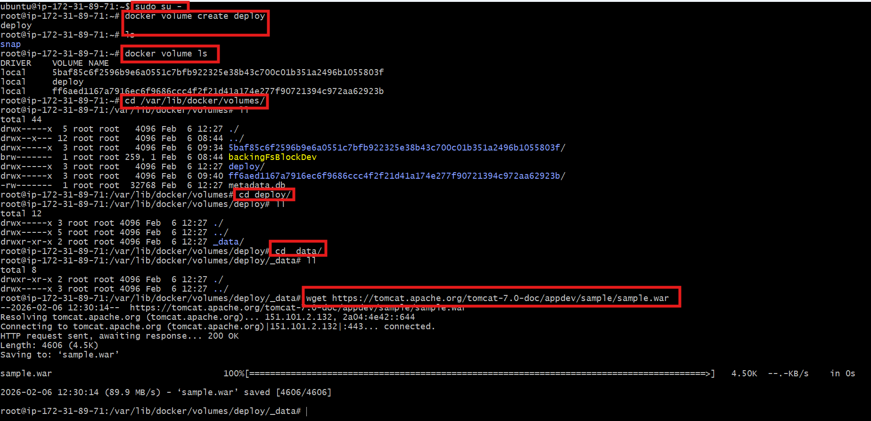

Now, a sample.war file has been created under volume- deploy
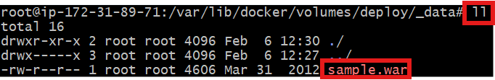

Step 2: Now run the command by providing full path and verify on browser
docker run -itd -p 8001:8000 -v /var/lib/docker/volumes/deploy/_data:/usr/local/tomcat/webapps tomcat

Successfully, we passed the volume path with container path.
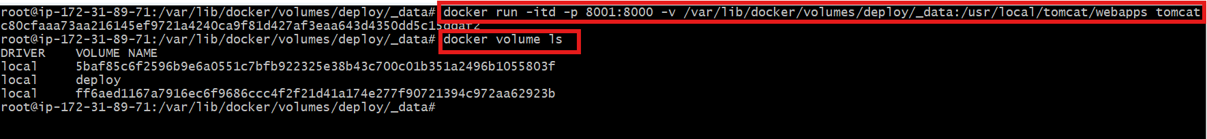

Step 3: Let’s verify in the browser
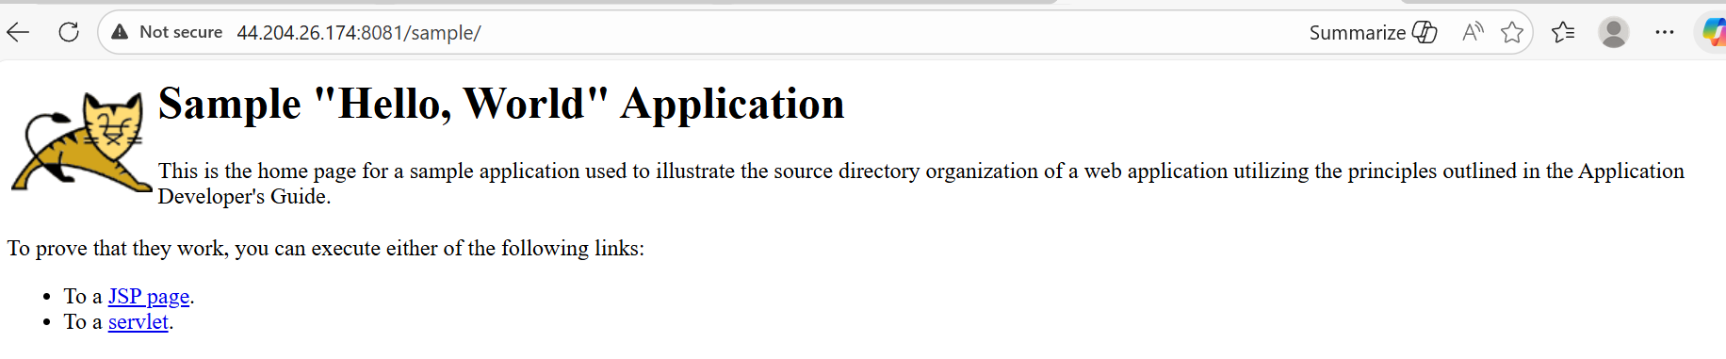

- Limit the nginx container to 500 MB.

Step by step Implementation:
Step 1: Use the command to start the container with memory limit
Docker container run -itd -p 82:80 –memory 500m nginx

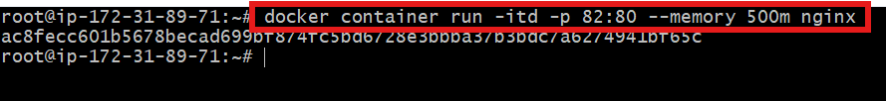

Step 2: Using the docker ps verify the container id and check the space
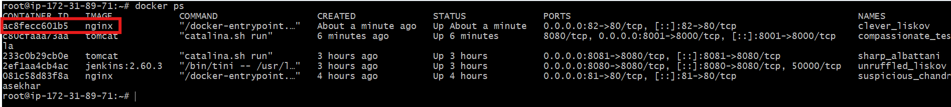

Step 3: Use the command docker stats to check the memory

Conclusion: The Nginx container was successfully deployed with a 500 MB memory limit, ensuring controlled resource usage and preventing excessive memory consumption.

- Create a sample docker file using below instructions.
  - Base module as amazonlinux:latest
  - Maintainer you name
  - Install nginx
  - COPY one index.html file to image
  - Expose on port 80

Step by step Implementation:
Step 1: Docker file is very important where docker image get created when docker file instructions are provided as per requirement.

Step 1: Create index.html
Step 2: create Dockerfile and insert the data
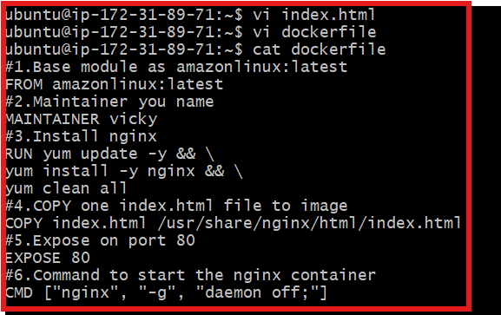
#1.Base module as amazonlinux:latest
FROM amazonlinux:latest
#2.Maintainer you name
MAINTAINER vicky
#3.Install nginx
RUN yum update -y && \
yum install -y nginx && \
yum clean all
#4.COPY one index.html file to image
COPY index.html /usr/share/nginx/html/index.html
#5.Expose on port 80
EXPOSE 80
#6.Command to start the nginx container
CMD ["nginx", "-g", "daemon off;"]

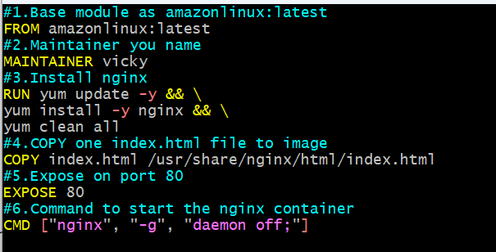

Step 3: After that execute the command docker build -t amazon-nginx . and it will download

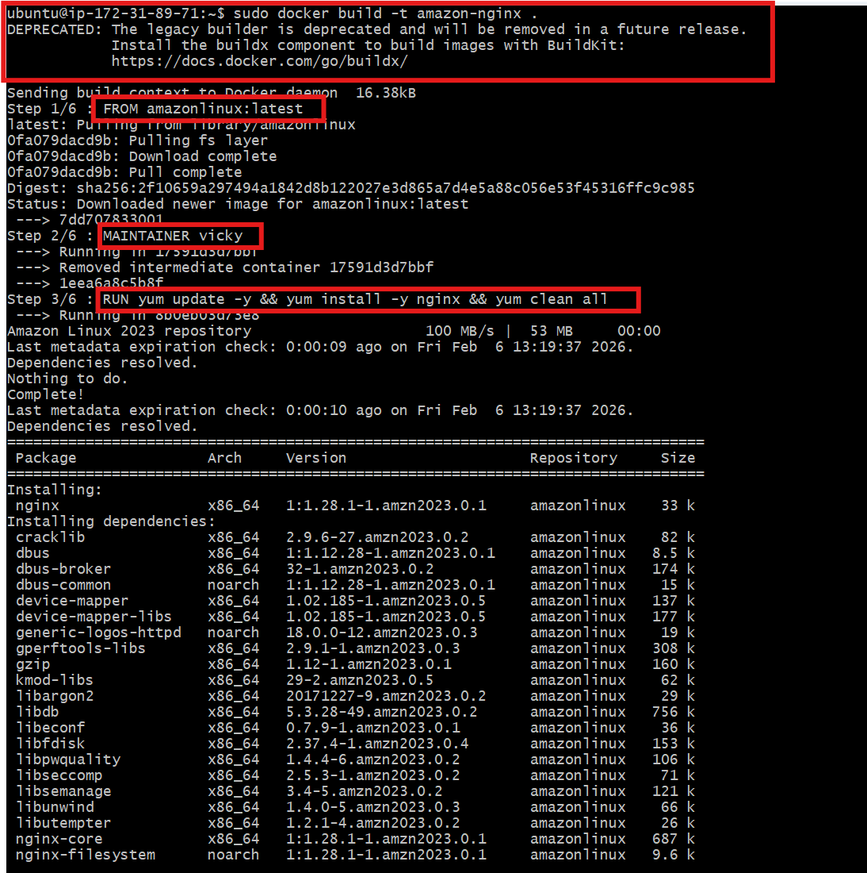

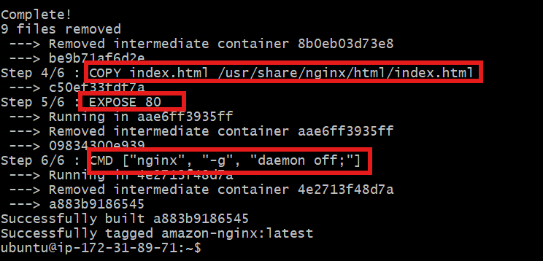

Running again nginx on port 83 and verified in browser
Command- docker run itd -p 83:80 amazon-nginx
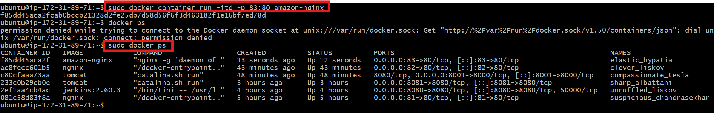

Let’s verify on browser if nginx is installed
Update security groups to add 83 port number.
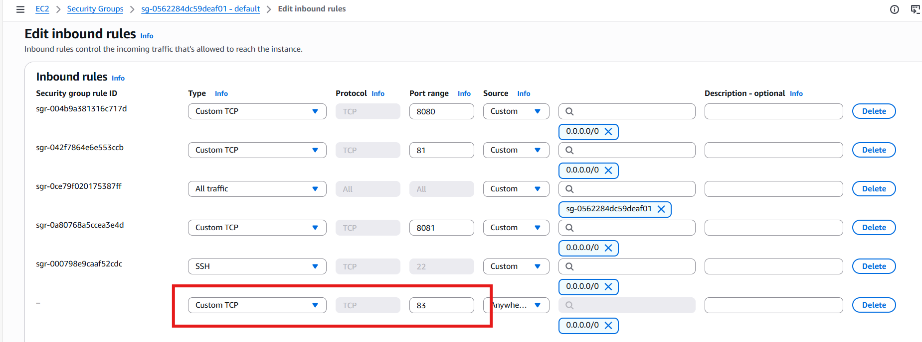

Let’s verify on browser if nginx is installed
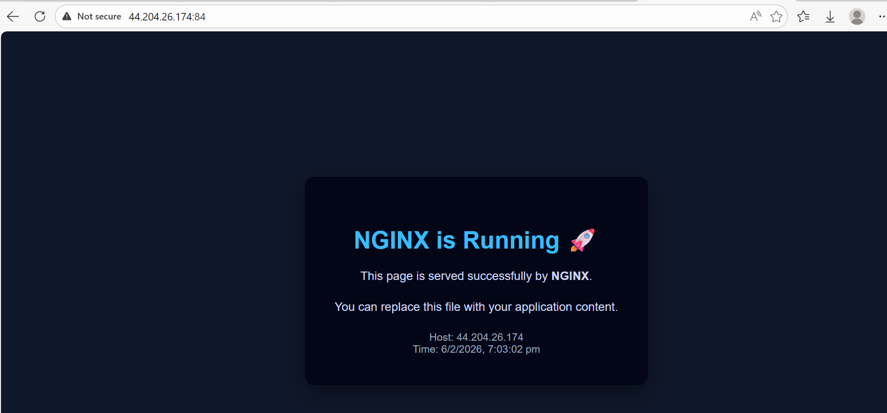
Task completed

- Push image to Docker hub

Step by step Implementation:
Step 1: Login to docker hub in browser
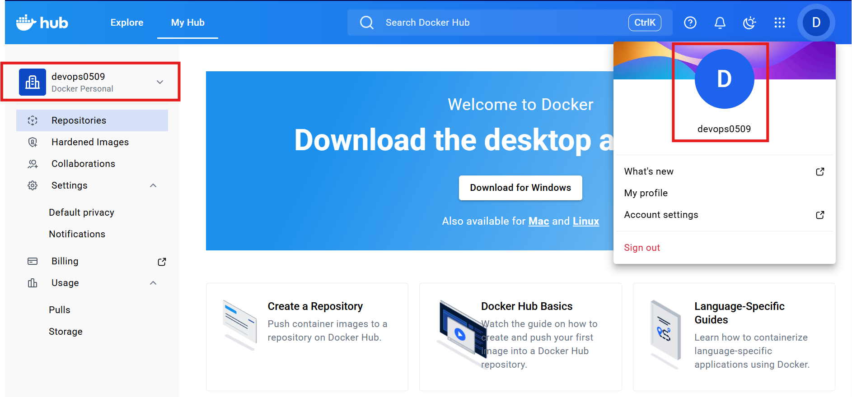

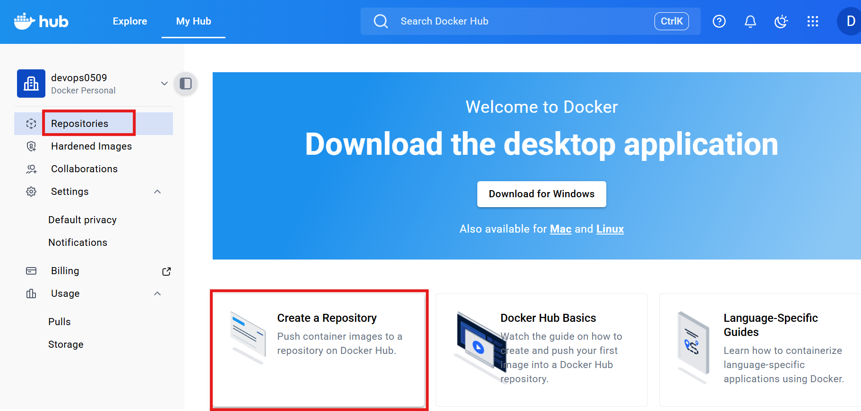

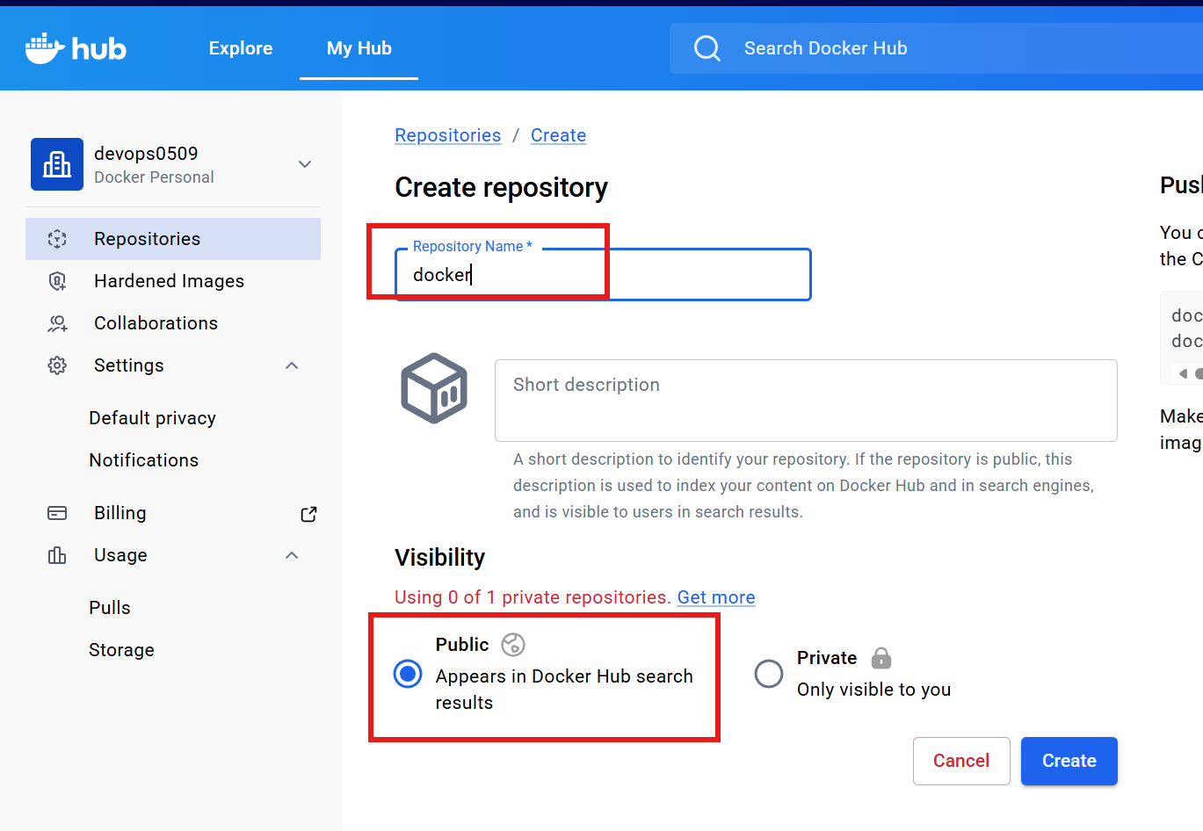
Docker repository created
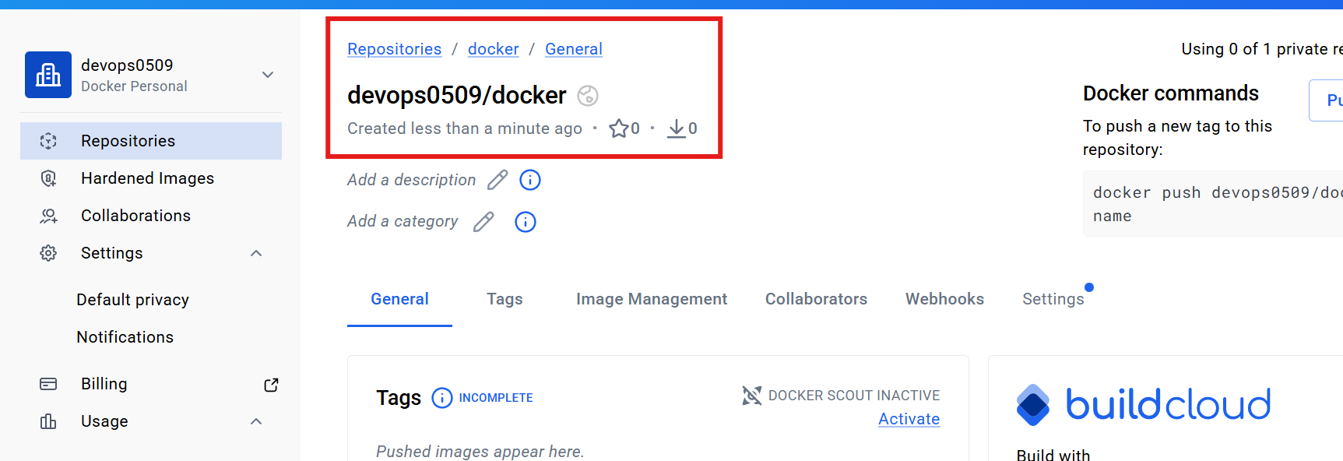

Step 2: Login to docker to integrate- docker login
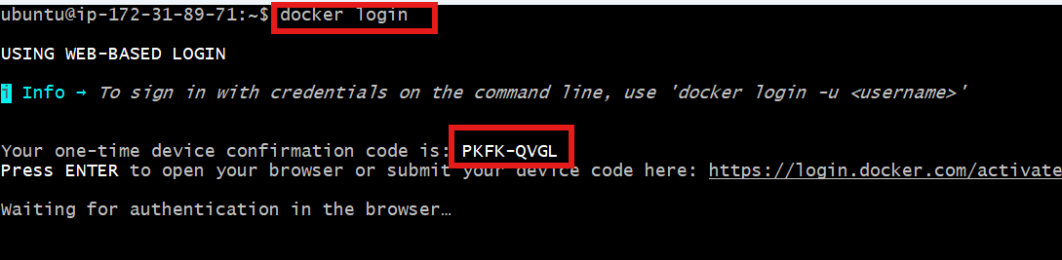
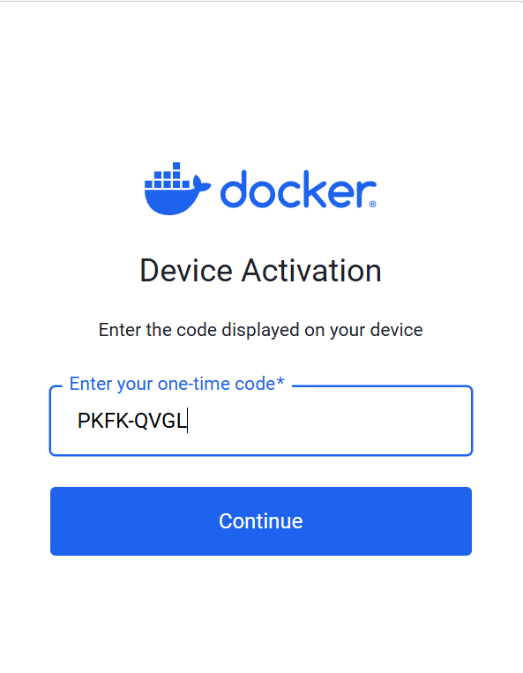

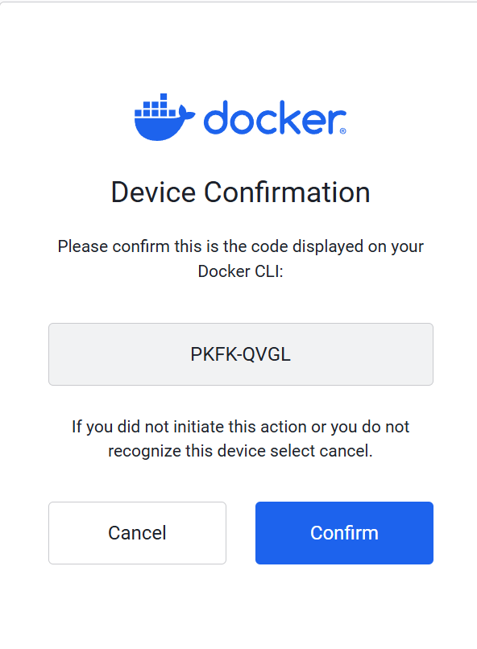
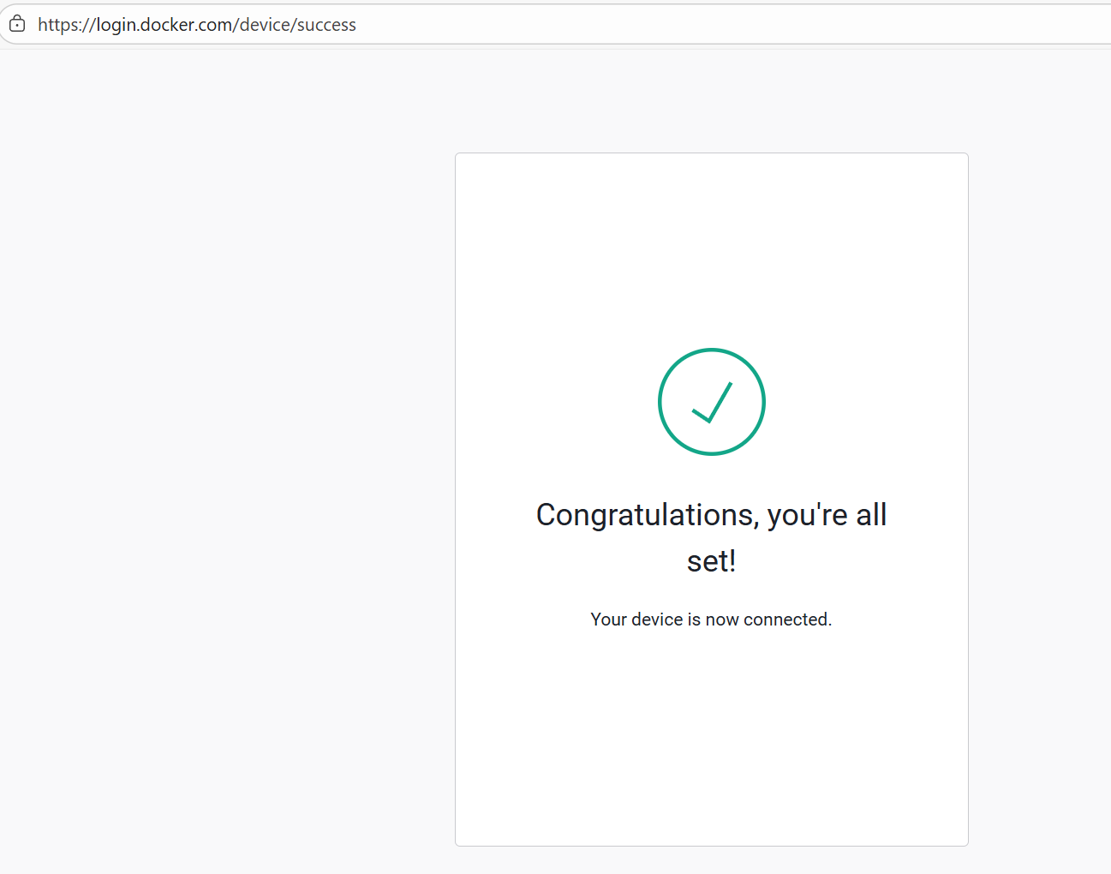

Step 3: We can see our login is succeeded.
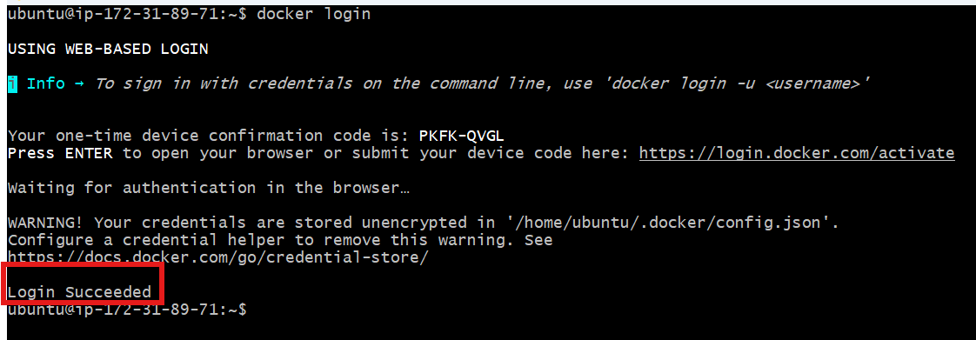

Step 4:
Tag the image
docker tag amazon-nginx devops0509/amazon-nginx:latest
Docker ps
Then docker push
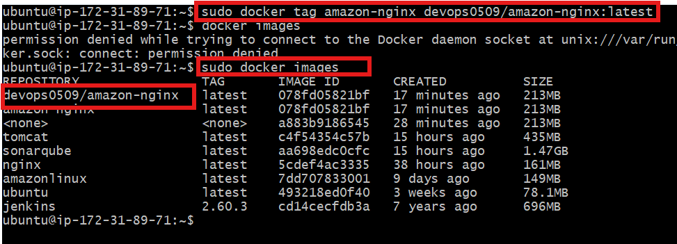
Now, we created the link between docker image and Docker hub
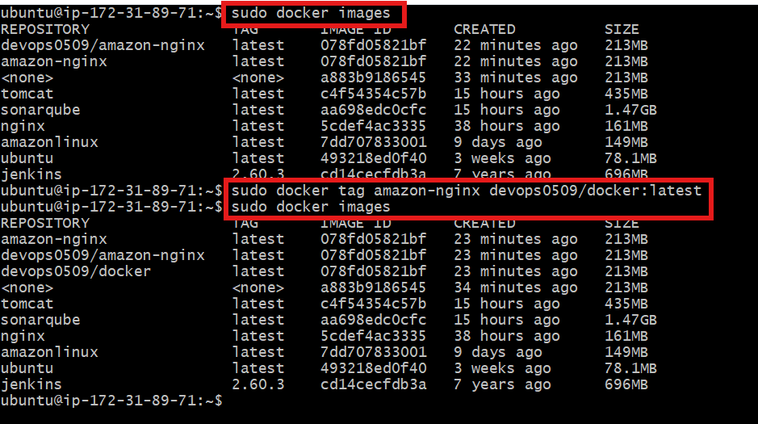

Step 5: Let’s push the image from local to Docker Hub
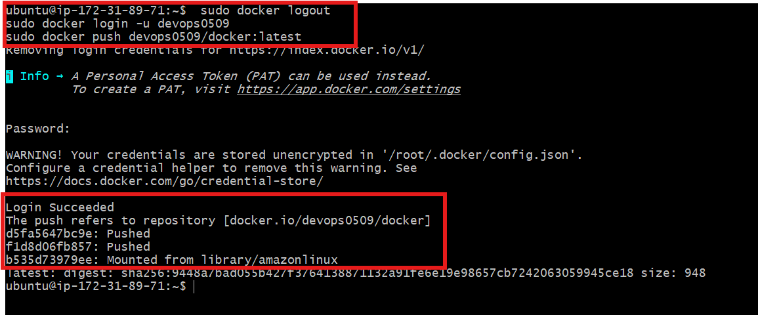

Let’s verify in Docker Hub
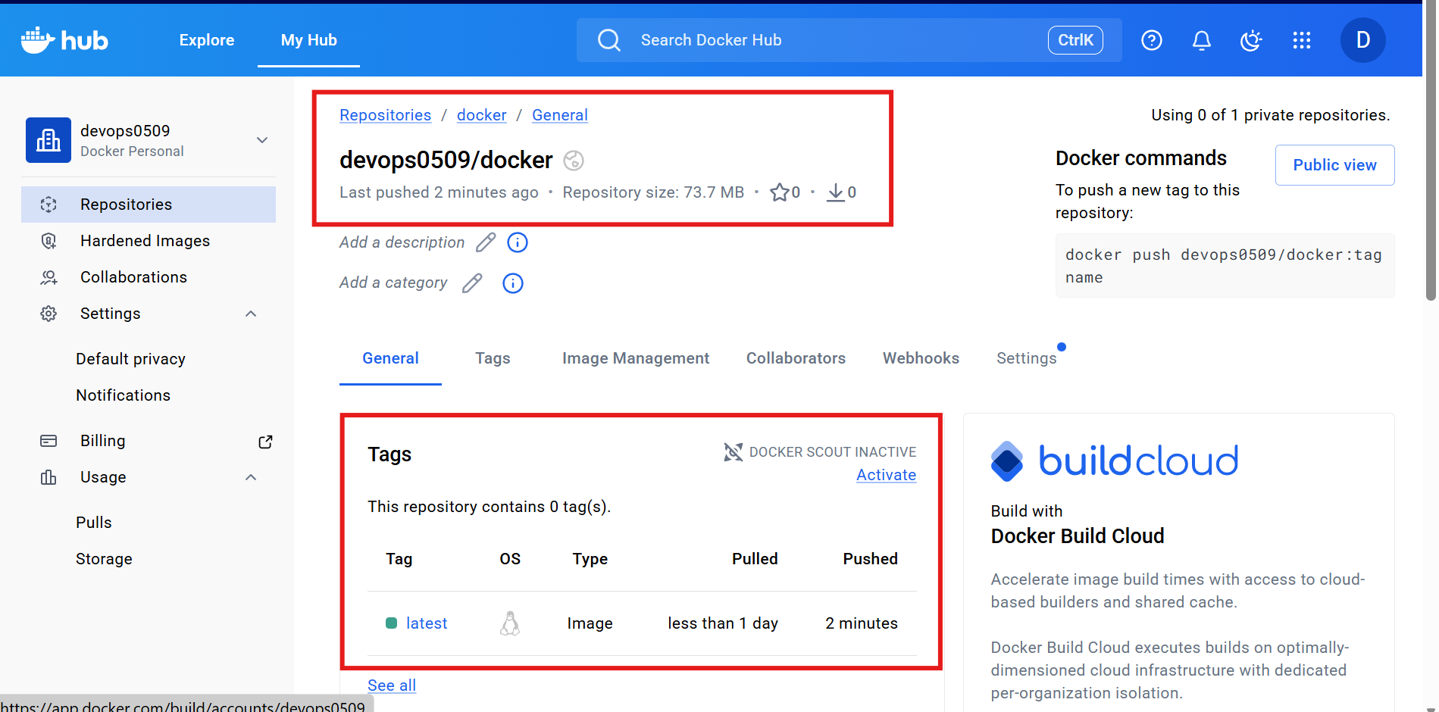

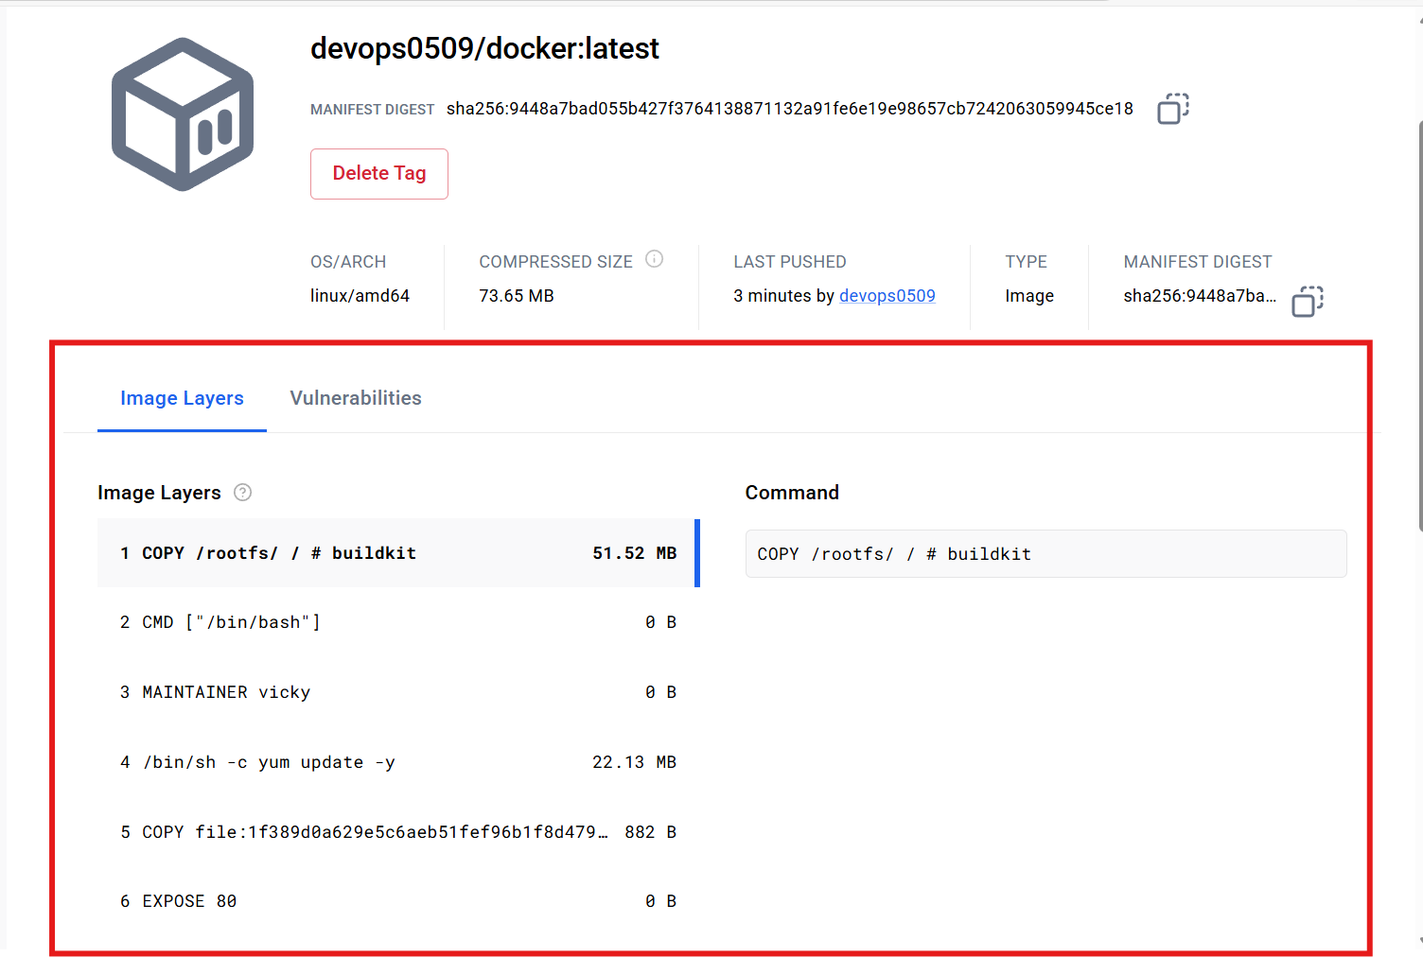

Task completed

- push image to AWS ECR
To push a Docker image to AWS ECR (Elastic Container Registry) for secure storage and use within AWS services.

Step by Step Implementation

Step 1:
Navigate to ecr and create a repository
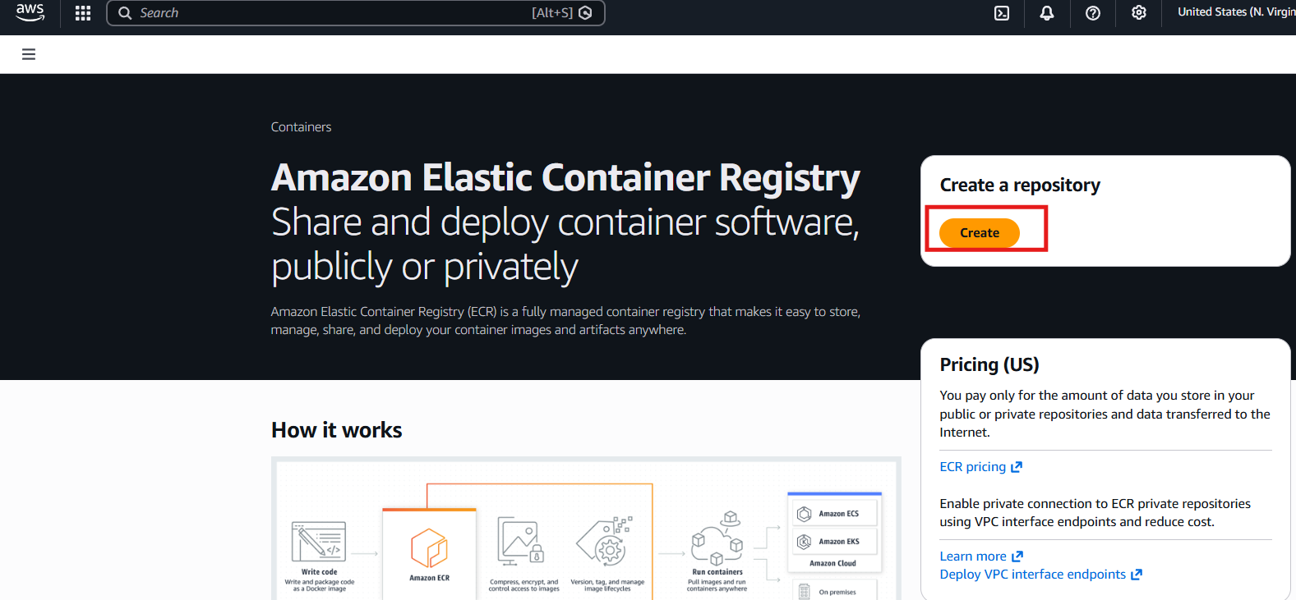

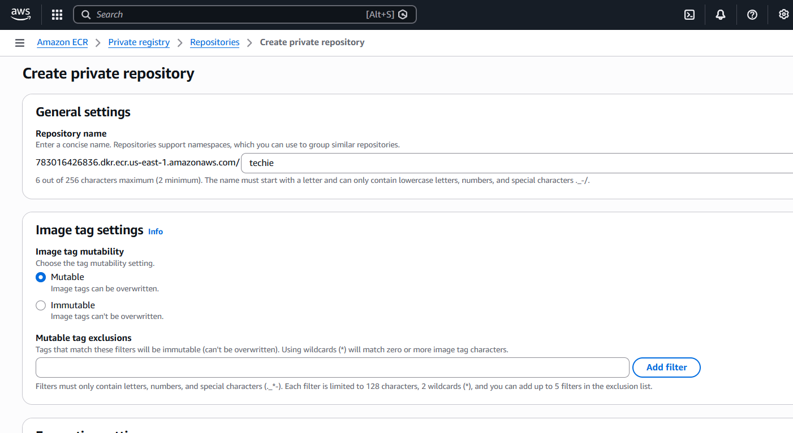
Techie repository created
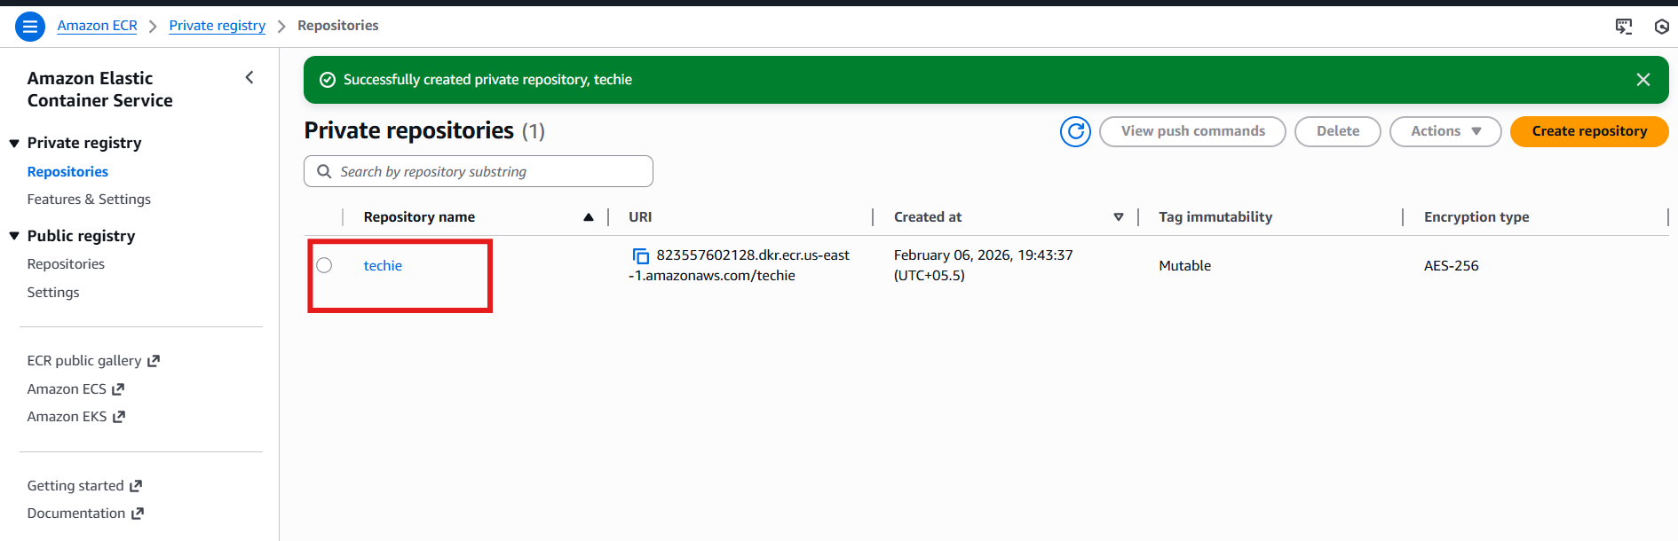

Step 2: Perform aws configure
Issue: In Ubuntu, aws configure is possible when we install the cli
Steps to install aws cli:::
Update packages
sudo apt update
Install required packages
sudo apt install -y curl unzip
Download AWS CLI
curl "https://awscli.amazonaws.com/awscli-exe-linux-x86_64.zip" -o "awscliv2.zip
Unzip installer
unzip awscliv2.zip
Insall AWS CLI
sudo ./aws/install

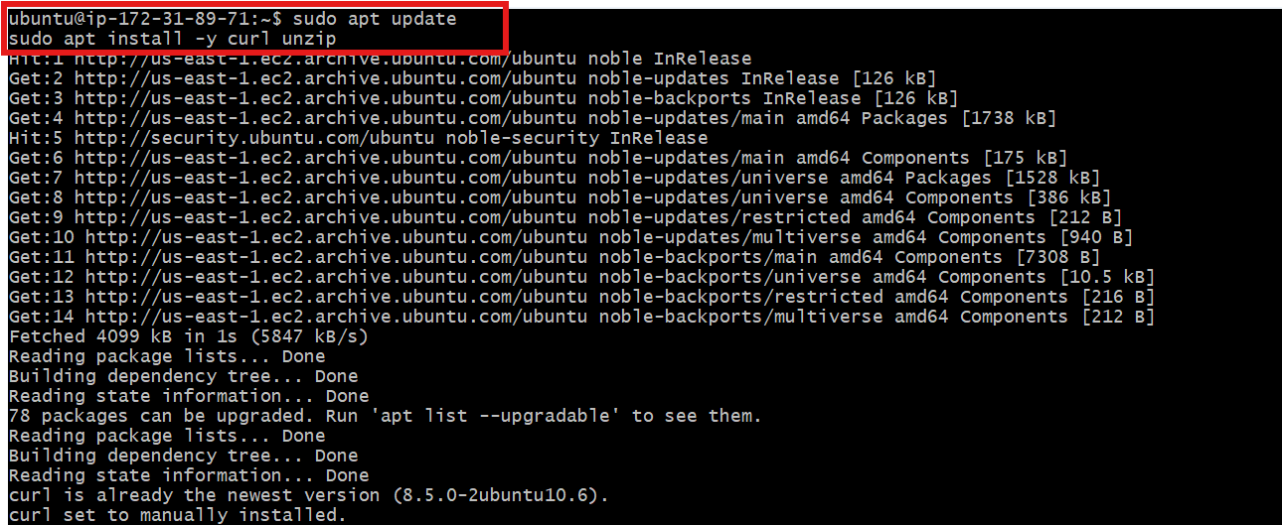
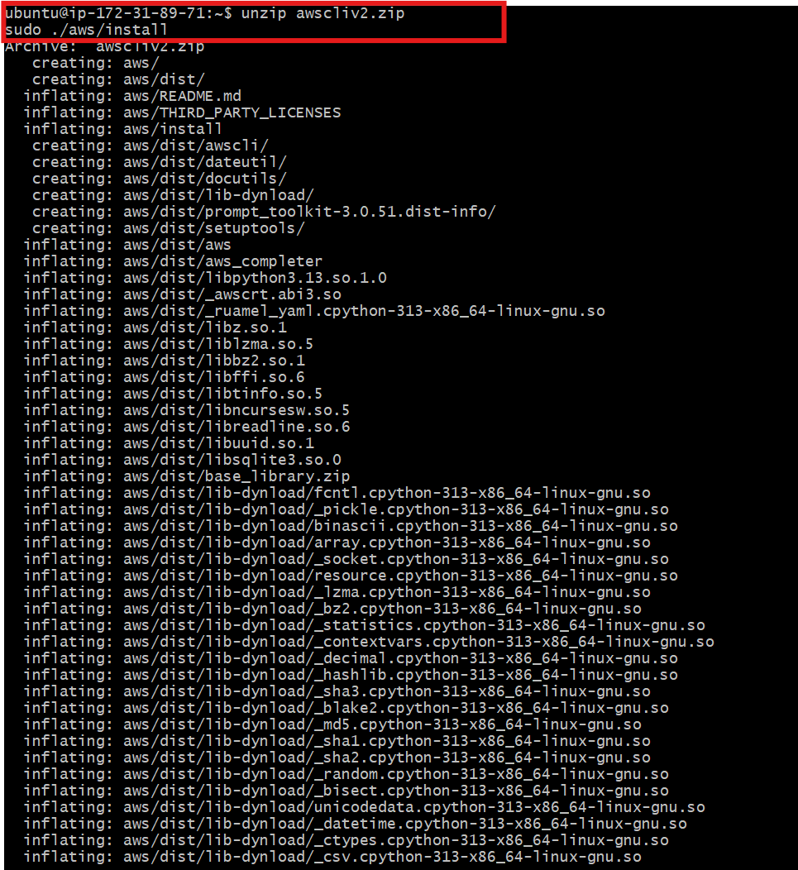

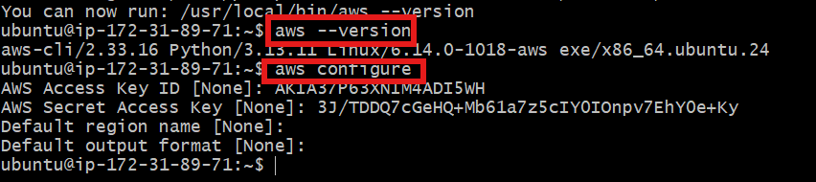

Step 3: Authenticate Docker to AWS ECR
aws ecr get-login-password --region us-east-1 | docker login --username AWS --password-stdin 823557602128.dkr.ecr.us-east-1.amazonaws.com/techie
We can get 823557602128.dkr.ecr.us-east-1.amazonaws.com/techie from ecr repository.
Login successful

Step 4: Tag your image for ECR
docker tag amazon-nginx:latest 823557602128.dkr.ecr.us-east-1.amazonaws.com/techie
Push image to AWS ECR
docker push 823557602128.dkr.ecr.us-east-1.amazonaws.com/techie:latest

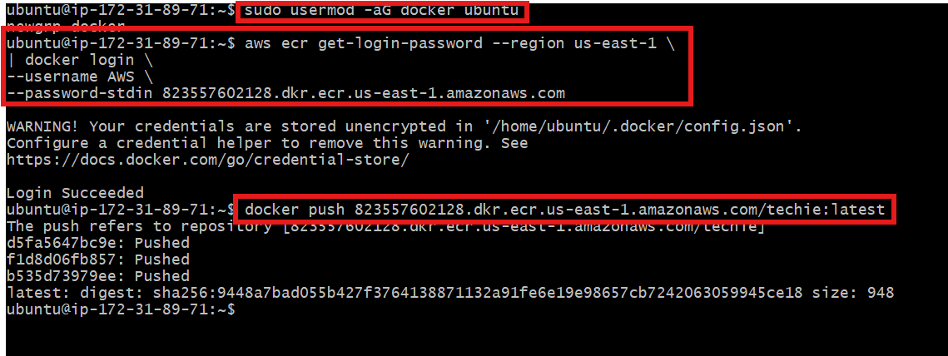

Verify
aws ecr list-images --repository-name techie --region us-east-1
