Docker-03

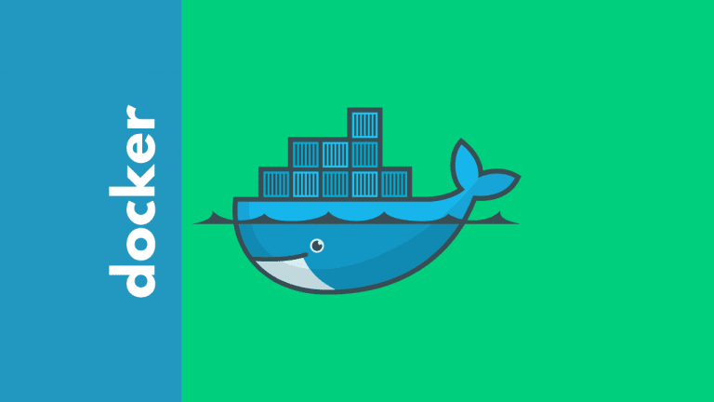

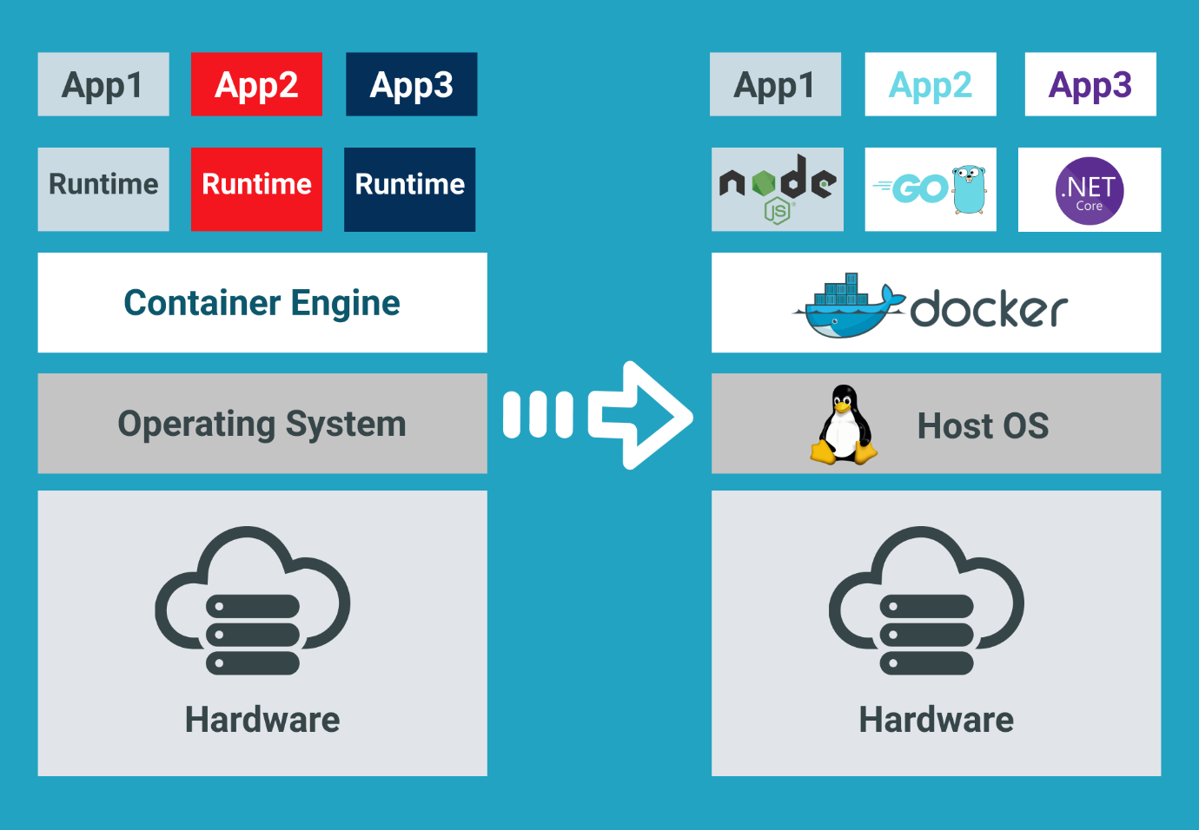

Task Title
Docker-03
Objective
The objective of this task is to watch the Docker-03 video posted on slack and worked on executing the initializing Ansible shown in video.
Prerequisites
List all requirements before starting:
- Dockerfile
- Single stage docker file
- Multi stage docker file
- Docker Image Networks
- Docker save and load
- Docker commits
- Docker scan
- Docker compose

Issues Faced: Briefly mention issues and how you fixed them. Posted below in the last.
Conclusion
Conclusion has been provided for every task at the end.

Tasks

Task 1- Create an image from running container.
Step by step Implementation
Step 1: To create a new Docker image from an existing running container in order to preserve its current state, configurations, and changes.
Pull NGINX image
docker pull nginx:latest
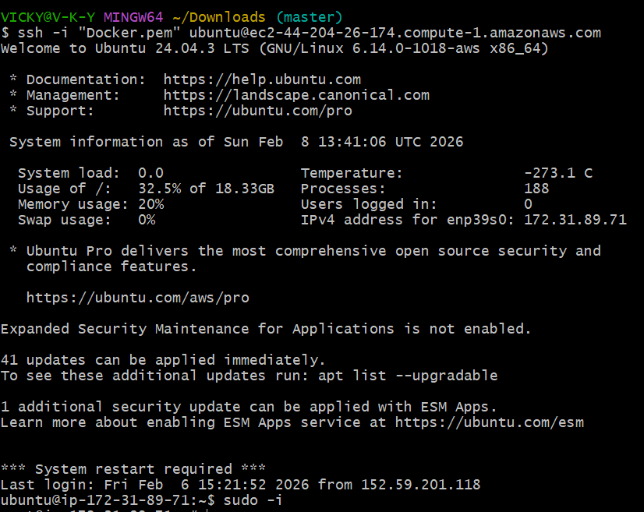
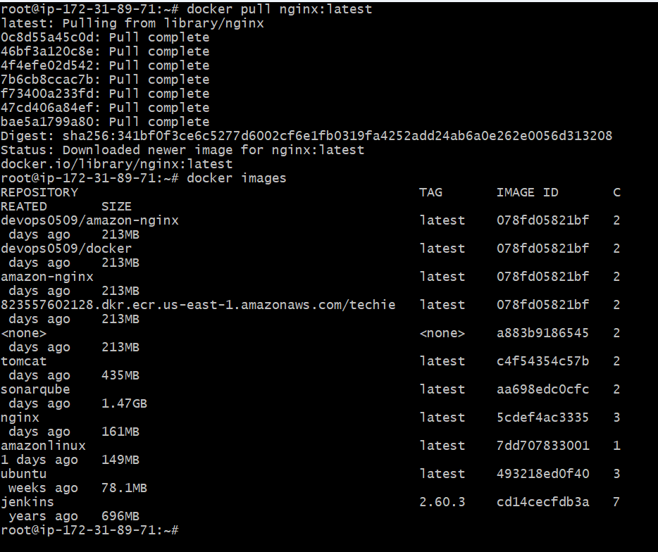

Step 2: Run NGINX container
docker container run -itd -p 8080:80 --name nginx-container nginx:latest
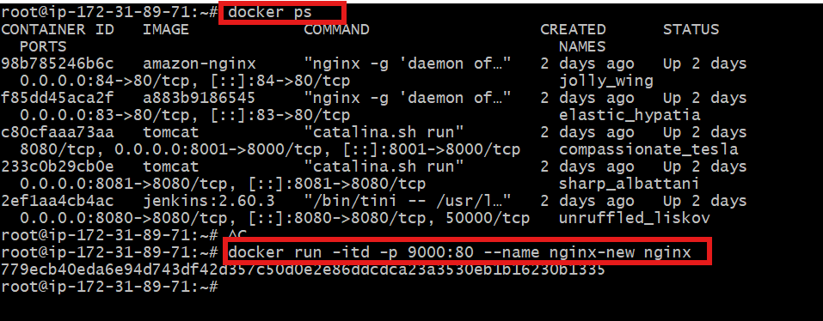

Step 3: Enter running container
docker exec -it nginx-container /bin/bash
Step 4: Modify NGINX default page
echo "<h1>NGINX Image Created from Running Container</h1>" >
/usr/share/nginx/html/index.html
exit
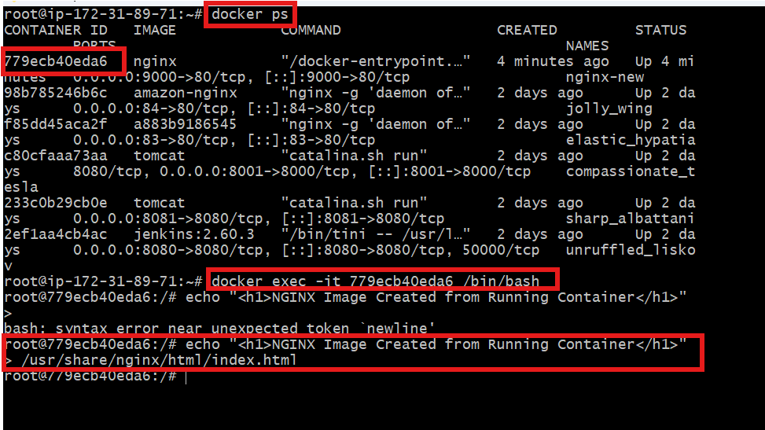

Step 5: Create image from container
docker commit nginx-container custom-nginx:v1
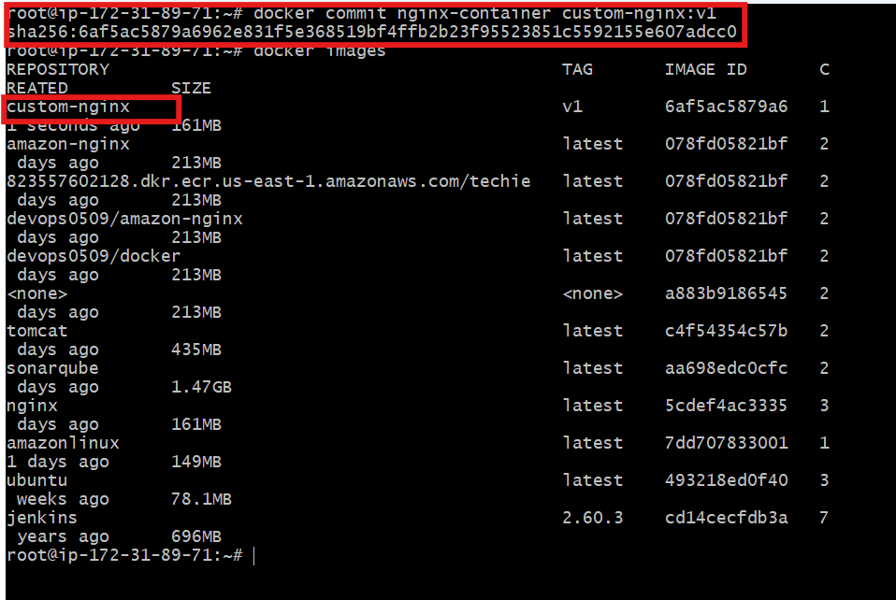
Update the security groups to allow 9000
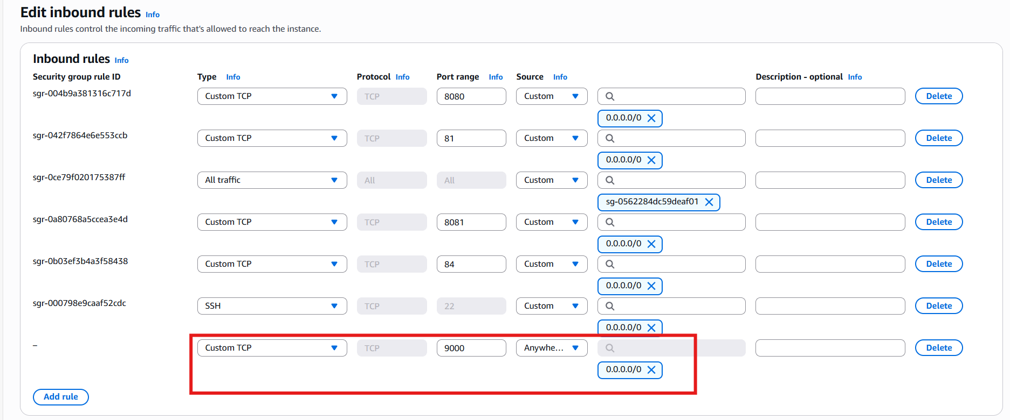

Validation:
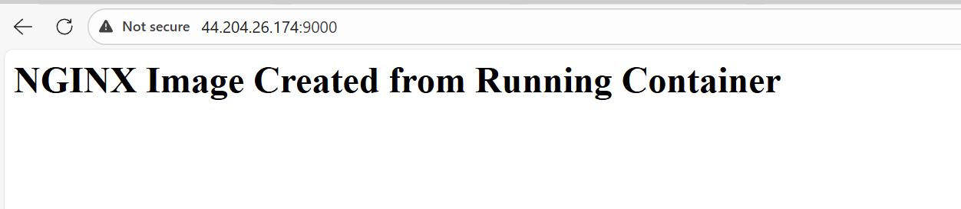
Task 2 - Create Docker image using alpine and customize with tomcat.
Objective:
To create a lightweight Docker image using Alpine Linux and customize it by installing and configuring Apache Tomcat for running Java web applications.
Step by step implementation
Mkdir alpine-tomcat
Cd alpine-tomcat
Vi Dockerfile
FROM alpine:3.19
# Install Java and required tools
RUN apk add --no-cache openjdk11 wget tar bash
# Set working directory
WORKDIR /opt
# Download and extract Tomcat (YOUR URL)
RUN wget https://dlcdn.apache.org/tomcat/tomcat-9/v9.0.115/bin/apache-tomcat-9.0.115.tar.gz \
&& tar -xzf apache-tomcat-9.0.115.tar.gz \
&& mv apache-tomcat-9.0.115 tomcat \
&& rm apache-tomcat-9.0.115.tar.gz
# Expose Tomcat port
EXPOSE 8080
# Start Tomcat
CMD ["/opt/tomcat/bin/catalina.sh", "run"]

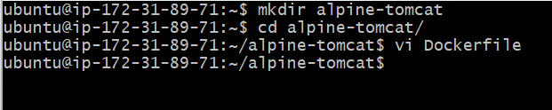
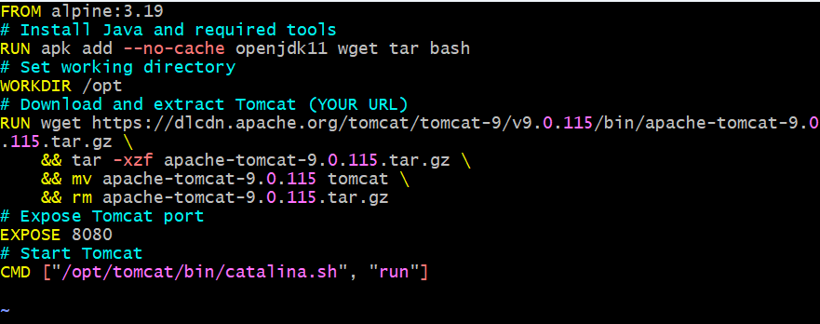

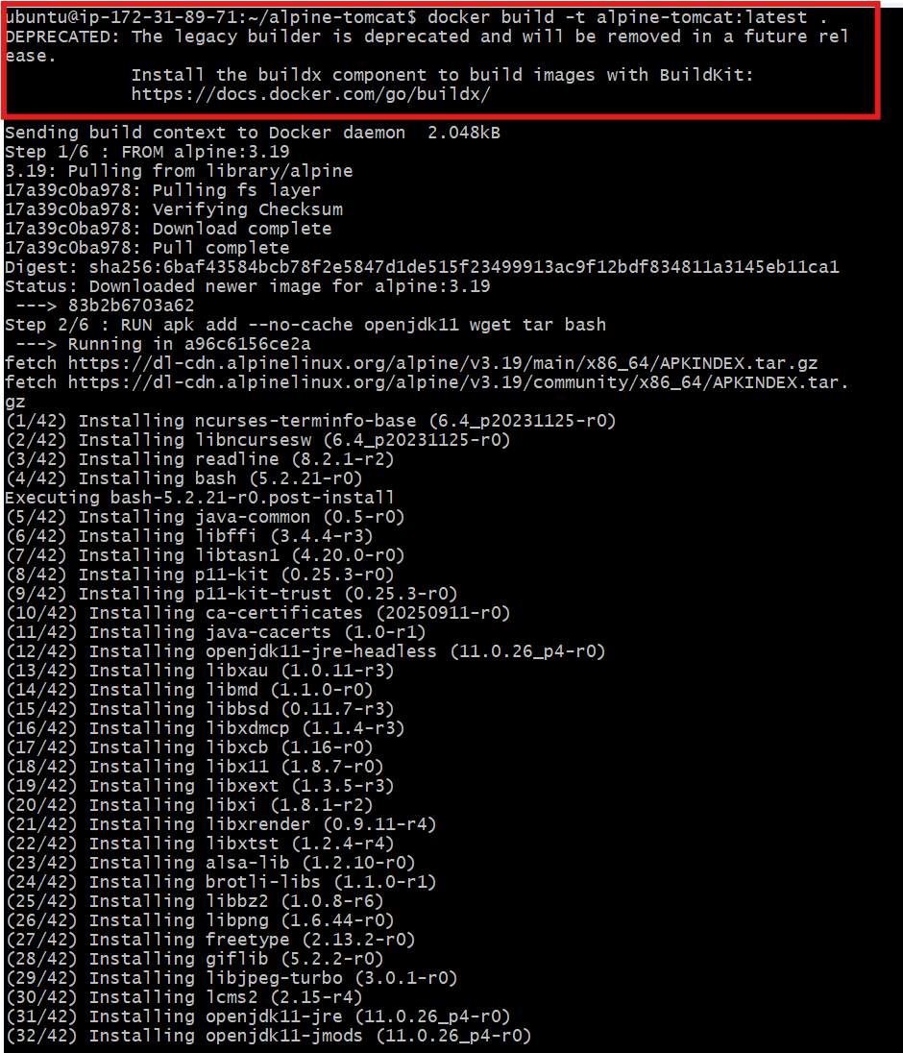

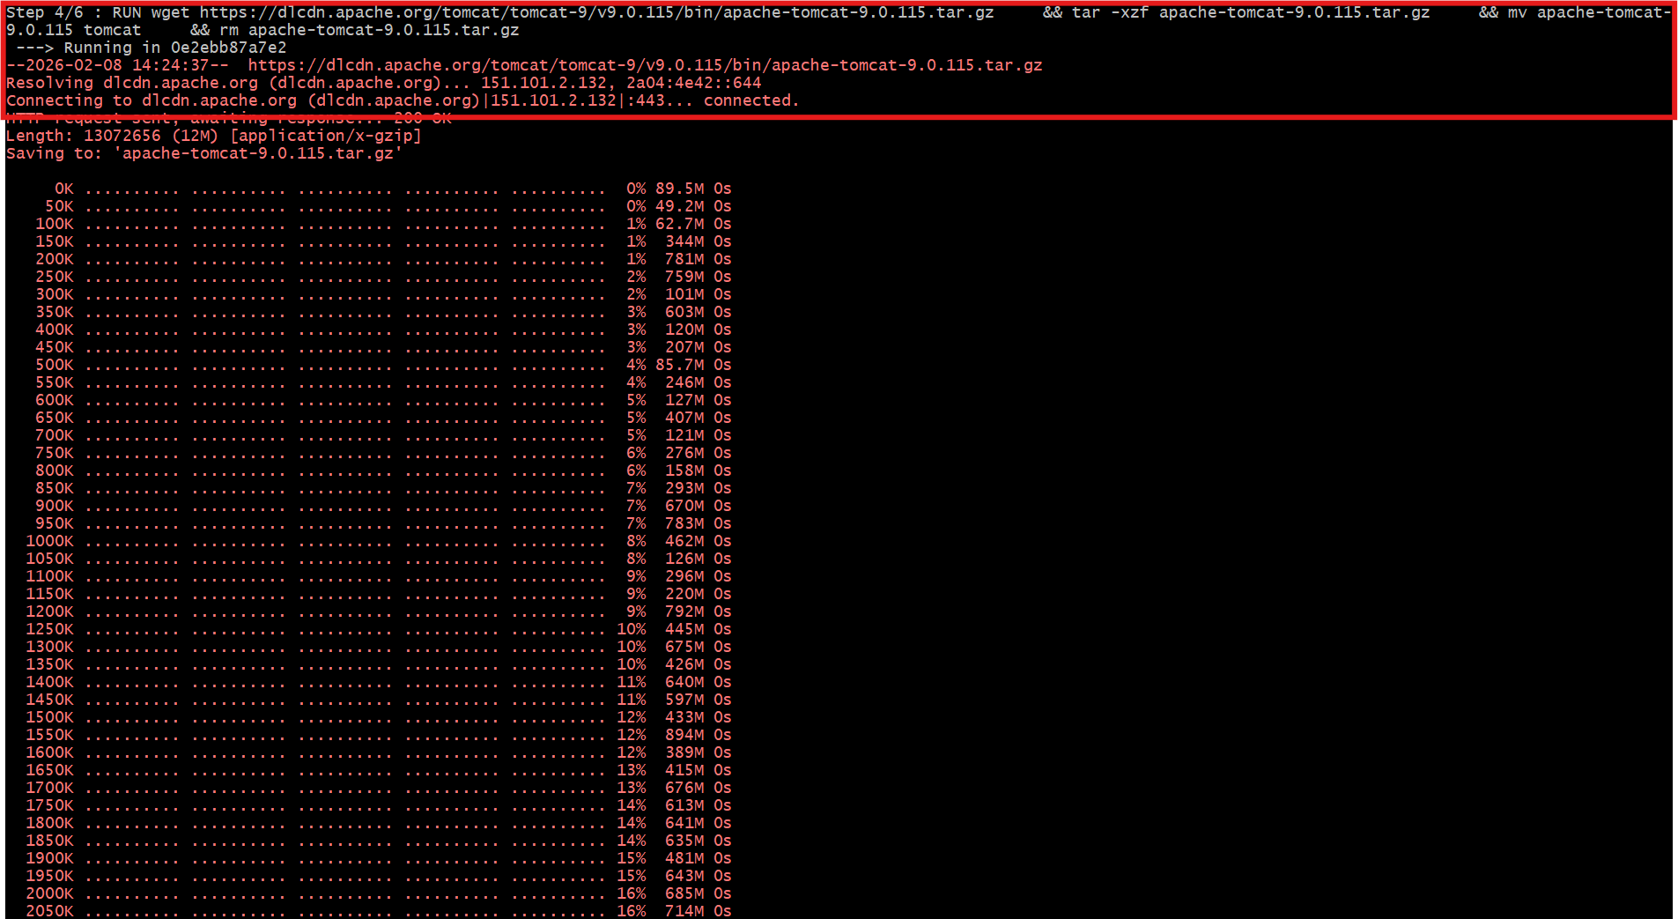
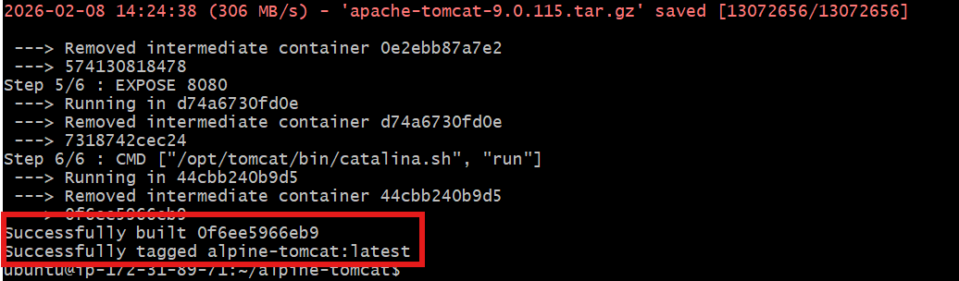
Docker images
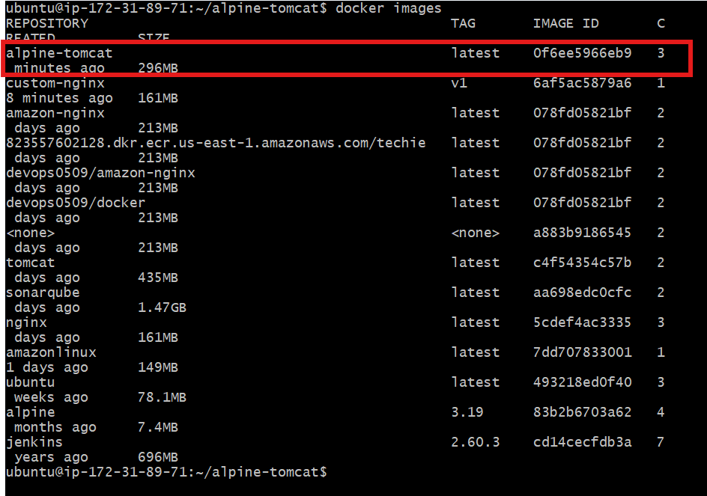
Run container
docker run -d -p 8080:8080 --name tomcat alpine-tomcat:latest

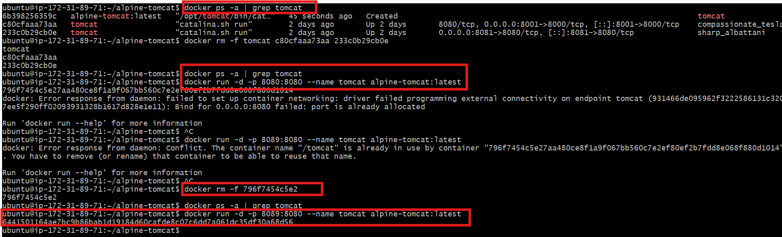
Allow 8089 port for alpine-tomcat
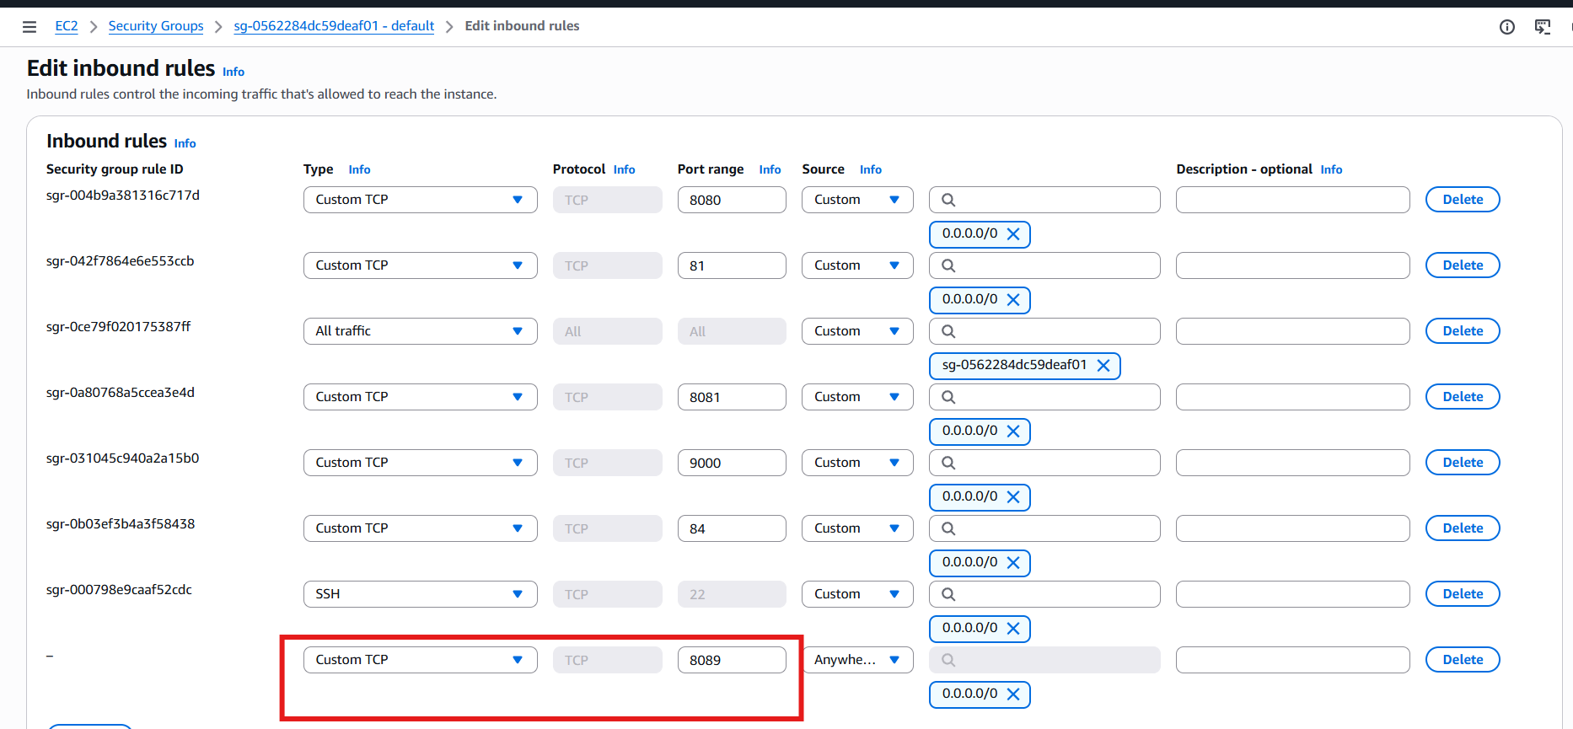

Validation:
Succesful
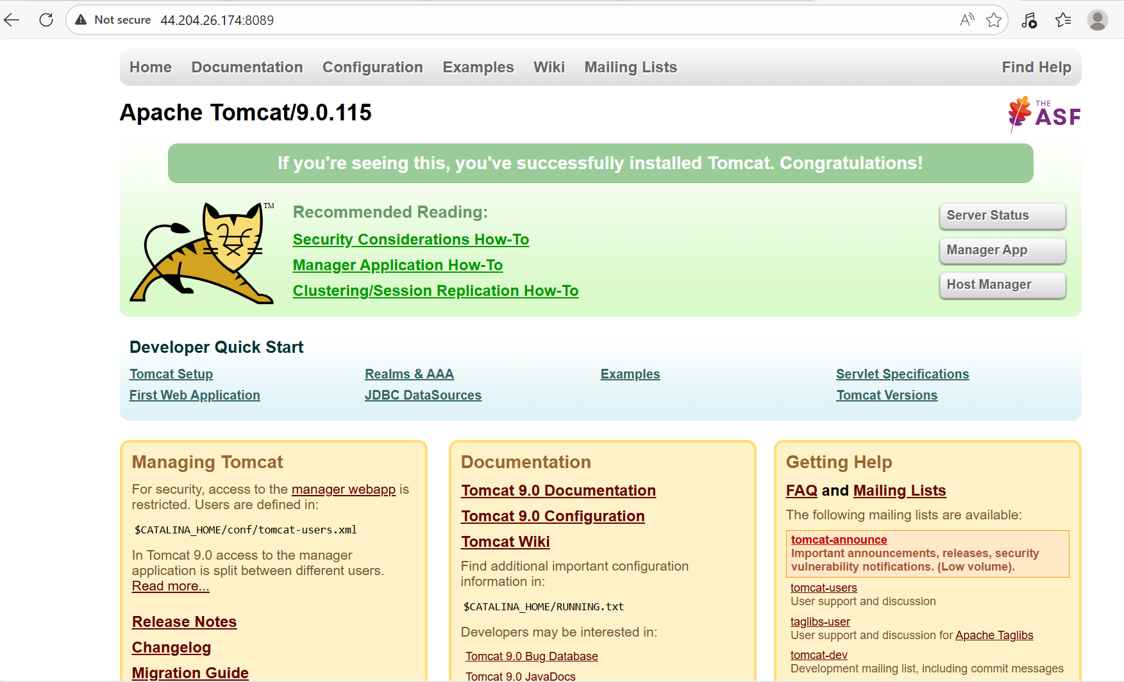

Task 3 - Create single stage and multi stage docker file using this source code: https://github.com/betawins/multi-stage-example.git
Objective
- To understand how single-stage and multi-stage Dockerfiles work
- To compare image size and efficiency between both approaches
- To apply Docker best practices for building containerized applications
Step By Step Implementation
Step 1: Clone repository
git clone https://github.com/betawins/multi-stage-example.git
cd multi-stage-example
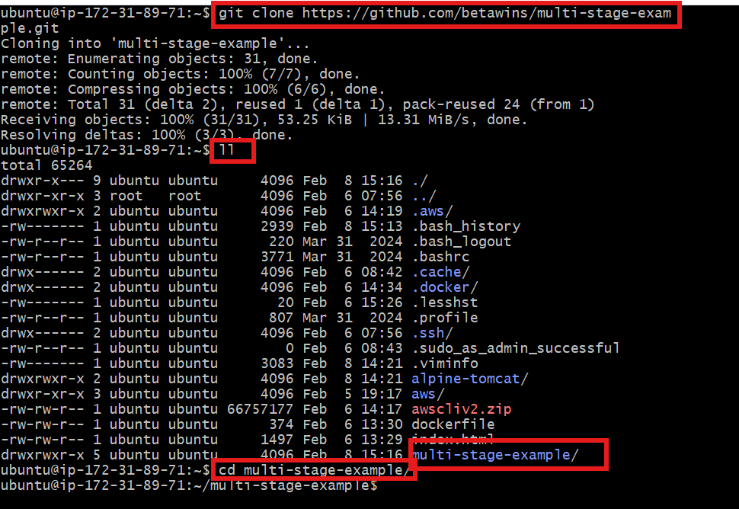
Vi Dockerfile.single
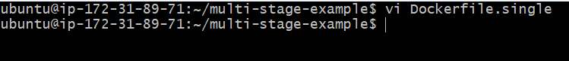
And paste
FROM maven:3.9.6-eclipse-temurin-17
WORKDIR /app
COPY . .
RUN mvn clean package -DskipTests
EXPOSE 8080
CMD ["java","-jar","target/multi-stage-example-0.0.1-SNAPSHOT.jar"]

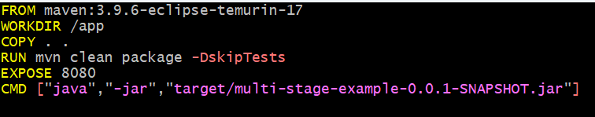
Build single-stage image
docker build -f Dockerfile.single -t single-stage-app .
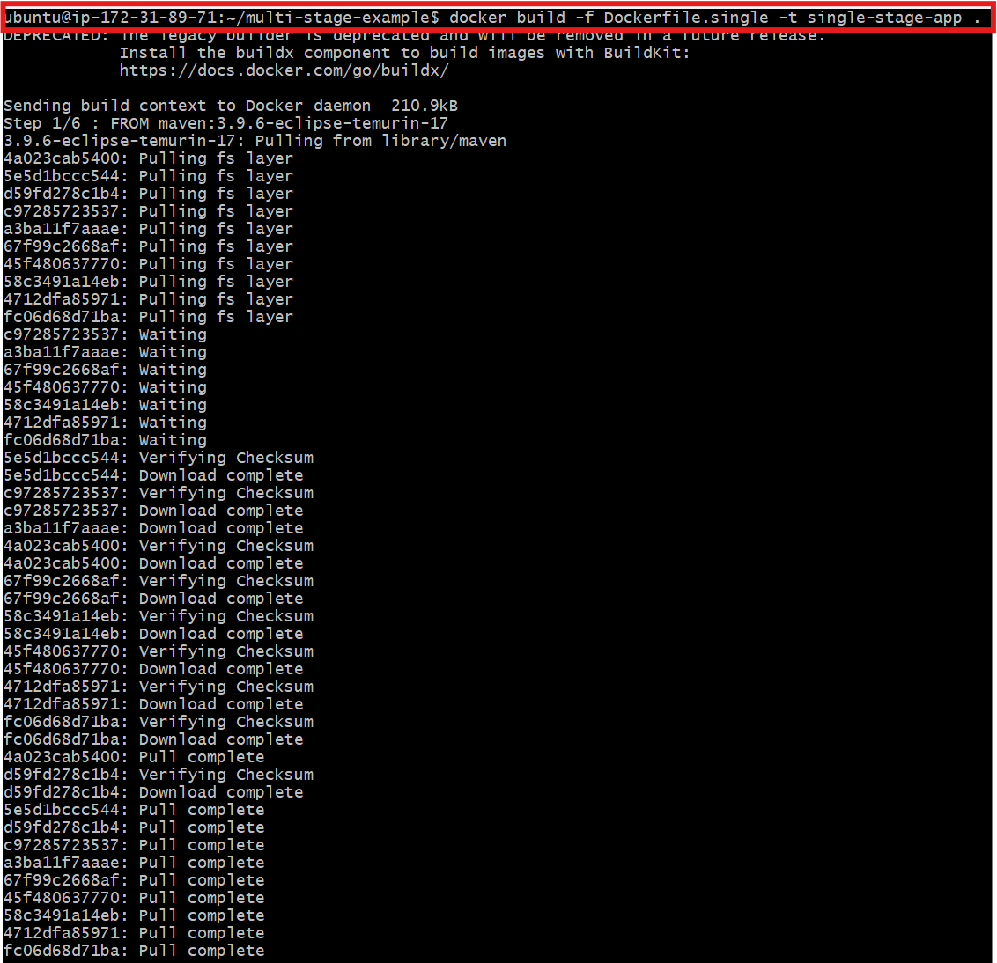

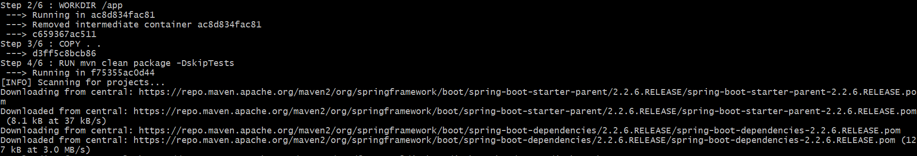

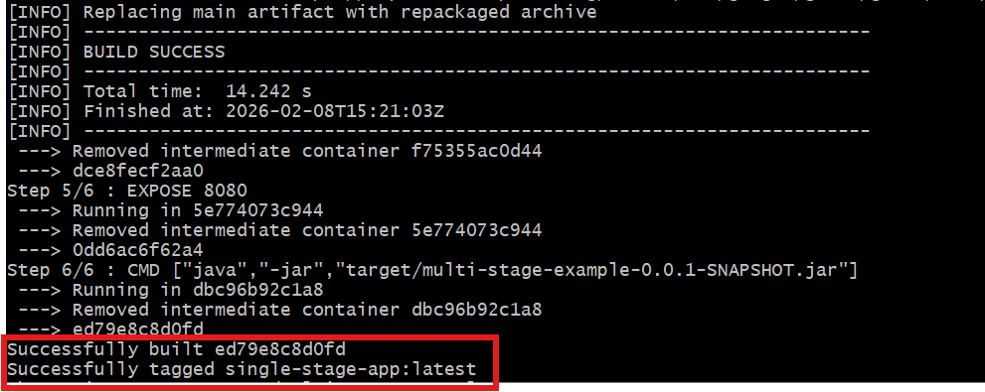
Run single-stage container
docker run -d -p 8081:8080 --name single-stage single-stage-app

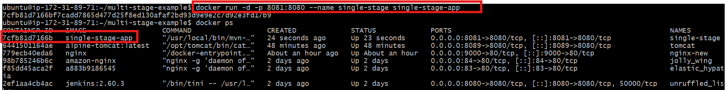

Validation:
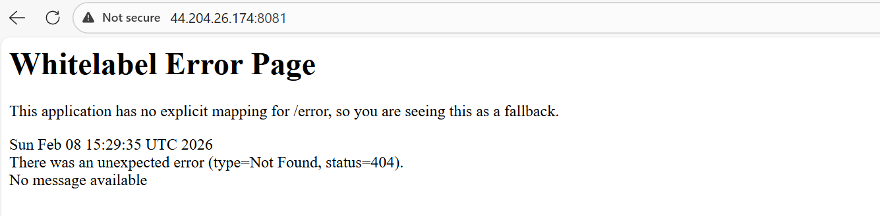

Multi-Stage Dockerfile
vi Dockerfile.multi
FROM maven:3.9.6-eclipse-temurin-17 AS builder
WORKDIR /app
# Copy pom first to cache dependencies
COPY pom.xml .
RUN mvn dependency:go-offline
# Copy source code
COPY src ./src
RUN mvn clean package -DskipTests
FROM eclipse-temurin:17-jre-alpine
WORKDIR /app
# Copy jar from builder stage
COPY --from=builder /app/target/*.jar app.jar
# Expose application port
EXPOSE 8083
CMD ["java","-jar","app.jar"]
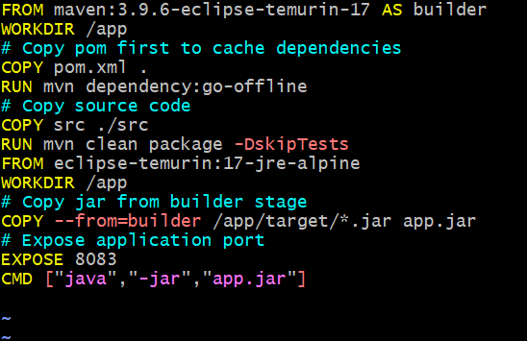

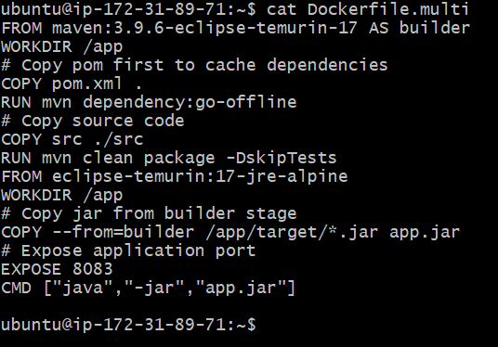

Build multi-stage image
docker build -f Dockerfile.multi -t multi-stage-app .
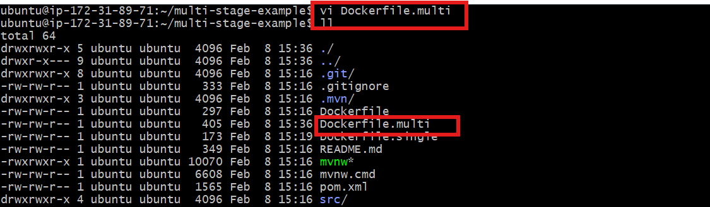

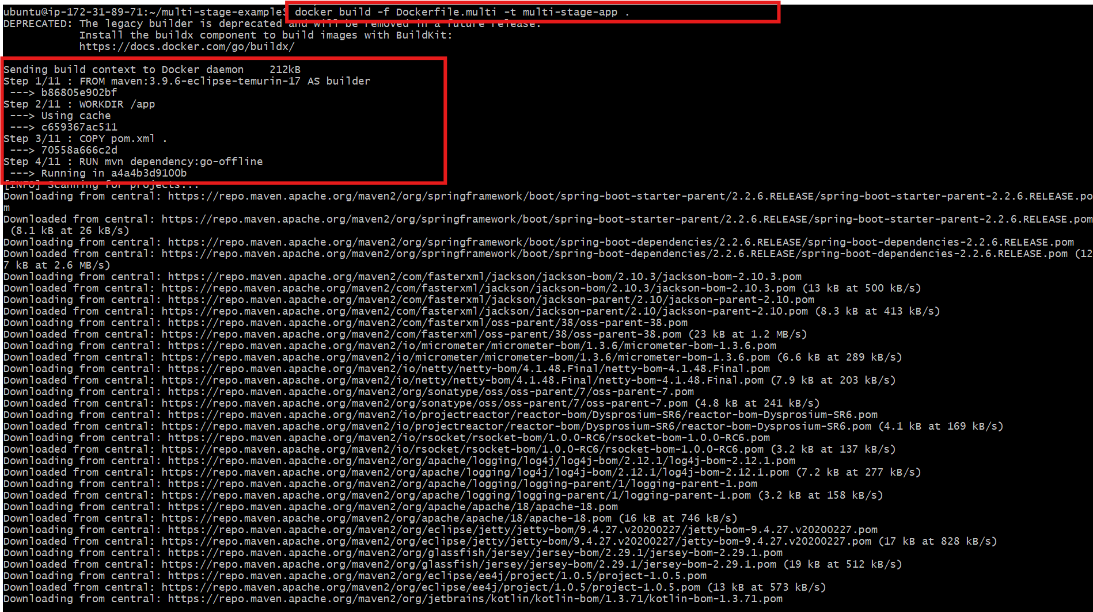

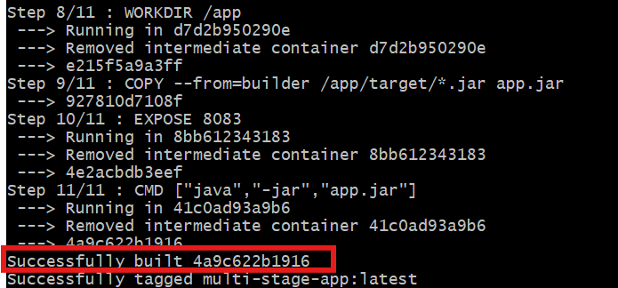

Run Container
docker run -d -p 8083:8080 --name multi-stage multi-stage-app
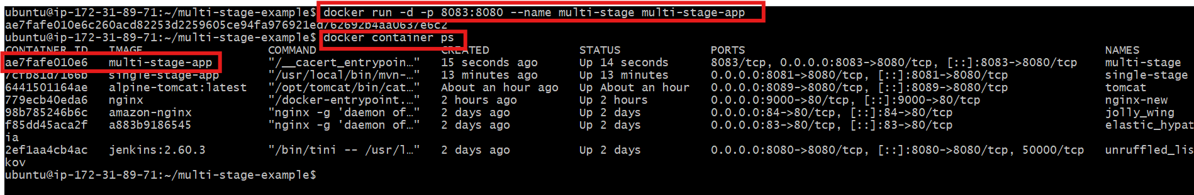

Update the security groups to allow 8083 port.
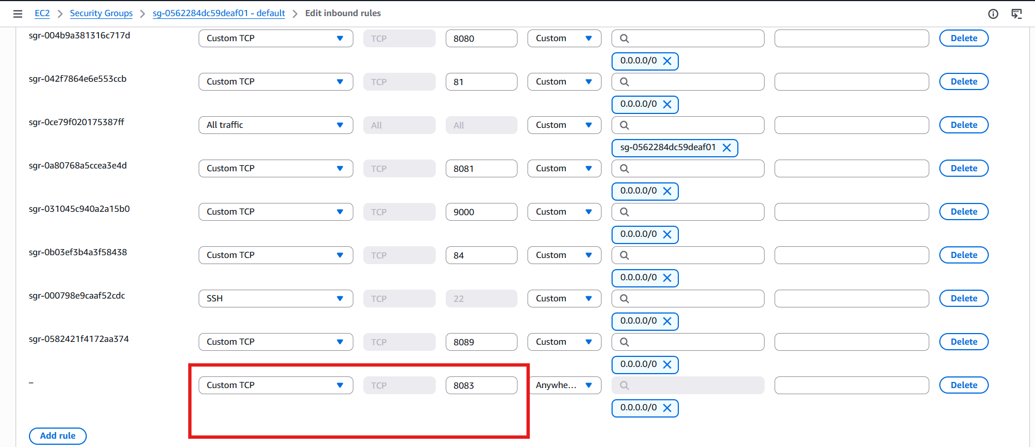

Validation:
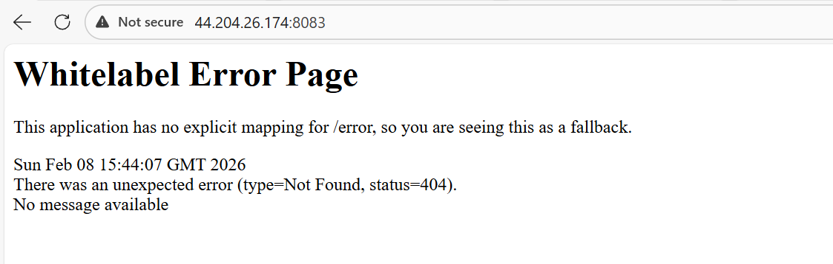

Conclusion
- Single-stage Dockerfiles are simple but result in larger images
- Multi-stage Dockerfiles remove unnecessary build dependencies
- Multi-stage builds are more efficient and suitable for production use

Task 4 - Install docker compose and execute sample application.
Objective
- To install Docker Compose on the system
- To understand how Docker Compose manages multi-container applications
- To run and verify a sample application using Docker Compose
Step by Step Implementation:
Step 1: Install Docker Compose
sudo curl -L https://github.com/docker/compose/releases/latest/download/docker-compose-linux-x86_64 \
-o /usr/local/bin/docker-compose
sudo chmod +x /usr/local/bin/docker-compose

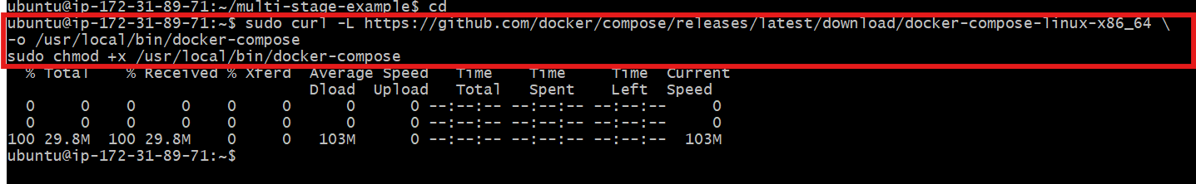

Verify installation
docker-compose version
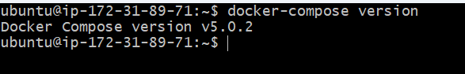

Step 3: Create docker-compose.yml
vi docker-compose.yml
Step 4: Add content
version: "5.0.2"
services:
web:
image: nginx
ports:
- "8085:80"
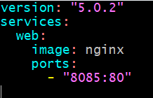

Step 5: Run application
docker-compose up -d
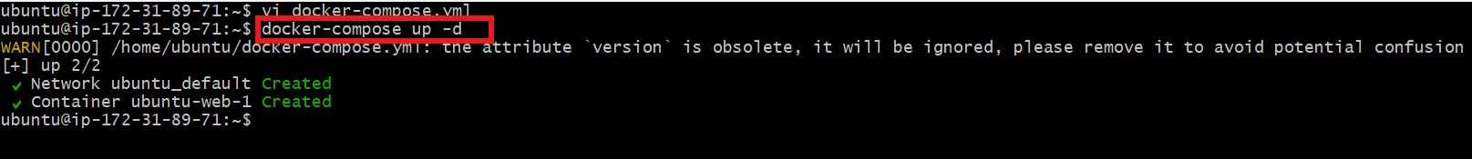
Docker ps
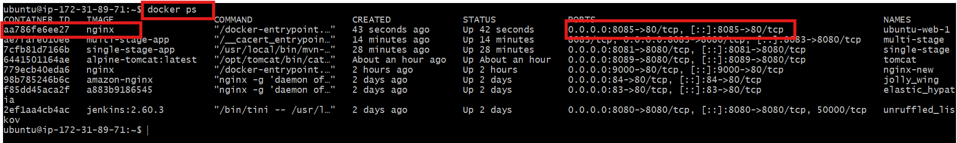

Update security groups to allow port 8085
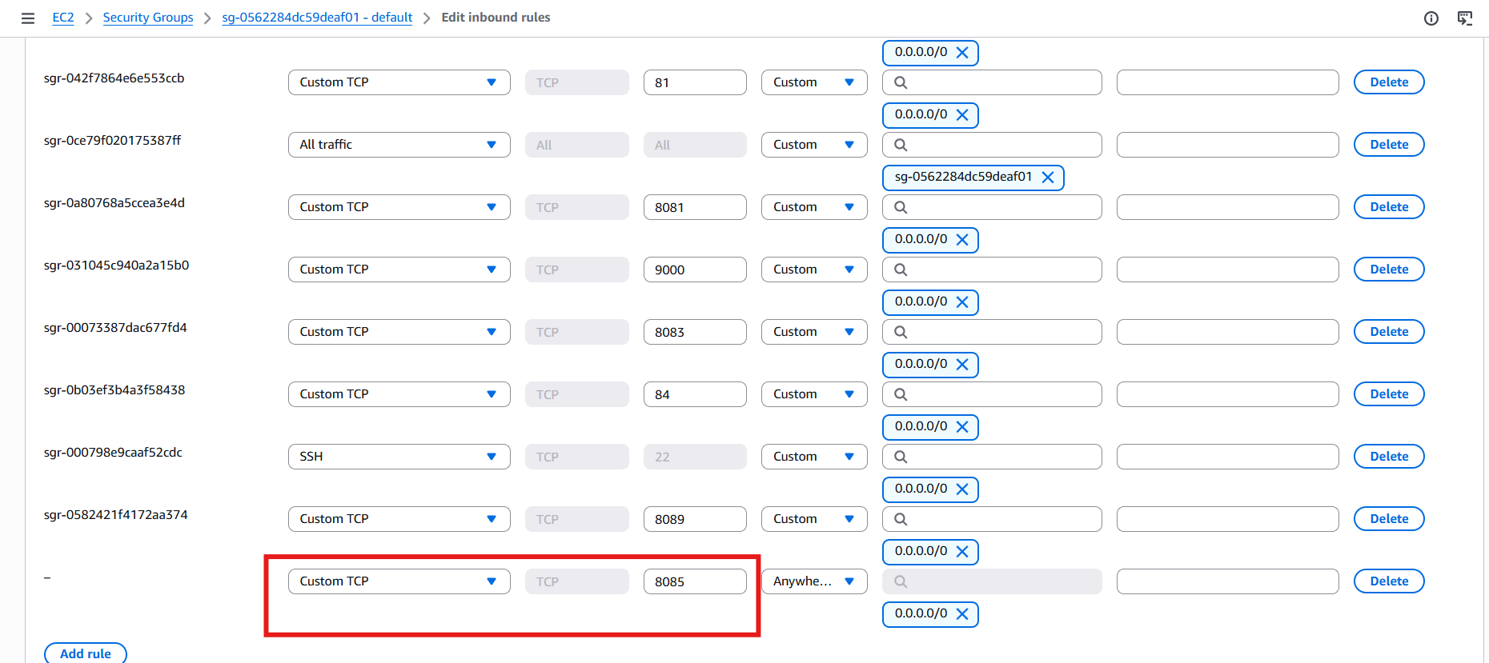

Validation
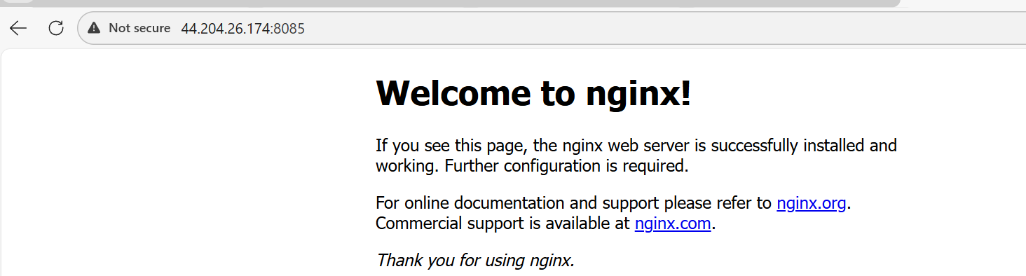
Conclusion
- Docker Compose simplifies application deployment
- Services can be started with a single command
- Docker Compose improves development and testing efficiency

Task completed

Task 5 - Implement solution to scan images when pushed to docker registry.
Objective
- To implement an automated solution for scanning Docker images
- To detect vulnerabilities when images are pushed to a Docker registry
- To improve container security in the CI/CD pipeline
Step by Step Implementation:
Step 1: Enable Image Security Scanning in Docker Hub
Log in to Docker Hub.
Navigate to:
Repositories → <username>/<repository> → Settings
Under Image security insight settings, select:
- Docker Scout image analysis (Recommended)
Click Save.
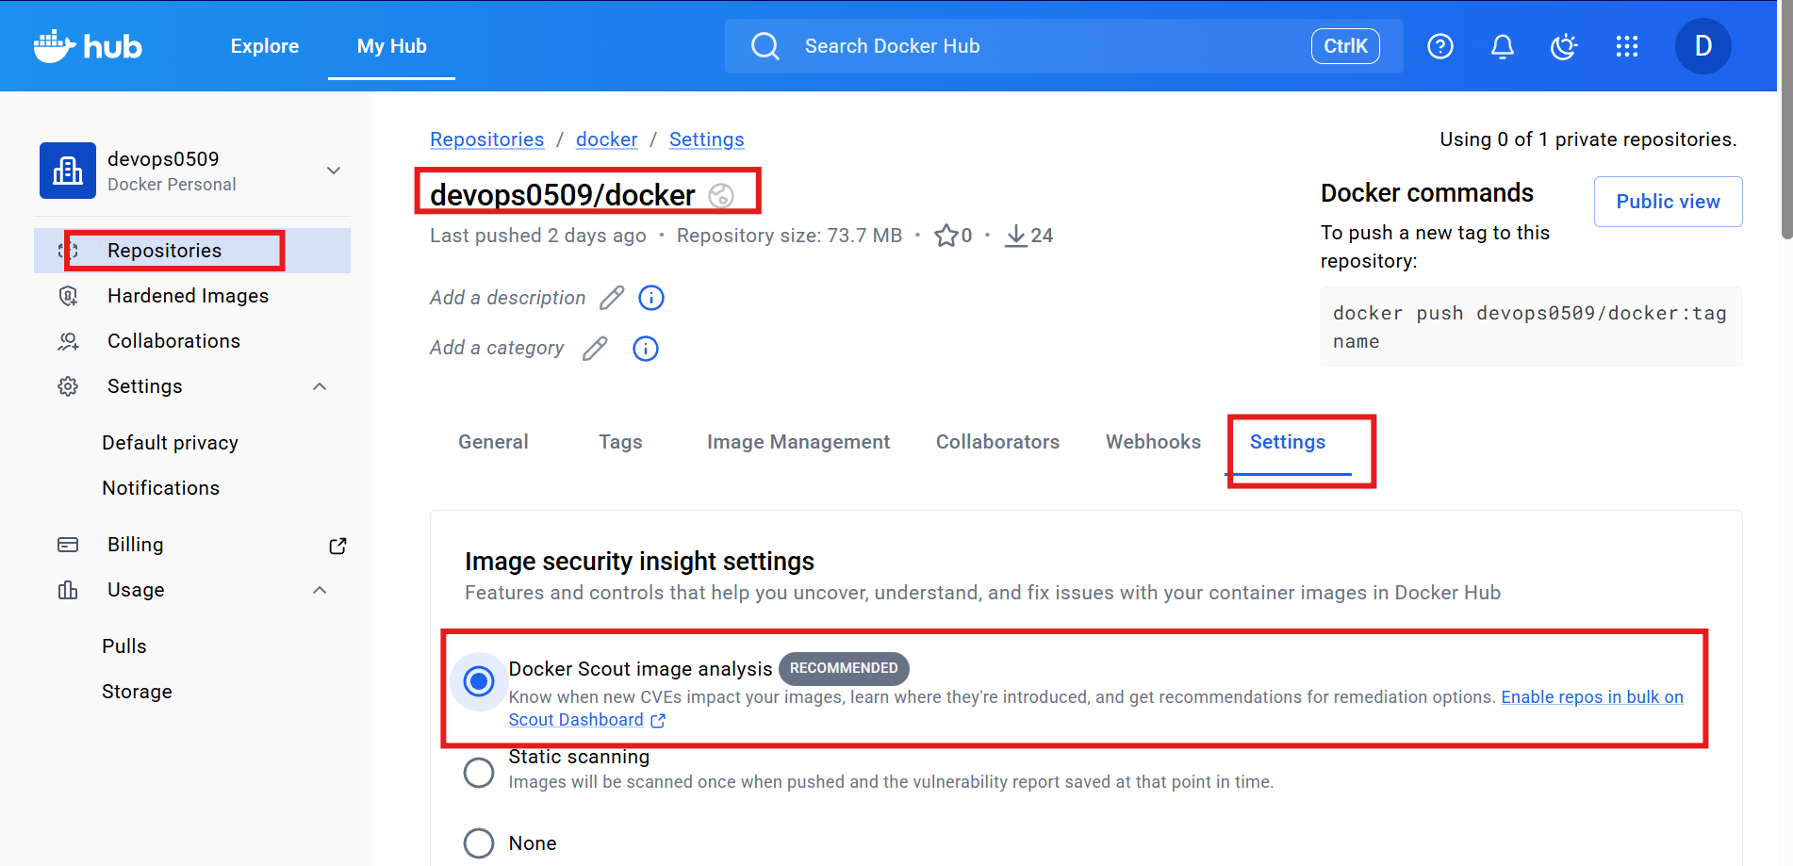

Step 2: Authenticate to Docker Hub from the CLI
Docker login
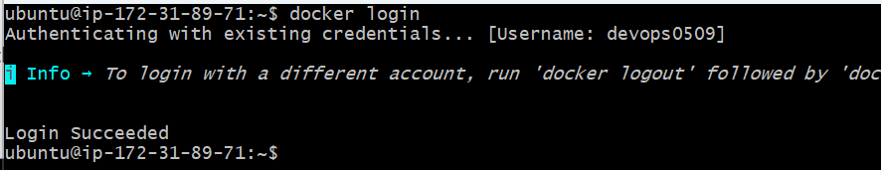

Step 3: Navigate to the Application Source Directory
cd multi-stage-example
ls -l
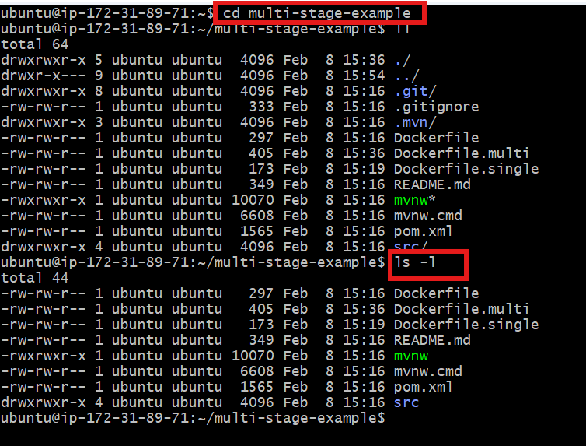

Step 4: Build the Multi-Stage Docker Image
docker build -f Dockerfile.multi -t multi-stage-app:latest .
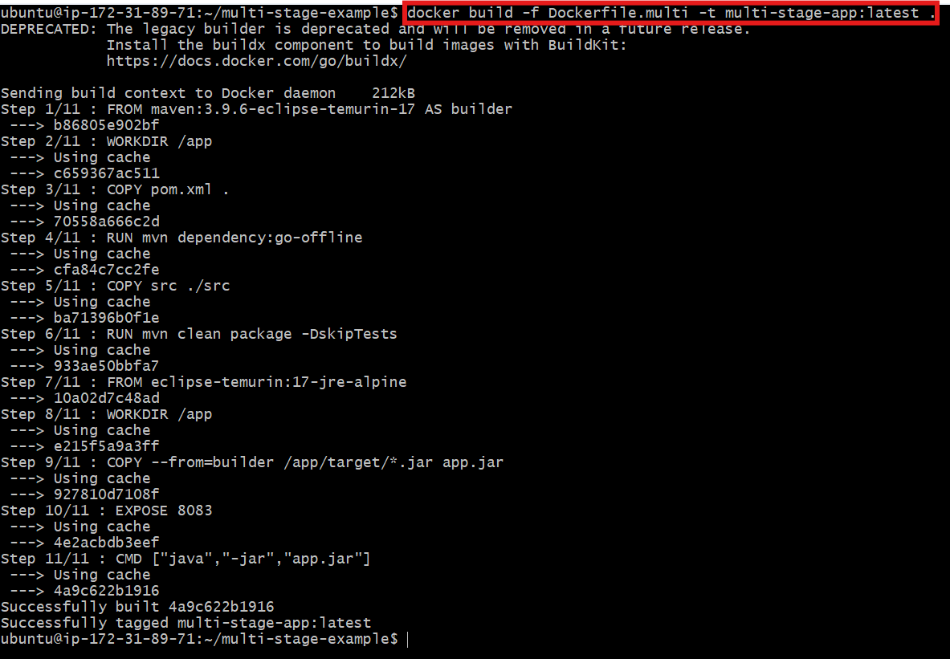
Step 5: Verify Built Images Locally
Step 6: Tag the Image for Docker Hub
docker tag multi-stage-app:latest <dockerhub-username>/devops:1.0
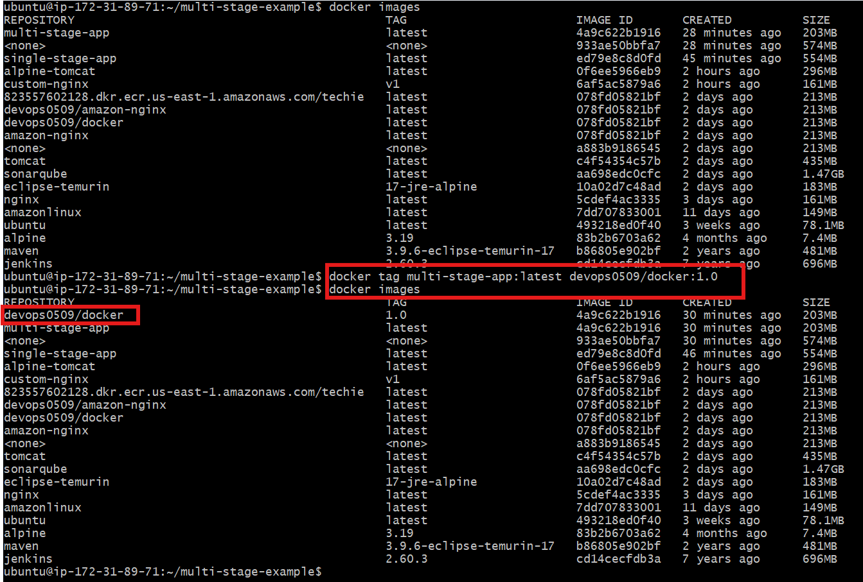

Step 7: install trivy and Scan the Image Locally with Trivy
Tool Used
Trivy (popular open-source container vulnerability scanner)
Download Trivy binary (latest stable)
sudo apt-get update
sudo apt-get install -y wget
wget https://github.com/aquasecurity/trivy/releases/latest/download/trivy_0.48.3_Linux-64bit.tar.gz
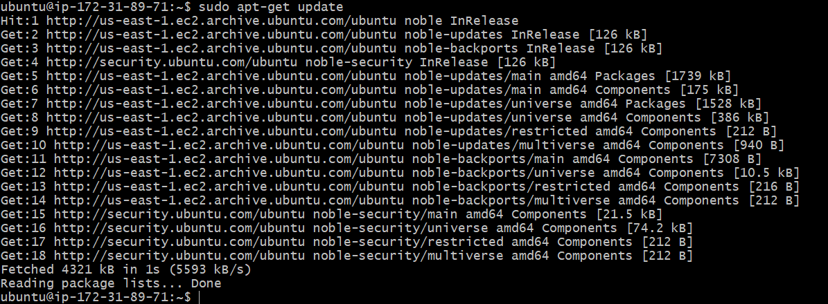

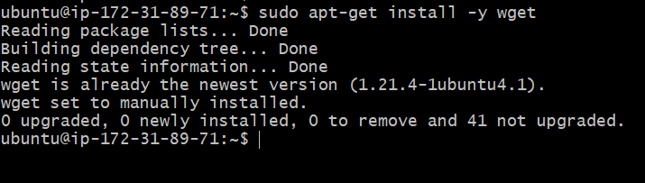
sudo apt-get update
sudo apt-get install -y wget gnupg lsb-release
wget -qO - https://aquasecurity.github.io/trivy-repo/deb/public.key | sudo apt-key add -
echo "deb https://aquasecurity.github.io/trivy-repo/deb $(lsb_release -sc) main" | sudo tee /etc/apt/sources.list.d/trivy.list
sudo apt-get update
sudo apt-get install -y trivy

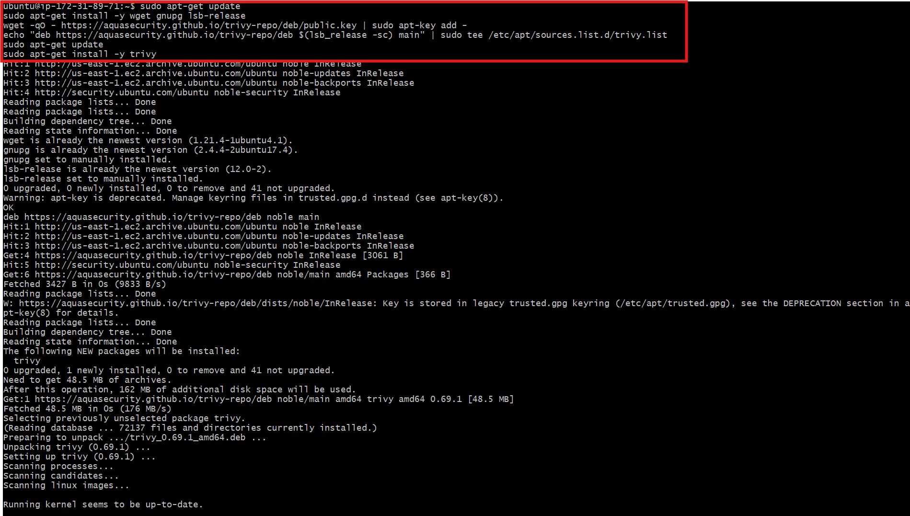
Trivy --version

Now scan your Docker image
trivy image devops0509/docker:1.0
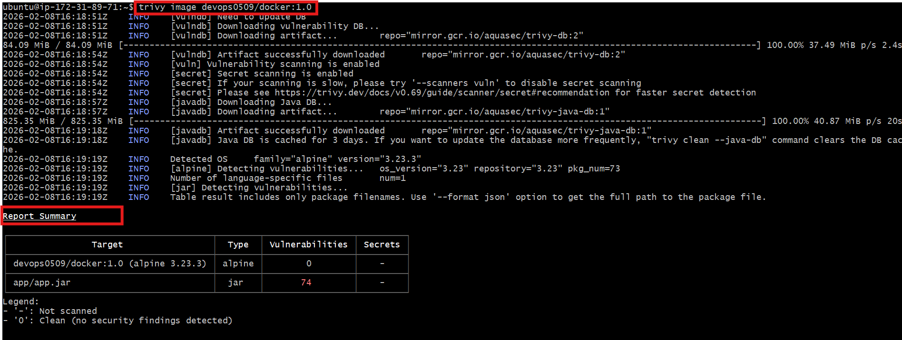

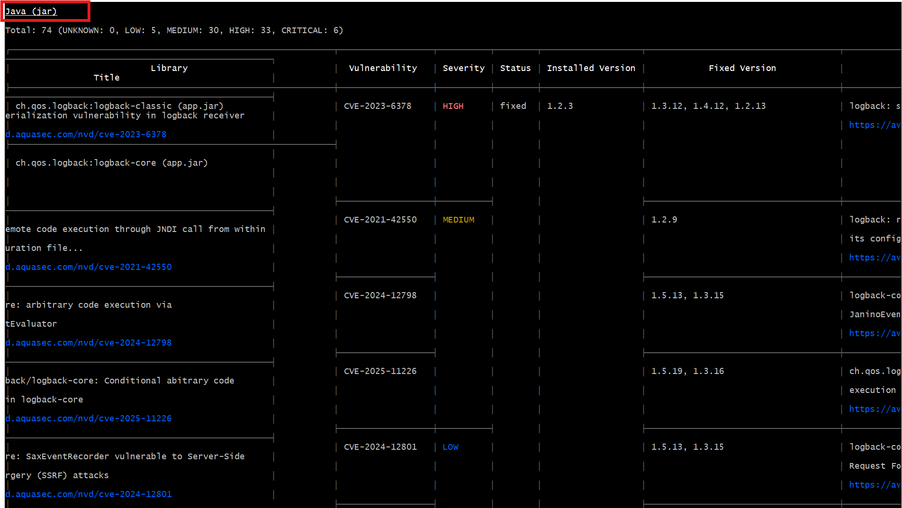

Step 8: Push the Image to Docker Hub
docker push devops0509/docker:1.0
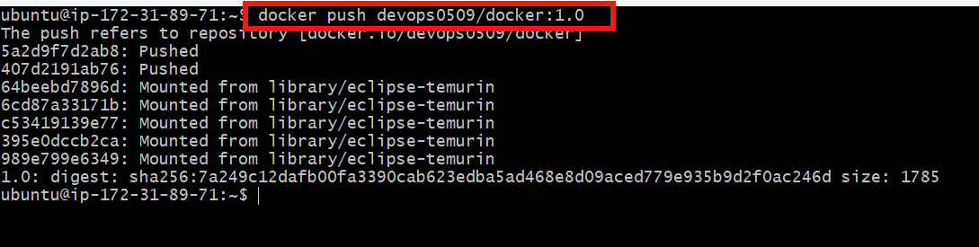

Step 9: Verify Image in Docker Hub Repository
Docker Hub → Repositories → devops0509/docker → Tags

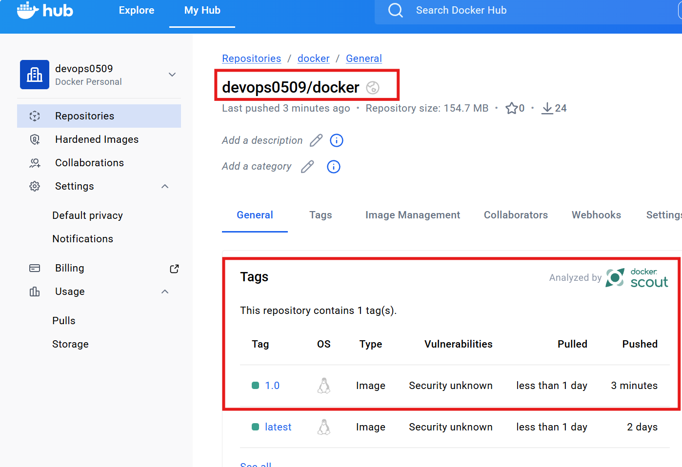

Conclusion
- Image scanning helps identify security vulnerabilities early
- Automated scans reduce the risk of deploying insecure images
- Integrating scanning with the registry strengthens overall container security

