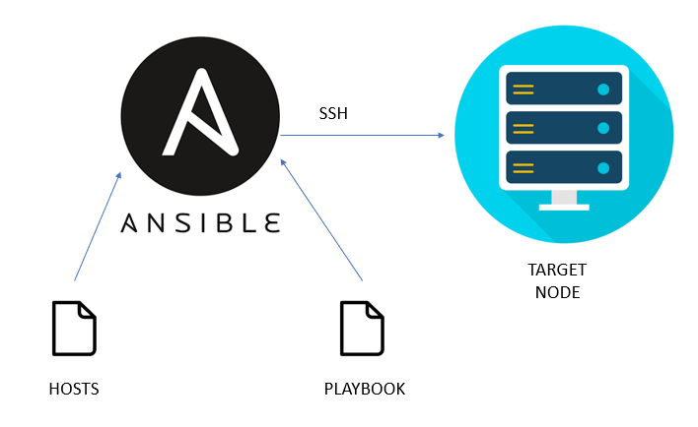

Task Title
Ansible-01
Objective
The objective of this task is to watch the Ansible-01 video posted on slack and worked on executing the initializing Ansible shown in video.
Prerequisites
List all requirements before starting:
- Master Controller server
- Nodes- workers
- Ad hoc commands

Issues Faced: Briefly mention issues and how you fixed them. Posted below in the last.
Conclusion
Conclusion has been provided for every task at the end.

Tasks
- Watch ansible-01 video and write down notes.

Ansible:
Ansible is an open-source tool for configuration management.
Ansible is used to provision infrastructure and used for deployments purposes as well.
Example: If we want to configure a package in 100 servers (ec2), we can use Ansible

To control all the 100 servers we need to install one Master server
Master server is called – Controller

In controller we need to have two components:
- Inventory/hosts
- Playbook

Inventory/hosts:
We need Inventory hosts to store all 100 servers IPs, so that we can communicate with all 100 servers from Controller.

Playbook:
Playbook is a place where we input what needs to be executed.
Task/play can be called anyways.
For example: Httpd/apache2
Task: httpd
Yum install state = latest
Task: start httpd
Service: httpd state = started
Ansible works on protocol: ssh and port= 22

Pre-patching and post-patching

We can write a playbook for pre-patching and post-patching, execute to bring up and down the servers.

Ad hoc commands

Scenarios:
- When patching activities are completed, then we need to check the runtime, when patching started/completed.
- We need to verify if all servers are responding, then we can use Ad hoc commands.
- We can use playbook as well to write execution script, but playbook should be simple, rest simple or small commands execution can be done via Ad hoc commands.
Example: ansible all -m “uptime”

Inventory/hosts:
In inventory, we store all Ips by dividing into groups.
- Development –Groups –Test (so, in test, I can change for 1 specific worker and add an IP)
- Staging
- Prod

Ssh- passwordless authentication
Ssh passwordless authentication needs to be performed on Controller all worker severs
Because, if we need to communicate with all servers and make changed to all via automation, then we need to do ssh-keygen in controller and paste the key in all worker servers.

Other configuration tools:
- Chef -pull based
- Puppet- pull based
- Salt stack- push based.

The above are the configuration tools similar to Ansible.
But Ansible is a better option to use, because:
- Ansible is agentless (no mediator in between)
- Ansible works on push based.
- Ansible supports n number of plugins/modules.
- Ansible is developed in python language.

Ansible Architecture

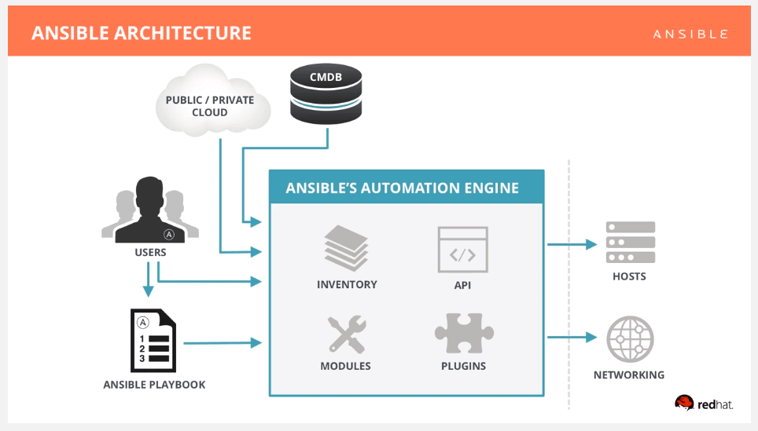

- Setup one master and two worker nodes in ansible.

Step by step implementation:

- Navigate to ec2 and create 3 servers 1- Master controller and 2 worker nodes.

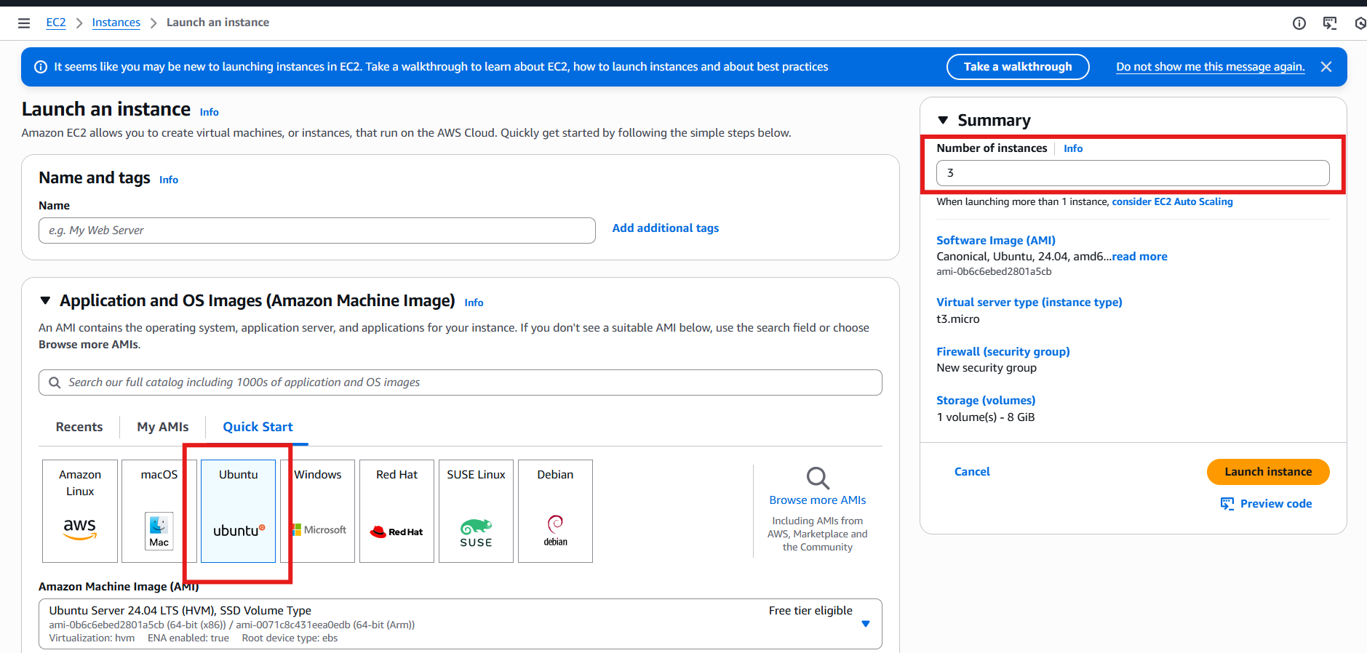

Created new key pair
Default VPC selected
Default SGs selected
Launch the instances.
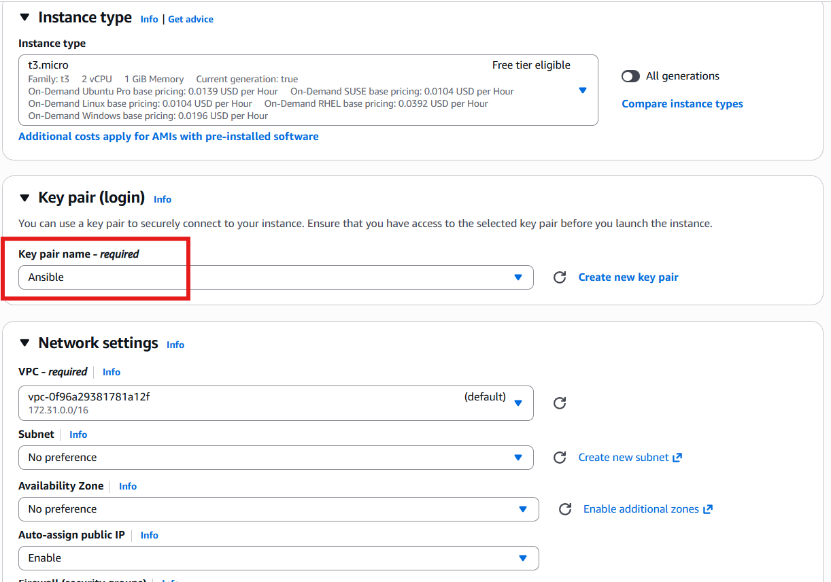

Instances launched
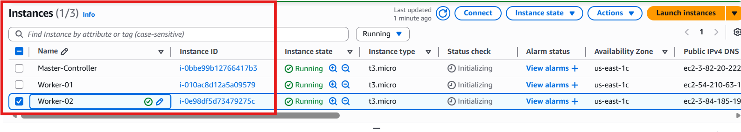

Let’s connect to Master-Controller
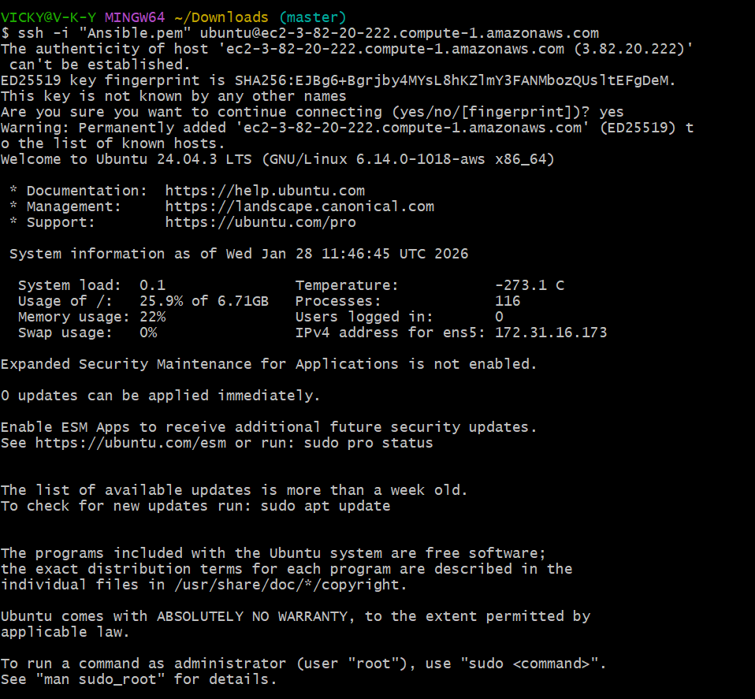

Verify python version
By default, python will be downloaded in aws.
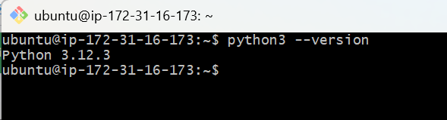

Updating packages- apt update -y
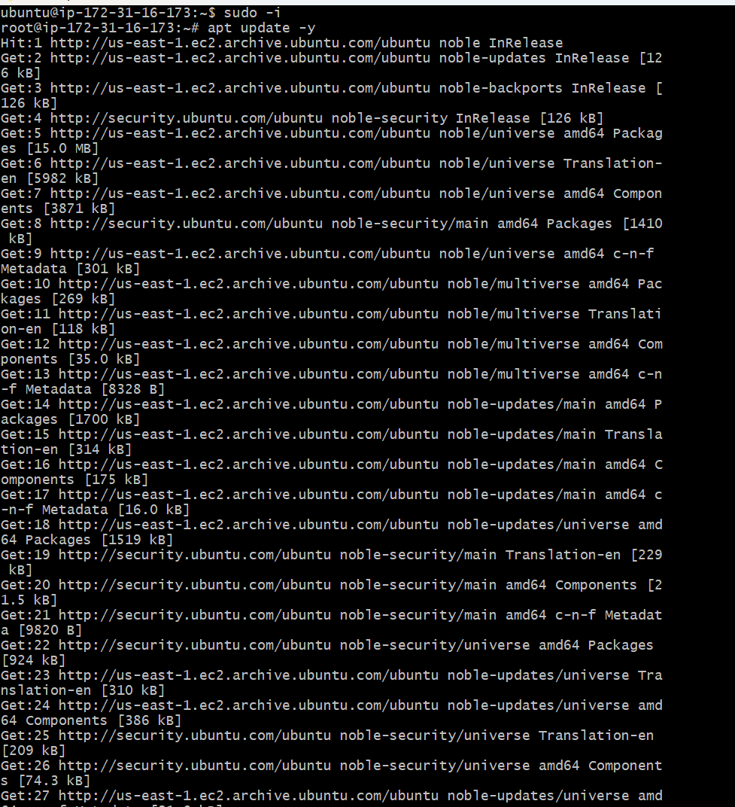

Ansible installation
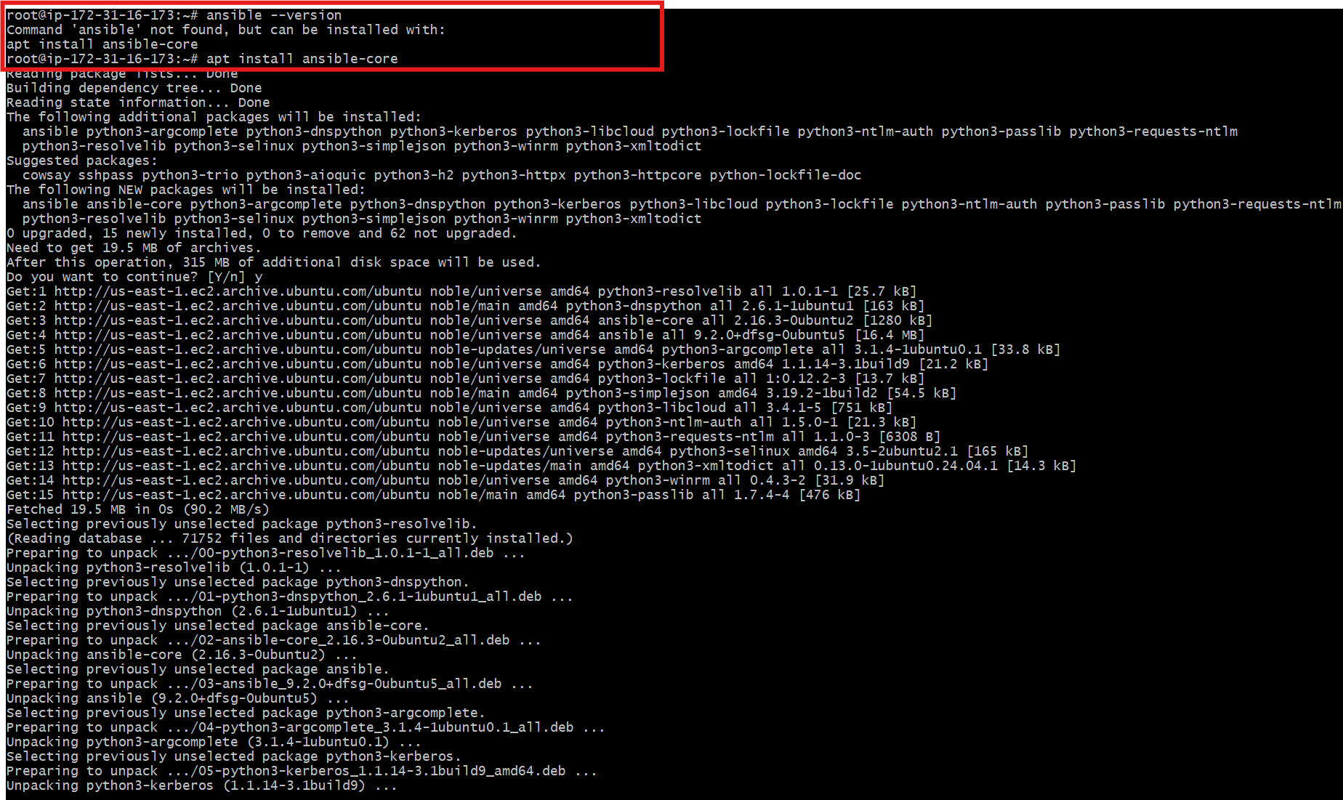

Cd /etc/ansible/
Cat ansible.cfg- here is where we make all the changes.

Issue:
By default, Ubuntu does not create /etc/ansible/ansible.cfg or /etc/ansible/hosts
anymore — instead, you’re expected to create your own config and inventory in your
project directory.

sudo mkdir -p /etc/ansible
cd /etc/ansible
vi /etc/ansible/ansible.cfg
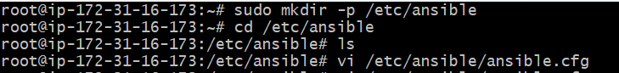
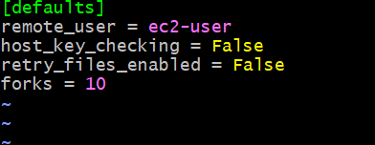

Created global inventory
=========sudo vi /etc/ansible/hosts


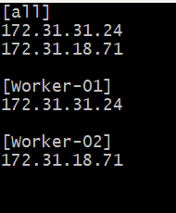

Save exit
Verify if hosts are available and communicating.
Success, host file is updated with Ips of Workers.
But, to communicate, we need to perform ssh-passwordless authentication.
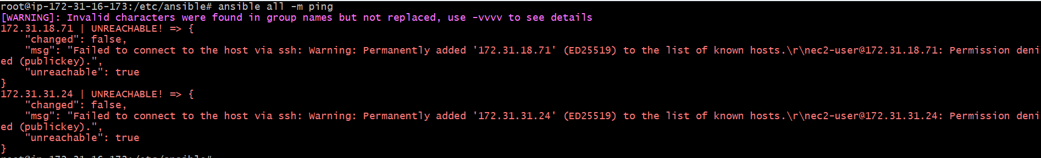

Next step- Set up passwordless authentication

Generate a ssh-keygen in Controller
Ssh-keygen
Cat /root/.ssh/id_ed25519.pub
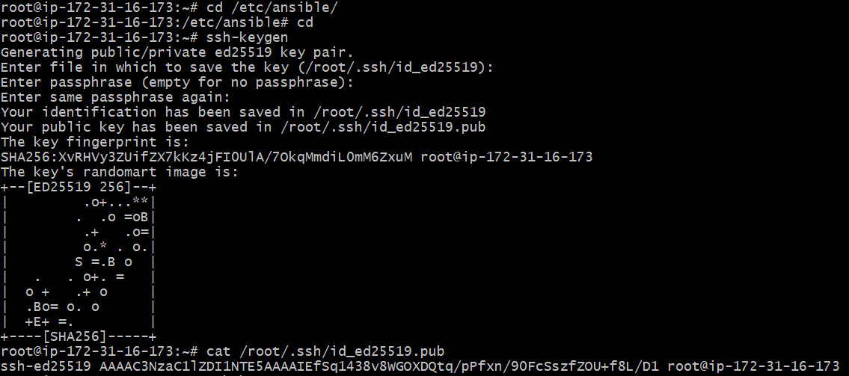

Its time to copy the above key and paste in both the worker servers.
1st worker- Worker-01
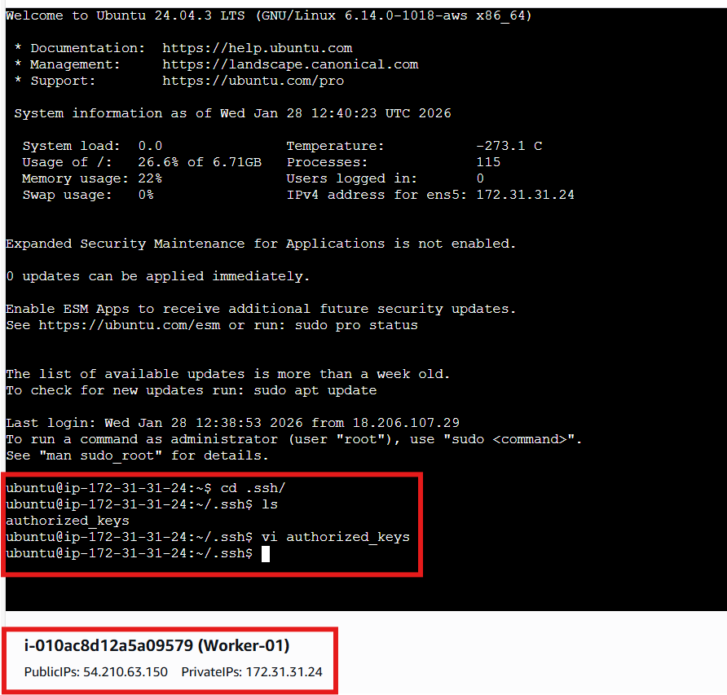

2nd worker
Worker-02
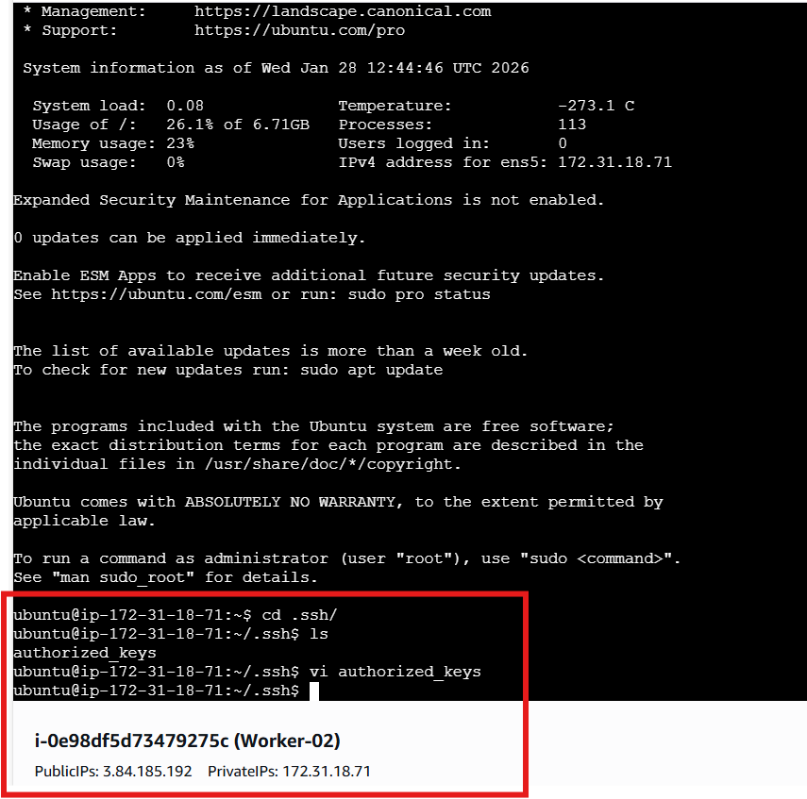

Now, we have provided the path to communicate with our workers.
Let’s verify if we are able to communicate from controller.
Success- we can now communicate automatically with our workers.
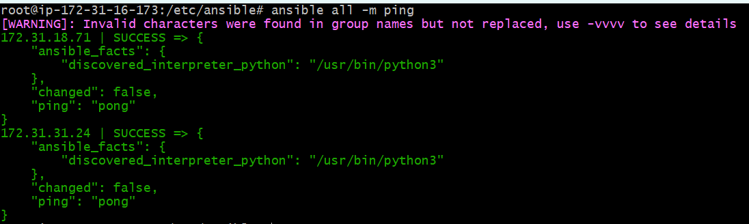

Task completed.

- Execute the ad hoc command shared in #dvps-cloud-documents-12 Channel.

Step by step Implementation:

In this task, we shall execute few ad hoc commands-
- To check the connectivity between slaves
ansible all -m ping

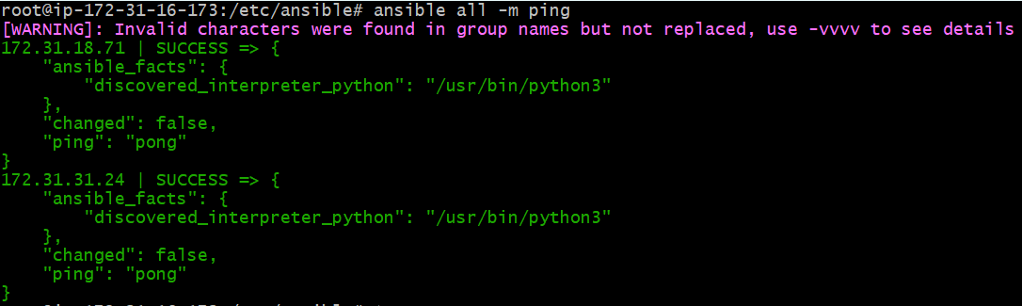

- Ansible Worker-01 -m ping

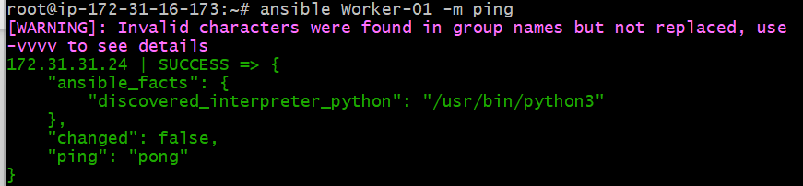

- Ansible Worker-02 -m ping

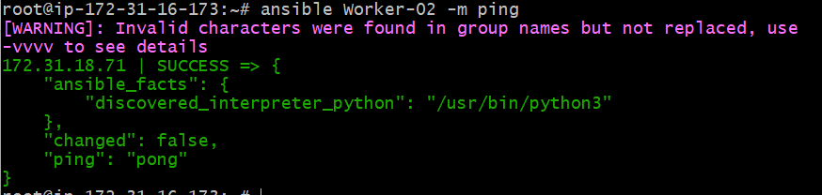

- By using the above workers 01 and 02, we were able to fetch from hosts file.


- How to gather facts of slave machine
# ansible all -m setup
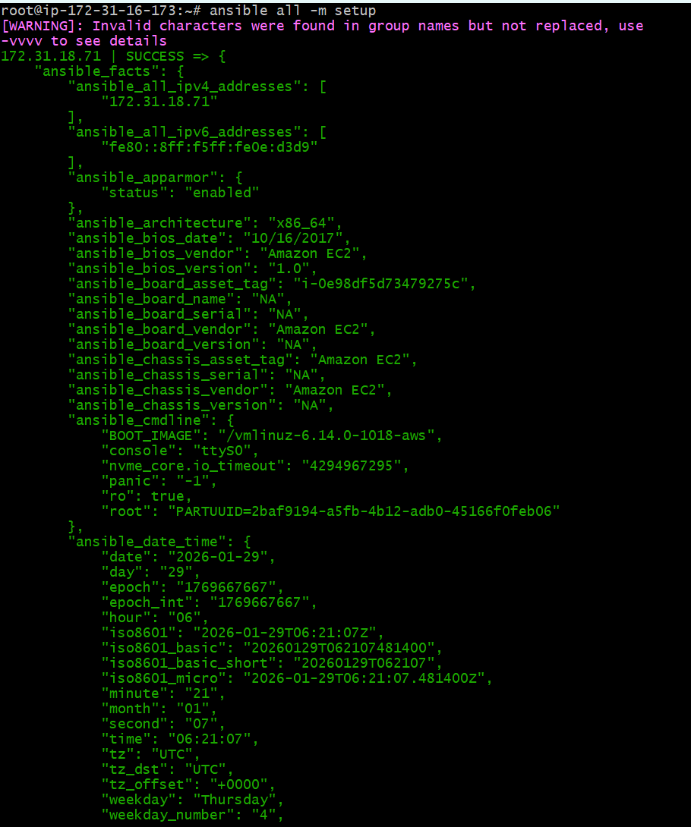

- TO check the uptime of a slave machine
# ansible all -a uptime
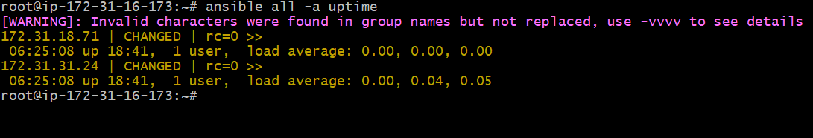

- Ansible all -m ping -vvvv
—-> to check with all log details

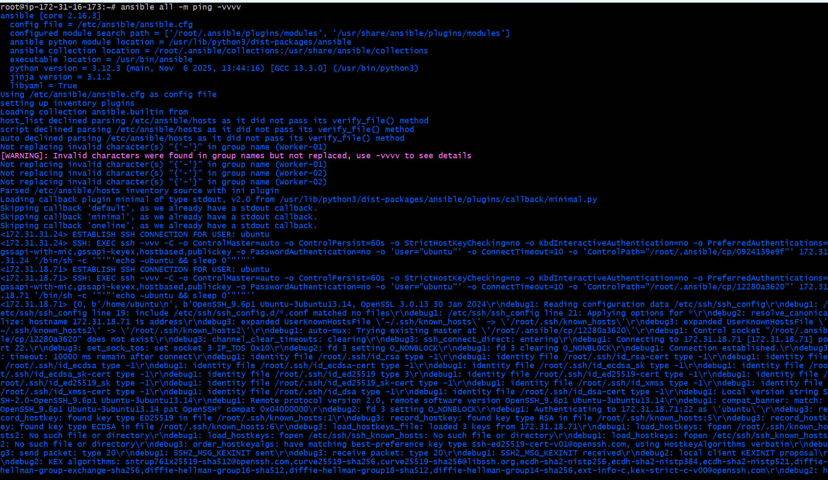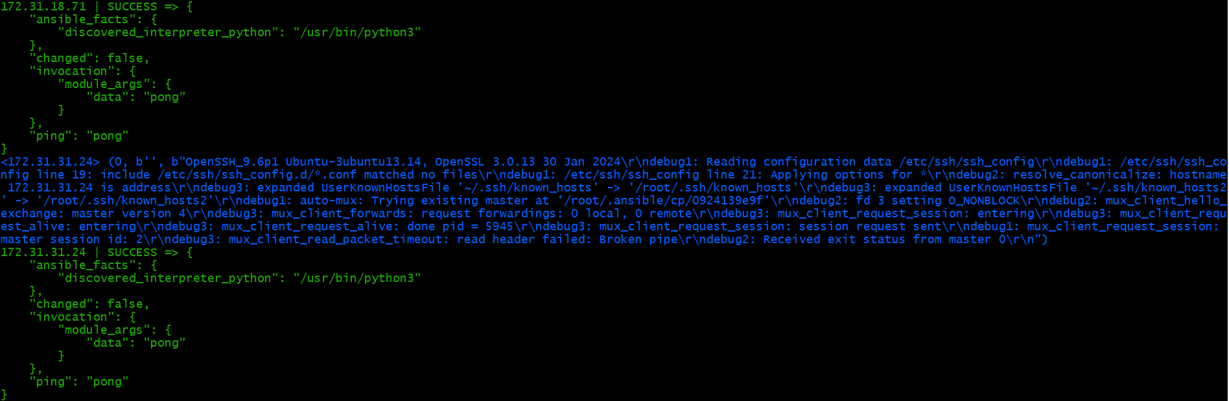

- #check the free memory or memory usage of host
ansible all -a "free -m"

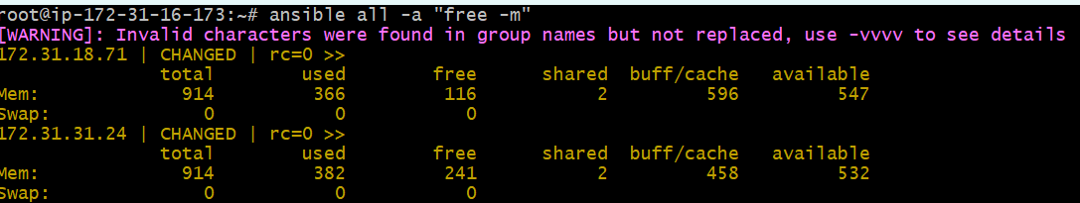
- Create directory using shell module
ansible all -m shell -a “mkdir ansible.log”

—> what it does it will create ansible.log directory in all severs.
We verified in worker-01 machine.
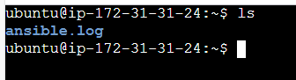

- Before installing the package, we need to update the packages using command- ansible all -m shell -a “apt update -y” --become

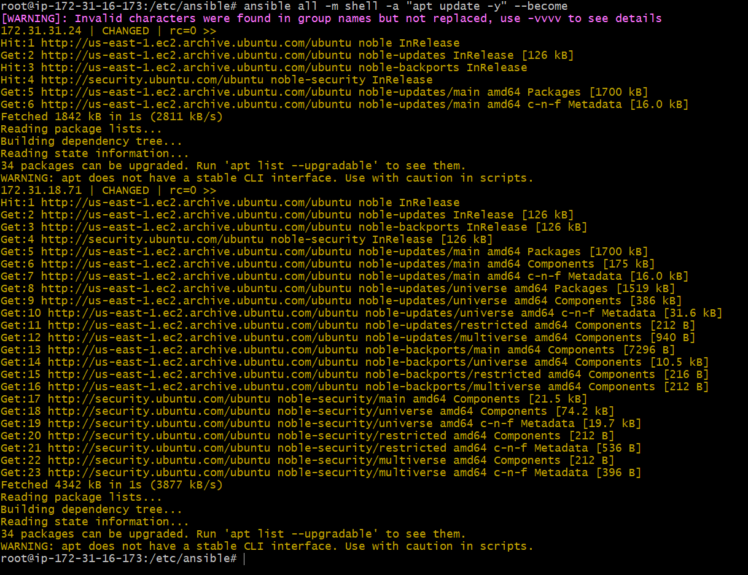
- Install a package using yum command
ansible all -m yum -a "name=httpd state=installed"
—> We are using ubuntu
ansible all -m apt -a “name=apache2 state=latest” --become

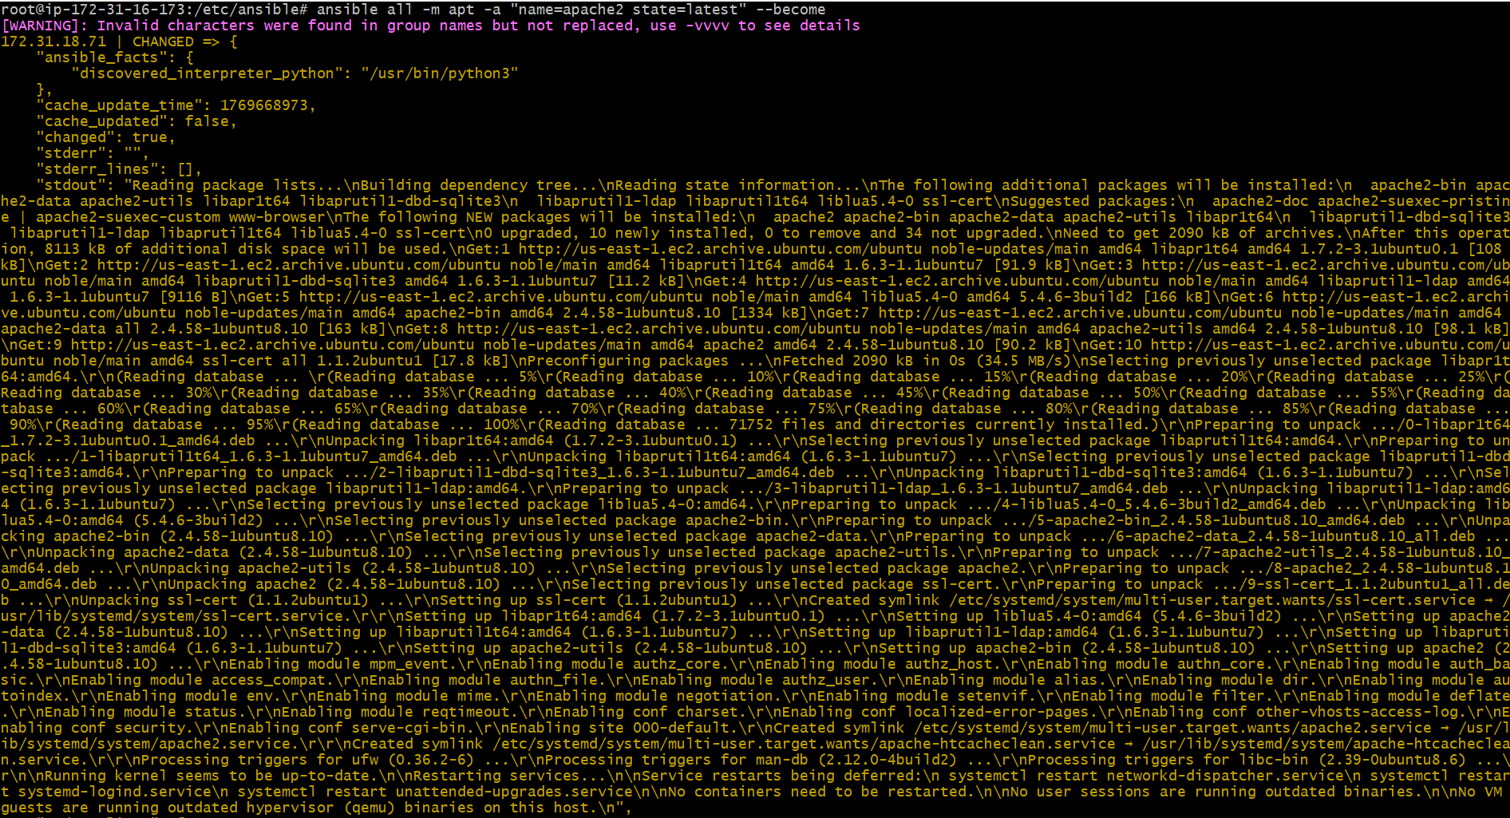

- now check your other workers servers if apache2 package
is installed or not
—->worker1

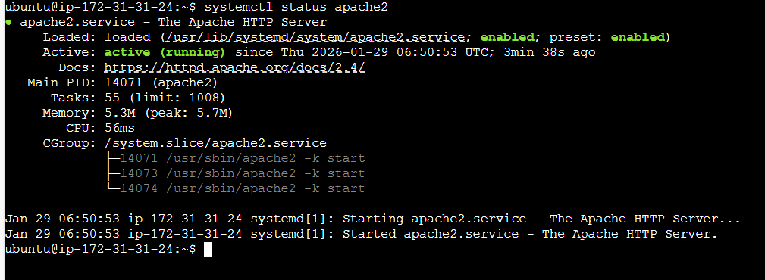

Verified in browser using IP of worker-01
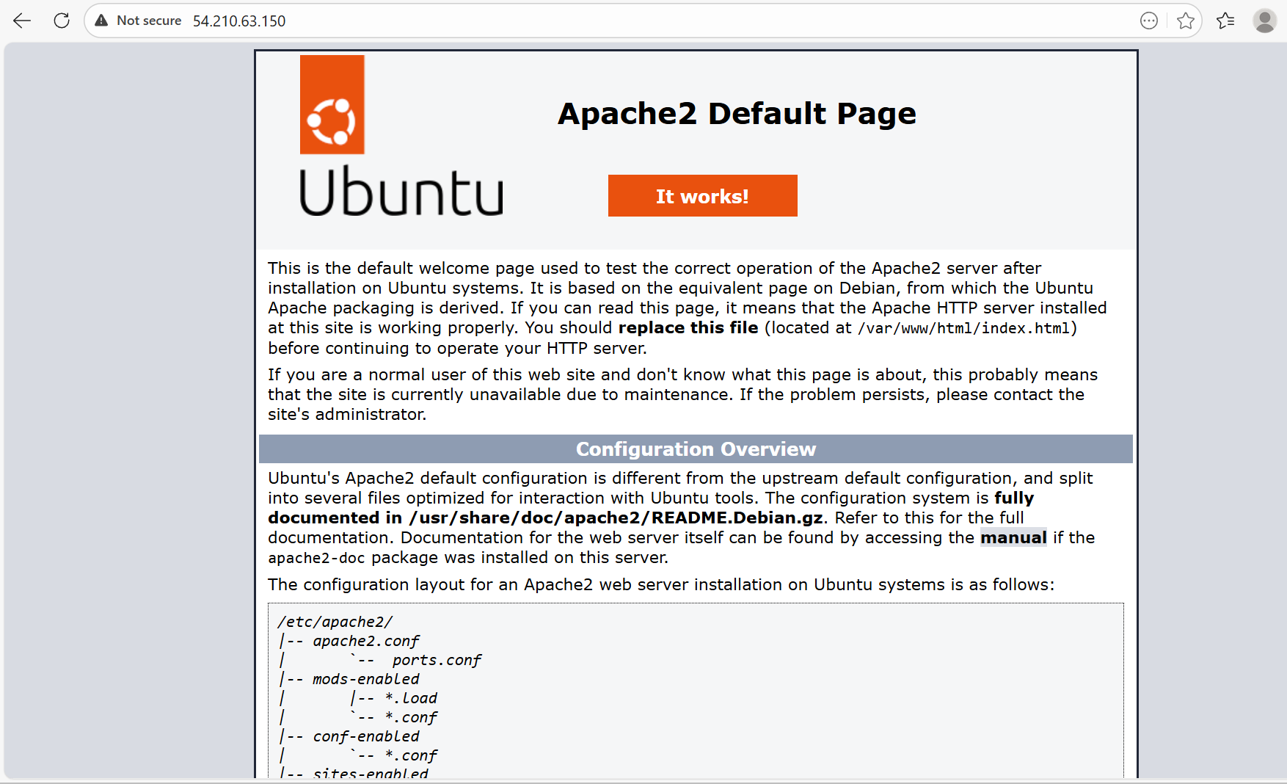

- # Start or stop the service
# To Start
ansible all -m service -a "name=httpd state=started” --become
enabled=yes"
# To Stop
ansible all -m service -a "name=apache2 state=stop enabled=yes"
To stop
—-> ansible all -m service -a "name=apache2 state=stopped
enabled=yes" --become

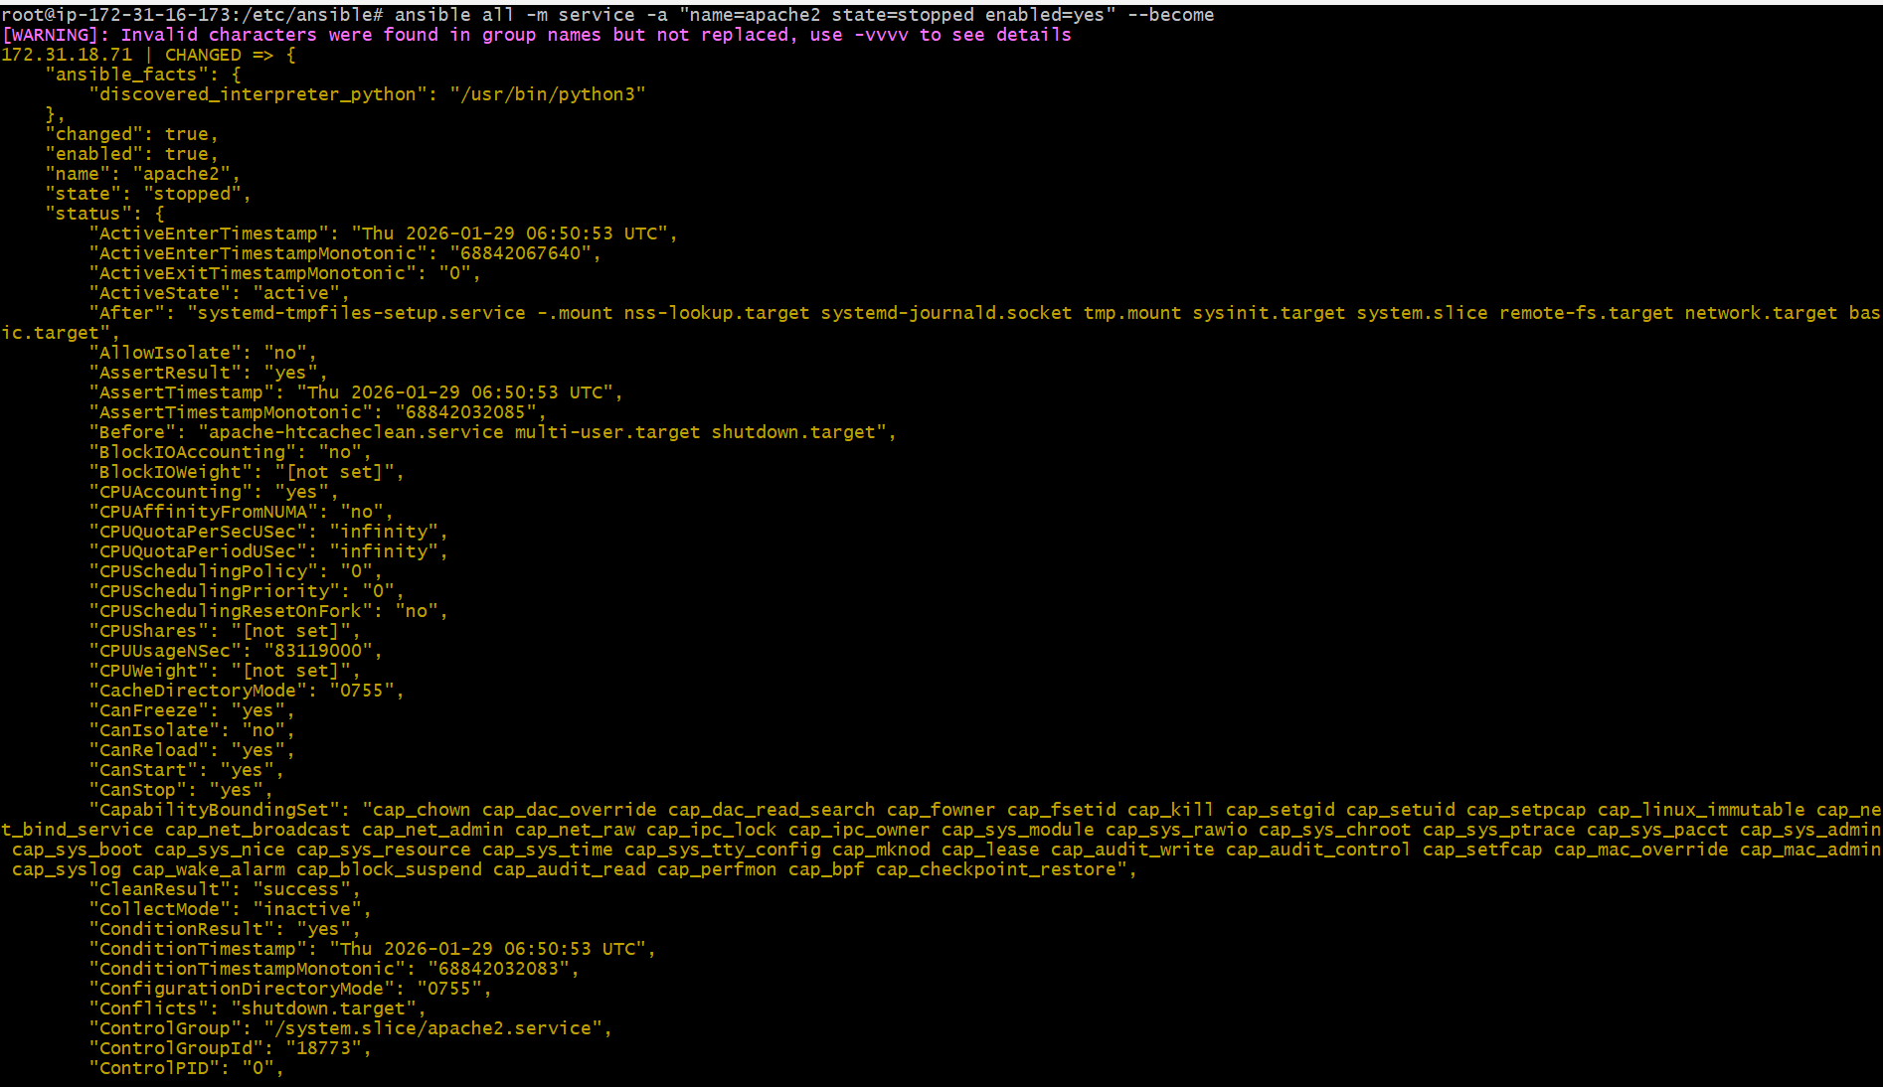

Let’s verify in worker machines
Success.

