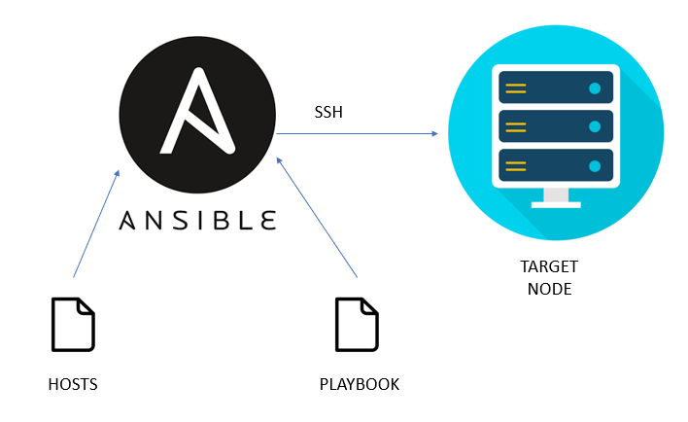
Task Title
Ansible-02
Objective
The objective of this task is to watch the Ansible-02 video posted on slack and worked on executing the Ansible tasks shown in video.
Prerequisites
List all requirements before starting:
- Master Controller server
- Nodes- workers
- Ad hoc commands
- Modules- handlers, notifiers
- Playbook
- Apache-tomcat
- Ec2

Issues Faced: Briefly mention issues and how you fixed them. Posted below in the last.
Conclusion
Conclusion has been provided for every task at the end.
Tasks
- Watch ansible-02 video and write down notes.

Ansible playbook:
Ansible playbook consists of set of tasks/play.
- Playbooks can be written in YAML language.
- YAML- Yet Another Markup Language
- YML- Yet Markup Language
- YAML is human readable

Extension: main.yml, main.yaml
Example: apache.yaml, apache.yml

Sample playbook for installing apache in controller
- hosts: all
become: yes
tasks:
name: Install Apache
apt: name=apache2 state=latest

Note:
We can edit & format the playbook script in either:
  - vs code
  - yaml online editor

Commands used for playbook:
  - To verify the syntax: ansible-playbook ourplaybook.yaml –syntax-check
  - Dry run: ansible-playbook ourplaybook.yaml –check
  - Execute: ansible-playbook ourplaybook.yaml

Modules:

  - Ping
  - Shell
  - Apt
  - Yum
  - File
  - Set-up
  - Register
  - Debug
  - Copy
  - Handlers
  - Notify

Handlers and Notify

The above two modules will help to add a dependency when every time deploying is not a good practice.
So, we can add notify and Handlers under a task, so that, whenever the task has a change, then the below handlers will trigger and make a change.

Debug and register module

Register: To capture the output of tasks
Debug: To display the output.

- Install apache2 using ansible playbook, use handlers, notifiers.

Step by step Implementation:
Connect to the Master-Controller
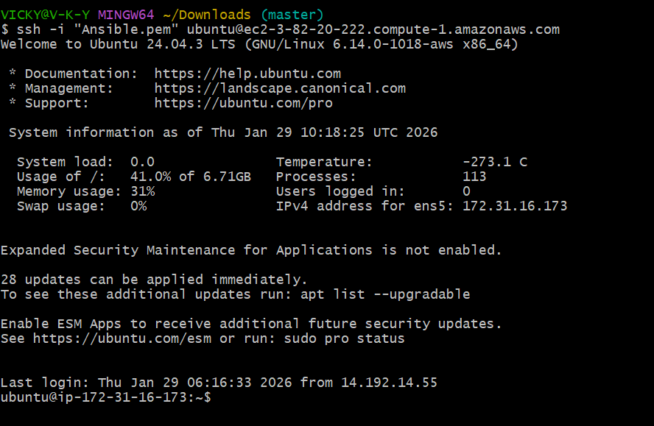

Deleted apache2 package from all machines- ansible all -m apt -a “name=apache2 state=absent” --become
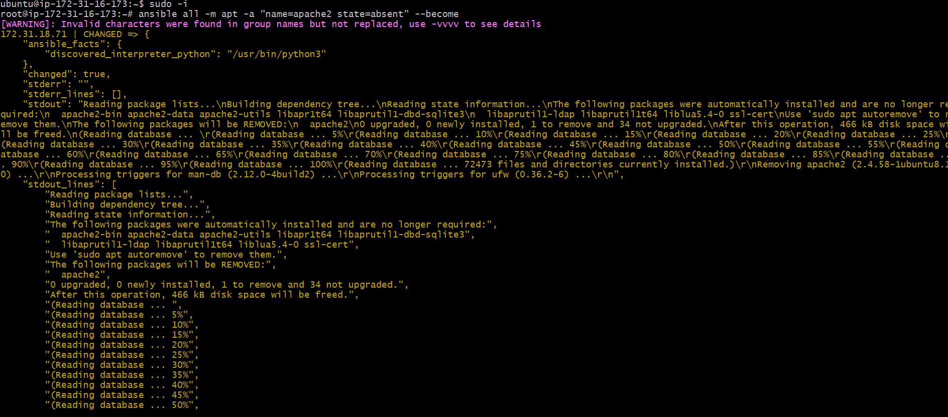

Verified in worker-01 machine if the package is destroyed
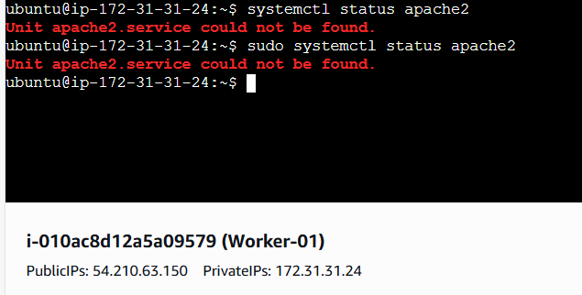

Requirement for this task-
Install apache2 using ansible playbook, use handlers, notifiers
  - Mkdir playbooks- first we need to create a playbook
  - Cd playbooks
  - Vi apache.yaml- create a playbook called apache.yaml
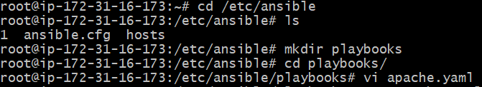
Now, it’s time to start updating the playbook
---
- hosts: all
become: yes
tasks:
- name: Install Apache
apt: name=apache2 state=latest
- name: copy index.html
copy: src=index.html dest=var/www/html
notify: Restart apache2

handlers:
- name: Restart apache2
service: name=apache2 state=restarted
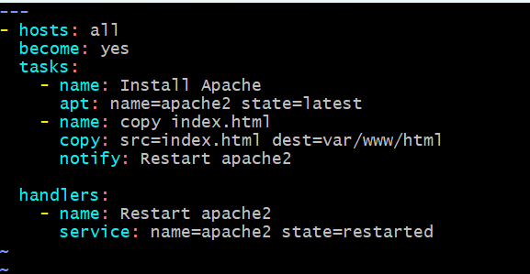

We added 3 requirements for the above task
- Install Apache2
- Copy index.html to var/www/html
- Restart Apache2
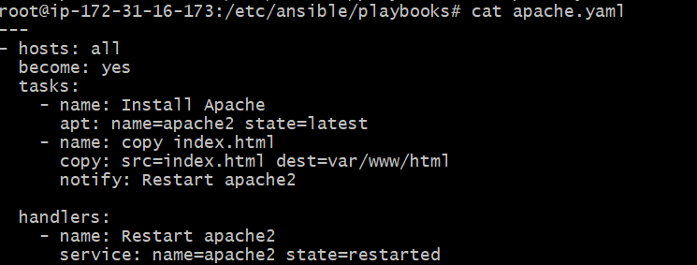
Here, we need to copy index.html, but we haven’t created one, so we shall create one index.html now.

No, we shall do a dry run syntax check before executing the playbook
Syntax All good and ready
Dry-run ready for execution
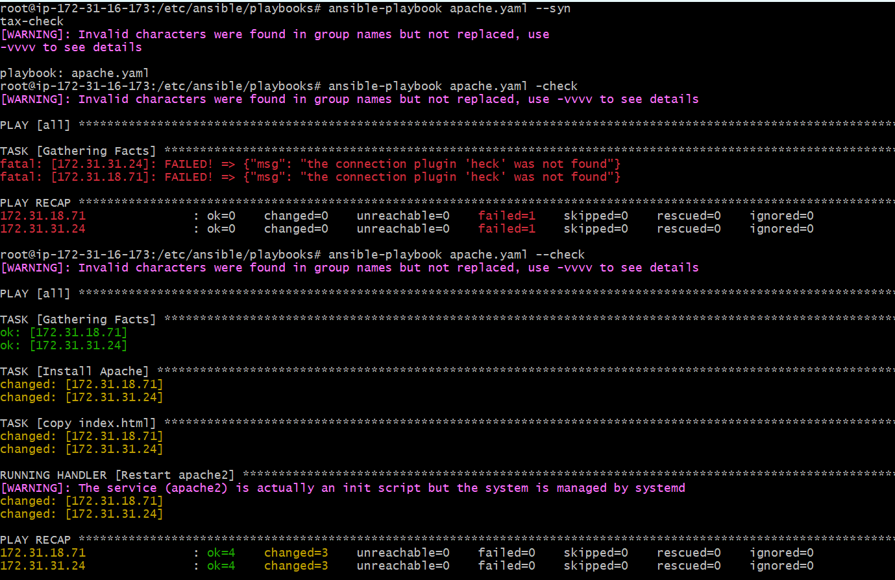

Let’s execute the playbook- ansible-playbook apache.yaml
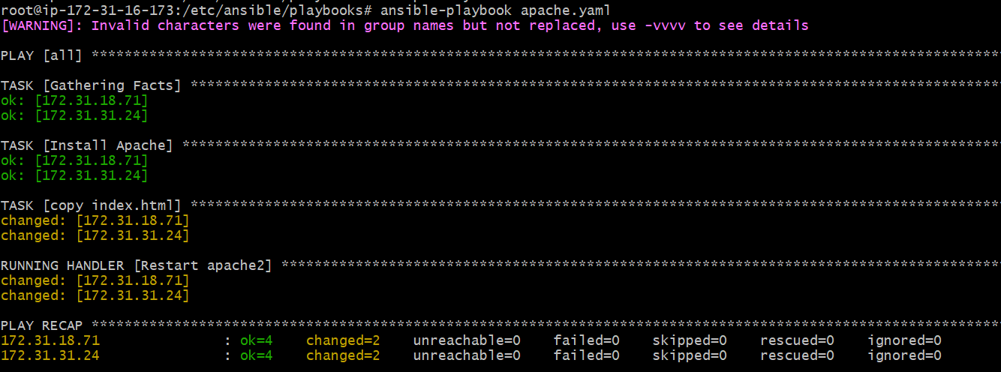

Task executed successfully.
Apache installed index.html was pushed to var/www/html
Apache restarted
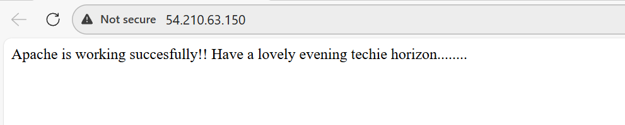

- Write an ansible playbook to install apache tomcat.

Step by step Implementation:
Requirement for this task-
Write an ansible playbook to install apache tomcat

- We have already created playbooks directory so we shall create a new playbook for tomcat.

Vi tomcat.yaml
---
- hosts: all
become: yes

tasks:
- name: Install Java
apt:
name: openjdk-11-jdk
state: present
update_cache: yes

- name: Download Tomcat
get_url:
url: https://archive.apache.org/dist/tomcat/tomcat-9/v9.0.85/bin/apache-tomcat-9.0.85.tar.gz
dest: /tmp/tomcat.tar.gz

- name: Create Tomcat directory
file:
path: /opt/tomcat
state: directory

- name: Extract Tomcat
unarchive:
src: /tmp/tomcat.tar.gz
dest: /opt/tomcat
remote_src: yes
extra_opts: [--strip-components=1]

- name: Start Tomcat
shell: /opt/tomcat/bin/startup.sh
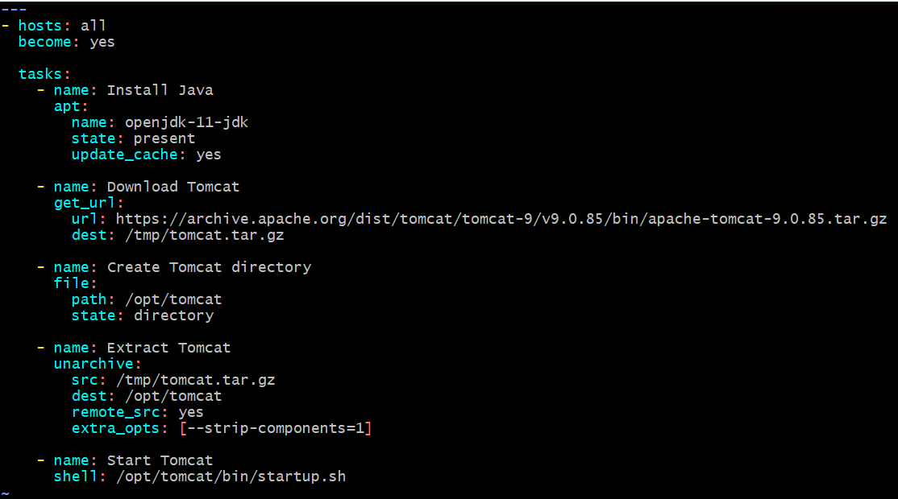

we shall execute the script once dry run syntax errors are checked.
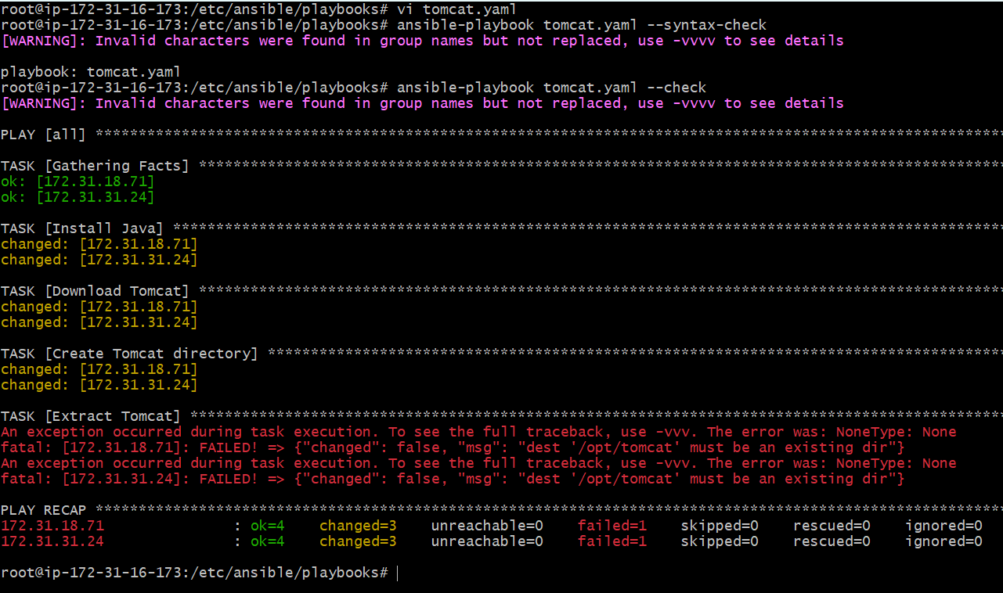
There is an error that, /opt/tomcat is not available, because yet tomcat isn’t installed.
So, we shall execute the playbook.
- Success- playbook executed successfully.
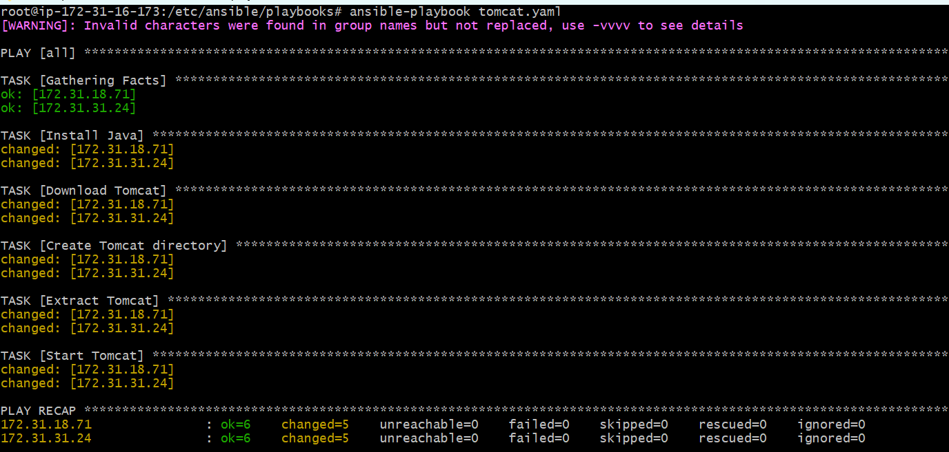

We shall verify in the browser if tomcat is running successfully.
Worker-01
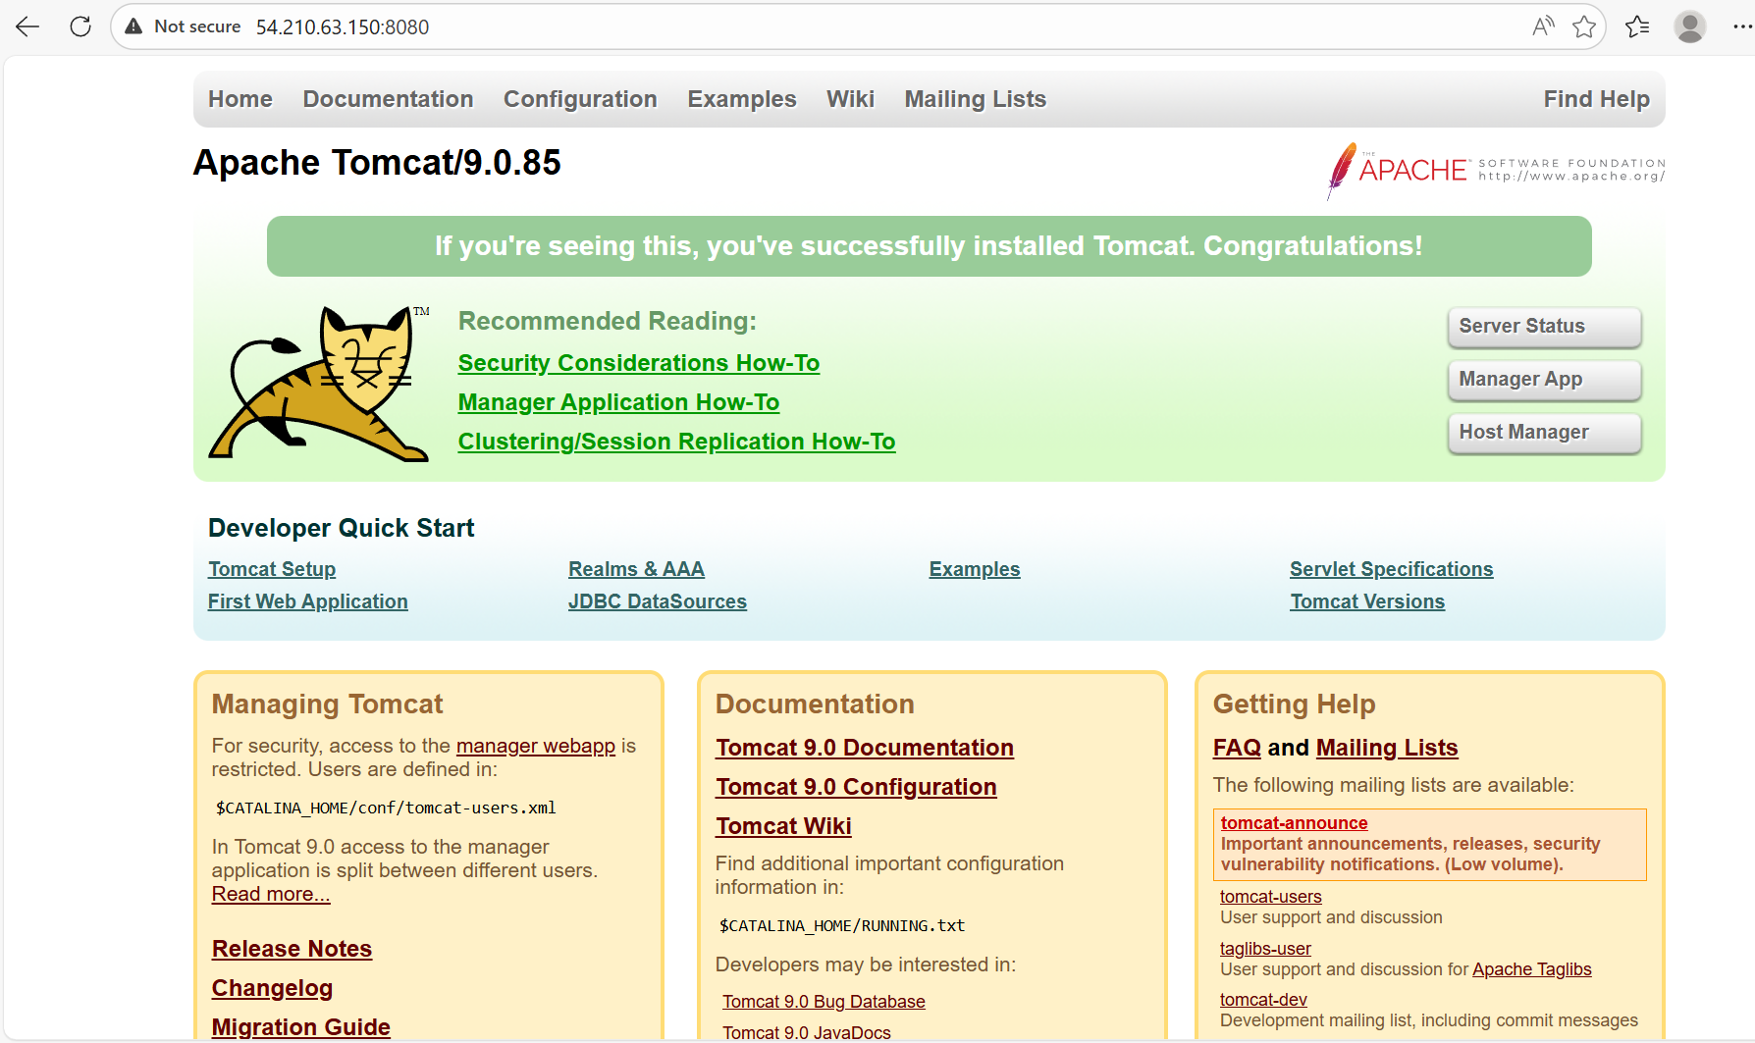

Worker-02
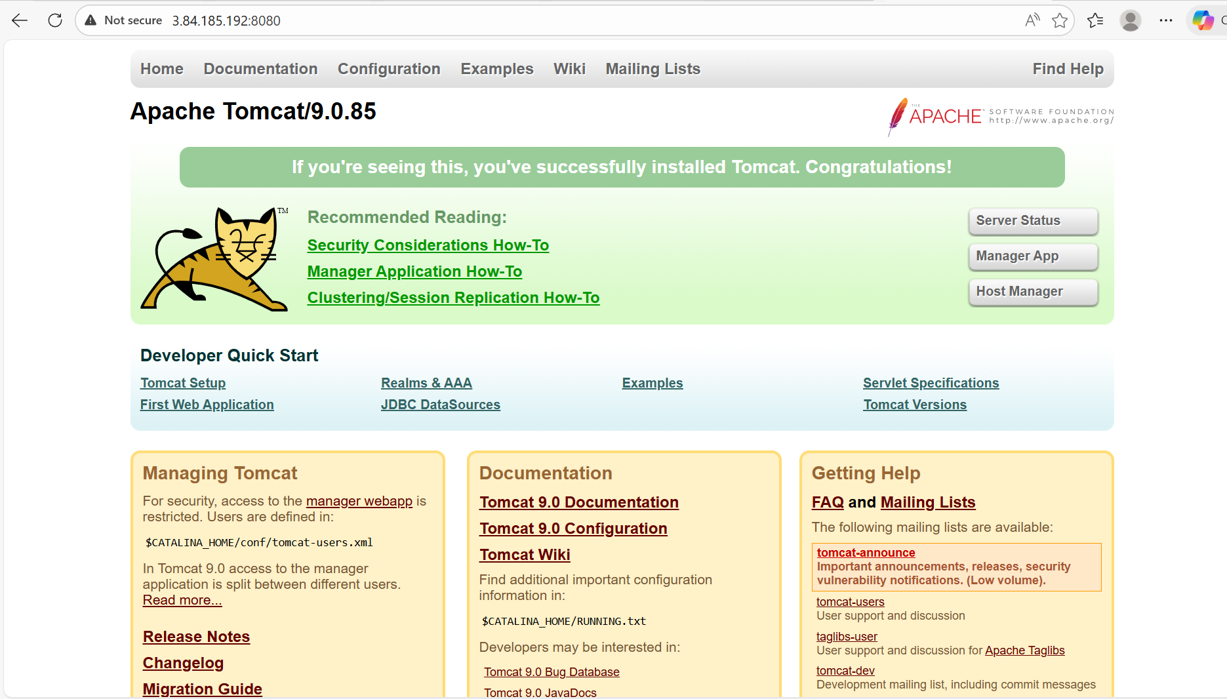

- Write an ansible playbook to provision one ec2 on aws.

Step by step Implementation:
Requirement: Write an ansible playbook to provision one ec2 on aws

Step 1: Install required tools
apt update
apt install unzip curl -y

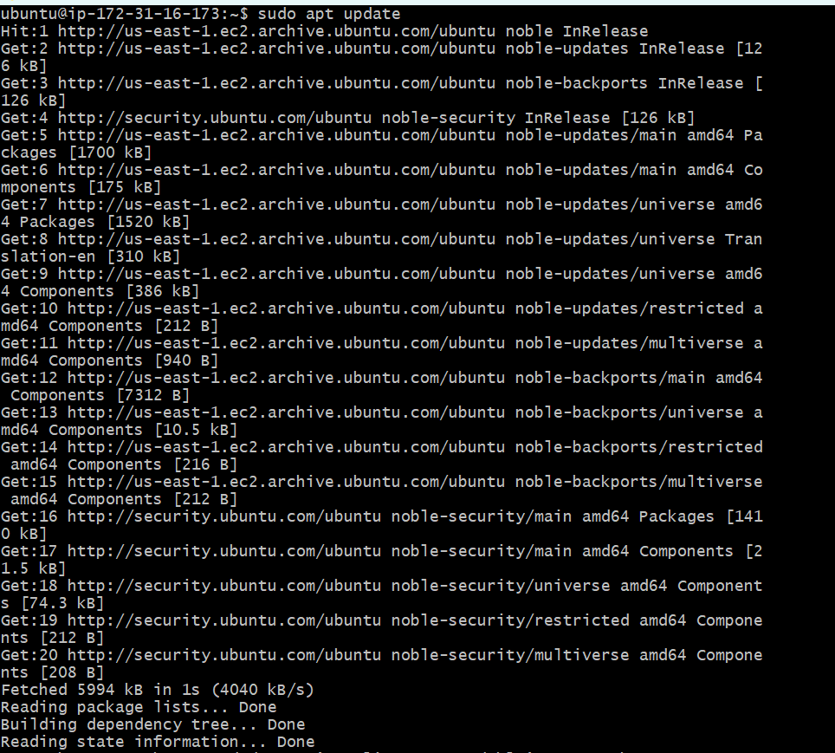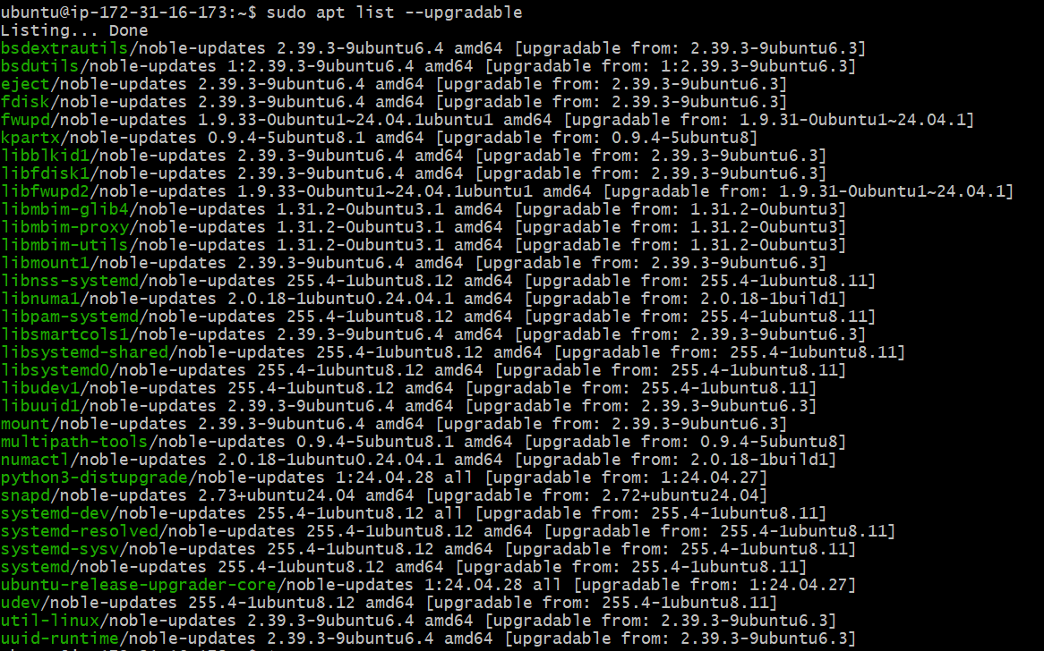
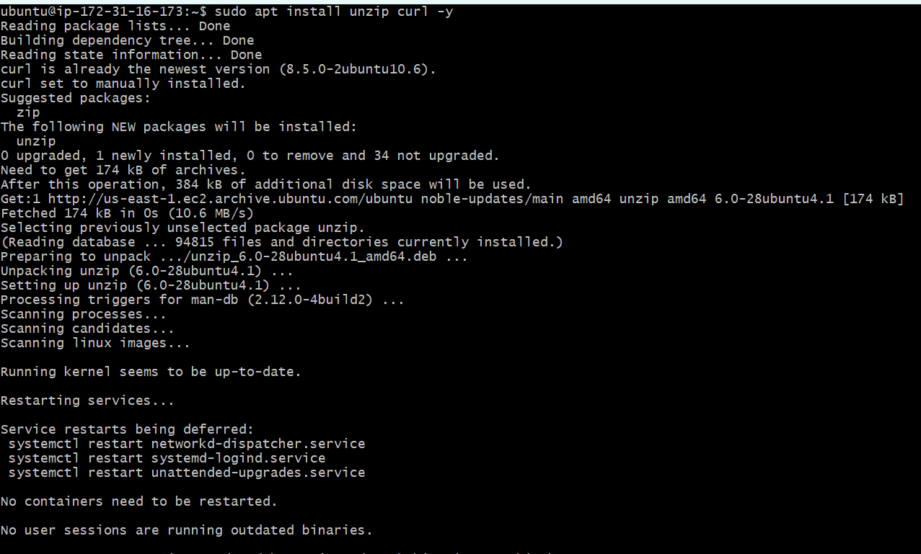
Step 2: Download AWS CLI v2
curl "https://awscli.amazonaws.com/awscli-exe-linux-x86_64.zip" -o awscliv2.zip
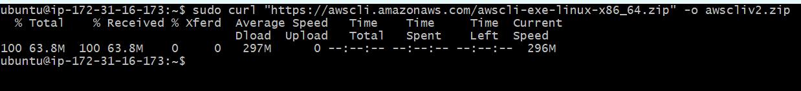
Step 3: Install
unzip awscliv2.zip
./aws/install
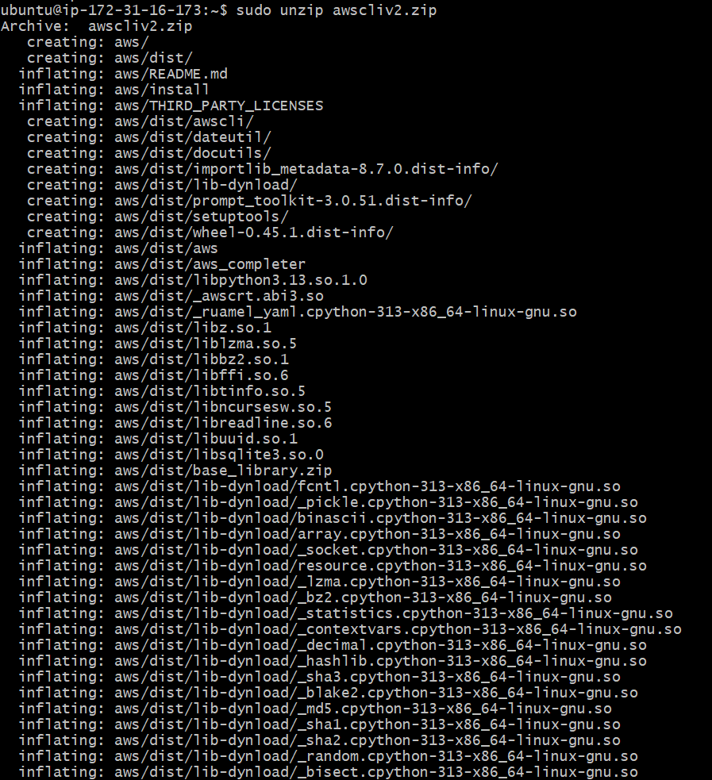

Step 4: Verify
aws –version
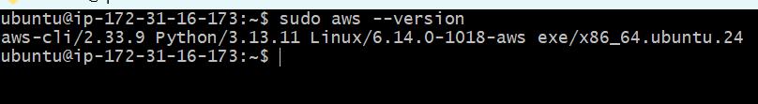

We have to create a access key and configure in controller
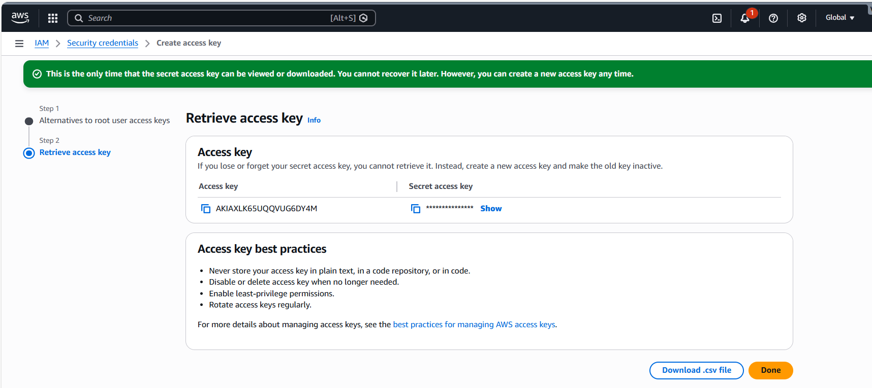

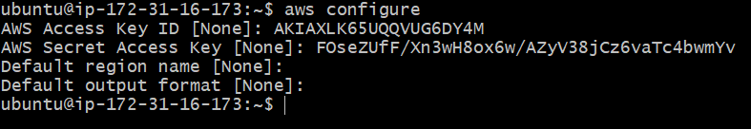
We have already created playbooks directory so we shall create a new playbook for ec2

Vi ec2.yaml
---
- hosts: localhost
connection: local
gather_facts: no

tasks:
- name: Create EC2 instance
amazon.aws.ec2_instance:
name: ec2-yaml
region: us-east-1
instance_type: t2.micro
image_id: ami-0532be01f26a3de55
key_name: Ansible
security_group: default
wait: yes
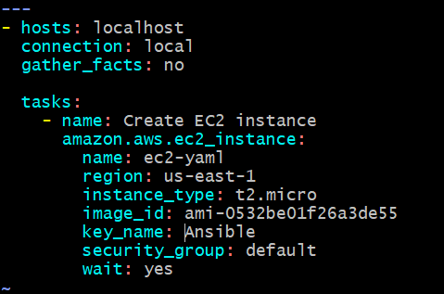

we shall execute the script once dry run syntax errors are checked.
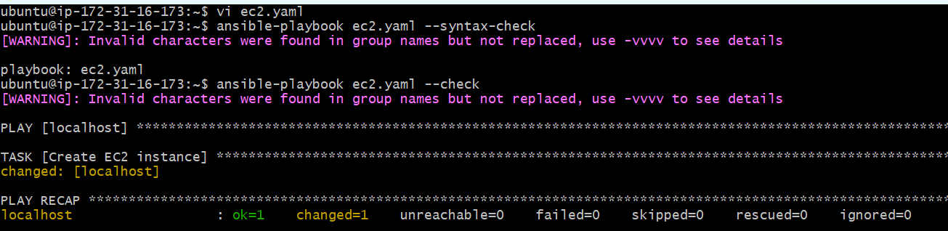

Ready for execution and executed
Success- playbook ran succesfully
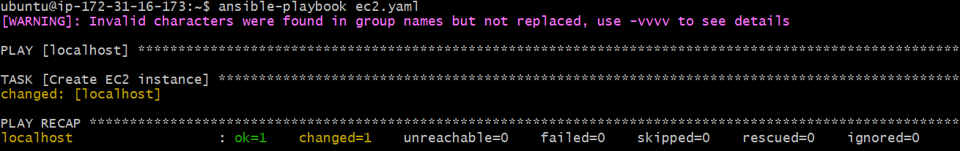

Automatically created ec2 from playbook
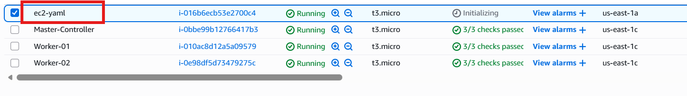

Task completed.

- Write an ansible playbook to copy one file from node-1 to node-2.

Step by step Implementation:
Requirement: Write an ansible playbook to copy one file from node-1 to node-2
Step 1: First, we need to create a file in worker-01, so used command- ansible Worker-01 -m shell -a "echo 'Hello from Worker-01' > /tmp/ansible.txt"

Step 2: Let’s create a playbook now
Vi copyfile.yaml

we shall execute the script once dry run syntax errors are checked.

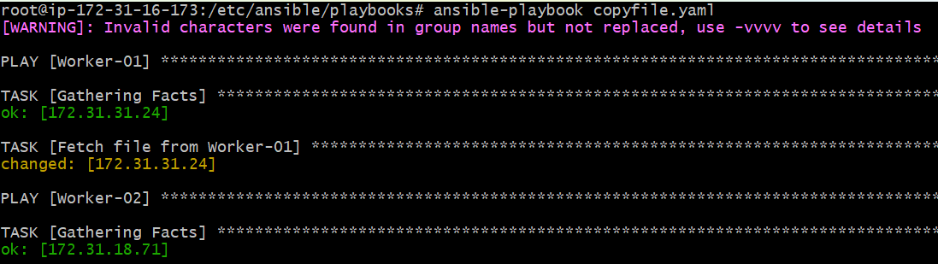
Executed the playbook
Success- playbook ran successfully.
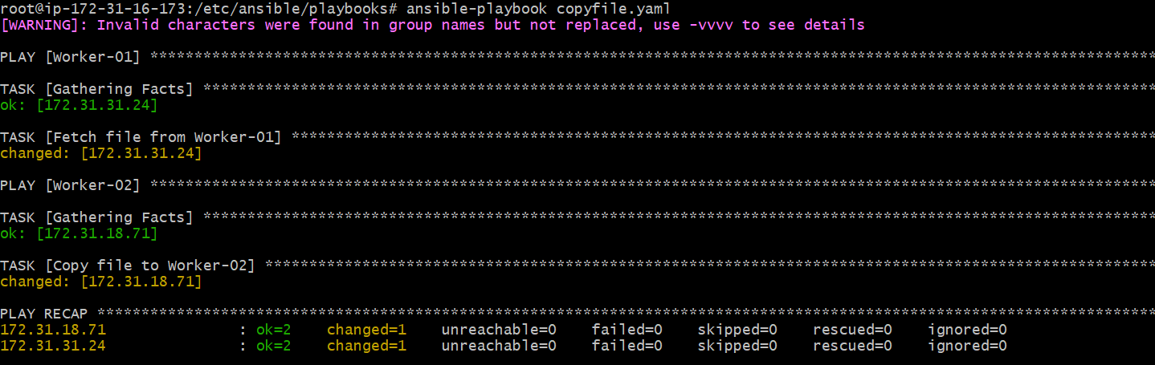

Let’s verify in Worker-01
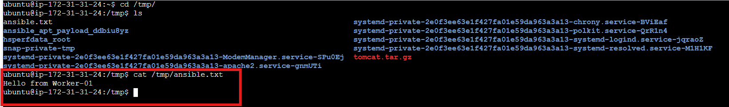
Task completed

- Write an ansible playbook to create different files with different names using single playbook.

Step by step Implementation:

Requirement: Write an ansible playbook to create different files with different names using single playbook

Ansible loops allow performing repetitive tasks efficiently.
Using a single playbook, multiple files with different names can be created.

- name: Create multiple files
hosts: all
become: yes

vars:
files:
- small.txt
- medium.txt
- large.log

tasks:
- name: Create files
file:
path: /root/{{ item }}
state: touch
loop: "{{ files }}"

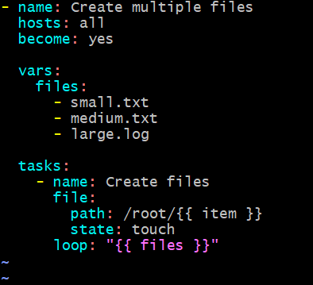
we shall execute the script once dry run syntax errors are checked.
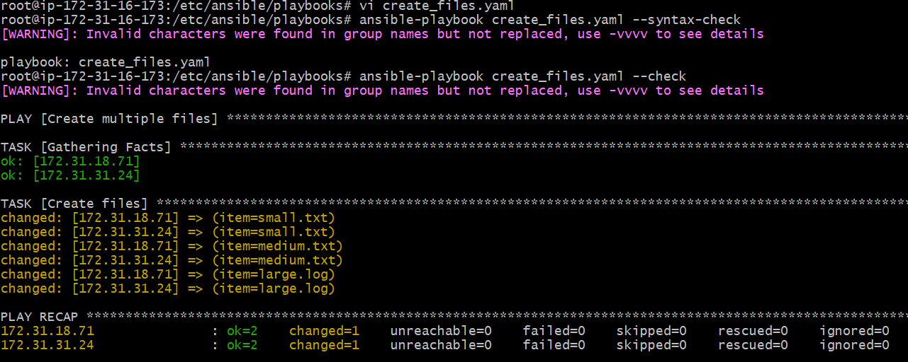

Executed the playbook
Success- playbook ran successfully.
